
PROGRAMME: BA BUSINESS MANAGEMENT
MODULE: MARKETING FUNDAMENTALS
STUDENT NAME:AKHILA BABU
STUDENT ID: 2225765
LECTURER NAME:TUSHARA

Executive summary
The major aim of the paper is to analyze the performance of Tesco Plc. As a marketing manager, after analyzing several research studies about Tesco, one of the biggest retail firms in the world, is the work at hand. The articles discuss a variety of Tesco-related topics, such as value chain reconfiguration, organisational structure, risk management, market prospects, and employee involvement. To summarise the main conclusions of these papers in a table that relates to Tesco's organisational structure is the goal of this assignment. Tesco's organisational structure is also studied in reference to a similar academic idea.
According to the report, Tesco has a complicated organisational structure that enables it to function successfully and efficiently in the fiercely competitive retail sector. The company's management style, risk control procedures, and capacity to spot and seize market possibilities all contributed significantly to its success. Tesco's competitive advantage is also significantly influenced by employee involvement in organisational change and the reorganisation of the value chain. The organisational structure contingency theory sheds light on Tesco's success factors.
According to this principle, businesses should arrange themselves to meet the context and surroundings where they operate. Tesco's intricate and flexible organisational structure enables it to adjust to market developments and keep a step ahead of its rivals. The results of this investigation point to a number of characteristics, including Tesco's organisational structure, leadership, risk management procedures, and capacity to recognise and seize market possibilities, as contributing to its success. Tesco's ability to adjust to changes in its environment and continue to be successful is explained by the contingency theory of organisational structure.

Table of Contents
Executive summary 2
Introduction 5
Literature Analysis for Tesco Plc 6
External Analysis 7
Significance of external analysis 8
Analysis of Tesco's External Environment 9
PESTEL Analysis 9
Political Analysis 9
Economic Analysis 9
Sociocultural analysis 9
Technological analysis 9
Environmental analysis 9
Legal analysis 10
Porter's Five Forces Analysis of Tesco's Industry Environment 10
Threat of new entrants 10
Bargaining power of buyers 10
Bargaining power of supplier 10
Threat of substitutes 10
Intensity of competitive rivalry 10
Evaluation of Tesco Strengths and Weaknesses 11
SWOT Analysis 11
Strengths 11
Weaknesses 11
Opportunities 11
Threats 12
Performance Evaluation 12
Resource-Based View Theory 12
Recommendations for Tesco 13
Conclusion 15
References 16

Introduction
Tesco Plc is a multinational British company with operations in 12 different countries that sells food and everyday items. Tesco Plc is known as one of the largest retailers around the globe to have millions of customers. The company is based on more than 6800 locations with more than 57.9 billion euros in sales in 2020-2021 according to Moura (2021). Jack Cohen began the firm in 1919, and since then, it has experienced a number of important changes to its business strategy that have allowed it to grow outside of the United Kingdom and establish itself as a worldwide retail juggernaut.
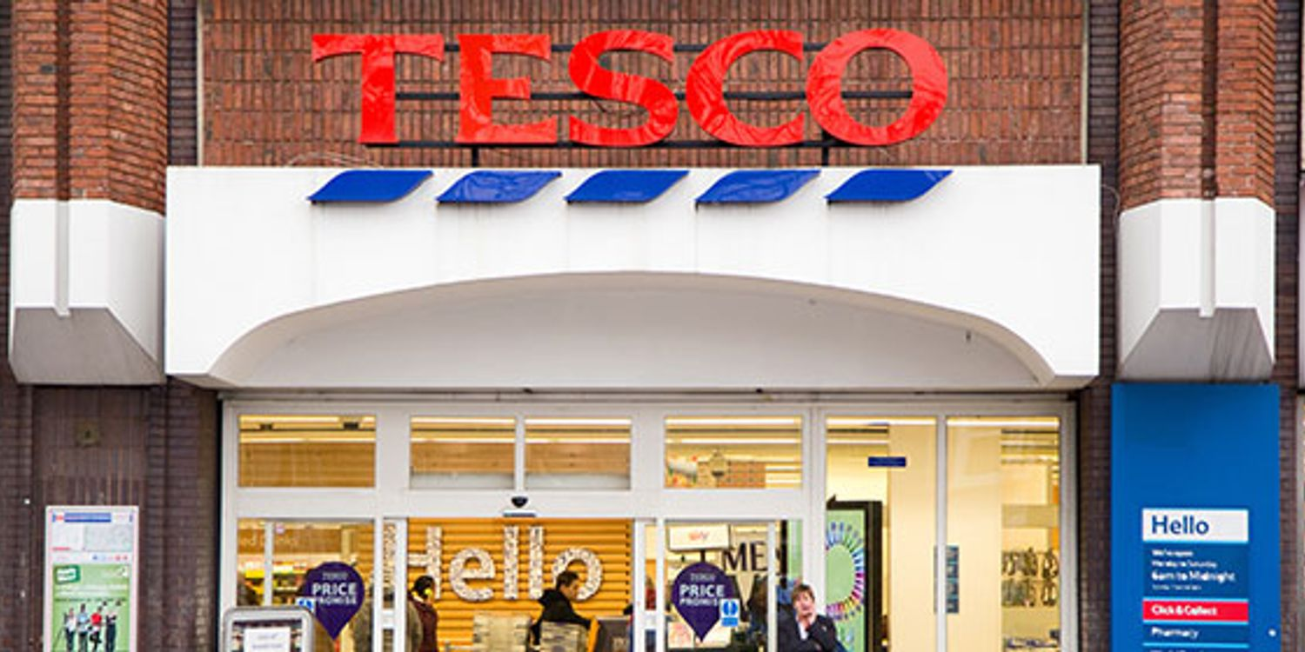
Focusing on client happiness, operational effectiveness, and innovation are a few examples of these activities (Catalo, 2022). Additionally, Tesco's capacity to adjust to alterations in the business environment, such as the Covid-19 pandemic, has aided the business in remaining resilient and expanding.
Tesco is a well-known retail behemoth with a sizable following both in the UK and abroad. According to Monte (2021), Tesco has been able to keep its competitive edge despite the COVID-19 pandemic thanks to its method for value chain reconfiguration. Tesco's success can also be ascribed to its attention to the wants and preferences of its customers and its capacity to change as the retail sector does. TRecently, esco has experienced both internal and external challenges that called for strategic adjustments. This essay attempts to offer suggestions for Tesco on how to take advantage of chances and lessen risks in its external environment, as well as how to strengthen its points of strength and deal with its areas of weakness.
As a marketing manager, presenting the report with the main objective to undertake a thorough study of Tesco Plc's internal resources, external environment, and strategic competencies in order to offer suggestions for seizing opportunities, averting risks, increasing strengths, and resolving weaknesses. The study's goal and objectives are to identify the important factors affecting the company's performance and competitiveness and to make recommendations for improving Tesco's position in the retail industry. Tesco is intended to benefit from the research and recommendations offered in this article in order to create and implement viable strategies for long-term success in the quick-paced, fiercely competitive retail sector.

Literature Analysis for Tesco Plc
Tesco is a large, international retailer that has been thoroughly studied and examined. The company's operating tactics and competitive environment have been the subject of several investigations. Data Envelopment Analysis (DEA) was used by Putra and Muzakir (2020) to analyze Tesco's and other international retail organizations' competitive environments. Tesco's market potential and difficulties were examined by Rosnizam et al. (2020), with a focus on the business's activities in Malaysia. Woods (2007) examined Tesco's approach to risk management by examining the relationship between strategic controls and risk management. The literature on Tesco gives useful insights into the business operations and serves as a foundation for additional study and analysis.
Tesco's organizational structure and culture are significant topics in the literature. Researchers have focused on the role Tesco's structure and culture play in the organization's performance and flexibility in responding to shifting market conditions. While Putra and Muzakir (2020) contend that the company's culture of innovation and continuous improvement enables it to stay ahead of rivals in the fiercely competitive global retail industry, Woods (2007) discusses how Tesco's decentralized structure allows for greater flexibility and responsiveness to local market conditions. This body of literature emphasizes how crucial organizational structure and culture are in determining a company's strategic direction and capacity to succeed.

External Analysis
External environment analysis is the process of identifying and assessing external factors that could affect the performance and strategic decisions of a business. Companies must analyze their external environment to comprehend the market's prospects and hazards and to create strategies that will seize those opportunities and lessen the risks. Two theoretical models that are widely applied for external environment analysis are PESTEL analysis and Porter's Five Forces model.
A methodology called PESTEL analysis examines the Political, Economic, Social, Technological, Environmental, and Legal (PESTEL) aspects that can have an impact on an organization. This methodology can assist companies in identifying outside variables that are beyond their control yet may have a big impact on their performance and operations. For instance, Adamyk (2019) employed PESTEL research to look at the macro-environmental factors influencing the performance of Tesco PLC. According to the report, changes in trade rules and regulations as a result of the UK's decision to leave the European Union (EU) may have a major effect on Tesco's business operations. Another paradigm for studying the external environment is Porter's Five Forces.
It outlines five competing forces, such as the threat of new entrants, the bargaining power of suppliers and buyers, the threat of substitute goods or services, and the ferocity of competitive rivalry, that influence the structure and profitability of the sector. This framework can assist companies in identifying the competitive environment of their sector as well as any potential risks and opportunities. Porter's Five Forces model, for instance, was utilized in the research by Monte (2021) on Tesco PLC to assess the processes involved in the company's value chain reconfiguration in response to COVID-19 demands.
Businesses must do external environment analysis to comprehend the opportunities and threats in the market. PESTEL analysis and Porter's Five Forces analysis are two theoretical frameworks that can assist firms in identifying and analysing external factors that may have an impact on their performance and developing efficient strategies to deal with obstacles and take advantage of opportunities.

Significance of external analysis
Analysis of the external environment is essential for the creation of a corporate plan. It assists companies in identifying potential dangers and opportunities that could have an influence on their operations, developing plans to take advantage of these chances and reducing the risks brought on by prospective threats. Businesses can better understand their industry, rivals, and the general business environment by doing an external analysis, which will enable them to create plans that will increase their success and competitiveness.
Finding the numerous chances that a company might use to enhance its operations is made easier with the help of an analysis of the external environment. For instance, a company may find a brand-new market segment to target, a technical advancement to capitalise on, or a brand-new distribution channel that will help them reach their clients more efficiently. By recognizing these possibilities, the company can develop a business plan to assist them in seizing them and enhancing their competitive advantage. However, external environment analysis helps companies find potential risks that could affect their operations. These risks could appear as new rivals, modified rules or regulations, recessions, or changes in consumer preferences.
By recognizing these challenges and creating plans to help them reduce the risks, businesses can strengthen their resistance to external changes. Analysis of the external environment can also help organisations better understand their industry and competitors. By investigating the external environment's strengths and weaknesses of their competitors, businesses can build strategies to increase their own competitive advantage. With the aid of this knowledge of the sector and the competition, businesses may create plans to stay ahead of the pack and flourish over the long run.

Analysis of Tesco's External Environment

PESTEL Analysis

Political Analysis
Politics has an impact on Tesco in the form of taxes and regulations. The business must abide by laws governing environmental standards, labour laws, and food safety (Rosnizam et al., 2020). Government policy changes like Brexit may have an effect on the business' operations and supply chain (Baliyan, 2021).

Economic Analysis
Economic issues including inflation, interest rates, and consumer spending have an impact on Tesco's business. Consumer spending may decline during economic downturns, which could harm the company's income (Rosnizam et al., 2020).

Sociocultural analysis
Tesco must accommodate the many demands and interests of its customers because it operates in a varied society. The organisation must adapt its marketing strategies and product offerings to the cultural and socioeconomic characteristics of the locations in which it conducts business (Rosnizam et al., 2020).

Technological analysis
Tesco's operations are greatly aided by technology, which includes anything from warehouse management systems to internet purchasing platforms. The business has made investments in a variety of technical advancements to improve customer experience, cut costs, and increase efficiency (Dumon et al., n.d.).

Environmental analysis
Tesco has an obligation to lessen its environmental impact. The business has introduced eco-friendly procedures like trash reduction, renewable energy use, and enhanced supply chain sustainability (Rosnizam et al., 2020).

Legal analysis
Tesco works in a highly regulated sector, and the business is required to abide by a number of rules, including those pertaining to consumer protection and employment (Rosnizam et al., 2020). The operations and financial success of the company may be impacted by changes in laws and regulations.

Porter's Five Forces Analysis of Tesco's Industry Environment

Threat of new entrants
Low entry barriers make it easy for new businesses to swiftly enter the retail sector. However, reputable companies like Tesco have an advantage due to their established supply chains, economies of scale, and brand recognition (Rosnizam et al., 2020).

Bargaining power of buyers
Customers in the retail sector have a lot of negotiating power and a variety of competitors to select from. To keep customers, Tesco must offer affordable rates, high-quality goods, and top-notch customer service.

Bargaining power of supplier
Because there are so many suppliers and retailers can switch between them, suppliers' negotiating power is constrained in the retail sector. To keep a solid supply chain, Tesco must however continue to have positive interactions with its suppliers (Pandey et al., 2021).

Threat of substitutes
Various substitutes, including online shopping, discount retailers, and wholesale clubs, compete with the retail sector. Tesco needs to set itself out with its goods and services to stay competitive.

Intensity of competitive rivalry
There are many businesses vying for market share in the fiercely competitive retail sector. Tesco is up against competition from long-standing firms like Sainsbury's and Asda as well as more recent firms like Aldi and Lidl.

Evaluation of Tesco Strengths and Weaknesses

SWOT Analysis

Strengths
Tesco is based on the solid brand recognition and market presence in the UK retail sector, and it has a wide range of products to meet different client needs. To optimise and enhance inventory management and improve customer experience, the organisation has made investments in supply chain efficiency and technical innovations. Tesco has diversified its activities over a number of retail formats, including online, convenience stores, hypermarkets, and supermarkets, and it also has a strong financial position. Tesco's market leadership in the retail sector is a result of its use of this diversification approach to reduce risks and seize market opportunities.

Weaknesses
Tesco has experienced a number of operational and financial difficulties despite having a significant market share, including accounting scandals and supplier payment disputes that negatively impacted the company's reputation and earnings. The company Tesco has also been subject to political and financial volatility as its excessive reliance on the UK market, which has hurt sales and decreased profitability. The latest increase in Tesco's debt-to-equity ratio is another sign of financial problems that could obstruct its possibilities for growth and shareholder value.

Opportunities
Tesco has a number of chances to grow its business and improve profitability. To diversify its revenue sources and lower market risks, the corporation could, for example, invest in emerging areas with a rising middle class and favourable economic conditions, including Asia and Africa. Tesco may also benefit from technological improvements by expanding its online sales channels and improving consumer experience. In order to expand market penetration and brand recognition in new markets, the corporation can also investigate strategic alliances and cooperation with regional shops.

Threats
Tesco's performance and market dominance are at risk from a number of issues. Due to the intense rivalry in the UK retail sector from established rivals like Sainsbury's and Asda and new entrants like Aldi and Lidl, Tesco's profitability and market share are more threatened. Tesco's product line and marketing tactics must also contend with shifting consumer tastes and shopping habits, such as those involving internet shopping and environmentally friendly goods. The unpredictability of the regulatory environment and geopolitical threats like Brexit and trade disputes may also hinder Tesco's operations and profitability in the UK and other markets.

Performance Evaluation
Due to a thorough approach to risk management and its international development plan, which allowed it to reach new markets and diversify its revenue streams, Tesco has maintained stable financial performance. The company's profitability has improved as a result of these tactics.
Tesco has successfully used the findings of its SWOT analysis to produce new items and enhance old ones in terms of product development (Soegoto, 2021). This has been essential in ensuring that the business maintains its competitiveness and can fulfil the constantly shifting needs of its clients. Tesco has also been successful in utilising technology to raise its performance. A number of technology-driven initiatives have been deployed by the business, including online ordering, delivery, and self-checkout systems, which have enhanced the consumer experience while simultaneously boosting sales.

Resource-Based View Theory
The Resource-Based Vision (RBV) theory is one academic idea that Tesco may be tied to. According to the RBV hypothesis, a firm's competitive advantage is based on the special resources and talents it has. This idea states that a company may establish a durable competitive advantage by better developing and utilising its resources and capabilities than its rivals.
Tesco has created a strong brand identity and reputation for quality and customer service, as well as investing in technology and innovation. These factors have helped Tesco develop a sustained competitive edge. During the COVID-19 pandemic, it was one of the first stores to provide online shopping and home delivery services, and it has since made investments in artificial intelligence and data analytics to better produce items that satisfy consumer demands.
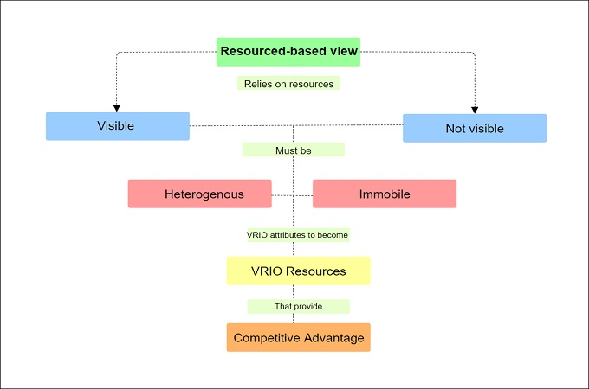
Source: Resource based view theory model from (Catalo, 2022).
The RBV hypothesis suggests that Tesco's success may be related to the company's effective utilisation of its resources and expertise. Tesco has maintained a competitive advantage in the very competitive retail industry by consistently growing and making use of its resources and abilities. Nevertheless, despite the business's overall strong performance, some weak points have been found. For instance, competing stores like Aldi and Lidl have given Tesco intense competition since they can offer products at lower prices, according to Sharmaa et al (2022). The company's profitability is impacted as a result of the company's profit margins being squeezed.

Recommendations for Tesco
- Tesco has a number of options to investigate in order to assure growth and profitability. Methods for maximising opportunities and countering risks in Tesco's external environment. One suggestion is for Tesco to broaden its online retail activities in order to capitalise on the expanding online shopping trend. Tesco may benefit from this trend by investing in its e-commerce skills and creating an effective and user-friendly online platform. The COVID-19 epidemic has further expedited the move towards online buying. This would make it easier for the business to reach more people and give its clients ease.
- Tesco may also take advantage of the growing market for locally produced, sustainable goods. The business may demonstrate its dedication to sustainability by increasing the selection of organic and locally sourced goods it offers. Building collaborations with regional vendors and enhancing these items' exposure in shops are two ways to do this.
- Tesco is threatened by fierce competition from rival stores like Walmart and Amazon, among others. Tesco can reduce this danger by concentrating on improving its customer experience and spending money on staff training and development. This would promote a devoted client base and assist to improve the standard of service offered to consumers. Tesco may also concentrate on creating creative marketing plans to raise brand recognition and draw in new clients.
Recommendations for enhancing Tesco's strengths and addressing its weaknesses in relation to the external environment:
- Tesco has a number of advantages that it may leverage to stay competitive. Its great brand reputation and image are one of these strengths. Tesco may benefit from this by boosting the awareness of its brand and raising the visibility of its goods and services. The company's distinctive selling characteristics and competitive advantages may be emphasised in effective marketing efforts to achieve this.
- Tesco's wide range of products is another one of its strengths. Tesco may concentrate on launching new items that address shifting consumer tastes in order to strengthen this strength. Finding upcoming trends and consumer preferences may be done by doing market research and obtaining customer feedback. Tesco may then utilise this knowledge to create new goods that satisfy these desires and appeal to a larger market.
- Tesco's capital structure has a significant degree of debt, which is one of its disadvantages. Tesco may concentrate on lowering its debt levels by taking steps like divesting assets, cutting costs, and boosting cash flow in order to solve this vulnerability. Tesco might also concentrate on streamlining its supply chain processes to cut costs and boost effectiveness. To streamline the flow of commodities and minimise waste, this may be done by implementing technology-enabled solutions like automation and artificial intelligence.
- Tesco can take use of its advantages and capabilities to stay competitive in a market that is undergoing fast change. Tesco can guarantee long-term development and profitability by fixing its shortcomings and averting dangers.

Conclusion
In conclusion, despite facing fierce competition and several obstacles from the outside environment, Tesco has been able to keep its position as the UK's top retailer. Tesco needs to address a number of strengths, weaknesses, opportunities, and threats as a result of the examination of the company's internal and external environments if it wants to maintain its competitive edge and experience steady growth. Tesco's strengths have been highlighted by the SWOT analysis, including its strong brand, varied product offering, and effective supply chain management. However, the analysis has also pointed out areas where the business needs to strengthen, such as the requirement to boost its online presence and enhance its marketing plan.
Tesco might think about putting plans in place including broadening its product line, investing in technology, enhancing customer experience, and investigating new markets in order to take advantage of the possibilities and reduce the dangers. Tesco can increase its competitiveness and hold onto its market position by capitalising on its strengths and correcting its deficiencies. Tesco has performed admirably, and by adjusting to the shifting external environment and putting in place suitable plans, the business has the capacity to thrive going forward.

References
Adamyk, K., 2019. PESTLE Analysis on Tesco PLC. http://dspace.wunu.edu.ua/bitstream/316497/35536/1/10.pdf
Awadari, A.C. and Kanwal, S., 2019. Employee participation in organizational change: A case of Tesco PLC. International Journal of Financial, Accounting, and Management, 1(2), pp.91-99. https://goodwoodpub.com/index.php/ijfam/article/download/93/23
Baliyan, R., 2021. A shift in paradigm for apparel industry post COVID 19. Turkish Journal of Computer and Mathematics Education (TURCOMAT), 12(13), pp.5203-5211. https://www.researchgate.net/profile/Priya-Diwan/publication/353233694_A_Shift_in_Paradigm_for_Apparel_Industry_Post_Covid_19/links/60ee54b59541032c6d39fdef/A-Shift-in-Paradigm-for-Apparel-Industry-Post-Covid-19.pdf
Catalão, I.D.P., 2022. Equity research: Tesco PLC (Doctoral dissertation, Instituto Superior de Economia e Gestão). https://www.repository.utl.pt/bitstream/10400.5/26748/1/DM-IPC-2022.pdf
Dumon, D., McDonald, K. and Schmitz, R., Innovative offers outside the field of traditional sport. https://www.engso-education.eu/wp-content/uploads/2021/08/Intellectual-output-3.pdf
Liu, K., 2022. Research on the core competitiveness of short video industry in the context of big data—a case study of tiktok of bytedance company. American Journal of Industrial and Business Management, 12(4), pp.699-730. https://www.scirp.org/journal/paperinformation.aspx?paperid=116928
Monte, A., 2021. A study of value chain reconfiguration processes under Covid-19 pressures: the case of Tesco PLC in the United Kingdom. http://tesi.luiss.it/31586/1/261361_MONTE_ALESSANDRO.pdf
Monte, A., 2021. A study of value chain reconfiguration processes under Covid-19 pressures: the case of Tesco PLC in the United Kingdom. http://tesi.luiss.it/31586/1/261361_MONTE_ALESSANDRO.pdf
Moura, M.B.L.D., 2021. Equity Research in Food & Retail Industry-TESCO PLC (Doctoral dissertation, Instituto Superior de Economia e Gestão). https://www.repository.utl.pt/bitstream/10400.5/23303/1/DM-MBLM-2021.pdf
Pandey, R., Dillip, D., Jayant, J., Vashishth, K., Nikhil, N., Qi, T.J., Kee, D.M.H., Mei, T.C., Xin, R.Y.K. and Qhi, L.Y., 2021. Factors Influencing Organization Success: A Case Study of Walmart. International Journal of Tourism and Hospitality in Asia Pasific (IJTHAP), 4(2), pp.112-123. http://www.ejournal.aibpmjournals.com/index.php/IJTHAP/article/download/1059/1018
Putra, Z. and Muzakir, M., 2020. Competitive Environment Analysis in Global Retail Companies Operation Strategy: A Data Envelopment Analysis (DEA) Based Approach. AFEBI Management and Business Review, 5(1), pp.16-36. http://www.journal.afebi.org/index.php/ambr/article/download/286/156
Rosnizam, M.R.A.B., Kee, D.M.H., Akhir, M.E.H.B.M., Shahqira, M., Yusoff, M.A.H.B.M., Budiman, R.S. and Alajmi, A.M., 2020. Market opportunities and challenges: A case study of Tesco. Journal of the Community Development in Asia (JCDA), 3(2), pp.18-27. https://ejournal.aibpmjournals.com/index.php/JCDA/article/download/807/772
Rosnizam, M.R.A.B., Kee, D.M.H., Akhir, M.E.H.B.M., Shahqira, M., Yusoff, M.A.H.B.M., Budiman, R.S. and Alajmi, A.M., 2020. Market opportunities and challenges: A case study of Tesco. Journal of the Community Development in Asia (JCDA), 3(2), pp.18-27. https://ejournal.aibpmjournals.com/index.php/JCDA/article/download/807/772
Sharmaa, A., Jain, R. and Pajni, N.S., Risk Identification Techniques in Retail Industry: A case study of Tesco Plc. https://jcgirm.com/wp-content/uploads/2022/09/13.-Article-13-V9-S1-201-214.pdf
Soegoto, F.A., 2021. Product development using SWOT analysis. International Journal of Entrepreneurship & Technopreneur (INJETECH), 1, pp.1-10. http://ojs.unikom.ac.id/index.php/injetech/article/download/4819/2314
Woods, M., 2007. Linking risk management to strategic controls: a case study of Tesco plc. International Journal of Risk Assessment and Management, 7(8), pp.1074-1088. https://www.researchgate.net/profile/Margaret-Woods/publication/228230822_Linking_Risk_Management_to_Strategic_Controls_A_Case_Study_of_Tesco_Plc/links/0deec520a51458bc0a000000/Linking-Risk-Management-to-Strategic-Controls-A-Case-Study-of-Tesco-Plc.pdf?_sg%5B0%5D=started_experiment_milestone&origin=journalDetail&_rtd=e30%3D

