Geo-technics and Foundation Technology:
Soil Mechanical Practical Report

Laboratory Portfolio
Presented by: Joshua Albrighton

Contents
1.0 Atterberg Limit Test- Page 3
1.1 Introduction- Page 3
1.2 Equipment- Page 4
1.3 Method for Liquid Limit Test- Page 5
1.4 Method for Plastic Limit Test-Page 6
1.5 Results- Page 7
1.6Analysis- Page 7
1.7 Conclusions- Page 9
2.0 Sieve Analysis Test- Page 10
2.1 Introduction- Page 10
2.2 Equipment- Page 11
2.3 Method- Page 11
2.4 Results- Page 11
2.5 Analysis- Page 12
2.6 Conclusions- Page 13
3.0 Soil Permeability Test- Constant Head Permeameter- Page 14
3.1 Introduction- Page 14
3.2 Equipment- Page 14
3.3 Method- Page 14
3.4 Results- Page 15
3.5 Analysis- Page 16
3.6 Conclusions- Page 17
4.0 Bibliography- Page 18
1.0 Atterberg Limit Test
1.1 Introduction
The Atterberg test is a test used to determine the plastic and liquid limit for different fine-grained clay and silt soil samples. The test is performed on soils that will pass through a 0.425mm sieve as per ASTM D 4318-00.
This test aids in the classification of soils and helps to determine the soils characteristics such as plasticity, and the shrink/swell potential of the soil. The test also determines the shrinkage limit, plastic limit and liquid limit of each soil sample and can also be used to differentiate silt and clay soils.
This test is important as it helps accurately determine the behaviour of soil samples under different moisture contents. This is useful in civil engineering as it can help engineers accurately predict how the soil will act when used in structures such as embankments, soil infills and also how the near-surface level soil will interact with foundations of larger buildings when exposed to different levels of moisture content.

1.2 Equipment
Evaporating Dishes- Mix specimen to desired moisture content
Spatula- To mix soil specimen.
Mortar and Pestle- To reduce specimen particle size.
Digital Scale- To weigh soil specimens (must have 0.01g readability).
Aluminium Containers- To keep soil samples.
Drying oven- To carry out moisture content test.
Grooving tool- To separate soil in liquid limit machine.
Liquid Limit Machine (Casagrande)
Glass Plate- To roll soil for plastic limit test.
Plastic Limit Roller- To roll fast and consistent samples (optional)
Wash Bottle- Used to add small amounts of water to soil samples.
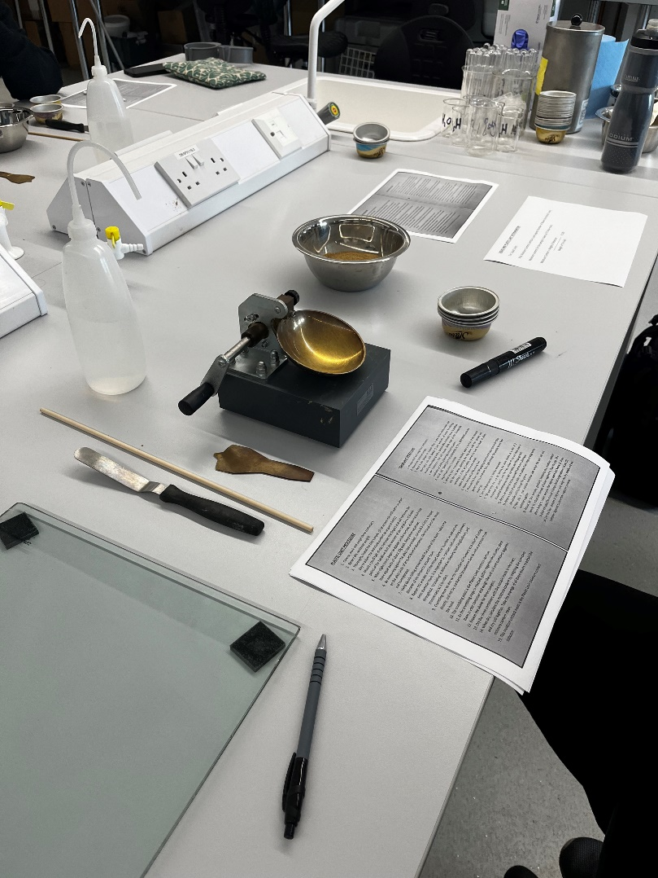
(Albrighton. J, 2023)

1.3 Method For Liquid Limit Test
The first step taken in the experiment was weighing and marking four aluminium containers. The weight of each container while empty was then recorded for later analysis.
The next step of the experiment was to place a soil sample of around 250g in the mixing bowl and a very small amount of water was added from the wash bottle and the sample was then mixed with the water thoroughly.
Once the soil had a clay-like texture it was then placed into the liquid limit apparatus (Casagrande) and spread evenly across the face of the dish. Down the centre of the sample, the grooving tool was used to create a 12mm gap in the soil sample. Any excess soil was returned to the mixing dish.
The next step in the experiment involved using the Casagrande. Before the liquid limit machine was used, the drop counter was set to zero to ensure the results gathered were accurate. The cup on the liquid limit machine was then lifted and dropped by using the crank on the side of the machine. The crank on the machine was turned at 2 revolutions per second every time to ensure repeatability of the experiment. The crank was turned at a constant rate until the gap created by the grooving tool was closed (this took around 35 drops).
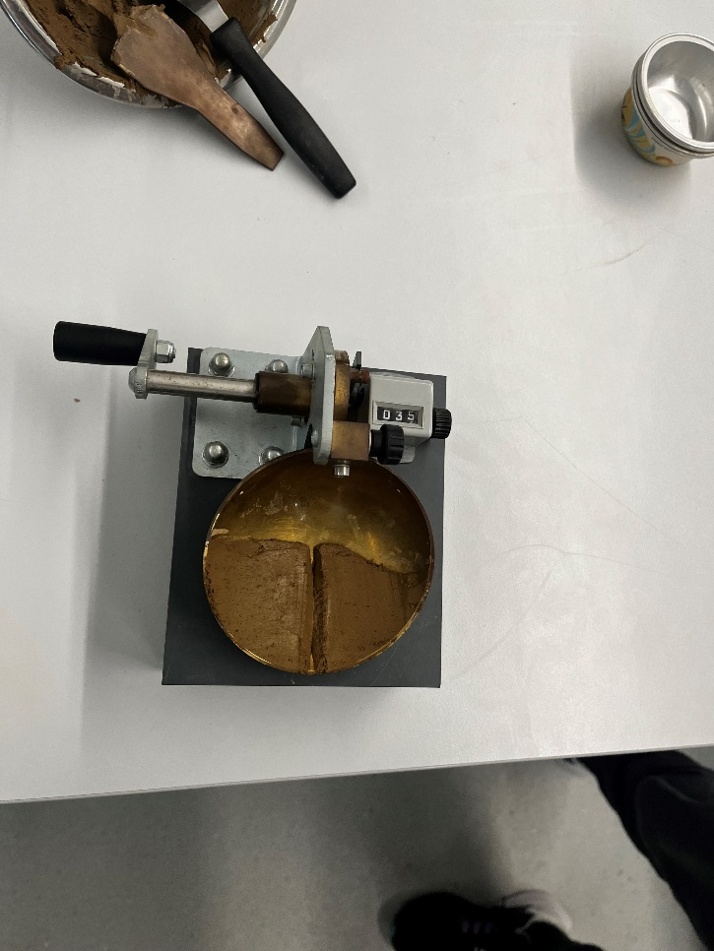
Casagrande machine (Albrighton. J, 2023)
A chunk of the soil sample was then collected by the spatula by dragging the spatula through the cup horizontally, ensuring to go through the groove in the sample. This sample collected by the spatula was then placed into one of the aluminium containers and weighed. This weight was recorded.
This process was repeated for three other samples, each increasing in moisture content, ensuring each weight was recorded along with the number of drops required to close the gap created by the grooving tool.
The four samples were then placed in a drying oven and left to dry then the weight when dry was recorded to determine the moisture content.

1.4 Method For Plastic Limit Test
The first step in carrying out this procedure was marking 3 different aluminium containers and weighing each container while empty. The results were then recorded to determine the weight of the soil without the container.
The next step was to add small amounts of water to a soil sample and knead the soil sample until the sample has a clay-like consistency.
The sample was then rolled into a ball. The ball of clay was then rolled in the palms of the experimenter’s hand until the sample was dry from the heat of the experimenter’s hands.
Once the sample was dry it was then divided into three separate, smaller balls. These would be the three samples used for the experiment, each around 10 grams.
The balls of clay were then rolled into 6mm threads on the glass plate. A 6mm rod can be used in this process to roughly determine the size of the clay-threads. Once the samples were rolled out to 6mm diameter and were still in tact they were then rolled on the glass plate until they had reached 3mm diameter. By this point the samples began to crumble. If the samples did not crumble but instead they bottle-necked or snapped then the process was not correct and must be repeated with the addition of more moisture. Ensure there is uniform pressure throughout the rolling process to gain repeatable results.
The crumbling point of the samples is known as the plastic limit for each sample.
The samples were then gathered separately and placed into the three aluminium containers previously marked and weighed. These containers were then all weighed with the samples in them and the weight was recorded.
The samples were then put into the drying oven and dried out completely before they were weighed again, and the dry sample weight was recorded. The moisture content was then calculated for each sample and the average of the three results was then recorded as the mean moisture content. This figure is an indicator to the Plastic Limit moisture content.

1.5 Results
 | 1 | 2 | 3 | 4 | 5 | 6 | 7
Type of Test | LL | LL | LL | LL | PL | PL | PL
Container Number | LL1 | LL2 | LL3 | LL4 | PL1 | PL2 | PL3
Weight of Wet Soil + Container (g) | 13.56 | 11.58 | 13.35 | 15.05 | 7.99 | 8.67 | 9.39
Weight of Dry Soil + Container (g) | 11.08 | 9.62 | 10.76 | 11.82 | 7.35 | 7.9 | 8.41
Weight of Container (g) | 4.67 | 4.7 | 4.75 | 4.76 | 4.66 | 4.69 | 4.76
Weight of Moisture (g) | 2.48 | 1.96 | 2.59 | 3.23 | 0.64 | 0.77 | 0.98
Weight of Dry Soil (g) | 6.41 | 4.92 | 6.01 | 7.06 | 2.96 | 3.21 | 3.65
Moisture Content % | 38.68 | 39.83 | 43.09 | 45.75 | 23.79 | 23.98 | 27.84
Number of Blows | 35 | 23 | 12 | 6

1.6 Analysis
Through these results, the liquid limit, plastic limit, and plastic index can be found. The liquid limit can be found by plotting a graph showing the moisture content plot against the number of blows as shown below.
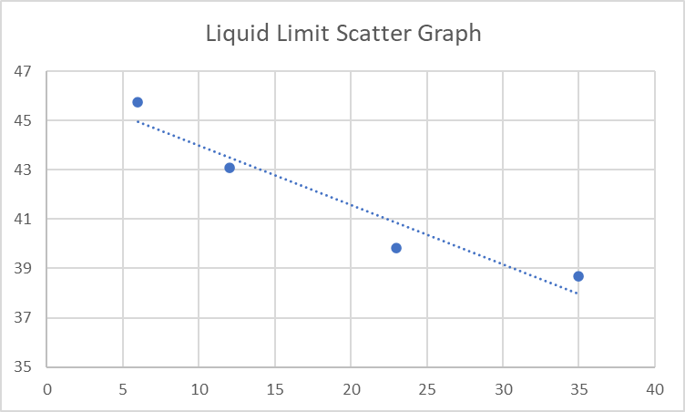
Liquid Limit = 40.5%
As shown by the table here the liquid limit is 40.5% moisture content.
The plastic limit can then be calculated by taking the average of the moisture content from plastic limit experiments.
23.79 + 23.98 + 27.84 = 75.61/3 = 25.2%
Plastic Limit = 25.2%
From these 2 figures the plastic index can then be found by subtracting the plastic limit from the liquid limit.
PI = 40.5-25.2 = 15.3%
Plastic index = 15.3%

These figures help engineers understand the soil’s structure and properties, and their behaviours. This means that engineers can then have a better understanding on where the soil can be used efficiently.
The way that engineers categorise these samples to allow them to accurately guess their characteristics is by using the Casagrande plasticity chart.
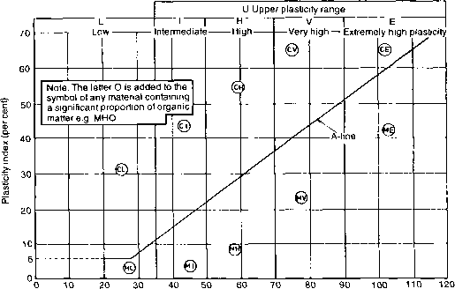

Soil Sample

(Chart provided by Skinner, 2023)

as you can see from the chart the soil sample has 40.5%, moisture content for liquid limit and 25.2% for plastic limit. This means that the sample is classified as a clay with intermediate plasticity.

1.7 Conclusions
In conclusion the experiment was successful as the experimenters were able to find the plastic limit and liquid limit from the results gained. The Atterberg limits tests are crucial in identifying soil and determining soil properties.
in future experiments it may be a good idea to do more extensive tests on the sample such as conducting 5 plastic limit tests to ensure there is less human error or anomalies or just to ensure there are more samples to get a more specific average.
Another possible improvement would be to roll out the clay samples in the plastic limit test using a machine as there was a lot of fracturing of the clay rods, meaning the process was partially trial and error so we cannot be certain that the results are correct or repeatable.

2.0 Sieve Analysis Test
2.1 Introduction
The Sieve Analysis (grain size analysis) test is used to determine the percentage of each grain size that any soil sample contains. This can be used to classify soils and determine their behaviour as results can be used to form a grain size distribution curve.
The sieve analysis test can be undertaken on particles that are larger than 0.075mm in diameter. If the particles are smaller than 0.075mm in diameter, then the hydrometer analysis test must be performed.
This test is usually used to grade aggregates. This means to look at how well the distribution of aggregate sizes are in a sample and can be very useful when looking for the correct aggregates for construction products such as cement mixes. The table below shows the different sizes in a standard British Sieve analysis test.
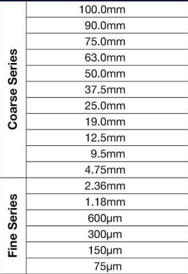
Table provided by GlobalGilson.com, n.d.

2.2 Equipment
Weighing Scale with Pan (Sensitive to 0.1g)
Brush- To brush particles that have clung to sieve.
Stack of Sieves with Cover
Drying Oven
Mechanical Sieve Shaker

2.3 Method
The first step of this experiment was to weigh the weighing scale pan on its own to get the pans weight without any soil. Once the pan had been weighed the soil sample was gathered and weighed (around 2kg of soil was used). The weight was then recorded ready for the sieves to be set out.
The sieves were then set out in a tower, the sieve with the largest opening on top and then decreasing in opening size further down the tower. This tower was then secured onto the mechanical shake plate and was left to vibrate for 2 minutes.
After 2 minutes had passed the machine was then stopped, the lid removed and the sieves released from each other one by one. A brush was used to then brush any particles that clung to the sieves through to the next sieve. Each sieve was then emptied into the weighing scale pan (one sieve at a time) and weighed to the nearest 0.1g, making sure to note the percentage of aggregate left on each sieve to the nearest 0.1%.
The sieve size was then plot against the percentage of aggregate passing through and is below in the results

2.4 Results
Sieve Size (mm) | Mass (g) | % On Sieve | % Passing
2 | 16.67 | 1.67 | 98.33
1.18 | 45.64 | 4.57 | 93.77
0.6 | 115.15 | 11.51 | 82.26
0.3 | 575.37 | 57.54 | 24.72
0.150 | 133.57 | 13.36 | 11.36
0.063 | 62.59 | 6.26 | 5.10
0.045 | 17.93 | 1.79 | 3.31
0.038 | 20.96 | 2.09 | 1.22
Bottom Tray | 10.57 | 1.18 | 0.09
 | 9.39 | 0.94 | 0.28

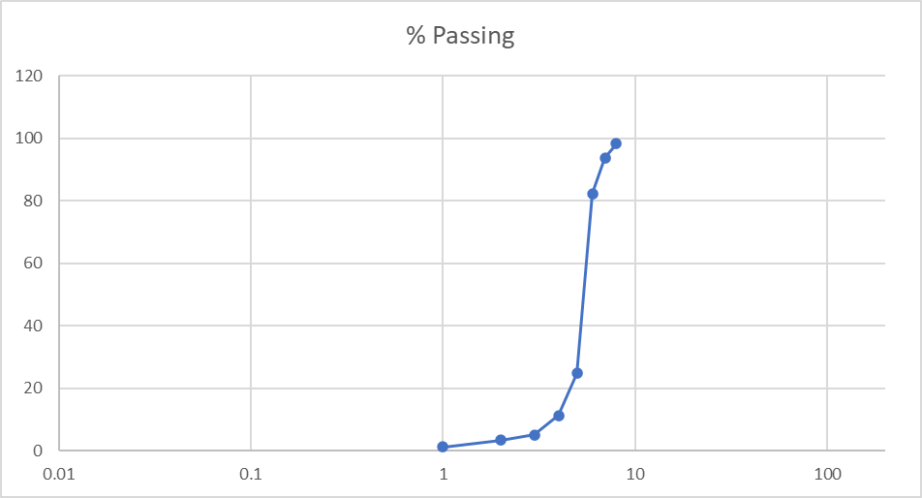
2.5 Analysis
The percentage passed and percentage left on sieve figures are found by weighing the entire sample, which came to 1000 grams, and then as the experiment is taking place each sieve is emptied onto a tray to be weighed and that weight is then calculated as a percentage of the entire sample.
This particle size distribution chart shows that there is no clay in the sample, 3.15% of the sample is silt, 1.67% is gravel and 94.98% is sand.
By comparing this to the soil texture triangle we can classify the sample and therefore predict the samples behaviours. From these results you can see that the sample lands in the sand category.
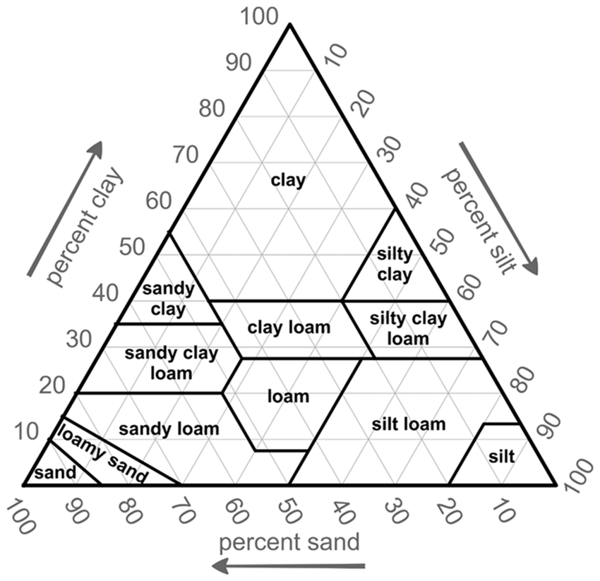(Chart provided by ResearchGate, n.d.)
Soil sample sits here.

These results show some important factors that civil engineers will find useful. One thing that these results show is the water flow potential. The sample is mainly sand and the water flow potential of sand is good so water can pass through easily and the soil will not absorb a lot of water. This does however mean that water holding capacity is poor so this soil would be poor for agricultural use but would be useful for urban needs. The results also allow us to predict the samples’ load bearing capacity. Loose sand has a relatively low load bearing capacity of roughly 100kN/m² which means that it would not be useful for larger scale projects but could be useful for smaller projects where deep-rooted foundations are not necessary.

2.6 Conclusions
in conclusion, these results are useful as they help to classify the sample and they show some of the characteristics and practical uses of the soil. These results show that the soil can be used in small scale urban building scenarios and would be poor in agricultural use and large scale projects.
Some of the drawbacks in this experiment include human error, equipment error and the humidity of the room. Although less than 0.02% of the soil was lost the experiment could have been done more efficiently to ensure that less of the sample was lost.
The humidity of the room would have affected the sample as it would have caused the sample to absorb more of the moisture from the room, making it possibly stick to the sieves instead of it all passing through as it should. A possible solution for this in future experiment would be to do this experiment in a more controlled environment with low humidity to ensure that none of the sample absorbed moisture from the air.
Another possible drawback was the possibility of the bristles from the brush getting stuck in the sieves, mixing in with the sample or gathering some of the sample on its bristles, causing it to get lost in the experiment. A solution for this in the future would be to buy brand new brushes for the experiment as it lowers the possibility of any bristles coming loose.

3.0 Soil Permeability Test- Constant Head Permeameter
3.1 Introduction
The constant head permeameter test is an experiment where water is run through a sample of soil at a constant flow rate and the amount captured is measured over a period. The waterflows through a piece of equipment called a permeameter and it is called a constant head permeameter test because there is a constant supply of water coming from the top of the permeameter.
The purpose of this test is to determine the permeability of different types of sandy soils.
This test is necessary when calculating seepage through earth dams, under sheet pile walls or to calculate the seepage rate of waste storage facilities such as landfills or ponds. It can also be used to calculate the rate of settlement of soil deposits especially those which are clayey (September 30 and Reply, 2015).
This experiment follows the standard test procedure set out in ASTM D 2434.

3.2 Equipment
Permeameter
Stopwatch
Sample soil
1000ml Measuring Cylinder
3.3 Method
the first step taken in this experiment was to set up the experiment. This involved setting up the permeameter by filling it with water and measuring out the initial mass of dry sample soil. The bottom valve of the permeameter was then opened to allow the water to run through the dry sample to allow the sample to become completely wet throughout to allow for a constant flow. The bottom valve of the permeameter was then closed.
After the soil was soaked through completely the constant head difference was established. In calculations this is known as h.
After the constant head difference was established, the experiment was ready to begin. the experimenter set up a measuring cylinder below the permeameter so there was a downhill movement of the water and the bottom valve of the permeameter was then opened again allowing water to flow into the measuring cylinder for exactly 30 seconds. The amount of water gathered in the measuring cylinder was then recorded and then the cylinder was emptied.
The experiment was repeated four times to prove repeatability and gain an average of the five results.
3.4 Results
Test Number | Water Collected in 30 Seconds
1 | 128
2 | 145
3 | 145
4 | 150
5 | 145

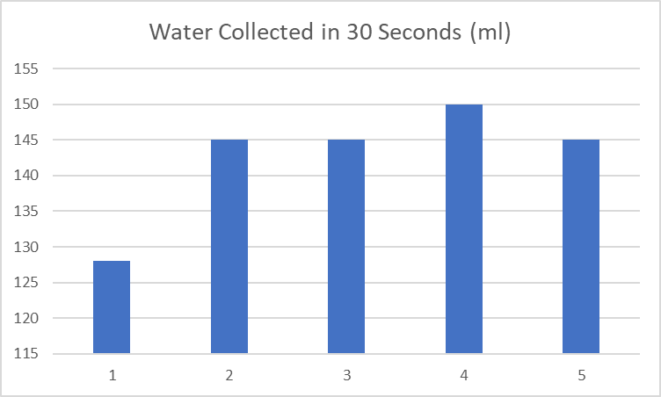

3.5 Analysis
These results show the amount collected in each measuring cylinder over a period of 30 seconds. As you can see from these results each experiment resulted in about 145-150ml of water being collected each time apart from experiment 1 which appears to be an anomaly, possibly caused by human error as the amount collected was much lower this time than any other. What caused this anomaly is unknown and could be due to many factors which will be listed in the conclusion.
To determine the soils permeability Darcy’s Law was applied to the results.
Henry Darcy’s Law states that the velocity of flow is proportional to the hydraulic gradient meaning that the velocity of the waters flow is directly related to the slope of the waters flow between two points.
K= Q x L
A x h x t
The formula for Darcy’s Law is:

K- Coefficient of Permeability
Q- Flow over time = 145ml/ 30s = 4.83333 (convert to m³/s= 0.00483333 m³/s)
L- Length of flow line = 0.07m
A- Area of Flow = πr² = π x (0.0793²) = 0.0198 m²
h- Hydraulic Head Difference = 0.041m
t- Time in Seconds = 30 seconds
K= 0.00483333 x 0.07
0.0198 x 0.041 x 30
K= 1.389230106 x 10⁻²

This equation shows that the soil used in the experiment has a relatively high coefficient of permeability, meaning that the sample soil is high in permeability. This means that there is more air between the particles of soil, allowing water to pass through quicker, this can mean that there will be more movement in the soil and unexpected settlement behaviour so this sample would be inefficient for construction purposes such as foundations.

3.6 Conclusions
the experiment was successful as the experimenter found the coefficient of permeability of the sample soil allowing for the engineer to make predictions about the soil’s behaviour accurately.
There were some drawbacks in this experiment that caused anomaly. These were likely due to human or equipment error. The likely cause of the anomaly was one of a few things: the tube the water flowed into the cylinder through was not set at a fixed height so the results may have been altered by the tube being too high of low, the stop watch was being started an stopped manually so may have been stopped too quickly, the experimenter controlling the flow was being told when to start and stop by the experimenter holding the stopwatch so there may have been failure in communication.
Some possibly solutions to cause less human error would be to set the measuring vessel and tube the water flowed through in fixed positions so no movement errors could be made. The flow and stopwatch could also be controlled by one experimenter if the water pipe and measuring cylinder were fixed into a position so there would be no communication errors.
Another note for further experiments is to gather a larger sample size for calculations by conducting more tests. This will allow for a more accurate average of flow rates which will make calculations easier in future.

4.0 Bibliography
GlobalGilson.com. (n.d.). Sieve Sizes: A Guide to U.S. and Metric Sizes. [online] Available at: https://www.globalgilson.com/blog/sieve-sizes.
ResearchGate. (n.d.). Fig 1. USDA Soil Texture Triangle. [online] Available at: https://www.researchgate.net/figure/USDA-Soil-Texture-Triangle_fig2_279631053.
September 30, A.S. and Reply, 2018 (2015). PERMEABILITY TEST OF SOIL – CONSTANT HEAD METHOD. [online] CivilBlog.org. Available at: https://civilblog.org/2015/11/26/permeability-test-of-soil-constant-head-method/.
Skinner, G. (2023). Plasticity Chart For Soil Mechanics - Soil Mechanics. [online] Euro Guide. Available at: https://www.euroguide.org/soil-mechanics/p.html [Accessed 24 Apr. 2023].

‌

‌

‌

