

Task 1 – Reading Task Template
Upload your photo of your A3 in-class notes here:
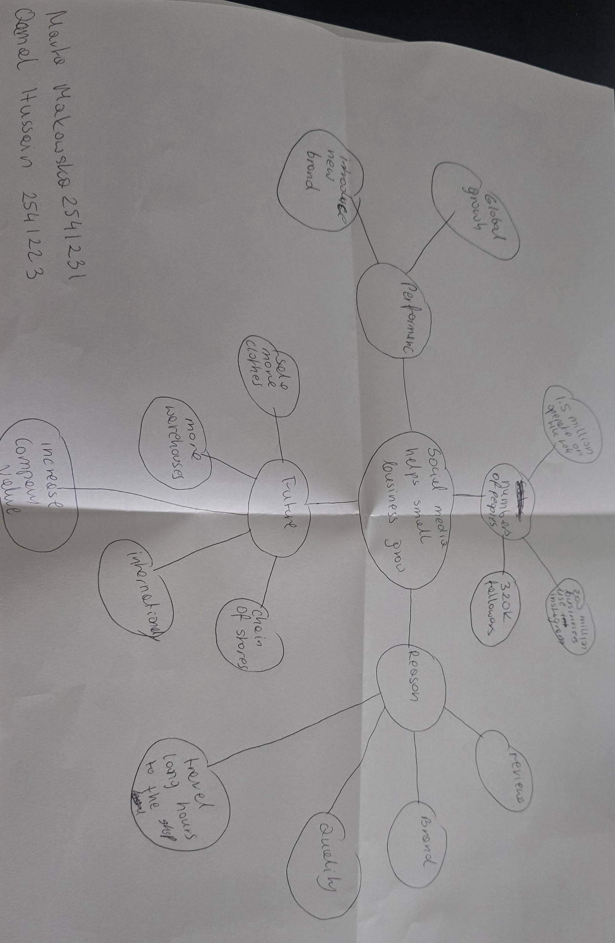

1. Answer these questions using the sentence starters below
a. What is the main idea of the text?
The main idea is that social media ,especially TikTok, Instagram or Facebook has helped small businesses get more customers and grow their sales.
b. What are two key points?
One key point is that Kristy Chamberlain was very successful after when she posting videos on TikTok and gained millions of views.
Another key point is that social media has great power and helps businesses attracts customers not only form UK but also other countries.
c. What part of the text did you find most important? Why?
The most important part is how social media changed businesses by bringing in new customers and increasing sales, because it shows the power of online marketing. Nowadays, social media is a force and power.
d. Was anything unclear or difficult to understand?
I was not sure about some of the statistics and numbers about views and fallowers because there were many figures in the txt.
e. How did your group help you understand the text better?
Me and Qamal discuss about main idea ,explaining difficult words, and compering our answers. We had a brainstorm .
3. One sentence reflection
Question: What did you find challenging about this task?
The hardest part was understanding all the details about the different businesses and remembering the information about each one and also finding the most important points (key points)

