Psychological Classifications and Provisions
Component 1: Individual Presentation (Academic Poster)
BMHP6029
Shabnam Kausar
2319036
Neal Haddon

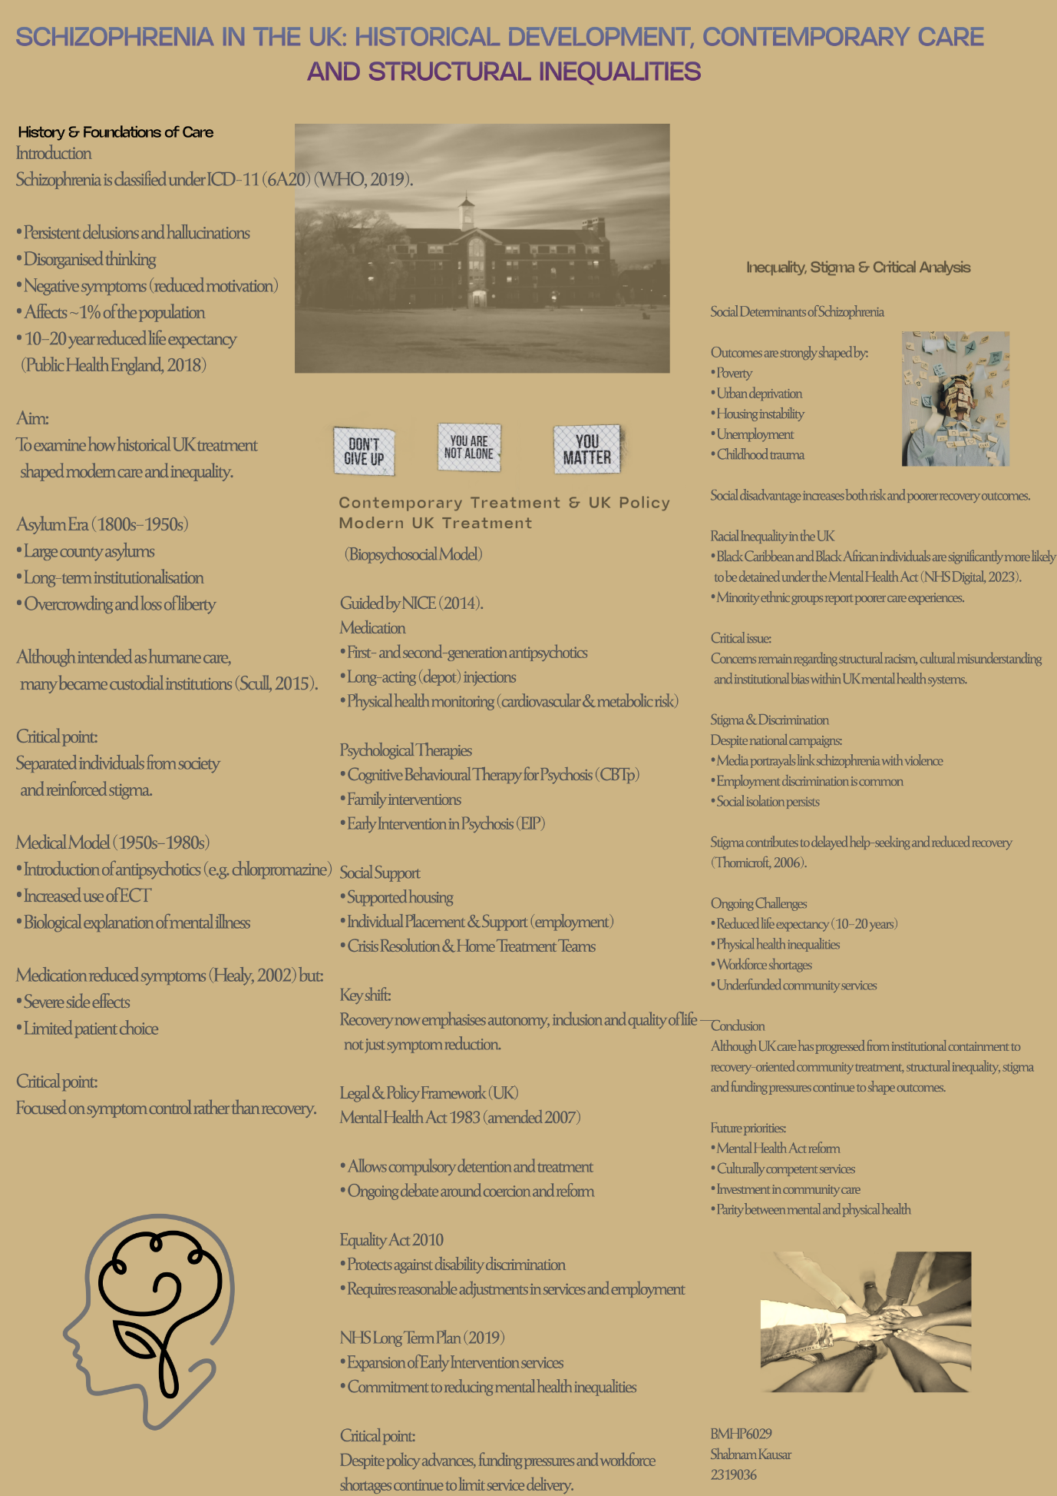

Reference List
Healy, D. (2002) The creation of psychopharmacology. Cambridge, MA: Harvard University Press.
Mental Health Act 1983 (as amended by the Mental Health Act 2007). London: HMSO.
National Institute for Health and Care Excellence (2014) Psychosis and schizophrenia in adults: prevention and management (CG178). London: NICE.
NHS Digital (2023) Mental Health Act statistics, annual figures, England 2022–23. Leeds: NHS Digital.
NHS England (2019) The NHS Long Term Plan. London: NHS England.
Public Health England (2018) Severe mental illness and physical health inequalities: briefing. London: PHE.
Scull, A. (2015) Madness in civilization: a cultural history of insanity. London: Thames & Hudson.
Thornicroft, G. (2006) Shunned: discrimination against people with mental illness. Oxford: Oxford University Press.
Turner, T., Hayward, R. and Angel, K. (2015) ‘Care in the community: historical perspectives’, The Psychiatrist, 39(3), pp. 97–100.
World Health Organization (2019) International classification of diseases 11th revision (ICD-11). Geneva: WHO.
Equality Act 2010. London: The Stationery Office.

