

Materials Testing and Sustainability in Composites for Motorsport & Automotive Industries

Oliver Moss
2204624

Module Code: ACHA6012
Submission Deadline: 04/05/2025
Lecturer: Dr Kerry Tudor
Word Count: 3206
1. Contents
1. Contents…………………………………………………………………..1
2. Introduction………………………………………………………………4
3. Literature Review………………………………………………………...5
3.1. What is a Composite?……………………………………………...5
3.2. Common Composite Applications………………………………...5
3.3. Composite Structures……………………………………………...6
3.4. Manufacturing of Composites……………………………………..7
3.4.1. Closed Moulding Manufacturing Process…………………..7
3.4.2. Open Moulding Manufacturing Process……………………8
3.5. Sustainability of Components……………………………………..9
3.6. Legislation and Sustainability of the Engineering Industry……...10
4. Methodology…………………………………………………………….12
4.1. Materials Tested………………………………………………….12
4.2. Test Methodology………………………………………………..13
5. Raw Results……………………………………………………………..14
5.1. Aluminium……………………………………………………….14
5.2. Carbon Non-Woven with Bio Resin……………………………..15
5.3. Carbon Woven with Bio Resin…………………………………..15
5.4. Carbon Woven with Epoxy………………………………………16
5.5. Kevlar Woven……………………………………………………17
5.6. Hemp Non-Woven with Bio Resin………………………………17
5.7. Flax Non-Woven with Bio Resin………………………………..18
5.8. Flax Woven with Bio Resin……………………………………...19
5.9. Combining the Average Results…………………………………19
6. Validation of Results……………………………………………………21
7. Analysis of Low-Speed Stress on Different Materials………………….23
7.1. Carbon Composites………………………………………………23
7.2. Sustainable Composites………………………………………….23
7.3. Woven Vs Non-Woven…………………………………………..24
7.4. Bio Resin Vs Epoxy Resin……………………………………….24
7.5. Aluminium & Kevlar…………………………………………….25
8. Sustainability Entering the Industry…………………………………….28
8.1. Composite Applications………………………………………….28
8.2. Problems with Sustainable Composites………………………….28
8.3. Sustainable Composites in the Engineering Industry……………29
9. Conclusion………………………………………………………………30
10. References………………………………………………………………31
11. Appendix………………………………………………………………..36
Figure 1 - Stress Strain Curve of Fibre, Resin and Combined as Composite (Hatton.G, 2019) 5
Figure 2 - Laminar Structured Composite at 90˚ Angles (Satishkumar.P, 2020) 6
Figure 3 - Cross Section of a Sandwich Composite (Satishkumar.P, 2020) 6
Figure 4 - Honeycomb Sandwich Composite (Satishkumar.P, 2020) 7
Figure 5 - Pre-Impregnated Fibre Manufacturing Process (Tudor.K, 2024) 7
Figure 6 - Resin Transfer Moulding Manufacturing Process (Tudor.K, 2024) 8
Figure 7 - Vacuum Infusion Manufacturing Process (Tudor.K, 2024) 8
Figure 8 - Hand Lay-Up Manufacturing Process (Tudor.K, 2024) 8
Figure 9 - Spray-Up Manufacturing Process (Tudor.K, 2024) 8
Figure 10 - Filament Winding Manufacturing Process (Tudor.K, 2024) 8
Figure 11 - Life Cycle of a Vehicle (Steel E-Motive, n.d.) 9
Figure 12 - Variables that Affect the Decision of Purchasing a Vehicle (Wellbrock et al, 2020) 11
Figure 13 - Denison Tensile/Compressive Test Machine 12
Figure 14 - Materials Tested 13
Figure 15 - Stress Throughout Tensile Test for Aluminium 14
Figure 16 - Max Stress Experienced on Aluminium 14
Figure 17 - Stress Throughout Tensile Test for Carbon Non-Woven with Bio Resin 15
Figure 18 - Max Stress Experienced on Carbon Non-Woven with Bio Resin 15
Figure 19 - Stress Throughout Tensile Test for Carbon Woven with Bio Resin 15
Figure 20 - Max Stress Experienced on Carbon Woven with Bio Resin 16
Figure 21 - Stress Throughout Tensile Test for Carbon Woven Epoxy 16
Figure 22 - Max Stress Experienced on Carbon Woven with Epoxy 16
Figure 23 - Stress Throughout Tensile Test for Woven Kevlar 17
Figure 24 - Max Stress Experienced on Kevlar 17
Figure 25 - Stress Throughout Tensile Test for Hemp Non-Woven with Bio Resin 17
Figure 26 - Max Stress Experienced on Hemp Non-Woven Epoxy 18
Figure 27 - Stress Throughout Tensile Test for Flax Non-Woven with Bio Resin 18
Figure 28 - Max Stress Experienced on Flat Non-Woven with Bio Resin 18
Figure 29 - Stress Throughout Tensile Test for Flax Woven with Bio Resin 19
Figure 30 - Max Stress Experienced on Flax Woven with Bio Resin 19
Figure 31 - Average Stress Throughout Tensile Test for Each Material 20
Figure 32 - Max Stress Experienced by Each Material 20
Figure 33 - Denison Machine Calibration Date 22
Figure 34 - SN-Curve for Carbon Epoxy Composite (Al-Qrimli.H, Mahdi.F, Alnaimi.F, 2015) 22
Figure 35 - Difference between Non-Woven (Left) and Woven (Right) Carbon (Tenowo, n.d.) 23
Figure 36 - Aluminium After Tensile Break 25
Figure 37 - Aluminium in Tensile Test, Outlining the Material Necking Throughout Test 25
Figure 38 - Material Necking (SUNGDA, n.d.) 26
Figure 39 - Kevlar After Tensile Break 26
Figure 40 - Zoomed in at Fracture of Kevlar After Tensile Test 26
Figure 41 - Failure of Carbon Non-Woven with Bio Resin 34
Figure 42 - Fracture of Carbon Woven with Bio Resin 34
Figure 43 - Fracture of Carbon Woven with Epoxy 35
Figure 44 - Fracture of Hemp Non-Woven with Bio Resin 35
Figure 45 - Fracture of Flax Non-Woven with Bio Resin 35
Figure 46 - Fracture of Flax Woven with Bio Resin 36

Table 1 - Common Composites and their Applications to Automotive & Motorsport (Khan.F et al, 2024) 5
Table 2 - Tested Material's Sustainability Properties (Data from: Ansys Granta, 2022 & easycomposites, 2024-2025) 9
Table 3 - Top 5 Countries Producing the Most CO₂ in 2024 (McShane.M, 2024) 10
Table 4 - Top 5 Countries Producing the Most CO₂ per Capita in 2024 (McShane.M, 2024) 10
Table 5 - Tested Material's Physical Properties 13
Table 6 - Validation of Max Tensile Strength Values 21
Table 7 - Epoxy & Bio Resin Properties (easycomposites, 2025) 24
2. Introduction
Composite materials have been widely used in all areas of engineering due to their ability of customising their properties to suit the environment they experience. However, in recent years, sustainability has become a larger concern for most countries, resulting in a strong push, by legislation and pressure groups, for civilisation to adopt more sustainable practices. This is where, this report aims to analyse both physical and environmental properties of multiple composites to outline why governments and businesses are struggling to simply implement more sustainable practices, as well as mentioning which composites suit different environments.

3. Literature Review
3.1. What is a Composite?
Composites “now account for up to 85% of today’s Formula 1 cars, but only roughly 20% of the weight”, as stated by Hatton.G (2019). This is due to their customizable properties, as seen below by Hulatt.L (2023).
- High Strength-To-Weight Ratio
- Corrosion Resistance
- Design Flexibility
- Thermal Properties
Hatton.G (2019) explains that composites are made from combining very different materials, commonly being a material like carbon and a resin. The fibres of these materials are significantly strong in one direction but weak under compression or bending, so they are combined with resin to act as an adhesive and support the fibres when experiencing compressive loads. This results in a more evenly strong material with a weaker tensile strength, as seen in figure 1, but a stronger compressive strength.
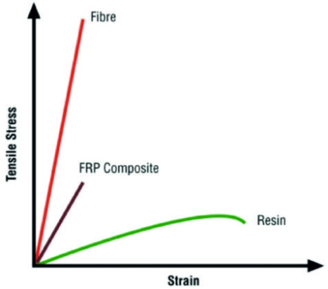
Figure 1 - Stress Strain Curve of Fibre, Resin and Combined as Composite (Hatton.G, 2019)
3.2. Common Composite Applications
Table 1 - Common Composites and their Applications to Automotive & Motorsport (Khan.F et al, 2024)
Composite | Applications | Advantages
Carbon Fibre | Body Panels  Chassis Parts  Interior Elements  Braking Systems | Improved Fuel Efficiency
Glass Fibre | Body Panels  Bumpers | Good Strength & Stiffness
Kevlar Fibre | Armour Panels  Protective Elements | Excellent Impact Resistance
Natural Fibre | Interiors  Door Panels  Non-Structural Components | Renewable  Lightweight  Environmentally Friendly
3.3. Composite Structures
A composite can be constructed with a laminar or sandwich structure. Laminar composites, like carbon fibre, are the most common type of composite and, as mentioned by Tudor.K (2024) along with other sources, these composites consist of multiple sheets of material bonded at specific angles to each other, as seen in figure 2. This angle can significantly control the overall properties of the composite because, as mentioned before, each sheet has one direction of high strength, so, placing at different angles results in the composite withstanding load in multiple directions (Satishkumar.P, 2020). This was the type of composite produced for this project, using a fibre orientation of 45˚ each.
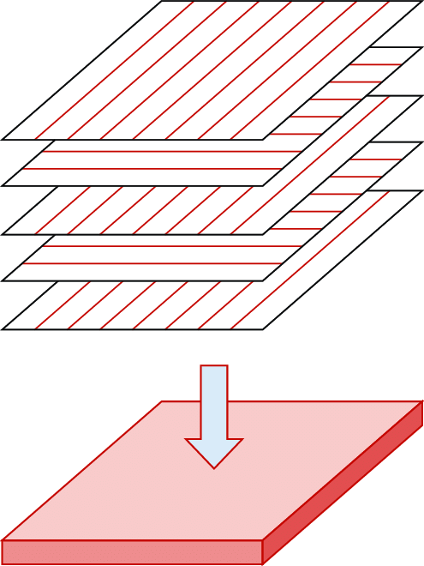
Figure 2 - Laminar Structured Composite at 90˚ Angles (Satishkumar.P, 2020)
Sandwich panel composites are structurally made of “faces” and “cores”, as seen in figure 3.
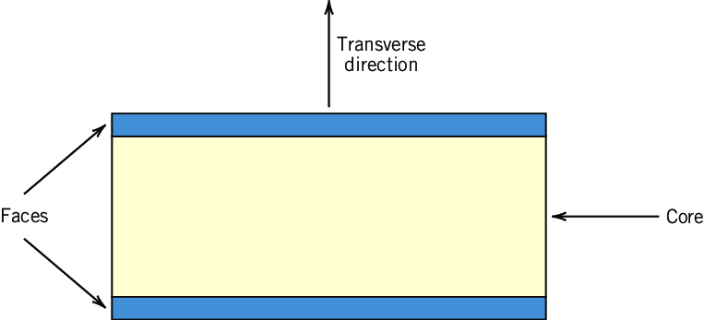
Figure 3 - Cross Section of a Sandwich Composite (Satishkumar.P, 2020)
Tudor.K (2024) and Satishkumar.P (2020) state that the “faces” are made from a strong material, like aluminium, as they are used to absorb the in-plane loading. The “core” is made up of a lightweight material with a low modulus of elasticity, as it is used to resist any bending due to loading in the transverse direction.

Commonly, the “core” consists of either:
- Rigid Polymeric Foams
- Wood
- Honeycomb (most popular), figure 4
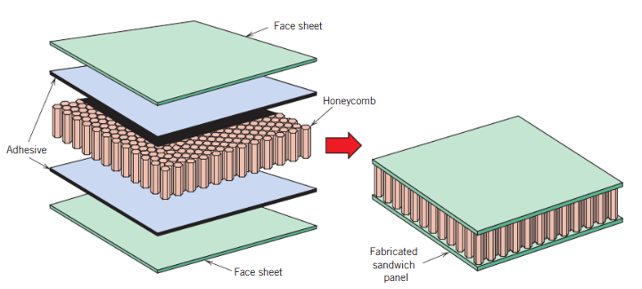
Figure 4 - Honeycomb Sandwich Composite (Satishkumar.P, 2020)
3.4. Manufacturing of Composites
When manufacturing a composite, multiple factors, as stated below, help to decide the best manufacturing method (Tudor.K, 2024).
- Production Speed
- Cost
- Performance
- Size
- Shape Required
Composites can be manufactured using an open or closed moulding process, with the 3 most popular for each stated below, with aid from PIRAN, 2023.
3.4.1. Closed Moulding Manufacturing Process
Pre-Impregnated Fibres (Prepeg)
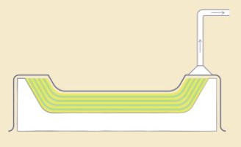  Figure 5 - Pre-Impregnated Fibre Manufacturing Process (Tudor.K, 2024) | Also known as vacuum bag moulding, it is the most common method involving pre-coating fibres with resin, placing them in the mould and applying heat and pressure to cure the resin and mould to the shape required.

Resin Transfer Moulding (RTM)
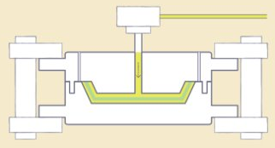  Figure 6 - Resin Transfer Moulding Manufacturing Process (Tudor.K, 2024) | Dry fibre is placed in the mould, and then resin is pressurised and injected into the fibres until the resin cures. This makes it the best option for complex shapes required.
Vacuum Infusion
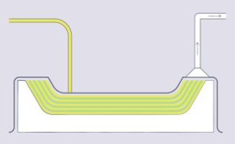  Figure 7 - Vacuum Infusion Manufacturing Process (Tudor.K, 2024) | Similar to RTM but uses a vacuum to pull the resin around the dry fibres in a mould.  This was the process used for this project.
3.4.2. Open Moulding Manufacturing Process
Hand Lay-Up
  Figure 8 - Hand Lay-Up Manufacturing Process (Tudor.K, 2024) | Fibres are manually positioned in the mould, then wetted with liquid resin and then repeated. It requires significant attention to detail and is then left to cure in the mould.
Spray-Up
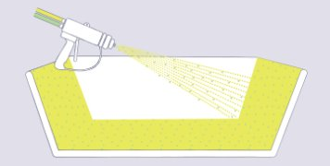  Figure 9 - Spray-Up Manufacturing Process (Tudor.K, 2024) | A mix of resin and small fibreglass is sprayed into a mould until the desired thickness is achieved. Fast and cost-effective if automated.
Filament Winding
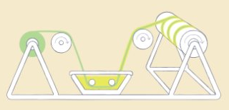  Figure 10 - Filament Winding Manufacturing Process (Tudor.K, 2024) | A mandrel is rotated, and wet fibre is applied under tension. Once it has cured, the mandrel is removed.
a
3.5. Sustainability of Composites
The big drawback with composites is their environmental impact at the end of their life cycle. Life cycle analysis is used to outline a component's life from start to end and measure its environmental impact.
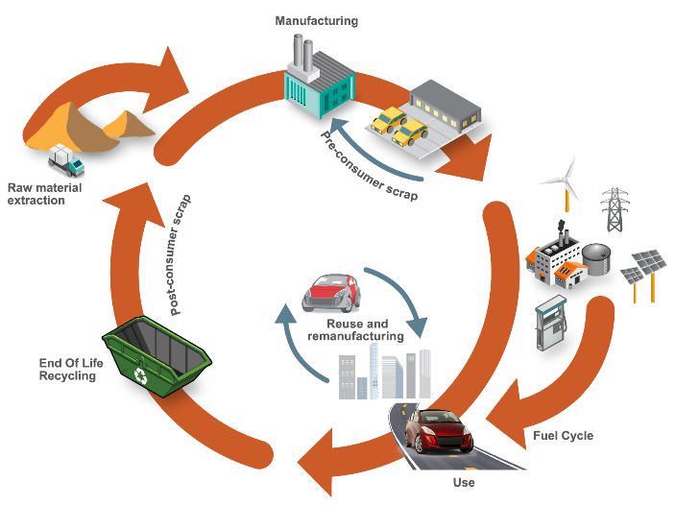
Figure 11 - Life Cycle of a Vehicle (Steel E-Motive, n.d.)
When a composite enters the end of its life, it cannot be recycled due to the fibres and resin being hard to separate. Also, the composite cannot be reused by reshaping and can only be downcycled, but at a cost of reduced performance. The more common option is to place the composite in landfill, which is harmful to the environment, as certain composites cannot biodegrade, as seen in table 2. This means that they sit there while new composites are made and more CO₂ is produced. Companies have tried to redesign composites to either be biodegradable or recyclable. Recycling has the best effect on the environment as it reduces the number of composites produced by reusing old composites. However, biodegradable seems to be the better option because parts of society are lazy and have less care for sustainability, making them less conscious of their decisions. This is why companies have invested time in natural fibre composites that can biodegrade when placed in a landfill.
Below shows a table of the sustainability properties of the materials tested.
Table 2 - Tested Material's Sustainability Properties (Data from: Ansys Granta, 2022 & easycomposites, 2024-2025)
Material | Price (£/kg) | CO₂ Produced (kg/kg) | Recyclable | Downcyclable | Landfill | Biodegradable | Energy from Burning (MJ/kg) | CO₂ from Burning (kg/kg)
Aluminium 1200 H14 | 1.64 | 8.845
Carbon Non-Woven Bio | 47.6 | 46.25 |  |  |  |  | 31.5 | 3.19
Carbon Woven Bio | 109.52 | 46.25 |  |  |  |  | 31.5 | 3.19
Carbon Woven Epoxy | 14.25 | 46.25 |  |  |  |  | 31.5 | 3.19
Kevlar Woven | 100 | 13.1 |  |  |  |  | 28.1 | 2.585
Hemp Non-Woven Bio | 11.67 | 1.6 |  |  |  |  | 18.25 | 1.58
Flax Non-Woven Bio | 17 | 0.44 |  |  |  |  | 17.45 | 1.425
Flax Woven Bio | 91 | 0.44 |  |  |  |  | 17.45 | 1.425

3.6. Legislation and Sustainability in the Engineering Industry
With increasing severity in environmental impacts affecting the future of civilisation, many legislations are rapidly being introduced to reduce each countries’ carbon footprint. The countries below, in table 3, produce the most amount of CO₂ and are ordered from most to least, from Boiler Cover (McShane.M, 2024).
Table 3 - Top 5 Countries Producing the Most CO₂ in 2024 (McShane.M, 2024)
Country | Population (million) | CO₂ Emissions (gigatons) | CO₂ per Capita
1. China | 1,425 | 11,400 | 7.9
2. United States | 340 | 5,057 | 14.87
3. India | 1,429 | 2,830 | 1.9
4. Japan | 123 | 1,054 | 8.5
5. Indonesia | 278 | 729 | 2.6
These 5 countries are the main cause to the global environment instability and more legislation and environmental control may be required in these countries. However, countries like China and India may not need to change as their sustainable practices could be adequate and instead their population is the cause of large CO₂ emissions as their CO₂ per capita is low. Table 4 shows the top 5 countries with the highest CO₂ per capita from Boiler Cover (McShane.M, 2024).
Table 4 - Top 5 Countries Producing the Most CO₂ per Capita in 2024 (McShane.M, 2024)
Country | Population (million) | CO₂ Emissions (gigatons) | CO₂ per Capita
1. United States | 340 | 5,057 | 14.87
2. Australia | 26 | 392 | 14.83
3. Canada | 38 | 548 | 14.1
4. Luxembourg | 0.65 | 7.5 | 11.4
5. Iceland | 0.38 | 3.5 | 9.4
Similarly, though places like Luxembourg and Iceland may seem unsustainable however, their CO₂ emissions are low and is mainly due to their population being low as well. Interestingly, Rao.D states that in 2024 Luxembourg was voted the 2nd most sustainable country, so while their CO₂ per capita is high, they are a significantly sustainable country.
With regards to motorsport, Mittal.S (2024) states the majority of Formula 1’s carbon footprint is from travel, accounting for 72.2%, as well as logistics accounting for 24.7%. To combat this, the FIA are aiming to be “Net-Zero Carbon” by 2030, by aiming to have 100% sustainable fuel by 2026 (Formula One, 2019) as well as “strongly pushing for renewable energy to power facilities” for permanent circuits and minimising the amount of freight transported (Mittal.S, 2024).
The automotive industry, on the other hand, has had a bigger push, with multiple aims being set and achieved by each business. Along with government aid, there has been a significant push with electric and hybrid vehicles beginning to dominate the automotive industry with 21% more vans and 17.8% more zero emission cars sold in 2023 compared to 2022 (SMMT, 2023). However, while the demand for electric vehicles was high, now each consumer that wants a sustainable vehicle has one however companies have mass produced these electric vehicles, expecting it to take over the market but hasn’t, causing businesses to have land taken up by unsold cars, with Tesla having produced 46,561 more vehicles than delivered in the first quarter of 2024 (Levi.D, 2024). This could be due to figure 12 showing how, in general, the sustainability of a vehicle is the least significant factor when buying a car.
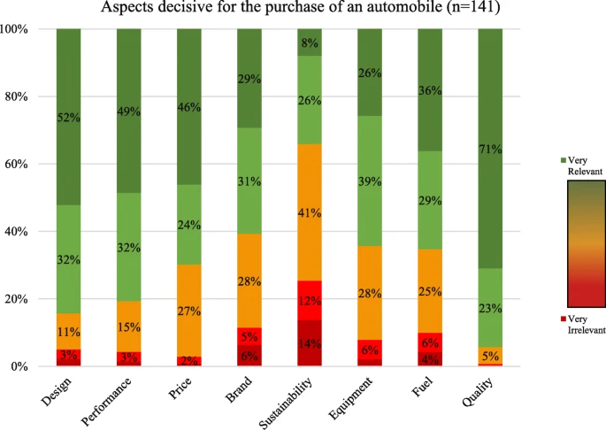
Figure 12 - Variables that Affect the Decision of Purchasing a Vehicle (Wellbrock et al, 2020)

4. Methodology
To analyse the properties of different composites, multiple composite materials, along with a baseline metal, were tested under tensile load using the Denison Tensile/Compression test machine from the University of Wales Trinity Saint David, figure 13. The tests were completed by students split into groups and a total of 14 low-speed tensile tests and 2 high-speed tests were completed for each material.
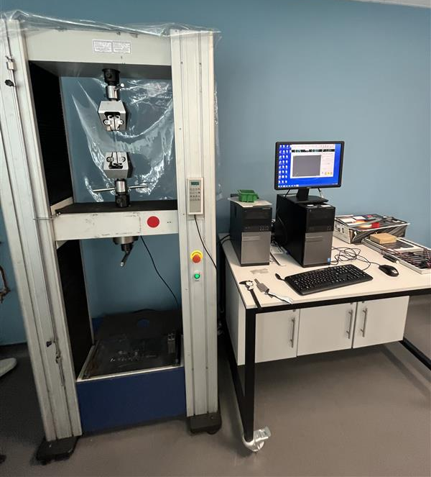
Figure 13 - Denison Tensile/Compressive Test Machine
4.1. Materials Tested
The materials listed below were produced in-house by a trusted technician. The woven composites consisted of 3x200g of each material, and the non-woven was 1x300g of material or, for the non-woven Carbon, was 3x100g.
Baseline Material
- Aluminium 1200 H14
Less Sustainable Composites
- Carbon Non-Woven with Bio Resin
- Carbon Woven (TR 30S 3L) with Bio Resin
- Carbon Woven (TR 30S 3L) with Epoxy
- Kevlar Woven
More Sustainable Composites
- Hemp Non-Woven with Bio Resin
- Flax Non-Woven with Bio Resin
- Flax Woven with Bio Resin
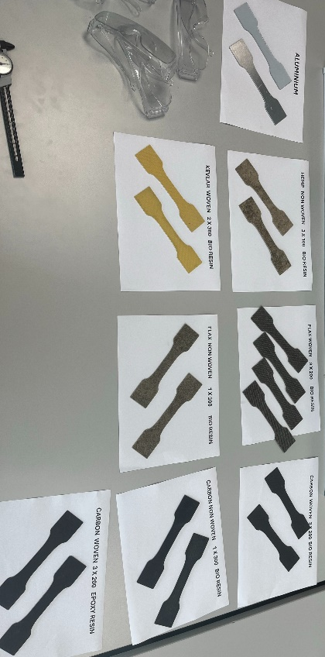
Figure 14 - Materials Tested
Table 5 - Tested Material's Physical Properties
Material | Density (g/cm³) | Tensile Strength (MPa) | Tensile Modulus (GPa) | Break Elongation (%) | Source
Aluminium 1200 H14 | 2.71 | 314 | 68.3 | 12.2 | Ansys Granta (2022)
Carbon Non-Woven Bio | 1.51 | 330 | 35 | 2 | Ansys Granta (2022) easycomposites (2024)
Carbon Woven Bio | 1.45 | 4900 | 11 | 2 | PYROFIL (2013)
Carbon Woven Epoxy | 1.525 | 467.5 | 43.5 | 1 | Ansys Granta (2022)
Kevlar Woven | 1.44 | 3000 | 112.4 | 2.4 | easycomposites (2025)
Hemp Non-Woven Bio | 1.45 | 108 | 11 | 2 | Ansys Granta (2022)
Flax Non-Woven Bio | 1.45 | 37 | 5 | 1.2 | EcoTechnilin (2023)
Flax Woven Bio | 1.45 | 61 | 7 | 1.5 | EcoTechnilin (2023)
4.2. Test Methodology
For each material the process below was taken, and safety glasses were required throughout due to the composite’s failure behaviour.
- Measure width and thickness at the centre of each material so that cross-sectional area (CSA) can be calculated.
- Clamp material in at the larger sections, made to help increase friction and stop the material slipping.
- Pre-load the material with a slight tensile load so that stress is already being experienced.
- Start the test at low speed, until the material fails, and the machine stops.
- Unclamp both pieces and return the machine back to its starting position.

5. Raw Results
Below shows the results for each material from the low-speed tests. From this, using the reliable data, an average trend and max value is chosen so that comparisons can then be made. While, high-speed was completed, the results were too inaccurate to compare and analyse, so were ignored in this report. Also, the test machine produces results for stress but instead the stress experienced was calculated using equation 1.
$$Stress,σ=\frac{Force}{Cross-Sectional Area}=\frac{F}{A}$$ | [1]
5.1. Aluminium
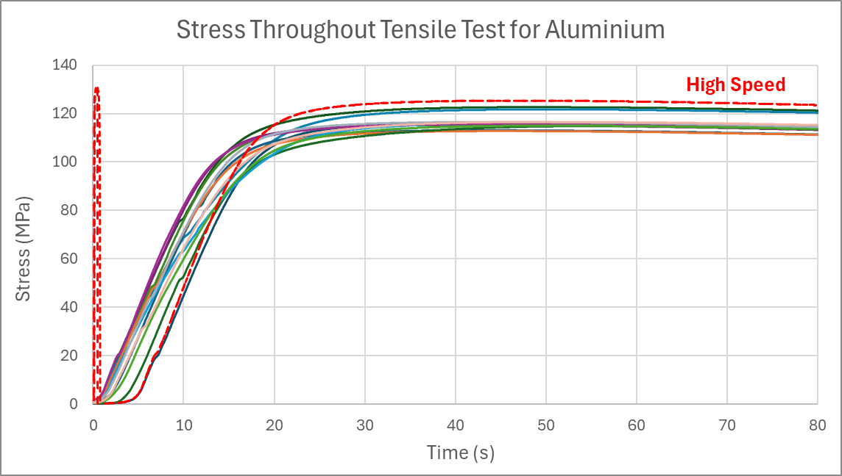
Figure 15 - Stress Throughout Tensile Test for Aluminium
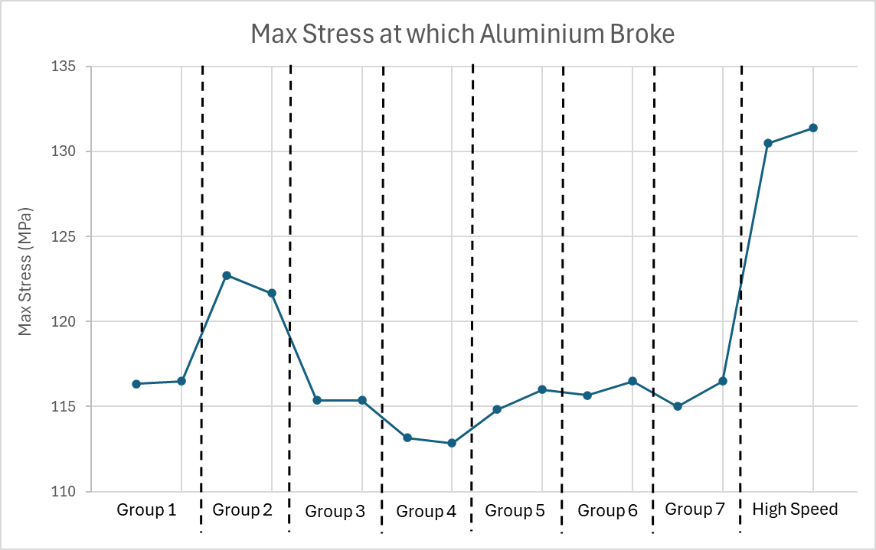
Figure 16 - Max Stress Experienced on Aluminium
Group 2’s data is taken as anomalous as there is a large difference in max stress, in figure 16, and has similar values to that of the high-speed test suggesting that group 2 didn’t set the right velocity of the machine.
5.2. Carbon Non-Woven with Bio Resin
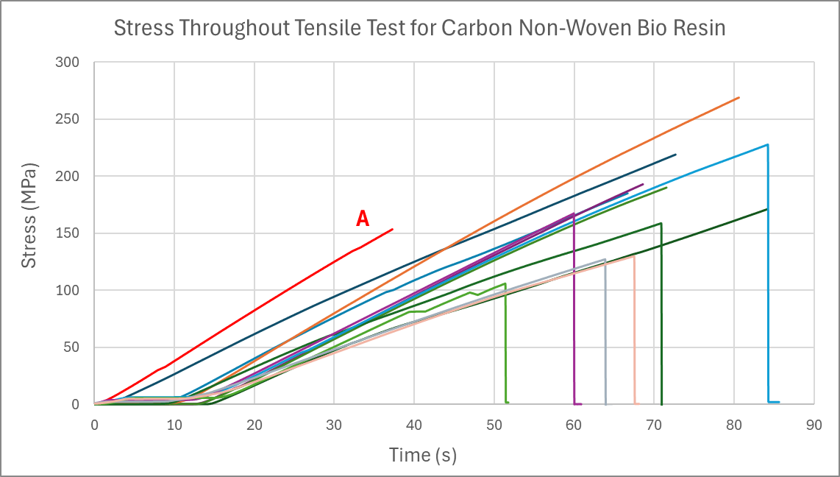
Figure 17 - Stress Throughout Tensile Test for Carbon Non-Woven with Bio Resin
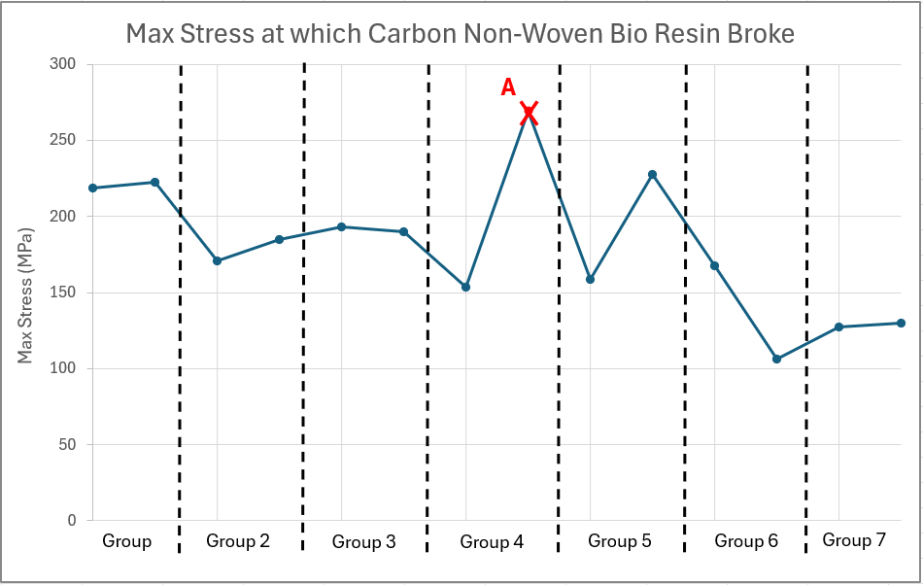
Figure 18 - Max Stress Experienced on Carbon Non-Woven with Bio Resin
5.3. Carbon Woven with Bio Resin
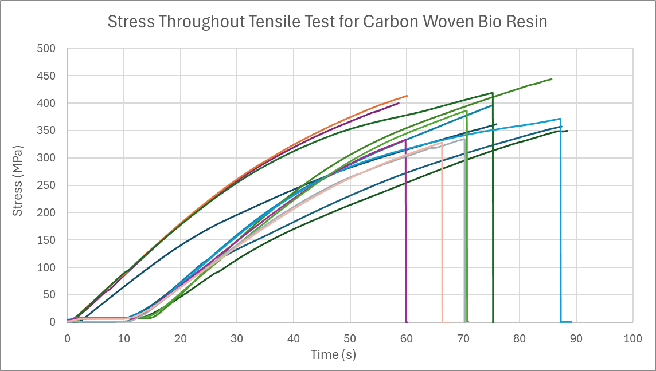
Figure 19 - Stress Throughout Tensile Test for Carbon Woven with Bio Resin
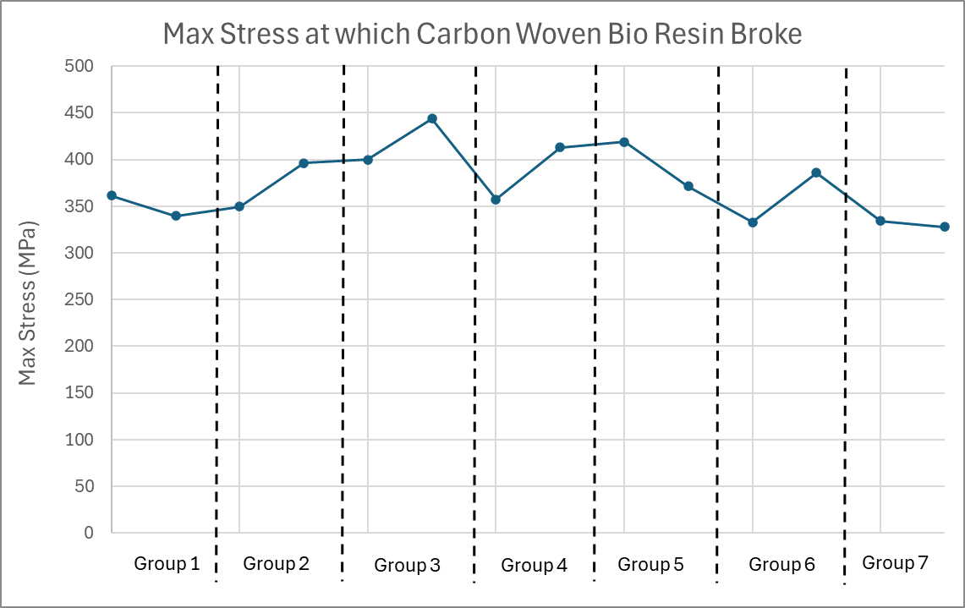
Figure 20 - Max Stress Experienced on Carbon Woven with Bio Resin
5.4. Carbon Woven with Epoxy
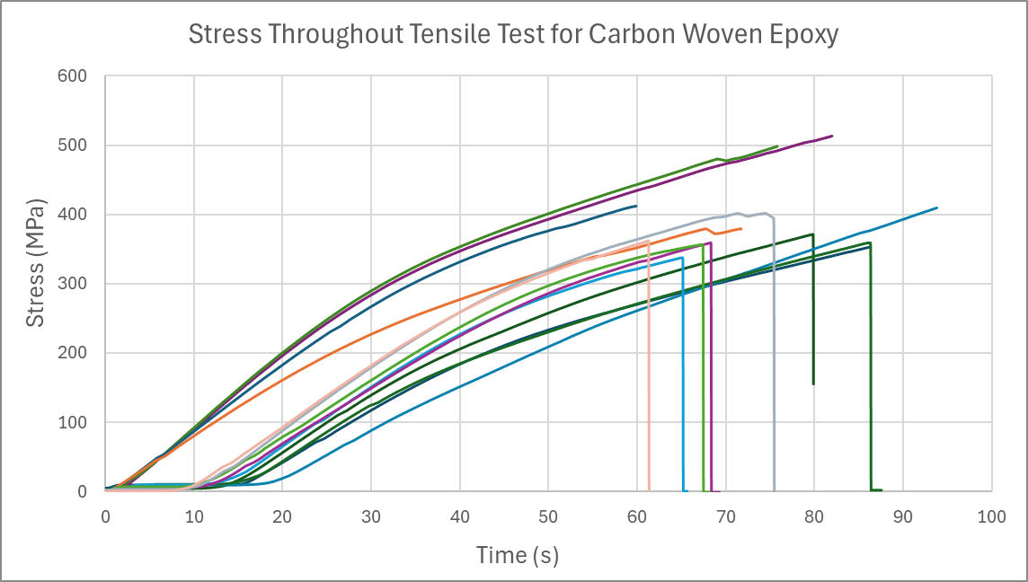
Figure 21 - Stress Throughout Tensile Test for Carbon Woven Epoxy
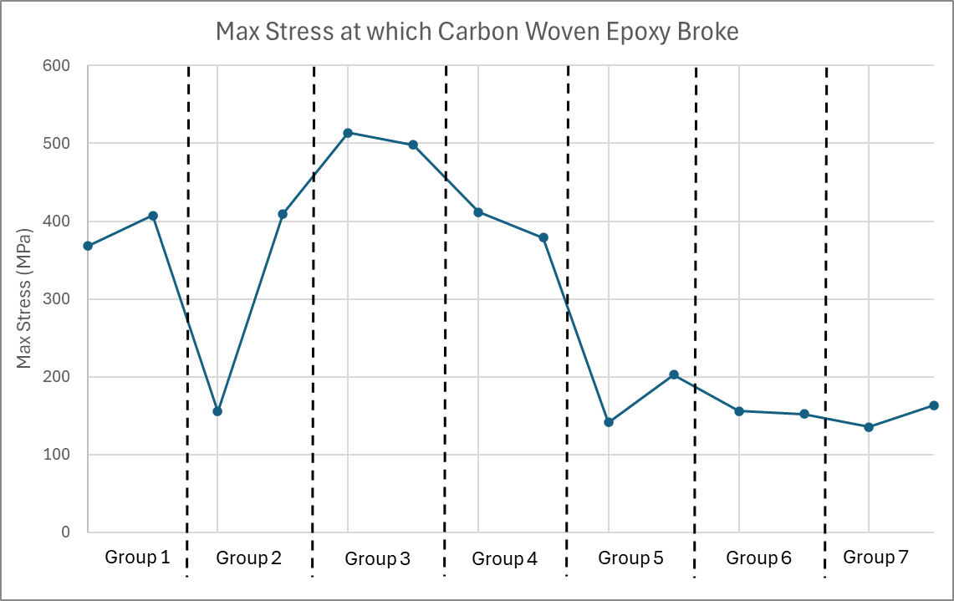
Figure 22 - Max Stress Experienced on Carbon Woven with Epoxy
5.5. Kevlar Woven
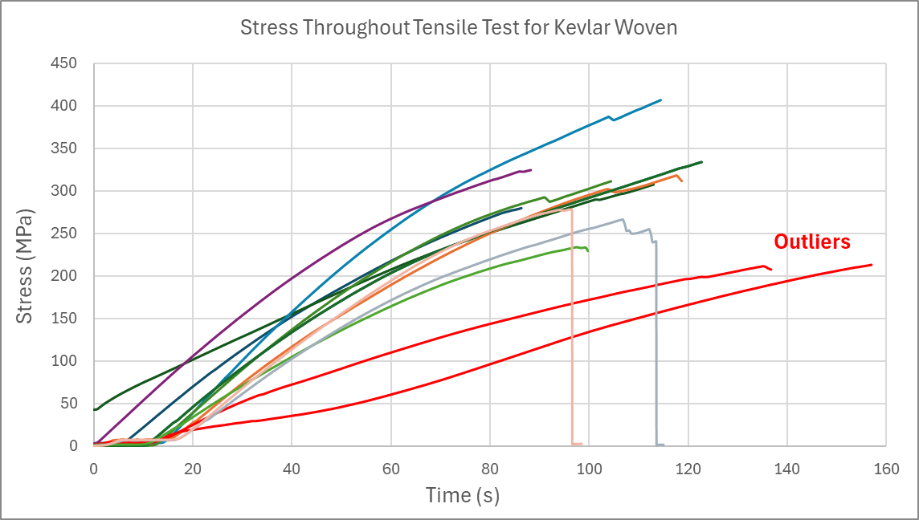
Figure 23 - Stress Throughout Tensile Test for Woven Kevlar
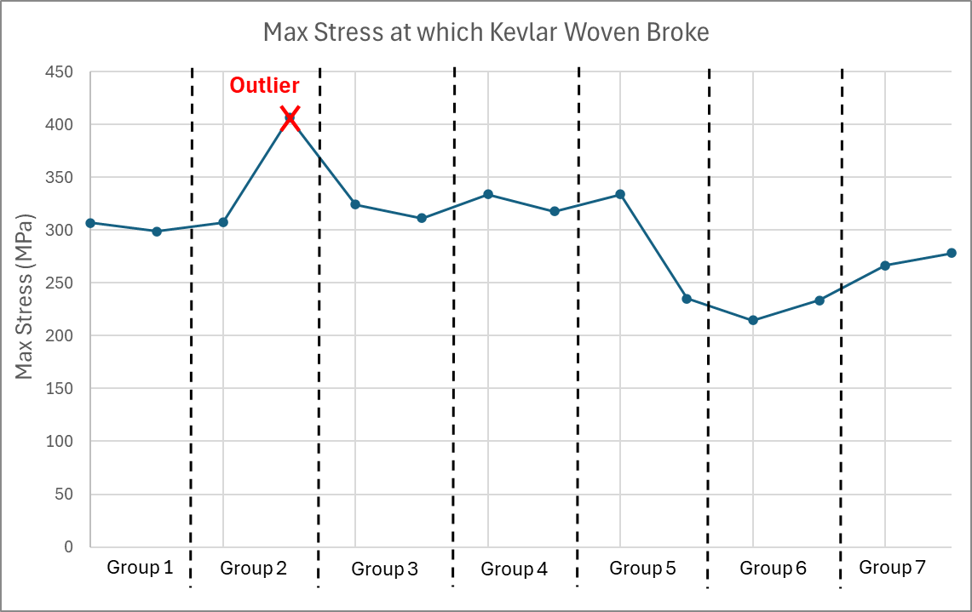
Figure 24 - Max Stress Experienced on Kevlar
5.6. Hemp Non-Woven with Bio Resin
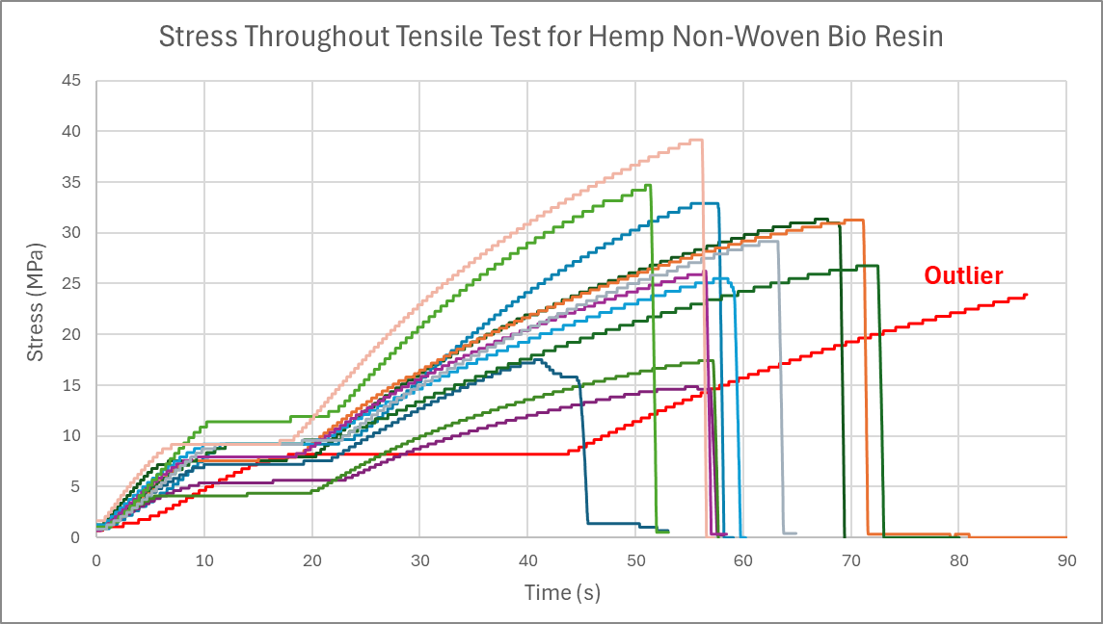
Figure 25 - Stress Throughout Tensile Test for Hemp Non-Woven with Bio Resin
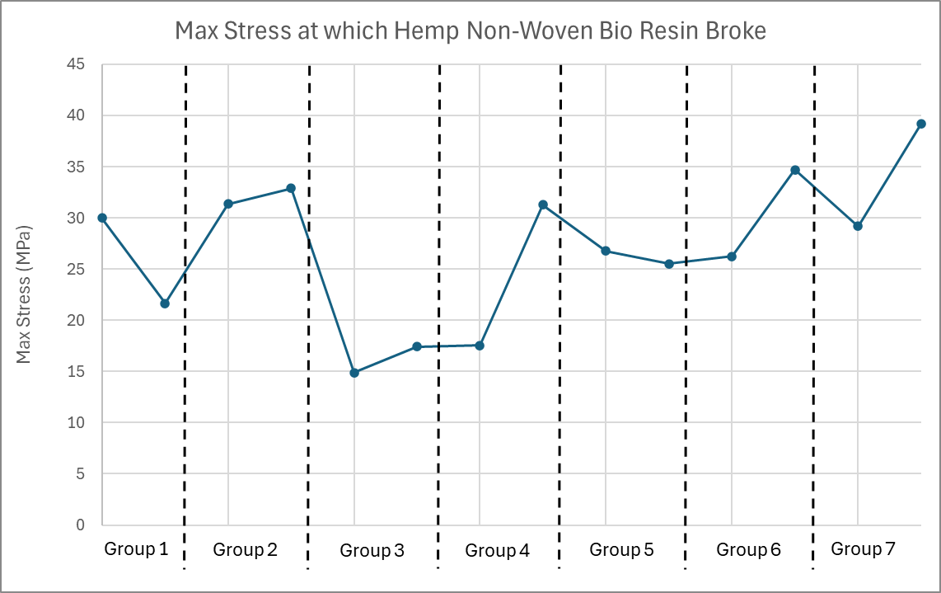
Figure 26 - Max Stress Experienced on Hemp Non-Woven Epoxy
5.7. Flax Non-Woven with Bio Resin
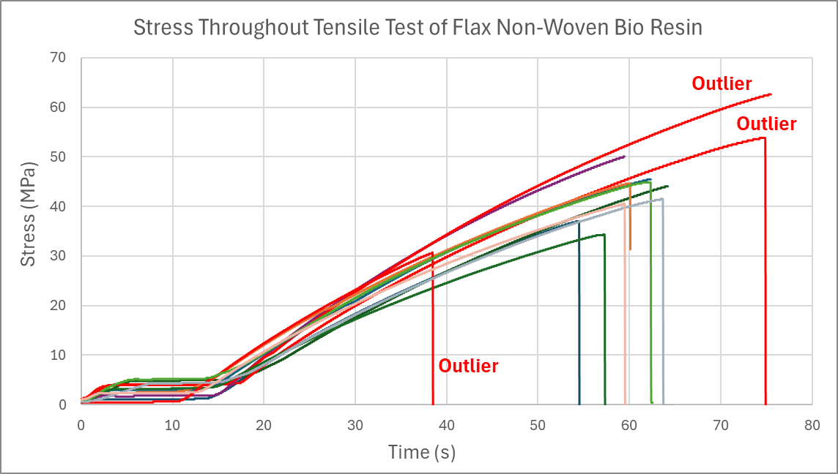
Figure 27 - Stress Throughout Tensile Test for Flax Non-Woven with Bio Resin
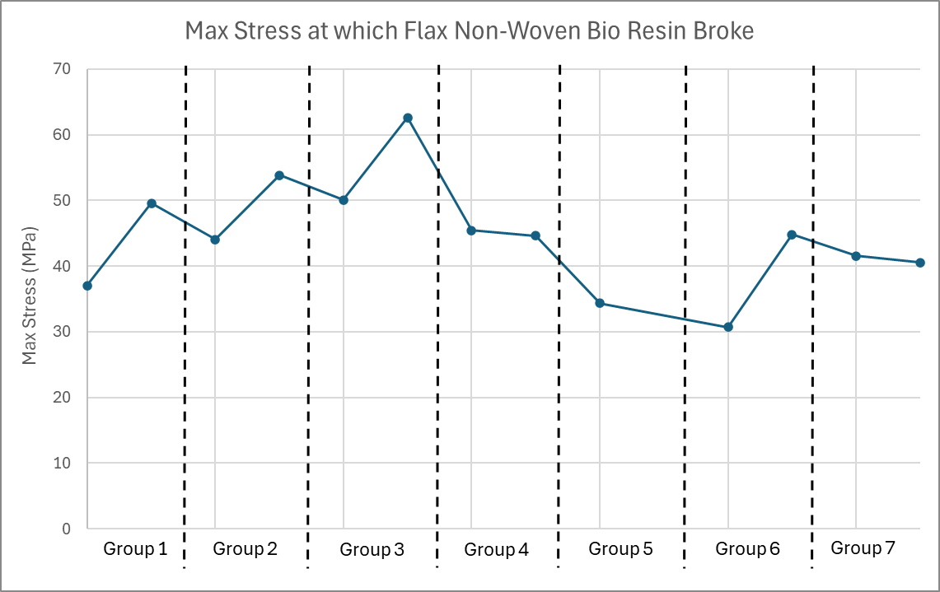
Figure 28 - Max Stress Experienced on Flat Non-Woven with Bio Resin
5.8. Flax Woven with Bio Resin
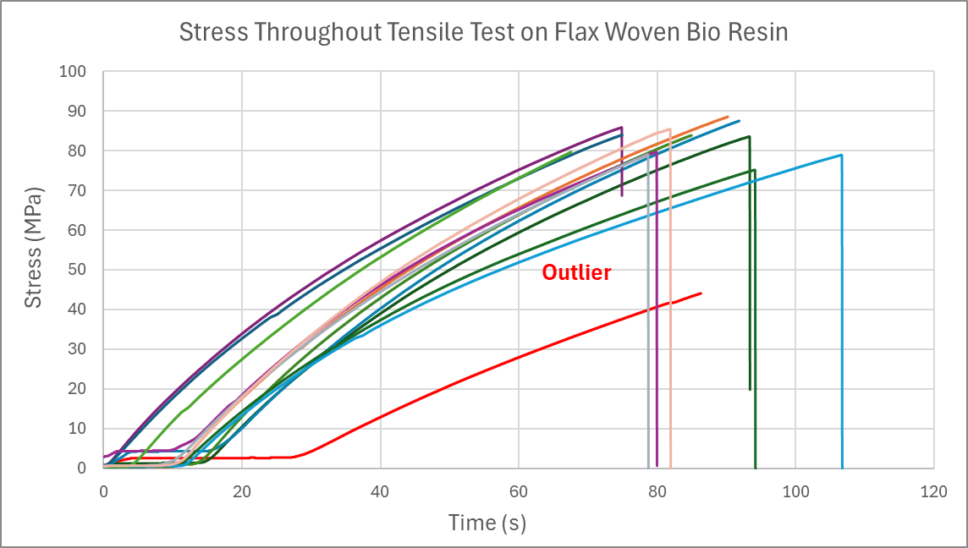
Figure 29 - Stress Throughout Tensile Test for Flax Woven with Bio Resin
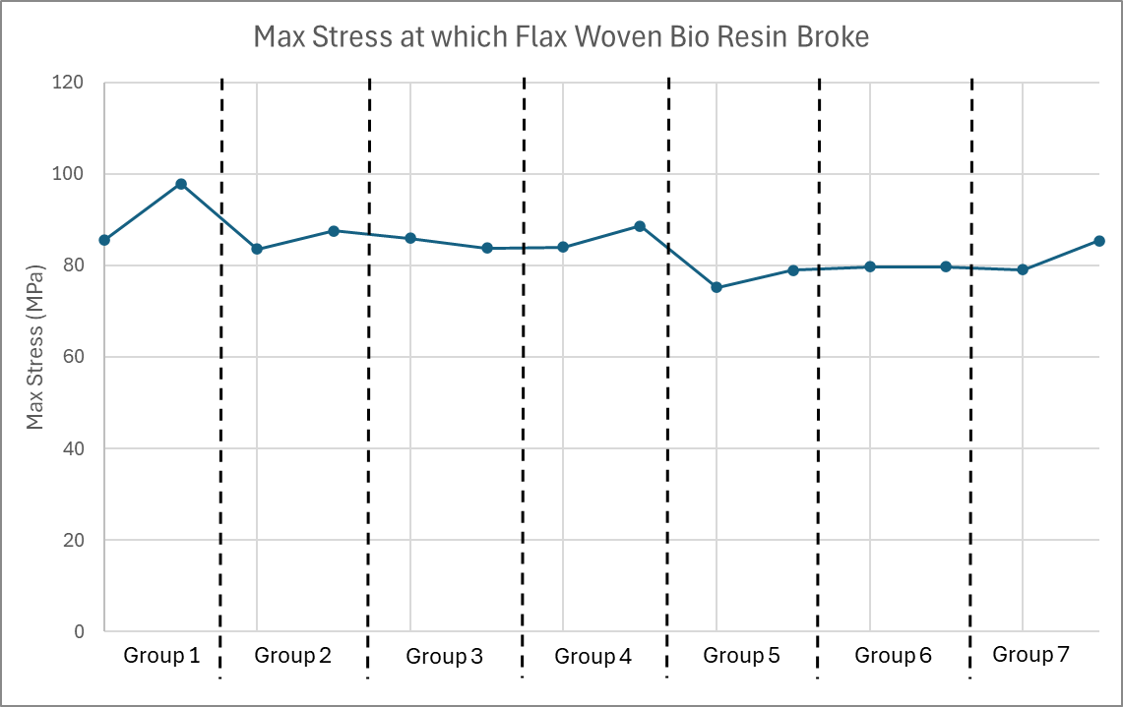
Figure 30 - Max Stress Experienced on Flax Woven with Bio Resin
The outlier shown in figure 29 could be due to the group not preloading the material with a tensile load as after that, the trend is similar to other results.
5.9. Combining the Average Results
From the raw data the best average is taken for each material’s stress.
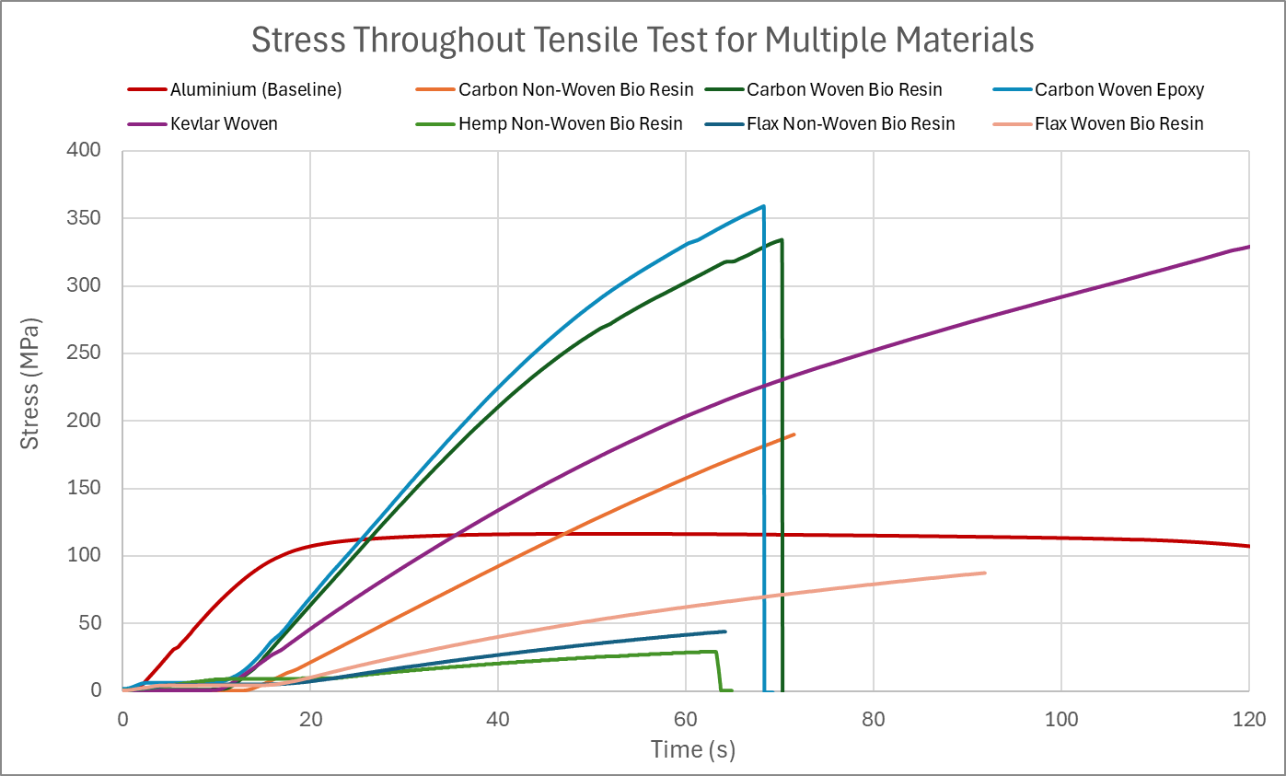
Figure 31 - Average Stress Throughout Tensile Test for Each Material
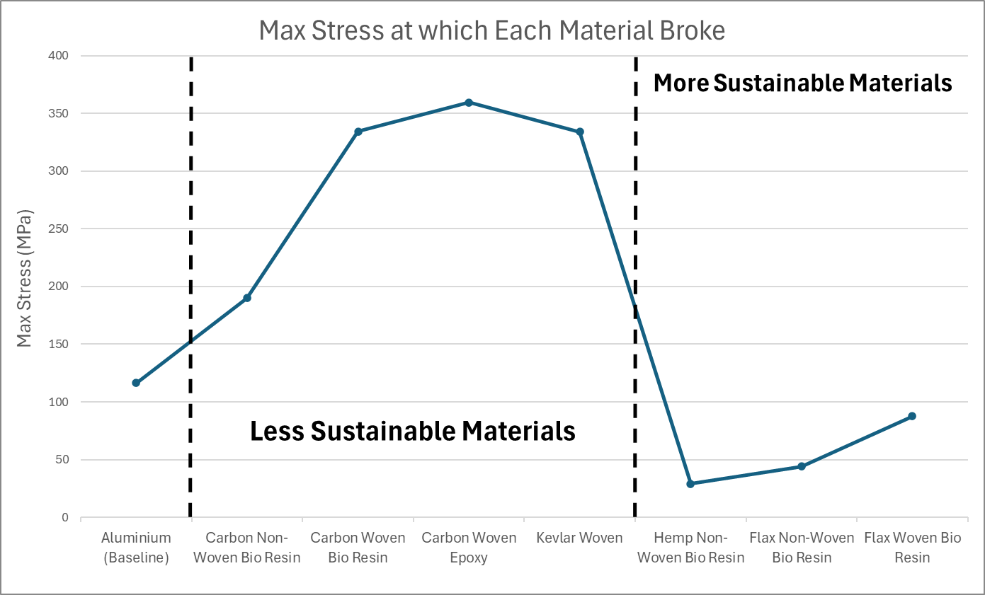
Figure 32 - Max Stress Experienced by Each Material
6. Validation of Results
To validate results, the values from figure 32 are compared with tensile strength values from Ansys (2022) of each composite. The direction at which load is applied can affect a composites strength, with the transverse stress being the lower limit and the longitudinal stress being the upper limit.
It is important to note that the data sourced for carbon non-woven was with epoxy resin instead of bio resin.
Table 6 - Validation of Max Tensile Strength Values
Composite | Project Stress (MPa) | Transverse Stress (MPa) | Longitudinal Stress (MPa) | Blend % (Fibre:Resin)
Aluminium 1200 H14 | 116.5 | 125 | 125 | -
Carbon Non-Woven | 190.1 | 330 | 290 | 70:30
Carbon Woven Bio | 334.4 | 133.8 | 2094 | 50:50
Carbon Woven Epoxy | 359.3 | 151.2 | 2098.5 | 50:50
Kevlar Woven | 333.9 | 150.1 | 1538.5 | 50:50
Hemp Non-Woven | 29.2 | 46 | 108 | 40:60
Flax Non-Woven | 44.1 | 44 | 37 | 18:82
Flax Woven | 87.5 | 58 | 61 | 29:79
The blue highlighted composites in table 6 were sourced from their sources used throughout this project, whereas the green highlighted composite’s sources did not have this information so were calculated using the equations below.
Longitudinal Stress (Upper Limit):
$$σ_{composite}=σ_{fibre}V_{fibre}+σ_{resin}V_{resin}$$ | [2]
Transverse Stress (Lower Limit):
$$σ_{c}=\frac{σ_{r}σ_{f}}{V_{r}σ_{f}+V_{f}σ_{r}}$$ | [3]
Table 4 shows that each composite is within or close to the lower and upper limits suggesting that the results and analysis for this project are reliable. The slight differences could be due to the sourced data having different blends of fibre and resin than used in this project as all composites were produced with a 50:50 mix. Also, the difference could be due to the machine being inaccurate as these tests were completed in February 2025, yet, as seen in figure 33, the re-calibration was due by January 2025 and had not been completed.
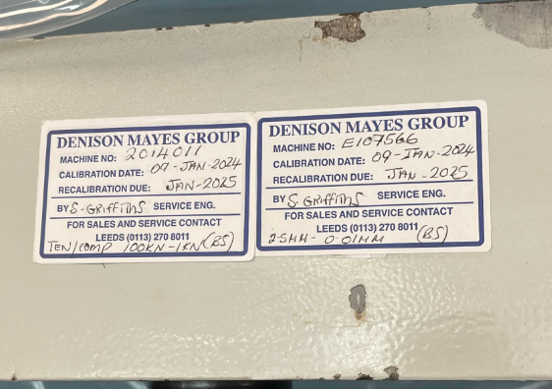
Figure 33 - Denison Machine Calibration Date

7. Analysis of Low-Speed Stress on Different Materials
7.1. Carbon Composites
Carbon composites are popular due to their high strength-to-weight ratio and high overall strength, as seen in figure 32, due to its lattice structure. Especially when woven, carbon has high stress tolerance making it similar to Kevlar but being significantly lighter. When comparing carbon to a similar weight, like aluminium, figure 32 shows that a carbon is significantly stronger than aluminium. This is why carbon composites get their high strength-to-weight reputation as they are a mix of the desirable qualities from Kevlar and aluminium. However, they cannot withstand these high stresses for a long time, lasting half the amount of time aluminium and Kevlar. However, not all components use carbon composites due to its brittle nature causing sudden failure, meaning there is no signs of failure occurring as there is negligible strain as seen in figure 34.
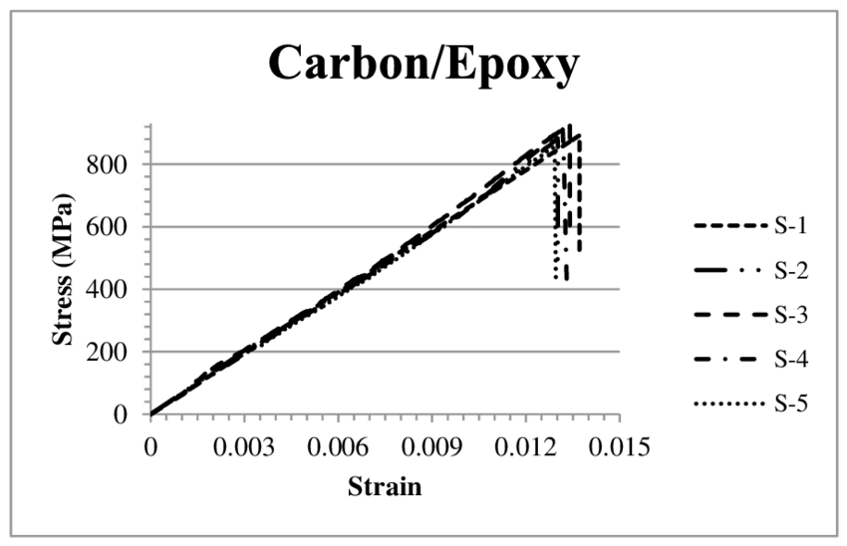
Figure 34 - SN-Curve for Carbon Epoxy Composite (Al-Qrimli.H, Mahdi.F, Alnaimi.F, 2015)
Also, carbon is significantly unsustainable, as seen in table 2, where an average of 46.25kg/kg of CO₂ is produced, which is significantly more than other materials. Therefore, if weight was less important, Kevlar may, sustainably, be the better option as it has similar strength but produces less CO₂ when made.
7.2. Sustainable Composites
Due to carbon’s sustainability problem, sustainable composites are desired, with the most common using Hemp or Flax fibres. However, figure 32 shows why these composites don’t dominate as they are weaker, with the max stress being considerably less. The only physical benefit can be seen in figure 31 where flax woven bio can last longer under load than carbon composites. Relating this to table 2 suggests that flax woven bio is the best sustainable option for areas of low stress with repeated or constant loading, as it is the strongest and has considerably low CO₂ production per kg as well as being biodegradable.
7.3. Woven Vs Non-Woven
A woven composite is formed when fibres are “weaved” together, overlapping each other and creating a structure as seen in figure 35, whereas a non-woven structure has no order to it and fibres are randomly bonded together.
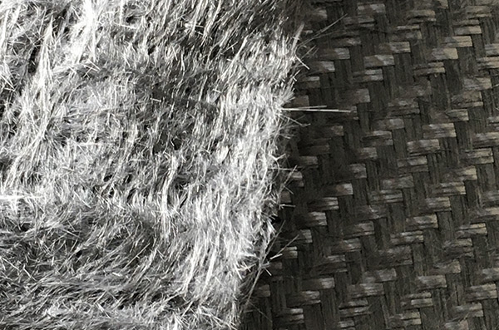
Figure 35 - Difference between Non-Woven (Left) and Woven (Right) Carbon (Tenowo, n.d.)
From the materials used, carbon and flax are both woven and non-woven. From figures 31&32 both show that a woven structure increases the stress tolerance of the material, as supported by sources like JPS Composite Materials (2021), with a significant increase in max stress for the Carbon composite. This, along with the increase time to produce explains why the price considerably increases, as seen in table 2. For a business, the considerable increase in strength for carbon is arguably worth the 50% increase in price however, for Flax, the slight increase may not be worth the 450% increase in price as both can only withstand low stresses.
7.4. Bio Resin Vs Epoxy Resin
Resin is an adhesive used to hold layers of fibres together, with the most common being epoxy due to it having “exceptional bonding properties, resistance to chemicals and moisture, and ability to withstand moderate temperatures” as stated by RS, (2023). However, epoxy can negative impact on the environment due to it being produced from petroleum, (KSRESIN, n.d.) and forming a plastic which cannot be biodegraded, as stated by Among The Trees (n.d.). To try combat this companies like KSRESIN try to produce more sustainable versions of epoxy resin by not containing any “solvents or other volatile components that could evaporate or contribute to air pollution”. For this project both resins were sourced from easycomposites with the properties seen in table 7.
Table 7 - Epoxy & Bio Resin Properties (easycomposites, 2025)
Epoxy Resin (IN2) | Bio Resin (IB2)
- Better than Any Bio Resins  - Ideal for Resin Infusion  - Outstanding Wetting Abilities  - Good Mechanical Properties  - Suited for High Performance Reinforcement  - Well Suited to Carbon Fiber & Kevlar  - Ultra Low Viscosity (200 - 450 mPa∙s)  - Density = 1.12 – 1.18g/cm³  - Tensile Strength = 68.5 – 80 MPA | - Lower Environmental Impact  - Ideal for Resin Infusion  - Outstanding Wetting Abilities  - Good Mechanical Properties  - Optimized for High Performance Resin Infusion  - Well Suited with Flax Fibres  - Recommended Motorsport Uses  - Panels  - Aerodynamic Elements  - Structural Members  - Significantly Low Viscosity (185mPa∙s)  - Density = 1.12g/cm³  - Tensile Strength = 60 - 68 MPa
Both IN2 and IB2 were used for resin infusion on woven carbon and, from figure 32, using epoxy gives the composite a slightly higher stress tolerance which is expected as easycomponents state their epoxy resin is suited to carbon whereas their bio resin is best with flax. Therefore, the type of resin used depends on the material as bio resin is made for sustainable fibres because it may not be logical to use a sustainable fibre with an unsustainable resin.
7.5. Aluminium & Kevlar
From figure 30, both Aluminium and Kevlar lasted longer which is mostly due to them having the largest elongation percentage in table 5 meaning they have high strain values, equation 2, but for different reasons.
$$Strain,ε=\frac{Change in Length}{Original Length}=\frac{∆y}{y}$$ | [4]

Aluminium
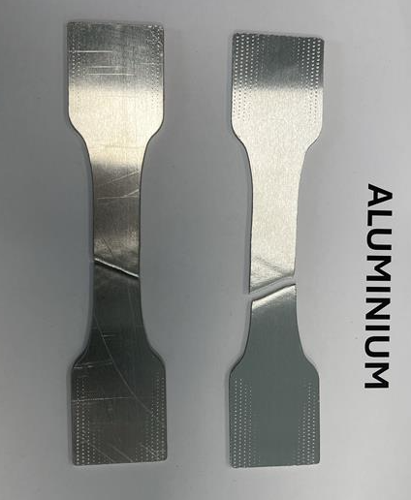  Figure 36 - Aluminium After Tensile Break | 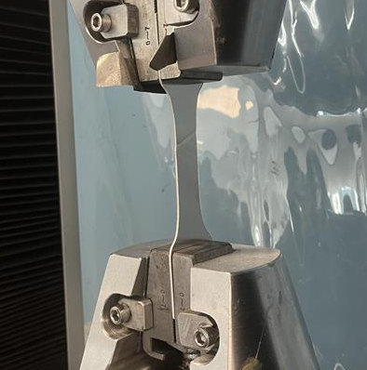  Figure 37 - Aluminium in Tensile Test, Outlining the Material Necking Throughout Test
Figure 37 shows that throughout the test the Aluminium was necking, like figure 38, which is where a material gets thinner before it breaks, due to a tensile load. It occurs when the stress experienced exceeds the ultimate tensile stress (UTS) of a ductile material. Once a slight indent (neck) occurs, it becomes a stress concentrator, experiencing the highest stress, resulting in the material’s CSA decreasing more and withstand less stress, as seen in figure 38, until fracture occurs, (University of Cambridge, n.d.). However, necking is a clear sign the material will fail so can be changed before this happens, unlike carbon composites that fail suddenly. Also, interestingly, that any ductile material, like Aluminium, will break around a 45˚ angle as seen in figure 36 as this is where max shear stress occurs.
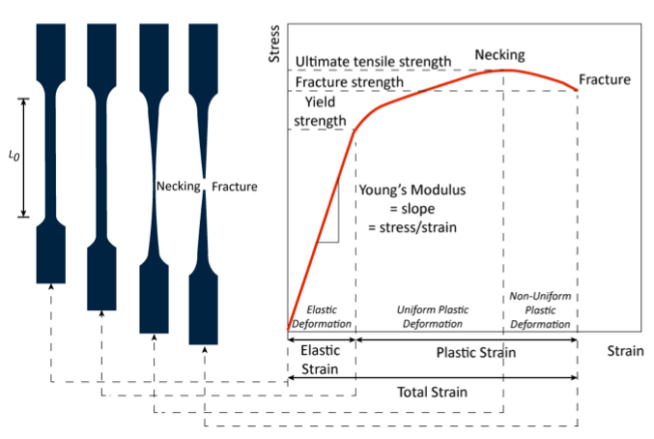
Figure 38 - Material Necking (SUNGDA, n.d.)
Kevlar
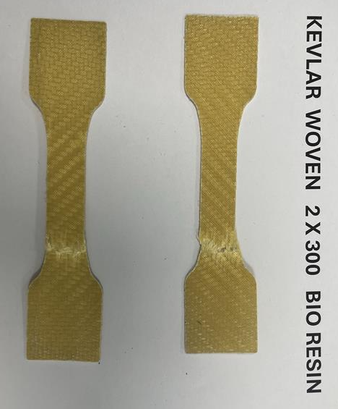  Figure 39 - Kevlar After Tensile Break | 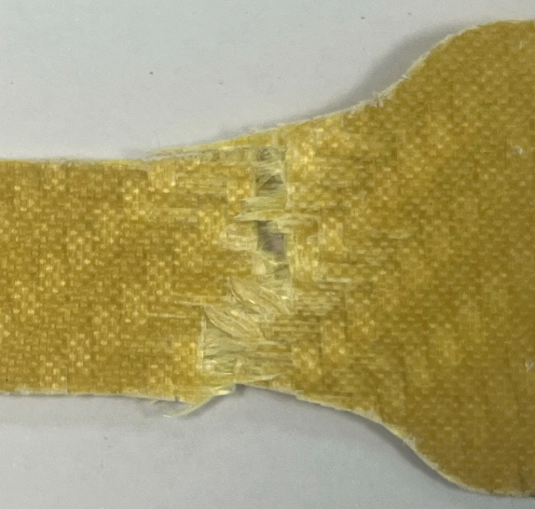  Figure 40 - Zoomed in at Fracture of Kevlar After Tensile Test
On the other hand, Kevlar’s elongation is mostly due to some fibres breaking apart but other fibres, which are still intertwined, being strong enough to hold the material together and experience more stress. Figure 40 shows that, after the test, the composite hadn’t fully broke into 2 pieces but was very weak.

8. Sustainability Entering the Industry
8.1. Composite Applications
Recommendations can be made for which composite suits certain environments. Aligning results with research clearly outlines why carbon composites are a highly common material used throughout engineering from bodywork to wheels and structural components (Penta, n.d.). The more sustainable materials are better suited for areas on a vehicle of less importance, where low stress occurs like interior design and bodywork, excluding aerodynamic devices that experience higher loads. In general, this sustainable material will be a flax composite due to them having higher strength and, importantly, better sustainability than hemp, at 0.44kg/kg of CO₂. Hemp composites could be more common outside of the engineering industry, in non-critical environments where business’s prioritise cost over any other factor. The best example for hemp could be packaging as cost and sustainability are the most important factors with which hemp is cheaper than flax and is biodegradable making it easier to dispose of the unwanted packaging. However, hemp has not taken over the packaging industry due to better alternatives already available, with the best being cardboard. The properties of cardboard can be seen below (Ribble, n.d.).
- Lightweight
- Less added weight
- Reduced cost to transport
- Recyclable
- Easy to dispose for consumers
- Material can be reused
- Cheaper
- Easier to Produce
- Has a greater established infrastructure
- Less complex materials required compared to composites
- Versatile
- Easier to change shape at any part of its life cycle
8.2. Problems with Sustainable Composites
This example above highlights a reason these sustainable composites have not dominated industries as they are trying to be the middle ground, balancing strength sustainability and cost, but failing due to useful alternatives already being available with similar or better properties and established infrastructure.

8.3. Sustainable Composites in the Engineering Industry
While sustainable composites may not seem as popular as intended, they still have a use in the engineering industry due to the social demand for sustainability rising. Initially, the automotive industry moved towards renewable powered vehicles and these sustainable composites could be the next step to help boost a business’ reputation and performance further as they reduce pressure groups and conform with new and future legislation. However, sustainable composites may not suit the motorsport industry as they may be less important due to the bigger problem of burning non-renewable fuels.

9. Conclusion
Overall, composites are a valuable material to the engineering industry due to their impeccable qualities. However, these unsustainable composites can cause backlash due to their environmental impact so companies can use natural fibre composites depending on the application. To date, there is no sustainable composite worth the research and development, but a breakthrough could result in them surpassing carbon.
10. References
Al-Abri.O, Pervez.T, Qamar.S, Khan.R, (2016), On the performance analysis of AHSS with an application to SET technology – FEM simulations and experimental measurements.
Al-Qrimli.H, Mahdi.F, Alnaimi.F, (2015), Carbon/Epoxy Woven Composite Experimental and Numerical Simulation to Predict Tensile Performance, Advances in Materials Science and Applications.
Among The Trees, (n.d.), The Environmental Cost of Resin, Available at The Environmental Cost of Resin — Among The Trees reclaimed timber Marrickville, Accessed 15/04/2025.
Ansys Granta, 2022, Granta EduPack 2022 R2, [Software], Ansys.
Bunsell.A, Thionnet.A, (2022), Quantifiable analysis of the failure of advanced carbon fibre composite structures leading to improved safety factors, Progress in Materials Science.
CompositesWorld, (n.d.), SUSTAINABILITY, Available at https://www.compositesworld.com/kc/sustainability, Accessed 11/04/2025.
easycomposistes, (2025), 100g Carbon Fibre Non-Woven Mat 1000mm, Available at 100g Carbon Fibre Non-Woven Mat 1000mm - Easy Composites, Accessed 09/04/2025.
easycomposistes, (2025), 100g Non-Woven Flax Fibre Mat (480mm), Available at https://www.easycomposites.eu/100g-non-woven-flax-fibre-mat, Accessed 09/04/2025.
easycomposistes, (2025), 150g Non-Woven Hemp Fibre Reinforcement Mat (480mm), Available at https://www.easycomposites.co.uk/150g-non-woven-hemp-fibre-mat, Accessed 09/04/2025.
easycomposistes, (2025), 200g 2x2 Twill Flax Fibre Cloth (1000mm), Available at https://www.easycomposites.co.uk/200g-22-twill-flax-fibre-cloth, Accessed 09/04/2025.
easycomposistes, (2025), 300g 2x2 Twill Weave Kevlar Cloth (1000mm), Available at https://www.easycomposites.co.uk/300g-22-twill-kevlar-cloth, Accessed 09/04/2025.
easycomposistes, (2025), 300g Carbon Fibre Non-Woven Mat 1000mm, Available at https://www.easycomposites.co.uk/300g-carbon-fibre-non-woven-mat, Accessed 09/04/2025.
easycomposistes, (2025), IB2 Epoxy Infusion Bio Resin, Available at https://www.easycomposites.co.uk/IB2-epoxy-infusion-bio-resin, Accessed 11/04/2025.
easycomposistes, (2025), IN2 Epoxy Infusion Resin, Available at https://www.easycomposites.co.uk/in2-epoxy-infusion-resin, Accessed 11/04/2025.
Egbo.M, (2021), A fundamental review on composite materials and some of their applications in biomedical engineering, Journal of King Saud University - Engineering Sciences.
Hai Huei, (n.d.), Woven vs Non-Woven: Major Differences and Pros & Cons, Available at https://www.haihuei.com/woven-vs-non-woven-textiles/, Accessed 14/04/2025.
Hatton.G, (2019), How are composites used in motorsport?, Racecar engineering, Available at https://www.racecar-engineering.com/tech-explained/how-are-composites-used-in-motorsport/, Accessed 10/04/2025.
Hulatt.L, (2023), Exploring Applications of Composite Materials, StudySmarter, Available at https://www.studysmarter.co.uk/explanations/engineering/materials-engineering/applications-of-composite-materials/#:~:text=Role%20of%20Composite%20Materials%20in%20Aerospace%20Engineering&text=They%20are%20used%20in%20a,embedded%20in%20a%20polymer%20matrix, Accessed 10/04/2025.
JPS Composite Materials, (n.d.), Woven vs. Non-Woven, Available at https://jpscm.com/blog/woven-vs-non-woven-fabrics/, Accessed 14/04/2025.
Kahl.S, Peng.R, Johansson.S, (2014), Tensile failure of thin aluminium sheet observed by in-situ EBSD, IOP Publishing Ltd.
Khan.F, Hossain.N, Mim.J, Maksudur Rahman.S, Jayed Iqbal.M, Billah.M, Chowdhury.M, (2024), Advances of composite materials in automobile applications – A review, Journal of Engineering Research.
KSRESIN, (n.d.), Is Epoxy Resin Environmentally Friendly?, Available at Is Epoxy Resin Environmentally Friendly or Bad for the Environment? – KSRESIN, Accessed 13/04/2025.
Niutta.C, Ciardiello.R, Tridello.A, Paolino.D, (2023), Epoxy and Bio-Based Epoxy Carbon Fiber Twill Composites: Comparison of the Quasi-Static Properties, PMC.
Niutta.C, Ciardiello.R, Tridello.A, Paolino.D, (2023), Epoxy and Bio-Based Epoxy Carbon Fiber Twill Composites: Comparison of the Quasi-Static Properties, PMC.
Penta, (n.d.), Carbon Fibre in the Automotive Industry, Available at https://www.pentapatterns.co.uk/carbon-fibre-in-the-automotive-industry/#:~:text=Structural%20Components&text=Structural%20applications%20of%20carbon%20fibre,plus%20side%20sills%20and%20more, Accessed 13/04/2025.
PIRAN, (2023), Composite Manufacturing Process: How are Composites Manufactured?, Available at Composite Manufacturing Process | Piran Advanced Composites, Accessed 14/04/2025.
PYROFIL, (2013), Typical Properties of Carbon Fiber, Mitsubishi Rayon Co Ltd.
Royal Society of Chemsitry, (n.d.), Sustainability and the composites sector, Available at https://www.rsc.org/policy-evidence-campaigns/environmental-sustainability/sustainability-reports-surveys-and-campaigns/sustainable-composite-materials/sustainability-trends/#waste-hierachy, Accessed 15/04/2025.
Satishkumar.P, (2020), Composites.
Steel E-Motive, (n.d.), Life Cycle Assessment: 6 areas designers need to consider when taking an LCA approach to vehicle development, Available at https://steelemotive.world/life-cycle-assessment-for-vehicle-development/, Accessed 15/04/2025.
SUNGDA, (n.d.), Causes of Conveyor Belt Elongation and Solutions, Available at https://www.sungda.com/index.php/causes-of-conveyor-belt-elongation-and-solutions/, Accessed 12/04/2025.
TENOWO, (n.d.), Carbon fiber nonwovens as an innovative and sustainable reinforcement textile, Available at https://www.tenowo.com/en/markets/composites/carbonfiber-nonwovens/, Accessed 12/04/2025.
testbook, (2023), What is a Composite Material? - Properties, Types, Applications, Advantages & Disadvantages, Available at https://testbook.com/mechanical-engineering/what-is-a-composite-material, Accessed 08/04/2025.
TEXTECH, (2024), What Is Carbon Composite?, Available at https://textechindustries.com/blog/what-is-carbon-composite/, Accessed 11/04/2025.
Tudor.K, (2024), ACHA6012 Automotive Materials Sustainability – Lecture notes 1-17, [PowerPoint], University of Wales Trinity Saint David.
University of Cambridge, (n.d.), Tensile Testing - Necking and Failure, Available at https://www.doitpoms.ac.uk/tlplib/mechanical_testing_metals/necking.php, Accessed 11/04/2025.
Varsani.D, (n.d.), Introduction: The Role of Composite Materials in the Motorsport and Automotive Industries, Motorsport Engineer, Available at https://motorsportengineer.net/composite-materials-in-motorsport-and-automotive-industries/, Accessed 13/04/2025.
Yang.Y, Boom.R, Irion.B, Heerden.D, Kuiper.P, Wit.H, (2012), Recycling of composite materials, Chemical Engineering and Processing: Process Intensification.
Wellbrock.W, Ludin.D, Gerstlberger.W, (2020), Sustainability in the automotive industry, importance of and impact on automobile interior – insights from an empirical survey, Springer
SMMT, (2023), Automotive Sustainability Report, Available at https://www.smmt.co.uk/uk-automotive-sustainability-report/, Accessed 03/04/2025.
Formula One, (2019), Net-Zero Carbon by 2030, Available at https://corp.formula1.com/impact/net-zero-carbon/, Accessed 03/05/2025.
Mittal.S, (2024), How the FIA is racing towards sustainability, edie, Available at https://www.edie.net/how-the-fia-is-racing-toward-sustainability/, Accessed 03/05/2025.
McShane.M, (2024), 2024 Climate Study: Examining Industrial Practices and Climate Impact, Boiler Cover, Available at https://boilercoveruk.co.uk/2024-climate-study-examining-industrial-practices/, Accessed 03/05/2025.
Rao.D, (2024), The most and least environmentally friendly countries, Available at https://theweek.com/feature/briefing/1017804/most-and-least-environmentally-friendly-countries, Accessed 03/05/2025.
Levi.D, (2024), Thousand of unsold Tesla cars pile up in abandoned mall parking lots; 46,561 more vehicles produced than delivered in Q1 2024, available at https://techstartups.com/staging/2024/05/16/thousand-of-unsold-tesla-cars-pile-up-in-abandoned-mall-parking-lots-46561-more-vehicles-produced-than-delivered-in-q1-2024, Accessed 03/05/2025.

11. Appendix

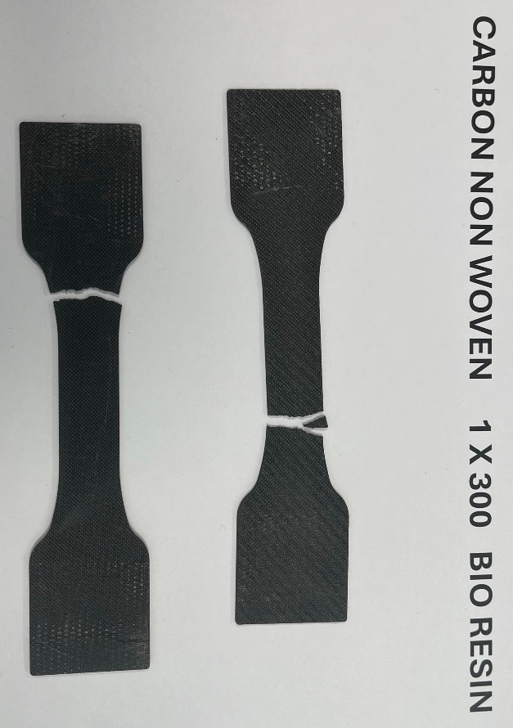
Figure 41 - Failure of Carbon Non-Woven with Bio Resin

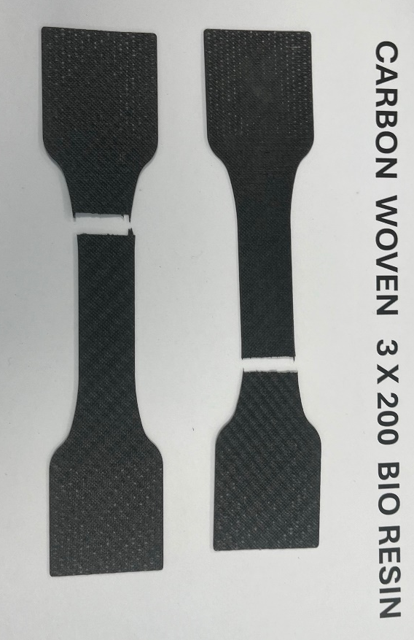
Figure 42 - Fracture of Carbon Woven with Bio Resin

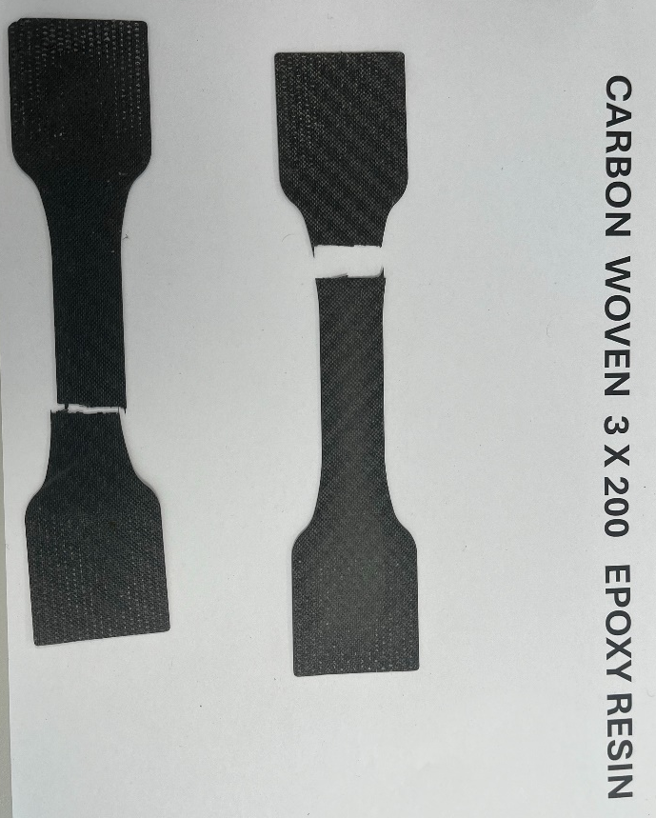
Figure 43 - Fracture of Carbon Woven with Epoxy

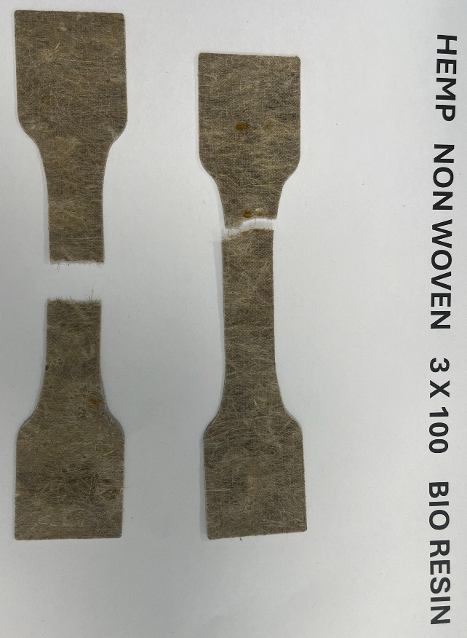
Figure 44 - Fracture of Hemp Non-Woven with Bio Resin

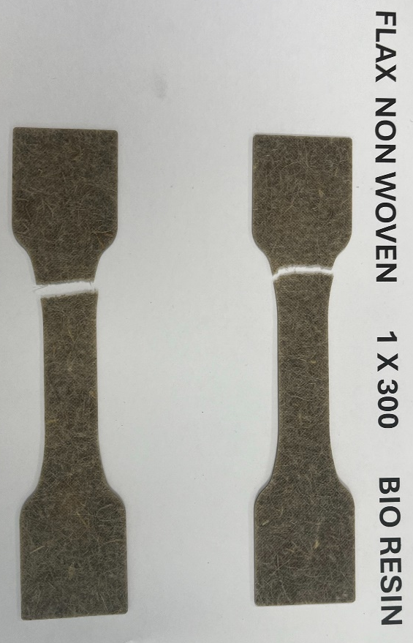
Figure 45 - Fracture of Flax Non-Woven with Bio Resin

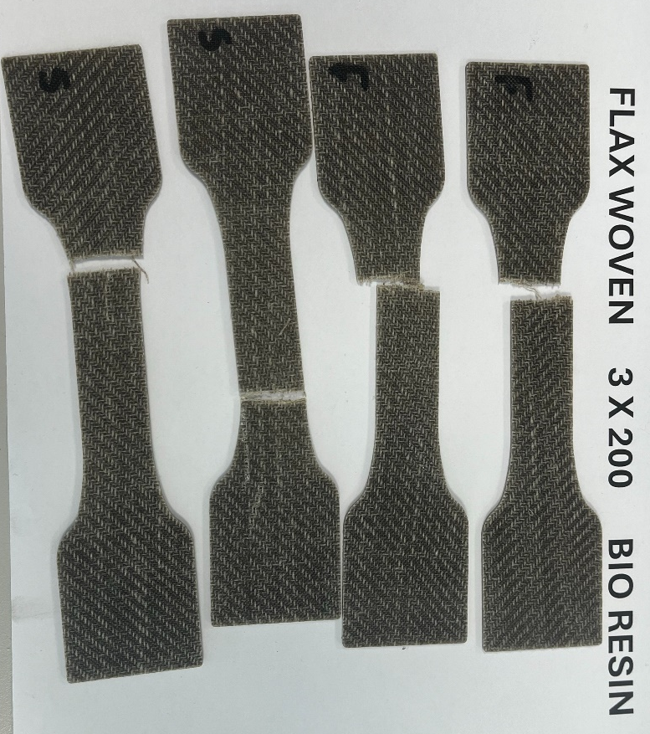
Figure 46 - Fracture of Flax Woven with Bio Resin

