

Student name: | Jasin Navas | Student ID number: | 2426726
Programme: | CertHE Computing Skills for Workplace
Module: | Analysing and Solving Problems
Module code: | ACCA4019
Lecturer: | Rajeev Nath
Assignment Title: | Assessment Component 2: Coursework-Problem Analysis and Solution Development
Submission deadline: | 17-12-2025 14:00 (2PM)

Table of Contents
Introduction 2
Problem Deconstruction 2
Key requirements and constraints 3
MoSCoW technique 3
Relevant variables 5
Proposed Solution and Explanation 6
Flowchart 6
Pseudocode 9
Reflection and Justification 10
Conclusion and Recommendations 12
References 13

Introduction
Grocer Quick is an online grocery delivery service which, now, is experiencing inefficiencies in handling its delivery routes. These have resulted in high fuel consumption and delays in delivering groceries to the customers. In solving this problem, there is a need to break down the problem into manageable components and determining the requirements and constraints that shape the design of the solution. Abstract thinking, prioritization frameworks, and systems analysis techniques assist in doing this and are widely used in computing and operations research.

Problem Deconstruction

Key requirements and constraints

GrocerQuick’s problem is about improving how deliveries are planned, as many different factors affect efficiency, cost, and customer satisfaction. By breaking the problem into smaller parts, it becomes easier to identify the main needs and limitations that will guide the solution.
The problem can be divided into three main requirements:
Efficient allocation of orders to delivery routes – Orders should be assigned to drivers in a sensible way based on location, delivery time slots, and vehicle capacity. Poor assignment can cause drivers to cover the same areas multiple times, increase travel distance, and reduce customer satisfaction. This type of routing challenge is known as the Vehicle Routing Problem (VRP), which focuses on reducing total travel cost while still meeting customer needs [1].
Reduced fuel consumption – Fuel is one of the main costs in delivery operations. By shortening travel distances and reducing waiting or idle time, fuel usage and emissions can be lowered. Well-known optimisation problems such as the Travelling Salesman Problem (TSP) and VRP are often used to help reduce the total distance travelled in delivery networks [2].
On-time delivery – Customers expect their grocery orders to arrive on time. GrocerQuick allows a maximum delay of 30 minutes. This sets a time limit, which is an important part of the Vehicle Routing Problem (VRP). The VRP is a logistics problem that seeks to find the best delivery routes for vehicles. It aims to minimize time or cost while meeting requirements like delivery deadlines. [3].

MoSCoW technique
The MoSCoW prioritisation technique is a simple method used to organise system requirements by how important they are, especially when time and resources are limited. This helps ensure that the most important system features are developed first, while less important ones are postponed [4].
The table uses the MoSCoW method to prioritise GrocerQuick’s system requirements. It divides features into four groups: Must Have, which are essential for the system to work; Should Have, which improve performance but are not critical; Could Have, which are nice-to-have features that add value; and Won’t Have, which are not included for now due to cost or complexity. This method ensures that the most important features are developed first while less critical ones can be added later [1].

MoSCoW Prioritisation of System Requirements
Category | Description | GrocerQuick
 | Things the system cannot work without. | Route planning to keep travel short and save fuel; assigning orders to vehicles based on size, weight, and location; making sure deliveries are no more than 30 minutes late; ensuring each vehicle’s capacity is not exceeded; scheduling drivers efficiently to cover all orders.
  Must Have
Should Have | Important things that make the system better, but not essential. | Using real-time traffic data to avoid jams; dynamically changing routes if delays occur; monitoring driver performance and vehicle status; providing backup routes for high-priority deliveries.
Could Have | Nice-to-have features that add value, but not urgent. | Predicting busy order times to plan better; sending customers updates about estimated delivery times; offering customers the ability to reschedule or track deliveries; integrating loyalty discounts for frequent customers.
Won’t Have | Things we will not include for now because they are too expensive or complicated. | Drones for delivery; fully self-driving delivery vehicles; AI-powered fully automated warehouse packing; long-distance delivery across cities using third-party carriers.

Relevant variables
The table summarises the main variables used in GrocerQuick’s delivery system. It shows what information is needed for each order, vehicle, and route, as well as the limits or constraints that must be followed. Understanding these variables helps plan efficient routes, assign orders to the right vehicles, and make sure deliveries arrive on time while minimising travel distance and fuel use, which is a key focus of the Vehicle Routing Problem (VRP) in logistics optimisation [2].
Variable | Description | In GrocerQuick
Orders | Customer requests with address, delivery time, and grocery size/weight. | They are the starting point. Orders decide where, when, and how much needs to be delivered.
Vehicles | Vans or cars used for delivery, with limits on capacity, fuel use, and driver availability. | Vehicles set the limits. They decide how many orders can be carried and which routes can be taken.
Routes | The paths between delivery points, shaped by distance, travel time, and traffic. | Good routes save fuel, reduce travel time, and make sure groceries arrive quickly.
Constraints | Rules the system must follow, like deliveries not being more than 30 minutes late, vehicles not overloaded, and fuel budgets | Constraints keep the plan realistic and reliable, preventing delays or wasted resources.
Objective Function | The main goal of the system: minimise travel distance and fuel use while delivering on time. | Ensures GrocerQuick balances efficiency with customer satisfaction.

Proposed Solution and Explanation
GrocerQuick wants to deliver orders in a smarter way. First, orders that are close to each other are grouped together so one driver can deliver several orders on the same route. Then, the system plans the shortest and fastest routes to reduce fuel use and save time. After that, it checks delivery times to make sure every customer gets their order on time. If any order would be more than 30minutes late, the route is changed, or the order is reassigned. This process helps GrocerQuick save money, work efficiently, and keep customers happy.

Flowchart

Flowchart of GrocerQuick
1. Start
This is the start of the delivery planning process. GrocerQuick’s system begins working either at the start of the day or whenever a new group of orders is received.
2. Input Orders & Vehicle Information
GrocerQuick collects all the important information needed for deliveries:
• Customer addresses: The locations where each order must be delivered.
• Delivery time Schedule: The time customers expect to receive their groceries.
• Vehicle details: How many items each vehicle can carry, how much fuel it uses, and when it is available.
This information helps GrocerQuick choose the right vehicle for each delivery and decide the best time and route to deliver the orders.
3. Group Orders by Location
Orders are grouped based on how close they are to each other. For example, if five customers live in the same neighbourhood, their orders are grouped together. This:
- Reduces travel distance.
- Saves fuel.
- Speeds up delivery.
GrocerQuick can do this automatically by finding the shortest and most efficient paths between nearby delivery locations.
4. Plan Best Routes
Once orders are grouped, the system plans the best delivery route for each group. It finds the shortest and fastest paths and decides the best order to visit each location. The goal is to travel:
• Reduce total travel distance
• Avoid going back and taking extra turns
• Save fuel and time
5. On Time?
At this point, GrocerQuick checks whether each planned route can deliver all orders within the expected time schedule. The rule is:
- No delivery should be more than 30 minutes late.
If the route passes this check, we move forward, (that means step7). If not, we go to the next step.
6. Change Route / Reassign
If a delivery route does not meet the time limit because of traffic or too many stops, GrocerQuick changes the plan. The system may move some orders to another vehicle, change the order of deliveries, or adjust the route using current traffic information if it is available.
If a route fails the time check due to traffic delays or too many stops, GrocerQuick adjusts the plan:
- Reassigns some orders to different vehicles.
- Changes the delivery order to save time.
- Uses real-time traffic information if available
This ensures that customers still get their groceries on time, even if conditions change.
7. Assign Orders to Vehicles
After the routes are planned and checked for time, the system assigns orders to vehicles. It looks at:
- Vehicle capacity: No vehicle should be overloaded.
- Fuel efficiency: More efficient vehicles get longer routes.
- Driver availability: Only available drivers are assigned.
This step ensures that deliveries are balanced and efficient.
8. Give Final Schedule
This helps keep everyone informed and improves customer satisfaction.
GrocerQuick sends the final delivery plan to:
- Drivers: So, they know their route and schedule.
- Customers: So, they know when to expect their groceries.
This improves transparency and customer satisfaction.
9. End
This marks the end of GrocerQuick’s delivery planning process. Once the plan is complete, GrocerQuick dispatches its vehicles and the deliveries begin.

Screenshots of Flowchart from Visio
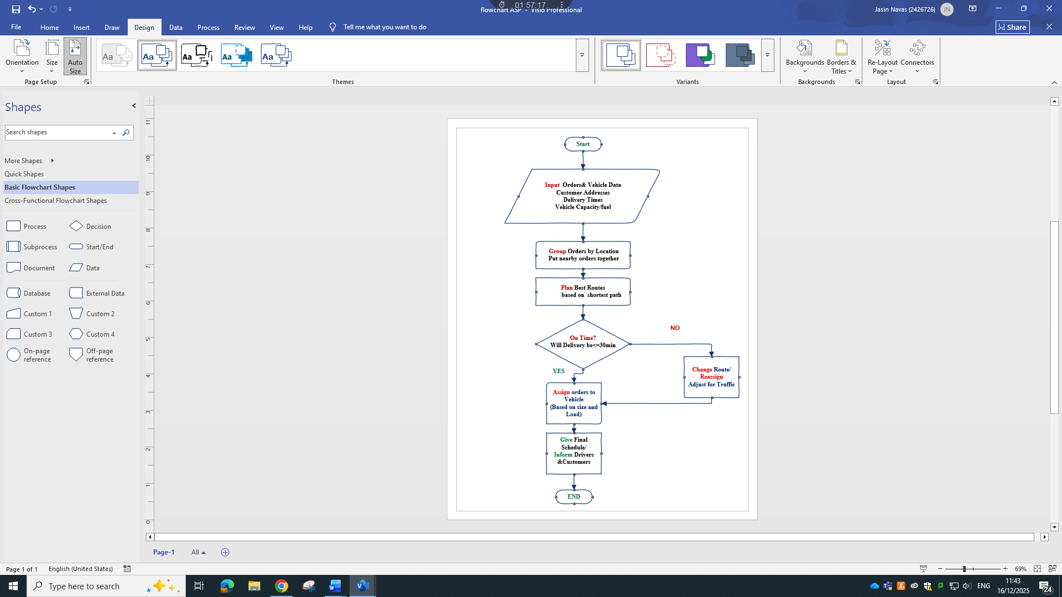

Pseudocode

START
// Start of GrocerQuick Delivery Planning Process
DISPLAY "GrocerQuick Delivery Planning Started"
INPUT orders_list
Includes customer addresses and delivery time schedules
INPUT vehicle_list
Includes vehicle capacity, fuel efficiency, and availability
GROUP orders_list BY nearby locations
This reduces distance, fuel usage, and delivery time
FOR each order group DO
PLAN best_route based on shortest path and fastest travel
CALCULATE estimated delivery times
IF estimated_delivery_time > promised_time + 30 minutes THEN
CHANGE route
REASSIGN some orders to other vehicles
ADJUST route using traffic information if available
RECALCULATE estimated delivery times
END IF
ASSIGN orders to vehicle based on vehicle capacity, fuel efficiency, and driver availability
END FOR
OUTPUT final delivery schedule with routes and times
INFORM drivers with assigned routes and schedules
INFORM customers with expected delivery times
DISPATCH vehicles
END

Reflection and Justification
Problem-Solving Techniques
To address GrocerQuick’s delivery optimisation problem, a set of structured problem-solving techniques was applied.
Abstract Thinking:
The problem was considered at a high level rather than focusing on individual deliveries. Orders, vehicles, and routes were treated as parts of a single system. This made it easier to design a solution that can work across different locations and delivery volumes. Abstract and systems-based approaches are commonly used in supply chain management to create flexible solutions 5].
Problem Subdivision:
The overall problem was broken down into smaller steps, including grouping orders by location, planning delivery routes, checking delivery time limits, and assigning vehicles. Dividing the problem into manageable parts improved clarity and made it easier to apply suitable solutions at each stage.
Systems Thinking:
GrocerQuick’s delivery operation was viewed as a connected system involving customers, drivers, vehicles, traffic conditions, and scheduling tools. This approach helped account for interactions between these components, such as how traffic delays affect delivery times and driver schedules. Systems thinking is widely recognised as an effective method in supply chain and logistics planning [5] .

Why This Approach Is Appropriate for GrocerQuick
This approach is appropriate for GrocerQuick because it improves efficiency, ensures timely delivery, and supports scalability.
Orders are grouped based on geographic proximity, reducing unnecessary travel and fuel consumption. Shortest-path routing methods are then used to plan efficient delivery routes, which is a common practice in logistics optimisation 6]. A strict time-check ensures that no delivery exceeds the 30-minute lateness limit. If delays occur, routes or order assignments can be adjusted, reflecting dynamic vehicle routing problem (VRP) approaches [6].
The solution is also scalable. The same algorithm-driven logic can be applied to small delivery fleets or expanded to support larger operations with many vehicles and orders. VRP frameworks are specifically designed to scale across different logistics contexts [7]. Additionally, sharing the final delivery schedule with both drivers and customers improves transparency and customer satisfaction.

Limitations
Despite its strengths, the solution has some limitations. Delivery accuracy depends on reliable real-time traffic data, which may not always be available. Route optimisation methods can also become computationally expensive when handling large datasets, requiring the use of faster but less optimal heuristics [6]. Human factors such as driver unavailability, customer absence, or vehicle breakdowns are difficult to predict and may disrupt deliveries.

Justification
Overall, this approach effectively meets GrocerQuick’s main objectives: efficient order allocation, reduced fuel usage, and timely delivery. While limitations exist, the solution is flexible and can be improved in the future by incorporating better traffic prediction or advanced optimisation techniques. This makes the approach practical, scalable, and suitable for real-world delivery operations.

Conclusion and Recommendations
By this assessment, I learned that breaking a big delivery problem into smaller steps makes it easier to solve. Grouping orders, planning routes, and checking delivery times showed me how a simple system can save fuel and keep customers satisfied. The main limits I faced were relying too much on traffic data and the difficulty of using complex algorithms when there are many orders. For future improvement, GrocerQuick could use smart tools like machine learning to predict busy times and sensors to track vehicles, making the system quicker and more reliable.

References

[1] | G.B.Dantzig,J.H.Ramser, “"The truck dispatching Problem",Management Science,” Vols. vol6,no.1, pp. 80-91, 1 Oct 1959.
[2] | Gilbert.Laporte, Fifty Years of Vehicle Routing, Vols. 43,no.4, 2009, pp. 408-416..
[3] | Jacques Desrosiers, François Soumis, Martin Desrochers, “Routing with time windows by column generation,” NETWORKS An International Journal, vol. 14, no. 4.
[4] | Vijayakumar, Suchetha; K., Krishna Prasad; M., Raviraja Holla, “Assessing the Effectiveness of MoSCoW Prioritization in Software Development: A Holistic Analysis across Methodologies.,” EBSCO ,Connecting you to content on EBSCOhost.
[5] | Daniell Wilden , John Hopkins , Ian Sadler, “The Prevalence of Systems Thinking in Supply Chain Management: a Systematic Literature Review,” 22 Oct 2021.
[6] | Bruce Golden, Xingyin Wang , Edward Wasil, “The Evolution of the Vehicle Routing Problem—A Survey of VRP Research and Practice from 2005 to 2022,” 01 January 2023.
[7] | Shi-Yi Tan,Wei-Chang Yeh, “The Vehicle Routing Problem: State-of-the-Art Classification and Review,” Applied Science, vol. 11, 2 November 2021.

