Awarding Body: University of Wales Trinity Saint David

Programme Name: BA Business Management

Module Name: The global business environment (LCBB4005)

Assignment Title: Zara retail company

Student Name and Number: Peter Imre / 2012896

Tutor Name: Hossein Shokri

TABLE OF CONTENTS

- INTRODUCTION

- OVERVIEW OF THE FASHION INDUSTRY AND ZARA RETAIL COMPANY

- SWOT ANALYSIS FOR ZARA

- PORTER’S FIVE FORCES

- PESTLE ANALYSIS

- PORTER’S FIVE FORCES MODEL TO SHOW THE CONSUMER AND SUPPLIER POWERS ALONG WITH OTHERS

- RECOMMENDATION

- CONCLUSION

INTRODUCTION

The term business environment can be explained as factors that may be internal or external and in micro or macro surroundings of the business that influence the activities and various elements in and around the organisation. Whereas, global business environment focuses on the environmental factors globally affecting the business. This project will be discussing about business model, various theories like PESTLE, SWOT and Porter’s five forces in regard to business environment.
Zara is a Spanish retail apparel company which was founded in 1975 and is headquartered in Spain (Inditex.com, 2021). The company is owned by Inditex and has more than 3000 stores globally with its brand value of $14.7 billion (Forbes.com, 2020). It is also known as one of the largest international fashion company (Zara.com, 2021).

OVERVIEW OF THE FASHION INDUSTRY AND WITHIN ZARA RETAIL COMPANY

The idea of fast fashion has become a prominent focus in recent years. Fast fashion means that clothing is produced in accordance with current trends and consumer requirements. Beauty, functionality, sustainability, and clarity are the 4 key words the brand has as a part of its core values (Inditex.com, 2021).
The business model of Zara revolves around its customers considering factors like design, manufacturing, sales and distribution (Zara.com, 2021). This depicts that the brand is vertically integrated as it controls all these departments and factors making it easier for them to supervise and maintain all business activities. Quality of products is a crucial aspect in every business and the business model as product is the element that generates revenue. Zara maintains the quality of products along with the style and designs as it controls all departments including designing. The brand has its stores worldwide and thus has an effective supply chain and distribution management. Additionally, it can be said that the brand uses location strategy to increase its sales by setting up stores globally and providing products worldwide.
Zara has made some key changes in its business model to keep up with the new technology and required changes considering the development in market and global business environment.
Use of e-commerce has helped the brand to expand its business and increase the sales. This also enabled to attract more customers as e-commerce provides the facility to customers to shop from anywhere and get the products delivered at desired locations. This enhanced the location strategy of the company as it allowed Zara to expand its business in more locations. The company invested around $3 billion in its e-commerce operations for the same reason (Fortune.com, 2020). Furthermore, the brand is taking sustainable approach towards fashion considering the current requirements of the world in regard to impact of carbon emissions and others. It can also be said as their CSR initiative which is necessary for every industry.
The concerns of stakeholders keep varying with time-to-time and as per the situations. Various concerns of stakeholders can be analysed as follows:
Investors: Situations in business may keep changing with time but the main concern of investors usually stays the same of earning profitable returns on their investments. Investors invest huge amount in business and expect to receive returns on time which are also profitable for them. Due to covid-19, the walk-ins dropped resulting in low sales. This became a concern for investors as they were doubtful for receiving their returns and because of the same, doubtful to invest any further for time being.
Customers: One of the key concerns for customers is to receive products that are of good quality and the prices do justice to them. While customer preferences keep changing with time, it is necessary for businesses to develop and adapt. Utilising new technologies enables the brand to provide better customer experience and satisfaction. Zara used augmented reality to build a Zara AR app that would allow customers to bring virtual models to life (Forbes.com, 2020). E-commerce has also helped the brand to provide better customer experience to its customers.
Government: The concerns of government are usually regarding the laws and regulations. It is expected by all organisations to abide by the government policies and carry out all business activities in respect to the same. Additionally, it is also expected by the businesses to pay their taxes on time and release their financial and annual reports.
Employees: Employees are considered as assets of any business and also play role of stakeholders. They normally expect to receive their salaries on time along with aspects like fair treatment, motivation, job satisfaction, positive work environment and others. In concern to covid-19, employees expected to be able to work-from-home and get paid on time. Further, their concern was also health and safety in the prevailing situations.

      - SWOT ANALYSIS FOR ZARA

Strengths | Every organisation has its own set of strengths which could be its organisational culture, employees, strategies or anything else. These strengths help the company during challenging situations. Zara is a well-known brand with a strong brand image and value which are some of its key strengths.
Weaknesses | Weaknesses are aspects a company needs to work towards as they may create negative influence on the company’s image and performance. Zara workers were not paid wages which acted as a weakness for the brand as employees are considered assets for any organisation (CBC.ca, 2018).
Opportunities | Opportunities can be explained as situations that act as an advantage for the company and provides benefit in some way or the other. E-commerce is one of the biggest opportunities for Zara to increase its sales and profits.
Threats | Threats are disadvantages for the company and have a negative influence on the performance as well as various other aspects of the business. Competitors of Zara can be said as threat for the brand.
Table 1: SWOT analysis
(Source: Learner made)

      - PORTER’S FIVE FORCES

Bargaining power of suppliers- The power of suppliers is high as Zara has a strong brand image which is because of the products being sold by the brand and to maintain the quality, variety and other elements of its products, the suppliers play key role. Thus, they possess high power.
Bargaining power of customers- The power in hands of customers is always high as they are the ones who buy the products of Zara. It is necessary to retain the existing customers and turn potential buyers into definite customers and to achieve the same, it is important for Zara to keep customers satisfied.
Threat by new entrants- As Zara is a well-known brand and has built its client base, threat by new entrants is usually low to medium. But the threat could increase depending upon the products being offered by the new start-ups as they tend to bring something new in the market.
Threat by substitutes- People may but products from local stores instead of Zara due to factors like price of products sold by Zara. There are various substitutes available in the market but the threat is usually medium as brand loyal customers tend to stick around with Zara instead of opting for substitutes. Whereas, there are customers who look for products that are more affordable as quality comes after price for them. In such cases, they might opt for substitutes.
Threat by rivals- Zara has numerous rivals like H&M, M&S, Chanel, Prada and various others. Though the threat by rivals is normally medium as every brand has something different to offer to the customers; yet multiple brands in market enable customers to have various options to choose from.

      - PESTLE ANALYSIS

Political | The exit of UK from EU has resulted in the movement of Brexit. This has influenced all industries and brands present in UK. | Brexit will have an influence on the increase in tariff rates leading to increased price of clothing in fashion industry by around 20%. This will make the clothes affordable to comparatively less population (BBC.com, 2019).
Economic | The outbreak of covid-19 virus has been creating an impact on the entire world since late 2019 till present. Every industry is facing losses due to the same. | Referring to the situations arisen due to corona virus, Zara shut down 3,785 stores globally but the brand saw an increase in sales by 8% due to online sales (Businesstoday.in, 2020).
Social | Customers are one of the most crucial stakeholders for every sector and their opinions and behaviour create an impact on the business. | Customers are a huge reason behind the success of Zara as the clothes make them feel confident as said by the influencer Jasmine Jonas (BBC.com, 2019).
Technology | E-commerce has been providing a great benefit to businesses by enabling them to buy and sell online with the help of websites and various other platforms. | Covid-19 led to stores being shut down temporarily as well as permanently but e-commerce helped businesses to continue their activities. The profits of Zara increased by 8% to €11.5 billion along with sales increasing by 7.5% to €19.8 billion (BBC.com, 2019).
Legal | There are various laws for employees to ensure aspects like their safety, equality and others. | A law passed by UK government is in regard to flexible working for convenience of employees which was also helpful during the situation due to covid-19 and Zara also provided this to their employees (Gov.uk, 2021).
Environmental | Corporate Social Responsibility should be a part of every organisation considering the climatic changes due to carbon footprints and various other reasons. Every organisation should take their initiatives for the same purpose. | Zara promised that by the year 2025, all the clothes being sold by them will be sustainable as the materials used like cotton, polyester and linen will be either sustainable, organic or recycled. The brand will be further taking old clothes from customers and reusing or recycling them into new ones as one of their CSR initiatives (BBC.com, 2019).
Table 2: PESTLE analysis
(Source: Learner made)

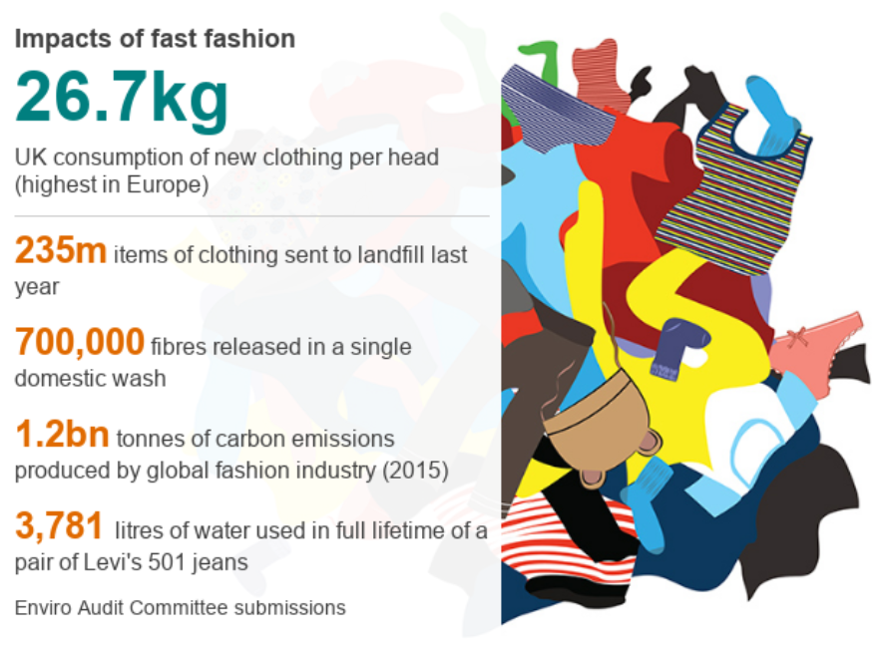
Image 1: Impact of fashion industry (Source: BBC.com, 2019.)

      - RECOMMENDATIONS
Factors like covid 19 are creating an impact globally, expecting businesses to adapt to them and take required measures. It is recommended for the management of Zara to be aware of the business environment globally at all times to evaluate issues that may arise and find appropriate solutions for them.
Application of Porter’s five forces, PESTLE and SWOT analysis efficiently will help the brand to analyse better and effectively. Further, changing with time for the enhancement of business performance is also recommended. Stakeholders also contribute in the success and welfare of the business and thus, they should be kept satisfied.
It is also recommended to indulge more in CSR activities as it is the need of the hour globally. Zara is taking initiatives for making their products sustainable. The brand should additionally perform various social activities as it will contribute in the welfare of society and also enhance the brand image in market. This will increase the brand value and act as advantage.

CONCLUSION

This project concludes that there are various aspects in the environment of an organisation that influence business activities and decisions. Theories like SWOT, Porter’s 5 forces, and PESTLE analysis help to understand the business environment better as they focus on various elements. It can also be concluded that businesses are developing with time considering various changes in the market; and so are the concerns of stakeholders changing with time.

REFERENCES

Inditex.com Zara. Available at: https://www.inditex.com/about-us/our-brands/zara. (Accessed on 29 April 2021.)

Zara.com Company, 2021. Available at: https://www.zara.com/ww/en/z-company-corp1391.html
(Accessed on 29 April 21)

Forbes.com Zara, 2021. Available at: https://www.forbes.com/companies/zara/?sh=2c6e70b07487
(Accessed on 29 April 2021.)

Forbes.com, 2021. Is immersive technology the darling of the fashion world? Available at: https://www.forbes.com/sites/solrogers/2020/02/19/is-immersive-technology-the-darling-of-the-fashion-world/?sh=4aff79422256 (Accessed on 29 April 2021.)

Cbc.ca Unpaid Zara garment workers say they still haven’t seen a cent. Available at: https://www.cbc.ca/news/business/zara-inditex-workers-still-unpaid-1.4414831 (Accessed on 29 April 2021.)

BBC.com Brexit: How could it affect the fashion industry? Available at: https://www.bbc.com/news/av/world-europe-47171131 (Accessed on 29 April 2021.)

BBC.com Fast fashion: Zara promises all its clothes will be sustainable by 2025. Available at: https://www.bbc.com/news/newsbeat-49022453 (Accessed on 29 April 2021.)

BBC.com Profits surge at Zara. Available at: https://www.bbc.com/news/topics/cq265lp6854t/zara (Accessed on 29 April 2021.)

BBC.com Zara uncovered: Inside the brand that changed fashion. Available at: https://www.bbc.com/news/business-49268965 (Accessed on 29 April 2021.)

Businesstoday.in Coronavirus impact: Zara owners shut down 4,000 stores worldwide. Available at: https://www.businesstoday.in/current/world/coronavirus-impact-zara-owners-shut-down-4000-stores-worldwide/story/398717.html (Accessed on 29 April 2021.)

Fortune.com Zara’s parent company to invest $3 billion in e-commerce – and expanding physical stores Available at: https://fortune.com/2020/06/10/zaras-parent-company-to-invest-3-billion-in-e-commerce-and-expanding-physical-stores/ (Accessed on 29 April 2021.)

Gov.uk Flexible working [Online] Available at: https://www.gov.uk/flexible-working (Accessed on 29 April 2021.)

