Emergence of VO

Introduction
The purpose of this study is to investigate the expansion of virtual organizations (VOs), as well as the opportunities and challenges that these organizations provide for strategic management. Voice over Internet Protocol (VO) networks are geographically dispersed networks that collaborate and share resources via the use of technology. Additionally, they provide cost-effectiveness, scalability, and access to a bigger talent pool, which are all advantages. There are, nevertheless, challenges associated with establishing confidence, cooperating with others, and communicating across distances. Following that, the study goes into three significant strategic management difficulties that virtual organizations (VOs) face: the development of virtual team dynamics and leadership, the utilization of technology for collaboration, and the formation of organizational structures. In conclusion, it examines the specific challenges that are faced by leaders in virtual workplaces, including the establishment of trust, the maintenance of communication, the involvement of employees, and the effective resolution of conflicts. Those in leadership positions have the ability to develop high-performing virtual teams that are able to achieve strategic goals by overcoming these challenges.

Main Body

Virtual Organizations: A Networked Approach to Business
A "virtual organization" (VO) is a dynamic network that consists of individuals, teams, or even enterprises that are located in different parts of the world but work together to achieve a shared goal. In contrast to traditional companies, which have hierarchies and centralized headquarters, virtual organizations (VOs) rely on technology and communication tools to collaborate and share resources across distances (Davidow and Malone, 2000).
Listed below is a breakdown of the most important characteristics of a voiceover:
- Geographically Dispersed: VO members may be located anywhere in the world, which means that there are no longer any physical obstacles to collaboration (Lipnack and Stamps, 1997). This is because VO members are geographically decentralized.
- Technology-Driven: Virtual assistants (VOs) use various communication and information technology solutions, such as cloud storage, software for project management, and video conferencing, in order to maintain contact with one another and share resources (Malone, 1987).
- Project-Oriented: According to Hacker, Johnson, and Saunders (2019), volunteer organizations (VOs) are often founded for specific projects or initiatives, and their membership and organizational structure are subject to change depending on the requirements of the situation.
- Shared Expertise: VOs foster innovation and enable access to a broader talent pool by bringing together individuals who possess specialized experience and talents (Davidow and Malone, 2000). This is accomplished via the sharing of relevant expertise.

Why Virtual Organizations Are on the Rise
Virtual companies are becoming increasingly widespread for a variety of reasons, including the following:
- Because of the emergence of trustworthy and fairly cost communication and collaboration solutions, it is now easier than ever before for geographically dispersed teams to cooperate and communicate effectively (Lipnack & Stamps, 1997). This is a result of technological advancements.
- As a result of operating in a more globalized market, businesses are being forced to work together with partners and employees who are located in different time zones and are located in different regions.
- VOs have the potential to save costs associated with travel, administrative labor, and physical office space (Malone, 1987). Furthermore, they may be more cost-effective.
- The ability of virtual assistants (VOs) to provide organizations with access to a bigger talent pool, regardless of location, is one of the ways in which they encourage diversity and competence (Malone, 1987).
- Virtual assistants are able to fast respond to changing market demands due to the fact that they are project-based and have a framework that is flexible (Hacker, Johnson, and Saunders, 2019).
Despite the fact that virtual organizations (VOs) provide a multitude of advantages, it is of the utmost importance to acknowledge the challenges that arise when attempting to develop trust and collaboration in a virtual environment (Malone et al., 1999).

Strategic Planning in Virtual Organizations: Challenges and Opportunities
Considering that virtual businesses have workforces that are dispersed around the globe, strategic planning presents a unique challenge for these organizations. An examination of both sides of the debate is presented in the following:
Challenges:
- Establishing Cohesion and a Shared Vision: According to Hacker et al. (2019), teams that are geographically scattered may have a difficult time establishing a strong sense of purpose and identity, which may inhibit the formation of a cohesive vision.
- Collaboration and Communication: According to Olson and Olson (2013), virtual environments have the potential to impede communication and collaboration, making it difficult to come up with ideas and effectively reach a consensus.
- Information sharing and transparency: According to Jarvenpaa, Shaw, and Staples (2004), virtual setups may diminish the openness of information flow and knowledge exchange, which may result in wasted effort and missed opportunities. This may be a consequence of the presence of virtual setups.
- Motivation and Engagement: As a result of the fact that it may be difficult to maintain the motivation and engagement of team members in a virtual setting, this may discourage them from participating in the process of strategic planning.
Opportunities:
- Diversity of Thought and expertise: Virtual teams have the potential to deliver a more diverse and in-depth set of strategic choices since they draw from a bigger pool of talent and expertise than traditional teams do.
- Cost-Effectiveness: The process of designing a strategy virtually is more cost-effective than traditional methods since it does not need expensive travel or meetings between individuals.
- Flexibility and Accessibility: Asynchronous engagement is made possible by virtual technologies, which enable members of a team to participate in the planning process whenever it is convenient for them, regardless of where they are located in the globe (Hacker et al., 2019). This allows for more flexibility and accessibility for the planning process.
- Real-Time Collaboration Tools: Virtual whiteboards and document sharing platforms are just two examples of the various real-time collaboration tools that technology can offer. These technologies may assist with the exchange of information and the generation of new ideas (Olson and Olson, 2013).

Designing Strategic Management Issues in Virtual Organizations
In light of the proliferation of virtual organizations (VOs), strategic management is presented with both new opportunities and challenges. Within this context, we will investigate three significant issues that need strategic consideration:
Organizational Design and Structure in Virtual Organizations
Teams that are geographically dispersed need novel ways, and classic hierarchical structures are struggling to function well in virtual companies. One of the most important decisions to make is determining the preferred level of centralization vs decentralization. According to Brown, Huettner, and James-Tanny (2007), a "hybrid" organization is desirable because it achieves a balance between dispersed team decision-making to encourage agility and centralized control for strategic direction. This makes it possible for the organization to function more effectively. In addition, there is the issue of task arrangement. VOs often rely on teams that represent many functional areas and need well defined roles and responsibilities. However, physical distance may also induce doubt over the work at hand. This is something that strategic management has to tackle in a number of different ways (Nydegger and Nydegger, n.d.). Two of these approaches include the establishment of a culture of collaboration and developing strong communication protocols.
Role of Technology in Enabling Virtual Collaboration and Communication
When it comes to the effectiveness of VO, collaboration and excellent communication are very necessary. As a means of bridging geographical distances, the use of technology is very necessary. Purchasing equipment that allow instant messaging, video conferencing, and cloud storage, in addition to facilitating information interchange and project management, is something that strategic management have to take into consideration. In spite of this, technology is not a silver bullet. The enhancement of the instruments' usability and the promotion of their wider use are two of the most important strategic concerns. In order to overcome resistance to technology and ensure that information flows without interruption, it is necessary to get training and help (Delone and McLean, 2003).
Virtual Team Dynamics and Leadership
VOs are subject to a unique set of team dynamics. When working in a virtual setting, it may be challenging to cultivate a sense of community and trust among participants. In order to find a solution to this problem, it is necessary to foster social participation and the development of virtual teams via strategic management initiatives. It is also necessary to replace the leadership. Effective virtual leadership requires a person to possess strong communication skills, cultural awareness, and the ability to manage effectively from a distance. In accordance with Jarvenpaa and Leidner (1999), essential components consist of the establishment of a culture of psychological safety, the provision of regular feedback, and the assurance of clear expectations.

Leading Strategic Management Issues in Virtual Organizations
The emergence of virtual organizations, in which teams are able to do their job from a distant location, presents unique challenges for strategic management. Leaders may find it challenging to effectively manage conflict and negotiate, to construct effective communication and trust, to inspire and engage virtual teams, and to develop trust among members of the team.
Leadership Challenges in Virtual Organizations:
For virtual teams to be successful, it is vital to adapt the way leadership is approached in order to inspire, engage, and monitor their progress. Charm and monitoring via face-to-face interaction are less effective than other methods.
But it could be difficult to keep them interested in what you have to say. Among the most significant factors that demotivate people, Jarvenpaa, Shaw, and Staples (2004) listed feelings of loneliness and a lack of social connection as crucial factors. In addition to the obligations that are associated with work, leaders are required to give opportunities for virtual communication. Through participation in social gatherings and activities that foster teamwork, it is possible to foster the development of connections and a sense of community.
An additional need for performance management is the ability to adapt. It is recommended by Duarte and Tennant (1999) that those working in a virtual environment construct accurate performance indicators that are capable of being assessed. In order to ensure accountability and identify areas that need improvement, it is vital to establish and achieve objectives on a consistent basis. In order to ensure that they are receiving feedback on their performance, leaders should make use of technical tools such as online polls and collaborative platforms.
Effective Communication and Trust-Building in Virtual Teams:
For every team to perform well, communication is essential; however, in virtual contexts, the need of communication is amplified. The authors Hung, Dennis, and Robert (2004) bring to light the issue that text-based communication is devoid of nonverbal cues, which might result in misconceptions. It is imperative that leaders encourage communication that is regular, unambiguous, and brief. This may be accomplished using a variety of channels, such as video conferencing, instant messaging, and collaborative platforms.
The establishment of trust is essential since virtual teams do not always have the opportunity to interact with one another in person. According to Jarvenpaa and Leidner (1999), open communication and openness are essential elements that contribute to the development of trust. In addition to being personable and easily available for discussion, leaders should make it a priority to actively seek out the feedback of their team members. In addition, the cultivation of a culture that is polite and welcoming is necessary in order to build a foundation of trust.
Managing Virtual Team Conflict and Negotiation:
It is possible for virtual teams to have conflict due to the presence of competing priorities, difficulties in communication, and cultural similarities. The authors Jackson and Chen (2007) assert that strategies for conflict resolution that are proactive are of great significance. Through the establishment of unambiguous norms for online communication, leaders have the ability to foster open and honest conversation inside their organizations. In order to limit the amount of conflict that occurs, it is important to encourage members of the team to communicate their viewpoints in a constructive way while maintaining a courteous tone.
When conducting negotiations in a virtual environment, there are extra challenges to contend with. Those in leadership positions have the ability to facilitate successful negotiation by establishing realistic expectations, communicating in a clear and concise manner, and using technology to facilitate collaborative decision-making.
The development of trust, the promotion of effective communication, and the cultivation of strong relationships are all vital components of effective strategic management in virtual companies. By addressing these concerns, leaders have the opportunity to construct a high-performing virtual workforce that is capable of achieving strategic objectives.

Conclusions
To summarize, virtual organizations provide a number of advantages, including reduced expenses, simpler access to a broader pool of talent, and more adaptability. Nevertheless, there are other challenges, such as fostering trust and fostering collaboration among team members. It is essential that these potentials and challenges be properly explored when it comes to the strategic management of virtual organizations. The creation of organizational structures that strike a balance between centralization and decentralization, the use of technology to promote communication and collaboration, and the cultivation of powerful virtual team dynamics by fostering social engagement and transparent communication are all crucial for leaders to accomplish. It is possible for virtual companies to establish high-performing teams that are able to effectively fulfil strategic goals by successfully addressing these issues.

Préci
An examination of the growth of online business in India is presented in this article. Both shifting lifestyles and the proliferation of the internet are contributing to this surge. The research investigates the numerous business-to-consumer, business-to-business, and business-to-business (B2C) e-commerce sectors and depicts the evolution of the industry over the course of time. More than that, it brings to light the challenges that the industry is confronted with, such as low internet penetration, slow speeds, and a mobile environment that is still in the process of emerging.
There are a number of variables that may be responsible for the emergence of the e-commerce business in India. These factors include the increase of the middle class, the availability of mobile phones at reasonable prices, and the widespread adoption of the internet. The number of people who use the internet has increased as a direct result of this, and a sizeable portion of those individuals have chosen to make their purchases via the realm of online shopping.
It is clear from the research that India has seen two separate waves of the e-commerce boom that has occurred in the country. The first wave of online dating began to emerge at the beginning of the 1990s, and it was differentiated by the arrival of ads for marriage and career services on the internet. This wave of online dating was characterized by both of these factors. within the second wave, which began in the middle of the 2000s, notable advancements included the coming of online shopping and the popularity of travel portals. Both of these innovations occurred within the same time period.
While online travel now has the highest share of the e-commerce market, online retail is swiftly catching up to it and becoming the dominant player in the industry. Despite the fact that cash on delivery is still a widespread means of payment, debit cards and mobile wallets are gaining more and more popularity.
Even with this enlargement, there are still issues to be resolved. It is possible that the low rate of credit card use and the lack of established mobile internet infrastructure may hinder the possibility for future e-commerce development. In addition, a significant proportion of clients who make failed online purchases for a number of reasons is a deterrent to them.
There are certain recommendations that are provided at the conclusion of the article with regard to the process of seeking solutions to these issues. It is feasible for businesses who are active in e-commerce to work together with traditional financial institutions in order to establish platforms that are compatible with mobile devices and payment processes that are safe. There is also the possibility that the Reserve Bank of India may get involved by keeping an eye on the growth of online transactions and requiring higher quality requirements. An illustration of their participation might be something like this.
As a result of the study, an optimistic image of the e-commerce scene in India emerges when all of the criteria are taken into account. After the difficulties that are now being encountered have been conquered, it is projected that the sector will have a more significant expansion in the years to come.

Question C – Summary of figures, tables and experiments

FIGURE 1
The many methods of doing business transactions using the internet in India are shown in figure 1. This image's data most likely originates from research that was conducted on the ecology of e-commerce in India.
The text included in the picture distinguishes between three distinct types of e-commerce transactions: business-to-consumer (B2C), consumer-to-consumer (C2C), and online classifieds.
B2C transactions, also known as business-to-consumer transactions, are the most common kind of e-commerce in India. These transactions include the direct online sale of products and services between businesses and individual consumers. The following are some examples of businesses that fall under this category: ticketing services, travel websites, and online retailers.
C2C transactions, often known as consumer-to-consumer transactions, are those that take place between individual consumers. In spite of the fact that it is now rather small in India, it is projected that this category will grow over the course of the next several years. There are instances of consumer-to-consumer transactions that take place in online marketplaces where users may buy and sell used items and services.
The term "online classifieds" refers to a broad category that encompasses a variety of websites that facilitate transactions between buyers and sellers. The websites that come under this category include those that are dedicated to online directories, online marketplaces, and classified advertisements.
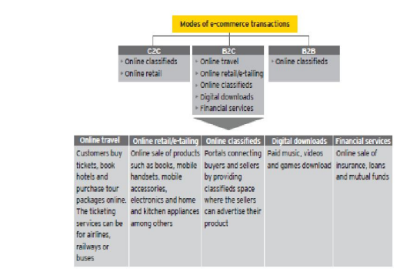
FIGURE 2
The second image depicts how the buying power of Indian consumers has risen over time. According to the information shown in the image, it is anticipated that India's annual family discretionary income would increase at a compound annual growth rate (CAGR) of 5.1% between the years 2005 and 2025.
Presented in the image is a table that illustrates the anticipated amount of discretionary money that each Indian household will have in the years 2005, 2015, and 2025. According to the research, it is anticipated that the amount of discretionary money would more than quadruple over the course of the next twenty years.
During the last 10 years, India's gross domestic product (GDP) has seen tremendous growth, which has led to an increase in income levels. As a consequence of this, India today has one of the consumer marketplaces that is expanding at the quickest rate in the planet. Based on the information provided in the text, it is anticipated that discretionary spending would rise from 52% in 2005 to 61% in 2015 and then to 70% in 2025. The term "discretionary expenditure" refers to the money that is left over after people have paid for essential responsibilities such as housing and food.
When everything is taken into consideration, the picture suggests that the economy of India is growing and that Indian consumers have more money available to spend after paying for necessities. This is really encouraging news for businesses who operate in India and provide their services and goods to other consumers.
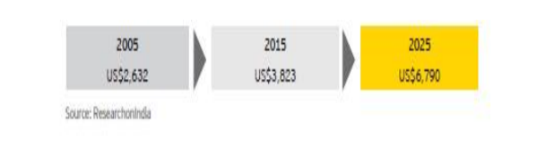
FIGURE 3
In figure 3, a line graph depicts the percentage of expenditures that are non-discretionary and those that are discretionary over the course of three years, from 2005 to 2025. The title of the graph is "Discretionary costs versus non-discretionary costs (percentage)."
- The years 2005, 2015, and 2025 are shown along the y-axis of the graph, which is most likely intended to signify the years.
- "Discretionary" and "non-discretionary" are the labels that are located on the x-axis, and the percentages vary from 0% to 100%. There are tick marks on the percentages, but there are no labels.
- According to the description that can be seen in the bottom right corner of the graph, the symbol that represents non-discretionary expenditures is an orange triangle, and the symbol that represents discretionary spending is a blue square.
The graph demonstrates that the proportion of discretionary spending has continually increased over time, despite the fact that the proportion of non-discretionary expenditures has decreased over time.
- The percentage of discretionary spending was 52% in 2005 (year concealed), while the percentage of non-discretionary spending was 48%.
- In 2015, discretionary spending increased to 61% of total expenditures, while non-discretionary spending continued to decline to 39%.
- When the year 2025 arrives, it is projected that seventy percent of expenditures would be discretionary, while thirty percent will be non-discretionary.
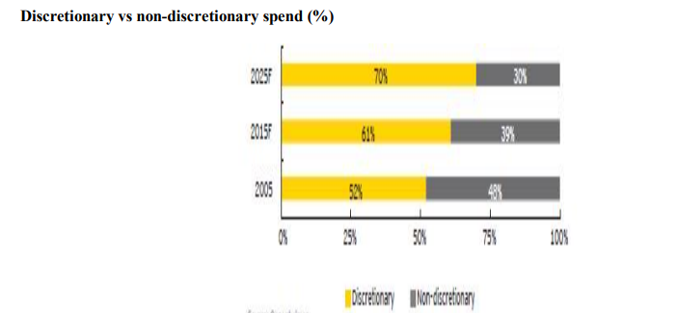
FIGURE 4
The percentage of people who have access to the internet in India is among the lowest in the world, coming in at 11.4% in June of 2012 (see image 4).
The words "(b) Internet" and "Internet penetration in India among the lowest in the world" are printed at the very top of the photo.
The body of the picture is comprised of a chart that presents a breakdown of the levels of internet use in each country. It is said that the countries in question include Germany, France, Japan, the United States of America, Russia, Brazil, China, and India.
- The internet is completely pervasive in Germany, making it the leader in the globe.
- Seventy-five percent of individuals in the United States of America, Japan, and France have access to the internet.
- A little less than forty-five percent of the population in Brazil and Russia is online.
- Internet access is used by forty percent of the population in China.
- 11.4% of the population in India is the lowest percentage of people who use the internet.
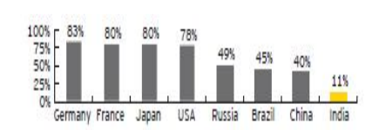

FIGURE 5
It is clear from looking at figure 5 that the prices of data cards and the rates for data plans are going down. According to the language that is shown on the picture, a reduced total cost of ownership (TCO) for internet connections is the result of lower data plan prices as well as lower costs for data cards and USB dongles.
It is notably mentioned in the article that there was a circumstance in which, between the years 2009 and 2011, the monthly prices of data plans for fixed line and cellular internet connections both reduced by fifty percent. Between the years 2009 and 2011, the table in the picture presents a comparison of the costs of fixed line and wireless internet connections in India. In the following manner, the information that is shown in the table is split down:
Fixed Line: During the year 2009, the monthly rate for the Fixed Line service was INR 1,300, and the installation charge was INR 1,000. In 2011, the installation costs were reduced to INR 500, and the monthly expenses were reduced to INR 699 because of the decrease. There was no change in the limitless data speed and speed of the fixed line internet connection; it remained at 512 Kbps.
Wireless: In 2009, the monthly rates were INR 1,250, and the installation expenses were INR 2,500. Beginning in 2011, the installation costs were reduced to INR 500, and the monthly rates were also reduced to INR 500. The maximum speed and capacity for wireless internet connections increased in 2011, going from up to 3Mbps/2GB to up to 3Mbps/unlimited. This increase occurred in 2011.
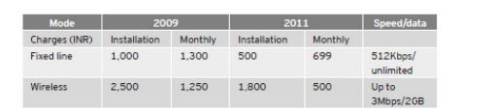

FIGURE 6
The graph illustrates the number of cards that each individual has in a variety of countries. The graph is titled "Number of cards per capita (August 2011)" and it displays the data.
- On the x-axis of the graph, the nine countries that are included in the report are listed as follows: Singapore, China, Brazil, Russia, Australia, the United States of America, Canada, and India.
- The y-axis labeled "Number of cards" has a range that goes from 0 to 5. There is no linearity in the scale; the numbers between 0 and 5 are represented by tick marks but do not have labels.
Based on the graph, it can be seen that each country has the following number of cards for each individual:
- United States of America: 4.5
- Canada: 4
- Australia: 2.9
- United Kingdom: 2.6
- Singapore: 2.6
- China: 1.2
- Brazil: 0.9
- Russia: 0.2
- India: 0.2
According to the graph, the United States of America and Canada have the highest card counts per capita, with 4.5 and 4 cards available to each individual, respectively. India and Russia have the fewest cards per person than any other country, with each having 0.2 cards.
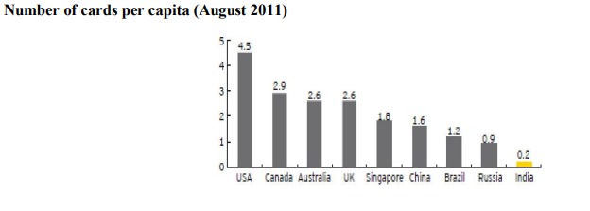

l.



