PROJECT PLANNING
AND
MANAGEMENT IN WORK PLACE
BMSW5104
SULTANA ISLAM 1709614
SUBMISSION DATE 20TH DECEMBER 2019
UNIVERSITY OF WALES TRINITY SAINT DAVID’S
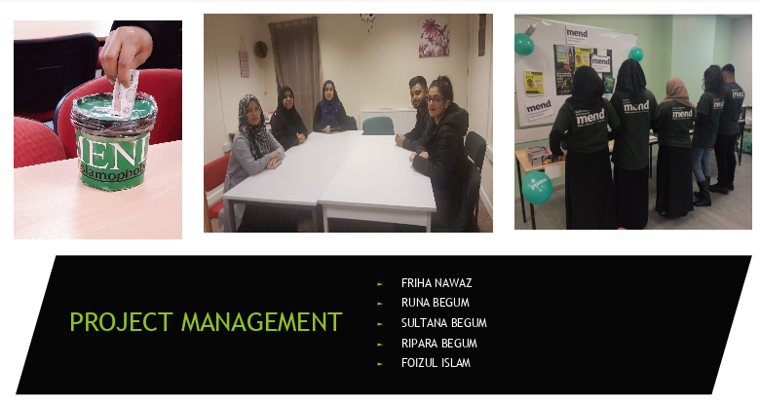

CONTENTS PAGE

Introduction………………………………………………….3
Main Findings……………………………………………4/13
Recommendation………………………………………….14
Conclusion………………………………………………15/16
References………………………………………………17/18

INTRODUCTION

This report analysis the Project Management Tools and Techniques for managing a Project.
According to Wrike, (2019) a project is temporary it has a clear beginning and ending time, and as a result defined scope and resources. For each project will be approved and unique objectives besides project plan, budget, timescale, deliverables and tasks. A project may involve people from different groups within an organization, brought together to accomplish a specific goal. Project management is the application of tools and techniques, knowledge and skills, to meet the project requirements.
To organise the Project, groups of five members were involved in an organisation MEND. It is 100% community financed and run, their purpose is to raise Awareness about Islamophobia, having a greater appreciation of British Muslim contribution and working with Stakeholders to reduce and tackle Islamophobia, according to MEND, (2019).
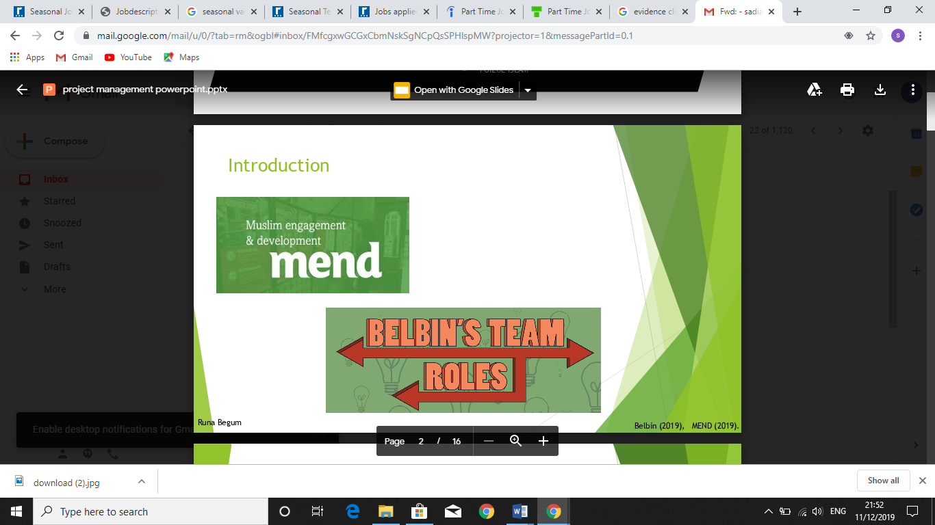
Project will involve a Workshop event and Presentation on Islamophobia Awareness in class at UWTSD.

To start up with the project all member’s team roles were decided, according to the individual’s qualities and skills in relation to Belbin’s team roles Belbin, (1981):
Friha (Project Manager) – The Plant
Runa – The Implementer
Sultana – The Team Worker
Ripara – The Co-ordinator
Foizul – The Complete Finisher
Main Findings

PROJECT LIFE CYCLE

According to Aston, (2016) The Project Life Cycle, is a systematic manner to define the project. Firstly, planning to outline all works need to be carried out and creating the route that needs to be followed. Five stages to be monitored:
- Initiating – where the project manager clearly defines how the project will succeed and recognise, working with the project supporter and stakeholders to approve deliverables.
- Planning – project manager records all the tasks and allocates deadlines for each group members, stating the relationships and needs between each activity.
- Executing - building the project team, collecting and allocating the resources and contribution available to exact tasks.
- Monitoring - runs the progress of project updates and work updates and project plans to reflect definite performance.
- Evaluating - project manager confirms the outputs delivered by the project are recognised by the company and ends the project team.
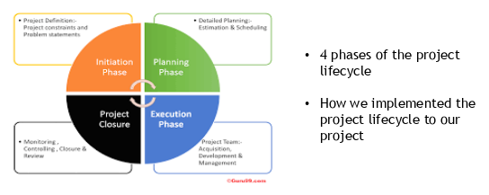

QUAD CHART
According to Quora, (2018) Quad chart are divided into four section laid out on a landscape viewpoint. It’s to form technical documentation to describe briefly an invention or other innovation through writing and illustration.
At this stage project members discussed the monitoring and evaluating, recapping tools and techniques been used in the project. Also, to reflect back on the planning to make the Quad Chart and monitoring to understand that everything going well according to plan.
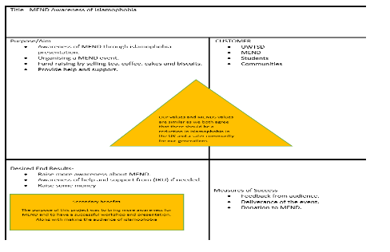

GANTT CHART
According to APM, (2019) Gantt Charts, it’s a project management tool helping to plan and schedule the project of all extents. It is to make project particularly simpler and useful to keep on track. Including, how much of the tasks is completed per stages, showing start and end dates, dependencies, scheduling and deadlines.
Team members, arranged the scheduled activities to be done in the Gantt chart. Organising start and finished duration of the project. For instance, the initial plan for workshop was changed due to student’s unavailability on that day.
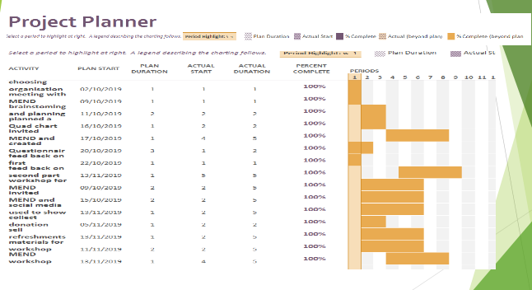

WORK BREAKDOWN STRUCTURE
According to Critical Tool, (2016) Work Breakdown Structure is a structure that starts with a large project and breaking down into smaller parts, this will benefit the teams to evaluate and distribute certain aspects. WBS generally focuses on deliverables and measurable milestones. The core purpose of WBS is to minimise complicated tasks to ease the task. This is essential for the project manager to give directions effectively than complicatedly suggested by Markgraf, (2019).
During the planning phrase of Project Life Cycle, the team decided to create the WBS, this will help to breakdown individual activities. First implementing the WBS by brainstorming main deliveries of the project and getting the information from Quad Chart. This method certainly helped the team to manage and prioritise work effectively. By looking at the chart below it clearly divides each member’s task according to their colours.
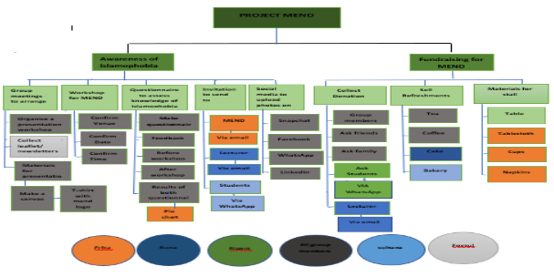

STAKEHOLDER ANALYSIS

According to ProductionPlan, (2019) Stakeholder Analysis is a process to identify the people before starting the Project. First of all putting them in groups according to their level of attention, contribution and influence in the project. Thompson, (2019) suggested Stakeholders are the people who need to be considered in achieving project goals and support needed to it success.
To Priorities MEND, there are three stakeholders with highest priority:
MEND – the organisation itself, given the opportunity for doing the project, which will help to gain experience for future project.
UWTSD – the main project organiser, giving the opportunity to work as a team.
Team Members – team member’s collaboration very important to accomplish the project, if one member is absent, then the pressure will be on another member.
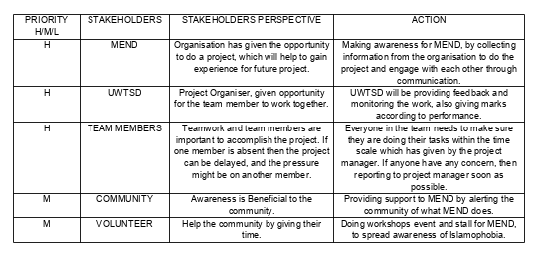

IRON TRIANGLE
According to Study.com, (2019) Iron Triangle is referred to triple constraint matrix, it’s a way to resolve the key factors of costs, scope and schedule competing limits on any project budget.
Team members Scope:
Cost - Limited costs, only team member’s contributed as not enough materials were supplied by the organisation.
Time - Limited time, due to lack of communication from the organisation, the event had to be done in less time scale.
Product - Organising workshop for MEND, to Raise Awareness for Islamophobia. Including donations, presentation and arranging a food sale. All contribution raised will be given to the organisation.
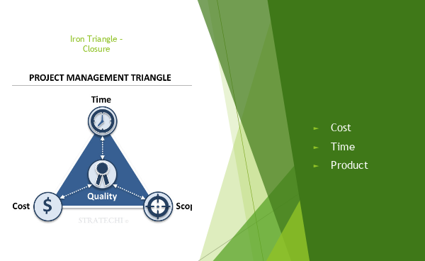

RISK ANALYSIS
Lavanya, (2008) suggested, Risk Analysis is most fundamental part of project before implementing a new project. It’s important to identify all the possible risk which may happen.
All the potential risks have been identified by managers and teams, in order to create mitigation plans. It has been assed that how likely the chances of risks and what are the impact. After identifying the causes, plan B will be taken place for further option to rectify it.
For instance, one major risk according to the project is MEND not turning up. In that case all members need to overcome the solution by taking part and using individual knowledge regarding MEND, and presenting to the audience to carry on with the event.

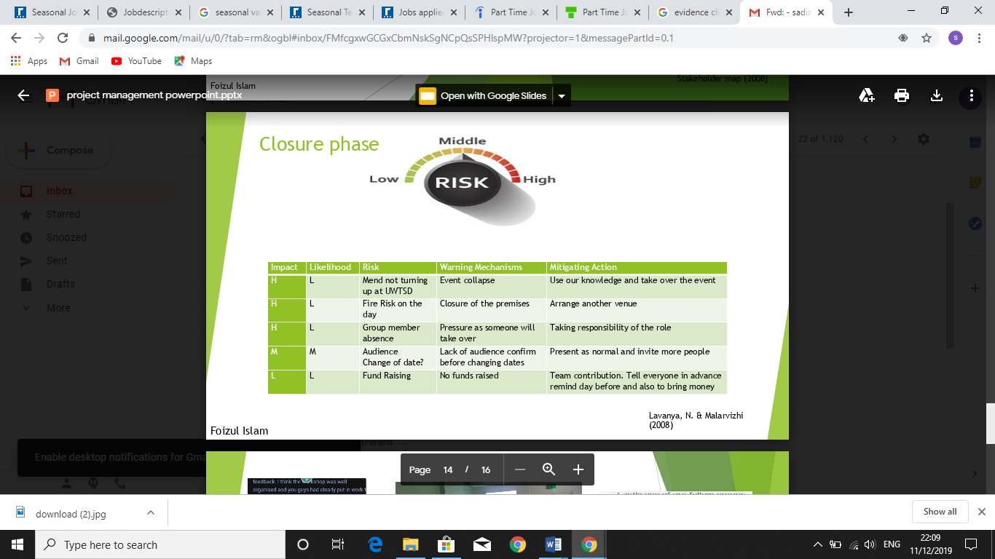

MONITORING: QUESTIONNAIRE

According to KnowledgeHut, (2017) Monitoring is a crucial element of all project plans. It shows where or why projects fail. It essentially comes down to keeping measurements and proactively recognizing possible problems and taking the necessary steps to guarantee the project is completed.
According to PMI, (2019) Questionnaire, is quick and simple way to collect data that comes straight from the sources.
The team members created two sets of questionnaire, one before the event to monitor how many individuals are aware of MEND, and second sets of questionnaire to see results of the differences, if individual have taken enough knowledge regarding Islamophobia and their organisation also, if anyone would like to become a member of MEND. This will be the soft outcome of the project.
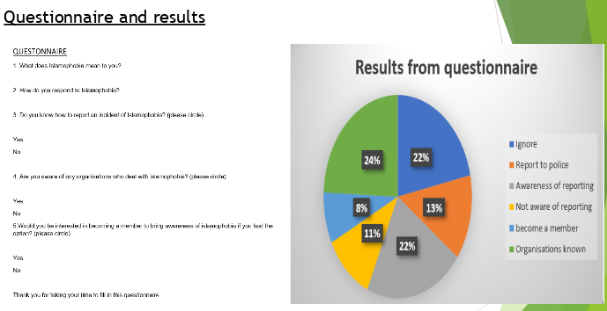

EVALUATION: PIE CHART

According to Sport & Dev, (2019) Evaluation means performing a rigorous analysis of completed objectives and activities to determine whether the project desired changes, produced planned results and expected benefits.
According to Study.com, (2003) Pie chart is generally divided into sections to represent values of differences, it easily shows which questions are most popular.
The hard outcome of the project is the Pie chart showing results, that more people are aware of Islamophobia after the event, then before the event taken place. Also, some members were interested in become a member for the organisation. This shows that arranging the event for the organisation was a great success.
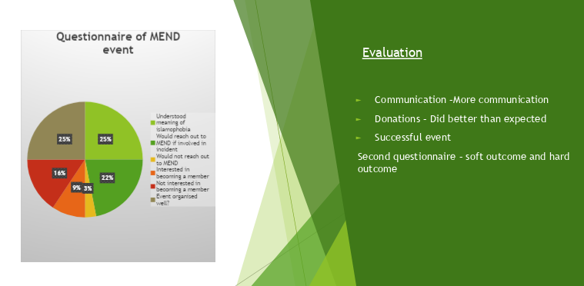

SWOT: MEND
MEND, (2019) SWOT Analysis shows their biggest Weakness is not known by the community, about the organisation and their Awareness that how to respond to Islamophobia. MEND seeks to empower British Muslims to be more keenly involved in media and politics, but British Muslims have remained downgraded in public, their participation are tremendously low.
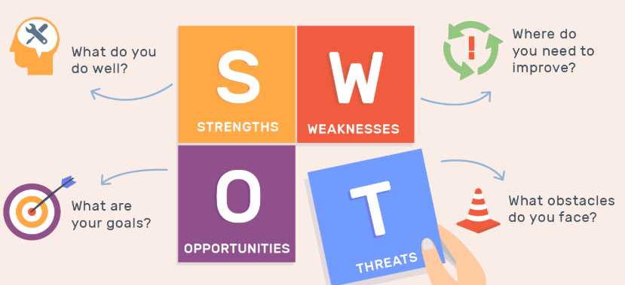
Hence fore, by doing this Awareness Workshop, the organisation will be recognised by the community and more Muslims getting engaged to the statistic there are people out there to tackle Islamophobia, not to suffer which will then be a critical step towards supporting the organisation.
PESTAL: MEND
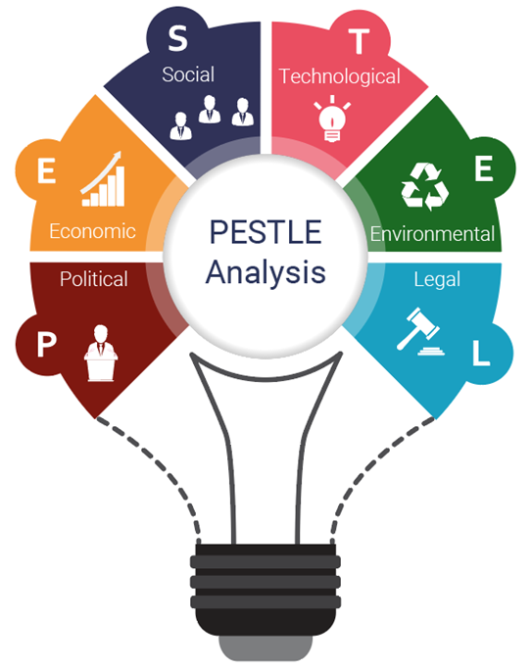
According to CIPD, (2018) PESTAL Analyst used by Marketers, to study and monitor the external environment factor in the market, that what’s impacting the organisation or their performance. By looking over the organisations political factors, it shows how much influence the organisation has from outside, the external facts that what’s impacting the organisation and manipulating decision making. MEND (2018) have contributed to Government legislation changes, were there have been discrimination of Islamophobia and Newspapers headlines on Anti-Semitism. By monitoring on Islamophobia continuously across the nation and working with the local council and Police, will help to bring the fight against Islamophobia to the political legislation area. Also, encouraging British Muslims to participate more effectively with political and media institution to play a greater role in Society and British politics by gaining confidence, capability and awareness within them.

RECOMMENDATIO

According to Asana, (2019) to stay on top Project goals and progress. Trying Asana for free for thirty days will:
- Collaboration software built for any projects.
- Workflows & Goals.
- Gantt Chart for Planning Project.
- Cross Team collaboration & Streamline Communication.
Available at: https://www.asana.com




CONCLUSION



Gibb’s, (1988) Reflective Cycle is a structure to learn from individual experience.
Description
Project organiser UWTSD, has given the opportunity to work as a group for an arranged organisation MEND. The organisation was never heard or seen by any of the group members before. It’s a company that raises Awareness for Islamophobia.
Feelings
It sounded very interesting and exciting, as it was the first project coming across and no previous experience. It’s going to be a complete new practice, something that can be learnt from and making awareness. Also, the organisation itself built on the community and the background were all the group members have come from, which will make the project attentive and certainly broaden the knowledge of individual. In regards to reaction, a positive action needs to be taken towards the project.
Evaluation
All group member’s contribution was excellent, each member’s activities, tasks and researches fulfilled according to the plan. The time limitation was very less, and lots needed to be undertaken on the project in a short time such as, organising the event, presentation, invitation, collecting resources and materials. Which sometimes made the team very pressurised and work overloaded. If there were a good time scale than the project would’ve been far better and less stress over it. The commitment for group meetings was difficult at times, as each members have their own personal circumstances, but again because of short time and the event was still taking place everyone managed to gather up to collaborate.
Analysis
This project has given direction to depth learning, it has taught how to do appropriate research, how to communicate with unfamiliar individuals and getting to know them. It was easy access through WhatsApp to connect with the organisation to arrange meetings. It felt very professional and not at any point felt let down, part from some slow responses when communicating.
Conclusion
From the overall experience it was a great project undertaken in limited time scale. The Awareness about Islamophobia expressed from the organisation MEND, was a great result for the Muslim community to be aware about. This has influenced and expanded the knowledge. The confidence has built up during the period of working with the organisation, which has encouraged to walk out free of fear to tackle Islamophobia when need to be. Also, spreading the information to others with the experience gained from the organisation will benefit the people suffering in silent. For future plan, it will be necessary to communicate with the organisations constantly, giving enough time to distribute the Workshop and in a better place, where there will be more Audience and public views for instance, University Campus or may be Streets.
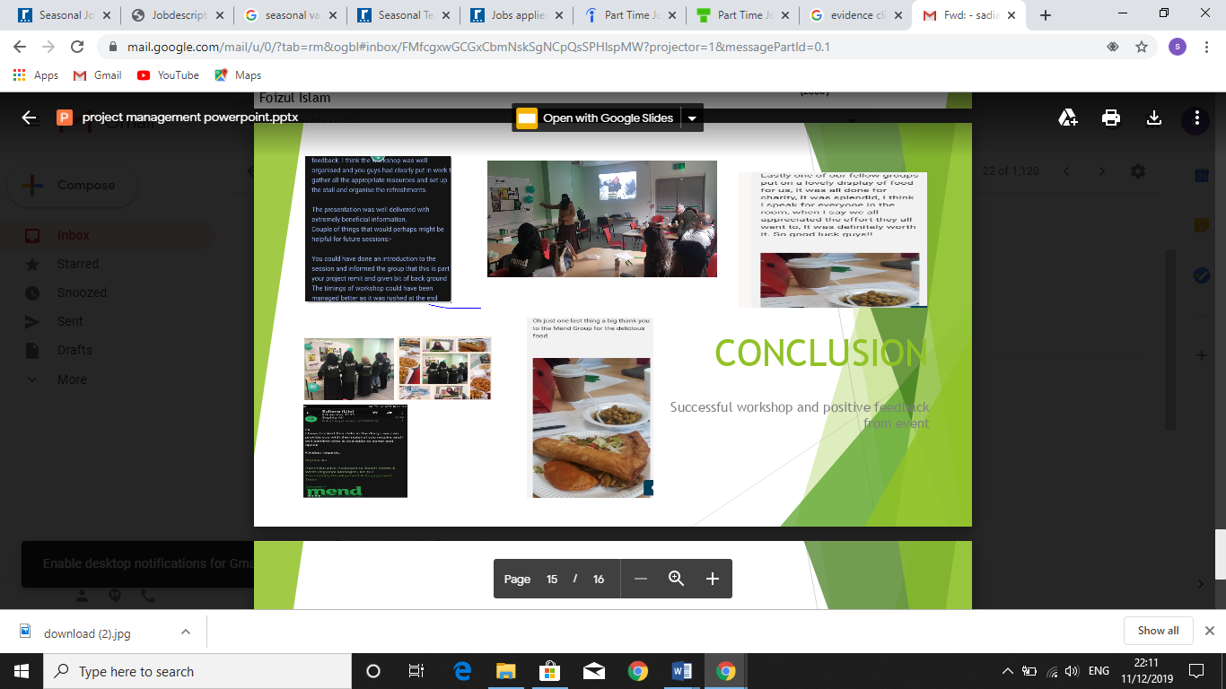

References

APM, (2019), ‘What is a Gantt Chart?’, ‘[Online] Available at: https://www.apm.org.uk [Accessed 4th December 2019].
Asana, (2019), ‘Project Planning Software for Teams’, [online] Available at: https://www.asana.com [Accessed 12th December 2019].
Aston, B. (2016), ‘Project Management Life Cycle: The Complete Guide’, [Online] Available at: https://www.thedigitalprojectmanager.com [Accessed 3rd December 2019].
Belbin, R. M. (1981), Managing Teams – Why They Succeed or Fail, London: Heinemann
CIPD, (2018), ‘PESTLE ANALYSIS’, [Online] Available at: https://www.cipd.com [Accessed 13th December 2019].
CRITICAL TOOL, (2016), ‘WBS Schedule Pro’, [Online] Available at: https://www.criticaltools.com [Accessed 9th December 2019].
Gibbs, G. (1988), ‘Gibbs Reflective Cycle’, [Online] Available at: https://www.ed.ac.uk [Accessed 11th December 2019].
KnowledgeHut, (2017), ‘How Important Is Project Monitoring And How Do We Implement It Through A1?’ [Online] Available at: https://www.knowledgehut..com [Accessed 10th December 2019].
Lavanya, N. (2008), ‘Risk Analysis and Management’, [Online] Available at: https://www.pmi.org [Accessed 9th December 2019].
PMI, (2019), ‘A Questionnaire on Project Management for use in Manager Introduction and Training’, [Online] Available at: https://www.pmi.org [Accessed 8th December 2019].
PMI, (2019), ‘What is Project Management?’ [Online] Available at: https://www.pmi.org [Accessed 25th November 2019].
ProductPlan, (2019), ‘What is Stakeholder Analysis?’ [Online] Available at: https://www.productplan.com [Accessed 1st December 2019].
Quora, (2018), ‘What is a Quad Chart?’ [Online] Available at: https://www.quora.com [Accessed 5th December 2019].
Sport & Dev, (2019), ‘Why is Monitoring and Evaluation Important?’ [Online] Available at: https://www.sportanddev.org [Accessed 5th December 2019].
Study.com, (2003), ‘What is a Pie Chart?’ [Online] Available at: https://www.study.com [Accessed 27th November 2019].

Study.com, (2019), ‘Iron Triangle of Project Management’, [Online] Available at: https://www.study.com [Accessed 9th December 2019].
Thompson, R. (2019), ‘Stakeholder Analysis’, [Online] Available at: https://www.mindtools.com [Accessed 30th November 2019].

