3/24/2025
University of Wales Trinity Saint David
London campus
E-Portfolio Link: https://sites.google.com/view/yahyasugallearningjourney/home?authuser=1

Module Name: Learning In the Digital Era
Module Code: ACCA 4025

Student Name: Yahya Sugal Jama
Student ID: 253258
Group: 1

Lecturer’s Name: Koushik Modak

LDE Assignment 1
E-Portfolio
Table of Contents
Introduction 2
Main Body 2
Task 1: Essential Academic and Employment Skills for the Future Career Path 2
Task 1 (a): Report on Essential Academic and Employment Skills 2
Task 1 (b): Evaluation of Task 1 (a) based on the Similarity report 2
Task 2: Collaborative Mind Map and Individual Poster 2
Mind Map (Collaborative) 2
Poster (Individual) 2
Task 3: Virtual Collaboration and RefWorks 2
Report on Virtual Collaboration 2
Step-by-step process of using RefWorks with visuals 2
Task 4: E-Portfolio Creation and Evaluation 2
Task 4 (a): E-Portfolio Creation 2
Task 4 (b): Illustrative Review of E-Portfolio Tool Selection 2
Conclusion 2
References 2
Task 1 References: 2
Task 3 References: 2

Introduction
My Name is Yahya Sugal Jama. At the moment, I am studying Information Technology, as I have an interest in furthering a career in Cybersecurity. One of the reasons for this is that many challenges arise when tackling IT equipment, whether that be software, malware or hardware issues. This fits my ethos, as I am motivated by the obstacle of protecting data, systems and people in the digital era.

Main Body
TASK 1A
Essential Academic and Employment Skills for a Career in Information Technology
To work successfully in Information Technology, one requires more than just technical ability. While knowledge of programming, networking, and cybersecurity is essential, many employers value a much broader range of professional skills. They value commitment, problem-solving and working as a team. These values are what differentiate others from just being technical and become truly effective IT professionals. There is no doubt that employers look for individuals who can communicate and who can adapt to changing environments. Furthermore, the ability to demonstrate initiative when facing many different predicaments is highly advantageous.
As stated by the Open University, “Employability skills are the skills almost everyone needs to do almost any job” [1]. This shows that IT graduates should combine their technical skills with transferable skills to remain competitive. This also shows that your capacity goes beyond others in terms of your commitment to staying competitive.
Ultimately, taking a career in Computer Technology is going to be built on a combination of balanced efficiency and technical proficiency, as well as essential employability.
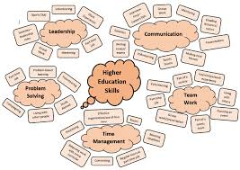
FIGURE 1: Several skills for Higher Education [2]
The skills depicted in the photo above will all be transferable to a career or job of your choice. Problem-solving, communication and teamwork are all essential skills in a workplace. These are also fundamentals to any work environment you work in.
ACADEMIC SKILLS
Academic skills form the foundation of Information Technology (IT). Through progressive studying, students develop certain independent research abilities, such as time management, structured analysis and critical thinking.
Cotrell states, “effective learning requires active engagement, critical thinking and reflection” [3],This highlights the importance of intellectual discipline in higher education. In IT, these skills are applied when developing and debugging code, analysing cybersecurity threats, or evaluating different system designs. These competencies not only enhance academic performance but also prepare you to be ready as a student when approaching real-world IT challenges in systems and the profession.
EMPLOYMENT SKILLS
Employment skills and academic skills complement each other and are both essential for long-term success in the IT industry. As stated by Menz, he argues that “ the integration of academic skills and employability enhances graduate adaptability and professional performance”. [4] this reinforcing the solid connection between university learning and professional learning.

References

[1] | T. o. University, “Employability skills,” Open University, London, UK, 2025.
[2] | Division of Communications, “The University of Manchester,” Marketing and Student Recruitment, Manchester, 2019.
[3] | S. Cottrell, The Study Skills Handbook, London, UK: Red Globe Press, 2019.
[4] | M. Menz, “Integrating academic skills and employability,” Applied Academic Practice, London, 2019.

Task 1b
Evaluation of my work
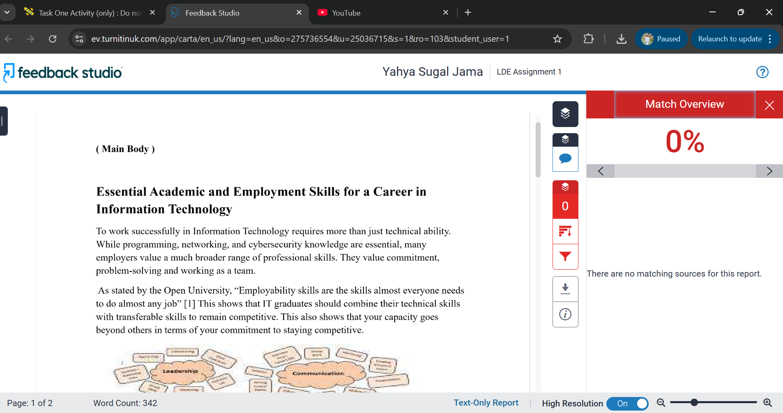
My work is unique and not plagiarised, as evidenced by my Turnitin report’s 0% similarity score. This proves that I followed academic standards and maintained the integrity of my work. It also demonstrates that I stayed away from depending too much on outside sources. Even when paraphrasing, I ensure I continue to use reliable sources and cite them properly. I should focus on refining my academic referencing in my next work and incorporating more evidence to support my arguments while maintaining uniqueness.
For this section of work, I would give myself a grade between 75 per cent and 80 per cent. The reason is that I have demonstrated a strong understanding of the topic and have proven a solid grasp of the subject. I have maintained academic integrity with my results and similarity score, and I have articulated succinctly in my own words. I have tried to continuously use relevant sources where necessary. I am conscious that there is still room for improvement, particularly in terms of strengthening my references and providing more substantial evidence; there’s always room for growth.
Task 2 A- Mind Mapping
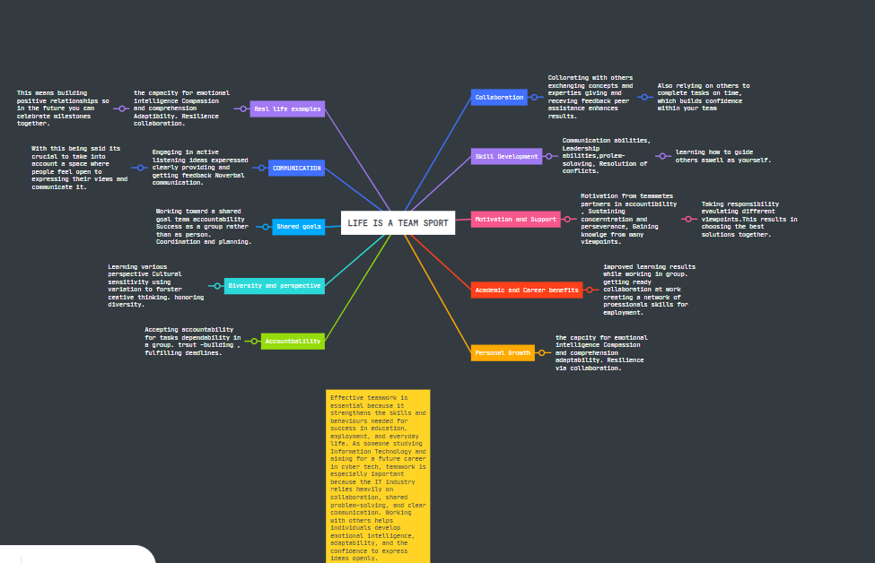
FIGURE: MINDMAP
WEBSITE LINK: https://mm.tt/map/3973198152?t=6ZgKt2WcRB

Working effectively and achieving shared goals depends on a couple of factors, which we will go through a couple of together. Everyone will be able to stay accountable and know what they are doing if roles and responsibilities are clearly defined. Team members will and can exchange ideas and prevent misunderstandings when there is strong communication, which includes active listening and clear messaging. Setting priorities and adhering to deadlines are examples of effective management that maintain team organisation and productivity.
This is a benefit because team members feel free to contribute and offer criticism in a setting brought up by trust and respect among one another. These differences enable us to resolve issues and come to an agreement when we are in union, with good leadership directing the group in the proper direction, which facilitates decision-making. Lastly, everyone can stay in touch and collaborate effectively by using tools like Microsoft Teams or Google Docs.

TASK 2B- INDIVIDUAL POSTER
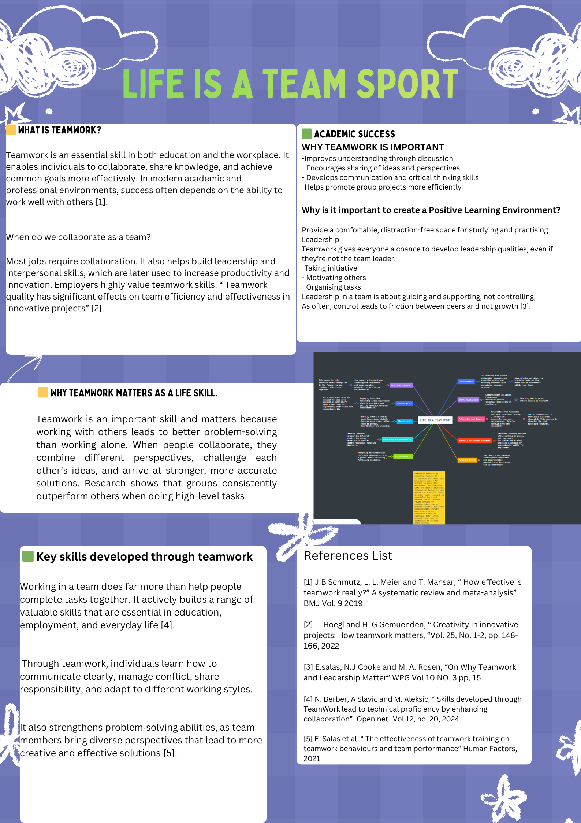
FIGURE: POSTER

POSTER LINK: https://canva.link/j49tjx3m06t5mta

Task 3 – Automatic Referencing Tool
Topic 2: Riding The Storm – Conflict In Virtual Teams

As teams increasingly operate remotely across different time zones and locations, virtual collaboration has become a crucial component of contemporary organisations. Constant changes in the digital world help speed up that process, as you may know its become vital for us to adapt to these changes, and virtual teams aid us in the transition. Although virtual teams offer flexibility and access to talent from around the world, they can also face challenges such as misunderstanding, misconception and miscommunication, which can lead to conflict among team members. There are many causes of conflict in virtual teams, including barriers, cultural differences, and a lack of in-person interaction.
The Lack of nonverbal communication is one of the primary reasons for conflict in virtual teams. Body language, facial expressions and tone of voice aid in accurate message interpretation in conventional face-to-face settings. However, these cues are absent from virtual communication methods such as email and instant messaging, which can lead to miscommunication or misinterpretation.[1] Team members may therefore interpret remarks as critical or unfavourable since this was not the sender’s intention.
Cultural diversity is a significant contributing factor to conflict in virtual teams. People from various nations and cultural backgrounds often form virtual teams. “Teams members should respect the differences in communication styles, expectations, and attitudes toward hierarchy, as it can lead to conflict”[2]For instance, “while direct communication may be valued in some cultures, indirect or courteous communication may be preferred in others.” [3]Another prevalent problem in virtual teams is conflict avoidance. The reason being people are uncomfortable talking about issues online or worry about straining their relationships with co-workers they don’t often see in person, team members. To ease that tension, we can use video meetings and regular check-ins to help strengthen relationships and reduce misunderstandings. For the team to continue its growth important to have these measurements in place as this harbours a positive environment and trust among peers.

In whole, conflict is a necessary component of teamwork, but virtual teams must handle it quickly and effectively. “Organisations can maintain the effectiveness and success of virtual collaboration by encouraging clear communication, cultural sensitivity and proactive conflict resolution.”[4]
In conclusion, while conflict can be an inherent part of teamwork, members need to develop and enhance strategies that ensure open communication, a sense of fairness, and ultimately understanding. This proactive stance or approach makes sure to consider all aspects of the workplace are considered and contribute to the success of the work.
Task 3b: Step-by-Step process of using RefWorks

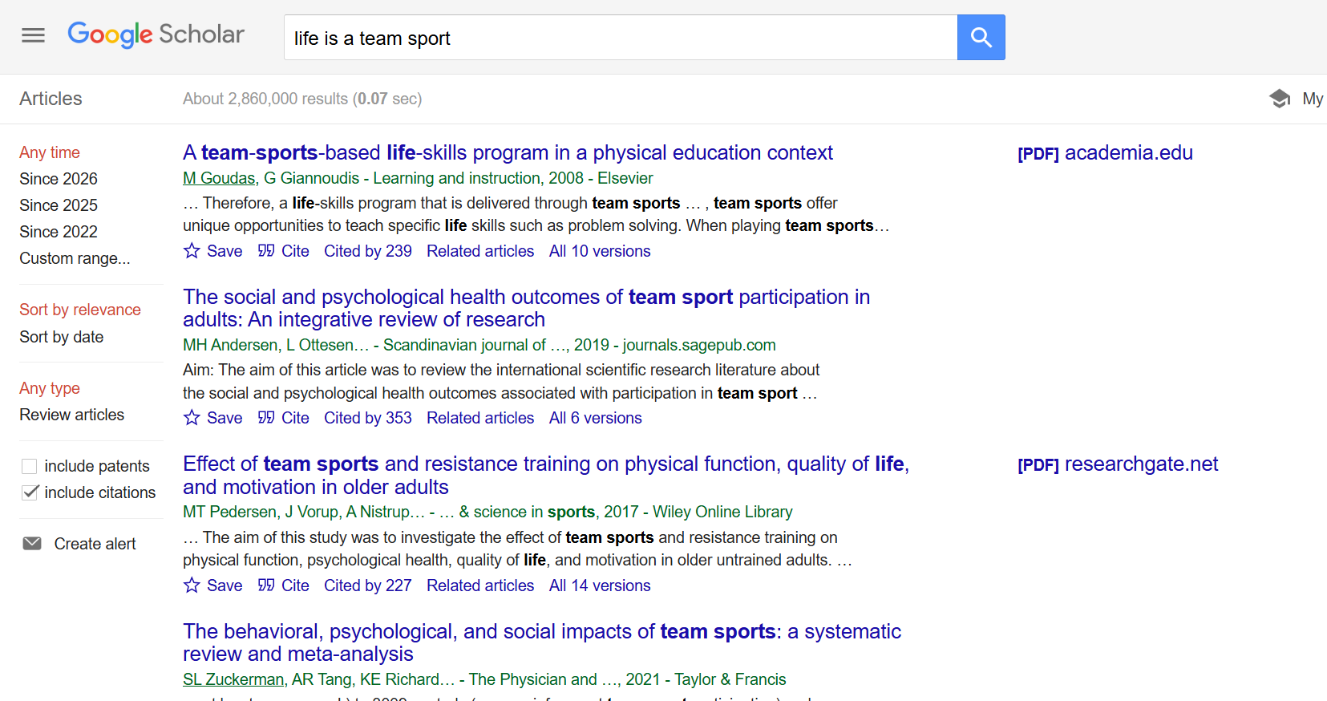
STEP 1 – I started by searching for articles on Google Scholar using the keywords “ Life is a team sport”, as shown in the screenshot above.

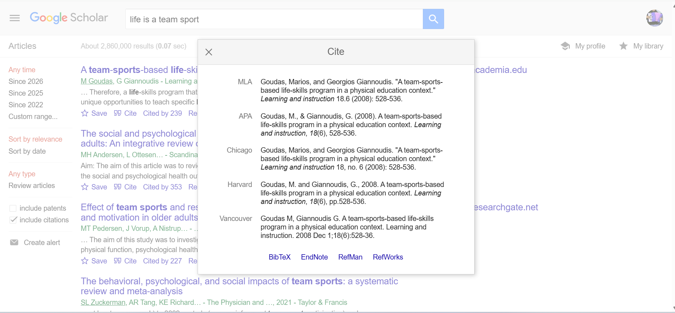
STEP 2 - After using the “Cite” Function in Google Scholar, I generate references in different formats, such as APA or IEEE. After I click on RefWorks, an option to export will appear.

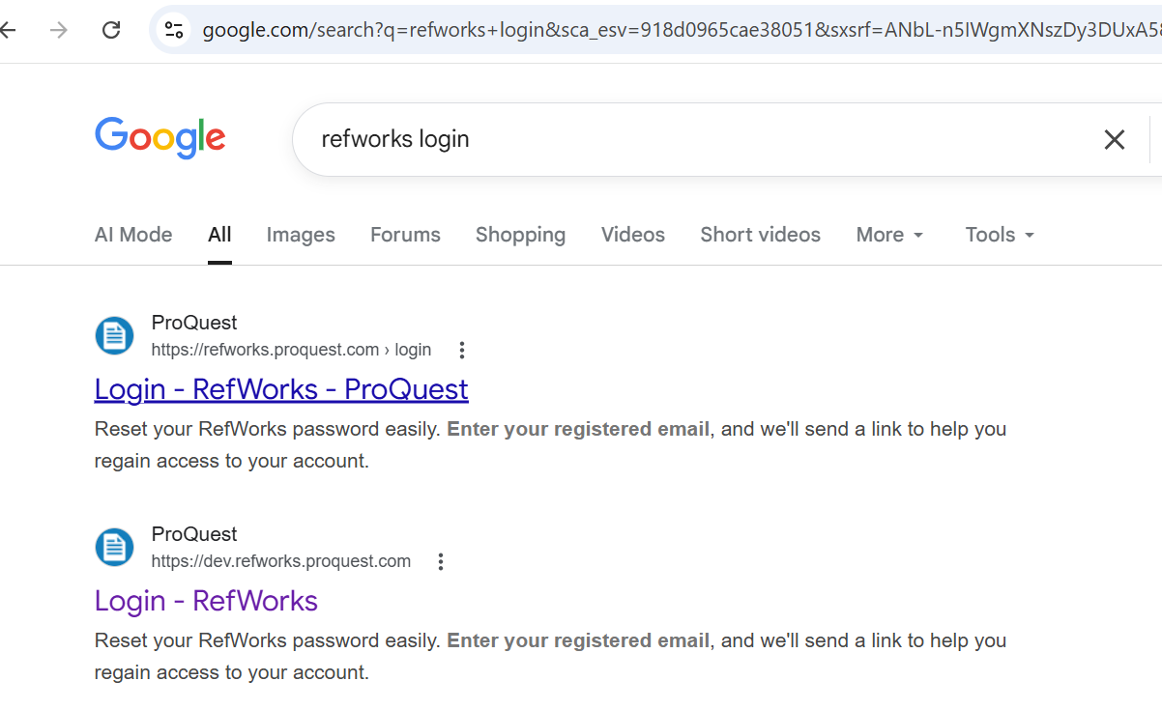
Step 3- After the second step is completed, you will need to search RefWorks using a browser such as Google. Where you will access the content you have just cited.

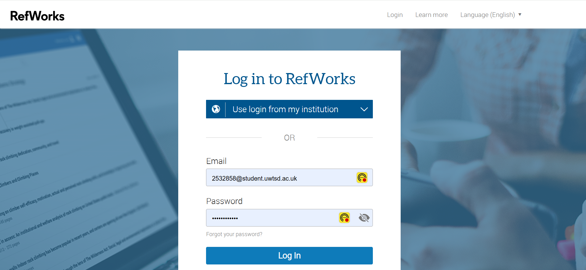
STEP 4 – After selecting the export option, I then create an account and log in to RefWorks using my institutional account.
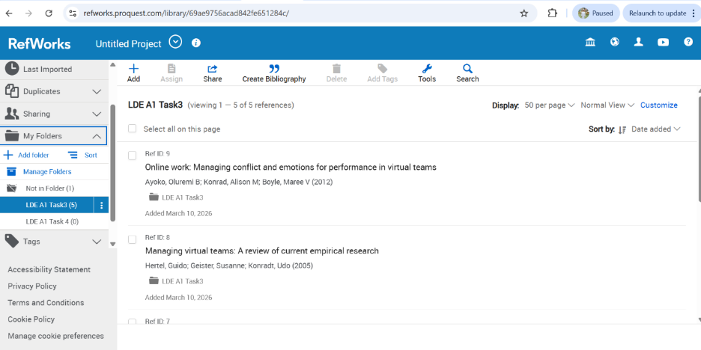
STEP 5 – I created 3 different folders, each one labelled, and you can also see the references added when you export.
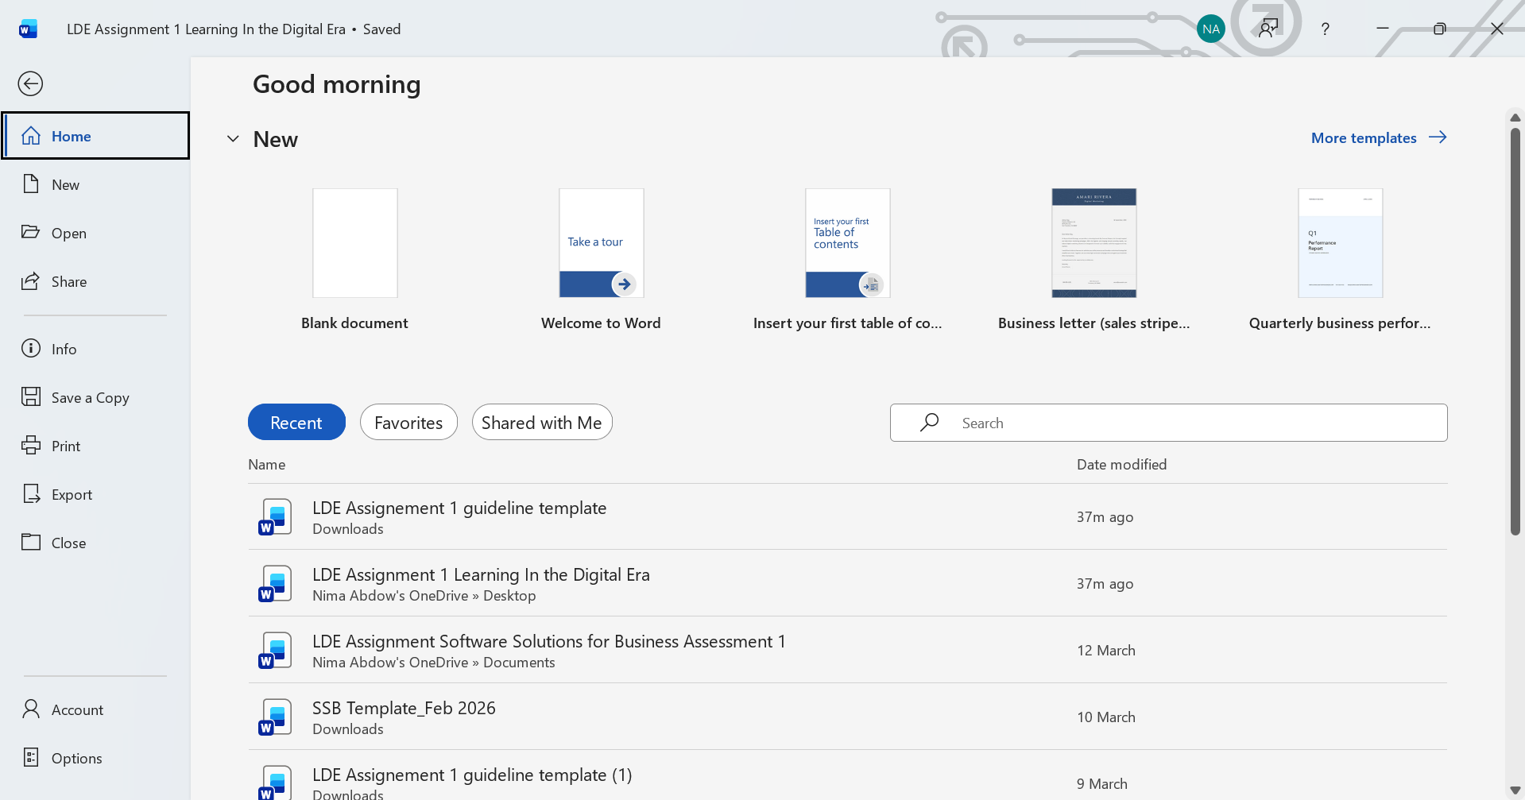
Step 6 - Now open the Word document and open the assignment I am working on. LDE A1, which is open already.

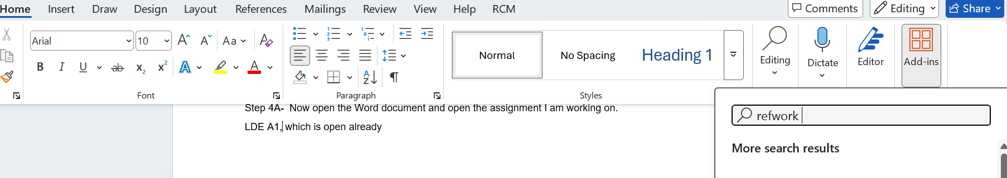

STEP 7 – In the top left-hand corner, click on Home, then select Add-ins on the far right and search RefWorks. The RefWorks app/ Citation manager panel will appear.
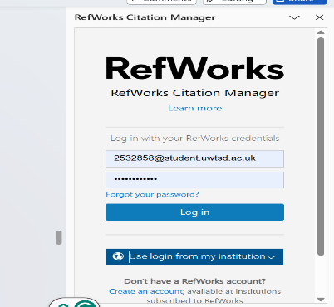
STEP 8- Once the Citation Manager panel is open, log in to RefWorks using your University Credentials.
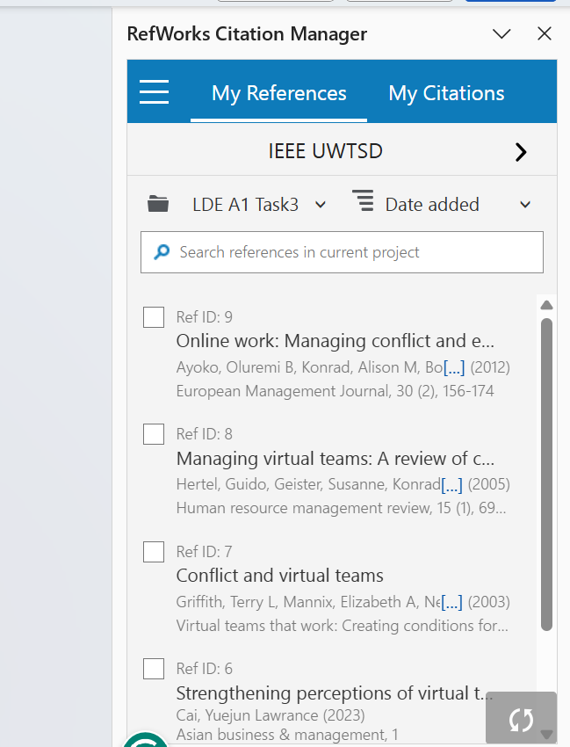
STEP 9 – This is the homepage of RefWorks Citation Manager; it displays all the current references and folders I have created. This shows the tool has been added successfully and is ready to use.
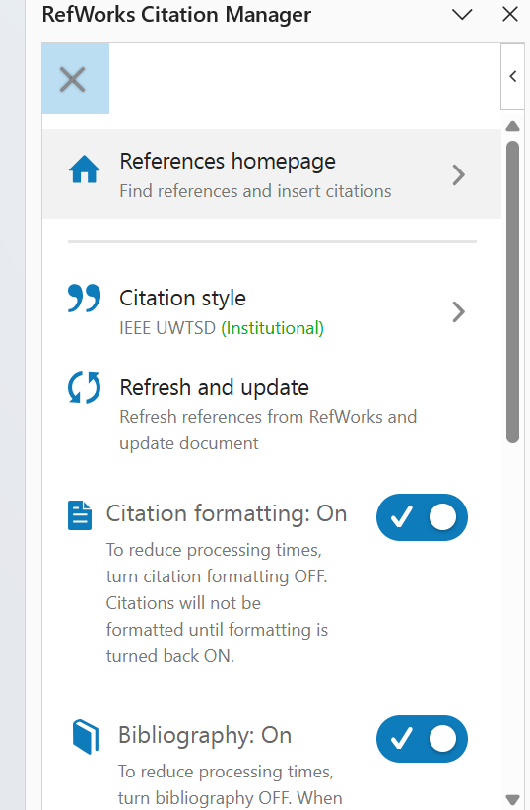
STEP 10 – This step is important; select the top three bullet points at the top of the page next to where it says references. As you need to make sure to have the correct university standard style, which is IEEE. Once this step is done, you can continue to the next one.
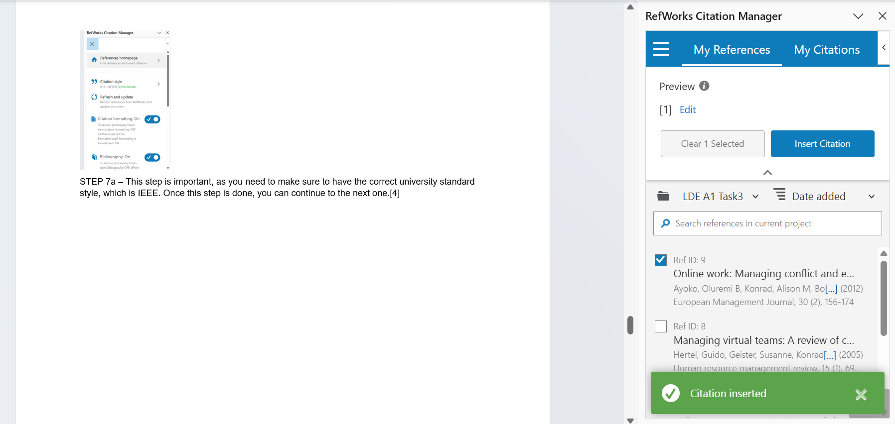
STEP 11 - Now, once you have completed changing the style, you can click off it, and you will be bought back to the home citation page. Select the reference you want to use, specifically in this example, the top one was selected. As you can see, the citation was inserted successfully using the RefWorks tool.

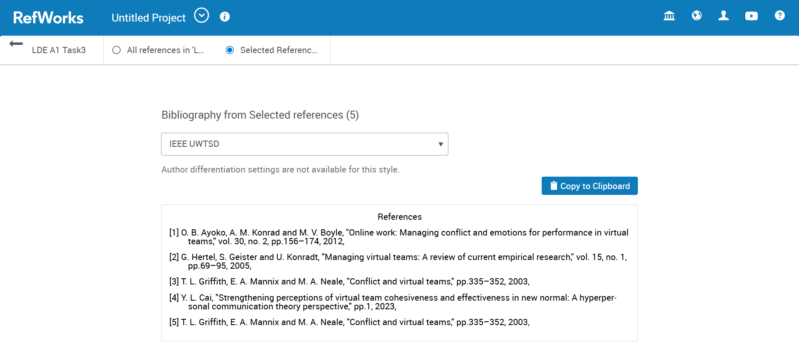
Step 12- Copying and inserting your final reference list, RefWorks will generate your bibliography in the correct IEEE UWTSD style, and then we transfer it to your Word document.
References
[1] T. L. Griffith, E. A. Mannix and M. A. Neale, "Conflict and virtual teams," pp.335–352, 2003,
[2] Y. L. Cai, "Strengthening perceptions of virtual team cohesiveness and effectiveness in the new normal: A hyperpersonal communication theory perspective," pp.1, 2023,
[3] G. Hertel, S. Geister and U. Konradt, "Managing virtual teams: A review of current empirical research," vol. 15, no. 1, pp.69–95, 2005,
[4] O. B. Ayoko, A. M. Konrad and M. V. Boyle, "Online work: Managing conflict and emotions for performance in virtual teams," vol. 30, no. 2, pp.156–174, 2012.
TASK 4A E-Portfolio Creation
For this task, I chose Google Sites as the platform of choice to create my e-portfolio. This was an easy decision to make because it is simple to use and has an intuitive interface that enabled me to create this website without any prior coding experience. Additionally, it is a free platform that facilitates many tools and functions that benefit users significantly, allowing for effective editing and the development of the content produced.

Task 4B Illustrative Review
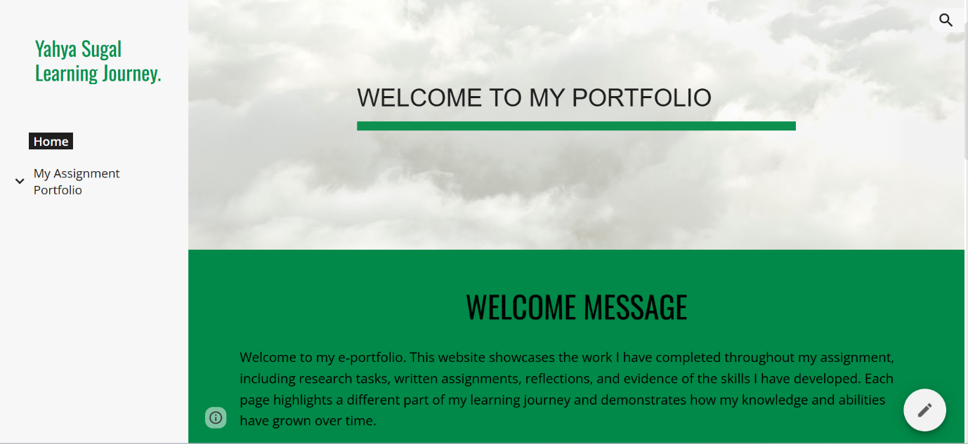
Figure 1- Home Page

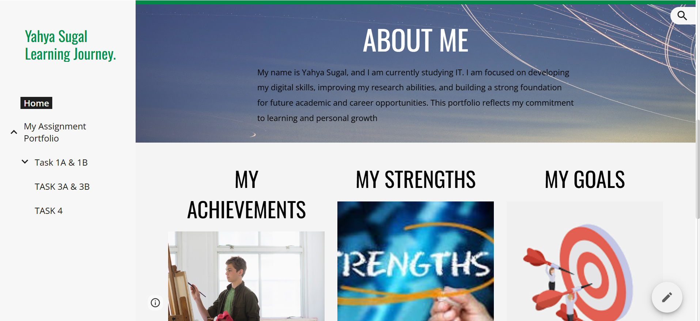
Figure 2 – About Me

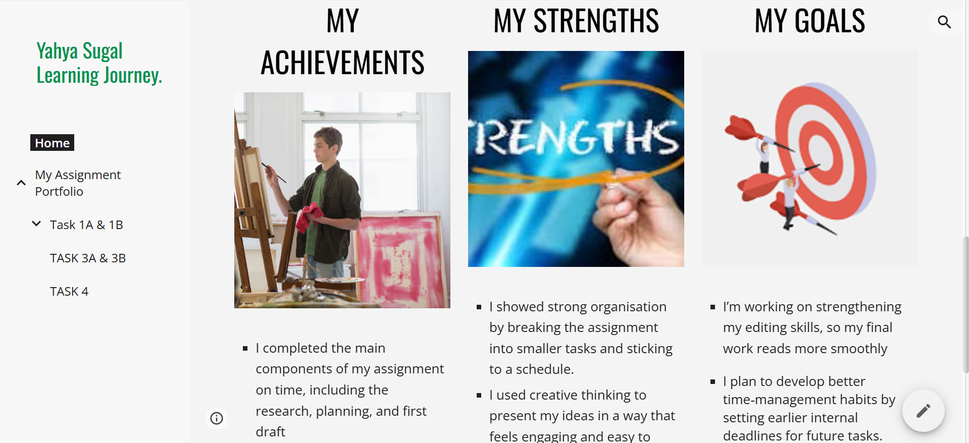
Figure 3 – Strengths & Goals
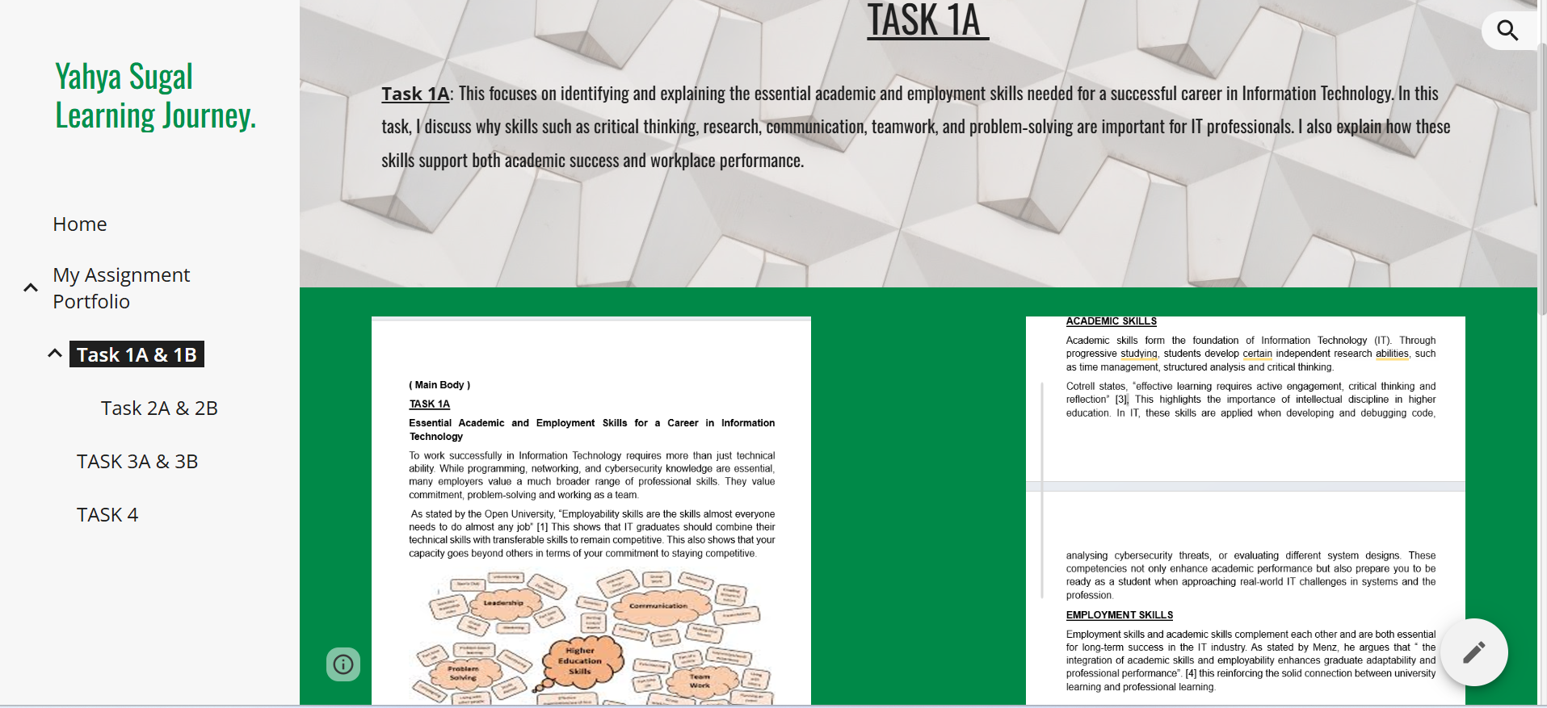
Figure 4 - Task 1a
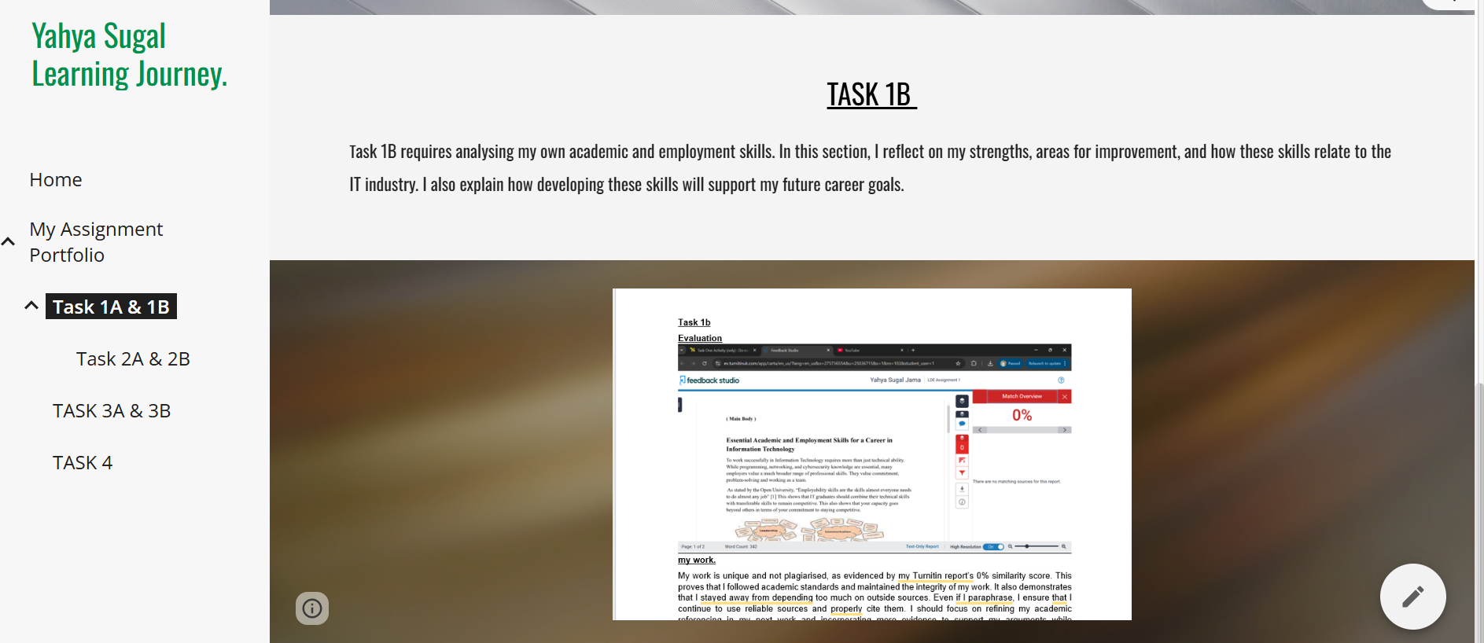Figure 5- Task 1B
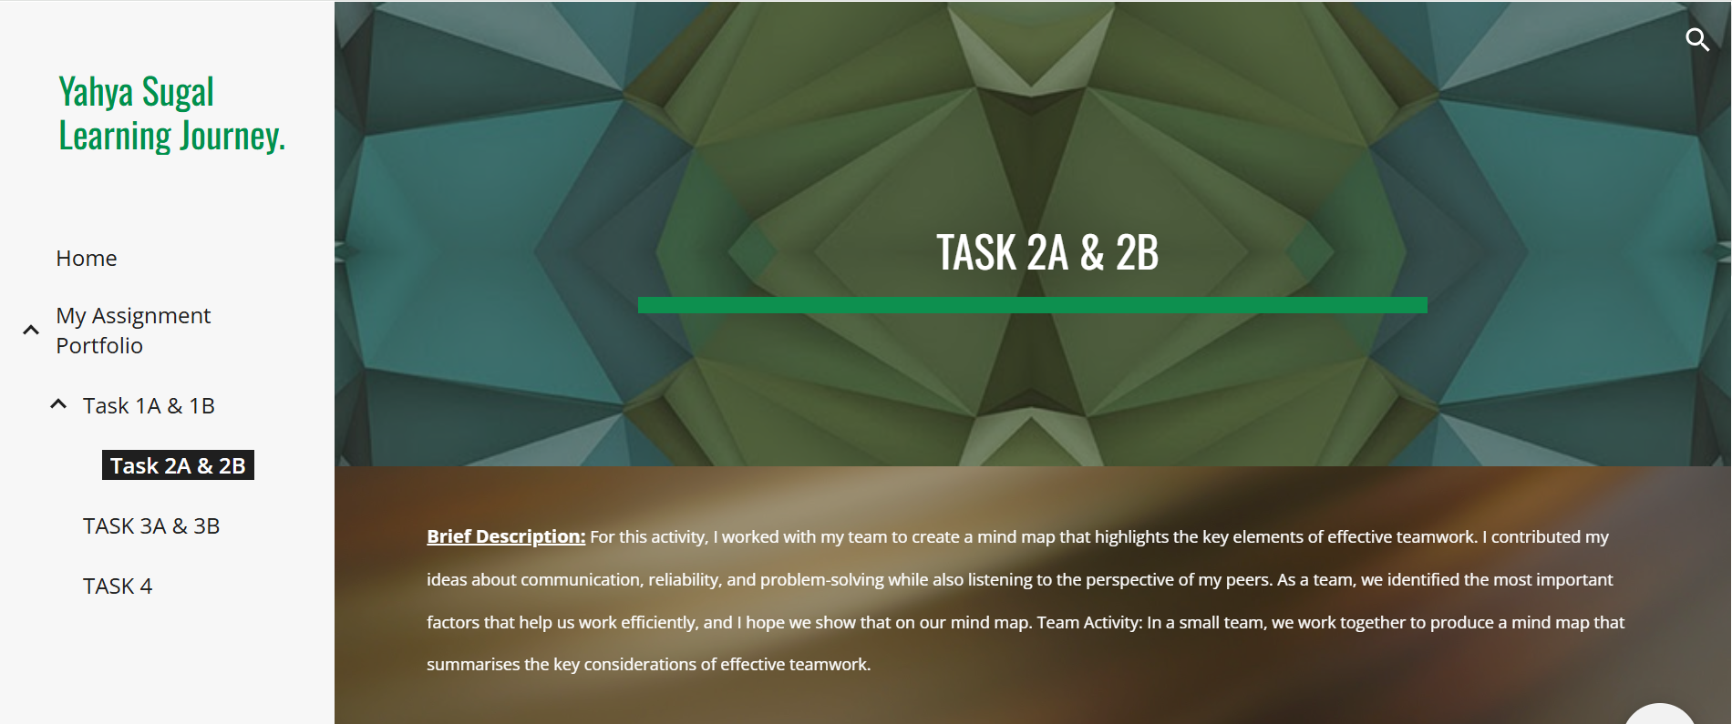
Figure 6- Task 2A and 2B

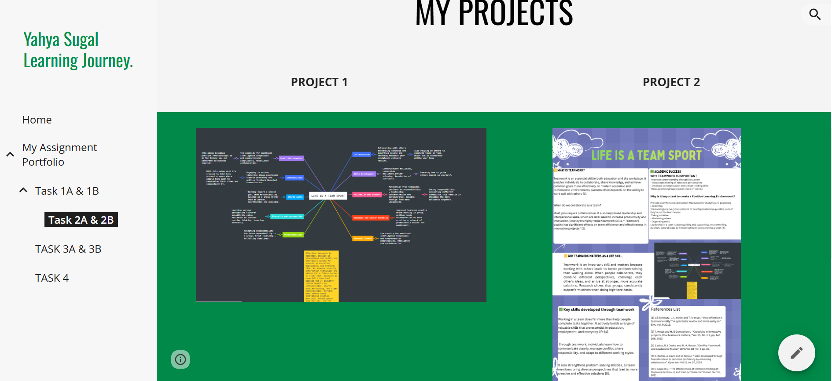
Figure 7 – Mind-Map and My Poster
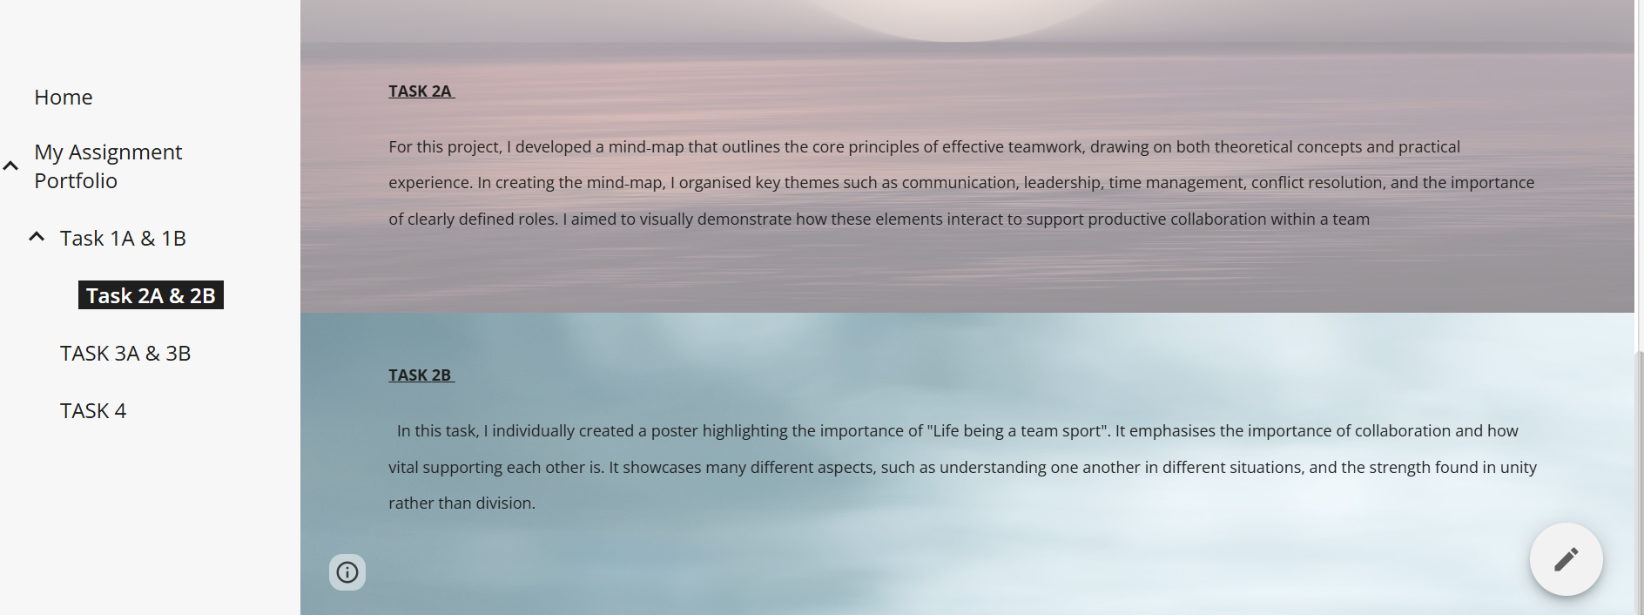
Figure 8 – Breakdown of Each Task
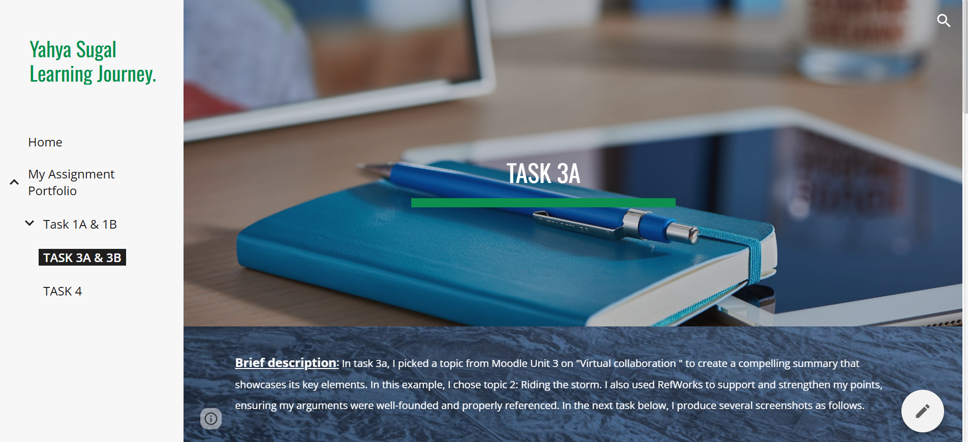
Figure 9- Task 3A Brief Description.

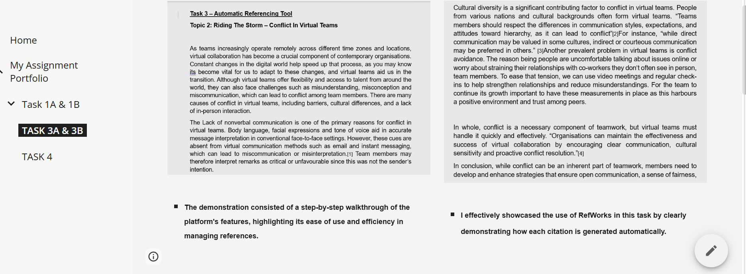

Figure 10- Topic 2 Automatic References Tool use
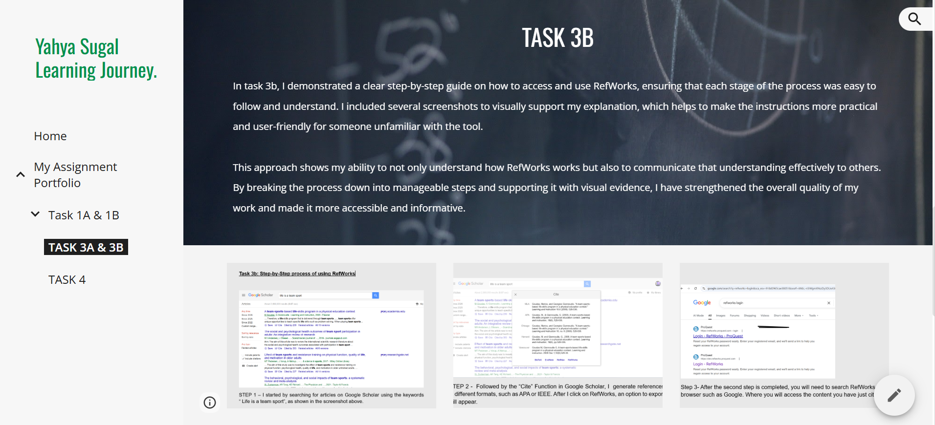
Figure 11- Task 3B Description,
including the first three steps as screenshots
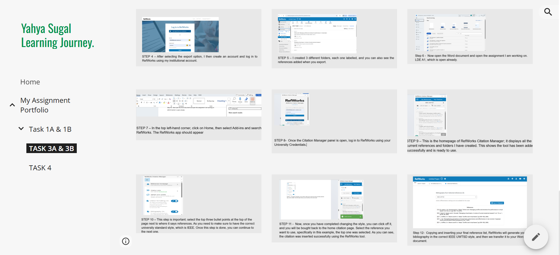
Figure 12- Screenshots of the remaining steps, starting from step 4 to step 12
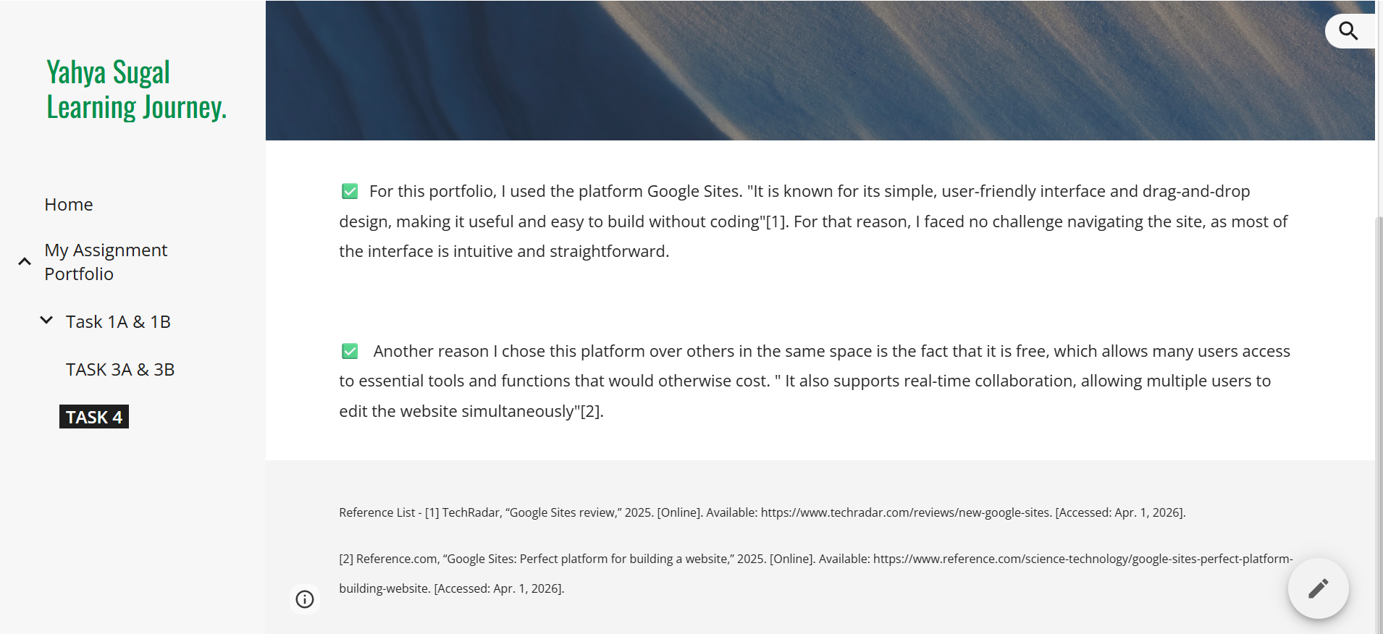
Figure 13- Summary of Task 4

Conclusion
In summary, this assignment required the successful creation of an e-portfolio. Using Google Sites to showcase the capacity to effectively develop and arrange digital information. The platform’s creative features, accessibility, and ease of use made it appropriate for a solid design process.
I took several screenshots to offer clear evidence of the completed e-portfolio’s structure. Taking all things into consideration, this assignment emphasises how important it is to employ the appropriate tools and use technical skills and digital media to produce a polished and organised web portfolio.

