

Marketing Environment Analysis
“Marketing Environment Analysis and Strategic Growth for Tata Steel: Transitioning Towards a Lower-Carbon Business Mode”

Student Name: Harsh Dipak Kundaliya

Student ID: 2535226

Module Name: Marketing Management

Module Code: LCMB7024

Lecturer’s Name: Sinan He

Work Count: 2561

Term 1

Table of Contents
Task 1: Marketing Environment Analysis 3
1.1 Company Selection and Context 3
1.2 External Marketing Environment Actor 1-Natural Environment 3
1.3 External Marketing Environment Actor 2-Political and Regulatory Environment 6
Task 2: Strategic Growth and Competitive Positioning 7
2.1 Strategic Growth Recommendation Using the Ansoff Matrix 7
2.2 Competitive Advantage Through Lower-Carbon Business Model 9
Task 3: Critical Reflection on AI Usage 12
3.1 Tool Disclosure 12
3.2 Critical Evaluation of AI Output 12
References 14
Appendixes 17

Task 1: Marketing Environment Analysis

1.1 Company Selection and Context
Company Overview
Tata Steel, a Tata Group flagship, is one of India’s biggest integrated steel businesses. With over 100 years of experience in its industries and a global footprint that extends crossways India, Europe, South-east Asia and other nations. Tata Steel has over 35 million tonnes of crude steel per annum production capability and manufacture of several kinds of flat steel, long steel, automotive steel, civil engineering supplies, manufacturing substances, and value-added steel options that cater to the automotive, structural design, engineering, packaging and customer sector (Tatasteel.com, 2026).
Sustainability Context
As pressure on the environment increases, Tata Steel has already committed to becoming Net Zero on carbon by 2045 and are taking rapid strides towards creating a lower carbon approach to steel industrial by investment in renewable energy (Tatasteel.com, 2025). R&D on a new hydrogen technology for steel making, activities around circular economy, better steel recycling, responsible procurement of materials, integrated ESG procedures etc. Such sustainability commitments enhance the competitive ability of the business and address the demands of the consumers and customers and the world’s growing needs for sustainable steel (Miani, 2025).

1.2 External Marketing Environment Actor 1-Natural Environment
Tata Steel's external marketing environment consists of a number of actors and the natural environment is one of them that has a significant influence on the company's strategic choices.
Climate Change and the Transition to Lower-Carbon Steel: Climate change has a major impact on Tata Steel's marketing environment due to the increase in temperature, global warming and international commitments on climate change under the Paris Agreement. According to Dhurandhar (2025) found that Carbon neutrality is a key priority for the steel industry as it accounts for about 7-9% of global CO₂ emissions. Through cleaner production technologies and adopting renewable energy, Tata Steel is working towards becoming a Net Zero emission company by 2045 (Mir et al., 2025). Figure 1 shows that India remain the countries with the highest values. For the other countries, they tend to be under 0.7.
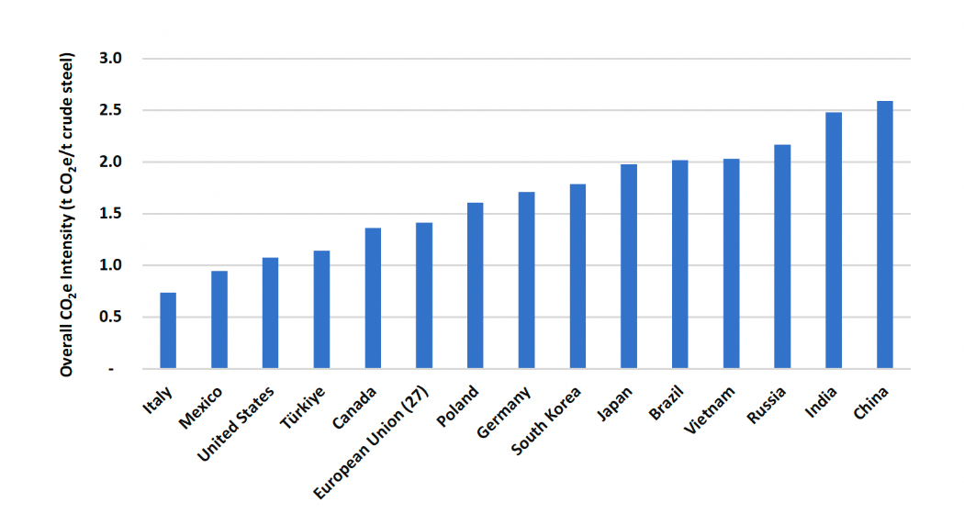
Figure 1: Global CO₂ Emissions from Steel Industry
(Source: Globalefficiencyintel.com, 2025)
Carbon Regulations and Sustainable Market Positioning: The carbon regulations are transforming Tata Steel's competitive landscape by promoting investments in cleaner manufacturing techniques (Sharma and Vij, 2024). Steel producers must cut emissions and increase transparency in the environment through the India's Carbon Credit Trading Scheme (CCTS) and the European Union's Carbon Border Adjustment Mechanism (CBAM) (Das, and Bandyopadhyay, 2025). Further, regulatory ESG disclosures create a sense of accountability towards investors and customers.
Resource Scarcity and Circular Economy Opportunities: The scarcity of resources poses operational and strategic problems for Tata Steel. The dependence on Iron Ore, Met-coal, Water and volatile energy prices, costs and supply chain risks become significant. However, raw material deficits are magnified by India’s consumption for finished steel which increased to 140 Mt in FY24 (Tatasteel.com, 2026). Thus, Tata steel is moving gradually towards greater requirement on recycled raw material input, greater utilization of scrap along with the investment into renewable segment, circular economy product lines that drives resource circularity (Mir et al., 2025). Moreover, these environmentally conscious business practices would go a long way in mitigating costs on account of climate impact and improve Tata Steel's long-term resilience and sustainability by a crucial competitive edge.
Biodiversity Protection and Corporate Reputation: Environmental stewardship has become a greater concern for Tata Steel given the impact of such mining operations can lead to biodiversity loss, land degradation, deforestation and water pollution. The company has embarked on land restoration programmes, biodiversity conservation programmes, responsible water management and environmental monitoring programmes in all operational sites (Souza Filho et al., 2021). The measures taken in terms of sustainability minimise ecological damage and improve relationships with local communities, governments and investors. The implementation of responsible environmental management helps elevate Tata Steel's corporate image, boost the trust of stakeholders, and promote ESG performance.
Consumer Demand for Sustainable Steel and Strategic Opportunities: Steel will be sought more and additional by the automotive, construction, substructure and renewable energy sectors to supply their climate targets. According to research conducted by Miani (2025), the green steel represents the main market for growth, with expected annual development charges greater than 75% in the next 10 years, and is thus a huge opportunity. Tata Steel has the option to seize this trend by providing guarantee for its lower-carbon products.
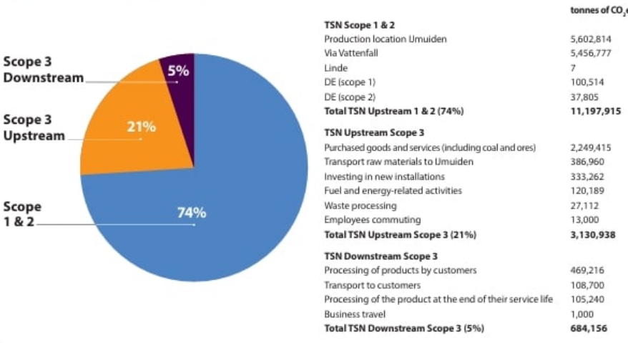
Figure 2: Tata Steel Climate Change
(Source: Saptakee 2024)

1.3 External Marketing Environment Actor 2-Political and Regulatory Environment
Justification for Selecting the Political and Regulatory Environment: The political & regulatory environment is chosen as it is a direct impact on Tata Steel's decarbonisation efforts. It is an external actor that influences investment strategies, market access, environmental compliance and sustainability policies, and is key to understanding the marketing environment of the company in the longer term and how it is competing.
Government Policies Supporting Sustainable Steel: Policies like the National Steel Policy 2017, National Green Hydrogen Mission and Make in India will encourage the transition toward clean industrial growth and domestic manufacturing (Souza Filho et al., 2022). The policies can further aid the transition for Tata Steel to low-carbon procedures, sustainable energy sources, innovation of hydrogen-based steel production and investments in production capacity that are sustainable and inexpensive.
International Trade Policies and Global Market Access: Tata Steel's export policy is greatly influenced by international trade policies. The European Union's Carbon Border Adjustment Mechanism (CBAM) will levy carbon costs on imports, and anti-dumping measures, as well as export laws, will affect the competitiveness of and prices for imports (Das, and Bandyopadhyay, 2025).
Environmental Regulations and Compliance Requirements: Tata Steel has to adhere to pollution control norms, environmental monitoring norms, and compulsory carbon reporting, as stipulated by the environment laws (Mallett et al., 2025). The regulatory requirements drive cleaner manufacturing processes, better transparency of the operations and investments in emission reduction technology, which helps the company achieve its sustainability goals and enhances the confidence of stakeholders and responsible corporate governance.
Opportunities Created by Political and Regulatory Factors: Opportunities are huge for Tata Steel with Government incentives, green financing programmes, technology partnerships and Industrial policy on sustainability (Lahri et al., 2025). These efforts enable exports to be more competitive, while also furthering the company's market presence in the emerging global green steel sector by investing in renewable energy, hydrogen-steel production, and advanced manufacturing technology.
Threats from Political and Regulatory Changes: Tata Steel is still plagued by regulatory issues, rising compliance costs, changing environmental regulations and trade restrictions from overseas (Kotler, 2024). Substantial capital investment and operational changes may be required in case there are frequent changes in the policies.

Task 2: Strategic Growth and Competitive Positioning

2.1 Strategic Growth Recommendation Using the Ansoff Matrix
The Ansoff Matrix is used to assess the strategic growth options of market penetration, market development, product development and diversification refer in figure 3. It helps Tata Steel make the best decisions on their lower carbon business transformation journey.
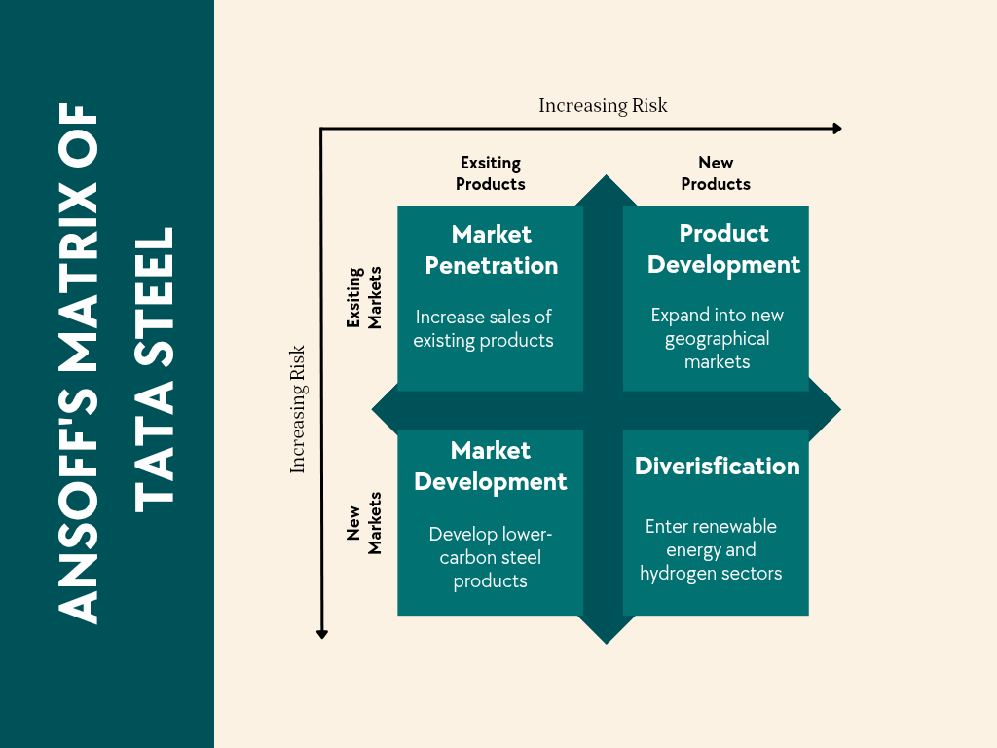
Figure 3: Ansoff Matrix
(Source: Self-created)
Market Penetration: Market penetration is the strategy that draws attention on the sales growth of Tata Steel products in the existing market, by developing customer relationship, enhancing sustainability brand and operational efficiency. India's total demand for steel reached 140 million tonnes in FY2024, offering potential to grow domestic demand (Tatasteel.com, 2026). The strategy has an advantage of having the distribution network, customer loyalty and lower investment level.
Market Development: Market development helps Tata Steel gain market access to new areas of the domestic market and to international markets for lower carbon steel products (Zhang et al., 2025). The demand for sustainable materials is increasing in Europe, Southeast Asia and renewable energy projects are significant export opportunities, and the global green steel market will grow at more than 25% CAGR (Tatasteel.com, 2025). International competitiveness is enhanced by complying with environmental standards like CBAM.
Product Development: Product development is the most suitable strategy as it addresses directly the Tata Steel's sustainability goals and positioning. Through their development of green steel, low carbon steel, hydrogen-based steel, recycled steel and smart steel products, the company is able to cater to the growing ESG expectations and support their Net Zero 2045 commitment (Dutta, 2025). This approach fosters innovation, builds a strong brand reputation, allows premium prices, meets the increasing demand of the automotive, infrastructure and renewable energy sectors and sets the basis for long-term sustainable growth and differentiation in the world market.
Diversification: Diversification requires investments in renewable energy generation, construction solutions, carbon management services and hydrogen infrastructure, etc. These programs help eliminate business risk for the long-term and generate additional revenues not from steel production (Jagnade et al., 2025). But diversification takes a lot of money, technical knowledge and time for implementation. The two should therefore be coupled but diversification should be used as a second measure to support Tata Steel's sustainability agenda.
Justification Product Development as the Most Appropriate Ansoff Strategy
Tata Steel is currently adopting a business model with lower carbon footprint, for which the most suitable option is the Product Development strategy in the Ansoff Matrix. The company is not just limited to the development of existing products or to entering other markets, it can build a competitive advantage by innovating green steel, low-carbon steel, hydrogen-based steel, recycled steel and smart steel products. This approach is going towards Tata Steel's goal of becoming Net Zero by 2045, differentiation of products, ability to meet premium pricing demands, fulfillment of increasing ESG demands and sustainable long-term growth prospects in domestic and global markets (Mir et al., 2025).

2.2 Competitive Advantage Through Lower-Carbon Business Model
The steel industry is one of the sectors that has gained a considerable competitive advantage through sustainability. The strategies offered by Porter’s generic strategies provide organizations the approach of acquiring competitive advantages either by being lowest cost producer in the market refer in figure 4.
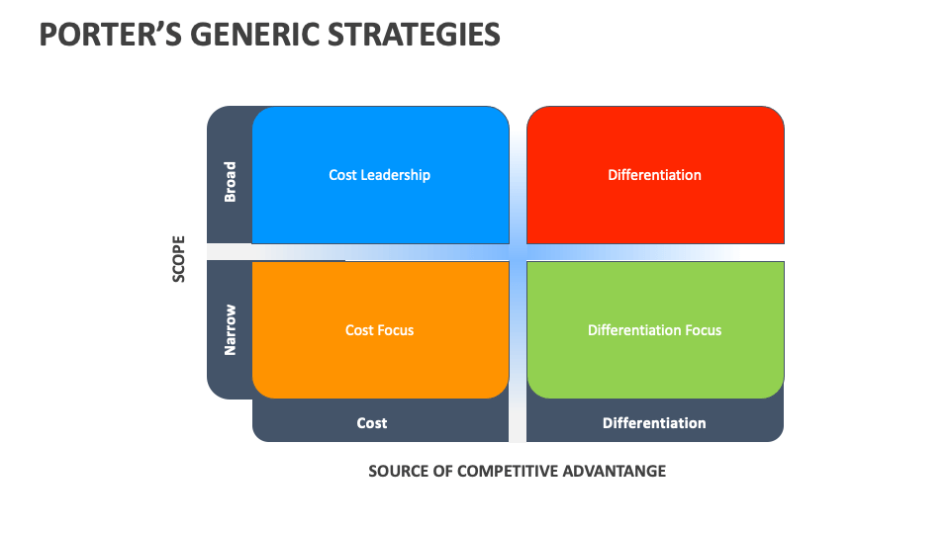
Figure 4: Porter's Generic Strategies
(Source: Collidu, 2025)
Cost Leadership: Cost Leadership - Tata Steel may achieve Cost Leadership by: Decreasing energy consumption; Starting and increasing the application of renewable energy; Digital Manufacturing and Automation; and; Reducing waste and employing Circular Economy Principles (Souza et al., 2025). Tata Steel seeks to growth efficiency and effectiveness in resource use while reducing carbon emissions and cost of production. By using renewable electricity, recycling scrap and streamlining procedures; the company may reduce dependency on fossil fuel that are attractive increasingly costly (Teixeira, 2025).
Differentiation: The most prominent competitive advantage for Tata Steel is differentiation which involves supplying the green steel, the low carbon steel and the expert sustainable materials to environmentally-conscious customer (Harpprecht et al., 2025). Considering the total outlook, the green steel market is likely to produce beyond 25% CAGR internationally and there is likely to be opportunity in premium products. Responsible sourcing and ESG performance reinforced by advanced and innovative technologies used for product development facilitate brand evenhandedness and customer relationship (Leuratti et al., 2025).
Focus Strategy: One of Tata Steel's focus strategies is to offer niche, lower carbon steel products to the growth industries, such as automotive, construction, renewable energy, infrastructure and electric vehicles. As governments and industries work towards ‘Net Zero' goals, there is rising demand for the use of sustainable materials (Souza et al., 2021). Personalized product solutions create customer value and enhance business relations in the long-term.
Competitive Advantages: These competitive advantages had accumulated over decades of successful operational performance and also due to Tata's robust global brand recognition. However, Tata's ability to innovate, stable long-term relationships with their customer base, existing partnerships with international corporations, governmental support, investment into ESG, as well as supply chain resilience (Zhang et al., 2025). These advantages provide assurance of success as Tata commits to net zero carbon emissions by 2045.
Real Industry Comparison
Tata Steel shows good strides towards a lower carbon business model when compared with ArcelorMittal, POSCO and SSAB, but is at various stages in making green steel (Tatasteel.com, 2026). SSAB has been leading the way with fossil-free steel produced with hydrogen-based technology, POSCO has been making substantial investments in hydrogen reduction processes and ArcelorMittal has already invested billions of dollars in decarbonisation and low carbon steel production across Europe.
Comparison Criteria | Tata Steel | ArcelorMittal | POSCO | SSAB
Hydrogen Steel | Research and pilot initiatives | Hydrogen-based DRI projects | HyREX hydrogen technology | Pioneer in fossil-free hydrogen steel
Green Steel Investment | Renewable energy and low-carbon steel investments | Multi-billion-dollar decarbonisation programmes | Large-scale green steel investment | Significant investment in fossil-free steel production
Carbon Reduction Target | Net Zero by 2045 | Net Zero by 2050 | Carbon neutrality by 2050 | Fossil-free steel production with Net Zero ambition
Market Positioning | Sustainable steel leader in India with expanding global presence | Global leader in low-carbon steel | Technology-driven green steel producer | Premium producer of fossil-free and sustainable steel
Table 1: Real Industry Comparison
(Source: Self-Created)

Task 3: Critical Reflection on AI Usage

3.1 Tool Disclosure
This report was assisted by the use of ChatGPT, Microsoft Copilot and Grammarly. AI tools, such as ChatGPT, were used to brainstorm ideas, structure the report, and provide initial marketing concept summarisations. Microsoft Copilot assisted in finding relevant literature and recent information in the industry, and Grammarly enhanced grammar, spelling, punctuation, and academic writing style. I also leveraged these tools to assist in reference checking and to clarify. But all content was to be reviewed, edited and improved before incorporating into final report, but I was responsible for that.

3.2 Critical Evaluation of AI Output
I realised that artificial intelligence driven material may include false or unverifiable information, so I checked all vital details prior to utilizing it. Statistics and facts regarding the subject were cross-checked in peer-reviewed academic journals, Tata Steel's annual and sustainability report, government publications and industry reports. If I encountered inaccuracies or possible AI hallucinations, I have made corrections (with reliable evidence). This verification process helped me to be more accurate, credible, and critical in my analysis of my marketing environment and to make sure that my conclusions were based upon trusted sources.

3.3 Contribution Analysis
The main role played by AI in the report was to offer structural suggestions, enhance grammar, format content, and suggest initial ideas for discussion. My role in the project was to choose the analytical frameworks, interpret the evidence, consider Tata Steel's marketing environment, make comparisons of industry competitors and make recommendations based on the Ansoff Matrix and Porter's Generic Strategies. I did the analysis of company reports and academic literature, synthesized the evidence and prepared the final conclusions myself. I have therefore used my own academic work in every aspect of critical thinking, evaluation and overall argumentation in this report.

3.4 Ethical and Professional Reflection
AI usage and using AI tools to help addition rather than replace my analysis. I was aware that AI might supply bias or inaccurate info so I had to review it for myself. Knowing that as a future marketer, that I should leverage the power of AI to increase productivity while also be ethical with the utilization, disapprovingly analyse and rely on evidence-based analysis to maintain integrity of the marketing suggestions. It is my belief that, in these examples AI should augment human competences rather than substitute. With the added analytics and guidelines provided by the humans, more fact-based decisions could be made and crucially it builds trustworthiness and confidence in the eyes of all stakeholders, as well as the professionalism skills that are predictable of practitioners working in sustainability.

References
Collidu (2025). Porter’s generic strategies. [online] Collidu.com. Available at: https://www.collidu.com/presentation-porters-generic-strategies [Accessed 21 July 2026].
Das, K. and Bandyopadhyay, K.R., (2025). Impact of carbon border adjustment mechanism (CBAM) on steel decarbonization in India: a multi-stakeholder perspective on ambition vs. equity: K. Das, KR Bandyopadhyay. International Environmental Agreements: Politics, Law and Economics, 25(2), pp.195-229.
Dhurandhar, A.P., (2025). High-Grade Ore in a Decarbonising World: Simandou, Green Steel and the Strategic Repositioning of India’s Iron Ore Sector. DOI: https://doi.org/10.51244/IJRSI.2025.12110142. [Accessed 21 July 2026].
Dutta, S.K., (2025). Towards an outcome-based approach in ESG reporting: sustainability drive of Tata Steel. IIM Ranchi journal of management studies, 4(2), pp.107-126.
Globalefficiencyintel.com (2025). Global efficiency intelligence. [online] Global Efficiency Intelligence. Available at: https://www.globalefficiencyintel.com/steel-climate-impact-2025-an-international-benchmarking-of-energy-and-ghg-intensities [Accessed 20 July 2026].
Harpprecht, C., Sacchi, R., Naegler, T., van Sluisveld, M., Daioglou, V., Tukker, A. and Steubing, B., (2025). Future environmental impacts of global iron and steel production. Energy & Environmental Science, 18(16), pp.8009-8028.
Jagnade, S.A., Patwardhan, S.C., Kumar, K., Dey, A.K., Gudimetla, S.K., Singh, M.K., Jha, A.K., Prakash, G. and Korath, J.M., (2025). Optimization of Continuous Steel Annealing Operations Using Model Predictive Control at Tata Steel, India. INFORMS Journal on Applied Analytics, 55(1), pp.48-65.
Kotler, P., Armstrong, G., Harris, L.C. and He, H. (2024) Principles of marketing. 19th edn. Harlow: Pearson.
Lahri, V., Virmani, N. and Jagtap, S., (2025). Sustainability framework for manufacturing in the steel industry: emphasis on eco-centric and sociocentric dimensions. Discover Sustainability, 6(1), p.743.
Leuratti, N., Marangoni, G., Drouet, L., Kamp, L.M. and Kwakkel, J., (2025). Green hydrogen in the iron and steel industry increases resilience against shocks in energy prices. Environmental Research Letters, 20(2), p.024021.
Mallett, A. and Pal, P., (2022). Green transformation in the iron and steel industry in India: Rethinking patterns of innovation. Energy Strategy Reviews, 44, p.100968.
Mallett, A., Kathuria, H., Pal, P. and Thool, K.S., (2025). Pathways for the Indian steel sector: Realizing low carbon industrial clusters through a place-based approach in eastern India. Energy Research & Social Science, 127, p.104209.
Miani, F., (2025). Steel Decarbonization in India: Balancing Rapid Growth with Climate Ambitions. Available at: https://www.gotrawama.eu/estep25udine/pdf/D_India.pdf [Accessed 21 July 2026].
Mir, R.N., Alsum, S.A., Madkhali, S.I. and Mathari, B., (2025). Corporate Social Responsibility (CSR) for Renewable Energy Adoption in Carbon-Intensive Industries: A Developing Economies Perspective with Focus on the Indian Steel Industry. Journal For Basic Sciences ISSN NO, 1006, p.8341.
Saptakee S (2024). A bold plan: Tata to transform green steel with nuclear power. [online] Carbon Credits. Available at: https://carboncredits.com/a-bold-plan-tata-to-transform-green-steel-with-nuclear-power/ [Accessed 22 July 2026].
Sharma, A.K. and Vij, S., (2024). Dynamic Capability of the Most Sustainable Firm in Indian Metal Industry: A Mixed-Method Approach. IUP Journal of Business Strategy, 21(1).
Souza Filho, I.R., Ma, Y., Kulse, M., Ponge, D., Gault, B., Springer, H. and Raabe, D., (2021). Sustainable steel through hydrogen plasma reduction of iron ore: Process, kinetics, microstructure, chemistry. Acta Materialia, 213, p.116971.
Souza Filho, I.R., Springer, H., Ma, Y., Mahajan, A., da Silva, C.C., Kulse, M. and Raabe, D., (2022). Green steel at its crossroads: Hybrid hydrogen-based reduction of iron ores. Journal of Cleaner Production, 340, p.130805.
Souza, L.L.F., Costa, J.A.C., Mascena, K.M.C., Fernandes, A. and Costa, J.S., (2025). Sustainable operations in the steel industry: a study in the business-to-business context. Journal of Business & Industrial Marketing, 40(7), pp.1525-1538.
Tatasteel.com (2025). Business responsibility and sustainability report for FY2024-25. (2025). [online] Available at: https://www.tatasteel.com/media/23970/brsr-fy2024-25.pdf [Accessed 21 July 2026].
Tatasteel.com (2026). Integrated Report/Annual report 2025-2026 | tata steel. [online] www.tatasteel.com. Available at: https://www.tatasteel.com/investors/integrated-reportannual-report/ [Accessed 21 July 2026].
Teixeira, R.L.P., (2025). Assessment of green steel production technologies: Feasibility, scalability, and economic viability. Revista de Gestão Social e Ambiental, 19(3), pp.1-16.
Zhang, C., Cheng, S., Tong, Y., Li, G. and Yue, T., (2025). An approach to CO2 emission reduction in the iron and steel industry: research status and development trends of integrated absorption-mineralization technologies. Sustainability, 17(2), p.702.
Zhang, J., Guo, H., Yang, G., Wang, Y. and Chen, W., (2025). Sustainable transition pathways for steel manufacturing: Low-carbon steelmaking technologies in enterprises. Sustainability, 17(12), p.5329.

Appendixes
Appendix A. Tata Steel Company Profile
Category | Details
Company Name | Tata Steel Limited
Headquarters | Mumbai, India
Founded | 1907
Industry | Steel Manufacturing
Parent Company | Tata Group
Global Presence | India, Europe, Southeast Asia and other international markets
Annual Crude Steel Capacity | Over 35 million Tonnes
Major Products | Flat steel, long steel, Automotive steel, Tubes, Wire products
Sustainability Goal | Net Zero Carbon Emissions by 2045

Appendix B. External Marketing Environment Summary
Marketing Environment Actor | Opportunities | Threats
Natural Environment | Green steel demand, ESG investment, Premium pricing | Climate change, Carbon emissions, Resource scarcity
Political & Regulatory | Government incentives, Hydrogen Mission, Export support | Carbon regulations, Trade barriers, Compliance costs

Appendix C. Ansoff Matrix Evaluation
Strategy | Description | Suitability for Tata Steel
Market Penetration | Increase sales of existing products | Moderate
Market Development | Expand into new geographical markets | High
Product Development | Develop lower-carbon steel products | Very High (Recommended)
Diversification | Enter renewable energy and hydrogen sectors | Medium

