
Skills for the Workplace
Module Assignment Submission
Student Name: | Aura Elena Antonache
Student Number: | 1705466
Module No: | BMSK4002
Module Title: | Effective Team Working and Communication  Part 2

Statement of Confirmation of Authenticity
By the act of making this submission, the student declares that this is the work of the student named above. The work has not, in whole or in part, been knowingly presented elsewhere for assessment, or where assessment has been built on a previous assessment, this has been identified. Where materials have been used from other sources it has been properly acknowledged. If this statement is untrue, the student acknowledges that an assessment offence has been committed.
Attention is drawn to the plagiarism and unfair practice policies of both the University and of ILM.

Table of Contents
￼
￼
￼
￼
￼
￼
￼
￼
￼
￼

Introduction
The process of the communication is made from a message being sent in and perceived by others. The communication is: talking means of making friends, interact with others, having different relationships. Communication is very important to lead a normal life, all of us communicate in our own way, but we need to learn how to do this effectively. Communication is split apart in two different types which are: verbal communication and nonverbal communication. The verbal includes oral communication through words and writing, however nonverbal does not include words, and it's made through expression, behaviours and body language. Verbal communication can be face-to-face, held over a phone call or messages over the internet.
Most of the time communication is considered as an activity only, it is a process. This includes transmission of information, ideas, emotions, skills and knowledge. Communication is the process of creating and negotiating meaning. This can be non-verbal, verbal or textual. It also can be aural, visual or even physical.
There are three models of communication well known:
-- Linear
-- Interactional
-- Transactional
Models of communication are: Lasswell model (1954); George Gerbner’s model (1956); Shannon and Weaver model (1949); Charles Osgood’s model (1954); Schramm model (1954); Theodore M. Newcomb’s model (1953); Bruce H Wesley’s and M.S MacLean’s model (1957).
A model originally developed by Shannon and Weaver (1948) describes communication as a linear process and assumes that communication only goes in one direction. Interactional models follow to channels in which feedback and communication flow between sender and receiver. Transactional model is the most dynamic and view communication as a transaction. This model forms the bases of communication theory because people are not simply senders or receivers, they are seen as dynamic communicators.
Communication cycle
The communication cycle expresses how the system of conveying and understanding messages operates. Communication cycles include different steps and descriptions.
Sender --- The person who initiates the communication.
Message --- The information that sender wants to give.
Encoding --- How the senders choose to send the message.
Channel --- The means by which the message is send.
Receiver --- The person to whom the message is sent.
Decoding --- How message is understood by receiver.
Feedback --- The receiver’s response to the message.
Communication cycle stages
The message is decided by sender. When a sender encoding a message must take in consideration a series of factors: language barriers, must be addressed.
The sender must know his/her audience and to anticipate the place where may happen a breakdown. The result of the message can be affected by the channel in which is sent. Some of the message can be more effective when they are delivered in person or in writing. The process of decoding begins when the receiver gets the message. A good feedback phase of a communication cycle is requesting clarification of elements of a message.

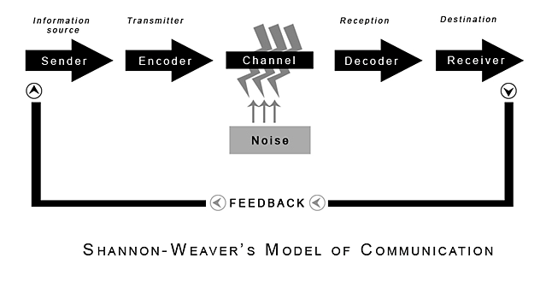
Shannon and Weaver model of communication is designed to develop the effective of communication between sender and receiver. They discovered factor which affect the communication process called” Noise”. First time was made to improve the technical communication. This model contains various concepts like:
--- information source
--- transmitter
--- noise
--- channel
--- message
--- receiver
--- information destination
--- encode and decode
Sender -----> Information source which selects desired message.
Encoder ----> Transmitter who converts the message into signals.
Decoder ----> Reception place of the signal who converts signal into message.
Receiver ----> The destination of the message.
Noise ----> Message is transferred from encoder to decoder through a channel.
In this process, message might be distracted or affected by physical noise like thunder and crowd noise, horn sounds which can affect the communication flow and the message is not correctly received.
Criticism of Shannon and Weaver model of communication.

More affective in person-to-person communication than groups.
One of the simplest models and is applied in general in various communication theories.
This model is also known as the “mother of all models” because of its wide popularity, known also as a “information theory” or the “Shannon theory” because the main person who developed this theory was Shannon. The primary value of this model is to explain how message is lost and distorted in the process of communication.
Advantages:
Concept of noise help communication to be more affective by removing the noise or the problem causing the noise.

Verbal and Nonverbal Communication

Verbal communication can be face-to-face, or a conversation held over a phone call or messages over the internet. This conversation or dialog are affecting by voice modulation, volume or speed and clarity of speaking.
Types of verbal communication:
--Speaking and writing
--Reading and listening
--Face-to-face discussion
--Telephone conversations
Nonverbal communication includes body language, (body posture and body movements, hand gestures.)
Types of nonverbal communication
--facial expression and eye behaviour
--gestures and postures
--vocal characteristics
--touching behaviours
--use of time and space.

Wilbur Schramm Model (1954)
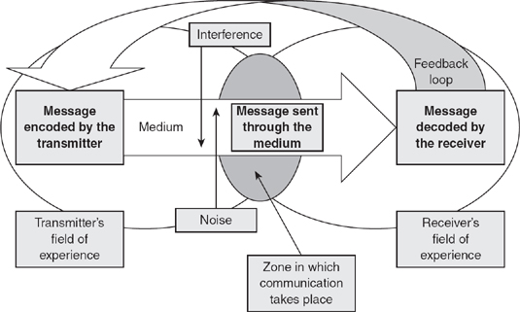
Wilbur Schramm (1954) stated “it is misleading to think of the communication process as starting somewhere and ending somewhere. It is really endless. We are little switchboard centres [sic] handling and re-routing the great endless current of information.”
This model was an attempt to rectify the earlier linear models of communication. This can be intrapersonal communication within our self or inter personal communication within two people, each person use interpretation because both act as a sender and receiver.
The encoding, interpreting, and decoding take place in the same time.
Advantages of Osgood-Schramm model of communication.
--dynamic modeshow how a situation can change.
--sender and receiver are the same person.
--assume that communication is circular in nature.
Disadvantages of Osgood-Schramm model of communication.
--this model does not include semantic noise and assume that encoding and decoding take place on its own.
--the model cannot deal with multiple levels of communication and complex communication process.
--feedback not mentioned.
--only two sources can communicate.

Berlo’s Model of Communication


This model represents the process of communication in its simplest form. Berlo’s SMCR model of communication (1960) describe the basic process of communication which includes four components that describe communication process.
Senderthis is the source who has created the message and send it to the receiver. There are many factors who influence the sender and there are also applicable for the receiver. Berlo’s SMCR model of communication identifies the following factors which affects the source:
Communication -skills which include reading, listening and speaking.
Attitude -when the meaning and the consequences of the message is changed.
Knowledge -this makes the communication more efficient.
Social systems -this includes values, beliefs, religion and rules; this influence how sender communicates the message.
Culture -This may result a different interpretation of the message.
Message -This is the information sent from sender to receiver. This message can be sent in different forms such as audio, speech, text, video or other media.
Message is influenced by:
Contentfrom beginning to the end.
Structurethe way in which is structured.
Treatment the messages packaging.
Elements this are nonverbal aspects such as gestures and signs who may influence the message.
Code the form in which the message is sent. (text, language, videos, gestures, music.)
Channel the medium used to send the message.
Receiverthe person who receive and decodes the coded message
A disrupted communication process include: loss or distortion (The sender must encode the message in a way in which the intention can be clear as possible), Noise (this disrupts the source causes that the message is received partially or at all).
Berlo’s model synchronizationthe process can be synchronous when the receiver is in direct contact with the sender, and asynchronous when they are not in direct contact.

Gap Analysis

Objective | Current Position | Deficiency | Action
What do I want to do? | What can I already do? | What am I lacking? | How do I fix this?
I’d like to graduate this year and to gain knowledge and skills for the workplace. | At this time, I am house keeper for a local hotel. | I don’t have enough knowledge about being a good leadership | By learning at my maximum potential everything about being a good leader
I want to become effective team worker and a good manager. | I can I can work with different type of people and different occasions which may appear at my workplace. |  | By asking advice from my tutor and being active to my classes.

PDP

Personal Development Plan to Improve own Communication Skills.

Objectives | Tasks | Success Criteria | Time Frame | Resources
List your Goals. | What do you need to do to achieve these goals? | How will you identify your success? | When do they need to be done by? | Who or what do you need to help you?
Becoming a leader | Attending my classes. Learning how to become a good leader | By receiving feedback from team workers | Done by December 2021 | I need to make a research to develop my knowledge and skills.
Making intensive English courses | Starting an English course. | By finishing the course. | Done within 2 months. | Classes and materials for my courses.
Graduating this university year | Attending my classes and be able to pass all my future assignments. | By receiving a degree. | Done by December 2021 | Online classes, feedback from tutor and research.

Conclusion

By receiving writing and verbal feedback from my colleagues and tutor saying that my communication is indeed excellent and that I prepared and was ready for my presentation I can say that I encounter no difficulties when communicating with them. Taking in consideration that English is not my first language I tried to deliver a writing and oral form of a presentation which they understood with no issues. At my presentation I tried to communicate to my audience about my presentation topics in writing and oral form. The feedback which I received from my teachers and colleagues was very positive and this gave me more trust in my communication skills. I collect this feedback in writing and verbal by receiving the feedback forms and their comments about my speech. I can say that my communication style is one very good and the person I communicated with understood everything I said, I have used verbal communication at all times because I would like for my colleagues and tutor to understand everything correctly. The models of communication are very important for individuals to acquire an efficient understanding of communication process. Models of communication are: Lasswell Model (1954), Shannon and Weaver Model (1949), Charles Osgood’s Model (1954), Theodore M.Newcomb’s Model (1953), Bruce H. Wesley’s and M.S MacLeans’s Model (1957). When understanding these models, individuals are able to identify how the information between senders and receiver take place. It can be stated that models of communication are making easy the process of communication in a well-organized manner.

References

The model of communication. September 2020. Radhika Kapur. University of Delhi.
Essentials of human communications; By DeVito, Joseph A. Pearson Education, 1997
The Evolution of human. Communication: from Theory to practice.
Verbal and nonverbal communication (November 2018) English language. Online.
Janse.B (2018) Berlo’s SMCR Model of communication. Retrieved [Insert date] from Tools Hero.
https://www.toolshare.com/communication-skills/berlo’s-smcr-model-of-communication/
https://ww.studymode.com
https://www.acdemica.edu
https://www.businesstopia.net
https://www.communicationtheory.org
SHANNON, C. E., & WEAVER, W. (1949). The mathematical theory of communication. Urbana, University of Illinois Press.
David Berlo's SMCR Model of Communication represents the process of communication in its simplest form. The acronym SMCR stands for Sender, Message, Channel, and Receiver. Berlo's SMCR Model of Communication (1960) describes the different components that form the basic process of communication.
The Schramm model views communication as a process that takes place between a sender (transmitter) and a receiver: there will be also a message, and a medium through which the message can be transmitted (Schramm, 1948).
https://sk.sagepub.com/books/key-concepts-in-marketing/n46.xml#:~:text=The%20Schramm%20model%20views%20communication,transmitted%20(Schramm%2C%201948).
https://www.communicationtheory.org/berlos-smcr-model-of-communication/

Blenkinsop, P. (2010) The Communication Cycle. [online] Available at: http://manyana-education.blogspot.com/2010/10/communication-cycle.html Accessed: 22.04.21
MindTools (2021) How good are your communication skills? [online] Available at: https://www.mindtools.com/pages/article/newCS_99.htm Accessed: 22.04.21
Shannon, C. and Weaver, W. (1949) The Mathematical Theory of Communication. Urbana: University of Illinois Press.
Skills You Need (2021) Interpersonal Skills Self-Assessment. [online] Available at: https://www.skillsyouneed.com/ls/index.php/343479 Accessed: 22.04.21

Appendix A

