Need to do RE-WRITE
Arrange pages

Are Autonomous vehicles the best decision for the future of Automotive Design?
Catherine Loraine
1702778
Transport Design
6056 Word count
Julia Lockheart

Table of Contents
Abstract 100-word count (not in word count)
Summary 100 words 147
Introduction 300 words 294
Chapter 1 2000 words 1907 1
Levels of autonomy
Manufacturing goals
Technology
Chapter 2 2300 words 746 2
Security issues
Physical security
Software security
Chapter 3 1000 words 2093 3
Maintenance
Liability
Conclusion 1000 words-848
Bibliography
List of Illustrations
Appendix

Summary
Connected and Autonomous Vehicles (CAV) are particularly relevant in today’s society as manufacturers are currently investing billions in their development; these vehicles are being tested for road usage and could be driven around on our streets in the near future. There are presently automated driving systems that help to prevent injuries and save lives. This new technology shifts to electrical technology, bypassing manual controls, with the information gained placed in a database. Self-driving vehicles are debateable with arguments against their usage in that the technology is leading to a direction that manufacturers should not go down, although there is also the argument that it could also prove to be successful. Autonomous vehicles are advertised on the news, in articles, newspapers and social media with manufacturers expanding their knowledge limits in regard to vehicles that can drive passengers, using only a computer system to navigate the public roads.

Introduction
Car manufacturers are solely directing themselves towards designs of the future, through research, experimentation, and development in their newest design rationale which is taking them forward to create a market for, flying vehicles, hovering cars and now the incredible selfless driving car.
As I develop my career in Transport design, I want to be open to all aspects of design decisions, but this topic astonishes me. I have always enjoyed the physicality of manual transport and reject the thought for electronic systems and the way that they work. Self-driving vehicles appear to be too futuristic and are also fully electrical in design. This includes the connectivity needed from the Internet to transfer data to facilitate being driven on the roads safely.
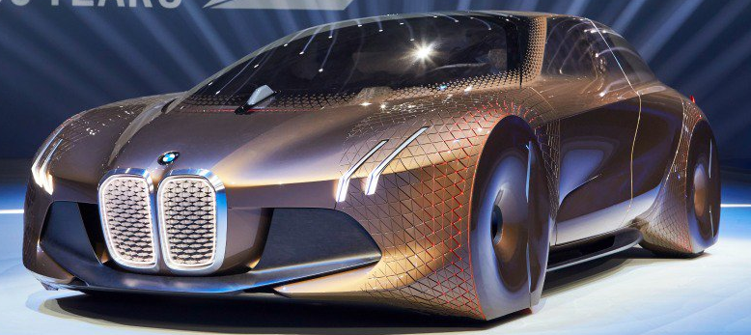

Fig.1 BMW Autonomous vehicle

Automotive Design is focused on future development and the creation of vehicles that are too far advanced, with the impact of becoming a dangerous area for error. Autonomous vehicles are the new focus for improvement, causing those in the industry to push further to create vehicles that are more electrical than manual. It could be great for the future, but they need them to be more intelligent than a person to keep on running well. Car manufacturers have started to follow this method of production, even Uber has stepped on board with their thirteen-million-pound project in London called the DRIVEN program created by Oxbotica’s autonomous software (The Future of Transport). The first question to ask, is whether passenger-carrying vehicles are adequate and have the safety of the road user as a priority? Opinions are widely spread which could make this production too risky to move forward. Furthermore, would an autonomous vehicle be safe when all of the passengers are asleep inside and how would assistance be notified if needed?

CHAPTER 1
Levels of autonomy
Autonomous vehicles are designed using a level system, starting from Level One and going up to Level Five. Using a set of guidelines created by the Society of Automotive Engineers (SAE) these levels are designed as a category for autonomous vehicles, one being the lowest to five sitting at the top of the chart. There are currently five levels and the question is whether ‘Level five’ could actually be achieved, be safe and reliable.
Pollard (2019) states that
Level one is the simplest category where the vehicle will use data from the sensors and cameras, but they leave the driver in charge of the vehicle. This first appeared in the late 1990s at Mercedes-Benz with its cruise control units, whilst Honda introduced its lane-keeping assist in 2008. These were the first steps taken for autonomous vehicles.

Level 2 is the category that all vehicles are currently classified. Brake function, cruise control, and speed systems have been around for several years. Whilst on the motorway you can use cruise control, have assistance braking for corners and have help with the motoring position inside a lane. Also, there is the facility to use sat-nav data inside the vehicles system to brake prior to corners and keep a safe distance from the car in front, although this system will speed up when the sensors are given information that the lane ahead is clear for overtaking.
In between levels 2 and 3, there is a level 2+. This category uses all the above and more, as these vehicles are also designed to be intelligent. The vehicle is designed to understand its surroundings and be able to respond if necessary, with information being documented based on the driver’s well-being. The driver's physical information is recorded and monitored, this then affects how the vehicle responds, it will know whether the driver is tired or aware. However, this leads to the question of whether it is more of a driving robot or is still under the control of the driver? (Mearian, 2019)
2020 is the year that manufacturers want to release level 3 vehicles to the public. Audi primarily plans for these vehicles to have a mode or setting, which lets the vehicle drive for the person making it autonomous, however, the driver must be aware and ready to take over when needed (Mearian, 2019).
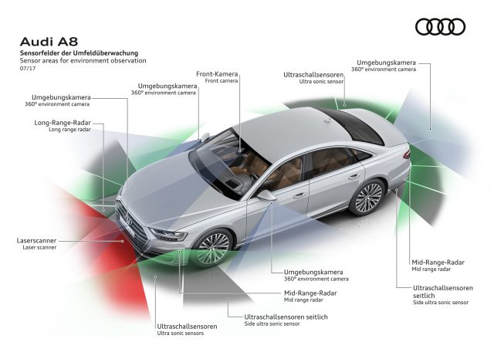
Fig. 5 Audi A8
Audi is currently manufacturing the new Audi A8, which will run on a level 3 platform this will be released as an autonomous vehicle by using maps, radar and sensors to write up data this includes multiple Nvidia processors which run using a 48-Volt Primary Electrical System. Moore-Colyer has stated that:
“Autonomous driving requires more than just a driverless system; it needs the hardware and software to enable the training of autonomous systems through the processing of huge amounts of data, often requiring the power of the cloud and data center grade servers. Once a system is trained it needs to be put into action using a technique called inference, whereby a smart system not only puts into action what it has learnt but also absorbs new information and effectively learns through experience.”
(Moore-Colyer, 2019)
Although it is known that Nvidia will be the supplier of the processors, the lack of information is concerning, with possibly the processor not be ready to use in these vehicles, as there is limited information regarding what the system is called, would Nvidia be able to run this vehicle safely?
The Audi A8 will drive using an AI Traffic Jam Pilot which will drive up to 37.3 mph or 60 kph whilst the passengers catch up with their daily notifications. The Audi A8 consists of ultrasonic sensors, a camera, five radars, six Nvidia processors and a laser scanner. As mentioned previously, the Audi A8 will be a Level 3 self-driving vehicle that takes control in the majority of situations, but the driver must be ready to take over when needed. When the driver becomes stuck in a stop, start, slow and accelerates in various situations with other cars in traffic, the vehicle will override control, steering itself sensing other vehicles, taking over whilst in this environment, providing the driver the facility to relax. Even though this vehicle will be at Level 3, the car will not be able to change lanes, cause traffic jams or drive itself beyond 37 mph. Also, it will not be able to drive around a broken-down vehicle, but it does let the driver relax to some extent in standstill traffic. If the vehicle does sense that the surrounding traffic is accelerating past the limit that it can go up to, the vehicle will alert the driver telling them to take over. If the driver is not alert, picking up the speed above 37 mph, the vehicle will slow down, stopping and activating the hazard lights. At the same time, it will call Audi’s emergency services, letting them know that the driver is unaware, and the vehicle has been stopped.
If the vehicle does accelerate past the 37 mph that is needed to take the car out of Level 3, then the vehicle will change into Level 2 making it adjust into a semi-autonomous mode. This mode allows lane centering and cruise control and helps the driver to relax so that the driver can rest their hands on the steering wheel, lightly. We currently have these functions inside the majority of new cars that have been bought since the Cadillac in 1960 (Lehman, 2014).
Audi will run their vehicles on a 48-Volt alternator, which will aid when the engine has to come to a stop. The engine will shut down at 14 mph, in contrast when the vehicle goes above 35 mph the engine will run for 40 seconds. This vehicle has many other extras including a specific element called Multimedia Interface (MMI). Multimedia Interface is used to transfer audio and video data through a single cable (Howard, 2017).
Are cars slowly becoming computer systems that move?
Within the next ten years, vehicles will fully be able to drive themselves in metropolitan areas using multiple advanced technologies, all of which are at level 3. Twenty of the main car manufacturers have all said that they will sell autonomous vehicles by 2022. Furthermore, Mercedes autonomous guru, Christoph Von Hugo when in discussion of future ownership of these vehicles states that,
“The likelihood is you will just be renting the car, rather than owning it. You won’t take this car on vacation to Florida but you’ll take it on an urban journey around New York, say. It is easier to have ultra-detailed mapping for carefully defined areas.”
(Pollard, 2019).

Negatively, there will be issues with map data, maps need information on the roads, it may not be possible to take a car oversees because the system may not be calibrated to know the roads in different parts of the world. Within current technology that is used today, potentially, if there is a loss of signal and the vehicle needs to gather information to know where its final destination will be, the person could be stranded. The system could glitch making the passengers have to ask for help and could lead to more trouble for break down companies. They would need to calibrate the system, helping it to know where the final destination is. Other problems include being able to avoid situations on the roads, by avoiding confrontations and having to make a choice of what to do. These vehicles will be robots that have been designed to think one way and will not work the same as a human’s mind that can solve problems.
To support these concerns Matthew Biggins, blogger tweeted:
“The year is 2025. A woman takes one last bite of toast and swig of OJ before heading out the door. She slides into her autonomous car and tells it to head for the office. This businesswoman settles in, glancing at her tablet for the morning news as the car pulls into the street. A green light — the car proceeds through the intersection. Just then, a ball bounces onto the road and a child darts into traffic to retrieve it — too little too late. The car’s onboard computer quickly calculates a crash is imminent. There are two outcomes. The car can try to slow but will hit and kill the child. Or the car can swerve to avoid the child but will ram into the median and kill its passenger. What should the car do? Save the woman who purchased the car or the innocent child?”
(2017)

To expand this further, one may drive down the road and a child runs out in front of the vehicle, as a passenger, you watch in horror as the vehicle hits the child and carries on driving away, with no parents in sight and a child who needs medical attention. A further situation may involve multiple vehicles and motorways that may have hundreds of autonomous vehicles in driving mode, there would be difficult to get all of the cars to stop at the same time causing greater danger than with human interaction from drivers. This causes concern and is proving to be a big decision when one considers the purchase of an autonomous vehicle.
Why should it be a manufacturer's decision on who should live and who should die, especially if a child makes a choice leading to a catastrophic death sentence? This would prove difficult for parents to choose when to let their children out to play and as a parent, it’s hard to decide when is the time that a child is ready to play outside. It is obvious that the manufacturers will be the ones to decide since they will need to program the vehicle to help it avoid situations such as this one above.
Autonomous vehicles will make it impossible to decide, including the electric vehicles that have no sound coming from them as there will be no audible notification, thus causing further possible danger on our streets. As a child I would listen for vehicles and look left and right, now you do not have that option because an electrical vehicle is silent. Could it be possible to add noise to these autonomous vehicles to make them more detectable?
The ethics of these vehicles has been discussed further by New Scientist in 2017 in which the possibility of “An “ethical knob” could let the owners of self-driving cars choose their car’s ethical setting. You could set the car to sacrifice you for the survival of others, or even to always sacrifice others to save you.” Furthermore, within this article on autonomous vehicles, it describes that the driver could decide what direction the vehicle would take. This could be helpful and basically the same as everyday driving on our roads today.
Level Four and Level Five are similar in comparison. These motor vehicles will both be able to drive freely anywhere and will use land markings and infrastructure with high volumes of data, frequency and computer technology at a very advanced level to be able to conquer circumstances, environments, and domains.
To put this into perspective as to how significant the number of vehicles these concern, it is believed “By 2035, 21M self-driving vehicles will be on the road” (Mearian, 2019).
--------------------------------------------------- intext references reminder to do these

Chapter 2

Fig. 3: Hacker

Security issues
It could be hacked using location services and Bluetooth.
The Financial Times writer Peter Campbell (2018) has more information regarding this topic. This article states that “greater connectivity gives criminals more access”, which highlights the possibility of wireless connections associated with autonomous vehicles. This article discussed the journalist from Wired experience of being driven without controlling his steering wheel and pedals. It was an experiment that proved that cars can be driven remotely and accessed without permission. Hackers are a major problem, when it comes to creating driverless vehicles, a positive aspect of this is that the transport community are aware of these security issues. The avoidance of this scenario will pose tough for the manufacturers until they find a way to block hacking completely, then this idea may never work in the world anytime soon. Facebook and Google are the main sources for gathering data and this is especially true when it comes to advertisements and collecting location data. Could Facebook be an entry point to hacking vehicles in the future, when they cannot see it happening and could they be blind to the possibility? Watching Watchdog on BBC One, Episode four, series forty-two, there was information based on mobile phones that used their location and shops gathering information on the person to give customized advertisements. If shops can basically hack into a person’s mobile phone, where does that leave autonomous vehicles? An autonomous vehicle would need to use location to know where the destination is and this is a very dangerous game to play, with people’s lives. Is there any way that using this system could be safe because every direction leads to an unsettling and disturbing result.
There is obviously the possibility as this can happen with mobile phones that drivers contact information including address and contact number could be sourced. Searching the web, it was impossible to find any information in regards to blocking cyber hackers from entering inside a vehicle’s information system. This includes the possibility of being able to get in via the way that the vehicle will be sending information over to itself.
Physical security

Fig 4 Break in a vehicle
When autonomous vehicles are seen on our forecourts, they will begin to use a new system that Bosch has started to try and achieve. Bosch stated in 2019 that
‘Perfectly keyless’ is an identity chip vehicle access system. Both passive vehicle access and start are controlled by a digital key on a mobile phone. What does this mean for the owners of these vehicles? Further research through Bosch declares that it is capable of using a fingerprint system on your mobile phone, you can lock and unlock the vehicle, making it tougher for hackers to enter. Could this stop thieves from gaining access to the vehicle using a copy of the person's fingerprint by the use of their mobile phone? Obviously, they can! By taking the mobile phone into the unlocking zone, the vehicle will automatically open using the system’s automatic opening function says, Bosch. So, where does this leave owners since the vehicle does not need a fingerprint to unlock it?
There would need to be a security system to be able to identify the owner of the vehicle. By placing an unlocking system inside the vehicle and your mobile phone, this would cause hacking and thefts, therefore, security insurance would be at the highest rate, making it impossible for many to be able to ever own one in the future.
It would be best if fingerprint systems were put on door handles or eye scanners were placed inside where the mirror is located, granting access to the owners and stopping the risk of thefts and vehicles being used for other purposes.

Software security
Is the software capable of dealing with all of the car’s functions? “The crucial flaw of self-driving cars? They will always need human involvement” (Naughton, 2018). Software for autonomous vehicles is advanced as previously mentioned, but with all of the research and conclusions that have been found, autonomous vehicles will always need a driver for back up. If there is no association of a driver inside the vehicle, then the vehicle will have to make decisions, and the software currently is not advanced enough, which in its current state can prove to be deadly. The manufacturers infur that there will not be any problems, but there will always be trouble when it comes to self-driving vehicles.

Chapter 3
Maintenance
Currently, regular checks must be completed by electricians and mechanics, this leads to the consideration of how often would you need to do this and how would maintenance change?
(IEEE Innovation at work, 2019) said, “Imagine the day when your car not only diagnoses its own maintenance needs but schedules its own appointment and then drives itself to the shop, leaving you with plenty of free time to do as you please.” Information regarding vehicle maintenance states that the vehicle will receive data for diagnostics, which will also notify the vehicle when it needs repair. The vehicle will drive away and return fixed meaning that the owner will need to have money to give directly to the mechanics for their services. This would mean that a debit or credit card would need to be in the car’s filing system, sending a payment method directly from the owner. This could prove to be a problem for the person who may not have the money available on the day of the service. Appointments may be missed, and workplaces may be left short because members of staff have not arrived in due time for their shift that day. Businesses will struggle when their staff do not show up to work because their vehicle has driven off to get fixed. If a warning system is put in place and the owner could be warned prior to the service, this would give them a time and price, they could leave the money inside the vehicle for the maintenance team to take for that day’s work. Whilst it is good to get these things fixed by going to the shop and buying a new battery. This direction will cause more and more people to be out of pocket, due to the excess amount of money that mechanics can charge for simple jobs that do not need to be fixed, to help their businesses to thrive.
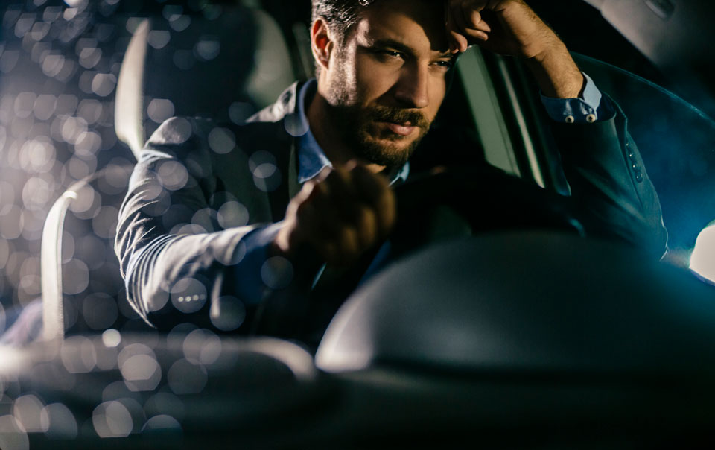
Liability
Fig 2 Sleepy driver
____________________

How often do people fall asleep at the wheel whilst driving a vehicle?
(ITV News, 2018) said: “Government data shows 62 people died and 462 were seriously injured on Britain’s roads last year when fatigue was a contributory factor.”
There is the possibility of passengers sitting inside a self driving vehicle, and due to the lack of concentration of the task fall asleep five minutes into the journey, or possibly be too deeply interested in the use of mobile phones or other distractions that passenger may not realise the dangerous situation. Inside an autonomous vehicle, you are more likely to fall asleep watching a video on YouTube or in general, being too comfortable after a long day of work, sleep-deprived, relaxed and unaware. Self-driving vehicles, no sleep, and social media are a curse when mixed together (reference) . Other issues may involve people who have taken drugs, people without a driving license, there are so many isues that provoke reaction. It is obvious that we do not know entirely what the manufacturers are thinking, but there are many different scenarios that could prove to be difficult when dealing with autonomous vehicles.
…………………….
Advancing this further and looking at it from a positive perspective, the idea of self-driving vehicles will become a top priority for safety because of the excess amount of sales and passengers that will be moved around in these vehicles. Safety components will be continuously updated and information would be gathered to ensure the safety of everyone inside these vehicles. This is obvious because of the extreme measures that the car manufacturers take to make sure that vehicles work the way that they should today. Recalls are put in place and with the high demands of the twenty-first century, they have to build them based on safety and regulations. They would be the most driven vehicle on the roads, cutting down costs for owners and helping those to relax and enjoy their vehicles to the fullest. If they were to become fully autonomous, there would be fewer crashes and all of the traffic would be traveling at the same time, but this would put many companies out of production and potentially remove people from their jobs. How? Companies that craft steering wheels, gear sticks, clutches and pedals, and clusters would not be needed to create the components for vehicles. If this was the instance, then they could possibly start to craft other items that are needed for the vehicles, helping to save jobs and which would keep the workers and the companies happy.
How often do passengers fall asleep whilst the vehicle is moving?
Sarah Blunden (The Conversation, 2019) (07/10/2019) wrote
“We may also fall asleep in a moving car because it is very similar to our beds. It’s warm and comfortable and we are usually feeling safe and relaxed. So, if you are sleepy, comfortable and feeling safe, you will likely fall asleep in the moving car.”
If this scenario is a true statement, it will be catastrophic in the events were drivers are re-directed to the passenger seat in an Autonomous vehicle. This will become venomous in terms of staying safe inside these vehicles whilst they are traveling. Who would it choose to save in an emergency, and would the owner be safe in their own vehicle that they have paid money for? Multiple vines of questions and answers needed and not enough information in terms of Autonomous vehicles. Previously mentioned was the statement regarding who would survive when these systems have to decide on who to save. A child should not lose their lives, because these vehicles are all over the world and too dangerous to step in front of. Emergency services would have to be careful when dealing with this type of situation and manufacturers need to think about whether they want to be the ones liable to risen deaths because of these vehicles. If there was an event, where many were killed would the public be able to forgive car manufacturers? In 1989 the Hillsborough football disaster was in the headlines about the 96 Liverpool fans who were crushed to death and their own were blamed for the dead being robbed, whilst the police urinated on their dead corpses. Even though they now have their justice, years on. The Sun newspaper is still receiving negative feedback from this incident from when they accused the supporters for engaging in this activity. They mislead many to believe that this story was true and in reality, it was a hoax that had become deeper than they possibly could have imagined. This is a perfect example of what can happen when trying to win over the public, you can end up in the firing range. Although they apologized and tried to fix what was broken, it was too late for them to gain back the respect of the public. Twenty-three years after the incident and a newspaper article called (Liverpool’s 23-year boycott of The Sun newspaper, 2012) was released with many comments saying that many will never forgive and forget. Vehicle manufacturers could end up in the same scenario and one wrong word could potentially be fatal for these companies' futures. Furthermore, what company wants to become the countries most hated, needing to going into liquidation whilst cars are being destroyed because people have brought them and violence starts to escalate, resulting in The Hillsborough again years later.
Reading an Abstract in the book Colour Machine Vision for Autonomous (Shashi, Buluswar and Draper, 1998) (04/11/2019) claimed that “colour can be a useful feature in autonomous vehicle systems that are based on machine vision, for tasks such as obstacle detection, lane/road following, and recognition of miscellaneous scene objects.” This feature is already available on the roads and there hasn’t been much information for this regarding this category making it impossible for me to comment any further.
Mercedes – (Christoph von Hugo, 2018) said that it will be as though you are renting the vehicle, which makes you question whether the manufacturers will be to blame if a vehicle does crash. It’s inevitable that these vehicles will crash in the future, who can argue and say that they are completely safe for our roads. So, if we are basically renting these vehicles then will it be the manufacturers to blame and will they be the ones liable for crashes and insurance groups become nil and void or will it be down to the passengers on board. They have atoll certificates for plane companies when they go under, will they have a scheme in place for vehicles that malfunction on our roads and can we really trust autonomous vehicles to drive us from a to b?
Researching on Google Scholar, there was a book regarding Autonomous vehicles and written in the Abstract was a statement about these self-driving vehicles (Shashi and Bruce A, 1998). The statement wrote as follows:
“Autonomous vehicles (AVs) should reduce traffic accidents, but they will sometimes have to choose between two evils, such as running over pedestrians or sacrificing themselves and their passenger to save the pedestrians.” Which direction would be taken when in a situation as dangerous as this? To know that the pedestrian could walk away safe, but the people that this vehicle was designed to keep safe is now in danger of possibly loosing their life because of this scenario is not promising. In contrast to this information, this gives a conclusion about what could possibly happen.”
The next question is who would be to blame if a driverless vehicle was to crash or kill a pedestrian?
Would insurance still be around, and would there be a safety net for everyone or would the driver who isn’t driving the vehicle be to blame? Reading the Atlantic, it would appear that a substantial amount of people are wondering the same question. So, what is the answer to this mysterious question?
A self-driving vehicle operated by Uber, killed a pedestrian when it struck the 49-year-old woman in Tempe, Arizona. Although it was the first time that a vehicle operated by a computer, had killed a human by force of impact. Self-driving cars have only started to be released and a death has been admitted. Would this happen more often than when a person is driving the vehicle?
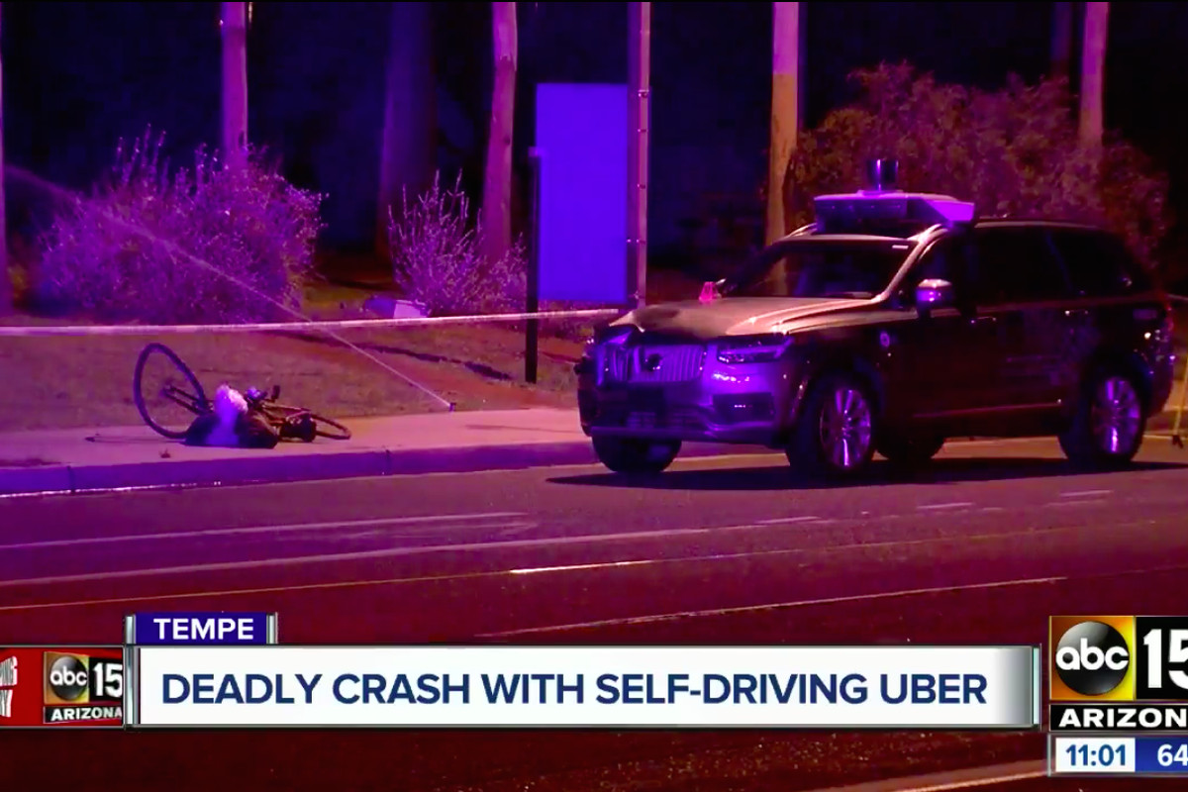 Fig 6 ABC 15
(The Conversation, 2019) are asking who’s liable to be blamed when it comes to self-driving vehicles because drivers are the cause of the problem when they drive the vehicle, but what about cars that drive by themselves? Is it the driver, manufacturer or computer system? If it was the manufacturer, they would have to pay out large sums of money in compensation claims and that could potentially shut down their businesses. Surely that’s enough to cancel the idea of creating them.
Especially with all of the recalls that aren’t being met by the manufacturers, due to the parts not being stocked. If there was a recall for all of the vehicles, then nobody would be able to get to work or go out because they would be major defects in the controls. This would also be a huge burden for the manufacturers and having high demands for fixtures of the vehicles.
Reading (The Verge 2019) website, there is information regarding the crash that involved an Uber and a pedestrian. After reviewing all of the evidence, the verdict is that the Uber vehicle and the driver were both to blame for the crash. (Andrew J Hawkins 2019) said:
The board also found that Uber’s autonomous vehicles were not properly programmed to react to pedestrians crossing the street outside of designated crosswalks. Moreover, Uber revealed to the board that its self-driving test vehicles had been involved in over three dozen crashes prior to the fatal one in Tempe.
There were failures of the vehicle operator who spent 34 percent of her time in the Uber, glancing at her mobile phone, inadequate safety risk assessment procedures and ineffective monitoring of the vehicle operations. Due to the lack of entertainment inside an autonomous vehicle, they were also blamed for not having a system in place to ensure the safety of the driver. In conclusion with the text above, it is evident that the driver, computer system and manufacturers were all at fault.
Conclusion
We cannot really say that these autonomous vehicles are positive or negative to have on our roads, but the future is dependent on it becoming available in our environment. They are great at what they are designed to do and there are no sources that can place these vehicles in a safe category. As technology advances and the car manufacturers working endless hours to try and get them to work, it could prove to be a fabulous decision. As it stands, we are best keeping Autonomous vehicles in the hands of people, leaving cruise control and extras up to Level 2 available and avoiding Level 3 upwards until our technology can deal with this crisis. With all of the vehicles being driven hands-on and trial run not giving the greatest outcome, it comes to what each individual thinks on this topic. At Level 2, these vehicles are safe with a backup plan of the driver and with manufacturers having 2022 as a deadline for these vehicles to be released, it’s inevitable that these vehicles are going to malfunction. There’s not enough evidence to prove that we should put our lives at risk to jump inside one of these vehicles, with all of the road works and vehicles that are on our roads today. Too many distractions at any given time for a vehicle as complex as an autonomous one to drive in our terrain. In the 1900s these vehicles would have been a brilliant piece in our communities, but with the number of vehicles accessing our roads now this proves to be a risky idea. Yes, we have fantastic opportunities and technology, but is it really wise to throw out vehicles that are robots who will drive around using only data from a chip to guide it. What would happen if the chips were hacked or the internet servers went down and the vehicles have limited information on where to go? This would make the vehicles incapable of driving to destinations and updates would need to be given every two seconds to ensure that the vehicles stop for crashes or roadworks because a vehicle hasn’t got a mind or eyes to tell it that there is a hazardous situation sitting around the corner. The vehicle will drive and suddenly it could smash into a previous crash that has already happened, but this is impossible to guarantee. They will not be able to stop for police that are blocking off roads in the event of an emergency going straight through the center of a situation. Move out of the way if a government vehicle needs a free pathway, slowing down response times and causing havoc. Car manufacturers have a great perspective in mind for creating these vehicles, but they need to look at every scenario before it happens and the list is endless of the possibilities that these vehicles could be facing head-on. What would happen if the battery was to die on them or a sensor was to stop working? Would the vehicle change direction or stop working entirely? What about the maps not updating? How would it travel to its destinations blind? As they say, a blind person can’t drive a vehicle so why should a blind vehicle drive itself.
Whilst there is a lot of negativity regarding this subject there are endless possibilities within the world of transport design. Vehicles that can travel to destinations, opening up taxi services without the need of a driver, driverless buses and trains and traffic that will move quicker and more conveniently. No slow drivers on the roads making travel times quicker, fewer vehicles on the road creating easier entry access points, reduced fines for drivers, pedestrians feeling safer when they need to cross the roads and more areas to build houses or company headquarters. People wouldn’t be charged vehicle tax or insurance for these vehicles and no claims would be made, making jails less busy because of careless driving and London would be easier to access instead of being stuck in standstill traffic for hours on end. Whilst there is negativity, people need to realize the positives to this situation just as much, but with newspapers consistently aiming for negative titles on social media and too many opinions in the 21st century, there is a lot of information needed regarding these autonomous vehicles. As once a person who seen autonomous vehicles as a negative, I now look at both sides and I am aware that there is a lot more going on in this industry then what they advertise. Try and go out in an autonomous vehicle, ask questions and even look into these sources regarding this situation and evaluate both sides of the argument and maybe you will understand what opportunities are available in the world of autonomy. We will just have to wait and see whether these vehicles make it into the real world with millions of them driving around or will they be forgotten in the past and trailed in the future, the same as the flying vehicle that still needs to land on our streets.
List of illustrations
Figure 1: Ciferri, L. (2016) BMW Autonomous vehicle. Available at: https://www.autonews.com/article/20160307/COPY01/303079908/bmw-unveils-futuristic-self-driving-concept (Accessed 09/10/2019)
Figure 2: Travelers Risk Control (no date), Sleepy driver. Available at: https://www.travelers.com/resources/auto/safe-driving/drowsy-driving-statistics-and-facts (Accessed 20/10/2019)
Figure 3: Vanian, J. (2016) Hacker. Available at: https://fortune.com/2016/09/16/technology-benefits-companies-hackers/ (Accessed 03/11/2019)
Figure 4: Torney, C. (2011) Break in a vehicle. Available at: https://www.confused.com/on-the-road/safety/beat-car-thieves-insider-tips (Accessed 07/11/2019)
Figure 5: Howard, B. (2017) Audi A8. Available at: https://www.extremetech.com/extreme/252289-2019-audi-a8-will-self-driving-37-mph (Accessed 26/11/2019)
Figure 6: Hawkins, A. (2019) ABC15. Available at: https://www.theverge.com/2019/11/19/20972584/uber-fault-self-driving-crash-ntsb-probable-cause (Accessed 20/11/2019)

Appendix
Bibliography
Baker, B. (2016). Infrequently Asked Questions: Why do we fall asleep so easily during car rides? [online] PhillyVoice. Available at: https://www.phillyvoice.com/infrequently-asked-questions-why-do-we-fall-asleep-so-easily-during-car-rides/ [Accessed 31 Oct. 2019].
Biggins, M. (2017). Self-Driving: Who decides who will die?. [online] Hackernoon.com. Available at: https://hackernoon.com/self-driving-who-decides-who-will-die-cffbed89c357 [Accessed 22 Nov. 2019].
BMW (2017). Autonomous driving – 5 steps to the self-driving car. [online] Bmw.com. Available at:
https://www.bmw.com/en/automotive-life/autonomous-driving.html. ( [Accessed 15 Oct.2019].

Bogost, I. (2018). Can You Sue a Robocar? [online] The Atlantic. Available at: https://www.theatlantic.com/technology/archive/2018/03/can-you-sue-a-robocar/556007/ [Accessed 12 Oct. 2019].
Bonnefon, 1., Shariff, 2. and Rahwan, 3. (2016). The social dilemma of autonomous vehicles. [ebook] pp.1573-1576. Available at: https://science.sciencemag.org/content/352/6293/1573 [Accessed 9 Nov. 2019].
Campbell, P. (2018). Hackers have self-driving cars in their headlights | Financial Times. [online] Ft.com. Available at: https://www.ft.com/content/6000981a-1e03-11e8-aaca-4574d7dabfb6 [Accessed 9 Oct. 2019].
cars, P. (2019). Perfectly keyless for passenger cars. [online] Bosch-mobility-solutions.com. Available at: https://www.bosch-mobility-solutions.com/en/products-and-services/passenger-cars-and-light-commercial-vehicles/connectivity-solutions/perfectly-keyless/ [Accessed 16 Oct. 2019].
Greedy, E. (2019). Highways Magazine - Self-driving cars navigate London streets with £13m project. [online] Highwaysmagazine.co.uk. Available at: https://www.highwaysmagazine.co.uk/Self-driving-cars-navigate-London-streets-with-13m-project/5193 [Accessed 29 Oct. 2019].
Hawkins, A. (2019). Uber is at fault for fatal self-driving crash, but it’s not alone. [online] The Verge. Available at: https://www.theverge.com/2019/11/19/20972584/uber-fault-self-driving-crash-ntsb-probable-cause [Accessed 26 Nov. 2019].
The Conversation. (2019). Curious Kids: Why do we always fall asleep in cars?. [online] Available at: https://theconversation.com/curious-kids-why-do-we-always-fall-asleep-in-cars-85909 [Accessed 10 Oct. 2019].
Garfinkel, S. (2017). Hackers are the real obstacle for self-driving vehicles. [online] MIT Technology Review. Available at: https://www.technologyreview.com/s/608618/hackers-are-the-real-obstacle-for-self-driving-vehicles/ [Accessed 4 Oct. 2019].
IEEE Innovation at Work. (2019). How Will Car Maintenance Evolve In the Autonomous Vehicles Era? - IEEE Innovation at Work. [online] Available at: https://innovationatwork.ieee.org/how-will-car-maintenance-evolve-autonomous-vehicles-era/ [Accessed 26 Oct. 2019].
Lehman, S. (2014). The Blind Man Who Invented Cruise Control. [online] Today I Found Out. Available at: http://www.todayifoundout.com/index.php/2014/11/blind-man-created-cruise-control/ [Accessed 7 Dec. 2019].
Mearian, L. (2019). By 2035, 21M self-driving vehicles will be on the road. [online] Computerworld. Available at: https://www.computerworld.com/article/3080590/by-2035-21m-self-driving-vehicles-will-be-on-our-roads.html [Accessed 19 Nov. 2019].
Moore-Colyer, R. (2019). Intel Processors To Power Autonomous Audi A8. [online] Silicon UK. Available at: https://www.silicon.co.uk/data-storage/intel-autonomous-audi-218595 [Accessed 12 Oct. 2019].
ITV News. (2018). One in eight drivers admit to falling asleep at the wheel, survey suggests. [online] Available at: https://www.itv.com/news/2018-11-01/one-in-eight-drivers-admit-to-falling-asleep-at-the-wheel-survey-suggests/ [Accessed 8 Oct. 2019].
Liverpool’s 23-year boycott of The Sun newspaper. (2012). BBC News. [online] 24 Feb. Available at: https://www.bbc.co.uk/news/uk-england-merseyside-17113382 [Accessed 19 Nov. 2019].

Pollard, T. (2019). What are autonomous car levels? Levels 1 to 5 of driverless vehicle tech explained. [online] CAR Magazine. Available at: https://www.carmagazine.co.uk/car-news/tech/autonomous-car-levels-different-driverless-technology-levels-explained/ [Accessed 17 Nov. 2019].
Shashi, D. and Bruce A, B. (1998). Intelligence. 11th ed. pp.245-256.
Shashi, D., Buluswar, A. and Draper, B. (1998). Color machine vision for autonomous vehicles. 11th ed. pp.245-256.
watchdog-series-42-episode-4. (2019). [video] United Kingdom: BBC.
The Conversation. (2018). Who’s to blame when driverless cars have an accident?. [online] Available at: http://theconversation.com/whos-to-blame-when-driverless-cars-have-an-accident-93132 [Accessed 11 Oct. 2019].
‌

