The Investigation of the Effect of Noise in SSB-SC and DSB-SC
THE UNIVERSITY OF WAIYSEL TRINATEY ST DAVIDS | SA1 Waterfront Campus, IQ Building
Radio Frequency Systems (ACDA5019)
Joseph Gillespie (2214885)
2025

Abstract
This report aims to show the effect that White Gaussian Noise (WGN) has on two different types of Amplitude Modulation (AM) methods. From these results, both modulation methods, Dubble Side Band Suppressed Carrier (DSB-SC) and Side Band Suppressed Carrier (SSB-SC), are then compared, proving that SSB-SC is the most efficient AM modulation method out of the two techniques.
The conclusion of this report was achieved via a test carried out on the software known as Matlab. Both DSB-SC and SSB-SC modulations and demodulation methods were constructed within the simulation with an added WGN block between the two sections. This WGN block value was changed to produce the results seen later in this report.
The following report structure will break down each AM method with a description, diagram explanation and results breakdown before coming together with a comparison and then the conclusion.

Table of Contents
Abstract 1
Table of Figures 3
Introduction 4
(1:0) AM Systems 5
(1:1) System Design 5
(1:2) Results 6
(2:0) DSB-SC 8
(2:1) System Design 9
(2:2) Results 9
(3:0) SSB-SC 11
(3:1) System Design 11
(3:2) Results 12
(4:0) System Comparison 13
Conclusion 14
Bibliography & References 15

Table of Figures
Figure 1, Radiofrequency segment of the Electromagnetic Spectrum [4] 4
Figure 2, AM Modulation and Demodulation 6
Figure 3, AM Modulation Transmission/Demodulation at 1 Modulation Index 7
Figure 4, AM Over Modulation at Modulation Index 1.5 7
Figure 5, AM Under Modulation at Modulation Index 0.5 8
Figure 6, DSB-SC Modulation and Demodulation 9
Figure 7, DSB-SC Modulation/Demodulation with No Noise Effect 10
Figure 8, DSB-SC Modulation/Demodulation at -5dB of WGN 10
Figure 9, DSB-SC Modulation/Demodulation Failure at -20dB WGN 11
Figure 10, SSB-SC Modulation and Demodulation 12
Figure 11, SSB-SC Modulation/Demodulation with No Noise Effect 12
Figure 12, SSB-SC Modulation/Demodulation with Added WGN at -5dB 13
Figure 13, SSB-SC Modulation/Demodulation Failure at -20dB of WGN 13

Introduction
Communication plays a vital role in today’s society, whether it is for personal use, entertainment or to allow the operation of electronic systems. It cannot be denied that it is needed in a variety of ways, but how is it achieved? Many systems and older methods of communication such as landline phones depended upon communication via wire, but as technology has advanced and the introduction of radios, wireless communication has become the favoured option.
This has brought into play the use of the radiofrequency segment of the electromagnetic spectrum which operates between 3kHz to 300GHz [1]. Within this frequency range are smaller divides such as Extremely Low Frequency (ELF), Medium Frequency (MF) and Extremely High Frequency (EHF) [2] to name a few, which further categorise the transmission types and tailors the transmission to the respected receiver.
For an electronic transmission to be placed within one of these frequency categories, Amplitude Modulation (AM) has to be performed upon the transmitted signal. Three main types of AM can be chosen depending on the transmission requirements, this modulation types are Double Sideband-Suppressed Carrier (DSB-SC), Single Sideband Modulation Suppressed Carrier (SSB-SC), and Vestigial Sideband Modulation (VSB) [3].
It is within this report that only DSB-SC and SSB-SC will be investigated, comparing the two modulation techniques effectiveness in modulation and demodulation while under the effect of White Gaussian Noise (WGN). The report will be broken down into a description of each technique, their construction within the Matlab simulation software and the results of their simulated tests before finalising on a comparison of the two’s performance.
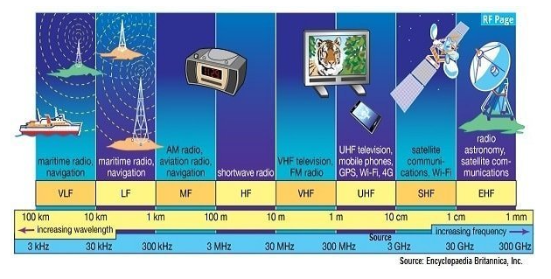
Figure 1, Radiofrequency segment of the Electromagnetic Spectrum [4]

(1:0) AM Systems
AM is the simplest and earliest method of modulation most commonly used within radio transmission [3]. It effectively transmits a consistent and reliable signal at long distances thou at the cost of its sound quality [5]. Alongside this, its demodulation process is far simpler than any other demodulation method, but this also makes its transmission/resaving signal much more susceptible to noise interference resulting in its poor sound quality.
The way in which AM works is by amplifying the amplitude of a message signal with the transmission signal before broadcasting it to the receiver. This modulation method only affects the amplitude of the message signal leaving the frequency the same. Due to this, discrete upper and lower sidebands are generated from the sum of the difference between the message signal and transmission signal [6].
The following equation is the method in how to calculate the upper (f_{USB}) and lower (f_{LSB}) sidebands:
$$fUSB = fc + fm$$
$$fLSB = fc - fm$$
To calculate the Carrier Signal:
$C(t) = C Sin(Ѡc + ҽ)$ [7]
Where:
C = Carrier amplitude
Ѡc = Carrier frequency in Hz
Ҽ = Phase of the signal at the start
To Calculate the Modulating Signal:
$m(t) = M Sin(Ѡm + ҽ)$ [7]
Where:
M = Carrier amplitude
Ҽ = Phase of the signal at the start
Ѡm = Modulated signal Frequency in Hz

(1:1) System Design
The block diagram shown in Figure 2 shows both AM and its demodulation counterpart. This Simulink diagram consists of several sections that make up the modulation stage of the transmission and is the source of the results seen in section 1:2.
The modulation starts with two sinewaves labelled m(t) and c(t). m(t) is the message signal, aver voice or music, and is times with the modulation index which decides the change that occurs to the signal's amplitude. c(t) is the carrier signal, and this is times to the transmission signal just before broadcasting.
The second stage of m(t)s modulation is to be added to a constant which prevents the message signal from going negative. Once applied, the carrier signal is multiplied to the message signal and then broadcast to its receiver.
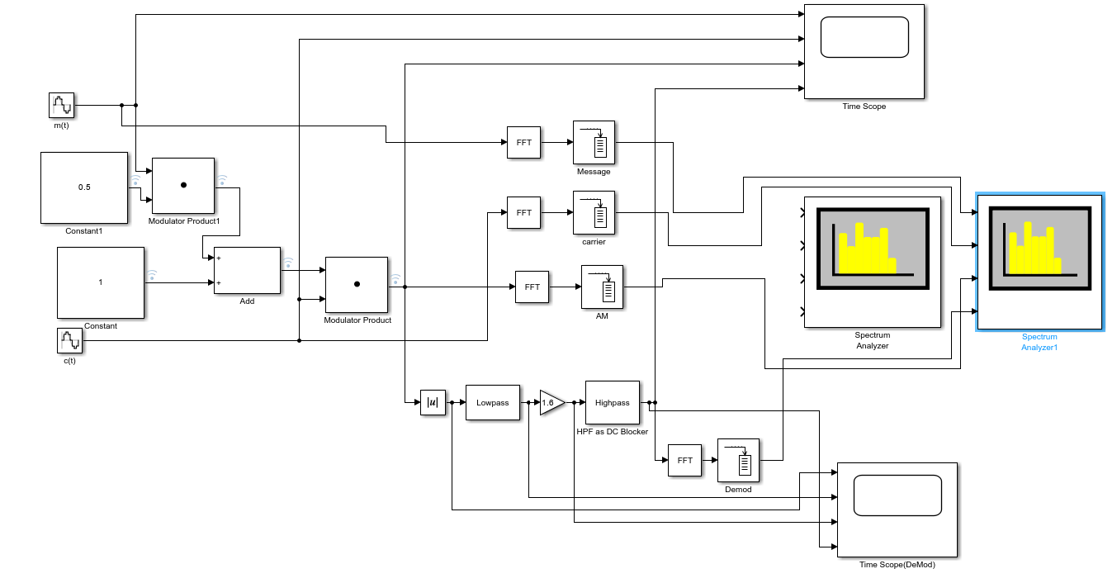
Figure 2, AM Modulation and Demodulation
The demodulation phase, seen at the bottom of Figure 2, primarily consists of two filters, starting with a low pass and followed by a high pass. Each filter is used to separate the transition from the message signal allowing for the message to be heard.

(1:2) Results
The following results show the effect that the modulation index has upon the transmission signal and how the demodulated signal compares to the original transmission. This was achieved simply by changing the constant value of the modulation index within the simulation and collecting the results vier a spectrum analyser and oscilloscope giving two different views on the effects.
To begin the test, a modulation index of 1 was chosen to keep the change occurring to the message signal the same. This is the ideal state of the modulation index as it limits the effect of noise on the signal once its intended target receives it. By doing this, a clear standard was set to compare any differences to when the index was changed. A way of calculating the correct modulation index for a system is by the following formula:
$μ_{a}= {A_{m}}/{A_{c}}$ [8]
Where:
A_{m} = Amplitude of the message Signal
A_{c} = Amplitude of the carrier Signal
Figure 3 shows both the frequency and time results of a steady modulation index. What is to note here, especially within the frequency measurement on the left of Figure 3, is that the career signal is the same power as the message signal. When looking at the results within the time domain, right side of Figure 3, the received message is higher than the transmitted message but is identical in its transmission.
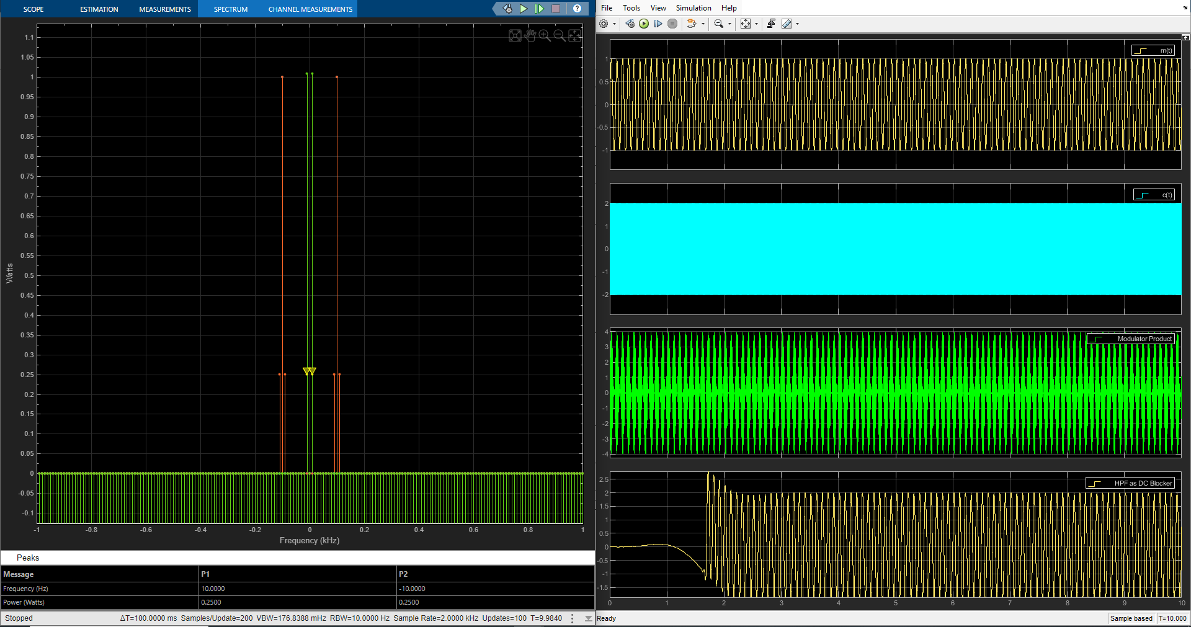
Figure 3, AM Modulation Transmission/Demodulation at 1 Modulation Index
When the modulation index is changed to 1.5, over modulation acres. This results in the message signal becoming distorted on receiving due to the signal being cut during the demodulation phase. It can be seen in figure 4 quit clearly that the message signal has significantly more power than its transmission signal. There is also a secondary smaller message signal seen at the base of the message signal too.
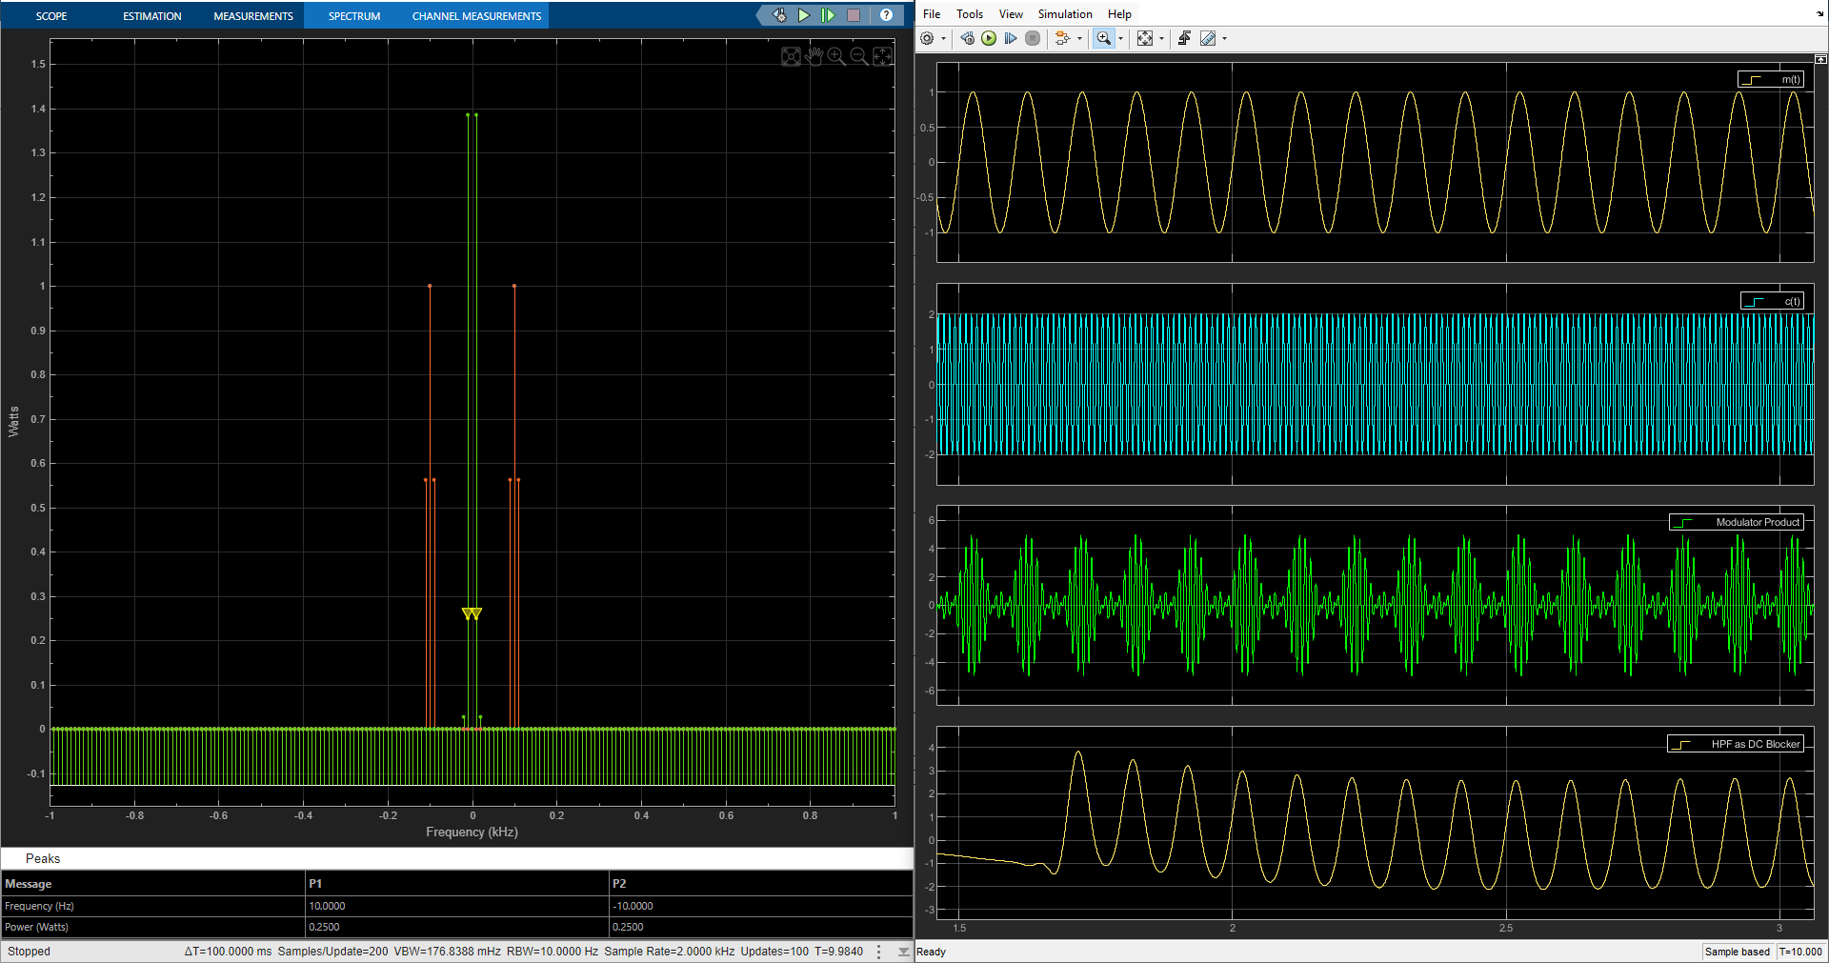
Figure 4, AM Over Modulation at Modulation Index 1.5
At a modulation index of 0.5, under modulation accrues. This is when the message signal is too small to efficiently effect the transmission signal resulting in parts of the message signal becoming filtered out during demodulation. It can be seen in the spectrum analyser readings in Figure 5 that the message signal, in green, is significantly less powered than the accompanying transmission signal.
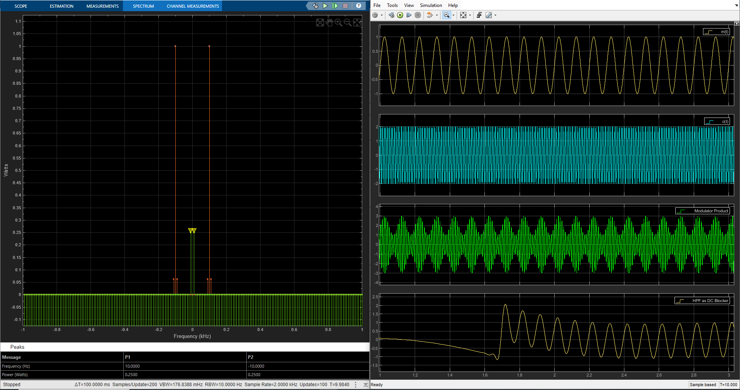
Figure 5, AM Under Modulation at Modulation Index 0.5

(2:0) DSB-SC
As another way of transmitting audio signals at a much more power-effective way compared to AM. DSB-SC only utilises that of two sidebands, one being the upper and the other being lower, when transmitting a signal [9]. The purpose of these sidebands is to keep the message signal together and to aide in the demodulation of the message on receiving it.
The calculations for DSB-SC follow the same construction as AM with the following equations being additions to those seen in section 1:0. To begin with, to calculate the bandwidth of DSB-SC:
$BW=f_{c}+f_{m}-(f_{c}-f_{m})$ [10]
To calculate the power required for DSB-SC, the power of the sidebands needed to be identified. The following equations can be split to calculate both sideband's power but within this configuration gives the total DSB-SC power:
$P_{t}={A_{m^{2}}A_{c^{2}}}/{8R}+{A_{m^{2}}A_{c^{2}}}/{8R}$ [10]
Where:
A_{m} = amplitude of modulated signal
A_{c} = amplitude of the carrier signal
R = lowed resistance

(2:1) System Design
DSB-SC’s modulation and demodulation method was created within MATLAB’s Simulink, seen in Figure 6. What is instantly recognisable on the diagram is that there is two modulation stages that are combined right before transmission which is located at the adder box labels S. Both of these modulation phases operate identically with the only difference being that of a constant which decided whether the location of the sideband is upper or lower. The structure of the modulation technique is also the same as the modulation of AM as seen in section 1:1.
Where DSB-SC separates itself away from AM is, excluding the two modulations but involving them, the combining of the two modulated signals witch can be branded as positive (high) and negative (low). Thies two signals are the lower and high sidebands which can be seen in Figure 7.
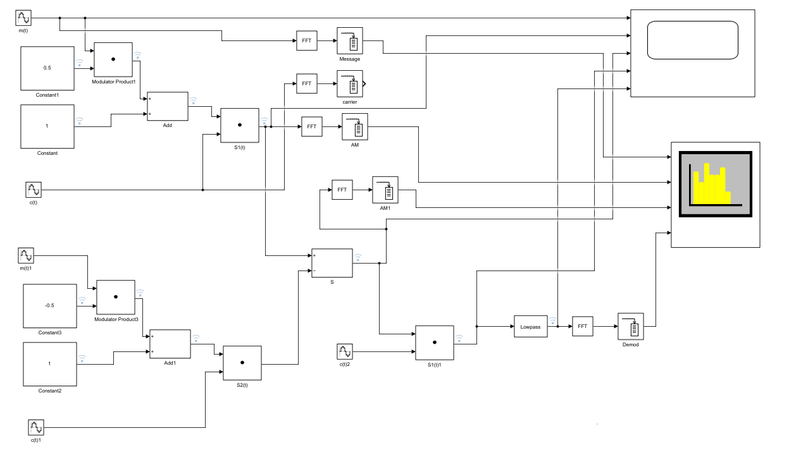
Figure 6, DSB-SC Modulation and Demodulation
As or the demodulation, the modulated signal is multiplied with the same carrier signal used within the modulation phase. Once this stage is completed, the signal is put throw a lowpass filter where the message signal is extracted.
For the tests witch results are shown in section 2:2, a WGN block was added between the end of the modulation signal and before demodulation. This is not shown within Figure 6.

(2:2) Results
What can be seen in Figure 7 is that of the unaffected transmission of BSD-SC. What should be noted is that of the two sidebands, in orange, on the spectrum analyser located to the left of the image. Figures 8 and 9 are the results of DSB-SC under the effect of WGN, interesting, the lower sideband if the first to become lost within the noise while the upper sideband rises slightly as the noise increases.
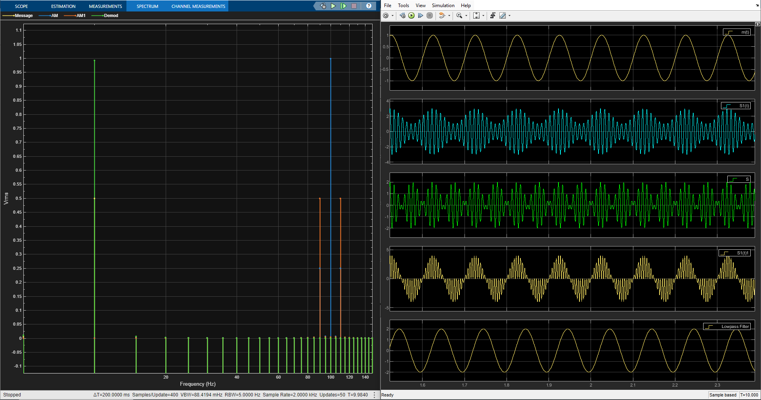
Figure 7, DSB-SC Modulation/Demodulation with No Noise Effect

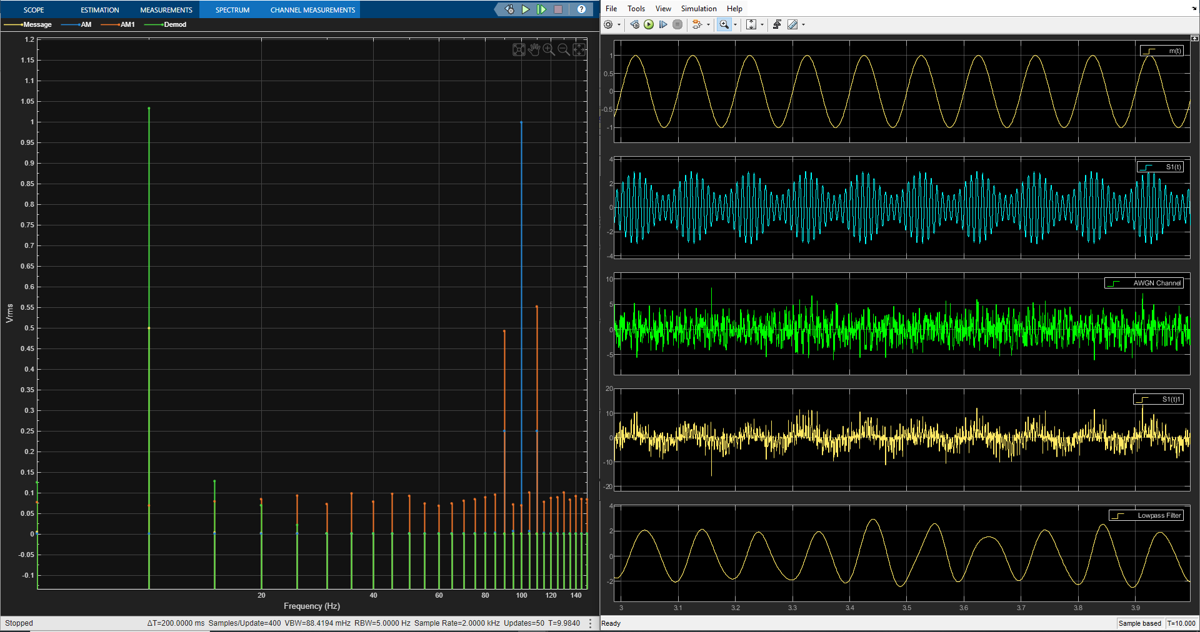
Figure 8, DSB-SC Modulation/Demodulation at -5dB of WGN

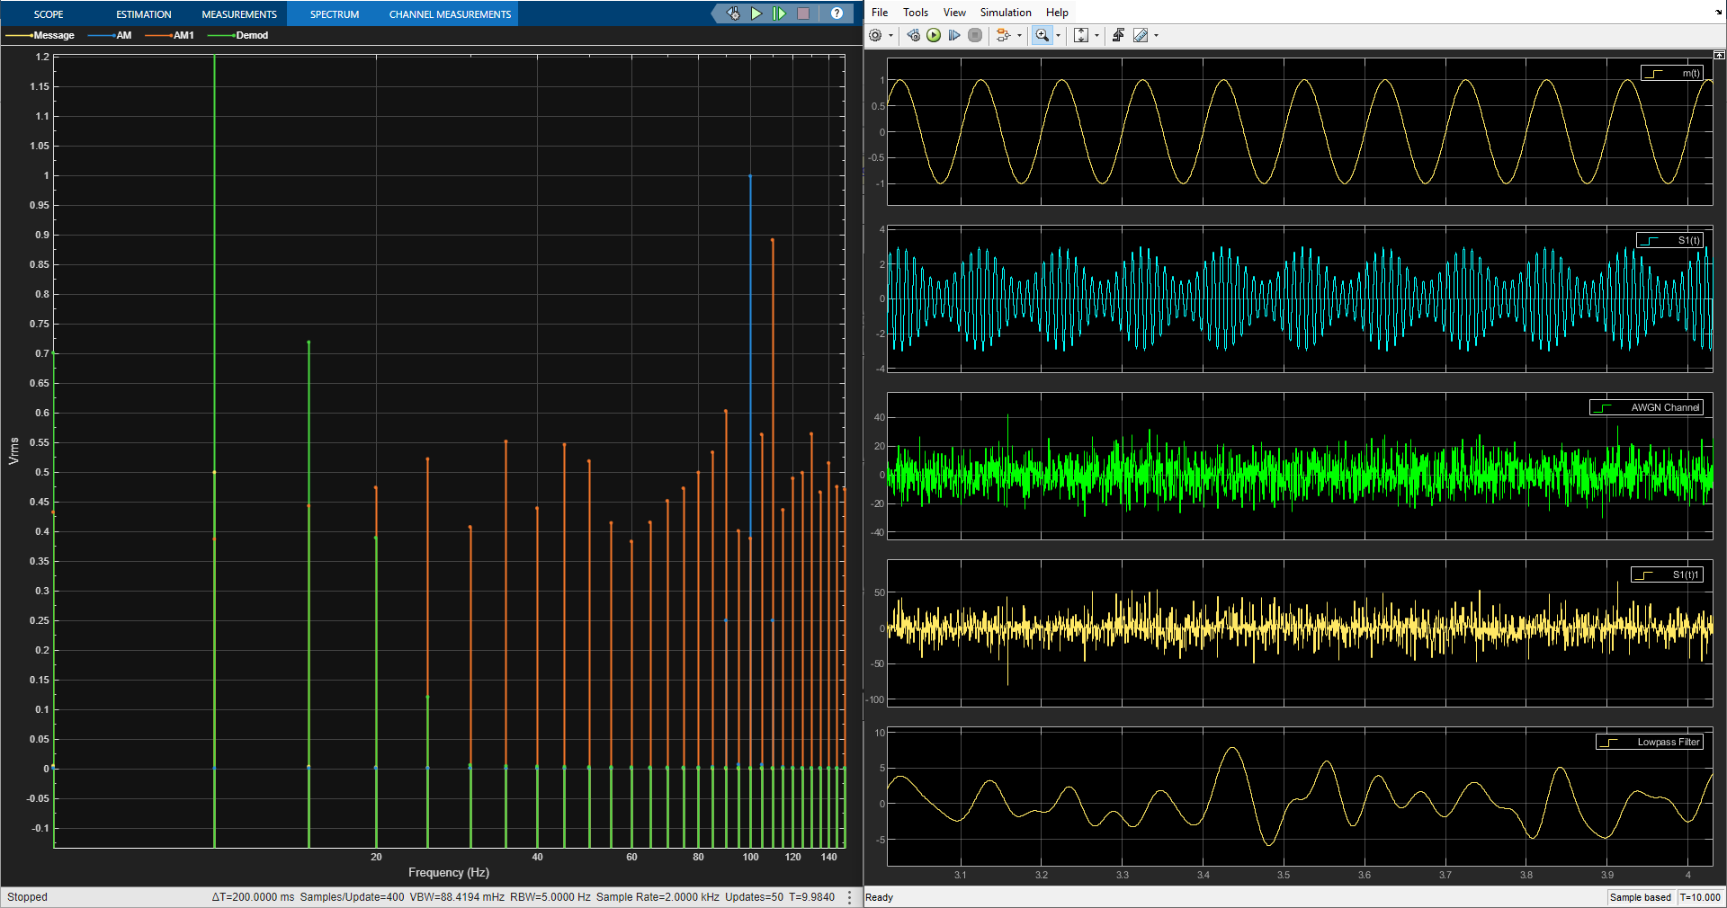
Figure 9, DSB-SC Modulation/Demodulation Failure at -20dB WGN

(3:0) SSB-SC
Popular in the amateur radio field and often used within military communication systems [11], SSB-SC utilizes that of a single sideband, aver high or lower, when transmitting. This modulation method drastically reduces the bandwidth of the transmitted signal, subsequently reducing the power required for transmission. This also allows for many more transitions to take part within the given frequency band due to the limited channel space taken up [12].
To calculate the bandwidth of the modulated wave of SSB-SC:
$BW= {{2f}_{m}}/2$ [13]
Where:
f_{m} = Is aver the upper or lower sideband.
To calculate the power of SSB-SC:
$Pt= {A_{m^{2}}A_{c^{2}}}/{8R}$ [13]

(3:1) System Design
SSB-SC takes a much simpler approach to its modulation method as seen in Figure 10. To begin with, the message signal m(t) is multiplied directly to the carrier signal c(t). While this is happening, a 90° phase shifted copy of both the carrier and message signal are also multiplied together. Once both signals are combined, the phase shifted copy, and the original signal are added together at block s(t) and then transmitted.
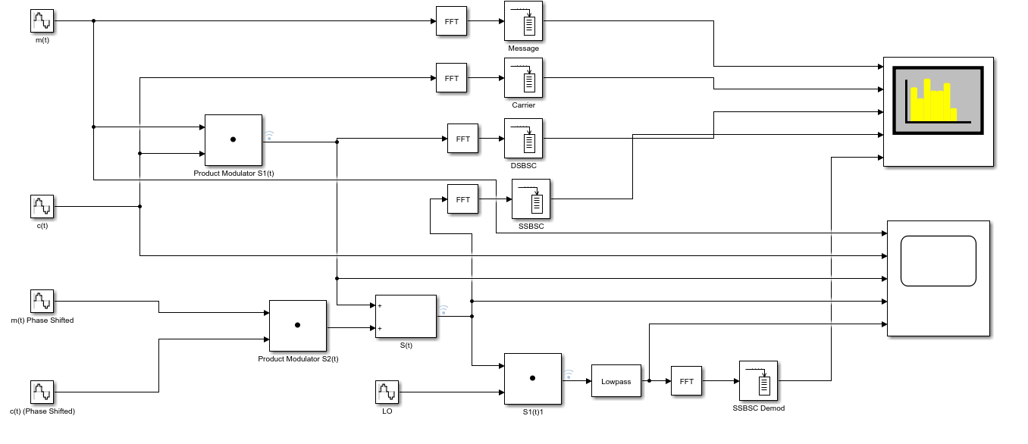
Figure 10, SSB-SC Modulation and Demodulation
The demodulation for SSB-SC followers the same path as DSB-SC with a signal similar to the carrier signal being multiplied to the modulated signal on receiving. This combination is then put throw a low pass filter where the message is extracted.

(3:2) Results
Seen in Figure 11 is that of the modulation and demodulation of SSB-SC. What can be seen in the spectrum analyser readings, located to the left of the image, is that of only one sideband highlighted in green. As the WGN levels are increased, shown in Figures 12 and 13, the single sideband still stays prominent enough to be identified but what can be seen within the oscilloscope readings is that the demodulation still fails at a WGN level of -20dB.
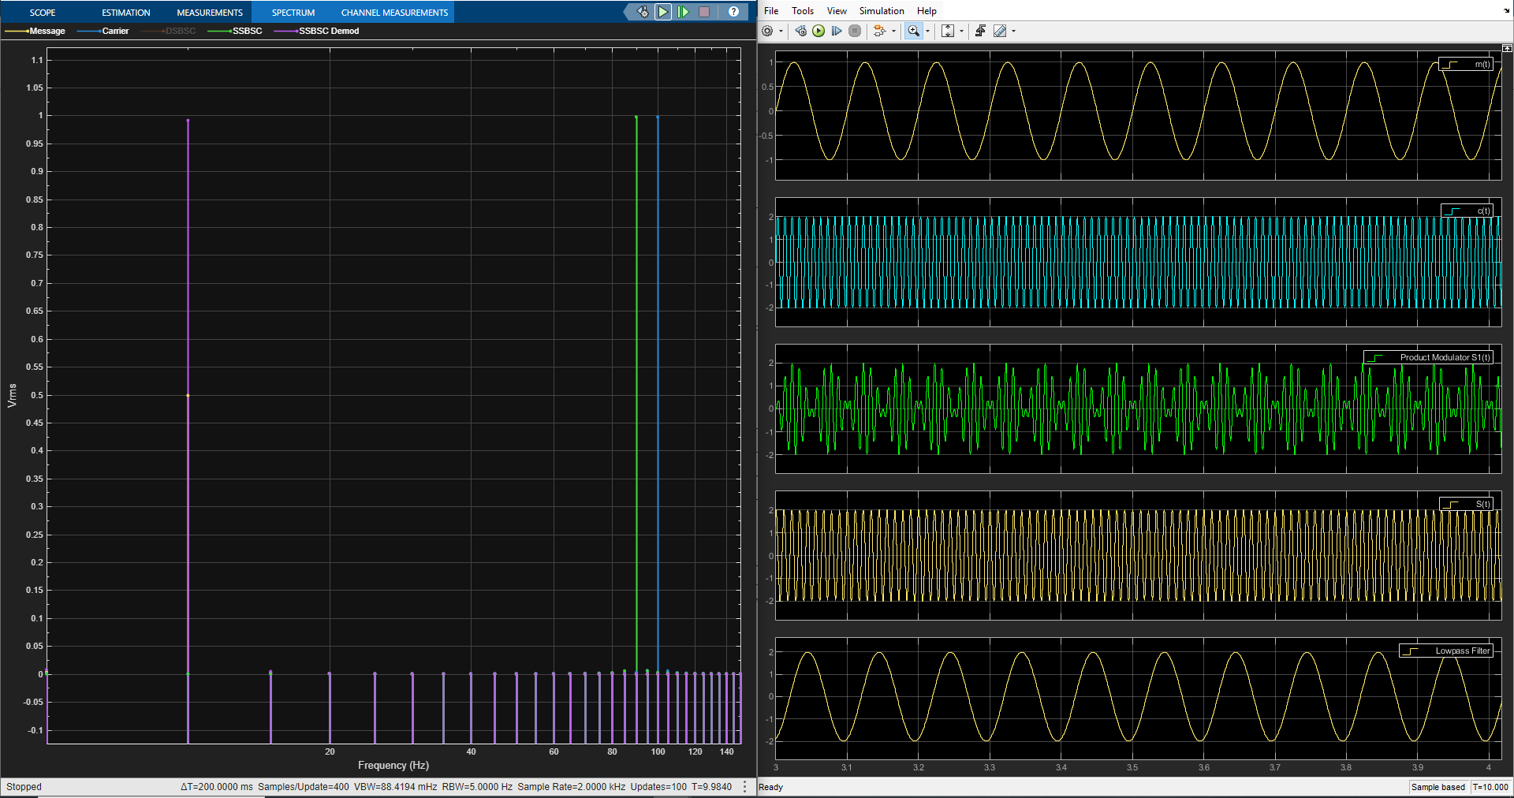
Figure 11, SSB-SC Modulation/Demodulation with No Noise Effect

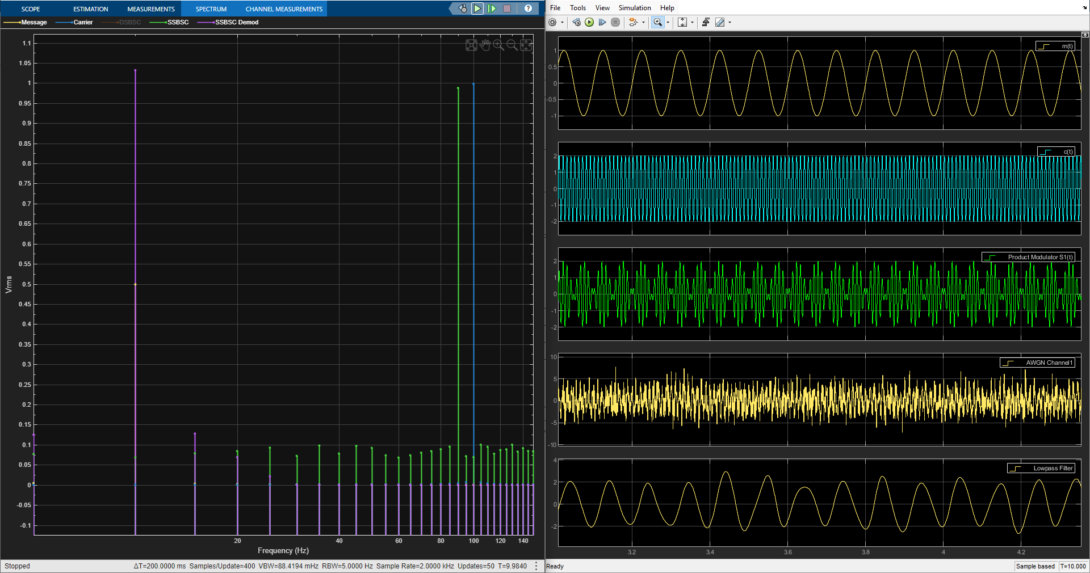
Figure 12, SSB-SC Modulation/Demodulation with Added WGN at -5dB

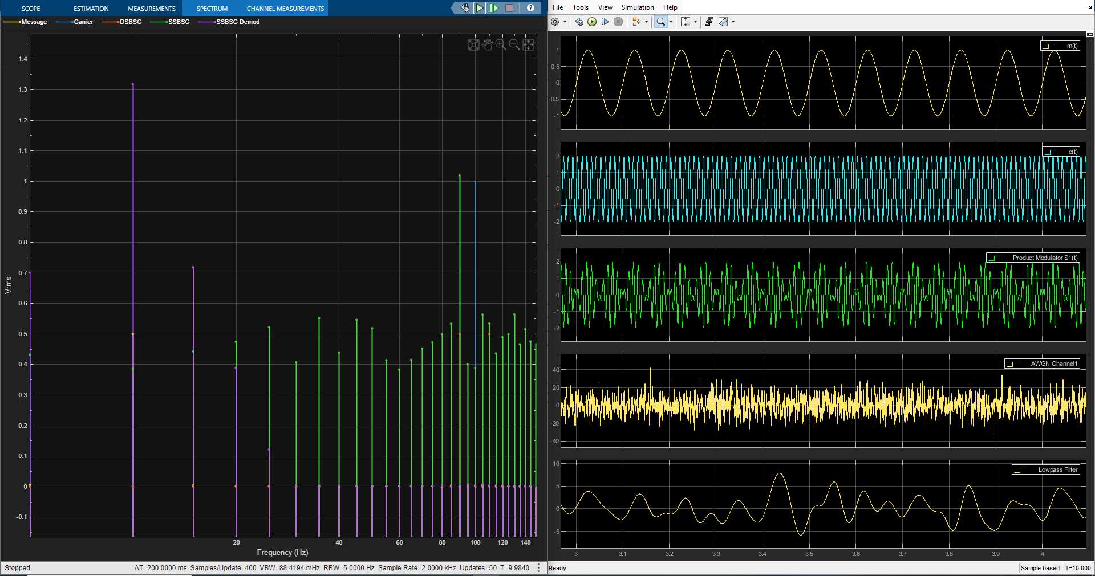
Figure 13, SSB-SC Modulation/Demodulation Failure at -20dB of WGN

(4:0) System Comparison
Each of the modulation techniques explored within this report have their advantages and disadvantages when operating in their respected systems. Unfortunately, due to the performance capabilities of both DSB-SC and SSB-SC while under the effect of WGN being almost identical in their results, as shown in sections 2:2 and 3:2. This section will look into the characteristics of their capabilities such as power usage and channel consumption.
As the most basic of all the modulation types examined in this report, AM is by far the most simplistic in its construction, resulting in it being the cheapest in manufacturing. It is capable of transmitting over long distances and sustaining a constant message while doing so but is extremely susceptible to noise resulting in its sound quality being poor. The methods in which it transmits is also inefficient taking up a large portion of the frequency channel and due to its two side bants, it requires high amounts of power [14].
In comparison, DSB-SC operates as a much more reliable and efficient modulation technique than AM. Its use of purely two sidebands results in the prevention of noise interference effecting the transmission signal, but it is due to these sidebands where DSB-SC can be seen as a failure. The power is increased due to the sidebands and the frequency channels taken up are increased, resulting in lesser communications taking part within that frequency range.
Thies issues are rectified with the use of SSB-SC as the modulation method. Sins SSB-SC only used a singular side band, the power levels are decreased drastically and the frequency channels required for broadcasting are limited. This allows for several more transmission styles to be used within the same frequency range [11]. The effect of noise on SSB-SC is like that seen on DSB-SC resulting in the power requirements and frequency consumption the only difference between the two. All thou better, the construction of SSB-SC is complex and if dun incorrectly at both the transmitter and receiving ends, can result in pore transmission quality.

Conclusion
In conclusion, SSB-SC is the better modulation technique when it comes to long distances and strict frequency regulations witch most transmission systems must abide by today. All thou DSB-SC and AM still have a place depending on the application.
In terms of results gathered in this report, they show a rather inconclusive comparison causing the conclusion to be formed primarily from research rather than testing. As the results under the effect of WGN almost look identical to each other.
On a repeat of the experiment carried out within this report, more test points will be added when conducting the WGN effect upon the transmission demodulation. This will improve results and show a much clearer point of failure for both SSB-SC and DSB-SC while making the visual evidence within the report much more supporting.
A follow-up experiment with physical modulation devices performing the same test within a reverberation chamber would further extend this. This would give a real-world visual of the effects of modulation outside of a simulated environment.

Bibliography & References
[1]Health Canada, “Limits of Human Exposure to Radiofrequency Electromagnetic Energy in the Frequency Range from 3 kHz to 300 GHz - Canada.ca,” Canada.ca, 2015. https://www.canada.ca/en/health-canada/services/publications/health-risks-safety/limits-human-exposure-radiofrequency-electromagnetic-energy-range-3-300.html
[2]C. J. Wells, “Amplitude Modulation (AM),” www.technologyuk.net. https://www.technologyuk.net/telecommunications/telecom-principles/amplitude-modulation.shtml
[3]“Amplitude Modulation,” BYJUS, Oct. 07, 2019. https://byjus.com/jee/amplitude-modulation/
[4]Rajiv, “What are Radio Frequency bands and its uses?,” RF Page, Jul. 24, 2016. https://www.rfpage.com/what-are-radio-frequency-bands-and-its-uses/
[5]“RF Basics: Difference Between AM and FM Modulation?,” RF Solutions, 2024. https://www.rfsolutions.co.uk/blog/rf-basics-difference-between-am-and-fm-modulation/
[6]“Product Documentation - NI,” www.ni.com. https://www.ni.com/docs/en-US/bundle/rfmx-waveform-creator/page/introduction-to-amplitude-modulation.html
[7]electronics notes, “Amplitude Modulation AM: Theory & Equations | Electronics Notes,” Electronics-notes.com, 2019. https://www.electronics-notes.com/articles/radio/modulation/amplitude-modulation-am-theory-equations-formulas.php
[8]AbdulRafay Moeen, “Modulation Calculator,” Omni Calculator, Apr. 10, 2022. https://www.omnicalculator.com/physics/modulation (accessed Dec. 29, 2024).
[9]R. A. Fenner, “Unit2.Lecture2 Double Sideband - Suppressed Carrier Modulation (DSB -SC) Learning Outcomes.” Accessed: Jan. 02, 2025. [Online]. Available: https://cdn.serc.carleton.edu/files/teaching_computation/workshop_2021/activities/double_sideband-suppressed_carrier_modulation.pdf
[10]“Analog Communication - DSBSC Modulation - Tutorialspoint,” Tutorialspoint.com, 2019. https://www.tutorialspoint.com/analog_communication/analog_communication_dsbsc_modulation.htm
[11]“SSB Modulation : Advantages, Disadvantages and Its Applications,” ElProCus - Electronic Projects for Engineering Students, Dec. 30, 2019. https://www.elprocus.com/what-is-ssb-modulation-and-its-applications/
[12]“What are the benefits and drawbacks of using double sideband (DSB) and single sideband (SSB) modulation?,” www.linkedin.com. https://www.linkedin.com/advice/1/what-benefits-drawbacks-using-double-sideband
[13]“Analog Communication - SSBSC Modulation - Tutorialspoint,” Tutorialspoint.com, 2019. https://www.tutorialspoint.com/analog_communication/analog_communication_ssbsc_modulation.htm
[14]“Advantages and Disadvantages of Amplitude Modulation,” Unacademy. https://unacademy.com/content/jee/study-material/physics/advantages-and-disadvantages-of-amplitude-modulation/

