

Changemakers: Creativity and Value Creation
Professions (BMHP5014)

Component 1: Online portfolio of set exercises

Student name: Mame Diarra
Student number:2335169
Lecturer’s name: Laila Surani

Table of contents

Introduction
This portfolio reflects my engagement with the module on creativity, leadership, value creation, and contemporary to technology in health and social care. It demonstrates my understanding of key concepts, explores practical applications, and provides reflections on learning activities.
The portfolio includes defined key concepts (Task 1), a problem solving mind map (Task 2), self reflection on group activities, and case study analyses, showing how theory can be applied to real world health and social care challenges.

Task 1- Defining Key Concepts in Practice (350 words)
Innovation refers to the process of developing and applying new ideas, products, or ways of working to improve outcomes and efficiency. According to the care quality commission (CQC,2022), innovation in health and social care involves both invention creating new approaches, services, or models of care and adoption, which means implementing successful ideas from other settings. This means that innovation is not only about creating something new, but also about improving and spreading effective solutions that make care safer, more person centred, and more efficient across health and social care services.
For example, the introduction of telehealth services allows patients to access care remotely, improving accessibility and reducing hospital admissions. Ongoing innovation is vital to improving treatment, communication, and overall quality care.
Creativity means coming up with new and imaginative ideas to solve problems or improve how things are done. In health and social care, it’s really important because it helps professionals adapt and find better ways to meet people’s needs. According to( NHS England 2019), creativity and the arts play a big role in improving health and wellbeing, even helping to reduce GP visits and hospital admissions. For example, a care worker might plan fun and personalised activities for someone with dementia to help them feel calmer and more engaged. Being creative helps keep care compassionate, flexible, and person centred.
Value creation in health and social care refers to providing care that genuinely benefits patients and improves outcomes relative to the sources used.( Landon et al. 2021) highlights that value is achieved when interventions lead to better health results while optimising efficiency. This is important because health services often operate under high demand and limited resources. For example, early intervention mental health services for young people can prevent conditions from worsening, reduce hospital admissions, and support long term wellbeing. Value creation ensures care is effective for patients and sustainable for the system.
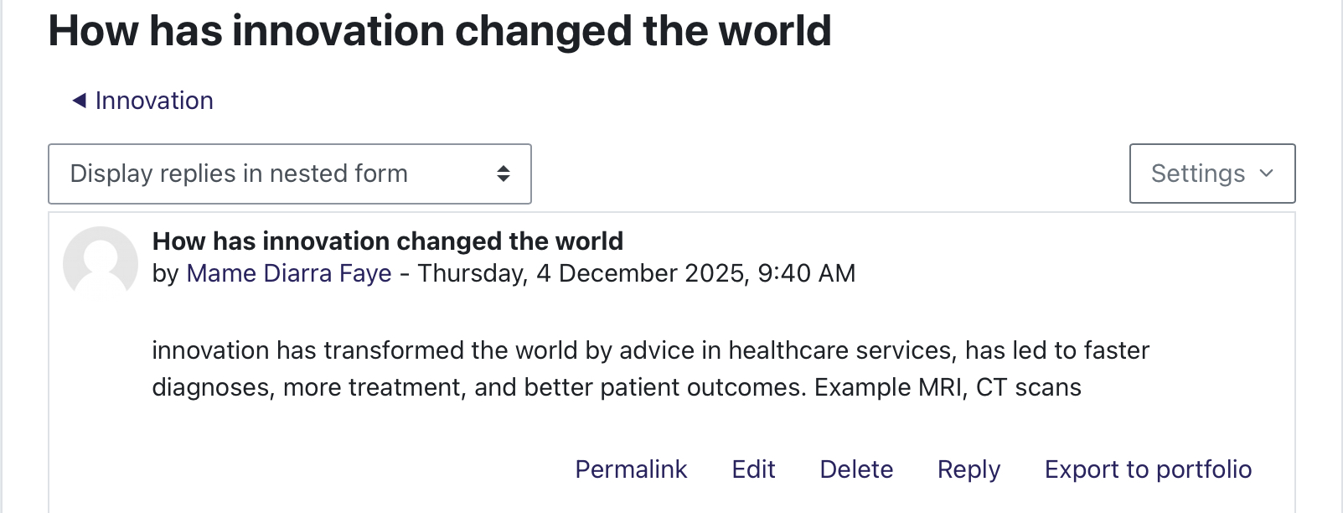
Change in health and social care involves introducing new practices, processes, or systems to improve quality and respond to evolving needs.( Harrison et al. 2021) highlight that successful change requires structured planning, clear communications, and staff engagement. Change is vital because technology, policies, and patient expectations are constantly evolving. For example, switching from paper base records to electronic health records improves accuracy, access to information, and patient safety. Embracing change allows services to remain efficient, safe, and responsive.

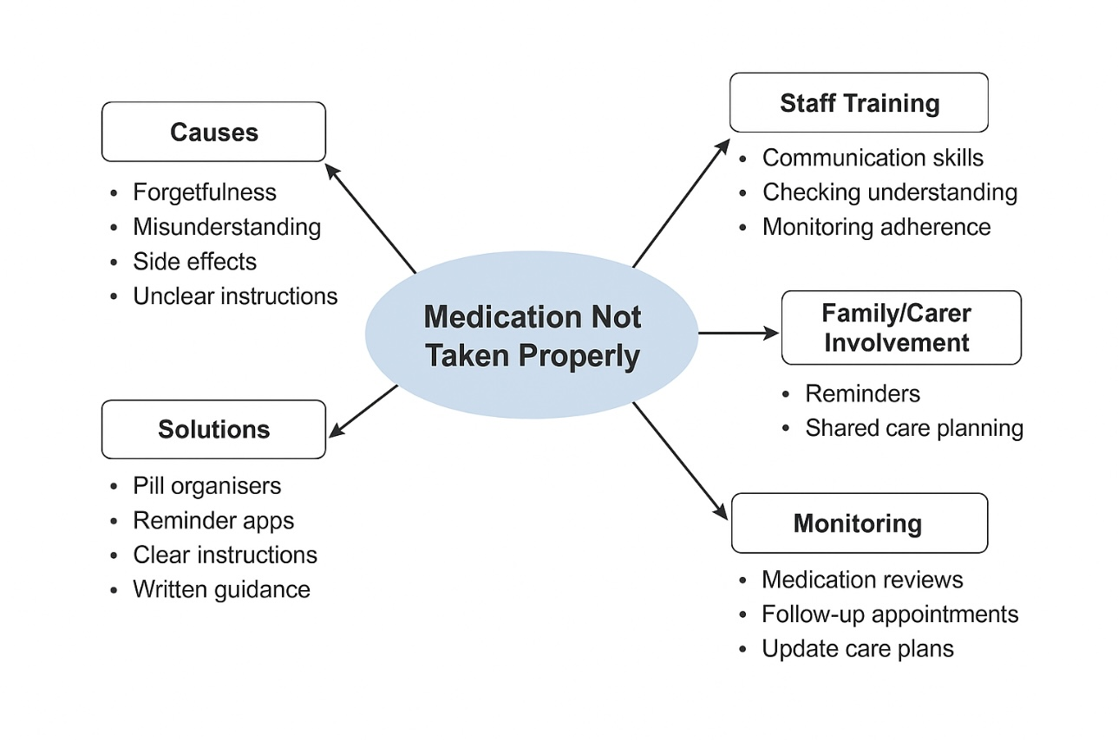
Task 2 - Mind Map (130 words)

CENTRAL PROBLEM: Patients not taking medication correctly. One branch highlights causes such as forgetfulness, misunderstanding, side effects, or unclear introductions from healthcare staff. Another branch focuses on solutions, including giving simple explanation, using pill organisers, reminders apps, and providing clear written guidance. A third branch involves staff training, such as improving communication skills, checking patient understanding regularly, and monitoring adherence closely. Another branch focuses on family and care involvement, encouraging support with reminders, shared care planning, and active engagement in the patient's treatment. The final branch covers monitoring, including routine medication reviews, follow ups appointments, and updated care plans as needed. Overall, the mind map shows that solving medication related problems requires clear communication, patient support, ongoing staff training, and consistent review within health and social care settings.
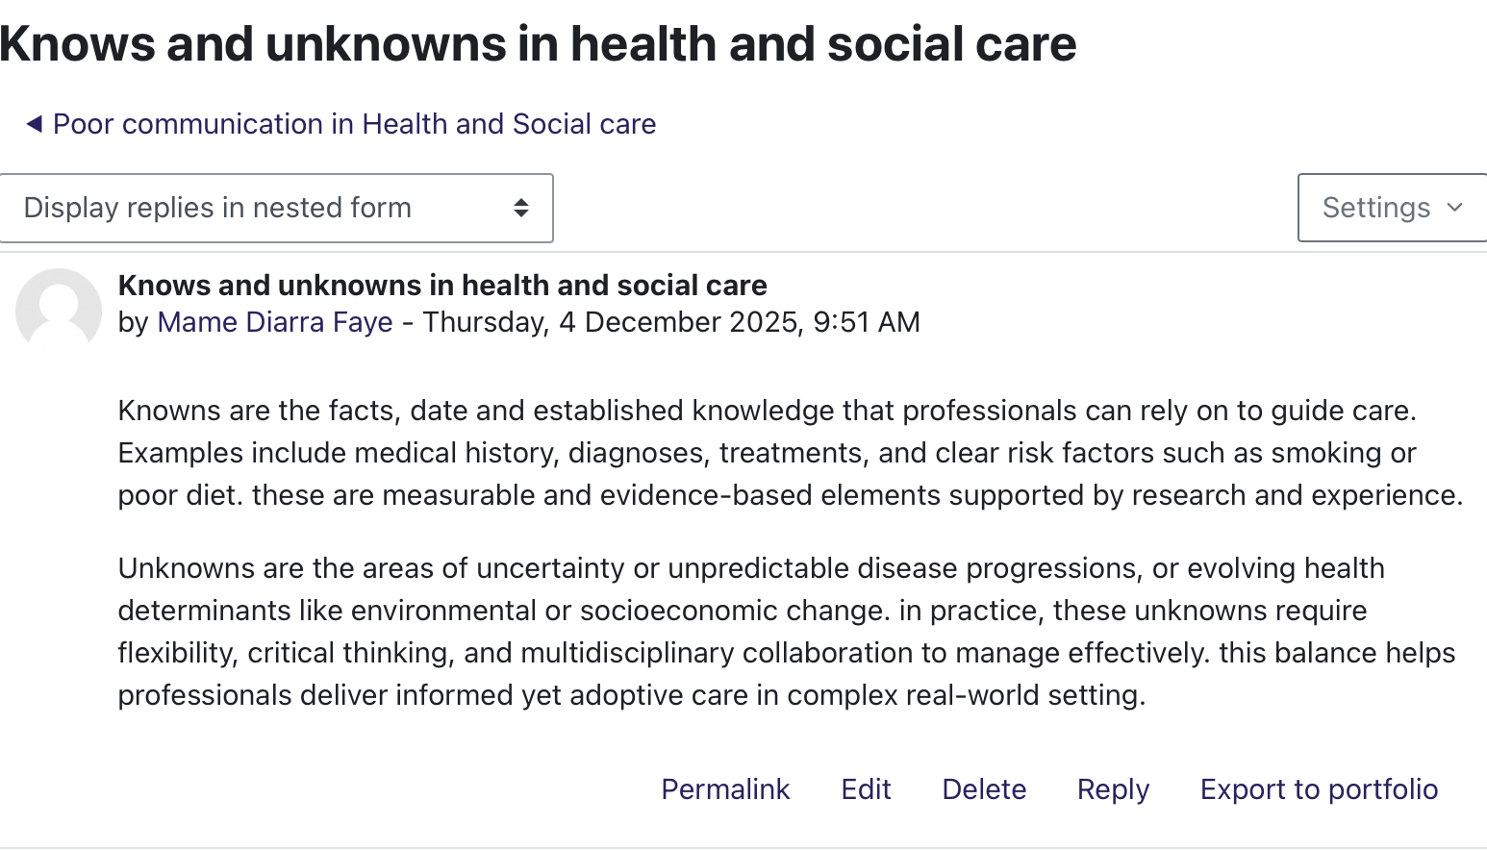

Task 3 - Self-Reflection of Group Activity (200 words).
During our group activity on mental health support for adolescents, I used both divergent and convergent thinking. Divergent thinking is about coming up with many different ideas, while convergent thinking involves focusing those ideas into practical, workable strategies (Javaid and Pandarakalam,2021). In the discussion, I suggested ideas such as raising awareness in communities, reducing stigma, improving access to mental health services for young people, and promoting mental health education in schools.
FEELINGS:
I felt confident when generating ideas, as I enjoy brainstorming creatively. At the same time, felt a little unsure when it comes to prioritising which ideas would be most effective.
EVALUATION:
The activity was positive because listening to other group members perspective helped me see which ideas were realistic and achievable. Combining our ideas led to a stronger, more balanced plan.
ANALYSIS :
I realised that while I can generate creative ideas easily, I sometimes struggle to judge whine ones to select. Using both divergent and convergent thinking together, alongside teamwork, enabled us to create innovative yet practical solutions for adolescent mental health.
CONCLUSION:
I learned that using a mix of thinking styles and collaborating with others improves both creativity and practicality when addressing complex social issues.
ACTION PLAN:
In the future group activities, I will focus on listening to others and critically evaluating ideas while also contributing my own creative suggestions.
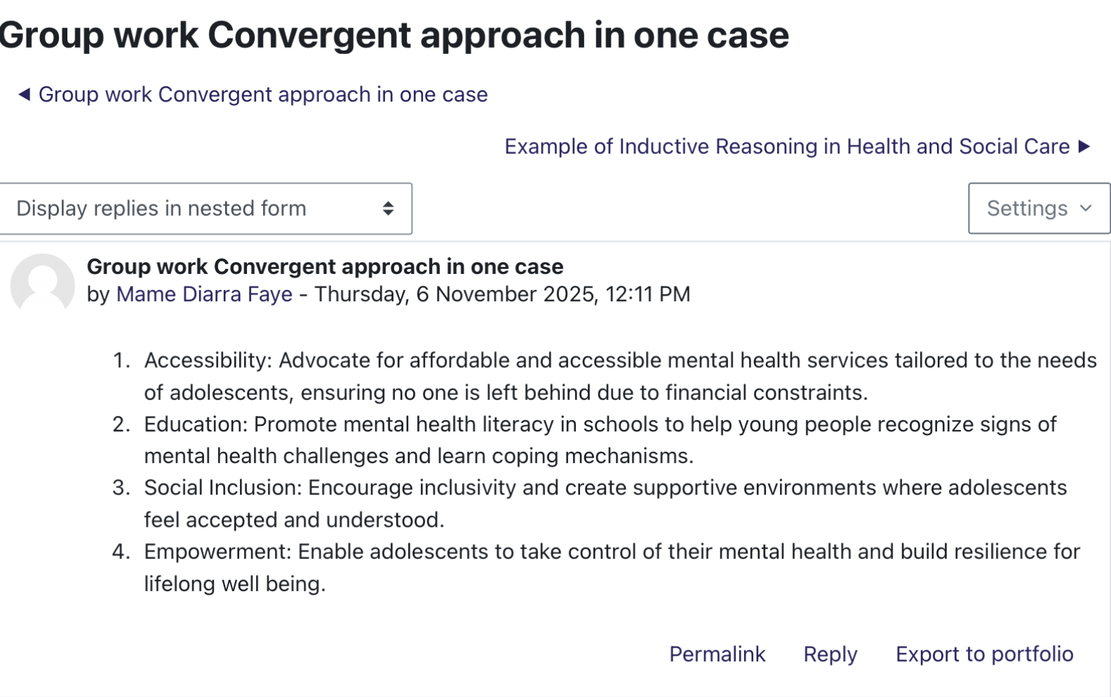

Task 4 - Case Study Analysis of a UK Innovation (200 words).
The NHS app is a major UK digital innovation created to improve patient access to healthcare services. Creativity was applied in its development through the use of user centred design, where NHS England worked closely with patients and clinicians to design simple digital solutions for everyday health needs (Reidy et al.,2025). This creative approach helped transform traditional administrative tasks into quick, self managed digital actions that are easier on for both patients and staff. The innovation was developed to address growing problems such as long GP phone queues, delays in booking appointments, difficulties accessing medical records, and rising pressure on primary care services. By allowing patients to book appointments, order repeat prescriptions, view test results, and access reliable health information directly, the app aimed to improve convenience, reducing waiting times, and support more efficient care. The value created by the NHS is significant. Patient gain greater control over their healthcare, staff spend less time on administrative tasks, and services can operate more efficiently with fewer delays. Evidence shows that the app has improved services delivery, with national data showing increase in digital prescription orders and appointment bookings(KC et al.,2024).
Overall the NHS app demonstrates how creativity and digital innovation can improve accessibility, efficiency, and patient experience across the NHS.
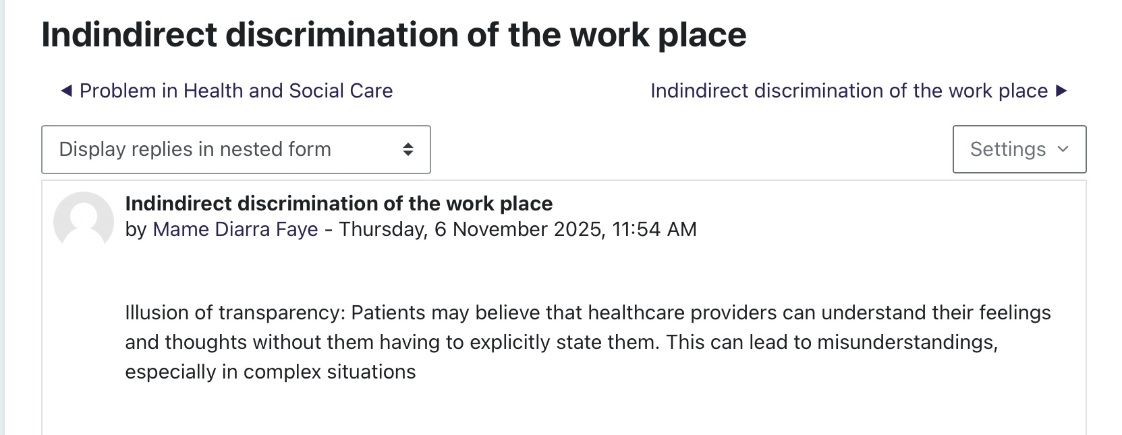

Task 5 - Research Task (200 words)
A major and growing issue in health and social care is staff burnout, many healthcare workers especially nurses now experience chronic exhaustion, mental strain, and emotional detachment, which undermines both their own health and the overall quality of care they provide. A recent meta analysis (Liang et al .,2025), found that during COVID19 pandemic around 48% of nurses experienced significant burnout. The study also showed that burnout was particularly high among nurses working in high stress environments such as ICUs, emergency departments or caring for COVID 19 patients. Contributing factors included long working hours, heavy workloads,, inadequate staffing, lack of organisational support, insufficient protective equipment, and poor working conditions factors, all of which worsened during the pandemic and increased pressure on staff.. Another useful source, factors affecting healthcare workers burnout and their conceptual models (De Heart, S.et al.,2024), reviewed many studies and identifies persistent occupational stress as the root of burnout among all healthcare professionals (not just nurses). This stress often due to excessive and prolonged workloads, understaffing, and organisation pressures, conditions common on health and social care system. The review argues that these systematic pressures (rather than individual weaknesses) largely explain why burnout remains high despite decades of research and ongoing attempts to improve working conditions.

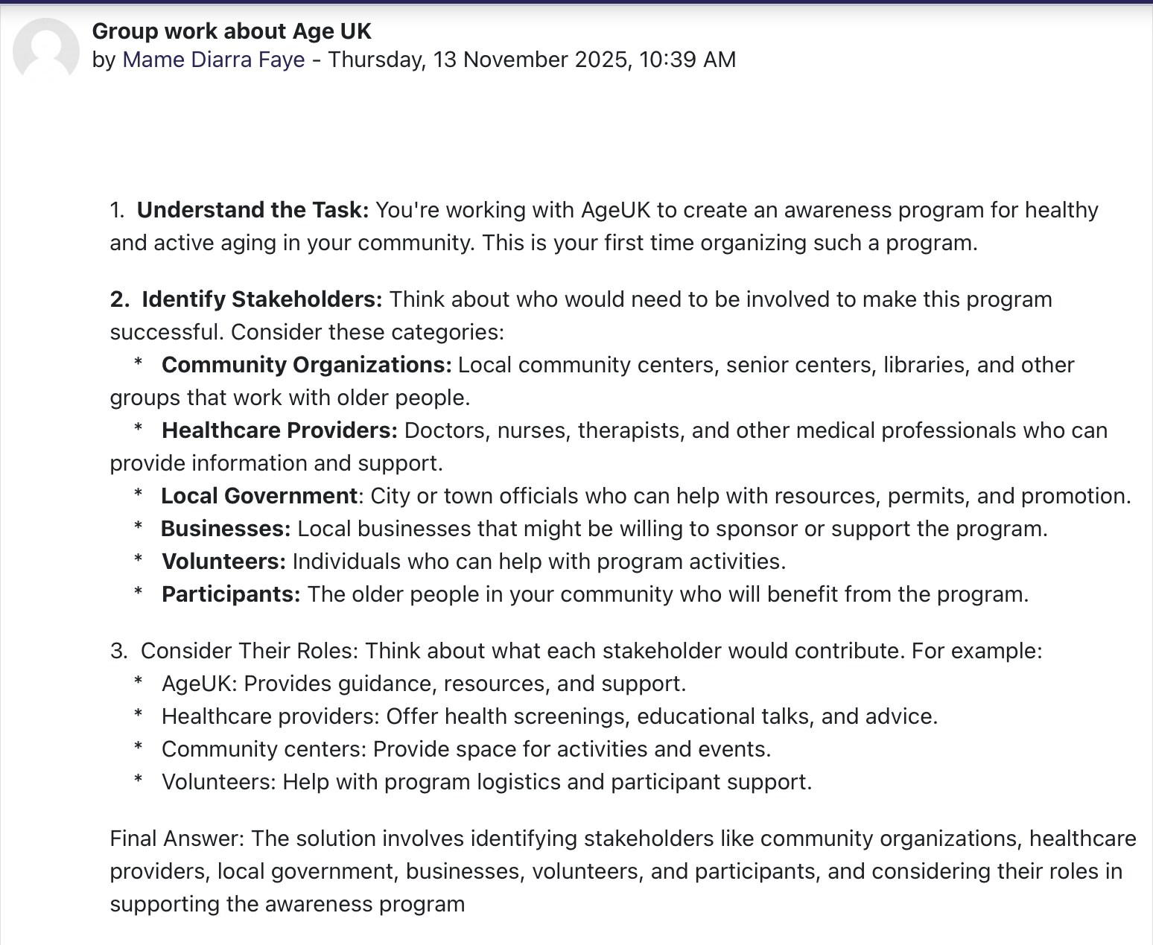
Task 6 - Exploring Digital Innovation in Health and Social Care (140 words each= 420 words in total)
Wearable health technologies, like smartwatches and fitness trackers, support people with chronic conditions by allowing real time monitoring of their health. A key benefit is that they help individuals track symptoms and detect changes early, which can prevent complications. For example, many smartwatches now monitor heart rate, sleep, and physical activity, and some can detect irregular heart rhythms. This means a person with a chronic condition such as hypertension or diabetes can notice unusual patterns quickly and take action. Wearable also allows data to be shared with healthcare professionals, helping them make faster more accurate decisions. Overall wearable increases patient involvement, improve self management, and reduce the need for unnecessary appointment by providing up to data health information.
Electronic health records (EHRs) improve communication and teamwork between healthcare providers by making patient information instantly accessible in one secure place. Instead of relying on papers notes or waiting for letters, professionals such as GPs, nurses, pharmacist, and hospital specialist can view the same update record. This helps reduce errors, prevent duplicate tests, and ensures everyone understands the patients needs. For example, if a patient with asthma is admitted to A&E, staff can immediately see their medication history, allergies, can past treatment. EHRs also support faster referrals because information can be shared electronically instead of through paperwork. This makes care safer, quickly, and more coordinated across services.
Digital technology plays a major role in preventing illness and promoting healthier lifestyles. Apps, online platforms, and digital monitoring tools can educate people, encourage behavior change, and help identify risk early. For example, the NHS app and other digital health apps provide reminders for vaccinations screening tests, and medication, helping people stay up to date with their preventative care. A hypothetical example could be a mobile app that tracks diet and exercise while sending personalised alerts high blood pressure risk. The app could also include educational videos about healthy eating or managing stress. This kind of technology supports people to take control of their health before conditions develop. It can also reduce pressure on healthcare services by encouraging early action and healthier habits.
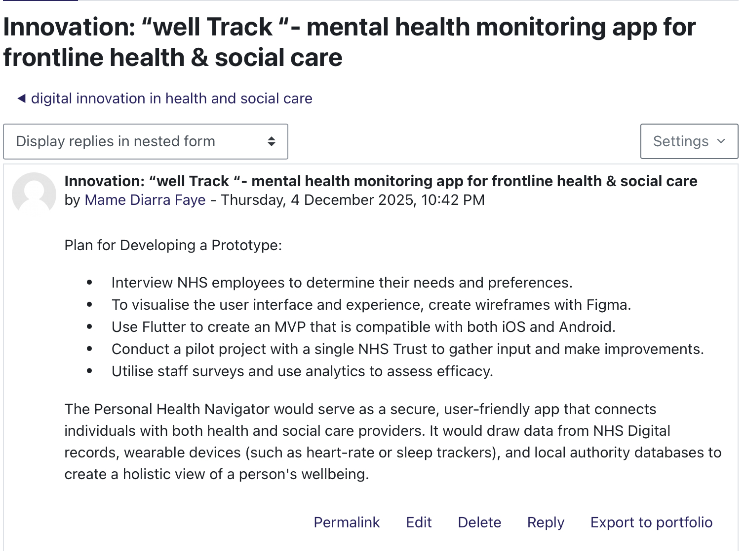

Task 7 - Understanding the NHS Leadership Framework (350)
The NHS leadership framework outlines the key behaviours, values, and skills that leaders at all levels in health and social care should demonstrate. It’s purpose is to support staff to work safely, collaborate effectively, and deliver high quality, person centred care. The framework includes behaviours such as inspiring shared purpose, leading with care, evaluating information connecting our service, holding to account, and developing capability. These behaviours help leaders create safe environments where staff feel supported and motivated. The framework is important because effective leadership directly influences patient outcomes, teamwork, and organisational culture. In health and social care, poor leadership can lead to mistakes, low morale, and unsafe practice, while strong leadership promotes innovation, better communication, and compassionate care. By using the NHS leadership framework, services can ensure consistent standard and develop staff who are confident, reflective, and able to improve patient experience.
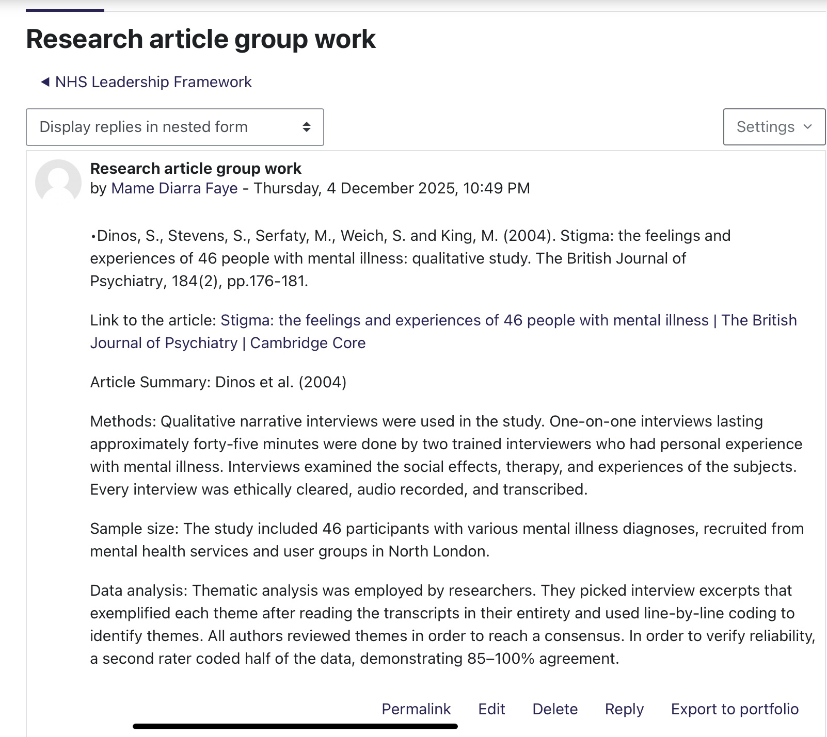
Leading with care means showing compassion, supporting staff wellbeing, and creating a safe environment where people feel valued. A leader can use this behaviour to encourage creativity by making staff feel comfortable sharing novel ideas without fear of judgment. When staff feel respected and listened to, they are more likely to speak up about innovative solutions that can improve patient care, such as new ways to deliver health education or streamline assessments. By checking in on staff offering emotional support, and recognising their effort, a leader builds trust helping the team confidently and creatively to meet patient and service user needs.

Task 8 - Self-Reflection Journal Entry (150 words)
Throughout this module, my understanding of creativity and value creation in health and social care has changed significantly. At the beginning, I thought creativity referred to big ideas or major innovations. However, I have learned that creativity can be small, everyday actions that make care safer, more personalised, and more efficient. For example, simple changes like improving communication tools, adapting assessments, or using digital technology in flexible ways can create real value for service users. Activities such as analysis digital innovations, exploring leadership behaviours, and completing the assignment helped me understand how creativity links to patient outcomes. I realised that creativity is not separate from clinical practice it is part of problem solving, teamwork, and responding to individual needs. Learning about framework like the NHS leadership framework also showed me how leadership can support creativity by encouraging collaboration, reflective practice, and continuous improvement. This learning will influence my future practice by helping me approach challenges with an open mind. Instead of sticking to routines, I will think about how to adapt and improve care. As a future health and social care professional, I want to contribute to environment where service user feel heard ands staff feel comfortable sharing ideas. Understanding creativity and value creation has made more confident in my potential to make a positive difference in people's lives.
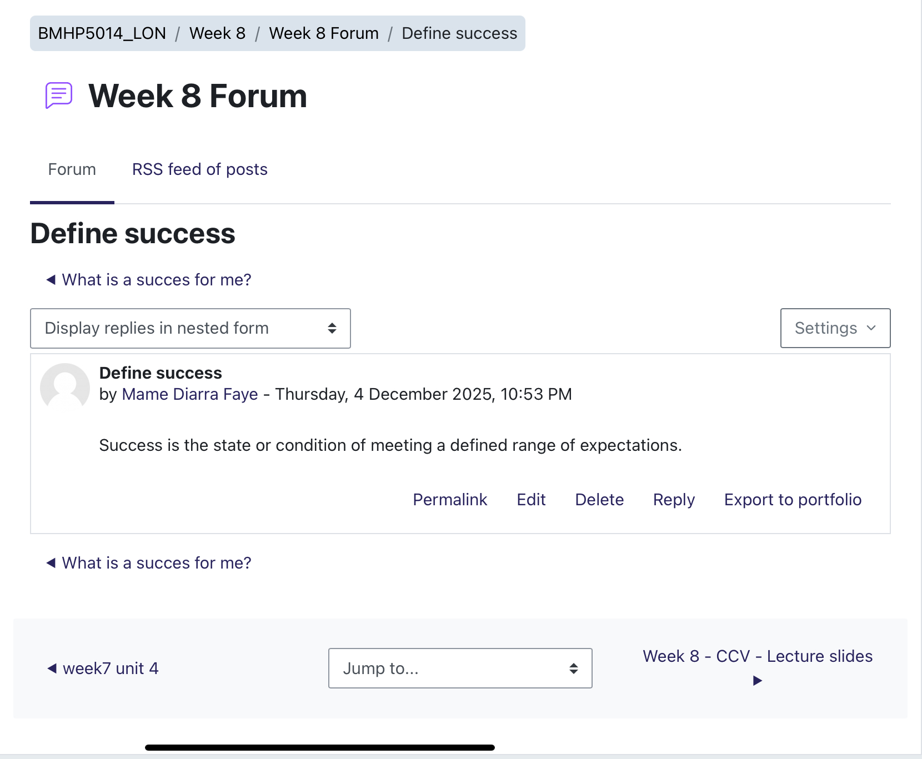

References
Care Quality commission (CQC), 2022. Innovation and why it is important. Available at https://www.cqc.org.uk/publications/themes-care/innovation-why-it-important (Accessed on 17 November 2025).

De Hert, S. et al. (2024) ‘Factors affecting healthcare workers burnout and their conceptual models: scoping review’, BMC Psychology, 12, Article 637. doi:10.1186/s40359-024-02130-9. Available at: https://bmcpsychology.biomedcentral.com/articles/10.1186/s40359-024-02130-9 (Accessed on 17 November 2025).

Harrison, R., Pappas, Y., and Powell, J.,2021. Where do models for change management, improvement and implementation meet? A systematic review of the literature. Journal of healthcare leadership, 13, pp.35-50. Available at https://pubmed.ncbi.nlm.nih.gov/33737854/ (Accessed on 17 November 2025).

Javaid, S.F. & Pandarakalam, J.P., 2021. The Association of Creativity with Divergent and Convergent Thinking. Psychiatria Danubina, 33(2), pp.133–139. Available at: https://hrcak.srce.hr/259485 [Accessed 19 Nov. 2025].

KC, S., Papoutsi, C., Reidy, C., Gudgin, B., Powell, J., Majeed, A., Greaves, F. & Laverty, A.A. (2024) ‘Differences in use of a patient portal across sociodemographic groups: Observational study of the NHS App in England’, Journal of Medical Internet Research, 26, e56320. Available at: https://www.jmir.org/2024/1/e56320/ (Accessed: 20 November 2025).

Landon ,S.,smith, R., and Brown, T., 2021. Defining value in health care: A scoping review. International journal for Quality in health care, 33(1). Available at https://pmc.ncbi.nlm.nih.gov/articles/PMC9162129/ (Accessed on 17 November 2025).

NHS England, 2019.Getting creative to change people's lives. Available at https://www.england.nhs.uk/blog/getting-creative-to-change-peoples-lives/ (Accessed on 17 November 2025).

NHS England (2022). Electronic Health Records and Integrated Care.
Available at: https://www.england.nhs.uk/digitaltechnology/ (Accessed on 17 November
2025).

NHS Leadership Academy (2011) The NHS Leadership Framework, p.6. Leeds: NHS Leadership Academy. Available at: https://www.leadershipacademy.nhs.uk/wp-content/uploads/2012/11/NHSLeadership-Framework-LeadershipFramework.pdf (Accessed on 17 November 2025).

NHS England (2023) about the NH app. Available at https://www.nhs.uk/nhs-app/about-the-nhs-app/
(Accessed on 17 November 2025).

Reidy, C., Papoutsi, C., KC, S., Gudgin, B., Powell, J., Majeed, A. & Greaves, F. (2025) ‘Qualitative evaluation of the implementation and national roll-out of the NHS App in England’, BMC Medicine, 23, p.20. Available at: https://bmcmedicine.biomedcentral.com/articles/10.1186/s12916-024-03842-w (Accessed: 20 November 2025).

The King’s Fund (2018) Leadership in today’s NHS: delivering the impossible. Available at: https://www.kingsfund.org.uk/insight-and-analysis/reports/leadership-todays-nhs

(Accessed on 17 November 2025).

