COUNTRY ANALYSIS FOR MARKET ENTRY
USA
(CALIFORNIA)
Introduction
PESTEL Analysis
- Political
- Economic
- Social
- Technological
- Legal
Transportation Infrastructure
Hofstede’s cultural analysis
- Social Trends
- Customer Behaviour
Market Evaluation
- Market size
- Porter’s Five Forces
Communication strategy
Pricing
- Cost
- Market demand
- Competition
Market Entry Method
Conclusion
Reference List
Appendices
- Appendix A: Model of Transportation Infrastructure
- Appendix B: Hofstede’s culture analysis
- Appendix C: Porter’s five forces

- INTRODUCTION
This project will examine the international market for entrance using various strategies. Large-scale and regional events are promoted by the organization. To determine the likelihood of entering a new market, the firm opted to analyze the potential of the US (California) market. The study will examine the viability of the indicated organization's entrance strategy by designing and criticizing it. The process will begin with an examination of the country's PESTEL and infrastructural elements. The cultural study of Hofstede will be given next, followed by societal trends and customer behavior. In addition, the author will evaluate the market size, Porter's Five Forces framework, and prospective strong rivals while analyzing the market. In addition, a communication strategy and price strategy will be discussed, as well as market segmentation and positioning. Finally, the study will show the chosen market entrance approach and determine whether or not joining this market is a good idea for the company.

PESTEL ANALYSIS
- Political
Political variables are important in determining the aspects that can affect California Resources Corporation's long-term profitability in this country or market. California Resources Corporation operates in Independent Oil & Gas in over a dozen nations, exposing itself to a variety of political risks and political systems. The only way to succeed in such a dynamic Independent Oil & Gas industry across multiple countries is to diversify the political environment's systematic risks. Before joining or investing in a market, California Resources Corporation can carefully consider the following factors:
- Political stability and the importance of the country's independent oil and gas sector to the economy.
- Military invasion threat.
- Corruption levels - particularly in the Basic Materials sector - are high.
- Government bureaucracy and intervention in the independent oil and gas business.
- Contract enforcement legal framework.
- Protection of intellectual property.
- Rates of taxation and incentives
- Legislation governing wages, such as the minimum wage and overtime pay.

- Economic
The aggregate demand and aggregate investment in an economy are determined by macroeconomic factors such as inflation rate, savings rate, interest rate, foreign exchange rate, and economic cycle. Microenvironmental elements such as competition standards have an impact on the firm's competitive advantage. California Resources Corporation can forecast the growth trajectory of not only the - sector but also the organization by looking at national economic factors like growth rate, inflation, and industry economic indicators like Independent Oil & Gas industry growth rate, consumer spending, and so on.
- Type of economic system in operation countries - what kind of economy exists and how stable it is.
- Intervention by the government in the free market, as well as related Basic Materials
- Exchange rates and currency stability in the host country.
- In the independent oil and gas industry, infrastructure quality is important.
- The host country's comparative advantages and the Basic Materials sector's comparative advantages in the certain country
- In the independent oil and gas industry, the workforce has a high degree of skill.
- In the economy, the level of education.
- In the economy, labour costs and productivity.

- Social
The culture and way of life of a society have an impact on the culture of an organisation in a given context. California Resources Corporation marketers will analyse the customers of a given market and build the marketing message for Independent Oil & Gas industry consumers based on shared views and attitudes of the people. Demographics and population skill level are two social elements that the leadership of California Resources Corporation should consider while doing a PESTEL analysis.
- In society, there is a class structure, a hierarchy, and a power structure.
- In the California Resources Corporation's industry, there is a high degree of education as well as a high standard of education.
- It is a matter of culture (gender roles, social conventions, etc.)
- The larger nature of society and the entrepreneurial spirit. Entrepreneurship is encouraged in some societies but not in others.
- Perceptions (health, environmental consciousness, etc.)
- Interests in leisure time.

- Technology
Across the board, technology is rapidly disrupting numerous businesses. The transportation business is an excellent example of this. Over the last five years, the sector has changed at a breakneck pace, leaving established players with little time to adapt. Uber and Lyft have dominated the taxi sector in recent years. The automotive industry is rapidly heading toward automation, with internet companies such as Google leading the way, and production is being disrupted by Tesla, which has declared an electronic car revolution. Understanding the following effects of technology is part of technology analysis:

- California Resources Corporation's competitors' recent technical breakthroughs Technology's impact on product offerings
- Impact on the independent oil and gas industry's cost structure
- In the Basic Materials sector, the impact on the value chain structure is significant.
- Diffusion rate of technology

- Legal
The legal framework and mechanisms in several nations are insufficient to protect an organization's intellectual property rights. Before entering such markets, a company should carefully consider its options because it could result in the theft of the company's secret sauce, reducing its total competitive advantage. Antitrust law in the Independent Oil & Gas industry and across the country are some of the legal concerns that California Resources Corporation leadership should examine before entering a new market.
- Anti-discrimination legislation
- Patents, copyright, and intellectual property law
- E-commerce and consumer protection
- Safety meant legislation
- Health and safety regulations
- Data Security

- Transport infrastructure
The American Road & Transportation Builders Association's economics and research team completed this study for the California Alliance for Jobs in Washington, D.C. (ARTBA). This
Dr. Alison Premo Black, the association's senior vice president and chief economist, did the analysis. (Appendix A)
The construction, maintenance, and operation of California's highway, street, bridge, and transit infrastructure is a major economic driver, generating an average of $200 billion in annual economic output, earnings, tax revenue, and user benefits over the next decade—returning $4.30 for every $1 spent on the system. Over 15,000 jobs are supported for every $1 billion spent across the economy.
The overall investment will support 700,000 jobs on an annual basis and contribute $52 billion to California's Gross State Product (GSP), accounting for approximately 2% of total economic activity.
There are additional benefits for California citizens and businesses that are not included in this analysis, such as increases in business productivity from better access to workers, suppliers, and consumers.
- The benefits of state highway, street, bridge, and transit investments, based on the predicted mix of capital projects and operations, include:
- Sales and revenue by state enterprises of about $101.5 billion each year, totalling $1 trillion over ten years. This is true in every sector of the economy.
- This will support an average of 700,000 jobs per year, with growing investment generating over 200,000 new jobs over the following decade.
- Over the next ten years, those workers will earn an average of $30.3 billion every year, totaling $303 billion in additional wages.
- These revenues are part of the $52 billion in annual value-added that these companies generate to the state's gross domestic product (GDP), accounting for 2% of the total.
- Tax collection from economic activity will average $21.2 billion per year for the federal, state, and local governments, totaling $212.2 billion for the decade.
- Estimated revenues from personal income, business, corporation, and sales and use taxes are included.

- Hofstede’s cultural analysis
Using innovative methodologies to the study of organizational culture and how to positively impact it, Hofstede Insights is uniquely positioned to provide a detailed grasp of the present cultural landscape. Professor Geert Hofstede, who performed one of the most complete studies on how culture influences workplace values, was instrumental in the company's founding. Hofstede Insights (2020) present USA (California) cultural dimensions analysis
(Appendix B)

- POWER DISTANCE
Because everyone is different, it follows that we are all unequal. The degree of power one individual has or can have over other people is one of the most conspicuous features of inequality; power is defined as the degree to which a person can influence other people's views and conduct.
This component deals with the fact that not everyone in a society is equal, and it represents the culture's attitude regarding power imbalances among people.

- INDIVIDUALISM
The degree of interconnectedness that society maintains among its members is the key problem addressed by this dimension. It has to do with whether individuals describe their self-image as "I" or "We." Individualist civilizations expect people to just care about themselves and their immediate families. People in Collectivist societies are members of "in groups" that look after them in exchange for unwavering devotion.
The relatively low Power Distance (40) combined with one of the world's most Individualist (91) civilizations reflects itself.

- MASCULINITY
The United States has a high Masculinity score of 62, which may be noticed in typical American behavioural patterns. This is explained by the combination of a high Masculinity drive with the world's most Individualist drive. In other words, each American expresses his or her Masculine drive in a unique way. The British, on the other hand, have the same culture in this regard. As a result, the query should be: is the same drive not generally visible on the surface? This disparity reflects the US's greater Uncertainty Avoidance score than the UK's. In other words, we find the same desire in all civilizations, but Americans express it upfront, whereas the British will catch you off guard.

- UNCERTAINTY AVOIDANCE
On the Uncertainty Avoidance dimension, the United States ranks below average, with a low score of 46. As a result, the perceived environment in which Americans find themselves has a greater influence on their conduct than if the culture had scored higher or lower.

- LONG TERM ORIENTATION
Low-scoring normative cultures, for example, seek to uphold time-honored traditions and norms while viewing societal change with skepticisms. Those with a high-scoring culture, on the other hand, adopt a more realistic approach: they advocate prudence and investment in contemporary education as a means of preparing for the future.
With a score of 26, the United States falls into the normative category in the fifth dimension.

- INDULGENCE
A propensity toward a relatively poor control over their impulses is referred to as "indulgence," whilst a predisposition toward a relatively strong control over their cravings is referred to as "restraint." Cultures can be classified as either indulgent or restrained. On the sixth dimension, the United States ranks as an Indulgent (68) society. When combined with a normative score, this results in the following contradicting attitudes and behaviors.

- Social trends
America is getting old. Over the last decade, Americans over the age of 65 have increased to account for 20% of the U.S. population. our market economy gets most of the credit for the increase in American life expectancy from 47 to 77. Infant mortality fell by 93%, while polio, TB, typhoid, and whooping cough were all eradicated by the twentieth century. The significant growth in life expectancy places strain on a social security system that was not designed to cover the retirement of residents in their nineties, who are supported by a dwindling pool of younger contributions.
On the other end of the scale, Generation Z (those aged 7 to 22) now account for a quarter of the worldwide population and spend more than $143 billion in the United States alone. Gen Z will have its own spending patterns as well as idiosyncrasies. They will not be contacted by television or email.

- Customer behavior
C.A. Cole, in Encyclopedia of Gerontology (Second Edition), 2007
Consumer behavior refers to the mental and physical behaviors that people participate in when looking for, assessing, purchasing, and consuming items and services. Consumers trade limited resources (such as money, time, and effort) for valuable things in the marketplace. A consumer researcher investigating how consumers buy long-term care insurance might look into (1) the characteristics of consumers who buy it (e.g., income, age, lifestyle), (2) where they buy it (e.g., from an agent vs. from an 800 number listed in an advertisement), (3) when they buy it (e.g., after a critical event such as a parent's illness or after seeing an ad), and (4) how they buy it.

- MARKET EVALUATION

- MARKET SIZE

In 1987, the market value of organically farmed vegetables in California was projected to be between $54 and $68 million at wholesale rates. This market is expanding at a rapid pace. In 1987, the value of organically cultivated vegetables increased by 41 percent. When this research was performed in early 1988, it was predicted that the market's wholesale value would approach $300 million by 1992. A sample investigation of organically produced broccoli price and volume from 1986 to 1987 revealed relatively stable pricing and a volume rise of more than 50%, implying a corresponding increase in market demand. Organic produce prices are much higher than conventional produce prices; nevertheless, despite considerable weekly volume fluctuation, organic prices tend to be less volatile than conventional produce prices. This article suggests that the collecting, reporting, and analysis of organic produce market data be continued and enhanced, as well as the incorporation of new data sources to assure the continuous availability of current market information

- PORTER’S FIVE FORCES

This article (2017) suggests that the collecting, reporting, and analysis of organic produce market data be continued and enhanced, as well as the incorporation of new data sources to assure the continuous availability of current market information. More market knowledge could boost efficiency and promote the growth of the organic goods business. The article also suggests that general trends in the organic produce business be routinely tracked by Federal-State Market News, and that increasing use of market information by organic producers, growers contemplating a transition, and other industry stakeholders be encouraged (Appendix C).
Porter’s five forces are:

- Threats of New Entrants
New entrants in the independent oil and gas industry offer innovation and new ways of doing things, putting pressure on California Resources Corporation through a reduced-price approach, cost reductions, and new value propositions to consumers. To maintain its competitive advantage, California Resources Corporation must handle all of these difficulties and construct effective barriers.

- Bargaining power of suppliers
Powerful suppliers in the Basic Materials industry utilize their bargaining leverage to exact higher prices from Independent Oil & Gas businesses. Higher supplier negotiating power has the overall effect of lowering Independent Oil & Gas profitability.

- Threat of substitute product/services
Almost all firms in the Independent Oil & Gas industry obtain their raw materials from a variety of vendors. Suppliers in dominating positions might reduce the market margins that California Resources Corporation can generate.

- Bargaining power of buyers
Buyers may be a demanding bunch. They want to get the greatest products offered at the lowest feasible price. In the long run, this put a strain on California Resources Corporation's profitability. The smaller and more strong California Resources Corporation's client base, the greater the customers' bargaining strength and capacity to demand growing discounts and offers.
- The industry competition
If competition among current participants in a sector is fierce, it will push down prices and reduce the business's total profitability. California Resources Corporation works in the highly competitive Independent Oil and Gas market. This rivalry has an impact on the organization's overall long-term profitability.

- Communication strategy
We propose to strengthen the ERC's collaboration with our main communication partners in 2021 (including National Contact Points, Host Institutions, the Euraxess Worldwide Network, and R&I Science Counsellors in EU Delegations, European Commission services). The ERC's 10,000th grantee celebration will give a critical chance to connect and mobilise these partners. They will also play an important role in distributing information about the ERC's grant programs and funding possibilities.
In accordance with the ERCEA's internal communication and employee engagement plan, we intend to give further chances for workers outside the Communication Unit to participate as ERC ambassadors next year. This will involve more training in many facets of communication, such as coaching for online speaking, as well as increasing engagement of employees in virtual events. We will increase ERCEA collaboration in order to convey the outcomes of ERC-funded initiatives, incorporating coaching for online speaking, particularly in relation to greater staff engagement in virtual events We will increase collaboration within the ERCEA in order to convey the results of ERC-funded studies, including policy input and science advice to policymakers.
- Pricing techniques
- Cost
The real cost of creating and getting a product to market is critical in establishing if exporting is financially viable.
- When using the cost-plus technique, the exporter begins with the domestic production cost and adds administration, R&D, overhead, freight forwarding, distributor margins, customs duties, and profit. However, if exporting costs are included in, this pricing strategy may cause the export price to rise into an uncompetitive range.
- A more competitive approach of pricing a product for market entrance is marginal cost pricing. The direct out-of-pocket costs of manufacturing and selling items for export are used as a floor below which prices cannot be set without suffering a loss.

- Market demand

Per capita income is a good indicator of a market's capacity to pay for most consumer products. Some items (for example, well-known American fashion labels) have such high demand that even low per capita income has little effect on their selling price. In markets with low per capita income, simplifying the product to lower the selling price may be an option for your organization. Currency changes may affect the affordability of your products, so keep that in mind.

- Competition
Companies in the United States carefully examine their competitors' pricing policies in the domestic market. In each possible export market, you'll also need to assess rival prices. If there are a lot of rivals in the foreign market, you might have to match the market pricing or even underprice the product or service to gain a foothold. However, if a product or service is new to a foreign market, it may be permissible to charge a greater price than is possible in the native market.

- Market Entry Method
Leih, S. Teece, D. (2014), Market entry strategies, In D. Teece and M. Augier (eds). Palgrave Encyclopedia of Strategic Management, London. UK: Palgrave Macmillan.

The business tactics employed by a company in terms of market selection, market entrance timing, and entry method can have a substantial impact on the company's performance. Control, experience, and cultural distance may all impact a company's market entrance strategy, such as whether to go with licensing or franchising, or whether to go with joint ventures or wholly owned subsidiaries. Scholars have looked at the decision to enter a market from a variety of theoretical viewpoints, including transaction cost economics, the resource-based approach, the capacities perspective, and the eclectic framework.

- Conclusion
To summarise, it has been demonstrated throughout the study that the United States (California) is a contemporary, stable, democratic country with great economic freedom. Political and economic stability fostered an autonomous and innovative community that values a high quality of life and prefers to spend money on family and leisure activities. The research has demonstrated that, if addressed correctly, the US market has a lot of opportunity for new, international enterprises. Furthermore, the California events sector, as well as the e-commerce market, provide several opportunities for the organization's expansion. The organisation can reach diverse sectors of the market and fulfil the market's value and quality criteria by offering a wide range of different sorts of approaches. To reach a larger audience, promote the business, and establish solid relationships with customers, social networking websites, outdoor advertising, and direct marketing were used.

- Reference List
Pestal analysis of usa market available at:
http://fernfortuniversity.com/term-papers/pestel/nyse4/112
-california-resources-corporation.php
Pestal case study of different market available at:
https://embapro.com/frontpage/pestelcase/2810-calpers-pers
( JayO. Light, Jay W. Lorsch, James E. Sailer)
transportation infructure (2017) available at:
https://infrastructurereportcard.org/wpcontent/uploads/2021/07/FullReport-CA_051019.pdf
planning infrature available at:
https://www.ebudget.ca.gov/2021-Infrastructure-Plan.pdf https://www.catransportationjobs.com/impact-results/?lstSectors=4%2C9&lstSpending&lstLocations&lstRegions=999&locationtype=stahttps://www.catransportationjobs.com/wp-content/uploads/2021/07/California
Cullture differnce of callifornia market available at:
https://www.businesswire.com/news/home/20210203005147/en/Hofstede-Insights-a-Leader-in-Organizational-Culture-for-Major-Multinationals-Enters-U.S.-Market-During
sales@hofstede-insights.com available at:(2020)
https://www.hofstede-insights.com/country/the-usa/
social trend by Marc EmmerNovember 19, (2019) available at:
https://www.vistage.com/research-center/business-financials/economic-trends/20191119-social-trends-impacting-business-in-2020-and-beyond/
Consumer Behavior
C.A. Cole, in Encyclopedia of Gerontology (Second Edition), 2007
available at:
https://www.sciencedirect.com/topics/psychology/consumer-behavior
An analysis of the California market for organically grown produce
Published online by Cambridge University Press: 30 October 2009
Availableat:
https://www.cambridge.org/core/journals/american-journal-of-alternative-agriculture/article/abs/an-analysis-of-the-california-market-for-organically-grown-produce/ED222291AA7842C4C720D6FC96E9C904
porter five forces of California (2017)
available:
http://fernfortuniversity.com/term-papers/porter5/analysis/112-california-resources-corporation.php
communication stragey (2021)available at:
https://erc.europa.eu/sites/default/files/document/file/ERC_CS2121.pd
pricing techniques(2014) available at:
https://www.trade.gov/pricing-strategy
Market Entry Strategies (2015)
Leih, S. Teece, D. (2014), Market entry strategies, In D. Teece and M. Augier (eds). Palgrave Encyclopedia of Strategic Management, London. UK: Palgrave Macmillan. available at:
https://papers.ssrn.com/sol3/papers.cfm?abstract_id=2673042

Appendices
Appendix A: Model of transportation infrastructure
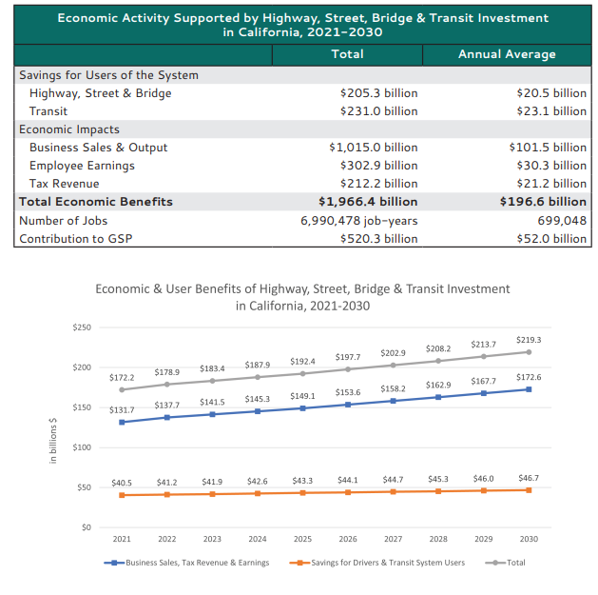
Appendix B: Hostede’s Analyse
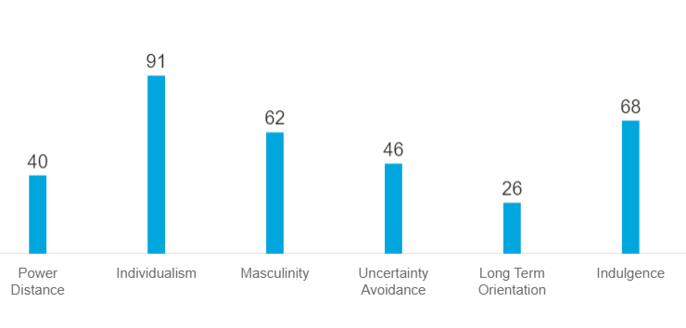
Appendix C: Porter’s Five Forces


