
APPENDIX GA36a

LEVEL 4 ASSESSMENT SPECIFICATION

Student name: | Gareth Finnegan | Student ID number: | 156038
Programme: | HNC Electrical and Electronic Engineering, HNC Instrumentation Engineering.
Module: | Industrial Measuring Systems
Module code: | PCEE4003 | Contribution to Overall Module Assessment (%): | 100%
Lecturer: | Anthony Howles | Internal Verifier: | Jason Pointer
Assignment Title: | Measurement systems | Word count (or equivalent): | 2000
Submission deadline: | 25/05/2022 | Return date of provisional marks & written feedback: | 08/06/2022
Submission method: | All written assessments, where practical and possible, must be submitted via Turnitin unless otherwise instructed by the Lecturer. (Please DO NOT put this assessment specification into Turnitin or it will match many similarities with other students’ submissions.)  Alternative submission method (if applicable):  Late submission of the assessment will result in a late penalty mark. Penalties for late submission: Up to one week late, maximum mark of 40%. Over one week late, 0%. Only the Extenuating Circumstances Panel may approve a change to submission dates.
Academic honesty / referencing: | Academic honesty is required. In the main body of your submission you must give credit to authors on whose research and ideas your work is based. Append to your submission a reference list that indicates the books, articles, etc. that you have used, cited or quoted in order to complete this assessment.

Module Learning Outcomes
(from module syllabus)
LO1, LO2.

TASK DESCRIPTION

Assignment Brief

For this assignment, you are required to complete six tasks that investigate sensor operation and characterisation, signal processing, signal transmission, open and closed loop control.

Task 1. Pressure sensor

To measure and indicate a process pressure value, analogue or digital systems could be used. For this task evaluate the two technologies with respect to an analogue bourdon tube pressure gauge and a digital pressure gauge employing a resistive strain gauge sensor (see figure 1). Compare and contrast these two instruments with respect to their principles of operation and their static and dynamic characteristics. Include any advantages and disadvantages for each of the measuring technologies in your answer.

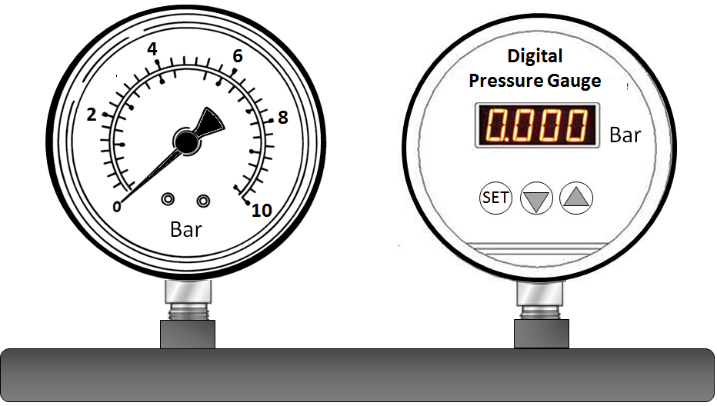

Figure 1. Analogue and Digital Pressure Gauges

Analogue pressure gauge
An analogue pressure gauge is used to read the pressure in a system and display the value of that pressure on a dial. It can be used in industrial services to measure different types of products and gases. It displays values of different ranges across a dial and uses a pointer to indicate the value.

There are many different pros and cons for using an analogue pressure gauge. One advantage of using a bourdon tube is that it is a simple construction and are easy to obtain. This is useful in situation where one may break and need to be replaced with a new one in a short period of time. They last for a long time, so they do not need to be replaced often. As well as that, they are a cheap item which means buying them and keeping them can come at a low cost. They have a wide array of different ranges, and they can measure small ranges as well as large ranges and the accuracy in which they measure to is high.
However, there are also a few cons with the analogue bourdon tube. One con is that they are susceptible to hysteresis. This means that their reaction time to the pressure changing may be slightly slow. Another disadvantage of a bourdon tube is that if they are in a noisy environment, vibrations can cause the pointer to shake which could give a false reading to the user.

With respect to a bourdons tube static characteristic, the sensitivity error of a bourdon tube is 2.5% of its full scale. The accuracy of a bourdon tube sits at around 0.25 to 1% of its full scale which is accurate. However, the drift on a bourdon tube can be caused from vibrations in the area that the gauge is located. If it is placed in a noisy environment the pointer may shake and outputs may vary. The range of a bourdon tube is extremely high and can measure pressure values ranging from 0.6 bar up to 7000 bar.
With regards to the bourdon tubes dynamic characteristics, the reaction time of a bourdon tube isn’t very quick and responds to process change slowly. A bourdon tube may take its time to settle out as the pressure changes are not picked up immediately by the bourdon tube.
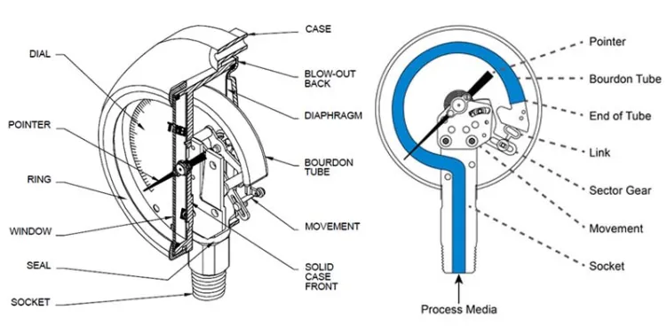

Resistive strain gauge
A resistive strain gauge is a pressure gauge that uses a resistance element that changes with respect to the change in pressure. As the pressure increases, the strain increases which outputs a larger resistance which causes the dial reading to change accordingly. However, the strain also is subject to change from temperature change, so compensation needs to be made for the effects of temperature change. The resistive strain gauge is put into a Wheatstone bridge and as the resistance changes, the output signal changes.

There are many different pros and cons that come with using a resistance strain gauge. One advantage of using a strain gauge is that there are no moving parts involved with the instrument. This means there will be less wear and tear with the device which means it will last longer than a bourdon tube. Another advantage is that the accuracy of the strain gauge is very high. They are small devices and can be bought at a low cost.
A disadvantage of using a strain gauge is that they are non-linear. Another disadvantage is that they are very sensitive to temperature, so the instrument needs to be compensated for in order to deal with the change in temperature, to avoid any inaccurate results. They also need to be calibrated regularly to ensure they are working appropriately.

Regarding their static characteristics, the resistance strain gauge is very sensitive to temperature change. The increase in temperature of the resistive measuring device can cause an increase in resistance which would give faulty readings. This can be compensated for by using an extra resistance detector. Resistance strain gauges have a very high degree of accuracy. They can measure pressure within +/- 1 x 10⁻⁶mm. Due to the change in temperature, this can cause slight drift as the resistance changes with temperature change. The resistive strain gauge can measure up to 700 ohms.
When looking at the dynamic characteristics of the resistance sensor, the reaction time is quick with respect to the change in pressure.
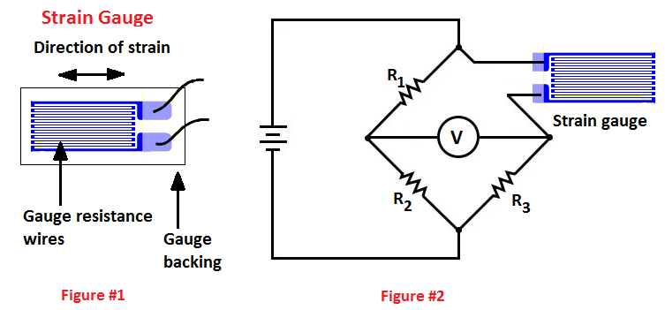

Task 2. Position sensors

- Identify a sensor that could be used to measure the angular velocity of an electric motor from 0 to 1000 RPM.

- Identify a sensor that could be used to measure the rotation of a 3-way ball valve through 180° operation. In addition, there is a requirement to indicate the operation of the valve from 0 to 100 % of its travel in both the forward and reverse action.

For both answers include an explanation of the sensor’s construction and its principle of operation. Include a data sheet for a commercially available sensor of the type you are proposing for each of the applications.

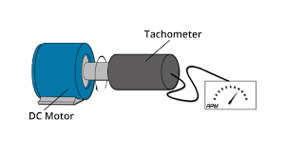
One sensor that could be used to measure the rotary speed of an electric motor could be a tachometer. A tachometer can read and display the speed of a rotating shaft. They unit of measurement used for a tachometer is revolutions per minute (RPM). The electric tachometer can work out the angular velocity by measuring the angular voltage. The angular velocity and voltage of the motor are directly proportional to one another. The type of tachometer that will be used in this application is an electric DC tachometer. The voltage that is created in the conductor is caused by the perpendicular motion between the magnetic field and the conductor.
A DC tachometer has a permanent magnet and a small armature. The armature is connected to the shaft of the motor which is placed in between the two poles of the magnet. As the shaft rotates, each time the armature passes the poles, an electromagnet force is created. This emf is directly proportional to the speed that the shaft is rotating at. Voltage is then created by the commutator and brushes when the armature passes this point. This voltage can then be measured and used to display the rpm of the motor. The polarity of the emf that is created determines the direction in which the motor is spinning.
 Datasheet for a tachometer

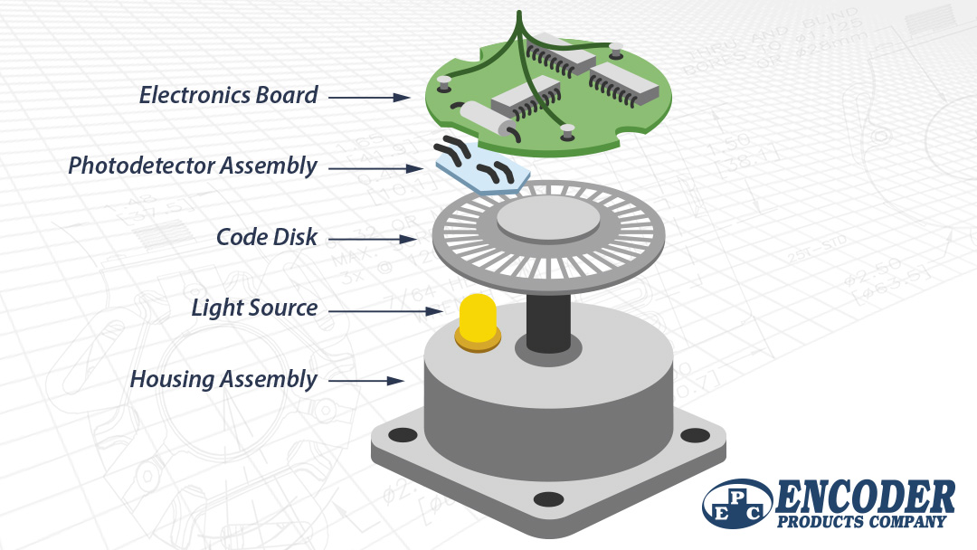
There are a few different ways to measure the rotation of a three-way ball valve. One way is to use an encoder. An encoder can sit on the shaft of the valve and as it rotates it can display a position from 0-100%. The job of an encoder is to turn a mechanical movement into an electrical signal which is ideal for displaying the rotation of the three-way valve.
The main parts of an encoder include an encoder shaft, a rotary disc, a light source with electronic board, receiving infrared photosensor, an optical mechanical block with gears and an electronic board with signal processors and digital interface converters. These parts come together to produce the encoder that will be used to calculate the rotation of the three-way valve.
The type of encoder that will need to be used to determine the position of the three-way valve will be an absolute encoder. An absolute encoder can determine the value of the shaft whilst it is moving and whilst it is stationary. The encoders shaft will have strictly defined optical code which allows the signal receiver to determine the exact position of the valve in an electrical signal.

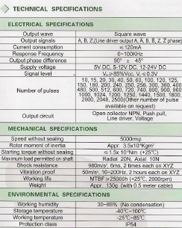 Data sheet for encoder

Task 3. Temperature Sensor characteristics

A PT100 platinum type RTD is being used to measure the temperature of a process from 0 °C to 100 °C. The RTD being used has a temperature coefficient of resistance of 3.85 x10⁻³ ⁰C. For this task, use these values to answer the following questions.

- Calculate the resistance of the sensor at 5°C intervals from 0 °C to 100 °C. You may use a table to collate your results but include all calculations in your answer.

- The platinum RTD is to be used in a voltage divider circuit (Fig 3.1 – Voltage Divider). If the supply voltage (V_{s}) is 10v, R = 100 Ω and R_{t} is the platinum RTD calculate the circuit output for the same range of temperatures in question 1a. You may add a separate column to your table to show these results but include all calculations in your report.

Resistance = 100 x (1+0.00385 x °C)

Resistance at 0°C = 100 x (1+0.00385 x 0) = 100Ω
The remaining results for resistance at each temperature can be seen in the table below.

Voltage output = 10 x Rt / (100+Rt)

Voltage output at 0°C = 10 x 100 / (100+100) = 5V
The remaining results for voltage output can be seen below.
Temperature (⁰) | Resistance (Ω) | Output Voltage (V)
0 | 100 | 5
5 | 101.925 | 5.05
10 | 103.85 | 5.09
15 | 105.775 | 5.14
20 | 107.7 | 5.19
25 | 109.625 | 5.23
30 | 111.55 | 5.27
35 | 113.475 | 5.32
40 | 115.4 | 5.36
45 | 117.325 | 5.40
50 | 119.25 | 5.44
55 | 121.175 | 5.48
60 | 123.1 | 5.52
65 | 125.025 | 5.56
70 | 126.95 | 5.59
75 | 128.875 | 5.63
80 | 130.8 | 5.67
85 | 132.725 | 5.70
90 | 134.65 | 5.74
95 | 136.575 | 5.77
100 | 138.5 | 5.81

- Assuming the input and output responses of the sensor are linear, determine the sensitivity of the circuit.

Sensitivity = difference in output / difference in input
At 60⁰C to 80⁰
Sensitivity = (5.67 – 5.52) / (80 – 60)
= 0.0075V = 7.5mV

- The temperature sensor has a first order response with a time constant of 5ms. Plot the output response to a step change in input from 0 °C to 50 °C in 1ms steps until a steady state condition is achieved.

T = T₀ (1 – e^{-t/₸})
T = output temperature
T₀ = final (steady state) temperature
t = time
₸ = time constant = 5ms
Time (ms) | Temperature (ᵒ)
0 | 0
1 | 9.06
2 | 16.48
3 | 22.56
4 | 27.53
5 | 31.61
6 | 34.94
7 | 37.67
8 | 39.91
9 | 41.74
10 | 43.23
11 | 44.46
12 | 45.46
13 | 46.29
14 | 46.96
15 | 47.51
16 | 47.96
17 | 48.33
18 | 48.63
19 | 48.88
20 | 49.08
21 | 49.25
22 | 49.39
23 | 49.50
24 | 49.59
25 | 49.66
26 | 49.72
27 | 49.77
28 | 49.82
29 | 49.85
30 | 49.88
31 | 49.90
32 | 49.92
33 | 49.93
34 | 49.94
35 | 49.95

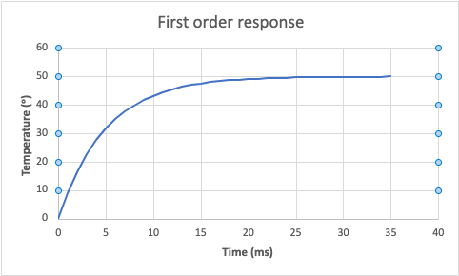

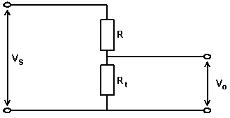
(Fig 3.1 – Voltage Divider)

Task 4. Indicators

- Explain the difference between an LCD and a LED seven segment display. Include in your answer advantages and disadvantages for each.

LCD stands for Liquid Crystal Display whereas LED stands for Light Emitting Diode. An LED is a PN junction diode that emits light when a current passes through it. As the current passes through, heat and light are both generated and emitted. An LCD uses a dot matrix and has a liquid crystal filament which is filled between the transparent electrodes. When the current passes through the electrodes, the filaments then become energised which emits light.

The main difference between an LED and an LCD seven segment display is that the LCD display uses liquid crystal light to display its light whereas an LED lights up when current passes through it. The liquid crystals are filled between the glass electrode, light is emitted when a power is applied across the liquid crystals. Another difference is the quality of resolution that the screens display. The resolution of an LED display is much better than those on an LCD. An LED consumes a lot more power than an LCD due to the plasma in the LCD that requires less power to be activated. The area of which an LCD emits its light is much greater than the LED as the PN-junction is the LED only displays light in one direction and the LCD displays light in all directions. An LED is more expensive compared to the LCD. You can turn an LED display off and on much faster than an LCD.

One advantage of an LCD is that they are very energy efficient. They also last for a very long-time which means they wouldn’t need to be changed often. Most LCD’s last for up to 60,000 hours depending on how often it is used. Another advantage is that there is no screen burn-in with LCD’s. This can occur when something is displayed on a screen for too long and gets imprinted onto the screen. An LCD doesn’t allow this to occur no matter how long something is left on the screen.
There are also a few disadvantages with an LCD. One disadvantage is that in high temperatures the contrast is decreased. Another disadvantage is they aren't very visible in bright areas. They also produce a lot of heat which is just waste energy.

One advantage of an LED seven segment display is that they are very cheap to buy. Another advantage is that they are very efficient. Another advantage is that they do not waste energy by emitting heat, this increases the life span of the device.
One limitation of using an LED seven segment display is that they can only display numbers from 0-9 and a few alphabets.it is also difficult to interface with controllers as the two types of displays are similar.

- Explain the operation of an analogue to digital conversion (ADC) process that could be used to turn a 4 to 20 mA signal into a digital indication. Include sensitivity, resolution quantization and quantization error in your explanation.

An analogue to digital converter is used to read analogue signals from sensors and turn them into digital signals so they can be read and understood by the user. It takes a voltage reading at a specific time and makes a digital output code which represents the voltage value. Binary digits or bits are then used to convert the digital voltage into an analogue voltage. The number of binary digits or bits depend on the resolution of the converter.
An example of where an analogue to digital convertor can be used is with a pressure transmitter. The pressure transmitter can read the pressure of a system and convert it to a 4-20mA signal. This 4-20mA signal has a direct relation to 1-5V. It can be converted from 4-20mA to 1-5V by using a 250Ω resistor. This 1-5V signal can be used to display the pressure reading using an LED indicator.
The sensitivity of an ADC is the smallest amount of change that the ADC can detect. A 0-5V ADC would be used as it would be able to measure the appropriate voltage with the best sensitivity. If a 0-10V ADC was used, then the sensitivity would not be as good.
Resolution is the range of different numbers or bits that the ADC can detect. The amount of resolution influences the quantization error that happens. Quantisation error is a rounding error that occurs between the analogue input voltage and the output digitized value.

Task 5. Signal transmission

- Explain the advantages and disadvantages of current and voltage signal transmission.
One of the main advantages of using current signal transmission is that they can be run over long distances with a small amount of signal drop. A varying current loop load impedance or change in supply drop will not affect the signal, unless the varying current or voltage exceeds the recommended component limits. They have a good signal with a low electromagnetic susceptibility. Cable wire is cheaper as they only require 2 wires to work. Another advantage is that you can see if the equipment has failed as it will read below 4mA. You can get a live zero at 4mA.
One disadvantages of using a current signal transmission is that they consume a large amount of power compared to other analogue signal types. Another disadvantage is that an elevated output is required for a zero. By increasing the load resistance of the circuit, the supply voltage supplying the transmitter will decrease.
One advantage of using a voltage signal to transmit a reading is that it is easier to measure. You can also amplify a voltage signal however amplifying the voltage causes the cables to make more noise which can result in an inaccurate signal.
When using voltage to transmit a signal, voltage drop occurs quite frequently especially over long distances. This means that the voltage detected by the transmitter may be much higher than the voltage in the control room. This causes inaccuracies with the readings. Therefore, voltage transmission is generally not used.

- The output signal from a measurement system typically has to be processed in some way to make it suitable for the next stage of the process. Explain the operation and identify reasons why the five processes listed would be applied to a measurement signal:

- Conversion
Conversion is used to change one signal to another signal. This may be required to change a voltage signal into a current signal so that it can be transmitted accurately over a long distance. One type of conversion that is used is changing voltage to milliamps. An example of where this is used is in a thermocouple. The thermocouple reads the temperature in millivolts before it is converted into milliamps so that it can be transmitted back to the control room and read from 0-100% so the operator can read it. It is also converted so the signal is transmitted back to the control room accurately as transmitting millivolts over a long distance wouldn’t be very accurate.
- Amplification
Amplification is used when transmitting a signal to ensure that the signal reaches its desired destination whilst showing an accurate reading. One type of amplification that is used is an op-amp. Op-amps are used to increase and drive weak signals over long distances. An OP amp has two input pins and one output pin, and its job is to amplify the difference in voltage between the two input pins and output it on the output pin. It is used to decrease the noise that is created by the input signal.
- Elimination
Elimination is used to either get rid of reduce the amount of noise caused by the signal. This is done to ensure that signals can be transmitted accurately with little error. One way to decrease noise is to avoid ground loops. This is done by only grounding the cable at one end, normally in the rack room, and ensuring it is grounded to a clean earth. Another way to reduce noise is by using conduit to shield cables. Another way to reduce noise is by using twisted pairs of wires as far as possible. The more twists in the wires, the less noise will occur.
- Manipulation
Signal manipulation is used to improve the transmission of signals, improve storage efficiency and detect components of interest in a measured signal. One type of manipulation technique is to make the signal linear. Non-linear signals can produce complex behaviours which include chaos, bifurcations, subharmonics and harmonics. A polynomial signal processing is a type of non-linear signal processing which can interpret the non-linear signal and turn it into a linear signal.
- Protection
Protection is used in signal transmission to ensure that the safe side of the circuit doesn’t get damaged. Any sudden increase in voltage in the hazardous area may cause serious damage to the safe side of the circuit so protection is used so that damage is reduced or eliminated. One type of protection is an in-line fuse. A fuse will be placed in-between a terminal block between the safe side and the hazardous side of the circuit. If the current on the hazardous side increases too high, depending on what rated fuse is used, the fuse will blow to ensure that the current cannot cause damage to the next piece of equipment.

Task 6. Basic control systems

- Briefly explain open loop control systems. Include an application, one advantage and one disadvantage in your answer.
An open loop control system is a system that has an input and an output. The input is an action which results in the output. There is no feedback step in this process. An example of an open loop system is making toast. The input is putting the bread into the toaster and setting it for a 3 minute timer. After the 3 minutes is up, the toaster pops the toast out of the toaster. The toaster doesn’t stop when the toast is brown, or slightly brown, it will only pop after the timer has finished.
Below is an image of an open loop system.
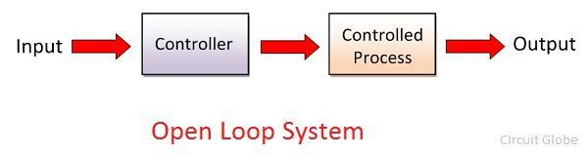

- Draw a block diagram of a closed loop control system and describe the function of each element.
Comparison element
Process
Correction element
Controller
Controlled variable
Output
Set point
Input

Feedback

Measured value

Set point – a value inputted by the operator for the position he wants the instrument to be in.
Comparison element – the element that compares the feedback measurement to the set point.
Controller – the element that controls the element, an I to P or relay.
Correction element – the element that controls the process, pump or actuator.
Process – the actuator moving or pump starting.
Controlled variable – the actual output of the actuator or pump.
Feedback – the instrument measuring the process.
Measured value – the output from the feedback.
Bibliography
Task 1
Bolton, W., 2021. Electrical Resistance Strain Gauge. [online] Science Direct. Available at: <https://www.sciencedirect.com/topics/engineering/electrical-resistance-strain-gauge> [Accessed 6 May 2022].

Editor, T., 2017. Advantages, disadvantages and applications of bourdon tube - Polytechnic Hub. [online] Polytechnic Hub. Available at: <https://www.polytechnichub.com/advantages-disadvantages-applications-bourdon-tube/> [Accessed 24 April 2022].

Fischer-Cripps, A., 2006. Bourdon Gauge. [online] Science Direct. Available at: <https://www.sciencedirect.com/topics/engineering/bourdon-gauge> [Accessed 2 May 2022].

Thorat, S., n.d. Strain Gauge. [online] Learn Mech. Available at: <https://learnmech.com/strain-gauge-advantages-and-disadvantages-application/> [Accessed 8 May 2022].

Task 2
Electrical Deck - All about Electrical &amp; Electronics. 2021. Electrical Tachometer - Construction & Types | DC & AC Tachometer. [online] Available at: <https://www.electricaldeck.com/2021/07/electrical-tachometer-construction-and-types.html> [Accessed 10 May 2022].

Eltra-trade.com. 2021. What is a rotary encoder. Types of encoders for motors | ELTRA TRADE. [online] Available at: <https://eltra-trade.com/blog/what-is-a-rotary-encoder-types-and-definition> [Accessed 12 May 2022].

Task 4
Circuit Globe. 2018. Difference Between LED & LCD (with Comparison Chart) - Circuit Globe. [online] Available at: <https://circuitglobe.com/difference-between-led-and-lcd.html> [Accessed 14 May 2022].

Electronics Tutorials. 2022. Analogue to Digital Converter. [online] Available at: <https://www.electronics-tutorials.ws/combination/analogue-to-digital-converter.html> [Accessed 17 May 2022].

Nelson-Miller, Inc. 2018. 5 Advantages of Liquid-Crystal Displays (LCDs) - Nelson-Miller, Inc.. [online] Available at: <https://www.nelson-miller.com/5-advantages-of-liquid-crystal-displays-lcds/> [Accessed 15 May 2022].

Task 5
ABLIC Inc. 2020. What is an Operational Amplifier? - ABLIC Inc.. [online] Available at: <https://www.ablic.com/en/semicon/products/analog/opamp/intro/> [Accessed 18 May 2022].

Applied Measurements Ltd. 2022. How Do You Avoid Noise in Sensor Cables?. [online] Available at: <https://appmeas.co.uk/resources/pressure-measurement-notes/how-do-you-avoid-noise-in-sensor-cables/> [Accessed 18 May 2022].

Sensorsone.com. 2022. Advantages and Disadvantages of using a 4 to 20 mA Signal. [online] Available at: <https://www.sensorsone.com/4-20ma-use-advantages-disadvantages/> [Accessed 17 May 2022].

GUIDANCE FOR Students IN THE COMPLETION OF TASKS

NOTE: The guidance offered below is linked to the five generic assessment criteria overleaf.

- Engagement with Literature Skills
Your work must be informed and supported by scholarly material that is relevant to and focused on the task(s) set. You should provide evidence that you have accessed an appropriate range of sources, which may be academic, governmental and industrial; these sources may include academic journal articles, textbooks, current news articles, organisational documents, and websites. You should consider the credibility of your sources; academic journals are normally highly credible sources while websites require careful consideration/selection and should be used sparingly. Any sources you use should be current and up-to-date, mostly published within the last five years or so, though seminal/important works in the field may be older. You must provide evidence of your research/own reading throughout your work, using a suitable referencing system, including in-text citations in the main body of your work and a reference list at the end of your work.

Guidance specific to this assessment: You must provide evidence of individual research with respect to theory and operation and provide relevant referencing.

- Knowledge and Understanding Skills
At level 4, you should be able to demonstrate knowledge of the underlying concepts and principles associated with your area(s) of study. Knowledge relates to the facts, information and skills you have acquired through your learning. You demonstrate your understanding by interpreting the meaning of the facts and information (knowledge). This means that you need to select and include in your work the concepts, techniques, models, theories, etc. appropriate to the task(s) set. You should be able to explain the theories, concepts, etc. to show your understanding. Your mark/grade will also depend upon the extent to which you demonstrate your knowledge and understanding.

Guidance specific to this assessment: Your report should show you gained knowledge of measuring systems, operational characteristics and the application of instrumentation and control theory.

- Cognitive and Intellectual Skills
You should be able to present, evaluate and interpret qualitative and quantitative data, in order to develop lines of argument and make sound judgements in accordance with basic theories and concepts of your subject(s) of study. You should be able to evaluate the appropriateness of different approaches to solving problems related to your area(s) of study and/or work. Your work must contain evidence of logical, analytical thinking. For example, to examine and break information down into parts, make inferences, compile, compare and contrast information. This means not just describing what! But also justifying: Why? How? When? Who? Where? At what cost? You should provide justification for your arguments and judgements using evidence that you have reflected upon the ideas of others within the subject area and that you are able to make sound judgements and arguments using data and concepts. Where relevant, alternative solutions and recommendations may be proposed.

Guidance specific to this assessment: The report should show analysis of the experimental work and calculated values.

- Practical Skills
At level 4, you should be able to apply the basic underlying concepts and principles to evaluate and interpret these within the context of your area of study. You should be able to demonstrate how the subject-related concepts and ideas relate to real world situations and/or a particular context. How do they work in practice? You will deploy models, methods, techniques, and/or theories, in that context, to assess current situations, perhaps to formulate plans or solutions to solve problems, or to create artefacts. This is likely to involve, for instance, the use of real world artefacts, examples and cases, the application of a model within an organisation and/or benchmarking one theory or organisation against others based on stated criteria.

Guidance specific to this assessment: Correct theoretical and calculated outcomes have been achieved.

- Transferable Skills for Life and Professional Practice
Your work must provide evidence of the qualities and transferable skills necessary for employment requiring the exercise of some personal responsibility. This includes demonstrating: that you can communicate the results of your study/work accurately and reliably, and with structured and coherent arguments; that you can initiate and complete tasks and procedures, whether individually and/or collaboratively; fluency of expression; clarity and effectiveness in presentation and organisation. Work should be coherent and well-structured in presentation and organisation.

Guidance specific to this assessment: Your work should be well organised and presented in a professional manner.

Student FEEDBACK FORM

This section details the extent to which the assessment criteria are demonstrated by you, which in turn determines your mark. The marks available for each category of skill are shown. Lecturers will use the space provided to comment on the achievement of the task(s), including those areas in which you have performed well and areas that would benefit from development/improvement.

Generic Assessment Criteria | Marks available | Marks  awarded
1. Engagement with Literature Skills
.
Engagement with an extensive range of relevant and credible literature. Consistently accurate application of referencing. | 20 | 14
2. Knowledge and Understanding Skills

Excellent knowledge and understanding of the basic underlying concepts and principles of the subject. | 20 | 15
3. Cognitive and Intellectual Skills

Excellent evaluation of the underlying concepts and principles. Can interpret qualitative and quantitative data accurately and with some insight. Excellent ability to devise arguments using evidence and make appropriate and valid judgements. | 20 | 14
4. Practical Application Skills

Very good evidence of different approaches to problem-solving in particular contexts and proposes appropriate solutions. | 30 | 21
5. Transferable Skills for Life and Professional Practice

Work is coherent, very fluent and is presented professionally. | 10 | 7

Assessment Mark (Assessment marks are subject to ratification at the Exam Board. These comments and marks are to give feedback on module work and are for guidance only until they are confirmed. ) | Late Submission Penalties (tick if appropriate) |  | 71%
 | Up to 1 week late (40% Max) |  | 71%
 | Over 1 week late (0%) |  | 71%

GENERIC ASSESSMENT CRITERIA

Level 4
In accordance with the Framework for Higher Education Qualifications, at the end of Level 4 students will be expected to have demonstrated knowledge of the basic underlying concepts and principles of a subject, and an ability to evaluate and interpret these within the context of that area of study. They should be able to present, evaluate and interpret qualitative and quantitative data in order to develop lines of argument and make sound judgements in accordance with basic theories and concepts of their subject(s) of study. They will have learned how to evaluate different approaches to solving problems, and will be able to communicate the results of their study/work accurately and reliably, and with structured and coherent arguments. They will be able to undertake further training and develop new skills within a structured and managed environment and will have the qualities and transferable skills necessary for employment requiring the exercise of some personal responsibility.

Level 4 | FAIL | MARGINAL FAIL | SATISFACTORY  (3rd / Pass) | GOOD  (2.2 / Pass) | VERY GOOD  (2.1 / Merit) | EXCELLENT  (1st / Distinction) | EXCEPTIONAL  (1st / Distinction)
Category | 0-29% | 30-39% | 40-49% | 50-59% | 60-69% | 70-84% | 85-100%
Engagement with literature (including reading, referencing,  academic conventions and  academic honesty) | Little or no evidence of reading and/or reliance on inappropriate sources.  Views and findings mostly unsupported and non-authoritative.  Referencing conventions used incoherently or largely absent. | Poor engagement with essential reading. No evidence of wider reading. Reliance on inappropriate sources, and/or indiscriminate use of sources. Heavily reliant on information gained through class contact. Inconsistent and weak use of referencing. | Engagement with a limited range of mostly relevant and credible sources but with some reliance on information gained through class contact. Some omissions and minor errors.  Referencing conventions evident though not always applied accurately or consistently. | Engagement with an appropriate range of literature, including sources retrieved independently. Some over-reliance on texts rather than other sources. Referencing may show minor inaccuracies or inconsistencies. | Engagement with a wide range of literature, including sources retrieved independently.  Selection of relevant and credible sources. Generally sound referencing, with no/very few inaccuracies or inconsistencies. | Engagement with an extensive range of relevant and credible literature. Consistently accurate application of referencing. | Exceptional engagement with an extensive range of relevant and credible literature. High-level referencing skills consistently applied.
Knowledge and understanding (Knowledge of the basic underlying concepts and principles of a subject.) | Major gaps in knowledge and understanding of the basic underlying concepts and principles of the subject matter. Inclusion of irrelevant material. Substantial inaccuracies. | Gaps in knowledge of the basic underlying concepts and principles, with flawed or superficial understanding. Some significant inaccuracies and/or irrelevant material. | Limited knowledge and understanding of the basic underlying concepts and principles within the subject area. Some elements may be missing. | Knowledge of the basic underlying concepts and principles is accurate with a good understanding of the field of study but lacks depth and/or breadth. | Competent knowledge of the basic underlying concepts and principles. Exhibits very good understanding. | Excellent knowledge and understanding of the basic underlying concepts and principles of the subject. | Exceptional, detailed knowledge and understanding of the basic underlying concepts and principles
Cognitive and intellectual skills  (Evaluate underlying concepts and principles of a subject and interpret qualitative and quantitative data in order to develop lines of argument and make sound judgements.) | Wholly or almost wholly descriptive work. Little or no evaluation of the underlying concepts and principles.  Failure to develop arguments, leading to illogical or invalid judgements. Minimal or no use of  evidence to back up views. | Largely descriptive work, with superficial evaluation of the underlying concepts and principles. Weak interpretation of data, flawed development of arguments and judgements. Information accepted uncritically, uses generalised statements made with scant evidence and unsubstantiated opinions. Ideas sometimes illogical and contradictory. | Limited attempt at evaluation of the underlying concepts and principles, tending towards description.  Can interpret qualitative and quantitative data but with some errors. Some evidence to support emerging arguments and judgements but these may be underdeveloped or with a little inconsistency / mis-interpretation. | Good evaluation of the underlying concepts and principles. Can interpret qualitative and quantitative data, with minor errors.  An emerging ability to use evidence to support the argument.  Mostly valid arguments and logical judgements. | Sound evaluation of the underlying concepts and principles. Can interpret qualitative and quantitative data accurately. Ability to devise arguments using evidence to make mostly appropriate and valid judgements. | Excellent evaluation of the underlying concepts and principles. Can interpret qualitative and quantitative data accurately and with some insight. Excellent ability to devise arguments using evidence and make appropriate and valid judgements. | Exceptional evaluation of the underlying concepts and principles based evidence. Outstanding interpretation of qualitative and quantitative data.  Exceptional ability to devise arguments using evidence and make wholly appropriate and valid judgements.
Practical skills  (Different approaches to solving problems in particular contexts.) | Limited or no use of taught, basic methods, materials, tools and/or techniques.  Little or no appreciation of the context of the application.  Very weak evidence of different approaches to problem-solving in particular contexts. | Rudimentary application of taught, basic methods, materials, tools and/or techniques but without consideration and competence. Flawed appreciation of the context of the application.  Weak evidence of different approaches to problem-solving in particular contexts. | An adequate awareness and mostly appropriate application of basic methods, materials, tools and/or techniques.  Basic appreciation of the context of the application.  Can identify problems in particular contexts and propose basic alternative approaches or solutions though there may be errors. | A good and appropriate application of basic methods, materials, tools and/or techniques.  Clear appreciation of the context of the application.  Good evidence of different approaches to problem-solving in particular contexts and proposes mostly appropriate solutions. | A very good application of a range of basic methods, materials, tools and/or techniques.  Very good consideration of the context of the application. Very good evidence of different approaches to problem-solving in particular contexts and proposes appropriate solutions. | An advanced application of a range of taught, basic methods, materials, tools and/or techniques.  The context of the application is well considered, and insightful.  Excellent evidence of different approaches to problem-solving in particular contexts and proposes appropriate solutions. | Exceptional levels of application and deployment skills in particular practical contexts. Outstanding identification of problems in particular contexts and formulation of wholly appropriate, thoughtful solutions / different approaches.
Transferable skills for life and professional practice  (Communicate the results of their study/work accurately and reliably, and with structured and coherent arguments; the qualities needed for employment requiring the exercise of some personal responsibility within a structured and managed environment.) | Work is poorly structured, disorganised, inaccurate and/or confusingly expressed. Very weak use of language and/or very inappropriate style. Failure to work effectively individual or as part of a group. Little or no evidence of the skills for employment requiring the exercise of some personal responsibility. | Work is poorly presented in a disjointed manner. It is loosely, and at times incoherently, structured, with information and ideas often poorly expressed. Weak use of language and/or inappropriate style. Flawed approach to individual or group work, meeting only partial obligations to others. Limited evidence of the skills for employment requiring the exercise of some personal responsibility. | Mostly ordered presentation and structure in which relevant ideas / concepts are reasonably expressed. Work may lack coherence and/or accuracy in places. Can work as part of a group, meeting most obligations to others but perhaps with limited involvement in group activities.  Demonstrates the basic skills for employment requiring the exercise of some personal responsibility, with some areas of minor weakness. | Mostly coherent, organised and accurate work, in a suitable structure and is for the most part clearly expressed. Can work effectively independently and/or as part of a team, with clear contribution to group activities.  Demonstrates the skills for employment requiring the exercise of some personal responsibility, with some areas of strength and some of minor weakness. | Work is accurate, coherent, fluent, well-structured and organised.  Can work effectively independently and/or as part of a team, with very good contribution to group activities. Demonstrates very good skills for employment requiring the exercise of some personal responsibility, with just occasional minor weakness. | Work is coherent, very fluent and is presented professionally. Can work effectively independently and/or as part of a team, with an excellent contribution to group activities. Demonstrates excellent skills for employment requiring the exercise of some personal responsibility with an appetite for further development. | Work is accurate, exceptionally coherent, very fluent and presented well. Can work effectively independently and/or as part of a team, with an exceptional contribution to group activities. Demonstrates exceptional skills for employment requiring the exercise of some personal responsibility with an appetite for further development.

THIS DOCUMENT IS ALSO AVAILABLE IN WELSH

