MARKETING ESSENTIALS
STUDENT NAME; IRENE NAKIMERA
STUDENT NUMBER; 2244610
LECTURER NAME; JAMES SCOTT
MOODLE TITLE; BMIH4001

Assessment 2 Structure;
Organisations new values proposition if there is a change. Strategies the business will use. (Strategy 250 words).
According to Ansoff Matrix, planning the flamework strategy to help develop businesses and choose their own strategies to go forward. Things to consider is working as a team and avoid interruptions to be able to focus more on the business.
The Ansoffs matrix is a 2x2 that brings the formation of strategic ideas such as the new markets, existing products, new markets as well as existing markets. Ecological passion, strength and change (Miller, 1987; Sohn et al, 2003) can have a serious impact upon widening strategies taken on for firm’s victorious run in any business.(Ansoff, 1957)
The four quadrants are, product development, Market penetration, market development and finally diversification or individuals. Market can be explored outside the current markets or unexplored needs and wants (john and Pineb, 2002) The product development strategy is where the business decides to develop new products or services targeting their existing customers or market. The diversification strategy is where a business creates a new product and new service at the same time. Using all these will help the business because the can be used as company tools and individual departments in marketing. And designed to help business focus and develop.
The changes that will be made to the old marketing mix will be promotion change for example using the social media, advertising using emails, video advertisement, bill boards. Changing places for businesses for example lots of businesses that had high street businesses, now are setting and using websites and changing the distribution channels going into a more modern approach to getting customers.
Changing product’s quality and appearance like lets say change from manual toothbrushes to modern electric ones. Changing the prices due to increasing demand of products and also inflation has affected businesses causing the rise in the of goods and services.

Aims of my marketing plan; My aims would be specifically have potential to solve world problems and open specific opportunities. Measurable to be able to be countable of the key matrix that will be applied. To be actionable towards the objectives to bring about positive change. To be relevant about the overall strategy in marketing. Should be time bound towards achieving the objectives to be set for different periods as targets to review against.
Changes that will be made to the old marketing mix; change in prices for example in hotels like holiday inn, due to the high inflation in the uk, prices have increased compared to years back. The way of promoting/marketing these hotel brands like holiday inn and six senses, is changed a lot as the world is growing at a high sped in technology for example the social media is a big platform where different businesses are advertising their brands, televisions, websites, Instagram etc all these are taking over the old way of marketing. The products on the market for example hotel brands now provide a very luxurious life style to their customers for example the spa, gyms, etc. The places for example lets look at six senses where its locations are so unique far outside the cities and holiday inn as well its locations are mostly in big cities targeting business people and young generation and It makes it easy for its customers to commute easily.
The strategies, how to use the new communication tactics to address the issues identified in the situational analysis; being specific on how to address the concerns raised from customer reviews and feedbacks. Being realistic and raise the brand awareness and bring about a realistic return.
Types of communications organisations should create to address the new mix and strategy like; sales and promotion where organisations and businesses can do their sales and promote their products to attract more customers. Also through advertising their businesses on different platforms like social media, billboards, conferences, word of mouth marketing , events and experiences, personal selling etc.
How we will measure success, new customers and increase profits in business is to target the audience for example six senses targets the wealthy people and it does provide first class services because it knows what its target is. Acting towards the mission and vision of the brand for example doing promotions, advertising, discounts and bonuses in order to attract new customers. Convert , diversitify, monetise he income sources to obtain profit. Good customer satisfaction is by increasing the lifetime value for your customers through informing the existing customers about any new products or new services and resources. Digital marketing, this is very important in assessing your annual and monthly performance of the company or organisation.

Presentation

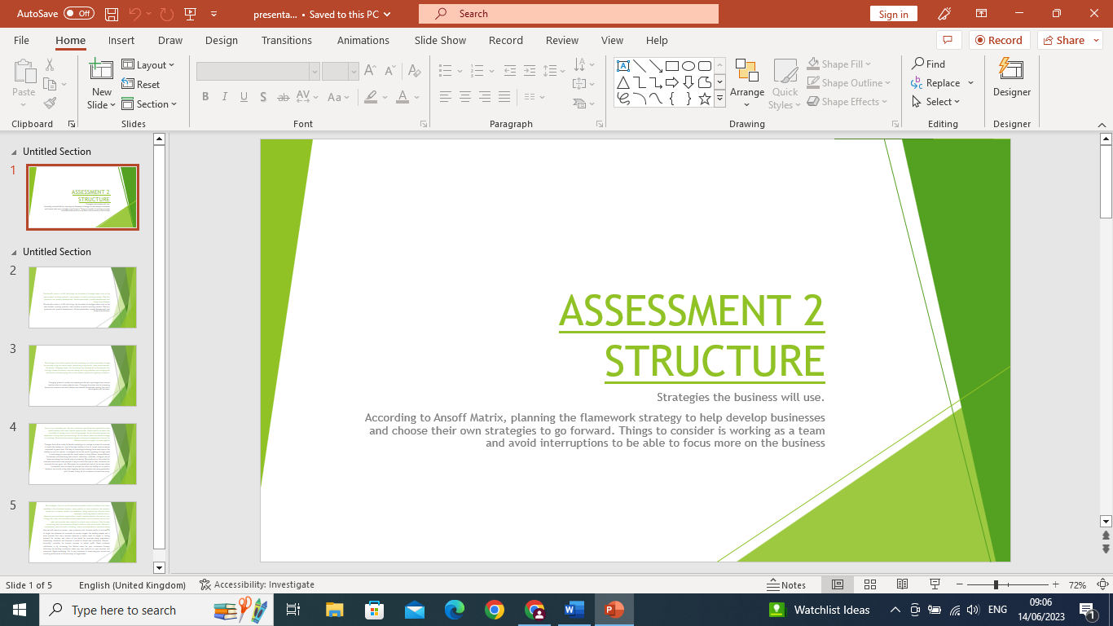
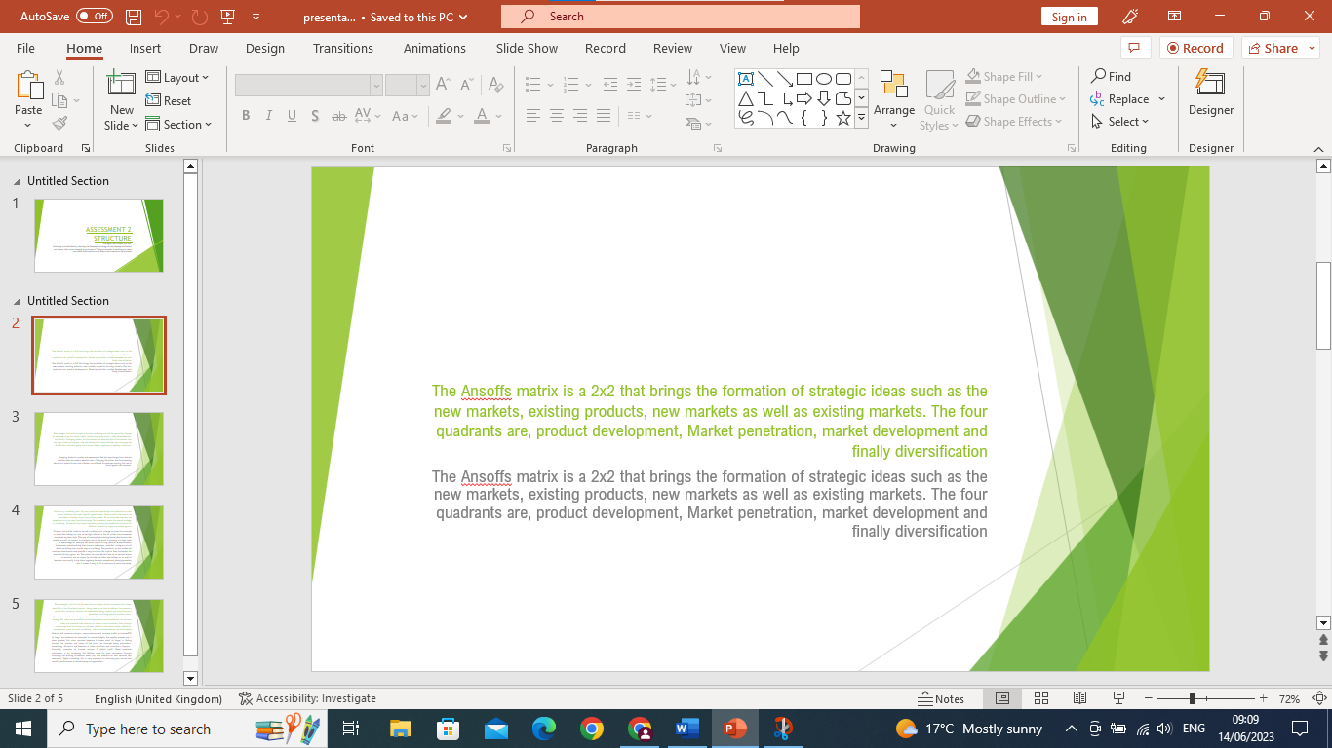
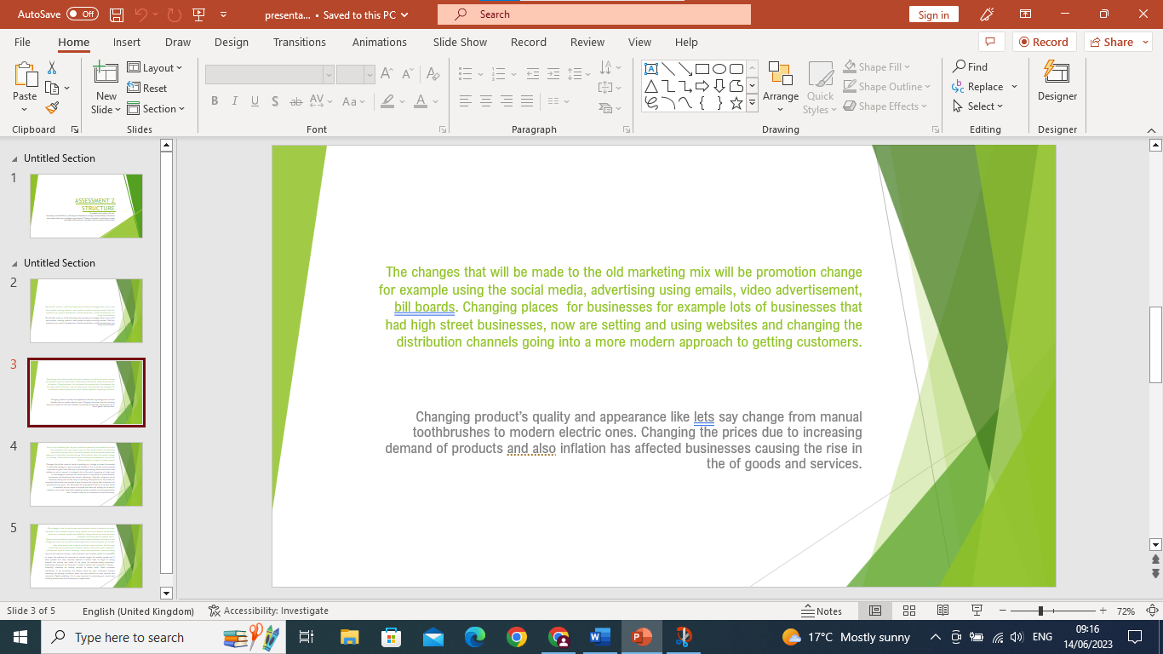
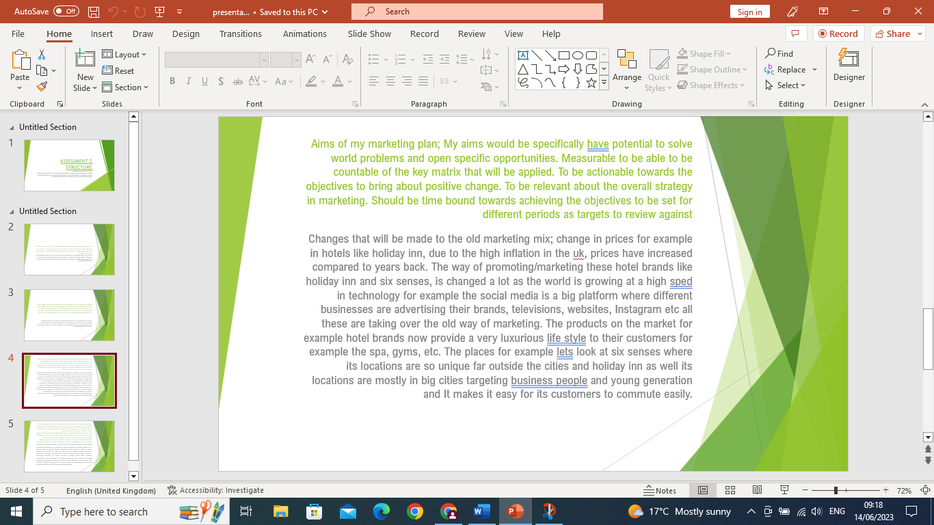
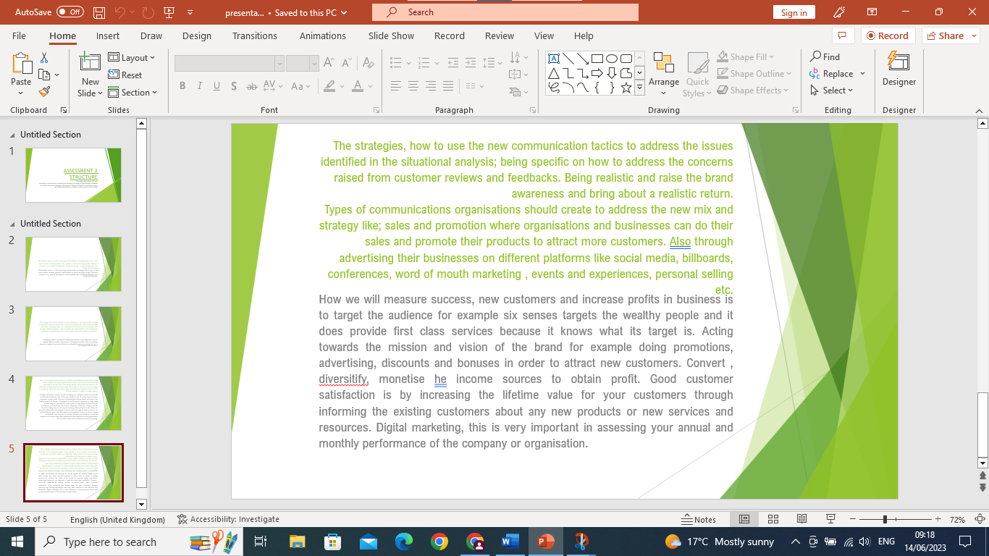
References:

