PART 1
Creating A Sustainable Strategic Business Plan for
The UK SMEs Business Devanet UK Ltd



By
Nargas Ahmadzai (2106756)
Module- Strategic Management for SMEs
Module Code-BMSW 6104
Lectures By- Dr Oluwaseun Adegbite

Table of Contents

Brief Overview 3
Introduction 3
Devanet UK Ltd PESTLE Analysis 6
Devanet UK Ltd SWOT Analysis 9
Devanet UK Ltd Stakeholder Analysis 11
Devanet UK Ltd Value Chain Analysis 12
Long-term Strategy for Sustainable Development 14
Recommendations 16
Conclusion 17
References 18

Table of Figures
Figure 1 Small and Midsize Enterprises 3
Figure 2 Devanet Belts 4
Figure 3 Devanet Company Profile 5
Figure 4 PESTLE Analysis 7
Figure 5 SWOT Analysis 10
Figure 6 Stkeholder Interst Matrix 11
Figure 7 Value Chain Analysis 13
Figure 8 Sustainability Pillars 15

Brief Overview
This report centres on a specific business owned by an SME in the UK. It presents an in-depth analysis of the business's current strategic plan portraying the vision, mission, and current objectives of the business. The ultimate goal of this report is to devise a sustainable strategic management plan that will secure the business's future using strategic tools including PESTLE and SWOT analysis to identify both macro and micro environmental factors that may impact the organisation's ability to achieve its vision—the value chain analysis to evaluate all the processes and activities for creating products. "The stakeholder analysis is a tool used to identify the relationships and interests different individuals or groups have in the business. It helps to understand who the key stakeholders are, what they want, and how they can influence the organisation's success.".
To lead other organisations the company must propose a long-term strategy for sustainability in the market by reviewing its current plan and implementing any new requirements to the plan.
The report further concludes and suggests recommendations for the business to maintain its strategies for overcoming challenges.

Introduction
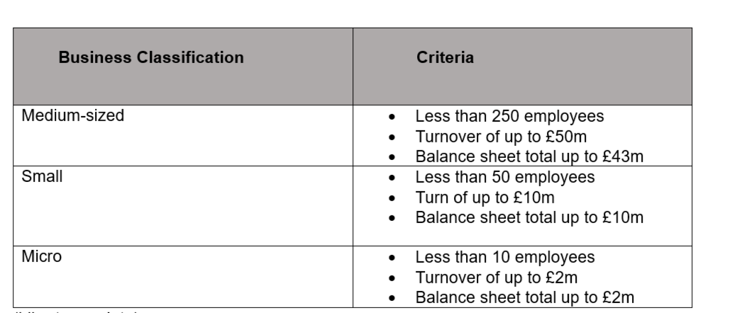

Figure 1 Small and Midsize Enterprises
Source: (Liberto, 2023)
As the table above shows, SME businesses stand for small to medium-sized enterprises, indicating businesses whose employee numbers and turnover fall under the expectations and threshold set by the government (Libert,2023).
The report chosen company to design a sustainable business plan and strategy for long-term survival is one of the SME businesses in the UK called Devanet UK Ltd.

Figure 2 Devanet Belts

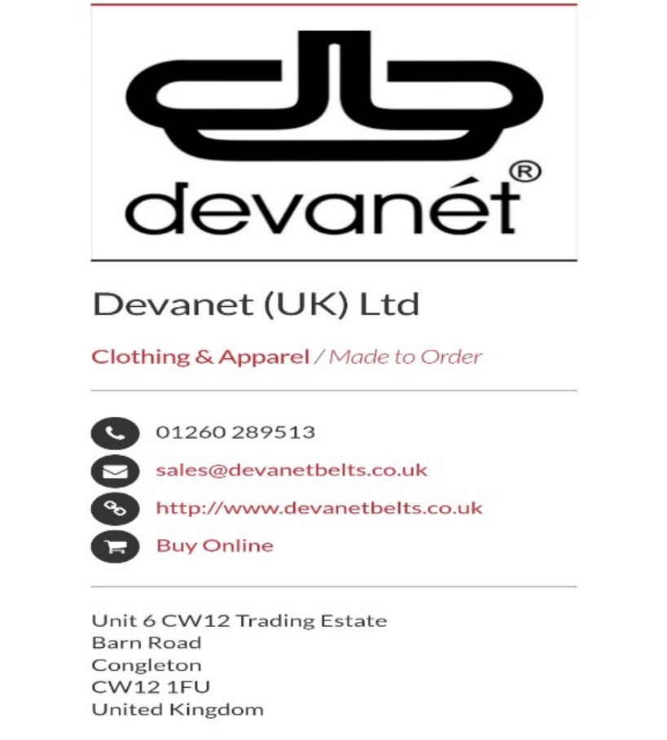
Source: (Devanet Belts, 2011).

This is a private British design and manufacturing company located in Cheshire. The revenue of the company is £3.4M and it has a total of 19 employees working to achieve its goal. Ricardo Bartorelli is the director and Giovanni Boscarino is in the executive team. The company started its business in 1999 in personalised clothing and accessories later on the focus of the business changed to concentrate fully on buckles and belts.

The representative of the company is David Webstar. Devanet is a successful company for finding ways to innovate and improve the quality of products according to the customer's expectations. The company believes that they learn daily and turn that into knowledge to improve sustainability and productivity (Devanet Belts, 2011).
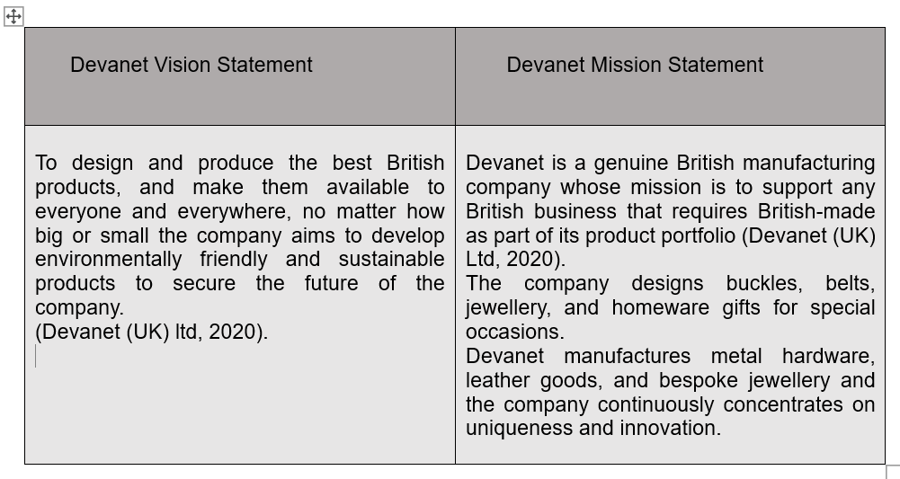

Figure 3 Devanet Company Profile
Source: (Devanet UK Company Profile: Management and Employees List, 2011).

The company's main focus is productivity and uniqueness to achieve its objectives. It was mentioned in an open-to-export case study that Devanet LTD's business strategy is the Export Action Plan, which helps the company grow every year. Currently, the company is shifting its market target to include GCC, the USA, and continental Europe, among other markets.
The Export Action Plan has been instrumental in helping the company focus on key issues and think of required strategies and solutions to develop potential. The company always conducts market research to stay ahead of competitors and identify barriers to entry. It also prioritises quality standards to meet other markets' requirements.
The Export Action Plan allows the company to order from Australia, Europe, the USA, and the Middle East, creating a production environment that has worldwide potential (William, 2019). The company utilises modern modelling software and rapid prototyping 3D prints with stereolithography technology, which enables it to complete orders within 48 hours.
Devanet is the only UK designer and manufacturer company that offers custom-made branded buckles and metal components complemented with belts, providing a complete package in-house. The company use trending technology and APIs such as Google Analytics, Live chats and Tag management to maintain business and customer services. The competitors of the company are GUIMER SRL, CATANIA MEDALLIC SPECIALTY INC, BABEL GIFTS CO LTD, MONTANA SILVERSMITHS LTD AND BUCKLE DOWN PUBLISHING CO (Devanet UK Company Profile: Management and Employees List, 2011).
The company invest yearly profit back into the business to improve and progress. The company take orders from small or big businesses about 25 units and produces one-off designer gifts for anyone. The company takes orders online, taking data protection very seriously to avoid customer disappointment. The Data Protection Act 2018 allows this company to collect and use data very carefully while processing orders and submitting applications (William, 2019).
Devanet is one of the successful UK SME businesses which is making its identity worldwide through its unique productivity. The outstanding customer service and the supply chain from its partners that supply raw materials on time enable the company to serve its customers satisfactorily. The company is very confident in achieving its objectives of the company through a variety of productions.
However, every day businesses face challenges and changes in the market. They must propose effective strategies to maintain their positions and compete with their rivals. To identify these challenges and factors some of the famous tools for example PESTLE and SWOT analysis are available that enable businesses to identify external and internal issues and according to these challenges find solutions or design a sustainable plan for long-term achievement.
The next phase of the report is to analyse Devanet's internal and external strengths and weaknesses using PESTLE and SWOT analysis.

Devanet UK Ltd PESTLE Analysis
The report aims to create a sustainable plan for the business's survival by assessing its current state and identifying requirements for future success by utilising the PESTLE Analysis tool an extension of the commonly used PEST Framework. The PESTLE tool helps organisations examine their external environment to understand the broader context in which they operate. This enables the organisation to take advantage of opportunities and minimise risks. The opportunities and risks are categorised according to the six factors of PESTLE's various categories. include: political, economic, social, technological, environmental, and legal factors (Pestle analysis, no date).
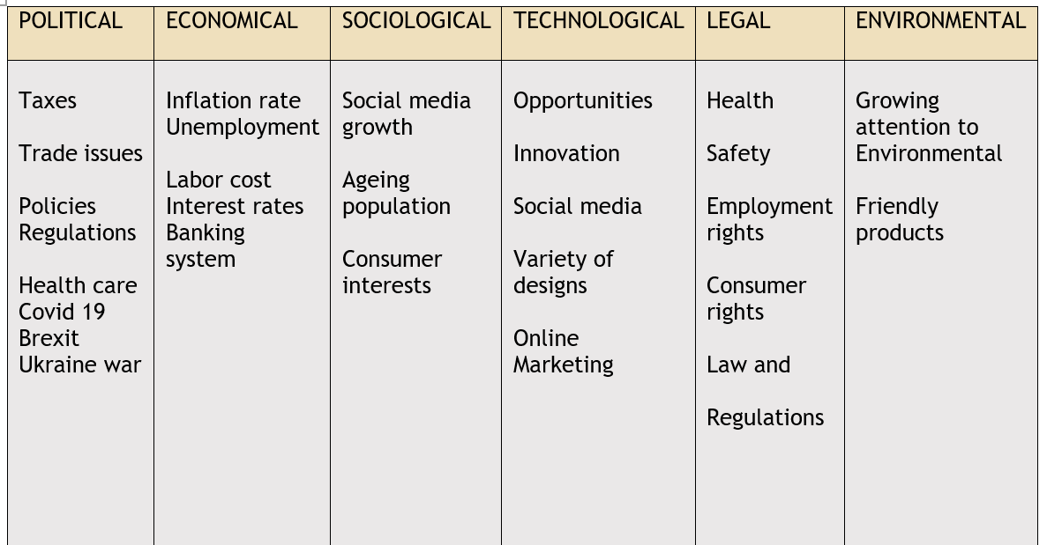

Figure 4 PESTLE Analysis
Extracted From: (PESTLE Analysis, no date; Made in Britain, 2020).

Political factors refer to those that primarily affect the country where a business operates, but they can also influence countries where suppliers operate. When assessing political factors, a business should evaluate how government policies and actions impact the economy and other factors that can affect a business (fitchuk,2021).
This factor affects businesses for instance the current taxes and trade issues have huge impacts on small or large organisations. David Webstar the Devanet representative told Made in BRITAIN, that as a unique manufacturing company in the UK, it designs the most demanding products, and the company deserves crucial support from the government. He added that during and after COVID-19 the company was neglected for more support as the government forced the company to import, at great expense and protect NHS staff and key workers. The company offered its support for PPE and PCR swabs supply during the lockdown, but the government never supported it back (Made in Britain, 2020).
The economic factor is the other external issue that affects business productivity. The current inflation rate in the UK is one of the challenges businesses face. The supply of the raw material that the manufacturing company uses is hugely affected. SME businesses such as Devanet contribute heavily to the development of different sectors such as manufacturing, ICT, and agriculture. The economy of a country affects SME businesses in the decision-making process. Inflation, taxes, and unemployment rates are the other challenges that impact businesses. Extensive research has proven that effective banking systems play a critical role in allocating savings to the most productive investment projects for instance Devanet which leads to efficient capital allocation and consequently enhances economic development and growth. However, corruption poses a potential threat to the efficiency of this process (Ullah, 2020).
Social factors examine ethical and cultural aspects that affect the demands of SME company's products and services. This is a fact that the taste of fashion is rapidly changing and one of the reasons is the growing popularity of social media. So, social networking such as Facebook, and Instagram are more popular with the young generation, and they prefer to shop online using digital technology. Therefore, companies must observe social and cultural changes to follow the trends and interests of society to maintain their customers and productivity. The company must analyse population and age growth to identify their lifestyle and interests. This helps the business to promote marketing strategy (Social factors affecting business,2023). Devanet focuses strongly on the changing interests of the customers to maintain its productivity and customer satisfaction.
Technology is very important for manufacturing industries such as Devanet because of business operations, availability of plans and diversity of product/service range. Trending businesses are relying on innovation and creativity, and this depends on sophisticated machines, types of equipment, and the fusion of different technologies and gadgets. According to Rahman et al (2016) analyses of technological innovation, social networking, computerised record-keeping, and online marketing can be classified within the current technological landscape. As Devanet applies a variety of technologies in designing its products it has a huge impact on the business profitability. On the other hand, the cost of implementation of these gadgets and training staff requires a strong budget and knowledge.

Legal Factor, the company must ensure that their products comply with relevant regulations and safety standards before making them available to the public. Even after a product has been released, the company remains responsible for ensuring its safety and providing consumers with sufficient information to use it safely. Additionally, the company must be able to trace the product back to themselves if necessary (Sykes, 1995). The industry must also monitor its usage and report any risks identified to the local Trading Standards service. So, the law and regulations have huge impacts on the business for instance health and safety, employment rights, consumer rights and discrimination etc. The leather manufacturing industry is subject to various regulations and laws, such as labour and environmental regulations, and animal welfare laws. Devanet has huge respect towards the law and regulations and works hard accordingly. As in the introduction the report mentioned that Devanet operates the Data Act 2018, to protect the rights of its customers.

Environmental Factors- the manufacturing industry is currently grappling with a major obstacle posed by the impact of environmental factors. The process of producing leather is intricate and requires a substantial amount of water, energy, and chemicals, which can unfortunately have adverse effects on the environment. The leather industry's environmental impact is significant, and it can be difficult to trace the origin of raw materials and ensure sustainable practices. This lack of transparency makes it challenging to identify unsustainable practices (Leather Manufacturing: Critical Issues and Challenges, 2023). Devanet Productions relies on innovative and environmentally friendly products, for instance, vegan leather which is made from plastic waste and other raw materials.

Devanet UK Ltd SWOT Analysis

Previously the report outlined the external factors and challenges that affect business sustainability using the PESTLE framework and described how Devanet Ltd manages to overcome some of these challenges by utilising strategies to maintain business sustainability.
The SWOT analysis is the second valuable tool for assessing a company's internal factors and identifying areas of strength and weakness. By highlighting opportunities and potential risks, this strategic technique can help organisations improve their productivity and maintain competitiveness (Mollenhorst & de Boer,2004).
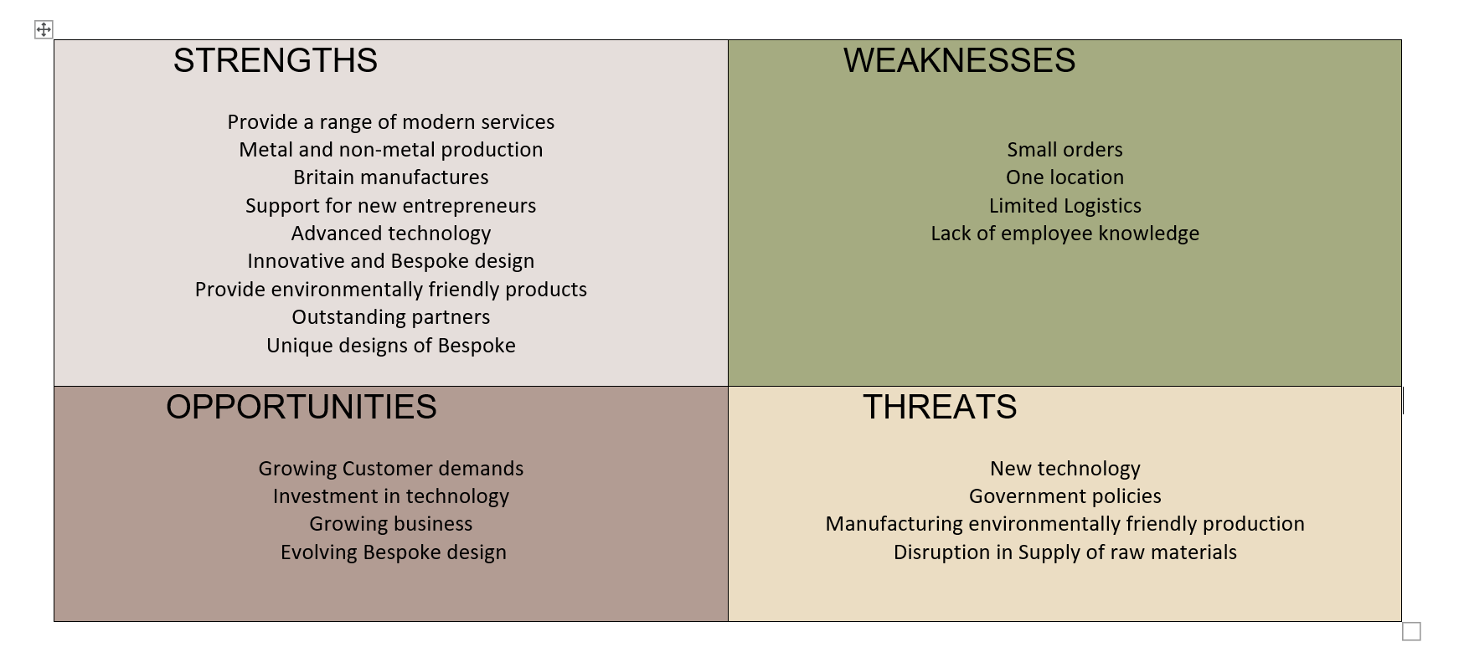

Figure 5 SWOT Analysis
Source: Devanet UK| Custom Made Buckles| Leather & Web Products|, 2011).

After applying a SWOT analysis in the above table, the report outlined some of the information about Devanet company.
The key findings of the report are.
Strengths- the company has variety in production utilising different modern technology. It has innovative and bespoke designs that attract more customers. The materials are environmentally friendly. It has an outstanding partnership with other companies which empowers the business to perform great (Ibid).
Opportunities- customer demands and interests in bespoke designs gasp opportunities for business growth. More investment in technology provides more productivity and profitability to the business.
Weaknesses- it has one location and due to fewer employees, the company takes fewer orders. To design better products the company has to train employees and lack of knowledge can impact productivity.
Threats- government policies are big threats for instance, utilising environmentally friendly products increases challenges for the business (Ibid).

Devanet UK Ltd Stakeholder Analysis
The third analysis to examine the sustainability of the company is stakeholder analysis. Stakeholders are a very important aspect of businesses because without stakeholders there are no organisations. This analysis evaluates the interests and expectations of people and organisations that can impact and can be impacted by the business. The other importance of the Stakeholder theory advocates for decision-makers to consider the interests of all stakeholders. However, before making any decisions, management must have a clear understanding of how their choices are perceived by other parties (Schwarzkopf, 2006).
The literature suggests three steps to do stakeholder analysis identifying, categorising and prioritising stakeholders according to their expectations and then planning to communicate and engage with them (What Is Stakeholder Analysis? Definition, Examples and Template, 2024).
The very commonly used model to categorise stakeholders after identifying them is The Interest Matrix Model. This model describes the levels of power and interests of stakeholders in the business.
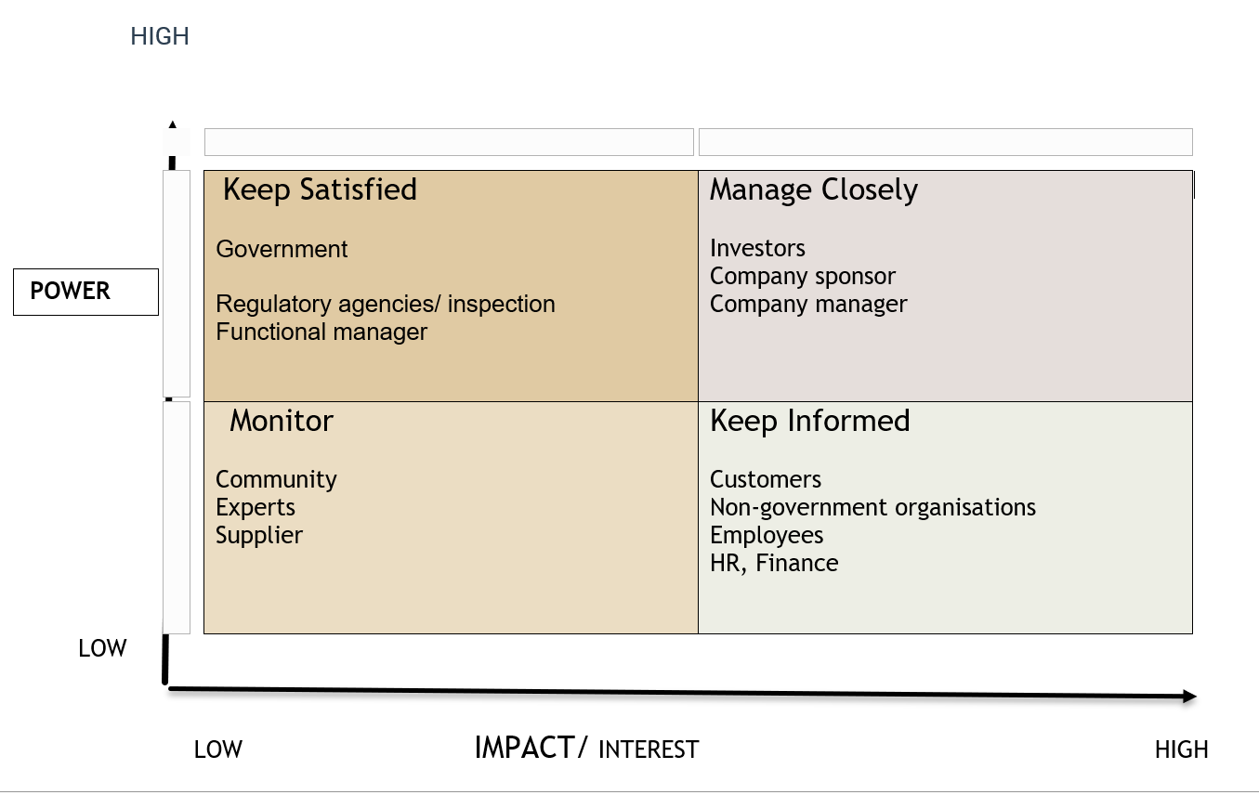

Figure 6 Stakeholder Interest Matrix
Source: (What Is Stakeholder Analysis? Definition, Examples and Template, 2024).

According to the Interest Matrix, the report categorised stakeholders into four categories of
High-power lower interest, high-interest low power, high power high interest and low power low interest.
As the table above shows each stakeholder is categorised according to its interest and power, and how to communicate and engage them according to their influence on the business.

Stakeholder analysis is important for business because it enables a company to determine which people to involve and manage closely and whom to just monitor.
Devanet takes stakeholder involvement seriously in the business because their engagement can identify social and environmental issues that must be addressed to maintain progress and meet their expectations. The other importance of stakeholder involvement in SME businesses is the financial stress and power that can lead to the failure of the company. According to the literature reviews the critical stakeholders that can impact long-term sustainability are customers, workers, and suppliers.

Devanet UK Ltd Value Chain Analysis

The stakeholder analysis enlightens how different categories of interests can impact the business and what engagement strategies must be implemented to keep each stakeholder satisfied. Businesses face challenges and adapt to changes to be sustainable.
The report outlined some of the challenges that impact SME businesses and how they can affect the sustainability of the company by utilising various analyses.

Michael Porter introduced value chain analysis for companies as a strategic tool that involves evaluating each activity within the organisation based on its cost, the value it provides, and how it can be optimized to maintain a competitive advantage.
This framework has divided the activities into two sections including primary activity and secondary activity.
The primary activity operates -inbound operations, outbound logistics, marketing and sales and services. The secondary activity contains procurement and purchasing, human resources, management (HRM), technological development and the company infrastructure (Stonehouse and Snowdon,2007).

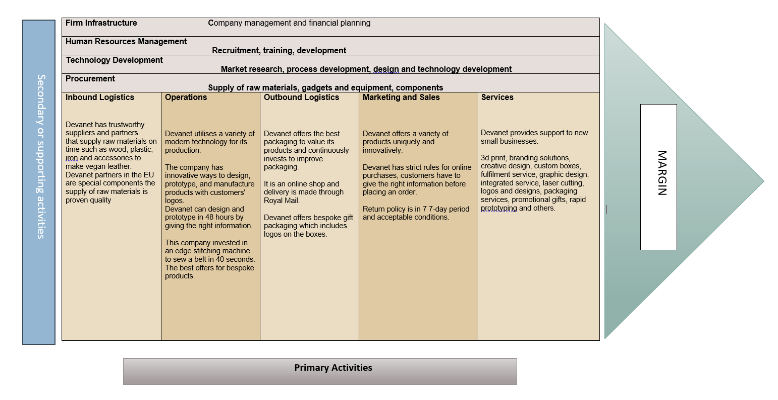

Figure 7 Value Chain Analysis
Source: (Devanet (UK) Ltd, 2020).

Value chain analysis evaluates business activities to manufacture products that offer customers value-added at an affordable cost and by increasing efficiency. Value chain analysis increases sustainability by identifying areas where a business can reduce waste, increase resource efficiency, and minimize its environmental impact.
By analysing the entire value chain, from the sourcing of raw materials to the disposal of products, a business can identify opportunities for improvement and implement sustainable practices throughout its operations. This can lead to reduced costs, enhanced reputation, and improved relationships with stakeholders who value sustainability.
The five primary activities of Devanet-

Inbound logistics- the outstanding partners and suppliers supply raw materials to the Devanet leather factory in Congleton Cheshire such as leather, wood, metal etc (Devanet (UK) Ltd, 2020).

Operations- Devanet invests in modern and sophisticated machines to add value to its products. The unique bespoke designs differentiate the company from competitors.
Outbound logistics- once the product is ready in a factory it is ready to be sold through its website, the company is working to add a section in its showroom where can customer visit and explore different products the company offers.

Marketing and sales- Devanet has an organised website and other social platforms including, Facebook, and Instagram to promote its business. The company is also partnering with the Made in Britain organisation to promote its production.
Services- Devanet offers a variety of services creative designs, 3d prints, unique packaging, logos and many more. It also supports new small businesses with its services and supply chain. (Devanet (UK) Ltd, 2020).

Devanet value chain analysis indicates that the company values differentiation by offering a unique and high-quality product utilising environmentally friendly materials. This includes vegan leather and bespoke designs that create competition for competitors in the market.
In primary activities from inbound logistics to services, the company analyses the areas of development and room for improvement.

For example, cutting delivery costs can increase customer value and this increases profit margin for the company. The use of quality materials increases customer value and business sustainability. Value chain analysis enables businesses to compare primary activities with competitors and gain a competitive advantage. The competitive advantage enables businesses to use strategies and become market leaders.

The competitive advantage of Devanet is the innovation in products and bespoke design. In 2022, Devanet formed a partnership with key suppliers to improve the supply chain of raw materials and become a strong competitor in the market (Devanet (UK) Ltd, 2020).

Long-term Strategy for Sustainable Development

Starting a business is a hard decision but not impossible, it is all about individuals’ capabilities to face challenges and take risks. It is the ability of strategic management planning and the process of implementation. The report evaluates how UK SME businesses balance strategies to overcome challenges. The report mentioned that businesses must review their performance consistently to avoid failure. The report utilises a variety of literature analyses such as the PESTLE framework, SWOT analysis, STAKEHOLDER analysis and VALUE CHAIN analysis to examine the impacts of external and internal factors that might affect business productivity and sustainability. The report analyses one of the UK SME businesses named Devanet UK Ltd and outlines how the company has increased its production since 1999. The company has a small revenue, but it has more achievements in quality and service.
According to the successful journey of Devanet UK Ltd every year a new goal to achieve and work hard to bring uniqueness into their production explains that Devanet is a sustainable company.
However, for SME businesses sustainability is hard because of small revenue, financial issues, number of employees and laws and regulations that can impact its growth and performance. A literature review suggests that sustainability can be divided into three pillars Social, Economic and Environmental or people, profits, and planet which are connected so a business to be sustainable, requires to consider each pillar closely.

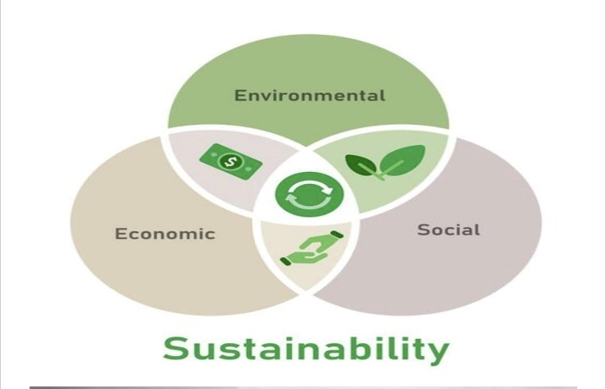
Source: (Enel, 2023).

Figure 8 Sustainability Pillars

Economic sustainability indicates the operations and practices that focus on long-term economic and profit growth development. To achieve sustainability company must focus on financial stability, internal cooperation and partnership, and efficiency in the economic system. (Enel, 2023).
Social sustainability refers to the well-being of people and community, considering their health and safety, their rights, and other aspects. To achieve sustainability businesses must consider the areas of poverty, inequality, insecurity or conflict, lack of resources, discrimination, and some other challenges.
Environmental sustainability is practices that protect the environment and manufactures that do not harm green zones. The company can be sustainable in balancing production and the environment, for example, by reducing greenhouse gas emissions, increasing production by using renewable sources etc (Enel, 2023).
Devanet UK Ltd is a sustainable business because the company consider all three pillars in their operations.
The company invest in technology to empower its productivity and strengthen its economy for long-term development and consistently works to adapt to changes and customers' interests.
The company utilises environment-friendly products to prevent harm and promote sustainability. The company's satisfaction is to provide equal rights to its employees and quality services to customers.

Recommendations
Devanet is a sustainable company however, the report has some key suggestions for the company to maintain its productivity and sustainability.

- To attract more customers company must have more locations, only the showroom in Cheshire lacks the opportunities.
- Offering affordable products can add value to customers.
- Flexibility is key to success for businesses, for instance, allowing extra time for return as Devanet has a strict return policy.
- Protecting the trademarks and copyrights to differentiate businesses from competitors.
- Review and keep updating the company website consistently to help customers.
- Adapt trending marketing strategies to attract customers from divorced communities.
- Avoid unnecessary services to help company budgets and reduce complications.

Conclusion

The report concludes that Devanet manufactures metal hardware, leather goods and bespoke jewellery and continually attempts to develop innovative and unique products. Every year, company exports are growing at a rate of 10% and the focus is shifting towards specific target markets such as the GCC, the USA and Continental Europe. Devanet invests every year in technology to increase the quality and variety of designs. The Export Action Plan helps the company to focus on the key issues and implement strategies for potential growth. In 2018,
Devanet achieved a licence to sell and apply Nano Ceramic coatings to metal. The company achieved 20 certificates of excellence in 2020. A small company that works very hard to make small differences through its bespoke designs for its customers, employees, and satisfaction (Devanet Belts, 2011). The different analysis including PESTLE, SWOT, VALUE CHAIN and STAKEHOLDER Analysis evaluates the strengths and weaknesses of the company and picture the macro challenges that can affect productivity. The stakeholder's involvement and value chain analysis indicate the strategies for the business to compete with its competitors and lead the business market. The report suggests some recommendations to keep its sustainability and productivity.

References
- About Devanet (2011) About Devanet belts | UK manufacturers of quality buckles & leather products|. Available at: https://devanetbelts.co.uk/aboutus.html (Accessed: 13 February 2024).
- Contributor, Pestle. (2023) Social factors affecting business, PESTLE Analysis. Available at: https://pestleanalysis.com/social-factors-affecting-business/ (Accessed: 14 February 2024).
- Devanet UK| Custom Made Buckles| Leather & Web Products| (2011) devanetbelts.co.uk. Available at: https://devanetbelts.co.uk/ (Accessed: 20 February 2024).
- Devanet (UK) Ltd (2020) Made in Britain. Available at: https://www.madeinbritain.org/members/devanet (Accessed: 13 February 2024).
- Devanet UK Company Profile: Management and Employees List (2011) Datanyze. Available at: https://www.datanyze.com/companies/conrex/399434892 (Accessed: 13 February 2024).
- Enel (2023) The 3 pillars of sustainability: environmental, social and economic, Enel. Available at: https://www.enel.com/company/stories/articles/2023/06/three-pillars-sustainability.
- Fitchuk, C., (2021). Creating a Sustainable Business Strategy for an SME.
- Leather Manufacturing: Critical Issues and Challenges (2023) Deskera Blog. Available at: https://www.deskera.com/blog/leather-manufacturing-critical-issues-and-challenges/.
- Liberto, D. (2023) Small and midsize enterprise (SME) defined: Types around the world, Investopedia. Available at: https://www.investopedia.com/terms/s/smallandmidsizeenterprises.asp (Accessed: 08 February 2024).
- Made in Britain (2020) Devanet qualifies for Made in Britain membership, Made in Britain. Available at: https://www.madeinbritain.org/news/devanet-qualifies-for-made-in-britain-membership (Accessed: 14 February 2024).
- ‌Mollenhorst, H., & de Boer, I. J. M. (2004). Identifying Sustainability Issues Using Participatory SWOT Analysis: A Case Study of Egg Production in the Netherlands. Outlook on Agriculture, 33(4), 267-276. https://doi.org/10.5367/0000000042664747
- Pestle analysis (no date) Impact Innovation & Growth Services Ltd. Business Management Consultants in Wales. Tel: 01633 215545. Available at: https://www.impact-innovation.co.uk/pestle-analysis (Accessed: 14 February 2024).
- Rahman, N.A., Yaacob, Z. and Radzi, R.M., (2016). An overview of technological innovation on SME survival: a conceptual paper. Procedia-Social and Behavioural Sciences, 224, pp.508-515.
- ‌Stonehouse, G. and Snowdon, B., (2007). Competitive advantage revisited: Michael Porter on strategy and competitiveness. Journal of Management Inquiry, 16(3), pp.256-273.
- Schwarzkopf, D.L., (2006). Stakeholder perspectives and business risk perception. Journal of Business Ethics, 64, pp.327-342.
- Sykes, A.O., (1995). Product standards for internationally integrated goods markets. Brookings Institution Press.
- Ullah, B., (2020). Financial constraints, corruption, and SME growth in transition economies. The Quarterly Review of Economics and Finance, 75, pp.120-132.
- What Is Stakeholder Analysis? Definition, Examples and Template, 2024) www.tractivity.co.uk. Available at: https://www.tractivity.co.uk/blog/stakeholder-analysis?_amp=true (Accessed: 21 February 2024).
- William (2019) Exporter case study: Devanet, Open to Export. Available at: https://opentoexport.com/blog/exporter-case-study-devanet/ (Accessed: 13 February 2024).

PART 2
Presentation Regarding the Key Elements of The Report




