

Module Name: Digital Skills for Personal and Professional Growth
Module Code: (BMSW4008_CARD)
Assignment Name: Evidence of Learning (E- Portofolio - task 1 and 2 )
Student Name: Mirela Nicoleta Paval
Student Number: 2410788
Lecturer: Philippa Fitzgerald

Deadline:20.06.2025

AI Acknowledgement
I confirm that I have not presented any AI generated materials as my own work.
I confirm that I have copies of my drafts, notes, and other resources I used, which I may be asked to provide in evidence.

Table of Contents

Task 1: Market research and website development project 3
Data analysis and key findings 3
Influence of business concept and Website Design 4
Marketing Materials…………………………….……………………….. ………………8
Audience segmentation and targeting 9
Conclusion 10
References ………………………………………………………………………………………………….11
Questionare and data collection …………………………………………………………………….12
Apendix 1…………………………………………………………………………………13
Appendix 2 13
Appendix 3 14
Appendix 4 14

Task 2: Financial Projection Spreadsheet and Essay 16
References 19

Task 1: Market research and website development project

Introduction
This report examines the creation of Nicolle Nails Art, a UK nail salon that introduces creative foreign methods learned from the best trainers in nail art industry from Russia and Japan. The market research study examines nail care customer preferences, habits and trends using a standardized questionnaire and data analysis. The report includes a complete website development strategy based on audience demands and marketing goals. Using modern technology and a targeted web presence, the company hopes to provide a unique nail salon experience at Nicolle Nails Art Uk.
Data analysis and key findings
What do you usually consider most important when choosing a nail salon?
It has been found from the survey that customers prioritise sanitation and safety when choosing a nail salon with 53.3% ranking it as the most essential consideration. Careless nail tool washing and sanitisation might ruin a spa routine (McAshan, 2019). Additionally, 43.3% appreciate a diversity of services and designs, demonstrating that variety also affects consumer happiness. However, just 3.3% prioritise the newest trends and practices, suggesting that innovation alone cannot promote consumer choice without cleanliness and service variation (Refer to appendix 1).
Would you be interested in trying nail services that use advanced or international nail techniques not currently available in the UK?
The survey highlights that Word-of-mouth effect is considered more among respondents as 50% of participants would try such services if advised by friends. In addition, 46.7% were price sensitive, showing cost is key to driving trials (Refer to appendix 2). Only 3.3% selected existing services showing a large market potential for novel nail procedures in the UK.
How likely are you to pay more for nail services that use healthier, longer lasting, or eco-friendly materials?
The survey found that 53.3% of respondents would pay more for healthier or longer-lasting nail materials, demonstrating a considerable interest in quality and wellness services (Refer to appendix 3). On the other hand, 30% of responses were neutral and 6.7% disagreed. Furthermore, consumer awareness of clean beauty products is rising (Zagalsky, 2024).
Where do you usually discover new nail salons or beauty trends?
The survey found that 93.4% of respondents regularly search nail trends and developments on social media, with 76.7% agreeing and 16.7% highly agreeing (Refer to appendix 4). Only 6.6% were indifferent or disagreed, demonstrating that social media heavily influences nail and beauty consumer behaviour. In a crowded UK nail salon industry, content and social media marketing must be strategic (Hillier, 2023).
Influence of business concept and Website Design
Nicolle Nails Art brings unique foreign nail technology, methods and the newest trends and products in nail industry to the UK market, creating a new business idea. Through the 4Ps of marketing, its unique offer affects website design and brand positioning.
Product: Russian gel system, Japanese gel systems and Korean nail art layers are used in sophisticated nail procedures not accessible in the UK like, Russian almond, glass effect nails, termo-nails, cat eye nails, slim nails. To educate and attract trend-conscious customers the website will emphasise these services with interactive images, videos, and informational text.
Price: Nicolle Nails Art will use value-based pricing as a premium and unique service provider. A transparent website will provide tiered packages or memberships for committed consumers ready to pay more for innovation and quality.
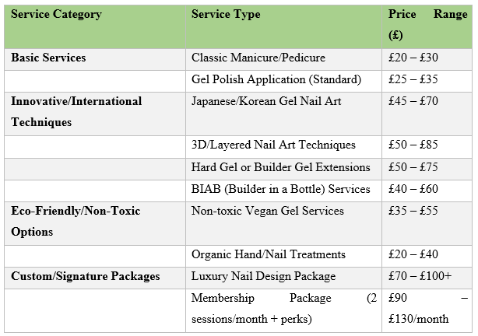
Place: With salon services, the website is the digital place for initial interaction. A mobile-friendly, SEO-optimized site with booking, service descriptions and location mapping will improve client convenience.
Promotion: To increase traffic and trust the site will include social media feeds, customer testimonials and nail trend blogs. Promo coupons or referral codes will help stimulate new client trials.

Website design:
Nicolle Nails Art's Weebly website showcases nail care innovation and innovative foreign procedures and materials not yet accessible in the UK. Two important functional pages were considered:
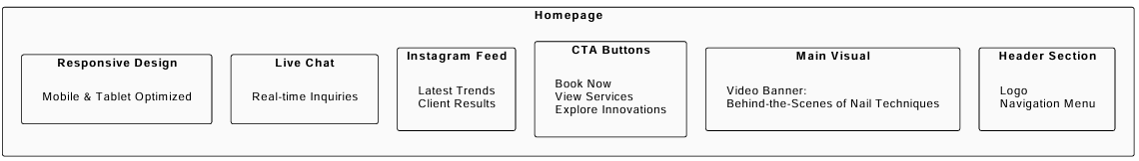

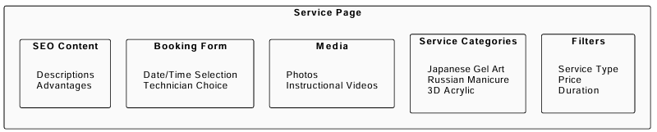

Website design of the company
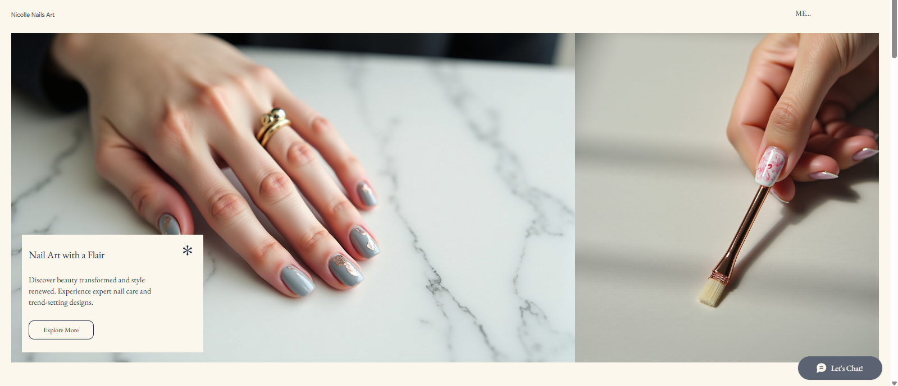
Figure: Home Page
The main page of Nicolle Nails Art greets the visitor with the revolutionary services presented by the salon. It has an appealing pictorial of sophisticated nail art paying attention to luxury and care. The CTA button invites people to know more about the special services of the salon by referring to the words Explore More. The sleek design reflects the quality of services as being high end and of a professional nature. There is Live Chat to communicate with customers immediately and provide answers to their questions. The page offers an effective presentation of the value provided by the salon and provides an excellent user experience with a properly arranged visual content and simplicity of navigation.
Figure: Services Page
Services Page shows the list of nail care services provided at Nicolle Nails Art neatly. These are Eco Manicure, Japanese Gel Art and Korean Nail Art in which the price is provided in each service (Lourenco, 2023). All the services are accompanied by photos of quality images representing the techniques. Users can also make booking on the spot by using the Book Now buttons and this enables a smooth booking process. On this page, it is possible to inform customers about uncommon international techniques of the salon, and ask to experiment with new nail trends, which cannot be found in the UK so easily.

Marketing materials
The marketing materials will comprise influencers along with media coverage. On the other hand, monthly newsletters, brochures along with nail trends exhibitions will also be considered as a part of marketing materials (Team, 2024). Loyalty programs will be arranged in which customers will be offered free nail art on each of the 6 visits.
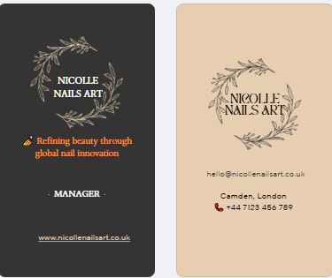
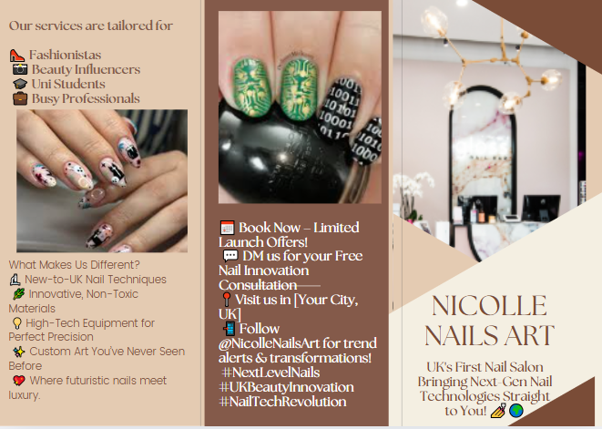Figure : Instagram post

Audience segmentation and targeting
Segmentation
Segmentation Variable | Segment Description
Demographic | - Age: Women aged 18–45,  - Occupation: urban professionals and students  - Income level: £25,000 - £60,000  - Family status: Small and large families
Geographic | - Urban: Bristol, United Kingdom
Psychographic | - Fashion-forward  - Tech-savvy  - values self-care and aesthetics
Behavioral | - Frequent beauty salon visitors  - Early adopters of trends  - Follows beauty influencers

SEO strategy
An efficient SEO approach helps Nicolle Nails Art acquire more customers by enhancing its online presence (Zlatilov, 2018). Central to SEO for nail salons is comprehensive keyword research, which serves as the foundation (Lourenco, 2023). By targeting phrases like “innovative nail techniques UK” or “advanced nail salons in London,” SEO boosts the salon's search engine rankings for unique nail treatments. Local SEO may increase foot traffic by showing in “near me” searches. Enhancing website content, Google My Business listings and social media presence boosts credibility. This cost-effective marketing strategy promotes organic reach, bookings and Nicolle Nails Art's UK trendsetting status.

Conclusion
The report concludes that UK customers prioritize innovation, cleanliness and eco-friendly manicure treatments, presenting a significant potential for Nicolle Nails Art. With an SEO-driven, user-friendly website, targeted marketing and global-trend-inspired services, the firm can attract and keep contemporary, beauty-conscious customers. Local search optimization, social media impact and loyalty programs will boost its market presence (Bakri, 2023). Nicolle Nails Art wants to revolutionize nail salons with quality, technology and trendy experiences.

References:

Bakri, Z.F., 2023. Analyzing the influence of digital marketing strategies on business performance in the beauty industry: a comprehensive analysis of social media engagement and influencer collaborations. Journal on Economics, Management and BusinessTechnology,2(1),pp.37-48. https://plus62.isha.or.id/index.php/JEMBUT/article/view/187
George, A.S., Baskar, T. and Srikaanth, P.B., 2024. The erosion of cognitive skills in the technological age: How reliance on technology impacts critical thinking, problem-solving, and creativity. Partners Universal Innovative Research Publication, 2(3), pp.147-163.
Hillier, A. (2023). UK Nail Salon Content & Social Media Marketing Expert Advice & Tricks 2023 | Featheredgemedia.com. [Online] Available at: <https://featheredgemedia.com/blog/uk-nail-salon-content-social-media-marketing-expert-advice-tricks-2023#:~:text=Social%20Media%20Marketing%20for%20UK%20Nail%20Salons&text=Instagram%20and%20Facebook%20are%20great,professional%20networking%20in%20the%20UK.> > [Accessed on: 15th June, 2025]
https://puirp.com/index.php/research/article/view/63
Lourenco, C. (2023). Loudachris Digital Marketing - Google Ads & Local SEO Agency in Adelaide |Loudachris.com [online] Available at: <https://www.loudachris.com.au/seo-for-nail-salons/> > [Accessed on: 15th June, 2025]
McAshan, B.R. (2019). Nail hygiene: How to ensure manicure and pedicure safety | News.com [online] NewAvailable at: <https://www.tmc./news/2019/01/nail-hygiene-are-manicures-and-pedicures-worth-the-health-risks/> > [Accessed on: 15th June, 2025]
Team, B. (2024). A Collection of the Best Nail Salon Quotes and Sayings| booksy.com [online] Booksy.com. Available at: <https://biz.booksy.com/en-us//a-collection-of-the-best-nail-salon-quotes-and-saying> > [Accessed on: 15th June, 2025]
Zagalsky, A. (2024). The Rise of Eco-Friendly Nail Art: The PRITINYC Story | Fashionglobe.com [online] Available at: <https://thefashionglobe.com/eco-friendly-nail-art-the-pritinyc-story/> > [Accessed on: 15th June, 2025]
Zlatilov, Z., 2018. Design and development of a responsive website to enhance business potentialpp 1-73. https://www.theseus.fi/handle/10024/159107

Questionnaire and data collection
1. How often do you visit a nail salon?
2. What do you usually consider most important when choosing a nail salon?
3. Would you be interested in trying nail services that use advanced or international nail techniques not currently available in the UK?
4. How do you usually hear about new nail salons or beauty services?
5. I am open to trying new nail materials or technologies if they offer better results.
6. I would pay more for a nail service that uses healthier or longer-lasting materials.
7. I often look for the latest nail trends and innovations on social media.
8. I trust nail salons more if they use high-tech or modern equipment.
9. I am more likely to return to a salon that offers unique services not found elsewhere.
10. I care about whether nail materials are eco-friendly or non-toxic.

Appendices

Appendix 1
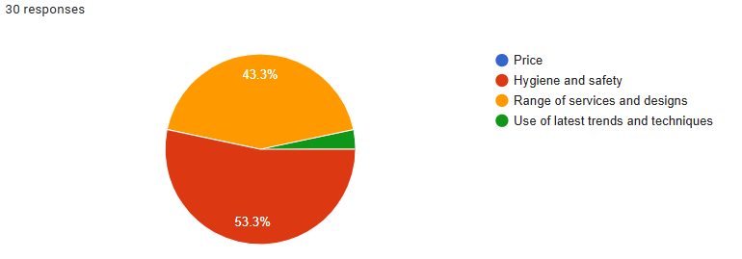
Figure 1: Essential factors when choosing nail salon
(Source: Self-created)

Appendix 2
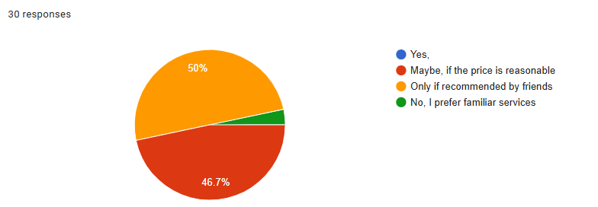
Figure 2: Preference in choosing nail services with advanced and international nail techniques
(Source: Self-created)

Appendix 3

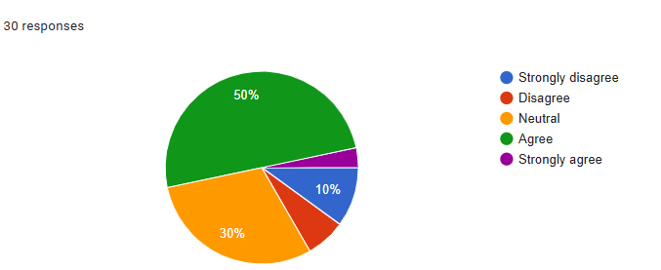
Figure 3: Likelihood of paying more for nail services using healthier and ecofriendly materials
(Source: Self-created)

Appendix 4
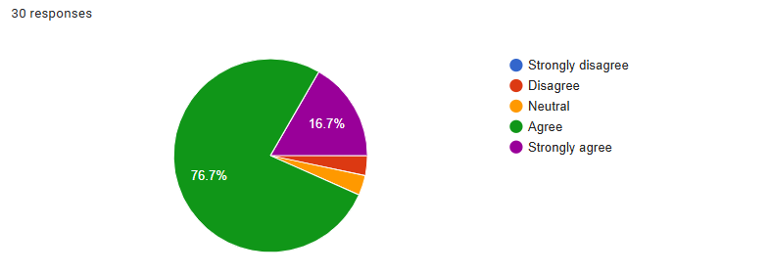
Figure 4: Discovering new nail salons
(Source: Self-created)

Task 2: Financial Projection Spreadsheet and Essay

Category | Jan | Feb | Mar | Apr | May | Jun | Jul | Aug | Sep | Oct | Nov | Dec | Total
Income
Nail Services | £5,000 | £5,500 | £6,000 | £6,500 | £7,000 | £7,500 | £8,000 | £8,500 | £9,000 | £9,500 | £10,000 | £10,500 | £84,000
Product Sales | £1,000 | £1,200 | £1,400 | £1,600 | £1,800 | £2,000 | £2,200 | £2,400 | £2,600 | £2,800 | £3,000 | £3,200 | £24,200
Total Income | £6,000 | £6,700 | £7,400 | £8,100 | £8,800 | £9,500 | £10,200 | £10,900 | £11,600 | £12,300 | £13,000 | £13,700 | £108,200
Expenses
Rent | £1,200 | £1,200 | £1,200 | £1,200 | £1,200 | £1,200 | £1,200 | £1,200 | £1,200 | £1,200 | £1,200 | £1,200 | £14,400
Salaries | £3,000 | £3,000 | £3,000 | £3,000 | £3,000 | £3,000 | £3,000 | £3,000 | £3,000 | £3,000 | £3,000 | £3,000 | £36,000
Supplies | £500 | £550 | £600 | £650 | £700 | £750 | £800 | £850 | £900 | £950 | £1,000 | £1,050 | £9,300
Marketing | £300 | £300 | £300 | £300 | £300 | £300 | £300 | £300 | £300 | £300 | £300 | £300 | £3,600
Utilities | £150 | £150 | £150 | £150 | £150 | £150 | £150 | £150 | £150 | £150 | £150 | £150 | £1,800
Total Expenses | £5,150 | £5,200 | £5,250 | £5,300 | £5,350 | £5,400 | £5,450 | £5,500 | £5,550 | £5,600 | £5,650 | £5,700 | £65,100
Profit/Loss | £850 | £1,500 | £2,150 | £2,800 | £3,450 | £4,100 | £4,750 | £5,400 | £6,050 | £6,700 | 7,350 | £8,000 | £43.100

The Importance of Microsoft Excel in the Digital Era

Data-driven decision-making has become an essential part of any business in the modern digital era because such companies aim to remain competitive within the dynamic environment. Microsoft Excel is the most efficient tool in terms of organising, analysis and projection of financial and operational data (Salijeni et al., 2021). Excel is the most essential to run budgeting, forecasting, inventory monitoring and customer analytics of small businesses such as the Nicolle Nails Art.
The management of financial information is the main strength of Excel. In the case of Nicolle Nails Art, doing the 12-month financial plan will assist in forecasting revenue, cost, and profitability. This enables the salon to automate the calculations that are repeated, such as the total it can use formulas such as =SUM (). But also, the profit can be automatic as there is another formula =B4-B11 that calculates the profit. This helps reduce the chance of human error. Conditional formatting can be used to emphasise any important trends like a seasonal increase in the demand which will aid the business in the process of staffing and marketing events. Besides, the scenario analysis feature of Excel enables the salon to experiment with various pricing procedures, i.e. charge a high price on professional nail painting services as opposed to the regular manicure, to identify the model that would yield the highest profits.
In conducting data analysis, the tools in Excel allow any business to derive sensible results out of raw data. At Nicolle Nails Art, the responses to the customer questions in the survey of Task 1 like the preferences based on hygiene aspects, higher prices on the products that are environmentally friendly, etc. can be planned in the PivotTables to determine any patterns and trends. As an example, in case that 53.3 percent of clients are interested in sanitation, the salon can underline its procedures of sterilisation in its ads. Likewise, monitoring on the services fetching the most profits such as Japanese Gel Art vs. 3D Acrylics facilitate efficient allocation of resources (Mahamud, 2024). The find it easy to present the findings to the stakeholders using excel charts like bar graphs to compare the monthly income and expenditure.
When operating a nail salon, one should keep a close inventory-polishes, gels, tools, disposables, etc. must be available all the time. With excel, it is possible to automate the reorder notifications when the stocks are running low, eliminating the inconveniences (Haider and Lucas, 2024). Simply, a spreadsheet can be used to record the cost of suppliers, which will enable Nicolle Nails Art to negotiate the prices better. As an example, when the cost of hypoallergenic nail polish falls by 15 percent in bulk sales, one will be able to estimate the annual savings with the help of the Excel. Also, monitoring of expiration dates of products also guarantees the use of fresh producing only high-quality materials, which would improve the satisfaction of customers (Kailaku and Djatna, 2022).
Excel may serve as a simple CRM system having the data on client contacts, history of the services and preferences. With information about booking frequency, Nicolle Nails Art will be able to recognise the loyal customers and launch personalised promotions like a discount of their next booking. Moreover, the results of promoting actions, including advertising in social networks or promotion programs, can be monitored in Excel to calculate the result of investment ROI (Mothapo et al., 2024). In case Instagram advertisement helps in attracting 30 percent more bookings as compared to that of Facebook, the salon will be able to redirect its budget.
Excel grows with Nicolle Nails Art as it grows. Customised spreadsheets can be used to manage multi-location finances, shift planning of employees and comparison of franchise performance. Another example is a dashboard with an overview of annual revenues per branch that will allow identifying the most profitable branches.
The Microsoft Excel is one of the foundations of the contemporary business efficiency (Nabil et al., 2023). To the case of Nicolle Nails Art, it can process raw data and convert them into tactics to work on pricing, inventory management, and customer retention. During the modern digital age of data dominance, Excel literacy can no longer be considered an asset, but a key to a long-term development (George et al., 2024). Through the full potential of the company, some of the small businesses will be able to compete with others of a larger firm that for sure take informed decisions which leads to their achievement.
References:
Salijeni, G., Samsonova-Taddei, A. and Turley, S., 2021. Understanding how big data technologies reconfigure the nature and organization of financial statement audits: A sociomaterial analysis. European Accounting Review, 30(3), pp.531-555.https://www.tandfonline.com/doi/pdf/10.1080/09638180.2021.1882320
Mahamud, F., 2024. Enhancing Inventory Management Efficiency-A Case Study on Inventory Optimization. https://www.theseus.fi/bitstream/handle/10024/858500/Mahamud_Fabio.pdf?sequence=2
Haider, G. and Lucas, E., 2024. Smart Inventory Management for SMEs: Leveraging IoT and Automation to Streamline Stock Control and Minimize Costs. https://www.researchgate.net/profile/Edward-Lucas-2/publication/386398281_Smart_Inventory_Management_for_SMEs_Leveraging_IoT_and_Automation_to_Streamline_Stock_Control_and_Minimize_Costs/links/67501145876bd177783b27ec/Smart-Inventory-Management-for-SMEs-Leveraging-IoT-and-Automation-to-Streamline-Stock-Control-and-Minimize-Costs.pdf
Kailaku, S.I. and Djatna, T., 2022, May. Traceability and quality monitoring improvement throughout carrot supply chain with the implementation of Internet-Of-Things. In IOP Conference Series: Earth and Environmental Science (Vol. 1024, No. 1, p. 012079). IOP Publishing.https://iopscience.iop.org/article/10.1088/1755-1315/1024/1/012079/meta
Mothapo, M., Thango, B. and Lerato, M., 2024. Tracking and Measuring Social Media Activity: Key Metrics for SME Strategic Success-A Systematic Review. Available at SSRN 4992468. https://papers.ssrn.com/sol3/papers.cfm?abstract_id=4992468
Nabil, D.H., Rahman, M.H., Chowdhury, A.H. and Menezes, B.C., 2023. Managing supply chain performance using a real time Microsoft Power BI dashboard by action design research (ADR) method. Cogent Engineering, 10(2), p.2257924. https://www.tandfonline.com/doi/abs/10.1080/23311916.2023.2257924
George, A.S., Baskar, T. and Srikaanth, P.B., 2024. The erosion of cognitive skills in the technological age: How reliance on technology impacts critical thinking, problem-solving, and creativity. Partners Universal Innovative Research Publication, 2(3), pp.147-163. https://puirp.com/index.php/research/article/view/63

