Vehicle Technology – Chassis & Aero
Since the late 80s, chassis rigidity of new cars has increased significantly. Whenever a new car is launched, the manufacturer must claim its torsional rigidity has been increased by at least 20%. This is due both to the requirements for crash protection, and to improve handling.

Q1 - Choose two of the following body/chassis structure types & discuss the pros and cons?

Bonded aluminium chassis tub with fibre glass body

The Lotus Elise is mostly known for the way it corners, this is down to the type of chassis it uses. It uses a bonded aluminium tub with sections glued together with epoxy. These are created by extrusion moulding, with Lotus’ volume of production low, a practical and cost-efficient way of producing these chassis was needed. They form parts of the chassis and glue and rivet together to create a tub. The Renault Sport spider used the same technique to form the chassis, but instead of gluing and riveting, Renault welded the sections together instead.
As you can see from the graph above the Lotus beats the Renault in all departments. Lotus produced a thinner and lighter chassis which was a full 1000Nm stiffer than the Renaults. Lotus's technology was originated by its supplier, Hydro Aluminium of Denmark. Hydro discovered that aluminium extrusion can be bonded by epoxy resin if it is adequately prepared by a special chemical in the bonding surface. Surprisingly, glue can bond the sections together strongly and reliably.

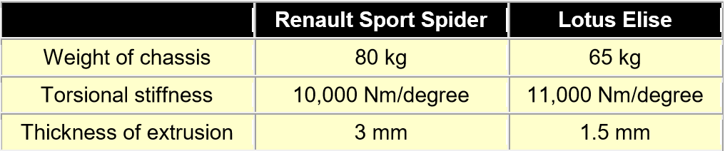
Most importantly, the aluminium extruded sections can be made much thinner than traditional welding technique. As welded joints are weak, the thickness of material was increased throughout just to make a joint strong enough. Therefore, Elise's chassis could be lighter yet stiffer.

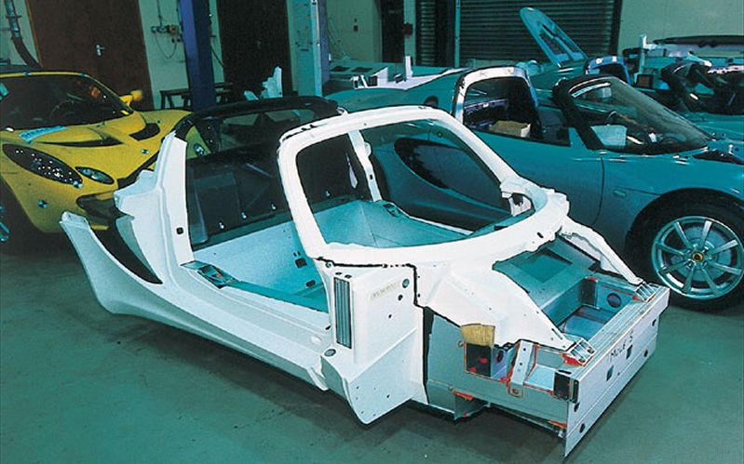
This form of chassis and its construction method has many advantages: -
- In comparison to welding there is no heat affected zone
- Joints can tolerate dimensional variances
- Dissimilar materials can be joined (eg Alloy to composite)
- Joint surfaces/designs can ensure maximum strength
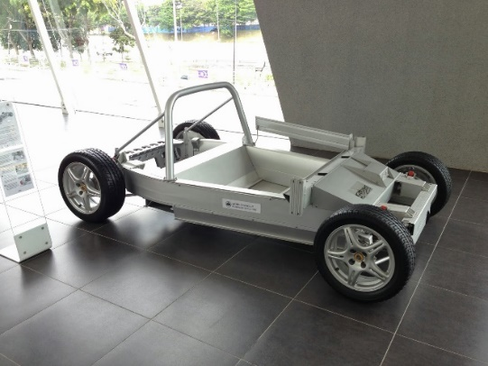
- Relatively low budget tooling and set costs
- Short lead time to first prototypes
- Aluminium widely recyclable, so no waste
(Lotuscars.com, 2018)
With this chassis fitted to the Elise, it means the car itself is extremely light, and for its size can out corner many supercars.
The Elise's light weight is achieved through several different methods. It starts with the chassis, which is made of aluminium. Formed of bonded aluminium sheets in a tub shape, the Elise chassis only weighs 65kg.
Next, the Elise is a very small car, a two-seat roadster with only a small storage space for luggage. The short wheelbase also keeps the car's profile trim and compact.
Finally, Lotus kept the Elise's weight down by stripping away many of the comforts that are considered mandatory in a high-priced car. Much of the aluminium tub is left exposed, and many of the interior panels have large holes drilled through them to further cut weight.
With the new Elise, Lotus has pioneered a new way of designing cars. The aluminium-tub chassis of the Elise is the first part of Lotus' Versatile Vehicle Architecture format. That same basic chassis has been made into the larger and more expensive Lotus Esprit, a four-seat car in the $125,000 range that features more space, more weight and lots more horsepower.
Although there are many positives for the aluminium tub chassis, it still has its negatives. Overall the welding capability is poor, therefore rivets and glue are used instead. Unless the aluminium is alloyed its strength is much lower than aluminium that is alloyed.
(Grabianowski, 2018)

Steel Monocoque

‘A Steel monocoque chassis integrates the chassis and body together. It forms a composite structure which increases the stiffness as well as a way of keeping weight down. In a monocoque chassis the stress generated by the vehicle during motion is being distributed among the structure and does not form localised stress which may have higher value of deformation. As the stress is being distributed equally among the structure the torsional stiffness of the chassis is high which proves advantageous for the suspension as they can be designed to be more robust and increases the performance of the vehicle. It proves to be a great balance between strength and weight which ultimately increases performance.’
(Quora.com, 2018)
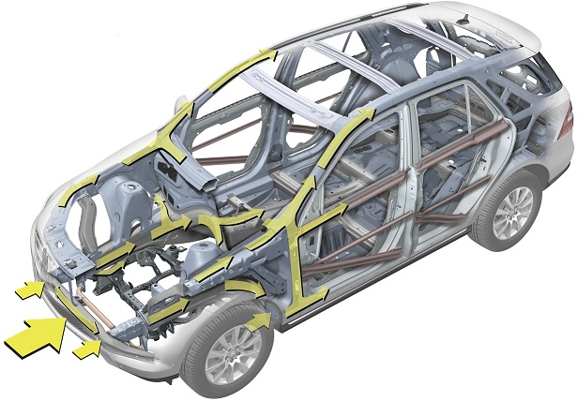
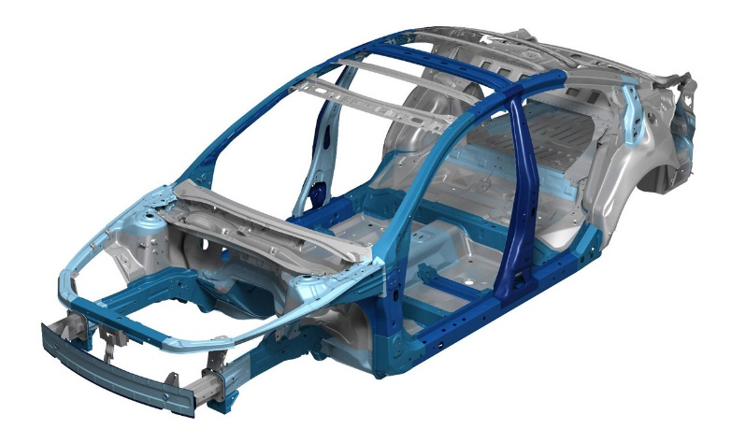
For the monocoque chassis, the skin formed completely of metal and is solely focused to bear the stresses. To put into context, it’s much like an egg’s shell. The formed sheets are welded onto the chassis to strength it and to bear tensile, bending and torsional forces that are created during cornering.
The sheet thickness that’s chosen to form various sections are important decision as it can affect the car’s handling capability to safety that it provides to the passengers.
A monocoque construction is much lighter in comparison to other chassis. Comparing the amount of material that it requires to provide significant strength to the car is much less that other types, therefore from a manufacturability point of view, it’s economical to produce.
All monocoque chassis can be made lighter with the use of better materials, this allows for greater benefits such as high fuel efficiency due to the low weight that it can achieve through inherent designing.
Monocoque chassis also benefit the safety of the passengers. This is because a larger volume of metal is used so the crumple zone can be built into the structure. The whole structure is an outer shell, unlike other types of chassis, thus allowing a large volume of space to be saved.
‘When comparing a monocoque to a body on frame construction, in a monocoque chassis there is no separate structure to offer support, the chances of permanently damaging the car are quite high. While a body-on-frame construction is comparatively easy to repair. Almost no production car uses a complete monocoque construction, instead they use a unibody construction or a semi-monocoque construction where sheet metal only bears part of loads.’ (Vig, 2018)

Q2 - An understanding of aerodynamics as it relates to automobiles is important to improve which major areas of performance and explain the criteria that effects drag or wind resistance of a vehicle?

The more aerodynamically efficient the car is, the less fuel it will use to travel along at any given speed. The faster the car moves, the more important it is to keep the air resistance and drag to a minimum.
Designing a car that will slip through the air in a straight line with now wind blowing is easy. But when forces are added to the car, e.g. cornering at high speeds or wind blowing form one side, this is where things become tricky.
When comparing the centre of pressure, if it is well above the centre of gravity of the car, a side wind would want to make the car roll as well as pushing it offline. But if the centre of pressure is well in front of the cars centre of gravity, as strong wind from the side would try to make the car turn around to put the centre of gravity in front.
When the car is travelling at speed, the location of the centre of pressure shifts in proportion, and in some cases the centre of pressure will move in front of the car itself. The solution is to ensure the cars centre of gravity is located well forward. Therefore, several car companies opt for front wheel drive, because it has a forward weight bias.
(How a Car Works, 2018)

Race car case study
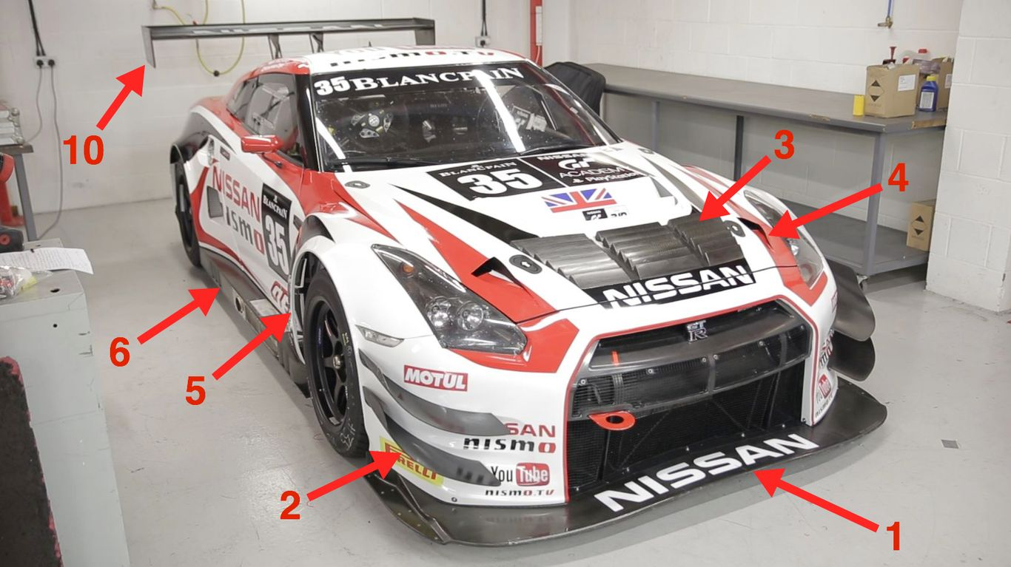

1. Splitter
A splitter is the leading edge of the front of the car. It is located very close to the ground forcing the air up, allowing the high air pressure to pass over the car instead of travelling underneath the car. The high pressure pushes down on the splitter, also helping to create downforce.

2. Dive Planes

The dive planes are located on the sides of the front bumper, they are shaped upwards allowing the air the be re directed, thus creating downforce. They are also used to channel air around the sides of the car, minimizing the amount of high pressure that enters the underneath of the car which would cause lift.

3. Hood Vents

These allow for clean air to exit which is passing through the radiator, they also help to keep airflow heading to the engine bay which increases cooling.


4. NACA Ducts

These are air scoops are designed to have as little impact on the airflow as possible. These are used for several purposes, whether its to feed air to the radiator or even cooling for the drive. The Ferrari F40 used several NACA ducts.

5. Side Vents

Side vents are located behind the front or rear wheels. This allows the air to exit the wheel wells which remains turbulent form the rotation of the wheels. They can also be used to channel hot air out of the engine bay if needs be.

6. Side Skirt

Side skirts have the same effect as splitters in theory, they are located as low as possible to prevent the high pressure to move underneath the car.

7. Underbelly

On race cars the underbelly will often be as smooth as possible to reduce the drag and turbulent air underneath the car. Working in tandem with the diffuser, the low pressure under the car can be produced into a large amount of downforce.

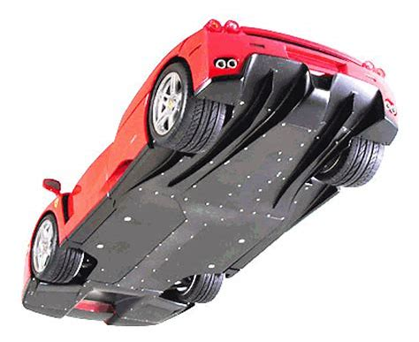
8. Diffuser
The diffuser is in A diffuser is a portion of the underbody which is shaped to create a location of increasingly larger air volume below the rear of the car. The diffuser helps to speed up the air passing under the car which reduces the pressure, thus creating downforce.

9. Spoiler
Spoilers are used to prevent the airflow by obstructing its path. With its path changed, the airflow at the rear of the car can leave in an upwards/horizontal direction preventing any lift.

10. Rear Wing
The job of a rear wing is to direct airflow upwards, pushing the car into the ground. This gives the car more downforce but for the expense of additional drag.
(Car Throttle, 2018)
Audi Case Study

Underbody

Typically, cars produce around 40-50% of the total aerodynamic drag around the wheels, wheel arches and the underbody. Audi have equipment to optimize these areas of the car, the air aeroacoustics wind tunnel. It allows the wheels to turn on 4 small treadmills, allowing data to be analysed which gives a much more detailed picture of what the airflow is doing under the car.
On several Audi models, the engineers have opted to fit a full area underbody, so only the exhaust system and rear axel are exposed to the airflow. NACA ducts selectively conduct cooling air streams to several components on the car, e.g. transmission’s oil cooler. Located at the rear of the car, a cover plate and the mufflers form a diffuser surface that rises as it extends rearward. (Audi Technology Portal, 2018)
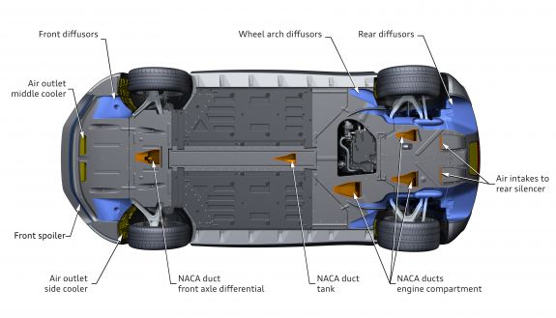

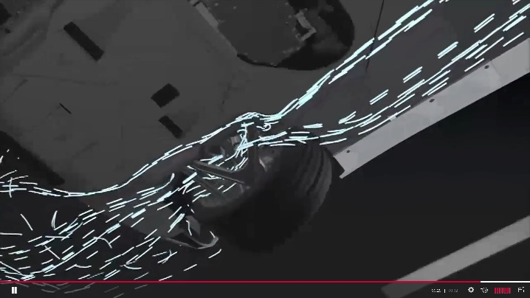
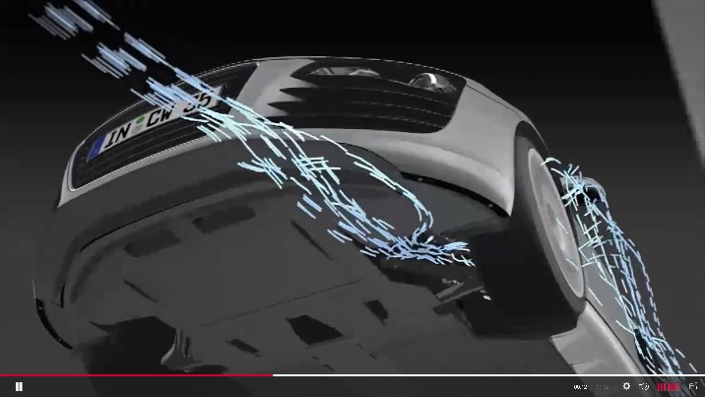
Audi R8 underbody

Air flow through engine compartment

Audi have begun to study the flow of air through the engine compartment, a recent branch of aerodynamics. On several of their new models, the area around the grille is sealed thoroughly, to prevent the air becoming turbulent. Instead the air reaches the radiator as a smooth airflow.
By introducing this technique, it allows the plate package and the fans impellers to optimize the airflow. Throughout the cooling module, the arrangement and function of all components are precisely coordinated, which means that the two fans require relatively little power.
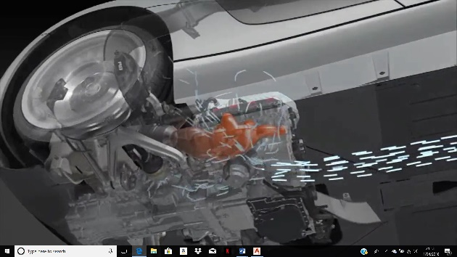
(Audi Technology Portal, 2018)
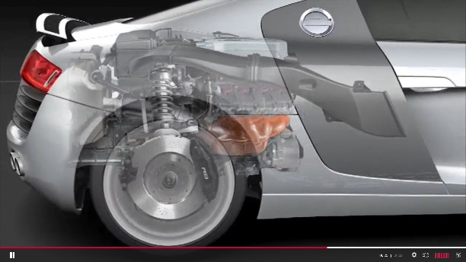

Bibliography

Lotuscars.com. (2018). Lightweight Assemblies. [online] Available at: http://www.lotuscars.com/engineering/lightweight-assemblies [Accessed 2 Apr. 2018].

Grabianowski, E. (2018). How the Lotus Elise Works. [online] HowStuffWorks. Available at: https://auto.howstuffworks.com/lotus-elise3.htm [Accessed 2 Apr. 2018].

Quora.com. (2018). What is a monocoque chassis and how exactly does it differ from a conventional one? - Quora. [online] Available at: https://www.quora.com/What-is-a-monocoque-chassis-and-how-exactly-does-it-differ-from-a-conventional-one [Accessed 6 Apr. 2018].

Vig, P. (2018). What is Monocoque construction?- AutoPortal. [online] autoportal.com. Available at: https://autoportal.com/articles/what-is-monocoque-construction-9692.html [Accessed 6 Apr. 2018].

How a Car Works. (2018). Car aerodynamics. [online] Available at: https://www.howacarworks.com/technology/car-aerodynamics [Accessed 6 Apr. 2018].

Audi Technology Portal. (2018). Audi Technology Portal - Aerodynamics. [online] Available at: https://www.audi-technology-portal.de/en/body/aerodynamics-aeroacoustics/aerodynamics [Accessed 6 Apr. 2018].

Audi Technology Portal. (2018). Audi Technology Portal - Air flow through the engine compartment. [online] Available at: https://www.audi-technology-portal.de/en/body/aerodynamics-aeroacoustics/air-flow-through-the-engine-compartment [Accessed 11 Apr. 2018].

Audi Technology Portal. (2018). Audi Technology Portal - Underbody. [online] Available at: https://www.audi-technology-portal.de/en/body/aerodynamics-aeroacoustics/underbody [Accessed 11 Apr. 2018].

Car Throttle. (2018). Engineering Explained: 10 Aerodynamic Features Of Race Cars. [online] Available at: https://www.carthrottle.com/post/engineering-explained-10-aerodynamic-features-of-race-cars/ [Accessed 11 Apr. 2018].

