An early YEARS PRACTITIONER’S GUIDE TO SUPPORTING Transitions

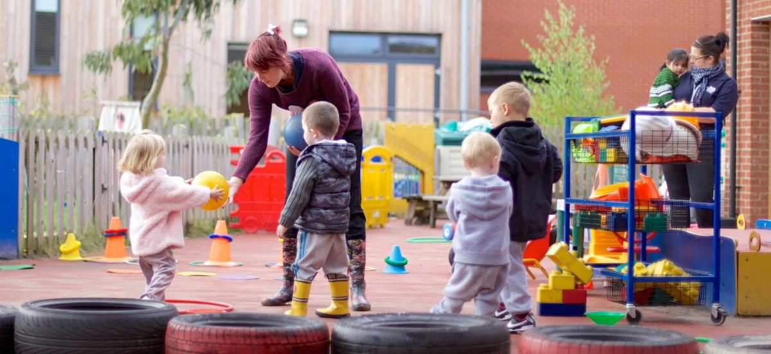

Eyalliance (2017)

Contents

Introduction Page 3

The need of the child Page 5
The role of the adult Page 8
Partnerships Page 13

Interventions Page 15

Outcomes Page 17

Reference list Page 18

Introduction

This aim of this handbook is to guide the early years practitioner through transitions, looking at the role the adult plays in supporting transitions and the needs of the child during these periods. It will explore the partnerships that should be developed between settings, families and agencies involved in the wellbeing of the child and what interventions or strategies may be employed to support each transition. Finally, outlining the proposed outcomes for a successful and smooth transition.
The focus of this handbook is to provide the early years practitioner with guidance on how to play an effective role during the transition phase for children when leaving a nursery or childcare setting and entering a school environment.

What is a transition?
“Transitions are key events or processes of change over the life course” (Flying start 2017).
People experience transitions through every stage of their lives from birth onwards. Starting school, leaving home, becoming a parent, marking special occasions through religious celebrations (Brooker 2008).
When applied to the early years environment, Education Scotland (2022) states:
“Transitions are the moves children and young people make from home to an early learning and childcare setting, from there to primary”.
The early years sector has seen transitions as a relatively new concept, for example, during the Second World War, when children were evacuated from their families, it was recommended that the children were told they would be going on holidays, thereby leaving them completely unprepared for the reality of being an evacuee, separated from families and friends. Also, in the past, when a mother was due to give birth, older children in the family were commonly sent away until after the baby had arrived and upon their return were presented with a complete shift in the family dynamics and their position within it (Trodd 2012).
According to Vogler et al (2008), research also suggests that there are two different forms of transitions: horizontal and vertical. Horizontal transitions are the smaller changes that children may experience daily, the transitioning of environments from home to school, or between classrooms during the school day for assemblies or group work. Vertical transitions are the major changes in a child’s life, which may happen individually or coincide with another major change, the move from home to a childcare setting or it may be that a child is moving home and changing childminders at the same time.
Transitions and how they affect a child’s wellbeing has been researched more heavily over the past 50 years (Education Scotland 2019), demonstrating the importance of smooth transitions in the early years.
The objective and desired outcome of a smooth transition is to ensure that a child builds confidence in the belief that the environment surrounding them is safe, thereby enabling them to navigate future changes successfully and with greater resilience. (The Educator UK 2017).
Early years practitioners should ensure that the transition from nursery is not a single, overwhelming event, whereby a child’s environment changes suddenly. Their transition should evolve and develop over time with many smaller steps leading up to the day they start school with continued, cohesive support from key workers, teachers and parents or guardians (Flying start 2017).

The Needs of the Child
In any early years setting, the needs of the child should be at the centre of all planning and policy. It is written in law through the United Nations Convention on the Rights of the Child, that adults and government must act with the best interests of the child when making decisions that will affect them (Article 3, UNCRC, no date).
A child may experience numerous transitions much earlier in life as mothers are more likely to work than they were in the past, making a child’s life an ever changing and evolving world (Brooker 2008).
To aid the child through these transitions, a practitioner may consider Maslow’s research on the Hierarchy of Needs and Self-Actualisation when planning on how to best support them.
Maslow’s research and theory on the hierarchy of needs and self-actualisation focused on what a human needed to perform to their best, both physiologically and psychologically (Aubrey and Riley 2017).
As shown in the pyramid below:
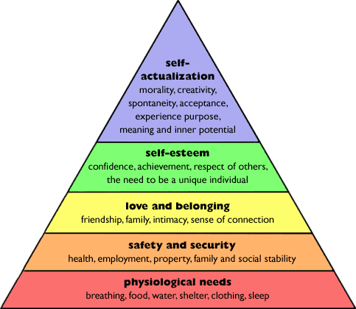(Research History 2012)
Maslow argued that a person must meet the needs of each level before progressing up the pyramid. He suggests that a person may move up or down the pyramid if a lower need is not being met sufficiently.
He also suggested that only 1-2% of people might actually reach self-actualisation which he describes as a person who still finds wonder in everyday, moment on moment experiences (Aubrey and Riley 2017).
A practitioner could put Maslow’s theories into practice every day, ensuring they are meeting their physiological needs, food, water, shelter, appropriate clothing for outdoor play. When these needs are met, consider the safety and security stage, encouraging the child to understand they are safe within their environment, building a trusting relationship with the child enabling them to feel confident to explore. Then move onto the love and belonging stage to enable the child to connect with the environment around them and develop a sense of belonging and their place within their setting and peer group.
Maslow’s theory could be put into practice within a setting using the following ideas
- A child could bring in snacks and drinks for their transition day and visit the dinner hall to understand where they will eat lunch.

- They could take part in day visits to their new classroom to allow them to feel safe in, what may be, completely new surroundings, maybe bringing a favourite toy or a photo of their family from home with them.

- Meet the teacher or stay and play visits could be arranged to demonstrate good communication between families and the teachers, allowing both children and parents to start building the foundations of a healthy and trusting relationship between home and school.

- Ensuring the child is heard by inviting feedback as to what they have enjoyed or expressed an interest in thereby building and developing the relationship between the child, school and their parents.

- Observing areas of concerns, if they grow anxious when moving around the school, for example, or if they feel unsure of the older, bigger children within the school, planning interventions or extra steps to prepare them for the transition.
Bowlby suggest that the bond a child makes with its mother in the first 3 years of life may affect any future attachments the child makes. He argues that children that have a strong, stable bond, based on his idea of a safe base, with their mother in those early stages of life will be better placed to cope with changes in environment (Conkbayir and Pascal 2014).
His theory of attachment suggests that for a child to feel secure to explore their environment, they need a secure attachment, that may be a practitioner within the setting but may also be a peer or sibling, maybe a twin or an older sibling within the school who could be visited regularly during the transition period if needed.

The Role of the adult
The role of the adult within an early years setting is to be an enabler. According to Welsh Government (2022) enabling adults “support learners to cope with uncertainty and change, preparing them to manage transitions and changes in daily routines”.
Transitions are a part of a child’s journey through life and how these transitions are managed may well affect a child’s development and should not be viewed as a single event but more as a continuous evolution (Early Years Matter 2022).
Thomas, Evans and Crowley (2016) suggest that development is best described as “patterns of change over time which begin at conception and continue throughout the life span”. Development can occur, biologically (physical changes), socially (changes in our relationships), emotionally (change in understanding and experiences) and cognitively (change in how we think).
Transitions will play a part in a child’s development, socially, emotionally, and cognitively, as their situation changes, so will their understanding of the world around them, their support structures will change as may their peers and friendship groups. Things to consider when planning transitions could be the environment, communication, and observations.

Environment and the importance of play
Environment can play an important role during a child’s transition. Practitioners should ensure that the child’s environment is engaging (Welsh Government 2022) and children should be encouraged and supported to explore their new surroundings, for example, during transitions days.
Article 31 of the UNCRC, states that every child has a right to leisure, play and culture. The Welsh Assembly Government (2002) argues that play is instinctive to a child and fundamental to their development.
Practitioners should ensure that the indoor and outdoor areas of their setting is full of curiosities to encourage exploration, Play Wales (2016) suggests utilising the natural world, creating opportunities to move, areas for role play and toys and equipment to understand and develop awareness of their senses.
Vygotsky argued that environment plays a strong role in a child’s cognitive development, he also argues that children learn from more learned members of society, for example, parents, teachers and peers and that children learn the values and skills that a particular culture considers to be important. (Thomas et al 2016).
Piaget believed that children learn through doing. He believed that a child was in control of their own learning and that they would learn through first-hand experience (Gray 2015).
He developed the idea of schemas, describing how a child makes sense of the world around them by sorting information into categories. He also believed that these schemas would evolve as the child gained more experience and knowledge.
Practitioners should be a good role model, listen to their interests, what they wish to learn or explore and enable them to do this by utilising the environments within the setting both indoor and outdoor.
Froebel believed that the outdoors and the natural environment played an important role in a child’s learning and development (Pound 2005). Learning through outdoor play is also highlighted in the new Curriculum for Wales as an important resource (Welsh Government 2022).

COMMUNICATION
The Children’s Workforce Development Council (2010) suggests that good communication can be key to a successful transition for a child and that practitioners should be welcoming, approachable and open communicators to encourage both children and parents/carers to feel comfortable discussing their aims, hopes or concerns to help build trust and respect between the family and the setting.
Flying start (2014) states that “transitions are of the highest quality when…positive relationships are established, and all adults who are involved with the child and family work closely together”.
Practitioners should be willing to listen, to read body language and other non-verbal cues to help understand and develop what should be a continuous open exchange of information supporting the wishes of the children and families that they support (CWDC 2010).
To help build rapport with children and their families a practitioner should
- Take the time to listen to each child and to the family that surrounds them.
- Start a conversation with a parent or carer. Discuss the displays in the classroom, the topics the child will cover or the outdoor areas they will have access to.
- Invite questions and feedback and look at each child and family individually.
- A variety of methods of communication should be utilised including home visits, face to face and group meetings, coffee mornings, letters, school website and social media.

OBSERVATIONS
Bronfenbrenner’s ecological theory highlights the effects of a child’s surroundings upon them but also their impact on that environment (Conkbayir and Pascal 2014).
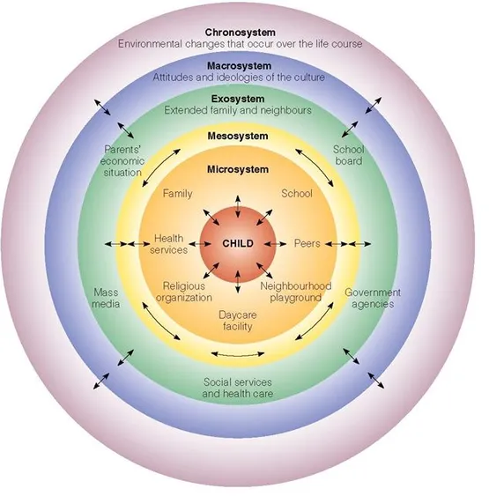
(Simply Psychology 2020)

The diagram above shows the systems that surround the child, the inner systems include family, school, peers and neighbours that surround the child, these are the people that have an immediate effect on the child’s life. Moving out to extended family and parents income, further still to the effects of media, government agencies and cultural ideologies, the child does not directly interact with the outer circles, however, they do have an impact on the life of the child (Conkbayir and Pascal 2014), for example, the UNCRC which is written into Wales’ domestic law ensuring that every decision made by government takes into considerations the impacts it may have on children (Children’s Commissioner for Wales 2022).
Gray (2015) state that Bandura and Bronfenbrenner suggested that society plays a part in the development of the child, and they both viewed the social interactions as central to their learning and development, they also agreed that culture played an important role in their schooling.
Practitioners should try to build an understanding of the child’s family to aid them in their understanding of the child as an individual. Knowing what religion may be practiced within the family, their cultural identity and how the child sees themselves within their family all help build a trusting and empathetic relationship between the child and their school.
If the child has attended a childcare setting, they would have been the subject of informal and formal observations. The results and information accrued over this time should be shared between nurseries or childminders and their new school to help the new setting to prepare for the child’s arrival and aid the child in their transition, for example, they may have an All About Me or a One Page Profile detailing their likes and dislikes, what positives other see in them and how they like to be supported (Flying start 2017).

Partnerships
Birth to 5 matters (no date) highlights six key points when looking at parents as partners in a child’s success in their school life and beyond.
- Parents have a crucial role to play in their child’s outcomes, involving parents in their schooling. The quality of the home learning environment can promote learning and overcome disadvantage. Parents and schools should have a respectful, trusting relationship to help develop learning in the home and at school
- Parents are their child’s lifelong promoters of development. Trust that parents and carers know their children best, what they enjoy, how best to support and care for them. Practitioners should listen to both the parents and the child to develop the best strategies to support their learning
- Each family is individual. Listen to what works best for the family, take the time to hear any stories or situations they’ve encountered and how they have overcome or celebrated to gain an understanding of how best to support that family.
- Looking at the levels of engagement for each family. Observe and reflect and which families have a good relationship with the setting and how to develop better relationships with families who may not be as engaged with the school. Maybe informal coffee mornings, an open-door policy or extra drop-in sessions with the teacher could be made available. Different forms of communication via social media or class DOJO be available for working parents who are unable to do the school run.
- Practitioners have a responsibility to work with every family. Families may experience several obstacles that prevent them from supporting their child or building the relationship they may want, there could be physical barriers, maybe the school is inaccessible, it could be that a parent or carer does not speak English or has difficulties communicating. What could be done to welcome them into the school setting, maybe letters home can be translated or for parents who have hearing/visual impairments communication can be adapted through utilising social media.
Articles 5, 14, 18, 27 and 29 of the UNCRC relates specifically to parents and recognises that they may need assistant from their government in fulfilling their role as parents (Flying Start 2017).

Interventions
Kirklees Council (2019) suggest several ways that transitions may be managed within the early years.
Ensure the pre-school provider is able to liaise with the school to provide one-page profiles, foundation phase profiles and any baseline assessments that have been carried out. These items will allow practitioners to assess and understand where a child is developmentally. According to Vygotsky a child will thrive within their proximal zone, he argued that practitioners and parents are more able to support a child when they understand where a child sits developmentally. He also placed great emphasis on learning through play which practitioners should support and observe through transitions periods to better understand a child (Lindon 2012).
Practitioners should ensure they give special consideration to children with additional learning needs and those who are transitioning to school without peers (Kirklees council 2019).
Children with additional learning needs and those moving to a new setting alone may need extra transition days, staggered start times to avoid the busy time of school drop off and pick up or shorter days until they feel confident and settled. They could be given social stories beforehand to share with their pre-school setting and parents with photos of their new classroom, teachers and staff who will be based in their setting.
Flying start (2014) suggests making a scrapbook of photos showing favourite activities, friends and keyworkers for a child to take with them when leaving their pre-school setting to show to parents and their new setting. They also suggest multi agency inclusion panel meet to plan an effective transition and a special needs health visitor may visit the new setting to suggest adaptations or alterations that may make the school more accessible.
Belfast Education and Library Board (2011) suggests holding group sessions with parents of children leaving a reception class and parents of children just joining the school to allow them to discuss experiences, worries and concerns.

OUTCOMES
The aim of all school settings, when introducing children to a new school environment should be a successful transition that effectively supports both the child and their parent/carer, Welsh Government (2022) states successful that transitions are important to reduce stress levels when dealing with new situations and environments, equip them to be confident, resilient learners able to interact with the environment, their peers and adults that surround them and to prepare them for school routines and expectations.

By utilising the idea discussed in this booklet, a child should be at the centre of planning, extra steps may be needed for children with ALN and those moving to school without friends. Communications should be open and honest between child, parents and practitioners to help build a holistic view of the child. Providing a welcoming environment designed to inspire curiosity and exploration will enable children to learn about their new setting through play and this should be supported by practitioners.

Providing, observing and reviewing interventions to find out what works best for each individual child could assist successful transitions where a trusting relationship can build between all agencies involved which should hopefully develop and flourish during the child’s time in a setting.

Reference List
Aubrey, K. and Riley, A. (2017) Understanding and Using challenging educational theories. 3rd edn. London: SAGE.
Belfast Education and Library Board (2011) Early years learner support handbook. Available at: Early Years Learner Support Handbook - PDF Free Download (docplayer.net). (Accessed: 01 December 2022).
Brooker, L. (2008) Supporting Transitions in the Early Years. Berkshire: McGraw-Hill Education. Available from: ProQuest Ebook Central. (Accessed: 10 November 2022).
Children’s Workforce Development Council (2010) The children and young people’s workforce. The common core of skills and knowledge. Available at: Course: Datblygiad Dynol/Human Development (ECEY4001/C) (uwtsd.ac.uk). (Accessed: 25 November 2022).
Conkbayir, M. and Pascal, C. (2014) Early childhood theories and contemporary issues. London: Bloomsbury.
Dunlop A-W. (2018) Transitions in Early Childhood Education. Available at: Transitions in Early Childhood Education - Education - Oxford Bibliographies (Accessed 10 November 2022).
Early years alliance (2017) SMARTpd. Introducing the alliance’s bespoke approach to professional development. Available at: SMARTpd | early years alliance (eyalliance.org.uk) (Accessed: 10 November 2022).
Early Years Matter (2022) Transitions. Available at: Transitions - Early Years Matters (Accessed: 14 November 2022).
Education Scotland (2019) Researching transitions in the Early Years. What and Why? 12 June. Available at: Researching transitions in Early Childhood - What and Why? (Accessed: 10 November 2022).
Education Scotland (2022) Parents Zone What is a transition. Available at: What are transitions? | Transitions | My child | Parent Zone (education.gov.scot) (Accessed: 10 November 2022).
Flying start (2017) Flying start annex – transition guide. Available at: Flying start transition: guidance for professionals (gov.wales). (Accessed: 25 November 2022).
Gray, C. and MacBlain, S. (2015) Learning theories in childhood. 2nd edn. London: SAGE.
Guy-Evans, O. (2020) Simply psychology. Bronfenbrenner’s Ecological System Theory. Available at: Bronfenbrenner's Ecological Systems Theory (simplypsychology.org). (Accessed: 25 November 2022).
Kirklees Council (2019) Kirklees guidance to transitions in the early years 2019. Available at: transition form (kirklees.gov.uk). (Accessed: 25 November 2022).
Lindon, J. (2012) Understanding child development: 0-8 years. Italy: Hodder education. Available at: - VleReader (Accessed 30 November 2022).
Play Wales (2016) Promoting physical activity through outdoor play in early years settings. Available at: Promoting physical activity through outdoor play in early years settings 2020.pdf (playwales.org.uk). (Accessed: 01 December 2022).
Pound, L. (2005) How Children Learn : From Montessori to Vygotsky - Educational Theories and Approaches Made Easy. Leamington Spa: Andrews UK (Practical Pre-school). Available at: https://search-ebscohost-com.ezproxy.uwtsd.ac.uk/login.aspx?direct=true&db=nlebk&AN=463587&site=ehost-live (Accessed: 18 November 2022).
Research History (2012) Maslow’s Hierarchy of Needs. Available at: Maslow’s Hierarchy of Needs – Research History (Accessed: 01 December 2022).
The Educator UK (2017) Managing Transitions in Early Years. Available at: Managing Transitions in Early Years – The Educator Magazine UK (the-educator.org) (Accessed: 11 November 2022).
Thomas, K., Evans, S. and Crowley, K. (2016). An introduction to child development. 3rd Edition. London: SAGE.
Trodd, L (ed.) (2012) Transitions in the Early Years : Working with Children and Families. London: SAGE Publications Limited. Available from: ProQuest Ebook Central. (Accessed 10 November 2022).
UNICEF UK (no date) A summary of the UN Convention on the Rights of the Child. Available at: UNCRC_summary-1_1.pdf (unicef.org.uk) (Accessed: 11 November 2022).
Welsh Assembly Government (2002) Welsh Assembly Government Play Policy. Available at: English Play Policy copy (playwales.org.uk). (Accessed: 01 December 2022.
Welsh Government (2017) Flying start- Annex Transition guidance. Available at: Flying start transition: guidance for professionals (gov.wales) (Accessed: 11 November 2022).
Welsh Government (2022) Curriculum for Wales. Implementation and practical considerations. Available at: Implementation and practical considerations - Hwb (gov.wales). (Accessed: 18 November 2022).

