Float or sink?
Let the kids feel each material and make predictions about whether it will float or sink. Drop each object into the water with caution to test it.
Note the results for every material in the table.
Material |   Float |   Sink
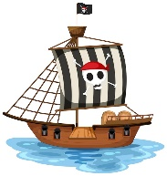
Pirate boat
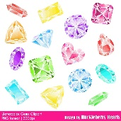
Jewels

Coins
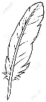
Feathers
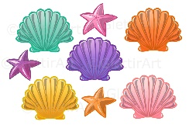
Shells
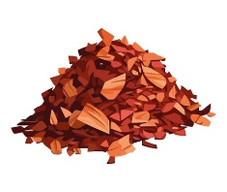
Wood chippings
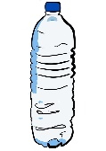
Plastic bottle

For more able and talented children, they could wrap the sinking materials in bubble wrap to make them float. Learn about density of objects.
Make their own pirate ships from recycled plastic containers and put sinking objects in the boat so that they float.
Activity 2
Find the best material to keep the treasure dry

