Module Name: Independent Project
Module Code: LCLM6005
Element 1: Dissertation document
Research Topic: Improper Training and Development in Organisations which affect Productivity at Work in the UK: A case of Expedia
Student Name: Corina Leonte
Student Number: 2213035@student.uwtsd.ac.uk
Supervisor: Lubna Rizvi

Abstract
The research has been based on the effects left by improper training and development plans on the workforce productivity of a UK-based company. Expedia has been chosen as the case business of the study. In the introduction chapter, a clear idea of the research context and the whole dissertation has been presented. The methodology section has integrated the approach taken by the researcher so that they can ensure the credibility and reliability of the study with the execution of the Saunders et al. framework. A literature review chapter has been performed to gain an understanding of the topic of the research. Relevant concepts, theories and knowledge gaps were highlighted clearly in this chapter. The thematic analysis has provided a theme-based view on the topic, while understanding the issues, the negative impact on the company and the employee. Further, the possible solutions have also been considered for Expedia to mitigate the challenges and increase staff productivity. The section of findings and discussion has analysed the key findings of the secondary qualitative and quantitative research. In this way, the data have been presented to make sense of the collected data and make it understandable. Furthermore, there is a discussion section to discuss the key similarities and differences of findings with the literature review chapter.
The conclusion chapter has set a base for the overall study with recommendations and future research directions alongside the limitations faced in the study.
Table of Contents
Chapter 1: Introduction 5
1.1. Chapter Introduction 5
1.2. Context and potential significance of the research 5
1.3. Research Aim and Objectives 5
1.4. Research Questions 6
1.5. Rationale of the Work 6
1.6. Brief idea of the methodology 6
1.7. Dissertation structure 6
1.8. Chapter Summary 7
Chapter 2: Literature Review 8
2.1. Introduction 8
2.2. Conceptual framework 8
2.3. Theoretical framework 9
2.4. Critical review of literature 9
2.5. Literature Gap 12
2.6. Summary 13
Chapter 3: Research Methodology 14
3.1. Chapter Introduction 14
3.2. Research Onion 14
3.3. Research Philosophy 14
3.4. Research Approach 14
3.5. Research Design 14
3.6. Research Strategy 15
3.7. Research Methods 15
3.8. Data Collection and Analysis 15
3.9. Time Horizon 15
3.10. Ethical Consideration 15
3.11. Gantt Chart 16
3.12. Chapter Summary 17
Chapter 4: Results and Discussion 18
4.1 Chapter Introduction 18
4.2 Results and Findings 18
4.2.1 Thematics Analysis 18
4.2.2 Statistical Analysis 22
4.3 Discussion 29
4.4. Chapter Summary 30
Chapter 5: Recommendations, Conclusion and limitations of the research 32
5.1. Chapter Introduction 32
5.2. Achievement of Research Objectives 32
5.3. Conclusion 32
5.4. Recommendation 33
5.5. Limitations 33
5.6. Future Research Directions 33
5.7. Chapter Summary 34
References 35

Chapter 1: Introduction

1.1. Chapter Introduction
Presenting an introductory idea of the whole research project is the key purpose of this chapter. First of all, the main context of the study and its potential importance will be discussed in the following section. On the contrary, the research aim and objectives will be included to show the basic pathway of completing the work. Additionally, the rationale of the project and the methodology of the entire work will be described briefly. The successful completion of a research work is mostly based on its overall structure (Germano, 2022). In order to ensure this fact, the structure of the entire dissertation will be highlighted as well.

1.2. Context and potential significance of the research
The selected topic for the research is to understand the effects of improper training and development on organisational productivity. Training and development are a crucial part of staff management (Saks, 2022). It helps to fill the skill gaps in the workforce and boost overall business performance. With the help of this initiative, businesses help their employees to work more efficiently in their respective job roles (Chen, 2021). The research will proceed by following Expedia as the case business for the study. The UK tourism market has been filled with numerous brands that are popular as well as competitive. Reports state that TUI is one of the leading companies among them for its popularity among 51% travellers in the UK. However, among these businesses, Expedia is famous among nearly 37% of tourists (Statista, 2025). The lack of workforce productivity within the entity can be mentioned as a major reason behind such poor fame (Won et al., 2021). From this, it can also be stated that companies similar to Expedia can boost their productivity through effective training and development (Blanchard and Thacker, 2023). The current knowledge shows a notable gap regarding the alignment of these factors. This research work can be valuable to fill this research gap and make organisations more aware regarding this. The findings can guide ventures in resolving the issues linked to their training and development plans. Furthermore, it can help them develop the most effective workforce-building strategies, increasing their competitiveness and profitability.

1.3. Research Aim and Objectives
Research Aim
To understand the negative effects of improper training and development on the employee productivity of Expedia.
Research Objectives
1. To identify the issues in the current training and development practices of Expedia.
2. To analyse the negative impacts of the training and development-related issues on the staff productivity of Expedia.
3. To evaluate possible solutions that can help in mitigating the training and development-oriented challenges at Expedia and improving its employee productivity.

1.4. Research Questions
1. What are the issues in the current training and development practices of Expedia?
2. What are the negative impacts of the training and development-related issues on the staff productivity of Expedia?
3. What are the possible solutions that can help in mitigating the training and development-oriented challenges at Expedia and improving its employee productivity?

1.5. Rationale of the Work
The availability of training and development scopes is a highly demanding factor in the job market of the 21st century (Li, 2024). Especially, the current generation of applicants prefers to work for companies that support the professional growth of their staff through this strategy. According to reports, organisations face the challenges of job vacancies that are mostly caused by the skill gaps among the job applicants. The government has enforced different upskilling rules, which have failed in mitigating the issue (Clark, 2025). However, the betterment of training plans can be a notable solution to this problem. For guiding businesses similar to Expedia regarding this, the findings of this study can be effective. On the other hand, human resource management is gradually becoming a popular topic in the business management field (Bratton et al., 2021). This research project can work as a reliable source of information for future researchers to explore a relevant topic. In contrast, the success of the project and its significant sides can enhance its researcher’s identity in the academic field.

1.6. Brief idea of the methodology
The development of a proper methodology is highly necessary to conduct research successfully. Research can be completed in two ways such as the primary and the secondary methods (Rose et al., 2023). Giving priority to existing data, the mixed secondary method will be followed in this work. Furthermore, the entire project will be developed on the pragmatism philosophy, along with an abductive approach to study. Following a specific company to research a chosen topic increases the focus of the work. Due to this reason, a case study strategy will be followed throughout the work, concentrating on the chosen brand, Expedia. Additionally, the gathered information will be analysed with the help of the thematic analysis method.

1.7. Dissertation structure
Building a dissertation is a vast activity and due to this reason, following a structured route is very important. This thing further helps in eliminating unnecessary confusion and enhances the understanding of each fact presented (Thompson, 2025). Following the introduction chapter, a review of existing literature will be added for giving a general context of the topic. On the other hand, the research methodology will be presented for discussing and justifying the selected methods. The gathered data sets and their interpretation will be discussed in the chapter on findings and analysis. Lastly, the overall findings of the research will be summarised in the conclusion chapter and the identified recommended strategies will be presented.

1.8. Chapter Summary
The chapter has been added to the dissertation to present an introductory context of the study. At the initial part of the chapter, a discussion on the research context has been presented, followed by its significance. Furthermore, it has highlighted the key objectives of the study to meet the research aim effectively. Based on the research goals, some questions have been designed to make the way towards achieving the aim more fluent. The rationale behind conducting the study and the methods considered for its successful completion have also been included in the chapter.

Chapter 2: Literature Review

2.1. Introduction
The following literature review chapter will be conducted to present an understanding of the issues of training programs. Past literature will be explored to gather relevant information on this topic. A focus on the UK travel sector will be placed while exploring and reviewing past literature. Relevant concepts will be illustrated and discussed through the development of a conceptual framework. On the other hand, a theoretical framework will be designed to provide an understanding of relevant theories. A critical review of the literature will be placed in this chapter, which will lead to the existence of knowledge gaps.

2.2. Conceptual framework
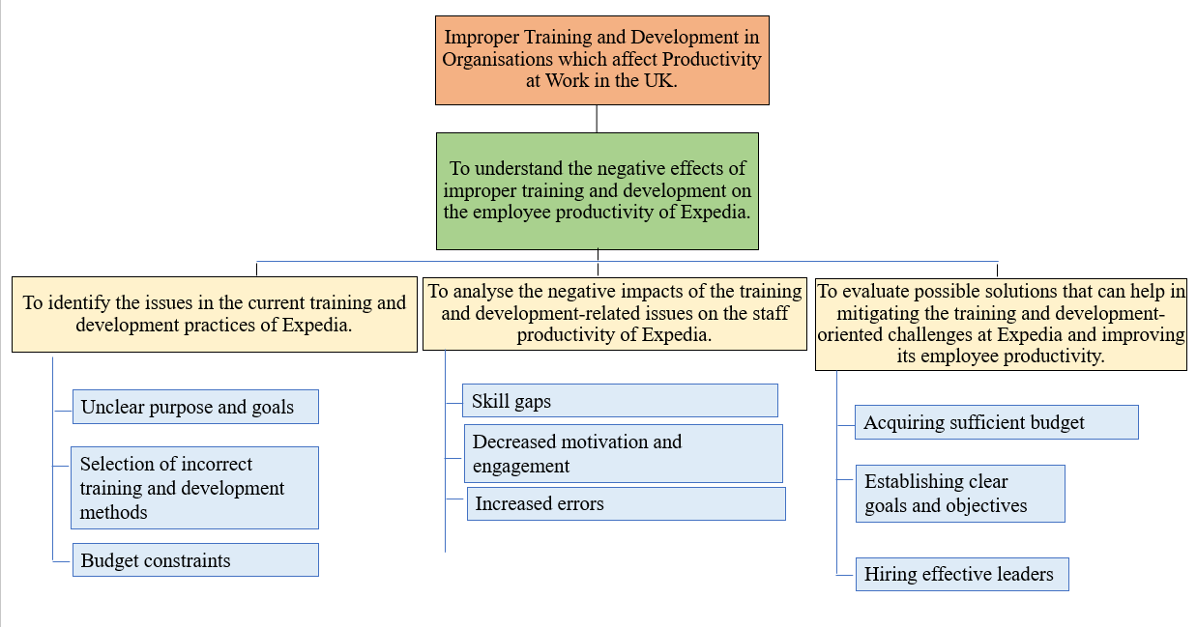
Figure: Conceptual framework
Source: (Author, 2025)
Analysis
The conceptual framework presented above has clearly illustrated the relevant concepts related to the training and development programs. Unclear purpose and goals, budget constraints and selection of incorrect training methods have been initially identified. They were related to the issue in training and development practices within the UK travel sector. On the other hand, skill gaps, decreased motivation and increased errors were also identified as specific concepts. They were mainly related to the negative effects of the training and development issues within the UK travel sector. Other concepts identified in this section were recruiting effective leaders, establishing clear goals and acquiring sufficient budgets. These concepts were related to the solutions for mitigating the issues of training programs.

2.3. Theoretical framework
Resource-based view theory
According to Freeman et al. (2021), the competitive advantage of an organisation depends on several factors, which also act as a source of motivation for them. The resource-based-view theory has highlighted the importance of the internal resources and expertise of a venture for maintaining its competitive position. The organisations in the UK travel sector often do not prioritise their training programs by perceiving their contribution to competitiveness. It has led to the existence of issues in the training programs that further affect workforce efficiency.
Expectancy theory
As per Feather (2021), the expected outcomes of individuals can drive them to accomplish various tasks. This concept has been clearly explained by the expectancy theory. It has been highlighted that perceiving the positive outcome of an activity can encourage them to actively participate in it. However, the issues with the training and development programs can lead to creating negative perceptions about outcomes. Hence, employees can naturally feel less motivated and engaged with the training programs. It further affected their overall participation in the training programs and caused disruptions in overall workforce efficiency.
Social learning theory
As stated by Rachmad (2025), the social learning theory has focused on explaining the importance of observations in the overall learning process of an individual. Hence, observing positive behaviour can lead to fostering positive learning among individuals and vice versa. Organisations need to make careful decisions while appointing role models in training programs. It is due to their influence on the learning of the staff and on the overall workforce efficiency. Employees need to be allowed to observe successful leaders to ensure positive learning outcomes. Appointing effective leaders can help in fostering positive traits, qualities and skills among employees.

2.4. Critical review of literature
Issues in the current training and development practices of organisations in the UK travel sector
The training and development facilities are usually provided to the employees to improve their skills and job performance. However, organisations in the UK travel sector experience several issues while planning and implementing the training and development practices. It has resulted in the development of poor training and development programs, which further affected workforce efficiency.
Unclear purpose and goals
As noted by Beqiri and Trakaniqi (2021), the quality of the training and development practices of organisations decreased due to the unclear purpose and goals. The leaders within travel-based organisations have often placed less focus on setting clear goals while providing training to the workers. Employees faced issues in understanding the things that are expected from them by joining the training and development programs. It has made the employees feel disengaged in the training and development programs as well, and their motivational level has also decreased. Other than that, unclear goals and purpose also lead to confusion between the employer and employees. It further affects the overall efficiency of the workforce.
Selection of incorrect training and development methods
As argued by Forelli and Ordonez (2025), the quality of the training and development programs offered to employees within the UK travel sector depends greatly on the methods. It has been identified that organisational leaders often overlook the effective methods of training and development. It has made it difficult for them to increase the productivity level of the staff. Few have claimed that management pressures and external influences have led to the incorrect selection of training and development methods. However, Galang et al. (2023), have argued that leaders also have insufficient knowledge about effective training and development methods. This has led to the incorrect selection of training and development methods within the UK travel sector.
Budget constraints
As said by Aslanova (2025), the budget constraints have been reported by several organisations within the UK travel sector as a vital issue. It has affected the quality of the training and development services provided to the workers. Lack of budget has posed challenges to the organisational leaders in terms of allocating required resources for training and development programs. Hence, the quality of training and development decreased, which further affected the overall productivity of the workforce. While Croes et al. (2025), have argued that the lack of financial resources has posed challenges in providing employees with competitive wages. This factor has contributed to reducing the motivation and engagement of employees to participate in the training and development programs.
Negative impacts of the training and development-related issues on the staff productivity within the UK travel sector
The training and development-related issues within the UK travel sector have various negative effects on the staff productivity levels. These issues mainly affected the training programs in terms of achieving intended outcomes, for instance, enhancing staff skills. Employees also feel demotivated and less engaged while participating in poor training programs, which further increases concerns.
Skill gaps
As stated by Kravariti et al. (2022), the issues related to the training and development facilities provided in the UK travel sector have often led to a skill gap. Improper training often involved a poor understanding of the needs and demands of the workforce. Hence, the leaders cannot determine the specific skills that need to be acquired by employees through skill-based training. On the other hand, others have argued that skill gaps can also result from the lack of employee participation in training. Poor training and development programs often failed in encouraging participation among staff. Hence, leaders were unable to work on skill enhancement of the workforce. It further resulted in creating skill gap issues.
Decreased motivation and engagement
As claimed by Carlisle et al. (2023), the issues of training programs often caused dissatisfaction, poor engagement and lack of motivation within the workforce. It is due to the negative perception of the employees about the value of the training. It has been claimed that employees often have past experiences related to their participation in ineffective training programs. It has shaped their future behaviour while participating in specific training programs in the UK travel sector. Others have also argued that the fear of time wastage among employees has decreased their motivation and engagement in training programs. Issues in training programs often involve the selection of ineffective training methods that make the staff feel frustrated. It also indicated the lack of effectiveness of those training programs in enhancing their skills and advancing their career. It further makes the staff feel less motivated and engaged, which further affects their overall productivity and performance.
Increased errors
As per Kwok (2022), the issues in the training and development programs have affected workforce productivity by increasing the risk of errors. Organisations in the UK travel sector with poor training facilities have often been criticised for their low-quality products and services. Many have claimed that ineffective training has led to the absence of necessary skills and expertise within the workforce. This further makes the staff incapable of delivering faster services and performing their job roles effectively. On the other hand, Pelit and Katircioglu (2022), have argued that poor training and development have affected the understanding of staff about the things which were expected from them. This lack of understanding has affected their overall work outputs and increased the chase of errors.
Effective solutions that can help in mitigating the training and development-oriented challenges and improving employee productivity within the UK travel sector
The mitigation of the challenges of training and development requires unique and innovative solutions to enhance productivity. Organisations need to identify the issues they have experienced while planning and implementing the training programs. It can enable them to design effective solutions which are focused on mitigating potential problems.
Acquiring sufficient budget
As said by Serhan et al. (2024), the organisations in the UK travel sector often have insufficient financial resources to fund their employee training programs. Hence, the major solutions for mitigating the issues of training and development would be acquiring sufficient funds. Many have claimed that organisations need to have the capability to cover the costs of their training programs to meet their organisational objectives. With sufficient resources, leaders can become capable of meeting each and every need of the employees. While employees can feel supported and valued in the company, that can make them feel highly motivated and engaged. On the other hand, Ercik and Kardaş (2024), have argued that training programs supported with adequate funds can freely work on skill enhancement of workers. Hence, adopting this strategy can help companies to enhance the overall productivity and performance of the workforce in the travel sector.
Establishing clear goals and objectives
As suggested by Michael and Fotiadis (2022), clear goals can provide the staff with a clear sense of direction and encourage them to actively participate in training programs. Hence, many have argued that organisations need to instruct their leaders to set clear goals while implementing training programs. Clear goals can aid in reducing confusion and enhance the understanding of workers about the outcomes. Chatzoudes and Chatzoglou (2022), have also argued that organisations also need to highlight the vital outcomes of training, like skill enhancement and career advancements. These outcomes can be communicated alongside the goals that can motivate employees to actively participate in training programs.
Hiring effective leaders
As noted by Yılmaz and Özgener (2022), the training programs fail mainly due to the lack of knowledge of leaders about correct training methods. It has been claimed that effective leaders have an appropriate understanding of effective training methods. It helps them to design and implement effective training programs and enhance workforce efficiency. While Saayman et al. (2023), have also argued that effective leaders bring their own qualities and skills that can be valuable in the training programs. Appointing effective leaders can help organisations to utilise their expertise to facilitate skill enhancements within the workforce. Hence, the overall efficiency of the workforce within the UK travel sector can be enhanced.

2.5. Literature Gap
The employee training programme has been a key topic of human resource management that has been widely explored previously. However, it has been identified that the majority of the past literature has placed less emphasis on the UK travel sector. It has resulted in the existence of a biased understanding of training and development. Other than that, the lack of numerical data also created major knowledge gaps. Past scholars have focused more on providing a descriptive understanding of this topic and less on statistical evidence-based understandings.

2.6. Summary
The above literature review chapter has discussed the relevant concepts which were associated with the issue of training and development. Social learning theory, expectancy theory and resource-based view theory have been explained to provide a theoretical understanding. Critically reviewing existing literature has offered a balanced view on the training and development topic. Lack of numerical information and less emphasis on the travel sector were the major contributors to the existence of knowledge gaps.

Chapter 3: Research Methodology

3.1. Chapter Introduction
The execution of this chapter is crucial as it allows justification of the approach taken by the researcher to ensure the credibility and the reliability of the study (Zou and Xu, 2023). In this research, the execution of the chapter has been accumulated with the guidance of “Handbook of research methodology” written by Mishra and Alok (Mishra and Alok, 2022).

3.2. Research Onion
Within the simplest level, the term research onion refers to the layered model, which allows researchers to use a sequential system for an organised study. The term was first developed by Saunders et al. as a conceptual framework, which allows guiding the investigators with a thorough process with all the stages accumulated for a fruitful delivery of the study. In this research context, the same has been initiated to use in order to find the progressive system over which the investigator forms their research proposal.

3.3. Research Philosophy
A set of assumptions and beliefs is evaluated within research as a guidance regarding how the research will be conducted is known as the research philosophy. Saliya states choosing a research paradigm is essential due to its ability to allow the researcher with the way they can start forming their research questions (Williams, 2021). The selection of a research philosophy can be essential for this reason, as this provides the classification of the study rather than starting off vague. In this study, the investigator has chosen the pragmatist philosophy so that the researcher can collect secondary qualitative and quantitative data (Manu and Akotia, 2021).

3.4. Research Approach
The concept research approach can be defined as the overall plan which one can execute in their study as the guidance of broad assumptions with detailed methods. With the execution of the approach, the researchers are able to establish necessary elements such as collection, analysis and interpretation (Taherdoost, 2022). For the context of this research, the investigator has utilised an abductive research approach, as this has allowed them to ensure alignment of their study for qualitative and quantitative data collection. The selection of this approach is ideal due to its ability to collect different opinions and form opinions in the study ahead, even when the data is complex.

3.5. Research Design
Research designs are the blueprint of a study, which creates a detailed plan for the study with chosen prospects, such as analysis and methods for a systematic research structure. For the context of this study, the researcher has been executing an exploratory research design as it has allowed the study to form the study with informed and validated knowledge even when there is limited data available. Moreover, the execution of the same has also provided this information to be well-validated and integrated (Gamage, 2025).

3.6. Research Strategy
The concept of research strategy is simple, as it allows planning the approach through which the researcher will guide their study (Johannesson and Perjons, 2021). This factor will allow the study to capture methods for data collection and analysis, alongside aligning the objectives. In this research study, the investigator has selected a case study strategy as it is deemed beneficial for the data collection of real-life scenarios with other cases as examples for this study.

3.7. Research Methods
Research methods are the backbone of a study, which determines the way specific procedures and techniques will be used for the analysis of the study (Denny and Weckesser, 2022). With the execution of the same, the investigator will be able to identify the what of the research while encompassing the wide range of tools. For the context of this particular study, the researcher has chosen a mixed method for the collection of both qualitative and quantitative data via secondary sources. With the execution of this method, the researcher was able to attain different complete opinions for the research development (Ghanad, 2023).

3.8. Data Collection and Analysis
The terms data collection and analysis are two terms which focus on collecting information from different sources while allowing for data analysis for the extraction of insightful knowledge. The data collection for this research topic has involved books, journals, articles, and government-published papers alongside websites from Google Search. The execution of so has also integrated the thematic analysis technique and the statistical analysis in order to extract statistical information with the identification of the themes (Clark et al., 2021).

3.9. Time Horizon
When it comes to research, choosing a defined time is essential (Maier et al., 2023). Hence, for the context of this research, a time horizon has been selected which has allowed the researcher to select the duration of the study. For the context of this study, the researcher has chosen a cross-sectional time horizon to find information at a single point in time to collect the snapshots of the information.

3.10. Ethical Consideration
Ethical consideration within research refers to taking into consideration what guides the researcher in a way to protect their study with integrity and credibility (Ovádek, 2021). In this research, the researcher has taken various considerations in order to maintain the authenticity and the reliability of the research. For the context of this research, the investigator has attained research ethics, such as proper citation, referencing and adherence to the data protection law with the Data Protection Act 2018. Additionally, this research has also integrated copyright adherence alongside the application of the updated information (Vu, 2021).

3.11. Gantt Chart
Elements | 1st week | 2nd week | 3rd week | 4th week | 5th week | 6th week | 7th week | 8th week | 9th week | 10th week
Choosing a research topic
Selection of the aim
Selection of the objectives
Literature Review
Methodology
Findings and Analysis
Discussion
Conclusion and Recommendations
Submission

3.12. Chapter Summary
Within this chapter, the overall understanding of research methodology has been provided, which further supports in different ways concerning the maintenance to ensure replication and critiques. Thus, in this chapter, the researcher has utilised several aspects along with the framework of the research onion introduced by Saunders et al. as the layered structure to consider

Chapter 4: Results and Discussion

4.1 Chapter Introduction
The chapter on results and discussion will be conducted to highlight and evaluate the findings of the research and showcase the key aspects in a proper way. In order to analyse the collected quantitative and qualitative data, analysis techniques will be used. Therefore, the thematic analysis process will be beneficial to make sense of the collected qualitative data. On the other hand, statistical analysis will be aligned with the analysis process of the collected quantitative data. Furthermore, different kinds of themes will be developed that will properly justify the objectives and aims of the research, with the purpose of giving a proper insight. A valuable theme in this aspect will be the issues that come on the path of training and development for the chosen organisation, Expedia. Furthermore, the negative impacts that are related to the issues that the company faces will be another theme. In order to give a valuable insight, the set of negative impacts that affect employees' productivity to some extent will be another key theme in thematic analysis. This chapter will also offer a set of possible solutions that the organisation can use to mitigate the issues. Apart from the thematic analysis, statistical analysis will also take place. Here, graphs, charts and data will be presented that perfectly align with the research aims and topic.

4.2 Results and Findings

4.2.1 Thematics Analysis
Theme 1: Issues in the current training and development practices of Expedia
Inconsistent alignment with job requirements
The job market is changing rapidly, with the requirements and efforts to update the skills and abilities of an individual. In such a case, the alignment of the training and development to these practices and meeting the requirements becomes highly essential. Expedia faces a gap in such a process, facing a gap while not align its training and development programs with the market requirements. The training and development process also lacks structural development, which signifies a need for a more comprehensive and systematic process to align with the requirements. With the lack of such a process, the issue of employees not gaining the proper skills and having inconsistent training can be seen with the current job requirements (Mikołajczyk, 2022).
Accessibility of training resources
The accessibility of the training resources is one of the most important aspects which highlights a better training and development process. In such a sense, Expedia face an issue with their lack of proper accessibility to the training resources. The lack of accessibility to the resource affects the success of the training and development program. The accessibility of the resources also creates an issue for Expedia to manage their employee output in the company, whereas time constraints can also be seen as a process. The issue faced by the company currently also has an effect on their overall operations and business aspect towards employee productivity (Traini, 2022).
Adapt to digital advancements
Considering the advancements in digital technologies, the training and development process also requires a significant amount of integration of digital tools. Expedia, being in the travel industry, needs to align their objectives with the digital advancements effectively. The lack of integrating digital tools in their training and development process also creates a challenge for them to adapt to the market changes. Changes which are significant factors for both the employees and the businesses are neglected due to this issue. The training and development process can be wide with a large number of skill enhancement processes, where the lack of digital advancements can affect their operations further significantly (Rivaldo and Nabella, 2023).
Theme 2: Negative impacts related to the issues faced by Expedia
Decreased employee morale
Considering the faced issues, the lack of proper maintenance of the training and development program impacts the employees mostly. The morale of the employees is affected due to such a process, which can have a significant impact, considering the work motivation and the inefficiencies within the workforce. Further, the issue also impacts the employee's ability to engage with the process further, which has a significant impact affecting the company operations negatively (Weyant et al., 2021).
Employee engagement
Employee engagement is a critical factor to consider in any company, whereas in the travel industry, for Expedia, employee engagement holds significant value. Considering the factors and a lack of a proper training and development program, the company can face decreased employee engagement, which affects the organisational workforce output significantly. With the lack of resources to maintain a better training program, the expectations of the employee in the process are also affected, which leads to poor engagement overall. This impacts Expedia negatively, which leads to their overall value being significantly decreased in the market, affecting their reputation (Bristol-Alagbariya et al., 2022).
Poor operational efficiency
Concerning the given issues and how they affect the company, understanding how the efficiency within the organisation will be maintained is also important. In such a method, the overall condition for the negative impacts can be directly related to the poor operational efficiencies overall. With the understanding of the issues and evaluating the negative impacts, the efficiency of the employees will also be said to decrease with the given time. The lack of proper training and development creates a gap in enhancing skills, which decreases efficiency (Patterson, 2023).
Theme 3: Negative impacts influencing the staff productivity in Expedia
Reduced skill utilisation
Productivity of the staff has also been seen as a form to be affected by the given issues and how it impacts Expedia. Within an organisation, there can be a large set of employees with a potential for better output through a skill enhancement process. This directly aligns with their utilisation of skills and productivity through which they contribute to organisational success. With the given issues and understanding the low morale impact on the employees within Expedia, it also affects their utilisation of current skills, negatively affecting the productivity of the workforce (Marion and Fixson, 2021).
Increased turnover
Considering an increase in employee dissatisfaction and low morale, the engagement factor can also affect how an employee is connected with an organisation. With the decreased engagement, the risk of turnover increase can be seen, which also affects Expedia in a negative manner. Allowing for a better training and development program can increase the skill of the employee and engage with the company more effectively. However, with the lack of such a process, the risk of employees finding new opportunities can be considered for Expedia (Hargitai and Bencsik, 2023).
Burnout risks
Lack of training and development programs creates a gap in providing the proper ability and skills to the employees to handle their jobs. Expedia, being within the travel industry, includes a large number of tasks which can stress an employee within the company. Without proper skills and the ability to handle the tasks, the risks of burnout for the employee also increase significantly. This affects the management of the workforce, as well as impacting the efficiency of the organisation (Gutterman, 2023).
Theme 4: Possible solutions to help mitigate the issues
Frequent feedback
Considering the lack of proper resources and meeting of the job requirements, the company directly mentions the employee and stakeholders for better suggestions. The solutions include the company offering frequent feedback, which helps to personalise the training and development program, understanding the current needs and how it can help the business effectively. Further understanding the value of the training and development program, the feedback can also help to consider proper resources which can help to mitigate the lack of resources issue for Expedia. This can further improve the training and development program of the organisation while adapting to the job requirements in the market (Toppin, 2025).
Integration of digital tools
The integration of digital tools can be a direct and highly effective solution, helping in understanding the current value in the market, which adapts to the trends. This will also help to enhance the training and development program within Expedia, allowing the diversification of the program further. The digital tool will also help to increase the skills and abilities of employees to handle digital tools. This can highlight a better training process which offers long-term value to the organisation (Warin and Darmawan, 2024).
Continuous learning programs
Understanding the issue of accessibility in the resource, as well as adapting to the rapidly changing market, a consistent learning process can help Expedia mitigate the issue. Considering the change in the market, continuous learning programs can further allow the employees to get industrial exposure and gain useful skills. The company also gains an increased output in efficiency as well as employee engagement. This helps to mitigate the issue with training and development programs within Expedia and allows a better management of employee engagement within the organisation (Bristol-Alagbariya et al., 2022).
Theme 5: Solutions to enhance employee productivity within Expedia
Reward system
The reward system is one of the most effective solutions, which has traditionally been proven to directly influence employee productivity within the business. The reward allows Expedia to offer proper recognition to the employee and their gained skill in the training and development program. This also acts as an incentive program, enhancing the overall productivity of the workforce. Employee productivity is further understood with the given recognition of the effort as an investment to increase the efficiency of the operations. In such an organisation, effectively offering rewards and recognising the employee can help to increase their productivity further (Sonnenberg, 2025).
Mentor-led programs
Productivity within an employee is directly aligned with the guidance provided to the employee to engage with the process. Proper guide and structural training and development manage the productivity of the employee within the process effectively. With a mentor-led strategy, Expedia can effectively enhance the productivity of their staff, which helps the company to gain better efficiency and output overall. Mentor-led programs offer a better structure and systematic approach to the training and development program, which helps to mitigate the issue as well as increase employee productivity effectively (Maxwell et al., 2024).
Peer-to-peer learning
Peer-to-peer learning also helps in understanding the value of the given challenges, which can affect the engagement level and productivity of the employees significantly. Allowing the memes of the training and development to engage with each other increases the potential of better skill utilisation. This enhances the overall productivity of the employee while providing a significant level of advantage to the company in relation to maintaining better staff retention and workforce efficiency (Awan, 2021).

4.2.2 Statistical Analysis
Graph 1: Importance of reskilling in the businesses of the UK

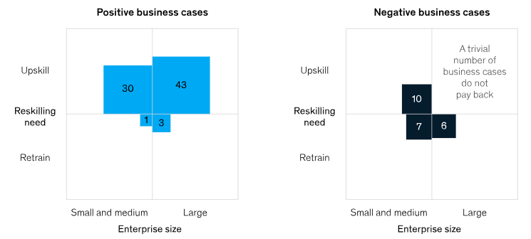
Figure: Reskilling cases in the UK
Source: (Allas, et al., 2020)
Analysis: As per the data of McKinsey, there are around 75% business cases that consider reskilling as an essential need in the business environment in the United Kingdom. However, there are 25% of cases that require further reskilling, and there is no chase that the employer will benefit from this reskilling (Allas, et al., 2020).
Graph 2: Changes in the training needs

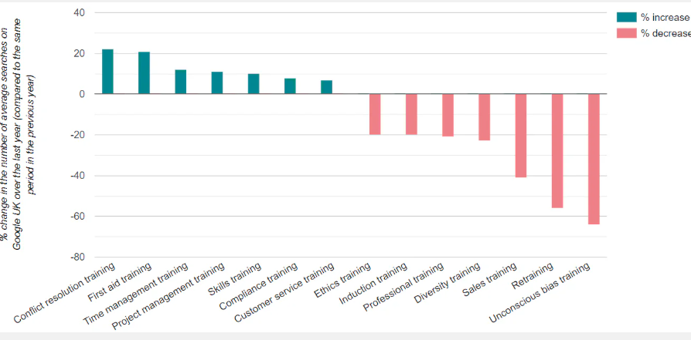
Figure: Training needs changes in the recent scenario
Source: (CIPHR, 2025)
Analysis: The research in 2022 shows that the types of employee training needs have changed a lot compared to 2021. It is evident that the need for conflict resolution training has increased among individuals by 22% in comparison to the previous year. On the other hand, training needs for first-aid and time management have also been enhanced by 21% and 12% respectively. This aspect can be shown as a massive change to the training needs in the UK-based tourism sector as well. Furthermore, the training requirement for employee retention and sales training has witnessed a decline. Due to this aspect, this demand has decreased by 56% and 41% in 2022, as compared to 2021 (CIPHR, 2025). Furthermore, the training for unconscious bias has lost its popularity as there is a decline in searches by 60%. However, it is important to mention that due to the demand of the tourism market, the demand for customer service training has increased by 10%. In addition to this, the demand for skills training has witnessed a growth of 12% (CIPHR, 2025). Considering these training needs, there is a requirement for the tourism organisations to offer training and development opportunities to their employees and fulfil these needs.
Graph 3: Training and development days in the UK
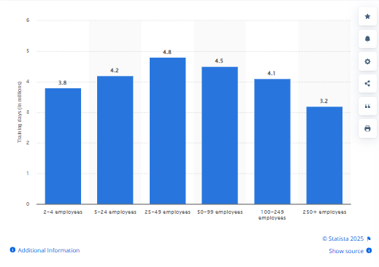
Figure: Training and development days for each employee in the United Kingdom by the size of establishment
Source: (Clark, 2024a)
Analysis: The training and development days per employee trained in the UK in 2017 are reflected in the presented statistics. As per the reports of 2024, there were around 2 to 4 employees trained in 3.8 million days in the UK. Furthermore, for 5 to 24 employees, the training days were 4.2, and for 25 to 49 employees, training took 4.8 million days. Apart from this, it has taken 4.5 million days to train 50 to 99 employees. There are around 4.1 million days to train 100 to 249 employees, and around 3.2 million days for the training of more than 250 employees (Clark, 2024a). It is important to mention that the training days per employee are reducing gradually, and it is a matter of consideration in the training and development aspect.
Graph 4: Different types of training in the UK
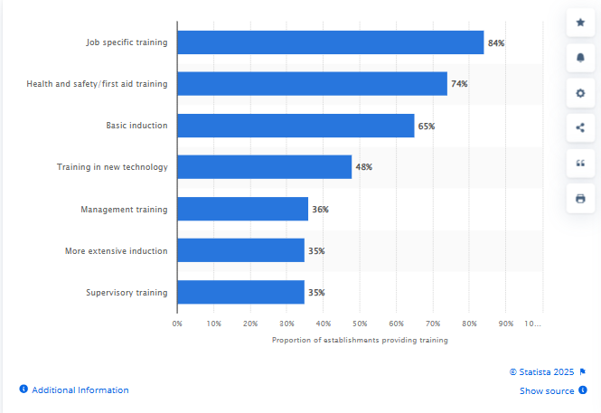
Figure: Types of training offered in the UK
Source: (Clark, 2024b)
Analysis: As per the survey in 2024, 84% of the training programmes in the United Kingdom are job-specific training. Furthermore, 74% training is offered related to health and safety and first-aid aspects. Around 65% of training is offered with the purpose of basic induction, as this aspect also plays a vital role in the relationship between employees and the organisation. There were around 48% of training programmes conducted for the development of new technologies among employees and to keep them aware in a proper way. The survey also reveals that 36% of management training is offered to employees. Apart from this, 35% of training is arranged to offer an extensive induction programme to employees and reduce their difficulties to an extent. Another type of training that can be mentioned here is supervisory training, as 35% of supervisory training is there. It is evident that each type of training is vital for employees as it provides them with upskilling opportunities and positively affects their productivity level.
Graph 5: Reducing investment in employee training: A major issue
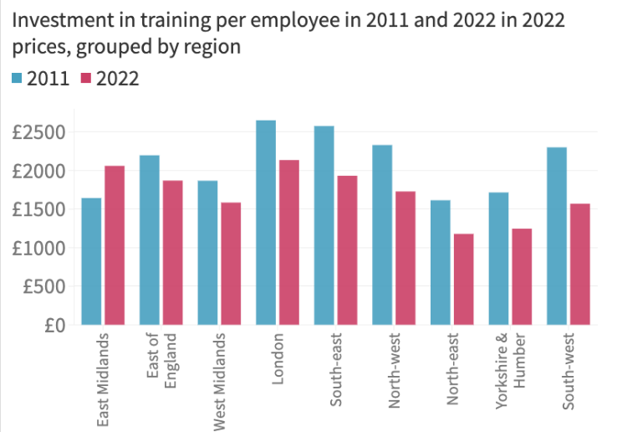
Figure: Investment in training in specific regions
Source: (NEF, 2024)
Analysis: The presented graph shows the investment of UK companies in training and development on a per-employee basis. As per this chart, within the time frame of 2011 to 2012, around 1500 dollars were invested in each employee for their training programmes in the East Midlands. This investment has witnessed a growth in 2022, with a 2100-dollar investment in the same region. On the other hand, businesses in the East of England invested 2200 dollars in 2011 with the purpose of employee training (NEF, 2024). However, this investment amount has decreased in 2022 to 1900 dollars. Furthermore, in the UK regions, the most investments are made in London as businesses invested 2600 dollars per employee in 2011. In contrast to this, the investment has decreased significantly in 2022, with a decline to 2100 dollars, and it is a matter of consideration. It is important to mention that in the Southeast, businesses invested an amount of 2500 dollars in 2011. However, this amount has witnessed a decline in 2022 as businesses invested 1900 dollars per employee for their training and development opportunities (NEF, 2024).
Graph 6: Traineeships regarding awareness among employers
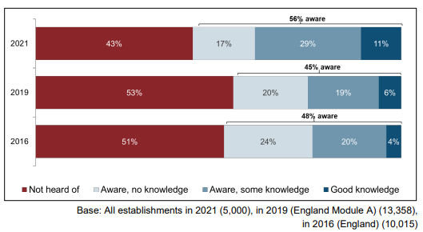
Figure: Awareness among employers regarding traineeships
Source: (Winterbotham, et al., 2022)
Analysis: The awareness among employers in the UK regarding traineeships is presented in the graph. In 2021, there were around 56% of employers were aware of the traineeship programmes, as 29% of them had some knowledge about this. However, it is a matter of consideration that there were around 43% of employers who did not hear about this aspect. Therefore, the issue of a lack of awareness becomes a major issue in the training and development paths in the UK organisations, and Expedia is one of them. It is important to mention that the issue was more severe in 2019, as the percentage of employers who were not aware of traineeships was 53% at that time (Winterbotham, et al., 2022). On the other hand, only 45% of employers were aware of this programme; however, 20% of them did not have any specific knowledge in this aspect. Being highly unaware of training programmes, there were around 51% of employers in the UK who were not properly aware of the traineeships in 2016. The chart shows that traineeship awareness has increased among employers over time, as there is a growth in the time frame from 2016 to 2021 (Winterbotham, et al., 2022). However, in the present scenario as well, many employers are not aware of traineeships and the related benefits, and this unawareness becomes one of the complicated barriers in the training and development path.
Graph 7: Challenges on the path of traineeships

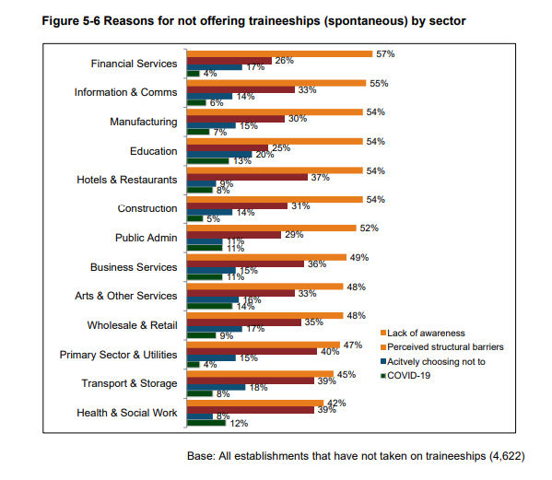
Figure: Reasons for not offering traineeships by sector
Source: (Winterbotham, et al., 2022)
Analysis: The presented chart shows the reasons that prevent organisations in specific sectors from developing efficient training and development programmes. It is evident that the chosen organisation of the research, Expedia, has its operations interconnected with the hotel sector, and due to this, these reasons are alleged for the chosen company. As per the presented data, a lack of awareness regarding traineeships is the major reason behind not offering traineeships in the workplace, with 54% of the responses. Furthermore, there are 37% of perceived structural barriers, and this aspect prevents the development of training programmes (Winterbotham, et al., 2022). Another reason that can be mentioned here is the desire of the organisations to actively choose not to organise training programmes in the workplace. There are around 9% of businesses that consider this aspect and do not offer traineeship programmes to their employees. On the other hand, due to the impacts of COVID-19, nearly 8% of the organisations in the restaurant and hotel sector fail to organise efficient traineeship programmes for their workers (Winterbotham, et al., 2022).

4.3 Discussion
In the section of the literature review, it is shown that the organisations in the current travel sector of the UK face several training-related challenges. These challenges are a lack of clear goals and purpose, and often organisations select improper training and development methods. Additionally, the negative impacts of training-related issues are skill gaps, decreased motivation and engagement among employees. The impact of increased mistakes in the tasks of the employees is also there, which affects the employee productivity level. It is further reflected in the literature review section that with proper budget and clear goals, organisations can overcome the issues to an extent. In addition to this, the role of efficient leaders can also be valuable in this aspect. However, this section contains a gap for Expedia-specific data and fails to offer real-world evidence. This particular gap has been properly fulfilled by the findings of the secondary analysis process. Despite this fulfilment, the findings of these two sections differ a lot from each other in different aspects.
The secondary qualitative analysis shows that there is a set of challenges that come with the path of research and development programmes of Expedia. Due to the inconsistent alignment of job requirements and a lack of training resources, the training process become negatively affected. Furthermore, the business fails to adapt to the digital advancements to improve the training processes to any extent. Apart from this, the negative impacts related to the issues faced by Expedia include reduced employee morale. Improper employee engagement and inefficient operational efficiency are several other gaps important to mention. It is seen that organisational productivity becomes severely impacted by aspects such as increased turnover rate and a lack of employee skills to implement opportunities. In addition to this, organisations can implement frequent feedback programmes to improve the process. The thematic analysis also highlights the solutions of the reward system and peer-to-peer learning to improve productivity at Expedia. However, the findings of secondary qualitative analysis and secondary quantitative research differ a lot from each other. As per the thematic analysis, the key issues that come on the path of training and development are inconsistent alignment of the training aspects with the requirements of the job. The other challenges are a lack of adaptability to digital advancements and improper training resources. However, the findings of secondary quantitative analysis highlight the major reasons, such as a lack of awareness regarding traineeships. They have an active desire for the organisations not to conduct training programmes and experience the impacts of COVID-19 in their initiatives. Considering this difference, it becomes clear that the outcomes of these two types of data analysis are clearly contrasting. On the other hand, the literature review section shows an unclear purpose and goals, and inefficient training methods are the major challenges. Furthermore, the secondary qualitative research shows that training issues affect employee morale and their engagement in the workplace. However, this outcome is completely different from the result of the literature review. As per the literature review, the negative impacts are skill gaps among employees and their increased tendency to make mistakes in their tasks. The point of affected employee engagement and motivation due to a lack of training is similar to the findings of secondary research. Through the review of existing literature, it becomes clear that solutions, such as the recruitment of efficient leaders and clear goals, can improve the training process. However, as per the secondary research findings, the key solutions can be feedback from employees on a regular basis and integration of digital tools. It becomes clear that the suggested solutions in the literature review and secondary findings differ a lot from each other.
Through the similarities in the literature review and secondary research findings, it becomes clear that due to the lack of training efficiency, the employee engagement and morale. However, in terms of challenges and solutions related to the training process, the findings of these two sections differ a lot. Therefore, it becomes difficult to consider the most appropriate ones. However, it is important to keep in mind that the findings of secondary research are based on Expedia. On the other hand, the literature review section does not contain any specific data for Expedia and has only generic data. Considering this difference, it can be stated that the outcomes of secondary research will be the more appropriate ones in this aspect. Through the proper use of the suggested outcomes, Expedia can improve the overall training and development process in the workplace. It can ask employees to provide feedback on a regular basis so that the employers can understand training gaps. In addition to this, digital tools can be integrated to improve the overall process to a great extent. A continuous learning process can also be one of the suitable solutions in this aspect.

4.4. Chapter Summary
The chapter of results and discussion helps to understand the research topic and present the collected data to analyse their key meaning. It is properly reflected in the thematic analysis that there are several issues that Expedia faces in the training and development process. In this aspect, inconsistent alignment with job requirements, adapting the digital advancements and a lack of training resources are key reasons. Furthermore, it is clearly mentioned in the thematic analysis that the negative impacts related to the issues include decreased morale among employees. Other than this, ineffective engagement of employees and a lack of operational efficiency have several impacts. There are several negative impacts, such as reduced skill efficiency and risk of employee turnover, that affect the overall productivity of the employees. It is clearly reflected in the thematic analysis that solutions, namely, frequent feedback, integration of digital tools and continuous learning programmes, can help to overcome the learning and development issues. Apart from this, there are solutions to enhance productivity levels within the organisation. Reward system, mentorship programs and peer-to-peer learning are several of these solutions. Additionally, it is clearly shown in the statistical analysis that a lack of awareness, a gap in active engagement are the challenges in the training aspect. Furthermore, due to the COVID-19 impacts, organisations fail to arrange and maintain effective training programmes. The importance of training is also a valuable part of the statistical analysis section.

Chapter 5: Recommendations, Conclusion and limitations of the research

5.1. Chapter Introduction
Within this dissertation, the aspect of the conclusion chapter is deemed crucial as this will cause summarisation of the key findings regarding the answering of the questions while explaining the significance of the study. The aim of this chapter is to systemise and synthesise the research information with a lasting impression on the readers. In this research chapter, the investigator has selected the achievement of the research objectives, a summary, recommendations, and the limitations found in the research to accelerate future research directions. With the execution of the same, the researcher was able to integrate a closure to demonstrate the overall value of the project.

5.2. Achievement of Research Objectives
The aim of the researcher was to find insights related to the negative impact of improper training and development on employee productivity within Expedia. Thus, in order to achieve the research objectives, the researcher has integrated information from the literature in the literature review section. Apart from that, the researcher has also invested in the data findings section with the data collection of mixed methods via secondary sources for the information. The study has focused on finding information related to how improper training within such companies can cause the organisations to face issues of reduced productivity via inefficiencies, mistakes, and delays. Different information related to how conflict resolution training has seen to increase of 22% causing the employees to feel motivated. However, due to the lack of proper training causing employees feel undervalued and lack career growth opportunities.

5.3. Conclusion
The consequences of ignoring training and development within an organisation for the employees can lead to various aspects, such as decreased productivity, higher turnover rates and even down morale. Thus, this research has been conducted in order to shed light on how improper training costs the company beyond money. Within this research, the execution of how the concept can cause the employee to feel negatively is examined. Nevertheless, the elaboration of how important it is for companies to invest in better employee training, as it allows the companies to make the employees feel valued and satisfied. Alongside, the research has also integrated a literature review section, which has shed light on the current issues faced by companies in the current training and development practices. Among these aspects are the budget constraints, the selection of incorrect methods, and the unclear purpose have surfaced. Similarly, in this instance, the findings and the discussion chapter have also formed an understanding regarding elements such as accessibility to training resources and no proper alignment. Thus, this showcases the support and cross-validation that the research materials have created in the study. A methodology section has been included in this research, which has determined the collection of both data types, making cross-validation of the information easier. The methodology has utilised the amalgamation of both data types via secondary sources. Furthermore, the research has also included recommendations as suggestions that the organisation or a similar brand can invest in order to improve their training and development practices.

5.4. Recommendation
Skill-based and technical training
The brand called Expedia needs to provide the training to its employees such as over new technologies such as machine learning and Artificial intelligence. In their current training operations, the brand needs to invest in employee skills. Thus, to do so, it is necessary for the brand to train the staff related to sustainability practices while providing them with information related to the booking system and mobile apps.
Performance and customer-focused training
The organisation needs to invest in performance and customer-focused training. Hence, to do so, it is essential for them to conduct a formal analysis so that they can identify the skill gaps within the workforce. This, in result, will allow the organisation to figure out the hindrances in their productivity alongside alignment of their business goals. Apart from that, in order to build skills, the organisation can invest in activities such as service role play and problem-solving games. With the execution of so, the brand will be able to remain competitive in the industry while achieving its business goals.

5.5. Limitations
Research studies need to be evaluated with several aspects to be considered, including study design, methodology, and execution, which impact the generalisability and validity of the findings. Within the context of this research, the researcher has also faced a number of hindrances regarding methodological choices. For instance, the researcher in this research has selected secondary sources for the data collection, and thus, this has caused the research to be hindered by outdated information and no real-time updates. However, the researcher, in order to tackle the issue, has integrated both method types, and thus, this has allowed cross-validation of the information for the development of the study.

5.6. Future Research Directions
The future direction of research could focus on investigating the long-term influence of a specific training program on the employees. Additionally, the research will also be exploring the impact of new training technologies and analysing the link between employee well-being and studying the challenges. All these instances can provide the context of the study to be able to rapidly find technological insights and changes from different laws.

5.7. Chapter Summary
In this chapter, the researcher has provided the execution of the research information concerning the evaluation of the overall topic. Thus, the research has implemented various aspects, like how they have achieved the research objectives, alongside what the research's future direction for research, suggestions that the companies can implement, and lastly the limitations faced by the organisation. All these instances have made this research to be fruitful, with a frame set for the readers to understand the research in a limited time.

References
Allas, T., Fairbairn, W. & Foote, E., (2020). The economic case for reskilling in the UK: How employers can thrive by boosting workers’ skills. [Online] Available at: https://www.mckinsey.com/capabilities/people-and-organizational-performance/our-insights/the-economic-case-for-reskilling-in-the-uk-how-employers-can-thrive-by-boosting-workers-skills [Accessed 23 October 2025].
Aslanova, D., (2025). CHALLENGES OF IMPLEMENTING MODERN MANAGEMENT PRINCIPLES IN THE TOURISM INDUSTRY. Journal of Multidisciplinary Sciences and Innovations, 1(2), pp.119-121.
Awan, O.A., (2021). Peer to peer learning: Its importance and benefits. Academic Radiology, 28(5), pp.747-748.
Beqiri, T. and Trakaniqi, F., (2021). Impact of Human Resources Trainings and Knowledge Sharing in Travel Agencies. KNOWLEDGE-International Journal, 47(1), pp.165-169.
Blanchard, P.N. and Thacker, J.W., (2023). Effective training: Systems, strategies, and practices. Sage Publications.
Bratton, J., Gold, J., Bratton, A. and Steele, L., (2021). Human resource management. Bloomsbury Publishing.
Bristol-Alagbariya, B., Ayanponle, O.L. and Ogedengbe, D.E., (2022). Developing and implementing advanced performance management systems for enhanced organizational productivity. World Journal of Advanced Science and Technology, 2(1), pp.39-46.
Carlisle, S., Ivanov, S. and Dijkmans, C., (2023). The digital skills divide: evidence from the European tourism industry. Journal of tourism futures, 9(2), pp.240-266.
Chatzoudes, D. and Chatzoglou, P., (2022). Factors affecting employee retention: Proposing an original conceptual framework. International Journal of Economics and Business Administration, 10(1), pp.49-76.
Chen, Z., (2021). Influence of working from home during the COVID-19 crisis and HR practitioner response. Frontiers in psychology, 12, p.710517.
CIPHR, (2025). 25 Employee training statistics in the UK. [Online] Available at: https://www.ciphr.com/infographics/employee-training-statistics [Accessed 23 October 2025].
Clark, D., (2024a). Training and development days per employee trained in the United Kingdom (UK) in 2017, by size of establishment. [Online] Available at: https://www.statista.com/statistics/290855/training-days-per-employee-trained-in-the-uk-by-size-of-establishment/?srsltid=AfmBOoqFrj_LE255_tEOvBoupp-COSPU9e4l6CodP_T-tnqbmAqfxE00 [Accessed 23 October 2025].
Clark, D., (2024b). Types of training provided over the last 12 months by employers that train in the United Kingdom (UK) in 2017. [Online] Available at: https://www.statista.com/statistics/290830/training-provided-over-the-last-12-months-by-employers-in-the-uk/?srsltid=AfmBOooPF_avpYfYNCKA0aC0aZk62APeVpdHdGM9pLQIhD_IK2nHNhn2 [Accessed 23 October 2025].
Clark, D., (2025). Young people in the UK labor market - statistics & facts. [Online] Available at: https://www.statista.com/topics/13196/young-people-in-uk-labor-market/?srsltid=AfmBOoo_bgE_i0xVclttzHNbfRfgbu8wO4Hnt6KYbQtwA18igZhmqDh4#topicOverview [Accessed 20 October 2025].
Clark, T., Foster, L., Bryman, A. and Sloan, L., (2021). Bryman's social research methods. Oxford university press.
Croes, R., Padrón-Ávila, H., Rivera, M. and Renduchintala, C., (2025). A triadic model of job retention and turnover dynamics in the hospitality industry. International Journal of Contemporary Hospitality Management, 37(3), pp.700-721.
Denny, E. and Weckesser, A., (2022). How to do qualitative research? Qualitative Research Methods. Bjog, 129(7), p.1166.
Ercik, C. and Kardaş, K., (2024). Reflections of digital technologies on human resources management in the tourism sector. Worldwide Hospitality and Tourism Themes, 16(5), pp.646-663.
Feather, N.T. ed., (2021). Expectations and actions: Expectancy-value models in psychology. Routledge.
Forelli, A. and Ordonez, D., (2025). Recruitment and retention challenges for tourism and hospitality professionals: the perspective of a travel industry company located in Mexico. Worldwide Hospitality and Tourism Themes, pp.1-13.
Freeman, R.E., Dmytriyev, S.D. and Phillips, R.A., (2021). Stakeholder theory and the resource-based view of the firm. Journal of management, 47(7), pp.1757-1770.
Galang, J.P., Pablo, J.J., Melad, Q., Tamaray, G.A., Velasco, R. and Catacutan, K.J., (2023). Employee Retention Strategies of Hotel Industries in the Philippines Amidst the Pandemic. Asian Journal of Applied Business and Management (AJABM), 2(1), pp.79-98.
Gamage, A.N.K.K., (2025). Research design, philosophy, and quantitative approaches in scientific research methodology. Sch J Eng Tech, 2, pp.91-103.
Germano, W., (2022). From dissertation to book. University of Chicago Press.
Ghanad, A., (2023). An overview of quantitative research methods. International journal of multidisciplinary research and analysis, 6(08), pp.3794-3803.
Gutterman, A.S., (2023). Training and development. Available at SSRN 4555407.
Hargitai, D.M. and Bencsik, A., (2023). The role of leadership in digital learning organizations. Emerging Science Journal, 7(Special issue 2), pp.111-124.
Huntington-Klein, N., (2021). The effect: An introduction to research design and causality. Chapman and Hall/CRC.
Johannesson, P. and Perjons, E., (2021). Research strategies and methods. In An introduction to design science (pp. 41-75). Cham: Springer International Publishing.
Kravariti, F., Voutsina, K., Tasoulis, K., Dibia, C. and Johnston, K., (2022). Talent management in hospitality and tourism: a systematic literature review and research agenda. International Journal of Contemporary Hospitality Management, 34(1), pp.321-360.
Kwok, L., (2022). Labor shortage: a critical reflection and a call for industry-academia collaboration. International Journal of Contemporary Hospitality Management, 34(11), pp.3929-3943.
Li, L., (2024). Reskilling and upskilling the future-ready workforce for industry 4.0 and beyond. Information Systems Frontiers, 26(5), pp.1697-1712.
Maier, C., Thatcher, J.B., Grover, V. and Dwivedi, Y.K., (2023). Cross-sectional research: A critical perspective, use cases, and recommendations for IS research. International Journal of Information Management, 70, p.102625.
Manu, E. and Akotia, J., (2021). Introduction to secondary research methods in the built environment. In Secondary research methods in the built environment (pp. 1-15). Routledge.
Marion, T.J. and Fixson, S.K., (2021). The transformation of the innovation process: How digital tools are changing work, collaboration, and organizations in new product development. Journal of Product Innovation Management, 38(1), pp.192-215.
Maxwell, B., Káplár-Kodácsy, K., Hobson, A.J. and Hotham, E., (2024). Effective mentor training, education and development: a qualitative multilevel meta-synthesis. International Journal of Mentoring and Coaching in Education, 13(4), pp.422-440.
Michael, N. and Fotiadis, A., (2022). Employee turnover: The hotel industry perspective. Journal of Tourism, Heritage & Services Marketing, 8(1), pp.38-47.
Mikołajczyk, K., (2022). Changes in the approach to employee development in organisations as a result of the COVID-19 pandemic. European Journal of Training and Development, 46(5-6), pp.544-562.
Mishra, S.B. and Alok, S., (2022). Handbook of research methodology. Educreation publishing.
NEF, (2024). Employers spending a fifth less on employee training than a decade ago. [Online] Available at: https://neweconomics.org/2024/03/employers-spending-a-fifth-less-on-employee-training-than-a-decade-ago [Accessed 23 October 2025].
Ovádek, M., (2021). Facilitating access to data on European Union laws. Political Research Exchange, 3(1), p.1870150.
Patterson, J., (2023). Creating A Culture Of Training And Development In The Workplace. [Online] Available at: https://www.forbes.com/councils/forbeshumanresourcescouncil/2023/06/13/creating-a-culture-of-training-and-development-in-the-workplace/ [Accessed 23 October 2025].
Pelit, E. and Katircioglu, E., (2022). Human resource management studies in hospitality and tourism domain: a bibliometric analysis. International Journal of Contemporary Hospitality Management, 34(3), pp.1106-1134.
Rachmad, Y.E., (2025). Social Learning Theory. United Nations Economic and Social Council.
Rivaldo, Y. and Nabella, S.D., (2023). Employee performance: Education, training, experience and work discipline. Calitatea, 24(193), pp.182-188.
Rose, S., Spinks, N. and Canhoto, A.I., (2023). Management research: applying the principles of business research methods. Routledge.
Saayman, E.Z., Slabbert, M.G. and Ottebacher, T.Y., (2023). Examining employee retention strategies in the South African hotel sector: A comparative study. African Journal of Emerging Issues, 5(5), pp.1-14.
Saks, A.M., (2022). Caring human resources management and employee engagement. Human resource management review, 32(3), p.100835.
Serhan, C., Nasr, N., Cheikh, G. and Nachar, G., (2024). Retaining young employees in the hospitality and tourism sector: the role of workplace context and management practices. EuroMed Journal of Business.
Sonnenberg, S., (2025). How To Solve Challenges In Rewards And Recognition Initiatives. [Online] Available at: https://www.forbes.com/councils/forbesbusinesscouncil/2025/04/11/how-to-solve-challenges-in-rewards-and-recognition-initiatives/ [Accessed 23 October 2025].
Statista, (2025). Most popular amusement, cruise, and travel brands in the United Kingdom as of 4th quarter of 2024. [Online] Available at: https://www.statista.com/statistics/952574/most-popular-amusement-cruise-travel-brands-uk/#:~:text=Most%20popular%20amusement%2C%20cruise%2C%20and,positive%20opinion%20of%20that%20brand [Accessed 20 October 2025].
Taherdoost, H., (2022). What are different research approaches? Comprehensive review of qualitative, quantitative, and mixed method research, their applications, types, and limitations. Journal of Management Science & Engineering Research, 5(1), pp.53-63.
Thompson, P., (2025). Thesis and dissertation writing. The handbook of English for specific purposes, pp.403-419.
Toppin, D. L., (2025). True Learning And Development Is Needed More Than Ever. [Online] Available at: https://www.forbes.com/councils/forbeshumanresourcescouncil/2025/02/11/true-learning-and-development-is-needed-more-than-ever/ [Accessed 23 October 2025].
Traini, L., (2022). Exploring Performance Assurance Practices and Challenges in Agile Software Development: An Ethnographic Study. [Online] Available at: https://link.springer.com/article/10.1007/s10664-021-10069-3#:~:text=The%20lack%20of%20guidelines%20and%20well%2Destablished%20practices,to%20sub%2Doptimal%20management%20of%20performance%20assurance%20activities. [Accessed 23 October 2025].
Vu, T.T.N., (2021). Understanding validity and reliability from qualitative and quantitative research traditions. VNU Journal of Foreign Studies, 37(3).
Warin, A.K. and Darmawan, D., (2024). Fostering adaptive employees: The importance of continuous feedback in HR development. Bulletin of Science, Technology and Society, 3(3), pp.27-34.
Weyant, E.C., Wallace, R.L. and Woodward, N.J., (2021). Suggestions for improving morale, part 2: Review of existing literature on librarian and library staff morale. Journal of Library Administration, 61(8), pp.996-1007.
Williams, H., (2021). The meaning of “Phenomenology”: Qualitative and philosophical phenomenological research methods. The Qualitative Report, 26(2), pp.366-385.
Winterbotham, M., Kik, G. & Selner, S., (2022). Employer Pulse. [Online] Available at: https://assets.publishing.service.gov.uk/government/uploads/system/uploads/attachment_data/file/1071259/Employer_Pulse_Survey_2021_Report.pdf [Accessed 23 October 2025].
Won, D., Hwang, B.G. and Chng, S.J., (2021). Assessing the effects of workforce diversity on project productivity performance for sustainable workplace in the construction industry. Sustainable Development, 29(2), pp.398-418.
Yılmaz, C. and Özgener, Ş., (2022). Competitive intelligence and competitiveness in accommodation businesses: the role of employee training effectiveness. Current Issues in Tourism, 25(18), pp.2905-2921.
Zou, P.X. and Xu, X., (2023). Research methodology and strategy: theory and practice. John Wiley & Sons.

