Craig y Nos Habitat Management Plan
By Naim Awal
1802441

Contents
- Introduction 4
  - Tree species and habitats 4
    - Soil quality 8
  - Fallen/cut trees 9
  - Invasive and non-native species 9
  - Funding methods 9
1.4.1. Funding cuts 9
  - Facilities 9
  - Public access and safety 10
  - River Tawe bridge 10
  - Riverbank 10
- Management recommendations 11
  - Tree planting recommendations 11
  - Riverbank recommendations 11
  - Funding recommendations 11
- Overview 12
- References 13

List of tables
Table 1 – a table to show some tree species in Craig y Nos, its favourable status (habitat/climate) and the advantages and disadvantages. 5

List of figures
Figure 1 – an Ordnance Survey map from Digimaps to show Craig y Nos Country Park. 4
Figure 2 – A map to show Craig y Nos Country Park separated in multiple blocks. Image credit to Craig y Nos Management Plan 2001-2004. 4
Figure 3 – A Digimaps to show the type of vegetation growth of Craig y Nos. 5
Figure 4 – Cranfield University (nd). An image shows the geology of Craig y Nos as loamy and clay soil. (Accessed 1st December 2019). 8
Figure 5 – Cranfield University (nd). An image shows the geology of Craig y Nos as Loamy soil. (Accessed 1st December 2019). 8
Figure 6 – a photograph to show a designated footpath in block 2 (figure 2). 10
Figure 7 – Natural Resources Wales (2019). A line graph to show water levels of River Tawe in November 2018. (Accessed 1st December 2019). 11

- Introduction
Craig y Nos Country Park is approximately 40 acres in size and it’s located in the Brecon Beacons National Park, 51º49’34.89” N 3º41’04.58” W, in the upper Swansea Valley. Figure 1 shows an Ordnance Survey map from Digimaps of Craig y Nos showing that the Country Park is situated near A4067. The Brecon Beacons National Park established Craig y Nos as a Country Park in 1976 after the Countryside Act 1968 given National Parks UK the authority to create Country Parks within National Parks.
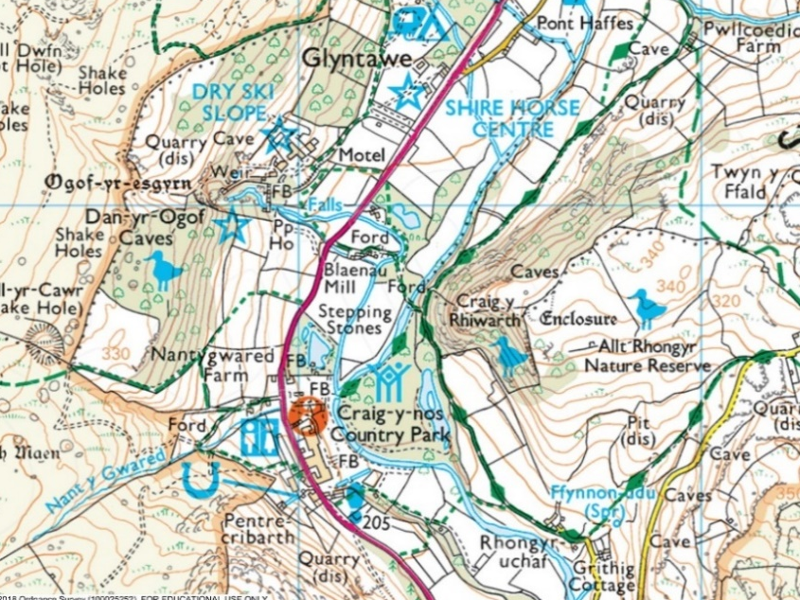
Figure 1 – an Ordnance Survey map from Digimaps to show Craig y Nos Country Park.
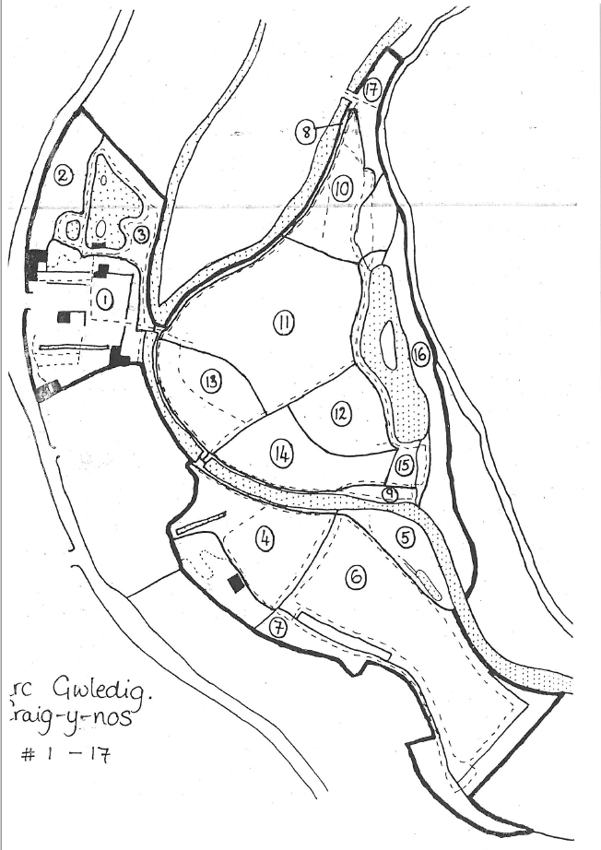
Figure 2 – A map to show Craig y Nos Country Park separated in multiple blocks. Image credit to Craig y Nos Management Plan 2001-2004.
Craig y Nos was made famous when one of the world’s famous opera singer, Adelina Patti, bought Craig y Nos Castle in 1878. The CADW/ICOMOS Register of Historic Parks and gardens listed the building grade II with its historical value as it attracts tourists to the park and the castle, with a reputation to host family functions and other events.

Figure 2 shows Craig y Nos Country Park divided into multiple blocks. Blocks 1-17 are used to help allocate species and habitats upon the investigation. The car park, café and main gifts and crafts shop are located in block 1, the castle and the second gift shop are located adjacent to block 16 and are not part of the country park.

  - Tree species and habitats
According to the Craig y Nos Country Park Management Plan 2001-04, the park considers woodland a vital source of habitats when it is in favourable status – which means an important site of management, like a woodland, must contain high abundance of features, such as the diversity of plants, animals and nutrients, that remains in the long term.

A small area of the country park is part of the Craig y Rhiwarth a Site of Special Scientific Interest (SSSI) and was dealt along with Countryside Council for Wales (CCW), now part of Natural Resources Wales (NRW). The regulations and legislations come from the Biodiversity Action Plan, Habitat Directive, Habitat Regulations (1994) and the Wildlife and Countryside Act (1981).
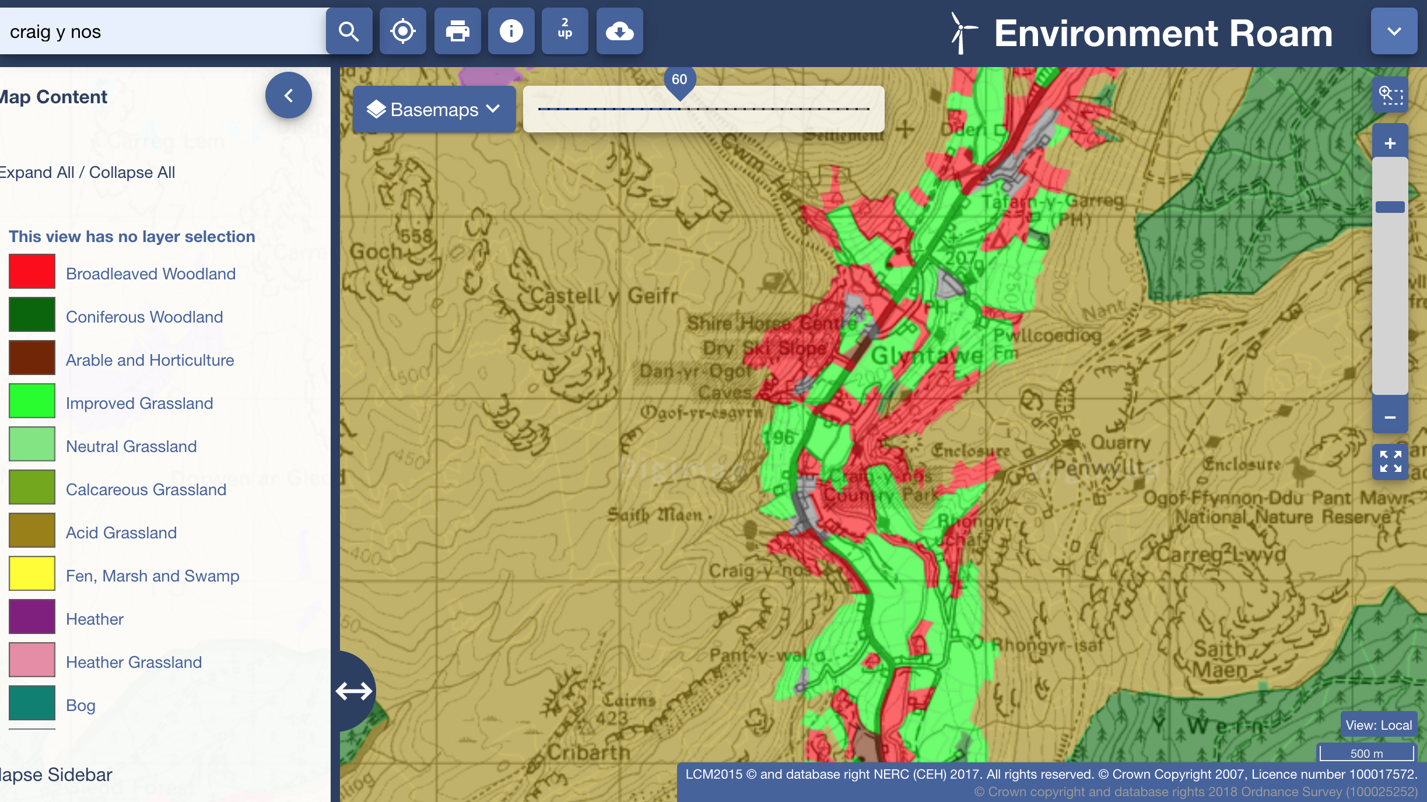
Figure 3 – A Digimaps to show the type of vegetation growth of Craig y Nos.

Figure 3 shows a Digimaps image of the type of vegetation growth of the country park. Craig y Nos is predominantly covered by broadleaved woodlands and improved grasslands. Surrounding the park is acidic grasslands and coniferous woodlands.

Trees | Favourable status (habitat/climate) | Advantages | Disadvantages
Redwood  (Sequoiadendron) | Soil: sandy (light), loamy (medium), clay (heavy). Ideally, well-drained soils.  pH: acidic, neutral and alkaline soils.  Exposure: trees grow in isolation or developing woodlands, can also withstand strong winds and not maritime conditions. | Aesthetically pleasing for visitors. | Invasive, non-native species, not allowing native species to develop.
Sycamore (Acer pseudoplatanus) | Soil: sandy (light), loamy (medium), clay (heavy). Ideally, well-drained, moist, nutrition deficient and heavy soils.  pH: acidic, neutral and alkaline soils.  Exposure: trees can grow in isolation and developing woodlands, can withstand maritime conditions. | - | Bark damaged to show evidence of grey squirrels; invasive, non-native species
Ash (Fraxinus excelsior) | Soil: sandy (light), loamy (medium), clay (heavy). Ideally, wet soils.  pH: acidic, neutral and alkaline soils.  Exposure: trees grow in isolation and developing woodlands, can withstand maritime conditions and atmospheric pollution. | - | Diseased by Ash Dieback. Also, being killed by waterlogged soil.
Alder (Alnus glutinosa) | Soil: sandy (light), loamy (medium), clay (heavy). Ideally, well-drained and nutrition deficient soils.  pH: acidic, neutral and alkaline soils.  Exposure: trees grow in isolation and developing woodlands, can withstand maritime conditions. | Can be used to coppice to protect river bank from erosion. | -
Rhododendron | Soil: sandy (light), loamy (medium). Ideally, well-drained and moist soils.  pH: acidic soils.  Exposure: trees grow in isolation and developing woodlands. | Aesthetically pleasing for visitors. | Invasive, non-native species, not allowing native species to develop.
Willow (Salix caprea) | Soils: sandy (light), loamy (medium), clay (heavy). Prefers dry, moist and wet soils.  pH: acidic, neutral and alkaline soils.  Exposure: trees cannot grow in climax woodland, can maritime conditions and atmospheric pollution. | Can be used to coppiced to protect riverbank from erosion. | Weak and easy to breach.
Beech (Fagus sylvatica) | Soil: sandy (light), loamy (medium), clay (heavy). Ideally, well-drained soils.  pH: acidic and alkaline soils.  Exposure: trees grow in isolation, climax and developing woodlands, can also withstand strong winds and not maritime conditions. | Can be used to coppice to protect riverbank from erosion. | Diseased by honey fungus.
English Oak (Quercus robur) | Soil: loamy (medium) and clay (heavy). Ideally, moist, wet, dry and heavy soils.  pH: acidic, neutral and alkaline soil.  Exposure: trees grow in isolation and developing woodlands, can withstand strong winds but not maritime conditions. | - | Lack of biodiversity with surrounding trees.
Table 1 – a table to show some tree species in Craig y Nos, its favourable status (habitat/climate) and the advantages and disadvantages.

Table 1 suggests some trees species found at Craig y Nos, its favourable status and its benefits and setbacks; such factors that may impact Craig y Nos. Many native and non-native trees, such as alder and sycamore are found across the park in abundance with similar favourable status’ for soil; these trees can grow in loamy soils (figure 4) and loamy/clay soils (figure 5), with soil potentially acidic. The tree population for beech and ash, are in peril due to diseases, such as ash dieback and honey fungus. Invasive and non-native species found in section 1.3., figure 3 and table 1 suggests that these trees adapt in broadleaved and coniferous woodlands.

    - Soil quality
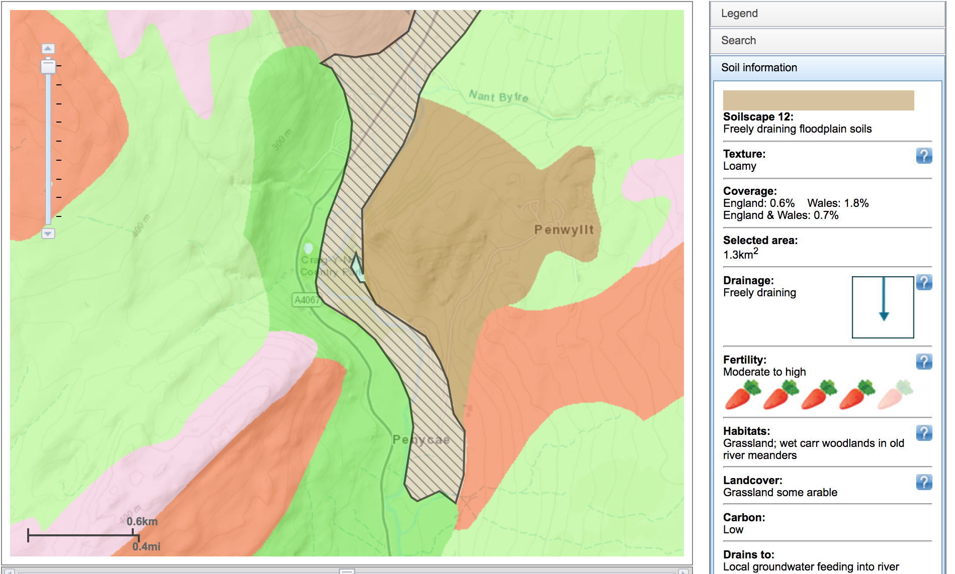
Figure 5 – Cranfield University (nd). An image shows the geology of Craig y Nos as Loamy soil. (Accessed 1st December 2019).
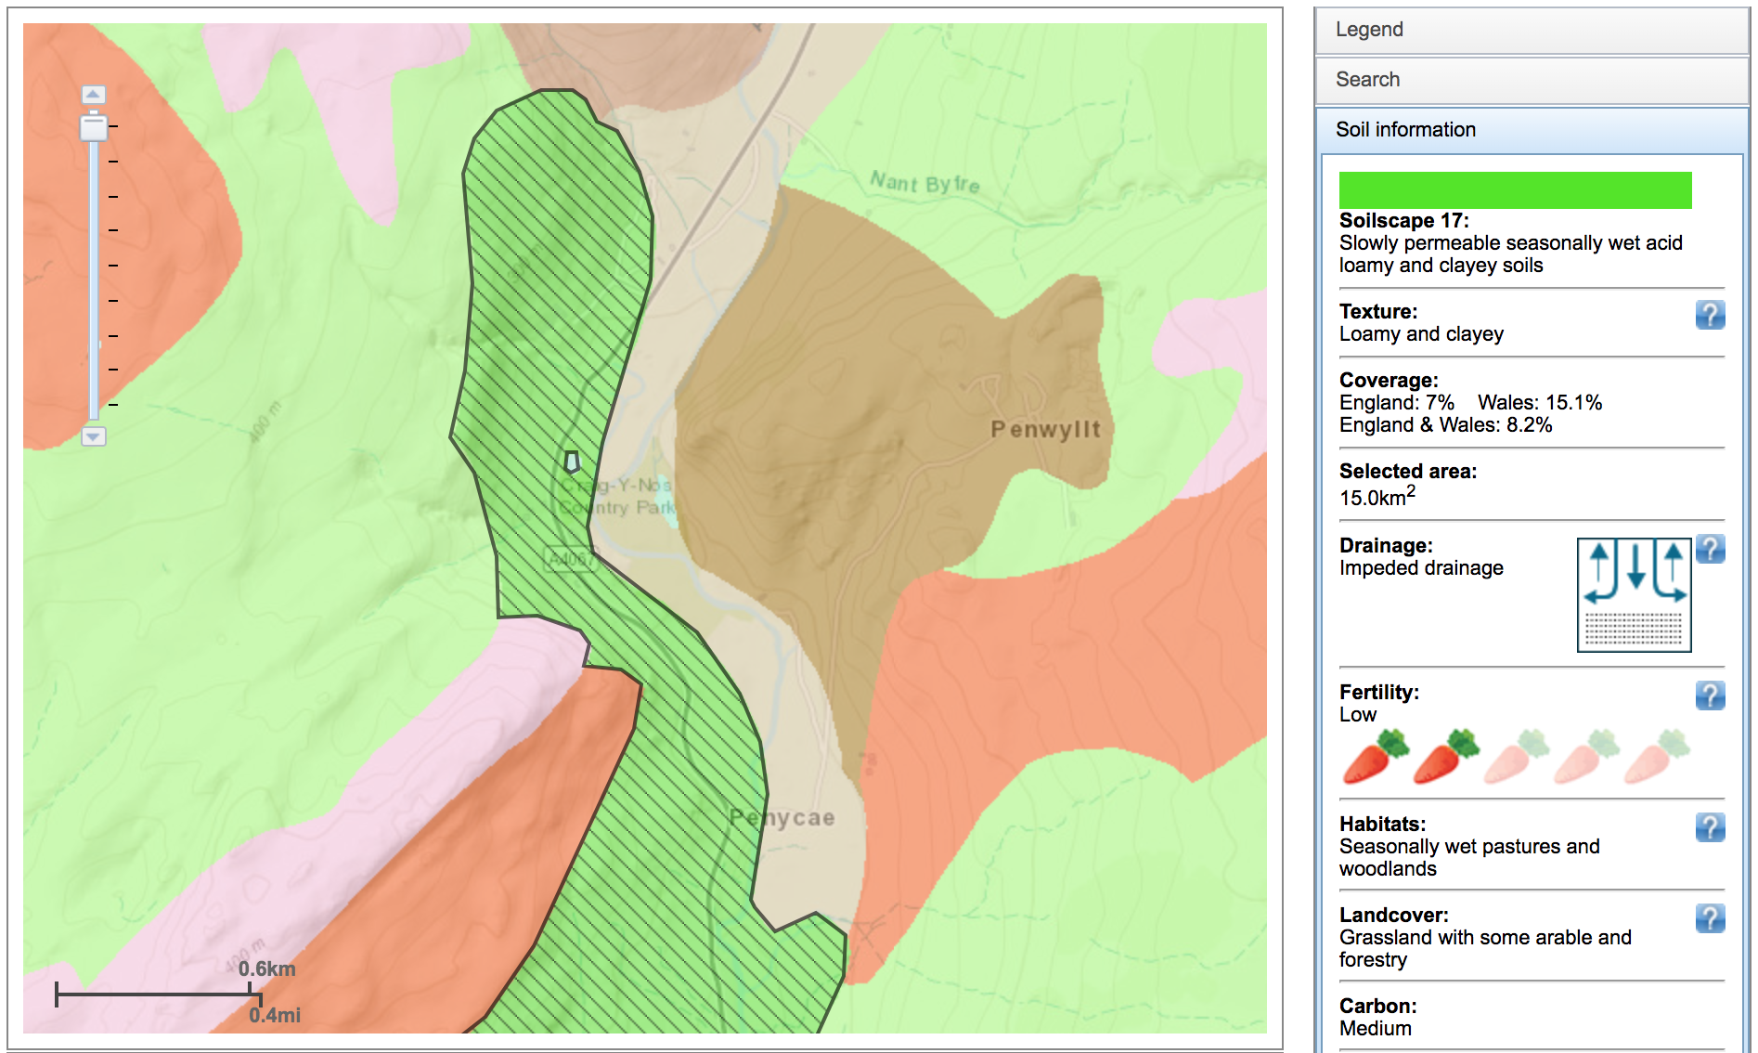
Figure 4 – Cranfield University (nd). An image shows the geology of Craig y Nos as loamy and clay soil. (Accessed 1st December 2019).

Figure 4 and figure 5 shows maps from Cranfield University of the country park geology. Figure 4 states the soil is loamy and clay, wet and acidic while permeates slowly and low fertility. Figure 5 states the soil is loamy, freely drained floodplains and medium to high fertility.

  - Fallen/cut trees
In 2017 and 2018, 53 trees fell or cut and eventually removed due to numerous concerns, such as the impact of adverse weather, impact of diseases, poor planting plan that may lead to public health and safety concern (Jenkins and Chapman, 2019). However, the evidence has shown in block 2 (figure 2) that there is a forest school with cut trees that remained. Despite being away from the footpath and is closed off to the public, the forest school has a high ecological value making a diverse habitat for many species, such as insects and moss.

Plenty more trees across the park are due to be cut because of the impact of diseases, block 3 (figure 2) has beech trees that are covered with laurels and brambles and diseased with honey fungus (Armillaria mellea); honey fungus has mycelium containing roots that look for nutrients for growth. However, the roots are rotting the trees, trapping silt preventing erosion and sloping down to the duck pond (Jenkins, 2019). The country park is planting trees across the park; however, it is yet unknown how many trees planted and whether the number of planted trees is sufficient to compensate for the trees lost. The park has made a priority to plant specific trees suitable for the climate and soil conditions (Chapman, 2019).

  - Invasive and non-native species
There are some non-native species in the park (table 1), amongst the non-native tree species are rhododendron and the redwood, which were aesthetically popular plants to during the Victorian ages despite the potential to show harm towards native species as evidence of low biodiversity shown near these species at the park. The redwood is native to North America, although not invasive, and rhododendron is native to southeast Asia and are very invasive. Despite having no ecological value, these plants have economic value as both species are considered to be aesthetically pleasing to visitors; the redwood is known to grow largely in height and width, while the rhododendron blooms purple flowers during the summer.

  - Funding methods
Craig y Nos Country Park does not obtain its funding from the Welsh/British Government; however, funding comes from the Brecon Beacons National Park Authority. Over the years, the country park made its staff redundant with only one staff member running the park who rely on volunteers’ help due to lack of funding. Other ways of funding come from hourly car park charges approved by BBNPA and selling timber from cut wood to individuals and organisations.

    - Funding cuts
According to the Brecon Beacons Summary Report 2018/19, the BBNPA’s expenditure for Craig y Nos was £47,577 – from this figure, the park’s income was £30,325 (possibly including salary cost), £1,613 on other commitments and £3,225 unspent leaving the budget profile for the park at £9,548. To understand the severity of funding cuts, the summary report of 2016/17 states that the BBNPA’s expenditure for the country park was £70,319 – the park’s income was £45,141, £1,015 on other commitments and £4,258 unspent leaving the budget profile for the park at £23,498. The budget profile declined by £13,910 in recent years.

  - Facilities
Facilities, such as toilets and bins, are located at the café with the disables parking are located away from the café but closest to the park entrance gate. These facilities are not found across the park with reasons potentially being they are not aesthetically pleasing for visitors when walking in the park and there will be a level of expectation raised to monitor cleanliness – despite the majority of workers are volunteers. One possible issue with no bins is that visitors may litter in the park and may become a risk to some species.
  - Public access and safety
The park is identified as an area of a Public Right of Way (PROW). Public access and safety have significantly improved over the years. The main footpath gets regularly maintained, such as removing any nearby fallen trees, branches and leaves. However, removing these fallen items depreciates the ecological value as a potential loss of habitat for some species. If any accidental injuries sustained by a member of the public, they may be eligible to claim from the Public Liability Insurance. Evidence showed that the park has provided safer public access in block 2 (figure 2). On the first visit that took place on 14th October 2019, there were no designated footpaths, which risks trampling of vegetations. On the second visit that took place on 19th November 2019, figure 6 shows an image of a footpath in block 2 (figure 2) suggesting that improvements for public access were made.
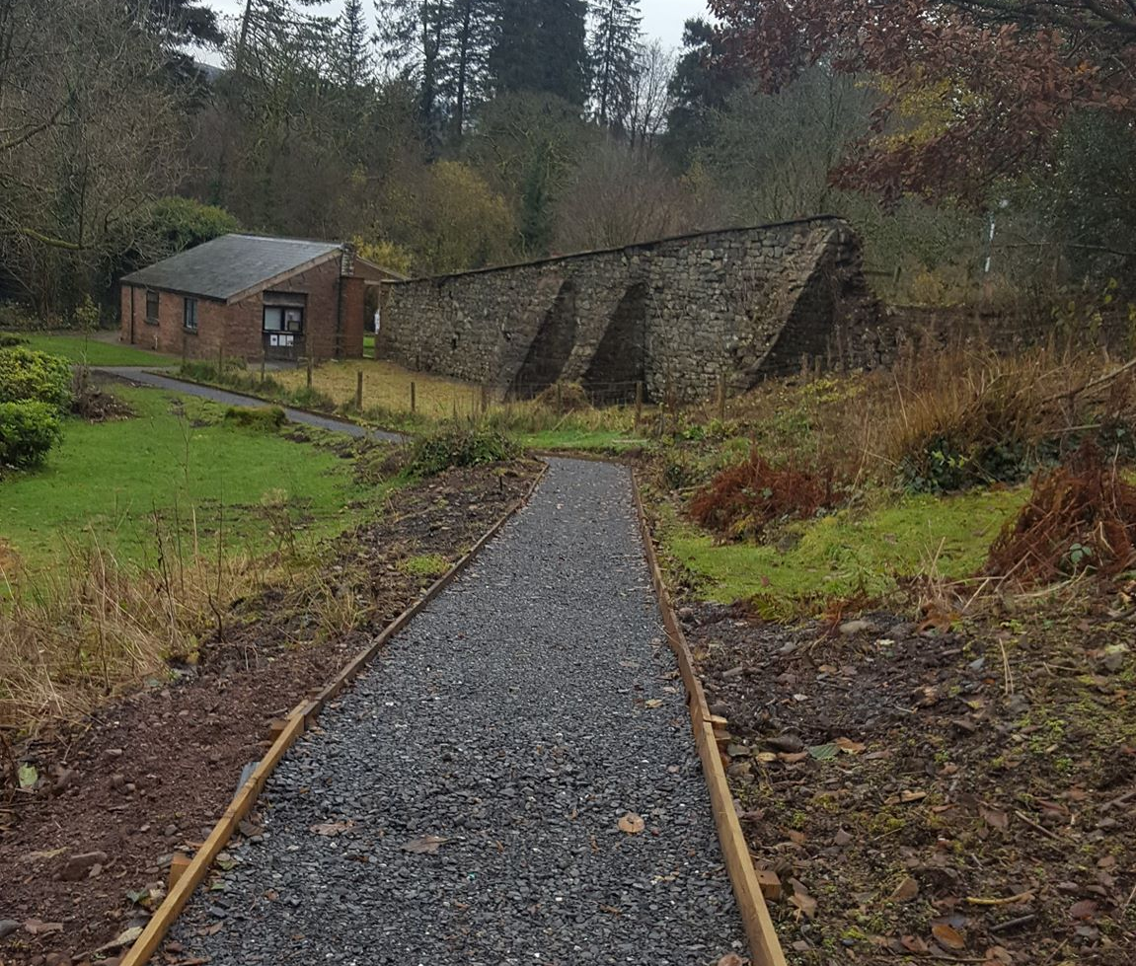
Figure 6 – a photograph to show a designated footpath in block 2 (figure 2).

  - River Tawe bridge
The River Tawe bridge connects block 1 and block 11 (figure 2) and is built strong and wide enough to allow vehicles to drive on. Although the Natural Resources Wales monitoring water levels and pollution on River Tawe, the bridge was built by a local private company – a group of workers who are higher skilled to build a bridge than those who work at the park. Furthermore, the timber for the bridge is not sourced from fallen wood from the country park as the timber needed to be a certain strength to comply with standards of building the bridge (Chapman, 2019).

  - Riverbank
At one side of the river – bordering blocks 1, 3, 4, 5 (figure 2) – the riverbank consists of limestone. Whereas the other side of the river – bordering blocks 8, 9, 10, 11, 13, 14, 16, 17 (figure 2) – the river bank consists of red sandstone. Limestone is a hard rock meaning the rates of erosion will be low, unlike red sandstone, as the material is a soft rock and the rates of erosion will be high.

Regarding the bank protection of River Tawe, work has been conducted in October 2018 by volunteers of University of Wales Trinity Saint David (UWTSD) to plant coppices of willows to act as a natural river barrier and absorb water to avoid a potential breach. However, the next visit was 14th October 2019, there was no evidence of the coppiced will at the riverbank indicating that the river levels has risen to breach the barrier. Figure 7 shows when the river may have breached the willow coppice barrier.

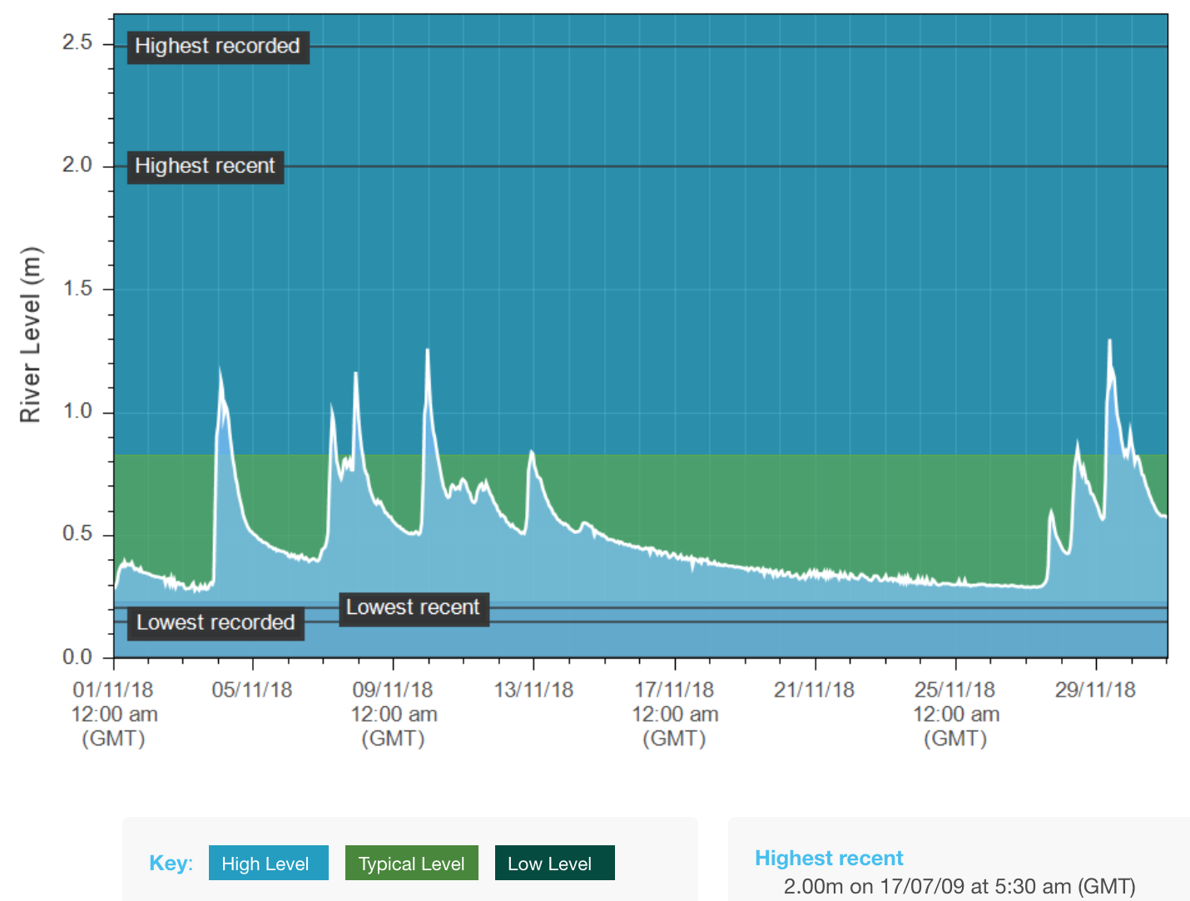
Figure 7 – Natural Resources Wales (2019). A line graph to show water levels of River Tawe in November 2018. (Accessed 1st December 2019).

Figure 7 shows a line graph of water levels of River Tawe in November 2018, one month after UWTSD volunteers planted willow coppices at the riverbank (section 1.8.). The highest level was 1.3m on 25th November, an indication of potential river barrier breach with the typical level was 0.5m less than the highest level.

- Management recommendations
Over time, improvements were made and are still needed to ensure Craig y Nos can benefit economically and environmentally – despite having only a member of staff on a salary, the majority of the work relies upon the volunteers.

  - Tree planting recommendation
Although some trees are being planted in some areas, like blocks 11 and 12 (figure 2), plenty more trees must be planted to compensate (section 1.2.) for the trees lost in 2017 and 2018 to ensure that the country park maintains its ecological value, especially to suit climate and soil conditions.

  - Riverbank recommendations
To maintain ecological value and to protect red sandstone river bank, it is vital to use a natural river barrier; To strengthen the River Tawe bank, it is recommended to plant alder coppice instead of willow coppice. Alder has an epicormic growth; this means that planting alder trees and slicing the tree trunk at a given angle to allow tree growth from the base from the side – with time, the additional tree branches will grow and can secure strength as a natural river barrier.

  - Funding recommendations
It may be inconvenient to the country park to renovate and rent out the abandoned buildings in the park due to the requirement of significant funding and approval by the BBNPA. However, there are other ways to raise money.

Previous trips to Craig y Nos were made during the off-season period of October and November 2019, when the gifts and crafts shops remained closed despite the opening hours suggested otherwise. If Craig y Nos opens their gifts shops during the seasonal holidays with potentially more visitors to the park, perhaps the opening hours could be more consistent as a possibility of raising more money. Although the café and gifts and crafts shop do not contribute towards funding Craig y Nos, one suggestion is to sell specific food or souvenirs and some of the profits could go towards the park

The Craig y Nos Castle is not part of the country park, thus not generating any money for funding the park, one funding suggestion is hosting a Christmas fair at the castle; perhaps selling souvenirs from the gifts and crafts shops, perhaps selling freshly prepared snacks from the café, while allowing visitors to enjoy the historically scenic views of the castle and walking in the country park.

- Overview
Despite the financial depreciation (section 1.4.) of Craig y Nos Country Park over the years, the staff and the volunteers showed a significant impact on the park.

- References
- Brecon Beacons National Park Authority (2016). Brecon Beacons Summary Report:- up to 31/12/2016. p.2.
- Brecon Beacons National Park Authority (2018). Brecon Beacons Summary Report:- up to 30/09/2018. p.2.
- Brecon Beacons National Park Authority, (nd). [online] Available at: http://www.breconbeacons.org/craig-y-nos-country-park [Accessed 6 Dec. 2019].
- Citypopulation.de. (2018). United Kingdom: Wales (Local Authority Districts and Communities) - Population Statistics, Charts and Map. [online] Available at: https://www.citypopulation.de/en/uk/wales/admin/ [Accessed 6 Dec. 2019].
- Chapman, P. (2019) Personal Communication. 27th November 2019.
- Landis.org.uk. (2019). Soilscapes - National Soil Resources Institute. Cranfield University. [online] Available at: http://www.landis.org.uk/soilscapes/ [Accessed 6 Dec. 2019].
- Natural Resources Wales (2019). NRW River Levels Station Monitoring. [online] Available at: https://rloi.naturalresources.wales/ViewDetails?station=4091 [Accessed 6 Dec. 2019].
- Pfaf.org. (2012). Rhododendron arboreum PFAF Plant Database. [online] Available at: https://pfaf.org/USER/Plant.aspx?LatinName=Rhododendron+arboreum [Accessed 6 Dec. 2019].
- Pfaf.org. (2012). Alnus glutinosa Alder, European alder, Common Alder, Black Alder PFAF Plant Database. [online] Available at: https://pfaf.org/user/Plant.aspx?LatinName=Alnus+glutinosa [Accessed 6 Dec. 2019].
- Pfaf.org. (2012). Fraxinus excelsior Ash, European ash, Common Ash PFAF Plant Database. [online] Available at: https://pfaf.org/user/Plant.aspx?LatinName=Fraxinus+excelsior [Accessed 6 Dec. 2019].
- Pfaf.org. (2012). Acer pseudoplatanus Sycamore, Great Maple, Scottish Maple, Planetree Maple PFAF Plant Database. [online] Available at: https://pfaf.org/user/plant.aspx?latinname=Acer+pseudoplatanus [Accessed 6 Dec. 2019].
- Pfaf.org. (2012). Fagus sylvatica Beech, European beech, Common Beech PFAF Plant Database. [online] Available at: https://pfaf.org/user/plant.aspx?LatinName=Fagus+sylvatica [Accessed 6 Dec. 2019].
- Pfaf.org. (2012). Salix caprea Goat Willow, Kilmarnock Willow, Pink Pussy Willow, Pussy Willow PFAF Plant Database. [online] Available at: https://pfaf.org/user/Plant.aspx?LatinName=Salix+caprea [Accessed 6 Dec. 2019].
- Pfaf.org. (2012). Quercus robur Pedunculate Oak, English oak PFAF Plant Database. [online] Available at: https://pfaf.org/user/Plant.aspx?LatinName=Quercus+robur [Accessed 6 Dec. 2019].
- Pfaf.org. (2012). Quercus robur Pedunculate Oak, English oak PFAF Plant Database. [online] Available at: https://pfaf.org/user/Plant.aspx?LatinName=Quercus+robur [Accessed 6 Dec. 2019].
- Jenkins, R. (2019). Personal communication. 19th November 2019.

