UNIVERSITY OF WALES TRINITY SAINT DAVID

INDIVIDUAL ASSIGNMNENT 2

DATA HANDLING AND BUSINESS INTELLIGENCE
LCBB 5000

Name: Anca-Diana Gog
Student Number: 1918426
Module Lecturer’s Name: Khaza Ahmed

April 2022

Part 1
In the first part of the report, we are analysing the Crime data set to determine the crime rate calculated in number of offences per million population. The analysis is done using Excel functions such as IF, LOOKUP, Pivot tables, charts, and graphs.
First step in analysing the Crime data set was to establish the contents and to choose the data we want to analyse. Some of the data is not relevant for our analysis, such as the nominal data, therefore it will be ignored, and we will focus our attention on the relevant data.
The Crime data set contains 48 rows of information. Each row contains crime rate, youth, southern, education, expenditure year, labour force, males, if there are more males or not, state size, youth unemployed, mature unemployed, high youth unemployed, wage and below wage.
The data contains elements related to the crime rate in year one and ten years after so we can analyse the difference and have a broader view of the data. The data has elements of social-economic nature that are related to the crime rate.
On a first glance at the Crime dataset, we can see that the maximum crime rate is 161.8 the lowest crime rate is 45.5 with an average of 102.8 and the total crime rate is 4832. These calculations were done in Excel using functions such as MAX, MIN, AVERAGE and SUM. We can better visualise the Crime Rate data in the following chart which shows the frequency of crime rate.

Figure 1
One of the methods of analysing the data is correlation, which is one of the most used techniques for analysing the relationships between two variables. “Correlation quantifies the strength of the linear relationship between a pair of variables” (Bewick et all, 2003). If the two variables move in the same direction, then those variables are said to have a positive correlation, if they move in opposite directions, then they have a negative correlation.
If we look at the Youth column compared to the Below Wage column, using the correlation function as =CORREL, the calculations show a correlation r=0.63, which is statistically significant. The correlation is positive, which shows us that the age of the people is strongly related to the wage they get, and this affects the crime rate presented in our data set. The calculation can be better illustrated in Figure 1, where the correlation between Youth and Below Wage is presented in a chart.

Figure 2

Also, we can see a strong positive correlation of r=78 between Expenditure Year0 and Wage, which show that there is a strong connection between these two factors that are determinant for analysing the crime rate. The information can be seen in the chart below.

Figure 3
For analysing the Education field, we used =IF function and after doing the calculations we discovered that most of the population in this data set is undereducated. When using IF function we used the following equation: =IF(D3>13, "educated", "undereducated") which means that if the value in each row is over 13 we have the value “educated” and if the value is under 13, it means we have the value “undereducated”.

Row Labels | Count of Education
undereducated | 34
educated | 13
Grand Total | 47

Figure 4
If we use the same function to analyse the Crime Rate field and we use the value 70 on the logical test, as we can see in the formula =IF(A2>70, "high", "low") we will have majority of high crime rate, as we can see in the Pivot Table and Pivot Chart in Figure 5.
Row Labels | Count of crime rate
high | 41
low | 6
Grand Total | 47

Figure 5
If we compare the two fields, Crime Rate and Education we can see that the crime rate is high where the undereducated is high, which show a strong connection between education and crime rate, as it can be seen in the Pivot Table and Pivot Chart in Figure 6.
Count of Education | Column Labels
Row Labels | high | low | Grand Total
educated | 12 | 1 | 13
undereducated | 29 | 5 | 34
Grand Total | 41 | 6 | 47

Figure 6
If we look at the unemployment data in our dataset, we can see that r=0.74, which means that the Youth Unemployment and Mature Unemployment are highly correlated. That tells us there is not a significant difference between the level on unemployment between young people and mature people that affects the crime rate. Figure 6 chart gives us a better visualisation of the information provided by the dataset on this matter.

Figure 7
The dataset contains ten years data, so we have the data in year one and the data for year 10. If we look at the Crime Rate in year 10, using the same functions to do the calculations, MAX, MIN, AVERAGE, SUM, we can see that the maximum crime rate was 178.2, the minimum was 26.5, with an average of 102.07 and the total of 4797.3. From these calculations we can see that in total the crime rate had a slight decrease over the 10 years period, although the average is almost the same. We can also notice that the maximum crime rate in year 10 is higher than in year 1 and the minimum crime rate is lower in year 10 than it was in year 1.

Figure 8
As the chart and calculations in Figure 7 show us, the corelation between the Crime Rate and Crime Rate 10 is very strong, which means that the difference between the two columns of data are not significant.
The analysis of such a large database as Crime is possible in Excel with the help of the functions, IF, PIVOT Tables, charts, and graphs.
“Excel is a software tool developed by Microsoft with the core function of making spreadsheets. However, the application can do more than just make spreadsheets. There is a vast selection of tools, settings, and other options. No matter how you want to present or organize your data, there are options available to help you.” (ppcexpo.com)
Today’s business world, and not only, is data-drive. Data are essential to running a business and it is essential for a manager or anyone who is running the business to understand that data. As we have seen in the analysis of the Superstore database, not all data is relevant, therefore it is very important to be able to determine which data is relevant for our business and how to analyse the data that we need. Excel comes with excellent tools to help in this process that sometimes seems a nightmare, especially when dealing with large databases of raw data from which you have to extract the relevant information.
Excel has the tools to enable the users to go through the process of analysing the data from pre-processing, analysing, and visualising the data. Data Analysis ToolPack includes descriptive statistics, correlations, t-tests, 1 or 2-way analysis of variance, regression that provide complete tests of statistical significance. The Pivot Table, one of the functions we used in our analysis provides summary tables of means, count, or standard deviations. Other Excel functions are used to generate statistical measures. “Functions generate a single number, so using functions you will likely have to combine bits and pieces to get what you want. Even so, you may not be able to generate all the parts you need to complete analysis.” (people.umass.edu)
There are some processes that need to be followed when analysing data in Excel. First, we need to specify data requirements. At this point we need to establish the structure and categories of data that is relevant to the analysis.
Once the variables are established, we need to collect all the data related to the analysis, making sure it is as relevant, qualitative, and accurate as possible.
The next step is data processing, when we need to put the raw data into a spreadsheet so can arrange the information logically. Even if the data is processed, it might be incomplete or contain errors so the next step would be data cleaning.
The next phase is data analysis when data visualisation tools are used. These tools enable us to see patterns and trends. Charting the data is a quick method for understand and analyse the data. After the analysis phase is finished, the final step is communication. The analysis is put into a report that goes to stakeholders, clients, team members, or other parties interested.

Part 2
I am assisting a local company to analyse a survey containing data collected on 200 high school students and their scores on various tests, including a video game and a puzzle. The outcome measure in this analysis is the students’ favourite flavour of ice cream – vanilla, chocolate, or strawberry- from which we are going to see what relationship exists with video game scores, puzzle scores and gender. The company has a copy of Microsoft Excel and has just downloaded a free copy of the open-source SPSS data mining software. The company has used Microsoft Excel before but not SPSS.
To produce the report, I used both software programs to evaluate the following: How many students like vanilla flavour? How many students are Male and Female? What are the Mean and Median of participants who like chocolate and strawberry flavour?
In the data set we have customer id, which is not relevant for our analysis, we have Gender, which has two values, 0 for Male and 1 for Female, we have ice cream data, which had three values, 1 for Vanilla, 2 for Chocolate, and 3 for Strawberry, and we also have Video and Puzzle, which represent the students’ score for these games.
To answer the first two questions, referring to how many students like vanilla flavour and how many are Male and Female, we used SPSS data mining software. We used Analyse tool from the SPSS tool bar then chose Descriptive statistics from the menu, select Frequencies and then the two values we were interested in, Female and Ice Cream. Two tables were generated that contained the information we needed to answer the questions.
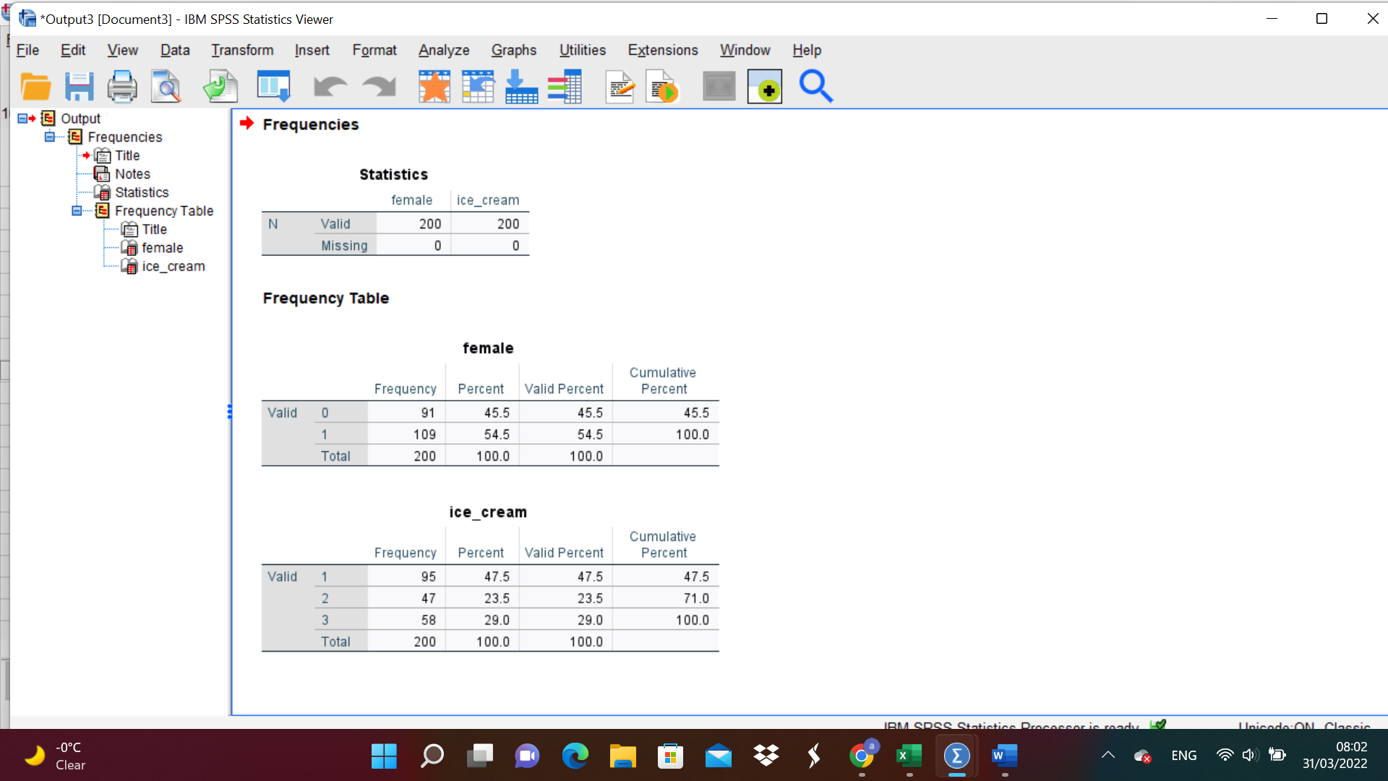
Figure 9
We can see that the total number of students is 200. 45.5% are Male and 54.5% are Female. Referring to the question how many students like Vanilla flavour, 95 students like vanilla flavour, which means a percent of 47.5%.
The next question is to find the Mean and Medium of the participants who like chocolate and strawberry flavour. Here we are only interested of 52.5% of the participants. To generate this information from our dataset we use the Analysis tool from SPSS, then selected Compare Means, and introduced in the Depended List Female and in the Independent List Ice Cream and selected Mean and Medium for the Options list. The findings are also illustrated by the chart we attached.

Report
female
ice_cream | Mean | Median
1 | .51 | 1.00
2 | .68 | 1.00
3 | .50 | .50
Total | .54 | 1.00
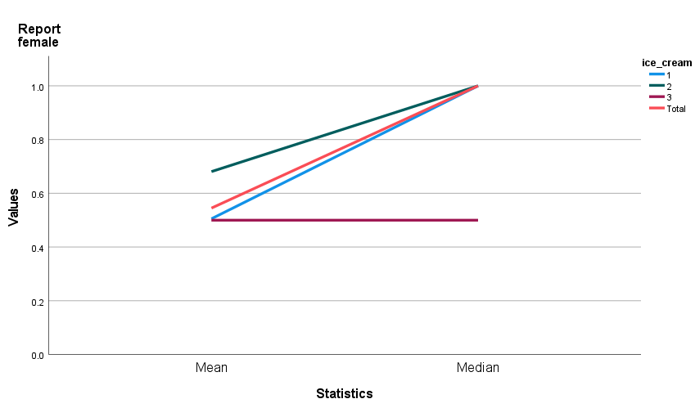
Figure 10

To better understand the information in our dataset we need to break the data using clustering, which is a fundamental operation in data mining. “Clustering methods partition a set of objects into clusters such that objects in the same cluster are more similar to each other than objects in different clusters according to some defined criteria” (Huang, 1997, p.1)
We used clustering so we could analyse the data and understand it in a better way. We generated if from the same Ice Cream dataset using the same Analysis tool, then selecting Classification tab and then selecting Gender in the Categorical Variables box and Video and Puzzle in the Continuous Variables box.
The findings are very interesting and offer us a better understanding of the data. We can see that 54.5% of the participants are females and they average score at playing video games was 50.70, and at puzzles, their average score was 52.94. From the second column we can see that the male participants percentage is 45.5%. The average score at video games for males is 53.23 and for puzzles is 51.79. From this information we can say that even though the female participants represent the majority, the males have higher scores at playing video games. If we analyse the puzzle score, we can see that females scores are better than males score.
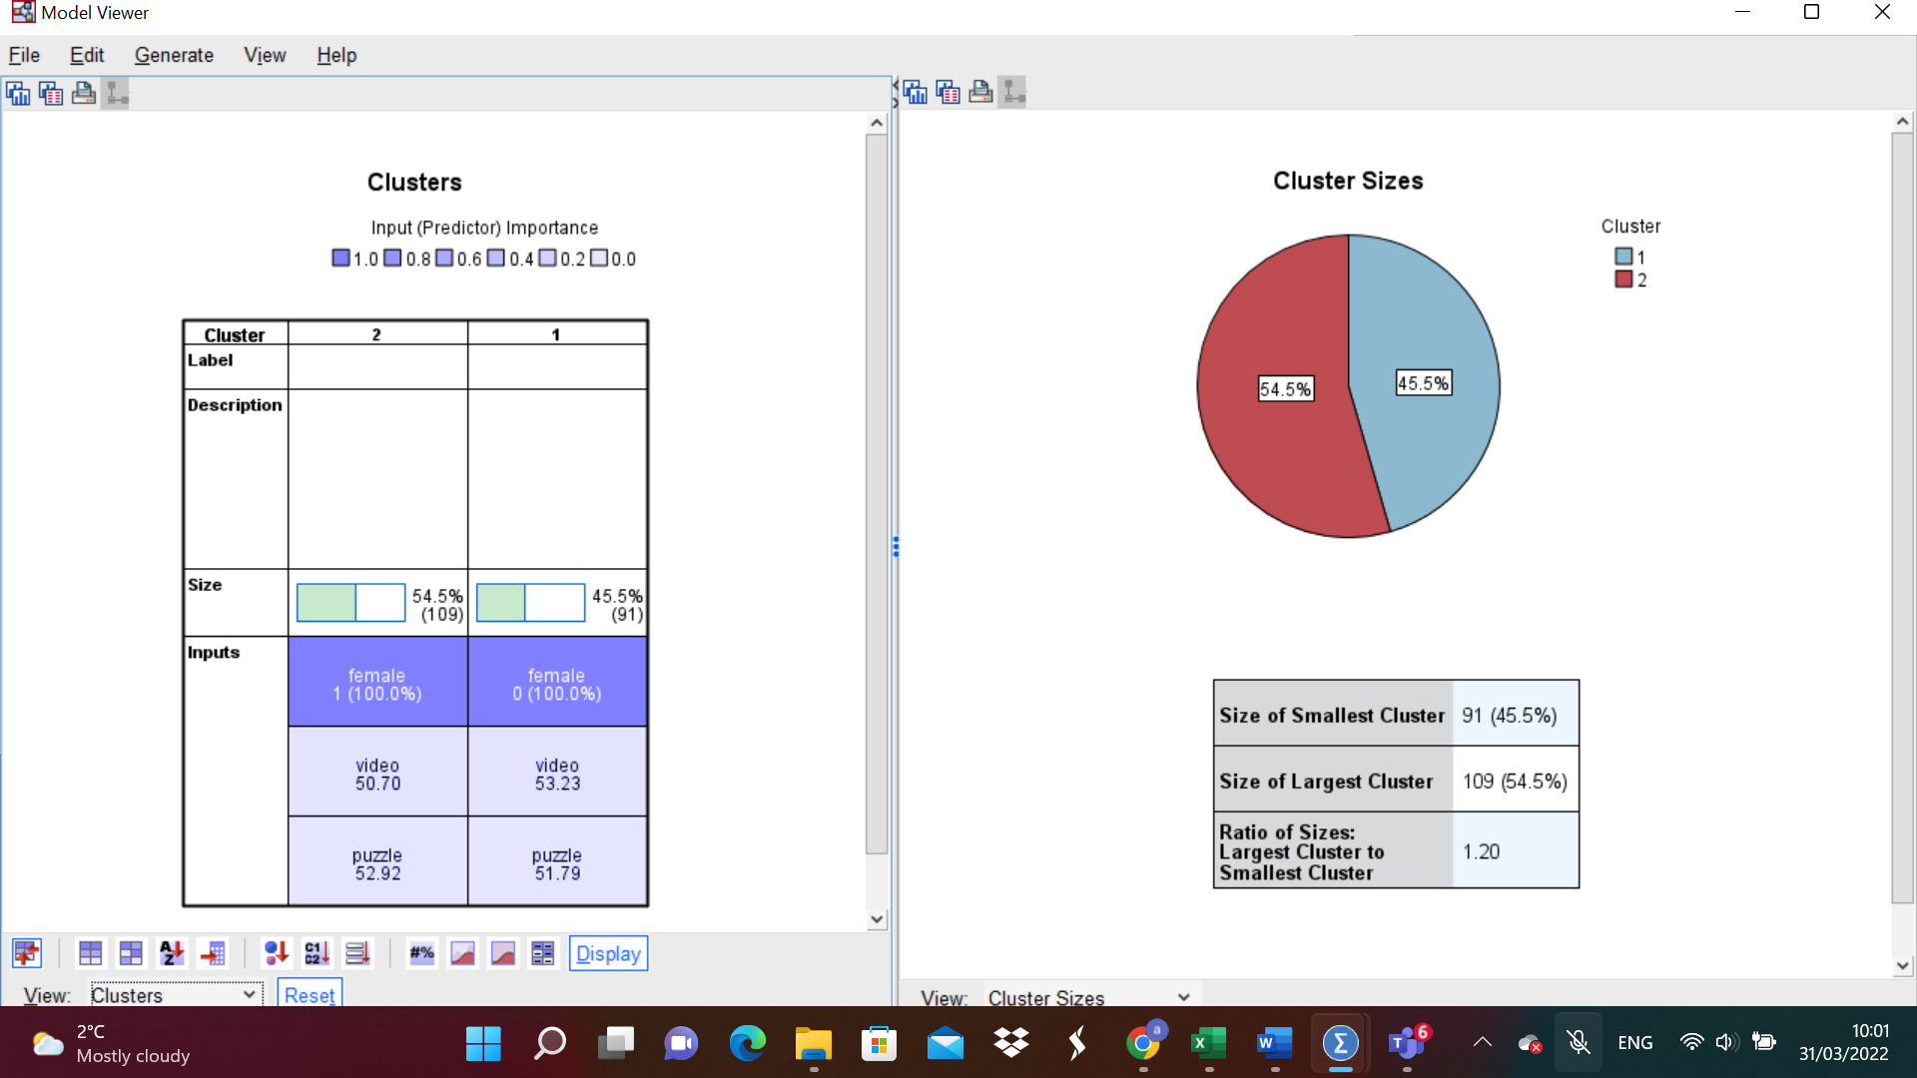
Figure 11
Text mining is “the process of extracting interesting and non-trivial patterns or knowledge from text documents” (Tan, 1999, p.65). It is also known as data mining or knowledge discovery from textual databases from unstructured text documents. However, text mining is more complex than data mining because the text data are unstructured. It involves “information retrieval, text analysis, information extraction, clustering, categorization, visualization, database technology, machine learning, and data mining” (Tan, 1999, p. 66).
Text mining appliance extends to a vast area of fields, such as lawn (court orders), biology (molecular interactions), finance (quarterly reports), technology (patent files), academic research (research articles) or marketing (customer comments). An example of text mining is the customers’ reviews, which represents a free-form text-based interaction with the customers and can be used for identifying product and service characteristics which lead to product or service improvement. Because this process is not restricted to a codified form, the customers can put in their own words what is their experience and their opinion on the company’s product or service (Sharda et all, 2014).
Microsoft Excel and SPSS are two software programs that have similar characteristics, they both have menus, spreadsheets, and built-in statistical functions. When using them for data analysis, SPSS has more advantages than Excel:
- Easier way to use the basic functions. For our report we used SPSS software because it was an easier and faster get the information, we needed from the dataset by using descriptive statistics.
- SPSS has a wider range of more detailed charts and graphs
- It offers faster access to statistical tests
- Effective data management
- Wide range of options
- Better output organization
- The software prevents data entry errors (worldpress.com)

References:
- Bewick, V., Cheek, L. and Ball, J., 2003. Statistics review 7: Correlation and regression. Critical care, 7(6), pp.1-9.
- Huang, Z., 1997. A fast clustering algorithm to cluster very large categorical data sets in data mining. DMKD, 3(8), pp.34-39.
- Sharda, R., Delen, D., Turban, E., Aronson, J. and Liang, T., 2014. Business intelligence and analytics. System for Decesion Support.
- Tan, A.H., 1999, April. Text mining: The state of the art and the challenges. In Proceedings of the pakdd 1999 workshop on knowledge disocovery from advanced databases (Vol. 8, pp. 65-70).
- https://ppcexpo.com/blog/analyze-data-with-excel
- https://people.umass.edu/evagold/excel.html
- https://pgdabm1618.wordpress.com/2017/01/14/spss-over-excel/

