

Knowledge and Information Management
Skills for the Workplace
-Amazon-
Student’s Name: Alexandru Munteanu
Student’s ID: 1920944
Lecturer’s name: Mohamed Kalam

Table of Contents
Executive Summary 3
Introduction 3
Knowledge and Information Management 4
Background of Amazon 4
What is KM 5
Why is KM important for any organization including Amazon 5
How KM helps the organizations in satisfying customer and achieving competitive advantage 5
Evaluation of Knowledge and Information Management Models/theories 6
How is knowledge generally embedded in products and the service concept in the tacit knowledge of individuals (employees and customers)? 6
How systematic approach (Management Information System/systems) help organizations in sharing and exchanging its knowledge base across the organization? 7
SECI Model 8
Socialization 8
Externalization 8
Combination 9
Internalization 9
Investigating of KM techniques used by Amazon.com 10
SOP 10
Outcomes using these procedures 10
Areas to improve 11
Conclusions and Recommendations 12

Amazon

Executive Summary

The following report will be related to Amazon company with the main purpose of giving a better understanding about the knowledge management process used by Amazon company in order to be successful on good and bad times such as Covid-19 pandemic. There will be discussed models and theories for a wider opening about the knowledge management subject as well as recommendations for a future plan that will boost the company even higher. Solutions will be given into the report as an answer to the challenges that Amazon company can meet along the way. Conclusions will be highlighting the main subjects followed in the report along with the references as a proof of academic research and plagiarism free tool.

Introduction

Amazon is one of the most successful cloud computing companies in the United States that is actually a leader in the e-commerce industry. The company started on a single niche of selling books and by time, they have developed a big customer base that allowed the expansion of the company which now sells clothes, furniture, beauty products and many other all around the world. Amazon has also created it’s own logistic company which includes transportation and deposits in many countries. Universities and government agencies are working with Amazon as it is proving that the company acts like a global giant in the e-commerce industry. Amazon has also developed the Alexa device that accomplished even a bigger success for the consumer electronics world company. (Fast Company, 2019).

The following report will be related to Amazon company in order to highlight their knowledge management strategy that bring the success during Covid-19 Pandemic. Good knowledge management development practices such as effective creation, storing, sharing, application and integration of information will be defined and developed in order to take evidence about their importance in the success of the knowledge management process of Amazon. The SECI Model will be defined and approached to Amazon company in order to highlight the knowledge management from inside out. (Tutorials Point, 2021). The SOP - Standard Operating Procedures - will be analyzed to attest that knowledge management became important for Amazon company and which outputs they have generated for it. Recommendations regarding how Amazon can overcome the existing challenges will be done from the acquisition - retention and transfer perspective so, like this, the strategy of success of the company will be strengthened along with the benefits of implementing a new knowledge management will be highlighted. Last but not least, there will be conclusions about the entire report that will actually summarize the findings from it.

Knowledge and Information Management

Background of Amazon
Amazon have been an innovative company since it first launched on the market the business with the books that can be achieved by anyone but actually this was part of the plan of the director Jeff Bezos that was aiming to make the company an everything seller giant. The success started from the day of launching because in just one year, the company have been sold books in all the stated on SUA which means that it engaged rapidly with their customers. (Hartmans, 2021)

After growing the business in 2000, Jeff Bezos have been adopting the two-pizza rule that he considered successful due to the fact that having fewer levels of management would make things more efficient and decisions can be done faster. Moreover, the two-pizza rule is also relating to the fact that communication withing the management levels of the company is more effective as there is not a crowded environment. Last but not least, to prevent data duplication, the two-pizza rule was adopted so every team minds it’s own business and is aware about their specialization without spreading the news between departments. (Tellis, 2020)

What is KM
As (Davenport, 1994) said, the Knowledge Management is related to the process of effectively attracting, distributing and managing the knowledge.

Why is KM important for any organization including Amazon
The Knowledge Management process is first of all, helping companies to reduce time of expertise and it is more effective in matter of costs for Amazon as well as for any other companies. The time-reducing aspect refers that having an efficient KM reduces the time of searching information as they are already existing in the KM tools which prevents wasting time, energy and focus of the company on the main issues or plans. It is a very well-known fact that the effectiveness of a KM is bringing success to any company, including Amazon. (Guru, 2020)

To state more of the importance of the Knowledge Management, there were companies on Fortune 500 that recorded looses pf $31.5 billion per year which means that not having a KM can destroy a business as big as Amazon. (Babcock, 2004)

How KM helps the organizations in satisfying customer and achieving competitive advantage
Customer satisfaction is aiming to improve the relationships between the existing and potential customers with the company. (Sales Force, 2021)

For this reason, the CRM tools are going hand in hand with KM as both are gathering data for the business success. For example, both tools are connecting the management levels such as marketing management, sales management and other is order to attract customers, what tupes of customers use Amazon’s services, and provide support in order to enhance the relationships between the company and customers also. (Kapture, 2017)

Moreover, while the Customer Relationship Management is working along with Knowledge Management, there is easier to win strategic value, which means targeting customers that will be loyal and will collaborate with Amazon on long term. As customers are expecting personalized products and innovative ones, the knowledge management should involve CRM to successfully do it and satisfy the consumer’s needs. Have the right Knowledge Management, makes easier to satisfy companies needs that can become Amazon’s customers, with the help of CRM by discovering each of the companies business models and as well, adapting to it to offer the best deals. In smaller terms, the KM is providing exclusive details about how a business is operating on their niche on the market while CRM is more involved in identifying the customers interaction type or nature. (SAP Community, 2008)

Evaluation of Knowledge and Information Management Models/theories

How is knowledge generally embedded in products and the service concept in the tacit knowledge of individuals (employees and customers)?
In order to connect with almost all the billions of people in the entire world, Amazon is effectively using their Knowledge Management strategy in order to provide personalized experiences to their customers that enhances the customer engagement and the contribute to the company’s success. Using the same interface and being able to buy from a single portal all their products is a tool used by Amazon that comes as a conclusion of KM. Having one portal and a single interface bring familiarity to the customers and at the same time a feeling of being comfortable buying from Amazon. It also contributes to the marketing strategy as while the customer searches for an electronic device such as a hair straightener, there will appear recommendations for hair care products which may generate more buys from Amazon by the same person. (Rosenberg, 2014)

Having multiple interfaces and shops while being a diverse seller will create feeling of crowd and tiredness while looking for multiple products. It may also lead to lose a customer or a huge number of them as they do not find it easy to make their purchases. (Rosenberg, 2014)

Amazon is also having a consistent presentation for all of their products as they are organized and presented in the same way in order to generate a familiarity aspect for their customers. It is important to present the products description in a consistent manner as the users are more likely attracted to read the details of a products in a single way than all the details to be chaotic. The main idea od presenting the details of the products in a consistent and similar manner is not to disconcert the users and decide to look for the same product on other website. (Stewart, 2017)

One of the most attractive things that have contributed to Amazon’s expansion is the fact that the website personalizes the experience of every customer. For this reason, the more one customer uses Amazon.com webpage the best it knows him or her and make more precise recommendation according to their preferences. This comes from the knowledge management process that is able to sort information and target the audience by recommending more likely products for them. (Amazon Web Services, 2021)

How systematic approach (Management Information System/systems) help organizations in sharing and exchanging its knowledge base across the organization?

The Management Information System is actually a tool that analyzes the information gathered by a company and reports data which helps the certain company in the decision-making process for more effective results. The MIS is contributing to a decisional factor in many departments such as Financial, Real estate, Marketing, Personnel, Timelines of projects, R&D, Raw materials, so on and so forth. (Ingram, 2019)

In the case of Amazon company, the Management Information System have been directly contributed for the business success as the information was aligned to be provided in an efficient manner between all the company’s departments in order to meet the customer expectations and increase their engagement. (Weber, 2010)

For example the MIS have been contributing to the sales strategy of Amazon by providing the needed information for the IT department that is responsible of personalizing the customers experience. First of all, Amazon have been focusing on business on business model of operations and business to consumer operations so, the latest trends in the e-commerce industry have been forcing to adapt and customize the relations with their customers. (Jordon, 2008)

Another example of how the Management Information Systems have been contributing to Amazon’s success was facilitating the exchange of information within the logistic department. For this reason, the customers should provide their shipping address which will generate different kind of shipping methods for the customer. The address can be added and changed but all of the customers addresses will be stored within their accounts in order to prevent manually introduction on data for every time a customer is willing to purchase a product from Amazon.com. (Anderson, 2011).

In order this to happen the information should be gathered by resource management- logistics and delivery department. (Jordon, 2008).

SECI Model

Socialization

This process is vital in any company, Especially in Amazon because of the fact that it enables employees to connect and share knowledge both for them as individuals and for the organization also. By the socialization process can be understood the connections that allow employees of Amazon to work together and mix their ideas in order to achieve the organization’s goals. This process os actually enhancing the quality of employees work. For example, if a new employee is hired by Amazon on a certain position, socializing and making connections within the department will make him to have a better understanding about the workplace culture, about the main subject, about what is needed to be done and how things should follow to achieve the target by sharing tacit knowledge. (Software Techniques, 2020)

Externalization

The process of externalization is made on two different levels, the employee and the organization that need to share tacit knowledge. For example, in Amazon, the externalization is the knowledge held by the individual which actually is the knowledge of the company as the individual is an employee of Amazon company. (Tsoukas, 2009)

Actually, the externalization process in Amazon is about the knowledge the employee is processing in vary forms in order to externalize it and present it to the department and further to the customers. For example, while creating a new product, the employees in the marketing department should be able to use the knowledge about the certain product in order to present it to the customer via images, web pages, graphs and so on. (Nonaka, 1997)

Combination

Combination is the process of helping departments to gather a better solutions in the process of creating or selling a product in order to meet the expectations of their targeted customers. For example, in Amazon company all the departments are connected between them while working on delivering products and services to their customers. For this reason, they should share knowledge to be able to deliver the perfect matching product according to the market trends. In this process there is also about the technology that is involved in matter of making things easier. E-mails, data bases, are the main tools used in collecting both internal and external knowledge along with meetings and other type of communication tools between departments of Amazon. The process of combination is actually allowing the departments to better communicate in order to create effective solutions. (First Up, 2020)

Internalization

The process of Internalization is consisting of implementing new ideas based on the knowledge and simulate new products or situations to see if they fit with the company and customers trends. For example, in Amazon, Jeff Bezos is the one who accepts and run these kind of experiments such as introducing new concepts or methods of selling the products in order to bring more success for Amazon company. This process is actually happening with the approval of Jeff Bezos and it transfers the lnowledge from Amazon company to their customers if it is accepted and the project moves on with the final product. (Nonaka, 1997)

Investigating of KM techniques used by Amazon.com

SOP
The Standard Operating Procedure is actually a guide which contains every step Amazon company should be following on a daily basis in order to achieve the success of the business by accomplishing targets. (Brush, 2021)

Amazon should be using the knowledge management system in order to establish their SOP that is conducting the company in achieving their goals and targets. Amazon is actually an example of a company that was able to bring innovation on the market by using both internal and external knowledge in order to create a successful SOP. (Birkinshaw, Monteiro, 2007)

As Amazon company started to develop, there was adopted the Standard Operating procedure based on Knowledge because it is more efficient and easy to conduct all the operations as well as obtaining the same result while having a list of procedures. Moreover, Amazon is at a level where mistakes are not something that the company affords to do and so, by in order to have an efficient Knowledge Management, The SOP is a guarantee that the employees follow the same and the best rules and practices, so they deliver successful services and products. (Help Juice, 2020)

Outcomes using these procedures
The main outcome by using procedures such as SOP’s and Knowledge management is that Amazon become successful by developing an efficient workplace for their employees that are able to deliver the best services and products. Also, by having a strong knowledge management system, there can be easily targeted the areas and employees that need training and improvements so, Amazon was able to implement them at the right time. Usually, trainings and investments made in employees are benefiting the company not just by increasing efficiency but also in retaining the talented workforce which is a great asset for Amazon. (Valamis, 2021)

Being able to make faster and better the decisions is also an outcome that have to be mentioned as Amazon is one of the companies that was able to record the best results even in times of Covid-19 Pandemic. Most of other big companies have been registering loses because of the fact that they have not been able to adapt and make the right decisions in such harsh times.

Areas to improve

First of all, it is important to be mentioned the fact that Amazon company have made some products that are not as successful as the company planned to be and for this reason, the main improvement the company should do is targeting the products that are a failure and stop developing them. Continuing to work on a product that is a total failure is a waste of time and also, it is consuming resources that can be used in diversifying successful products. (Green & Meisenzahl, 2021)

As Cloud based services are a trend in this decade, Amazon company is recommended to be involved in this process and expand in this area due to the fact that these services are an extent for any company that aims to have long-term results and development in the future. The main benefit of developing Cloud based services is that it enables diversifying the customer base, which means a better understanding of the consumers trends and also being able to develop products and services that will bring success for the company. (Sales Force, 2021)

Conclusions and Recommendations

In conclusion, Amazon is a company that successfully uses its Knowledge Management due to the fact that it became one of the biggest online retailers in United States. Moreover, the KM is reducing the time of expertise and it helps the company succeed rather than register loses. While the KM is efficient there will be also SOP’s developed in order to increase the profitability of the company by gathering effectiveness among employees.

In order to enrich the KM culture, Amazon company should encourage the brainstorming sessions due to the fact that they happen naturally first of all. Secondly, the brainstorming is a great opportunity for the employees to communicate and get to know better each other. Another benefiting aspect is that brainstorming generates new ideas that will benefit Amazon as well as the customers. It is also allowing the company to target the main challenges that are happening and being able to collect solutions from multiple perspectives. It is very well known the fact that collective solutions are more effective. (Harris, 2020)

References
- Amazon Web Services, (2021), Amazon Personalize Features, Accessed on November 21st 2021.
- Babcock P, (2004), Shedding Light on Knowledge Management, Published on May 1st, Accessed on November 21st 2021.
- Birkinshaw J., Monteiro F., (2007), External Knowledge Sourcing: Uncovering the technology scouting process, Accessed on November 22nd 2021.
- Brush K., (2021), Standard Operating Procedure (SOP), Published on October 15th, Accessed on November 22nd 2021.
- Davenport T. (1994), Knowledge Management, Accessed on November 21st 2021.
- Fast Company, (2019), Amazon, Accessed on November 21st 2021.
- First Up, (2020), How Amazon is Connecting Culture and Communication, Published on June 22nd, Accessed on November 21st 2021.
- Green D., Meisenzahl M., (2021), Jeff Bezos famously embraces failure. Here are the biggest flops Amazon has overcome under his watch, Published on June 29tg, Accessed on November 22nd 2021.
- Guru, (2020), What is Knowledge Management ?. Why is Knowledge Management Important?, Accessed on November 21st 2021.
- Harris J., (2020), How Amazon became a pandemic giant - and why that could be a threat to us all, Published on November 18th, Accessed on November 22nd 2021.
- Hartmans A., (2021), Jeff Bezos originally wanted to name Amazon ‘Cadabra’ and 14 other little-known facts about the early days of the e-commerce giant, Last Updated on July 2nd, Accessed on November 21st 2021.
- Help Juice, (2020), How to write a Standard Operating Procedure (SOP), Accessed on November 22nd 2021.
- Ingram D., (2019), What Is a Management Information System?, Last Updates on February 12th, Accessed on November 21st
- Jordon M., (2008), The secrets to Amazon Bookselling Success (Tenth Edition), Accessed on November 21st 2021.
- Kapture, (2017), Knowledge Management Propels an intelligent CRM, Published on October 12th, Accessed on November 21st 2021.
- Nonaka I., (1997), Organizational Knowledge Creation, Accessed on November 21st 2021.
- Rosenberg M., (2014), The Knowledge Management Genius of Amazon.com, Published on July 29th, Accessed on November 21st 2021.
- Sales Force, (2021), 12 Benefits of Cloud Computing, Accessed on November 22nd 2021.
- Sales Force, (2021), CRM 101: What is CRM?, Accessed on November 21st 2021.
- SAP Community, (2008), Knowledge Management in CRM, Published on December 31st, Accessed on November 21st 2021.
- Software Techniques, (2020), How workplace socialization benefits your company, Accessed on November 21st 2021.
- Stewart J., (2017), Consistency Is Key: Learning from Amazon, Published in July 18th, Accessed on November 21st 2021.
- Taoukas H., (2009), A Dialogical Approach to The Creation Of New Knowledge in Organizations, Accessed on November 21st 2021.
- Tellis S., (2020), 3 reasons why Jeff Bezos’s 2 pizza rule can help a company succeed, Last Updated on December 6th, Accessed on November 21st 2021.
- Tutorials Point, (2021), Models of KM Cycle - WIIG Model, Accessed on November 21st 2021.
- Valamis, (2021), Knowledge Management, Updated on August 11, Accessed on November 22nd 2021.
- Weber S., (2010), Sell on Amazon: A Guide to Amazon’s Marketplace, Seller Central, and Fulfillment by Amazon Programs, Accessed on November 21st 2021.






The following study will focus on Amazon, with the goal of providing a better understanding of Amazon's knowledge management approach in order to be successful in both good and difficult times, such as the Covid-19 epidemic. There will be discussed the following topics: Amazon company’s background, Knowledge Management Framework, the SECI Model, the challenges that Amazon may face during the evolution of the company, Solutions for the described problems, the main purpose of the KM Tools, SOP and MIS of Amazon.

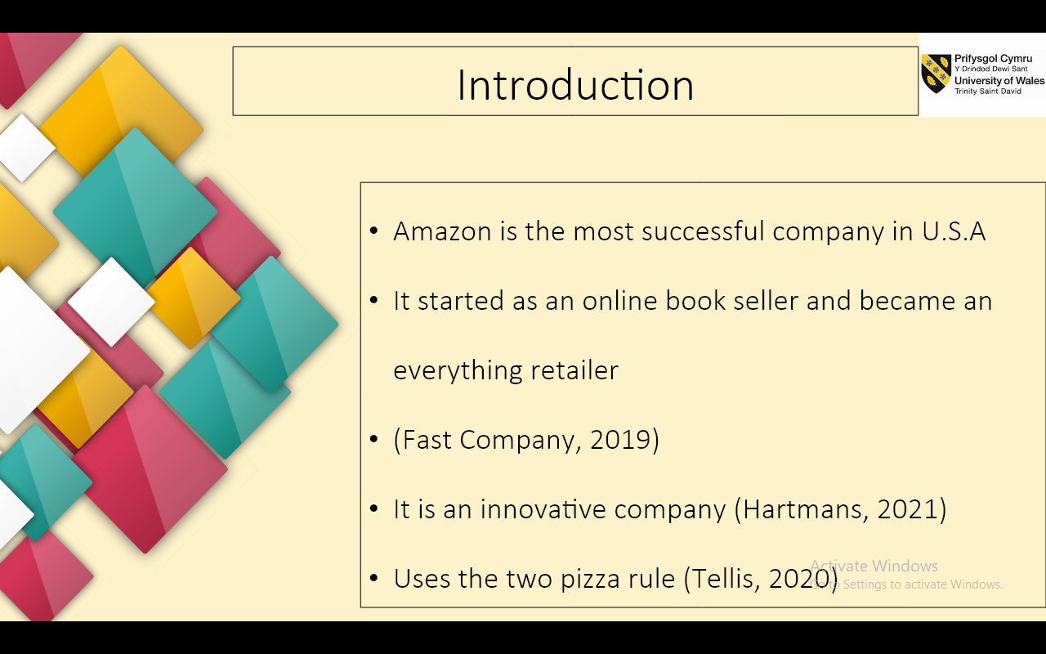

Since its inception, Amazon has been a forward-thinking firm, launching a business with books that anybody may buy, but this was all part of the director Jeff Bezos' strategy to turn the company into an all-encompassing retailer. After successfully developing the company in 2000, Jeff Bezos implemented the two-pizza rule, which he believed effective since fewer levels of management would make things more efficient and decisions could be made faster.

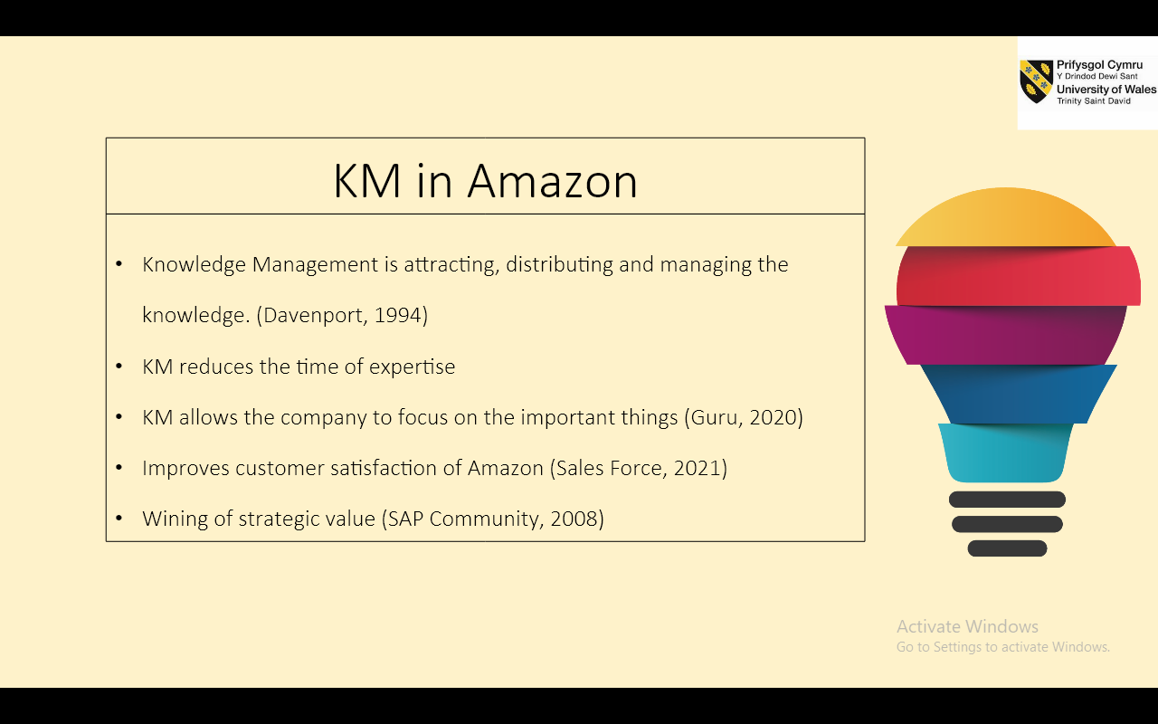

The Knowledge Management approach, for example, assists organizations in reducing time spent on expertise and is more cost-effective for Amazon and other businesses. The time-saving component relates to the fact that having an effective KM lowers the time spent searching for information because it is already stored in the KM tools, preventing the firm from wasting time, energy, and focusing on the most important issues or goals.

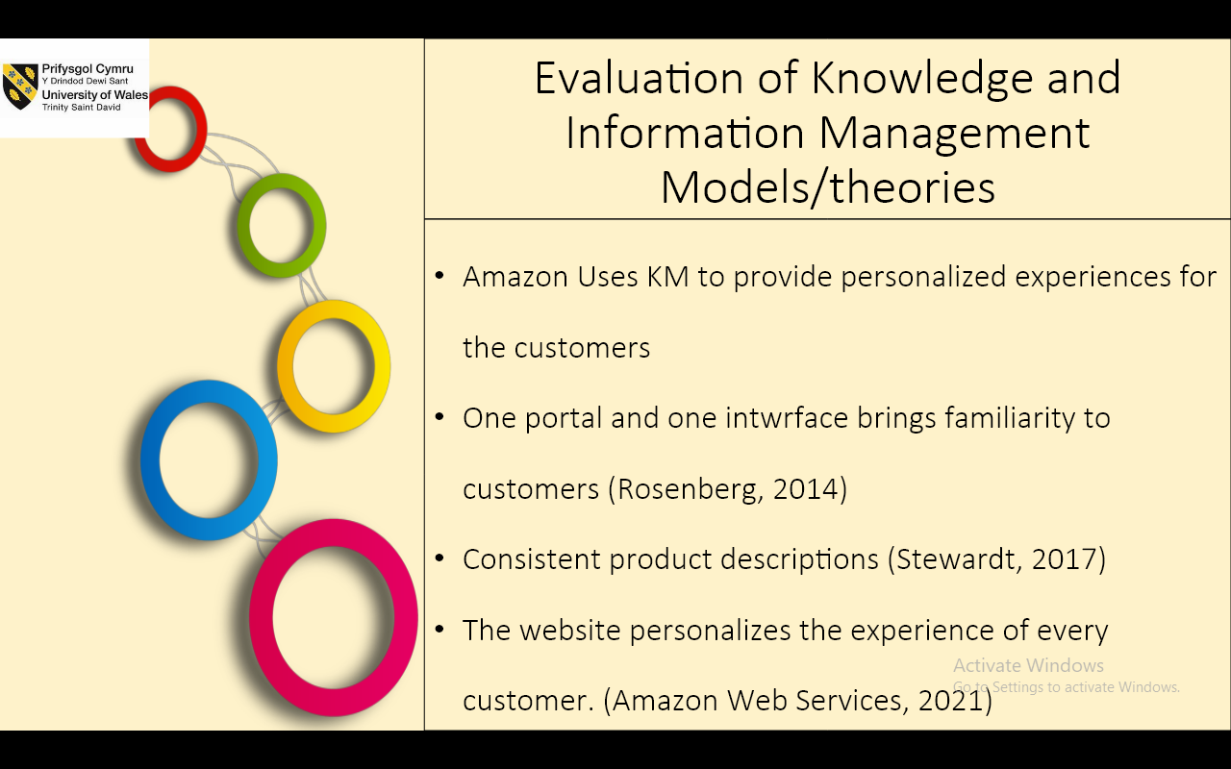

Amazon is efficiently leveraging its Knowledge Management approach to give tailored experiences to their consumers, which promotes customer engagement and contributes to the company's success, in order to connect with practically all of the billions of individuals in the whole world. Amazon's tool, which comes as a conclusion of KM, is to utilize the same interface and to be able to buy all of their items from a single site. Amazon also has a uniform appearance for all of its items, since they are all sorted and displayed in the same way to give their consumers a sense of familiarity. The fact that Amazon personalizes each customer's experience is one of the most appealing features that has contributed to the company's growth. As a result, the more a client visits the Amazon.com website, the more it gets to know him or her and can provide more exact recommendations based on their tastes.

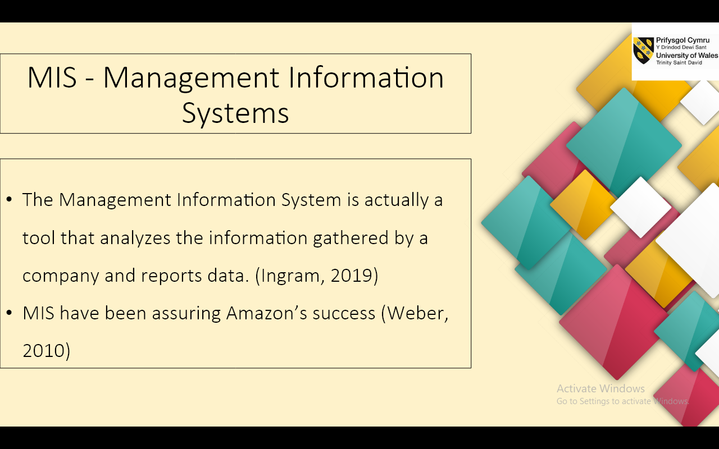

The Management Information System (MIS) is a tool that analyzes and reports data from a company's data, assisting the firm in making better decisions. In the instance of Amazon, the Management Information System contributed directly to the company's success since information was aligned to be supplied in an effective manner amongst all of the company's divisions in order to satisfy consumer expectations and enhance customer engagement.

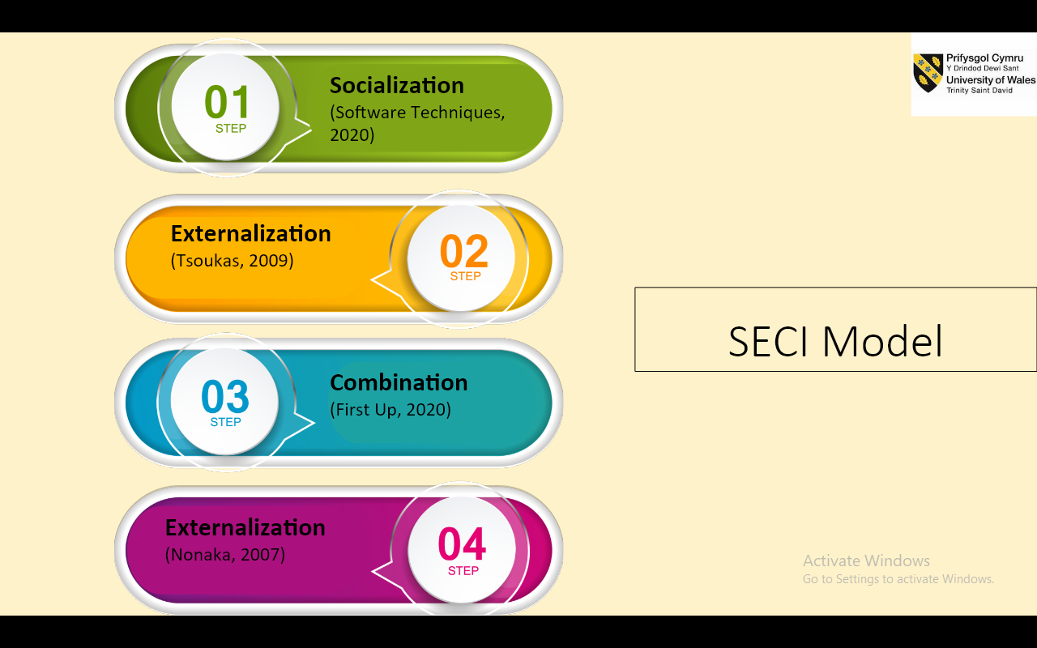

Socialization: The socializing process may be defined as the relationships that allow Amazon employees to collaborate and mix ideas in order to achieve the company's objectives. This method genuinely improves the quality of the employees' work.
Externalization: Actually, the externalization process in Amazon is about the knowledge that employees are processing in various ways in order to externalize and show it to the department and, eventually, to consumers. For example, while developing a new product, marketing staff should be able to leverage their understanding of the product to offer it to customers using photographs, web pages, graphs, and other means.
Combination: Combination is the process of assisting departments in gathering better solutions in the creation or sale of a product in order to suit the needs of their target clients. For example, while working on delivering items and services to its clients, all departments of Amazon are connected to one another.
Internalization: Internalization is the process of putting new ideas into action based on information and simulating new goods or scenarios to determine if they fit with the company's and consumers' trends. For example, Jeff Bezos, the CEO of Amazon, is the one who approves and runs such experiments as introducing new concepts or methods of selling things in order to increase the company's performance.

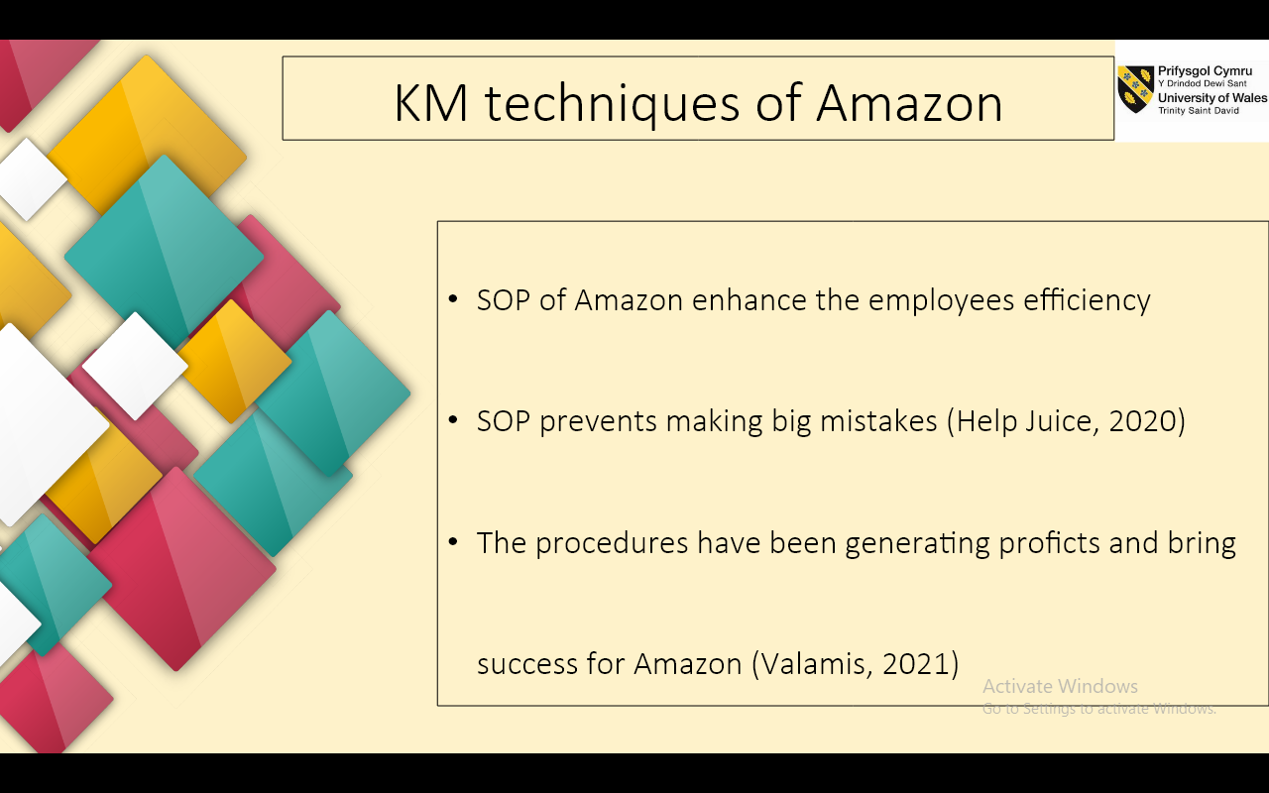

Amazon should use a knowledge management system to create a standard operating procedure (SOP) for attaining the company's goals and objectives. Amazon is an example of a corporation that was successful in bringing innovation to the market by combining internal and external expertise to establish a successful SOP. As the Amazon firm grew, it adopted the Standard Operating Procedure based on Knowledge since it is more efficient and easier to do all activities while having a list of processes, as well as achieving the same outcome.

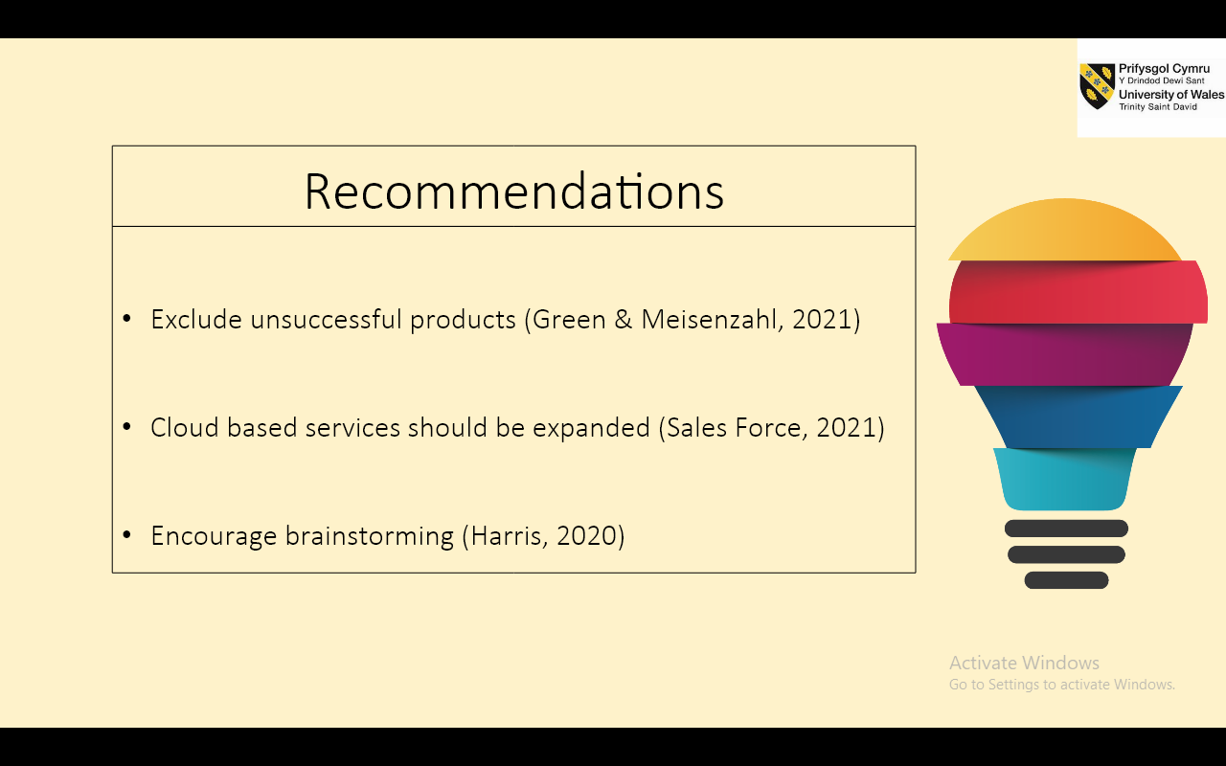

The Amazon corporation should support brainstorming sessions in order to develop the KM culture because they occur organically first and foremost. Second, brainstorming provides an excellent chance for employees to communicate and get to know one another better. Another advantage of brainstorming is that it develops fresh ideas that will help both Amazon and its consumers. It also enables the organization to focus on the most pressing issues and collect ideas from a variety of angles. The fact that group solutions are more effective is well established.



