Student Name: Michael Thomas

Student Number:1908080

Lecturer Name: Dennis Pepple

Program: BA Hons Leadership skills for the workplace

Module Title: Leading and Implementing Workplace Change

Assignment Title: Power and Politics

Submission deadline date: 02-04-2023



Table Of Contents
Section | Content | Page Number
1.0 | Introduction | Page No 4
2.0 | What is culture | Page No 5
2.1 | How does culture affect power within an organisation? | Page No 4-5
2.2 | Power Matrix (Educational Environment) | Page No 6-7
2.3 | Organisational Culture | Page No 8-9
2.4 | National Culture | Page No 9
3.0 | Reflecting on workplace conflict (teachers’ conflict) | Page No 9
3.1 | Story In Brief | Page No 9
3.2 | What Is the conflict about? | Page No 10
3.3 | What is the Management response to the current crisis? | Page No 10-11
4.0 | Reflecting on a workplace conflict | Page No 11-12
5.0 | Change Management Theory | Page No 12
5.1 | Taylor’s Scientific Management | Page No 12
5.2 | What is Taylors Scientific Management Model | Page No 13
5.3 | The use of Taylor’s Scientific Model for Managers | Page No 13-14
6.0 | Limitations of Taylors Scientific Model | Page No 14
7.0 | Kurt Lewin’s Change Management Model | Page No 15-16
7.1 | Limitations Kurt Lewin’s Model | Page No 16
7.2 | How do we deal with this conflict resolution | Page No 16
7.3 | Ting-Toomey Model | Page No 16-17
7.4 | Apply the Ting-Toomey Model to solve the conflict (Current Teacher’s strike) | Page No 17-18
7.5 | An alternative model that can be used to solve conflicts | Page No 18-19
8.0 | Conclusion | Page No 19-20
9.0 | Recommendations | Page No 20
10.0 | Reference list | Page No 20-23
11.0 | Appendix list | Page No 25-26

1.0 INTRODUCTION

This report aims to critically evaluate how power is distributed in an organisation and examine and outline culture’s role in day-to-day activities. It will present the close relationship between environmental change and an organisation’s capability. The data was obtained by extensive research using various credible sources and using the C.R.A.P test for any resources used during compiling the report (Dix, 2008)
To begin with, an analysis of the nature of change management and theories accompanied by various models such as Taylor's scientific change model and Kurt Lewin’s' Freeze, change and unfreeze’ model relating to leadership concerning change management.
Furthermore, exploring ongoing issues and their impact on business management and reflecting on any workplace conflict in the last 12 months, including identifying the cause of the conflict with the inclusion of how change management theory is associated with the conflict presented (Meyer, (2007).
Finally, another aspect to consider is analyzing and evaluating the relationship between organizational culture and change, incorporating the Ting-Toomey conflict resolution model. In addition, critically evaluate the various approaches used to resolve conflicts when they arise. (Ting-Toomey,1999)

2.0 WHAT IS CULTURE?
Kaplan and Norton (2004) define Organizational culture as a business's beliefs, values, and attitudes and how these influence the behaviour of its employees. Bain & Co (2007) adds culture affects how individuals experience an organization -that is, what the customer goes through to purchase a product or service from a company or potential supplier to work with them.
Imagine culture as the assortment of characteristics that make a particular company what it is a form of identity. A great culture reinforces ideas and feelings consistent with the corporation's beliefs (Hampden-Turner,1990). Boonstra (2013) agrees with Hampton and Turner (1990) and reinforces this by saying a few ways of understanding culture is by seeing it as the focused identity of the organization.
2.1 HOW DOES CULTURE AFFECT POWER WITHIN AN ORGANIZATION?
Morgan (1986) states that power is having a reasonable disagreement of interest that ultimately come to a good end. Power is all about creating a system with the intention of a win-win situation.
Cameron and Quinn (2011) suggest that power distance affects leadership and that, in turn, involves other aspects of culture in a particular organization. So, for example, the sharing of information, making decisions and communicating the outcomes with the satisfaction of the staff in their various working environments and job roles.
There are very few rules meaning little bureaucracy. Hofstede et al. (1990) say that Power Culture –control circulates from a few people, and the decision-makers make the majority of strategic decisions (Bournend Jenkins (2013) argue that decisions are extremely swift because only a few people within the organization hold real power and authority.
French & Raven (1959). (Smith et al., 2012) state that formal power is based on the person’s position within the organization. So, for instance, a manager has the power to reward the staff want, for example, financial or non-financial
According to Lunenburg (2012), In this type of culture, power is ascribed, and formal power is granted or recognized based on position in the organization. Greenberg (2011) points out that formal power is solely positioned based. For example, there are certain powers that the CEO of an organization has because of his office, overseeing the company’s organization. Here may include delegating and directing agendas and managing company organizational structure and strategy.

Informal or personal Power: This is about a position that he or she holds in the organization and has acquired specific characteristics or specialist knowledge. An example of this referent power is based on qualities that make a person stand out from the crowd and is admired by his or her peers. Expert Power derives from the expertise acquired over time that an individual holds. (Bourne and Jenkins, 2013)
Power is manifested through achievement; how much Power is based on qualifications which are linked to pay, position, and who are their connections? Respect for bosses is likely irrespective of how knowledgeable they are, for example, experience, skills, achievement, position, benefits, and financial package the organization offers. (Trompenaars & Hampden-Turner 1997)
Mumford (2000) stated that achievement is the urge to excel, a set of standards to achieve success, the need for Power, the desire to influence other individuals’ behaviour, and the desire to have control. Besanko et al. (2007) notes that achievers within the organization, for example, solving problems and achieving set goals, Is perceived as those with solid affiliation like to stand out and take more considerable risks as the financial rewards are more substantial for those who hold the most amount of Power at the top of an organization.
McClelland (1965), whose view is still relevant today, points out the need for achievement; some people become primarily competitive. He argues that those who are purely motivated to achieve to outshine their peers or compete with a certain standard of excellence—for example, Managers who are certified by performance.

As shown in Figure No 1 above: The diagram below shows how cultures may have differing opinions on how they assign organisational control and position
2.2 POWER MATRIX (EDUCATIONAL ENVIRONMENT)
According to Burnes (2017), the power activity grid is a matrix for classifying stakeholders during a change project, allowing them to be successfully managed.
Within an educational setting, the power starts at the top. The head teacher distributes it through daily briefings message to inform teachers of the weekly events in school.
From the grid matrix, here is an example, High Interest-high power. These associates have a strong interest in the school and possess significant power to influence its success; therefore, they are trustees, headteachers, principals, and the school board. They have considerable authority and are key decision-makers in the day-to-day running of the school (Carr, 2003).
It’s essential to keep the key players satisfied, manage the relationships, and engage regularly. Their support is vital and can help win more resources, such as people, time, or money. Continue to work on maintaining the relationships by identifying these people before the activity begins; placing employees according to their skill levels of participation, Interest, and influence in the project; and determining how best to involve and communicate with each stakeholder group throughout. Makes it more likely that a school will have a successful Ofsted inspection once it is about to be inspected (Apple, 1995).
The high-interest, low power-these various stakeholders have a strong interest in the project. However, they need more power to impact its success significantly. Examples include local community groups, government organisations (NGOs), parent governors, and residents. Also, suppliers and individual customers, parents and caregivers
More

Influence of power

Less
Keep Satisfied  Pupils Yrs. 7, 8, 9, 10,11, 12 & 13  Headteachers and senior leadership team  Local Councils  Parents  Government Inspectors/regulators  OFSTED-government inspectors  Stakeholders  Educational Trust  Safeguarding  Prevent  Outside agencies  Police  secretaries; other school staff; business owners; religious leaders; social service providers | Engage and consult  Parent governors  Caregivers  Local councils  Ofsted  Exam boards  National curriculum assessments  Timetables to teachers  Stakeholders  suppliers
Monitor  Tracking Pupils progress  Data  SATS  CPD for teachers  School budgets  Facilities/ Utilities  Departmental budgets  Resources  SEND Pupils- children with complex learning difficulties and disabilities.  Risk assessment-pupil safety  Attendance and behaviour-parents, senior leadership team  Health and safety policies | Keep informed  Caregivers  Parents  Pupils track progress  Exam boards  Teachers  Safeguarding  Prevent  Vulnerable children  Local councils  Stakeholders of the trust  Teachers strike  School closures due to adverse weather conditions. Parents, teachers and local councils.

Less Interest in Project More

Shown in Figure No 2 above: The diagram illustrates the power matrix of stakeholders.
2.3 ORGANIZATIONAL CULTURE
Greenberg (2011) defines organizational culture as influenced by many circumstances, such as its sector and geographic location. History and traditions. The personalities of its staff and how they interact with each other. For example, Clan culture – Is a people-oriented, friendly Collaborate Culture. Within a Hierarchy culture – The process-oriented, structured Control Culture. (Trompenaars & Hampden-Turner 1997)
Sorenson (2022) states that a flat organizational structure has many different layers of management. Making for a faster decision-making process as the chain of control is minimal. Reitzig (2022) says a flat organizational structure has many different management layers. Making for a faster decision-making process as the chain of control easier to handle
In addition, Senior (2010) states that this structure encourages employees to work flexibly and be given the freedom to work without strict supervision and the opportunities to use their voices when needed. Thompson’s (1987) category disagrees with Reitzig and Senior; a flat structure has a weakness; it is ineffective for large organizations with a large workforce.
Brazeal et al. (2014) mention that, as a result, some responsibilities and roles within a flat structure usually need to be clarified. Causing staff to lose direction and focus, and at the same time, Managers may need help controlling and gaining employee respect. The flat structure is used in these countries and mainly in the West. Denmark, England, Australia, Canada, Finland, Norway, Sweden, and Switzerland (George, 2016). Linked to Ascription-orientation

2. 4 NATIONAL CULTURE
Rue (2000) defines National Culture as a large group of staff who buy into the organization's mission and vision. Factors with a national culture tend to influence how employees' values are developed with respect to language, religion, education, legal system, and values such as working patterns. (Brooks 2003)
Lee and Kramer (2016) pointed out that human capital in organizations directly or indirectly affects their national culture; it, therefore, explains how resourced-based multinational companies gained a competitive advantage over their competitors and their respective external environment.
Ezigbo (2011) comments that there is a vast gap between the employees and the topmost manager. Within the hierarchal structure, there are various job titles. Consequently, a tall structure has many levels, and comparatively small management spans across departments. Hofstede (2001) recognizes advantages of this structure are more direct communication lines and improved relationships between the different departments.
Gerhart (2008) argues that communication issues may arise within this structure as the organization has many levels in the hierarchy. Child (1988) acknowledges that Concerns and consequences of critical decision-making can take a long time from the top level to reach employees on the front line who are dealing with customers daily. As Hofstede (2001) notes, this structure is more suited to Asian & South American cultures connected to achievement orientation.

3.0 REFLECTING ON WORKPLACE CONFLICT (TEACHERS’ STRIKE)
3.1 STORY( IN BRIEF)
Over recent years, studies have critically shown that the lack of support for both primary and secondary teachers has led to a depressed environment, leading many teachers to rethink their positions and many teachers leaving the profession in their droves. (Kelly et al., 2018)
Paul et al. (2022) comment teachers all over the UK are tired and overworked. The increasing demoralization of teachers suffering from burnout is eye-browsing raising, leading to low morale, job satisfaction, deflation, anxiety, stress, and, in most cases, depression.
3.2 WHAT IS THE CONFLICT ABOUT?
There are four types of conflicts-Interpersonal conflict-this happens between individual employees of a company: intra-group -conflict within a team setting or department. , in the past decade, teachers have found stressful surroundings and circumstances in educational school settings inter-group conflict between two sets of groups, teams or within a specific department. The final conflict is inter-organisational. This conflict usually happens across various organisations (Meyer et al., 2007).
Santoro (2018) defines conflict management as identifying and managing conflicts sensibly, fairly, and efficiently. The conflict management process deals with disagreements arising from example, diverging opinions, objectives, and needs. According to Athota et al. (2019), teachers have found stressful surroundings and circumstances in educational school settings in the past decade. OECD (2020)
In a recent poll in the UK, 57% of teachers say they experience a lot of stress at work, which is statistically similar to the OECD average of 53%.
Steiner (2021). Although these issues were highlighted, several teachers pointed out the indicators of workload, anxiety, stress, and depression; however, these problems have been allowed to fester without being addressed. (Dyke 2019) argues that teachers have simply had enough of the bureaucracy and the red tape. (Carver-Thomas & 2017) similarly agree teachers are finally striking over the toxic mix of low pay, excessive workload, lack of resources, and feeling undervalued in their profession.
Kevin Courtney, Joint Secretary of the NEU, said this dispute had been a long time coming; this is not just about our member’s pay but correcting the real historical terms of pay cuts that teachers have had to endure over the past decade. (Fairbrother 2015).
Bascia (2011) states unions have continually argued the average 5% pay raise for teachers this year is some 7% behind price increases. Amid a cost living of living emergency, that is an unstainable situation. Although
3.3 WHAT IS THE MANAGEMENT RESPONSE TO THE CURRENT CRISIS?
Cominetti et al. (2022) note that on the 1st of March 2023, many schools across the country will close their doors to all or some pupils as most educators gear up for their national strike in over six years. School leaders across the country are miserable that the education system has come to this; their focus is the education of our young children. (D’Silva 2022)

Referring to Scanlan (2021) argues two years of Covid 19, many children have missed out on education, affecting them for years to come. Furthermore, Steiner
(2021) By contrast, a parent stated “that their patience is running very thin with current teachers. Do they forget Covid when parents were at home-schooling their children?”
Zamri (2017) remarks that It is evident that the cutbacks to avoid reducing the staff have left most school leaders in a dilemma do they feed hungry children by setting up breakfast clubs and subsiding meals? By contrast, these are the discussions we are having with government officials.
In fact, In the summer of 2022, the UK government changed the law to allow staffing gaps caused by striking action to be plugged by agency workers. As the strike is imminent, teachers are deemed to be unprofessional, leaving the leaders with a whole new dilemma as they will have to hire agency workers to fill the gaps. (Miles 2014)
Othman (2019), at this point, argues that the school leader needs more time to look for applicants, and funds will have to be taken out of the school budget, denying our young people of resources they desperately need for teaching and learning.
Loomes (2022) pointed out the moral conundrum leaders faced if they chose temporary staff for the day. The teacher strikes run the risk of dividing staff. As a leader, a decision must be made; don’t want to do things when people are sacrificing their salary for the day that is going to aggravate the situation (Levitt, 2017)

4.0 REFLECTING ON A WORKPLACE CONFLICT
According to Roloff (1987), an organizational difference of opinion occurs when employees participate in activities that conflict with those staff within their department.
The key player’s immediate interest in the process is the Department for Education, teachers, carers, parents, and pupils, and indirect roles, such as government ministers, local councils, local MPs, businesses, and the community. (Connolly et al. 2017)
The focus of the workplace conflict will be the recent teachers’ strike. The right of many teachers to strike is the subject of a heated debate. In this particular case in the UK, teachers are taking industrial action. ( Figlio 1997)
Kleiner (1988) States teachers are boldly going on strike, and teachers will go on strike on various days depending on which union they belong to. They are all striking because of a dispute over pay, working conditions, and workload, and they no longer feel valued as professionals. They have requested a twelve per cent rise, but the government only offers a five per cent rise. The union argues that teachers’ pay over the past decade has fallen 24% since 2010 due to inflation. (Ballou 1997) states that teachers are at breaking point and have no choice but to strike. The NEU (National Education Union) is in conflict and is pursuing an above-the-inflation pay rise funded by the government.
Cameron (2008) notes The Department for Education (DfE) Said it wanted official talks on pay conditions and reform ahead of the latest strike days but only If the NEU called them off. Kevin Courtney and Dr Mary Bousted, Joint Secretaries of the NEU, said in a statement on 1st February 2023 we served notice to Gillian Keegan notifying her of our actions.
Rahim (2001) claims as a union, and we were very specific that she had until 28th February 2023, our next day of action In England. They had to devise a severe offer for our members to consider.
Simmons (2000) agrees next meeting is on 15th February; no severe offer was made; at this point, teachers felt very much like they had been let down. The teachers with no other alternative but to strike.
In the next section, the author will discuss the current situation with the teacher’s strikes, the conflicts between the government, managers and staff, and the adverse effects on all the stakeholders involved in the crisis and process. The conflicts will involve analyzing the two models dissecting the problems linking the two theories and seeing how both parties position themselves in this conflict.
5.0 CHANGE MANAGEMENT THEORY
The government is under pressure to resolve the current teachers’ strike. The dilemma both the managers and teachers seem to have is that they are the pole part when finding a solution. The teachers are standing firm together and initially asked for a pay increase of 12 per cent, but the government categorically rejected the pay claim. Despite the UK inflation rate being at 10.4%, this is where the problem arises, and both parties cannot seem to agree. (Bridgman 2016)
The Unions have argued that this is not a pay rise but a revision of significant real term pay cuts. Especially now, the current cost of living emergency and the considerable energy crisis affects all teachers as they feel the pay increase does nothing to ease the pain of struggling to pay their bills.
5. 0 DISCUSS CHANGE MANAGEMENT THEORIES
  - TAYLOR SCIENTIFIC MANAGEMENT
  - WHAT IS SCIENTIFIC MANAGEMENT?
Kotter (2011) defines change management as a framework for transitioning staff, practices, and resources to accomplish better outcomes. The scientific method is a suggestion for an approach that seeks to adjust profitable efficiency through the application of systematic principles to the work design in an organisation (Taylor,1917)
The purpose of Change management is a systematic approach to deal with the transformation of an organisation’s goals. To help implement strategies for effecting change, including new technology, working patterns, and helping staff adapt. To start the negotiation process, both managers and teachers must start by understanding why implementing change must take place.
The author will now use the model in conjunction with how the model links with management working practices and the teacher’s strikes.
Uddina ( 2015) comments that Taylor’s model brought a very scientific approach to productivity; through his thinking, he did not value the workers’ human needs. It is very relevant today. The government has offered an initial increase in teachers’ pay. The Union argues that teachers’ pay has been steadily declining since 2010 due to inflation. (Rue, 2000)
As the conflict continues, teachers in England stage more strikes after unanimously rejecting the pay deal. Schools are bracing themselves for more industrial action. (Metro News 2023 pg. 2) The employees of the National Education Union (NEU) Say, “their members turned the proposal by an overwhelming 98 cents”, with imminent conflict and strikes scheduled for Thursday, April 27 and Tuesday, May 2, 2023. The NEU argued that all their members felt insulted; the NEU said it amounted to a £1000 payment for the current school year and a 4.3 per cent payment for most teachers in England next year (Metro News, 2023, p. 2).
The conflict among members is that the pay rise needs to reflect, help, or support the current cost of living crisis. The Education Secretary said these current strikes are incredibly disappointing and would mean more disruption for children and parents. Mary Bousted and Kevin
Courtney (joint general secretary) of the ((NEU) Responded, “This resounding rejection should leave government ministers and Gillian Keegan in no doubt she and the leaders need to come back to the negotiating table with a much better offer. (Waddell et al 2013).
The education system finds itself in an astounding lack of direction and judgement and a desperate situation. The education system has been broken for years, highlighting the problem our young people are facing right now.

  - THE USE OF TAYLOR’S SCIENTIFIC MODEL (FOR MANAGERS)
5.3.1 SCIENCE IS NOT THE RULE OF THUMB
It is supposed that employees do not usually enjoy work, and because of this, they need to be monitored and controlled closely with each task. Fundamentally Taylor believed that staff naturally tended to take it easy and slack off, for example, in the teaching pressures of workload and excessive work on weekends. Instead of keeping things the same, Taylor wanted each job to be studied scientifically to identify the most efficient way to do that job.
5.3.2 SCIENTIFICALLY TRAIN EMPLOYEES
5.3.3 ENSURE THE MOST EFFICIENT WAYS OF WORKING ARE USED
To help with recruitment and induction, managers should break down each employee’s role into more manageable bite-sized tasks. For example, each teacher works in a different department and teaches a different subject knowledge is required for teaching young people. Don’t allow employees to train themselves. Instead, each employee should be taught exactly how each task should be performed. Through academic training at the university, preparing potential teachers perform these tasks in a standard way so that children within their care get the education they deserve. (Cameron, 2020).
5.3.4 DIVIDE WORK BETWEEN MANAGERS AND EMPLOYEES
Leaders and managers should be responsible for developing the processes and ways of working and monitoring. For example: In education, you, the headteacher down to the support staff and work is divided for each person to work towards the mission and goals of the organisation.
5.3.5 PAY BASED ON RESULTS
Staff should be paid based on how much they produce. This is done using piece-rate pay. For example, the recent conflict in teachers’ strike pay is the major issue; however, there are other issues affecting the pay, there as how much staff are valued and the very changing working environment (Waddell, 2007). See appendix Taylor Scientific Model 1A page 26
6.0 LIMITATIONS OF TAYLOR’S MODEL
The fundamental limitation is that employees should have been treated humanely, as the focus was only on productivity and efficiency. There is no concern for emotional well-being or psychological concern for the staff. Taylor’s Scientific Management put unnecessary pressure on staff to perform the tasks at a faster rate. Resulted in many exploitations of employees. Therefore many employees joined trade unions for a fair working environment which is still relevant in today’s modern working environment (Esther, 2020).
7.0 KURT LEWIN’S CHANGE MANAGEMENT MODEL (STAFF)
Lewin's Change Model controlling forces influence the behaviour of the group of individuals, ultimately deciding the fate of change (Cooke, 2013)
UNFEEZING: During this stage, the change agent (in this process, the government and the union's NEU) must find a way to ensure employees can let go of any counterproductive old behaviours. For example, Teachers work more unpaid hours overtime than any other profession. The government should have met its targets for recruiting secondary school teachers by 41% this year. Experienced teachers have seen a 23% real terms pay cut since 2010. create an environment for change; the stage is vital as teachers feel undervalued. The government must recognise that the teacher's profession prepares young people for the future and that the pay and finical package must reflect this in principle (Clegg et al. (2005).
Child (2005) argued that Lewin's model is far too simple for the modern robotic environment or unable to represent the reality of change. As stated, by Education support charity found that 77% of teachers experienced poor mental health due to their poor work environment and that 72% reported being stressed and overworked; for the environment to change, both the government and union need to set an agenda where both parties can come to an amicable agreement. Each staff member will experience putting their view forward and be able to adapt their view from counterproductive to productive. So that children's education can continue without disruptions (Badham et al., 2012).
CHANGE:
Any change should be planned: At this point, there will be many different emotions, such as apprehension, confusion, fear, and transition from comfort to discomfort. Employees need to adopt a growth mindset about their feelings and behaviour and adopt a strategy to help them cope with the transition period (Lippitt, 1973). Leaders need a clear communication channel on how the changes will benefit the organisation and staff. Also, at this stage, a clear direction path needs to be clear, concise, detailed, and transparent for staff to engage with the change process. Clear communication strategy and strong leadership skills are the main pillars of a successful change stage. (Lewin, 1951)
REFREEZE
The final stage in the process is about solidifying change so that modifications in the change stage can be normalised with the minimum disruption in the organisation's daily activities. This stage can be daunting as the process will not be completed overnight; it will take time to incorporate the practices, policies, and procedures. (Palmer, 2009)
The Refreeze stage is crucial for ensuring the changes made remain within the workforce and buy into the new organisation's daily activities. It also prevents staff from returning to the older way of doing things, less-preferred methods that may disadvantage the organisation's mission and vision. From the organisation's point of view, the goal is to remove any lingering doubt or conflict and ensure complete organisation-wide buy-in of the new normal.
Other essential activities during the refreeze stage include setting up a feedback system to collect employee comments and address new issues or concerns. Providing employee training and support to make employees comfortable and eliminate anxiety and doubts, hence measuring success and communicating progress and offering rewards to reinforce the new state.

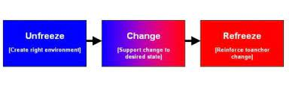

Shown in Figure No 3 above: Kurt Lewin's Change Model: How to manage change: Freeze-Unfreeze-Freeze
7.1 LIMITATION KURT LEWINS’ CHANGE MANAGEMENT MODEL
One limitation is that it assumes organisations function under static conditions and can thus quickly adapt to change and transform to a new status quo (Kanter et al., 1992). (Cooke, 2013) remarks in today’s modern companies function in highly dynamic and competitive global environments by geopolitical, financial, regulatory and security challenges. (Child,2005) points out that in such a volatile market, companies can’t seem to move from one state of stability to another without feeling some negative repercussions related to a change.
7.2 HOW, THEN, DO WE DEAL WITH THIS CONFLICT? RESOLUTION
7.3 TING TOOMEY MODEL
The Ting Toomey model has five different approaches in the model.
Approaches: Ignore the advantage cooling-off period. Time is a healer. Disadvantage ignorance only brings more problems and may worsen as the situations develop. Confront directly: clarity and understanding towards finding a solution. The disadvantage is that the process can become emotionally subjective. Involve a third-party advantage; conflict is addressed, and a solution is found. Disadvantage the state of being embarrassed; some critical issues could be missed at this point. (Trompenaars, F. & Hampden-Turner, C. 1997) Involve the team: There are many contributions from the other team members towards finding a solution. The dynamics are strong but must be led with an authoritarian leadership style. Escalate and appeal to authority. Advantage; effective at dealing with urgent situations. The disadvantage is that this is about a win-or-loss outcome; the parties involved may feel devalued and even embarrassed by the situation (Ting-Toomey,1999).
Approaches to which culture group and relationships-oriented culture, low-context, task-oriented and individualistic, are mainly associated with the West. High context, small power distance, and more significant power distance covers an array of culture when it comes to cultural conflicts, and every situation is different de[ending on the values of each person (Trickey, 2003)

7.4 APPLY THE TING TOOMEY MODEL TO SOLVE THE CONFLICT (TEACHERS’ STRIKE)
The author will explain how the model can help solve the conflict between teachers, unions, and the Government. By ignoring the teachers, the Government now faces a real challenge, and they could have a cooling period for the teachers. However, this has yet to work, as teachers will stage a one-day strike on the 25th of April, 2023. Confront NEU group members demanded a pay rise of 12 per cent, but the Government officials presented an increase of only five per cent. There seems to be a stumbling block as both parties cannot see a way through this complex crisis. The teachers may emotionally charge the process as they deem the pay rise insufficient to meet the current cost of living crisis. On the other hand, the Government cannot accept the union’s proposal of 12 per cent as this would rise above the current inflation rate of 11.1% (Hofstede,2001)
The teachers do have the backing from the unions. Involving a third party to find a solution must include all the conditions the teacher asks for. As the Ting Toomey model states, both parties must find a happy medium. It’s not about who comes out on top, as this is not feasible, and teachers will feel they have lost. It is about all parties coming around the table to listen to both parties’ claims, follow a logical framework, understand each other’s arguments, and have the evidence to put forward their concerns with justification. The point here is that the Government, teachers and unions have a common ground to work toward a solution (Smith,2012).
Involving the Unions to find a compatible solution meant that teachers had to solidify their conditions. It’s not just about pay as this is part of the conditions; however, even if the Government gave the teachers the 12% pay rise hypothetically, the problem would remain as the conditions would include excessive workload, working long hours, toxic work environment, teaching budgets and resources need to for the young children to give them the best teaching-learning (Dix, 2008).
Teachers in England have eliminated a pay offer from the Government that would have seen a pay rise of 4.5% for each teacher next year, alongside a one-off payment of £1,000 for this year. Using Ting Toomy’s model to come to some agreement, find that common ground sharing values making the audience understand what you are fighting for. Both parties feel they have used various approaches to find that degree of opposition; the counterargument in this situation is looking at all angles from others’ points of view, not just your own. (Ting-Toomey,1999)
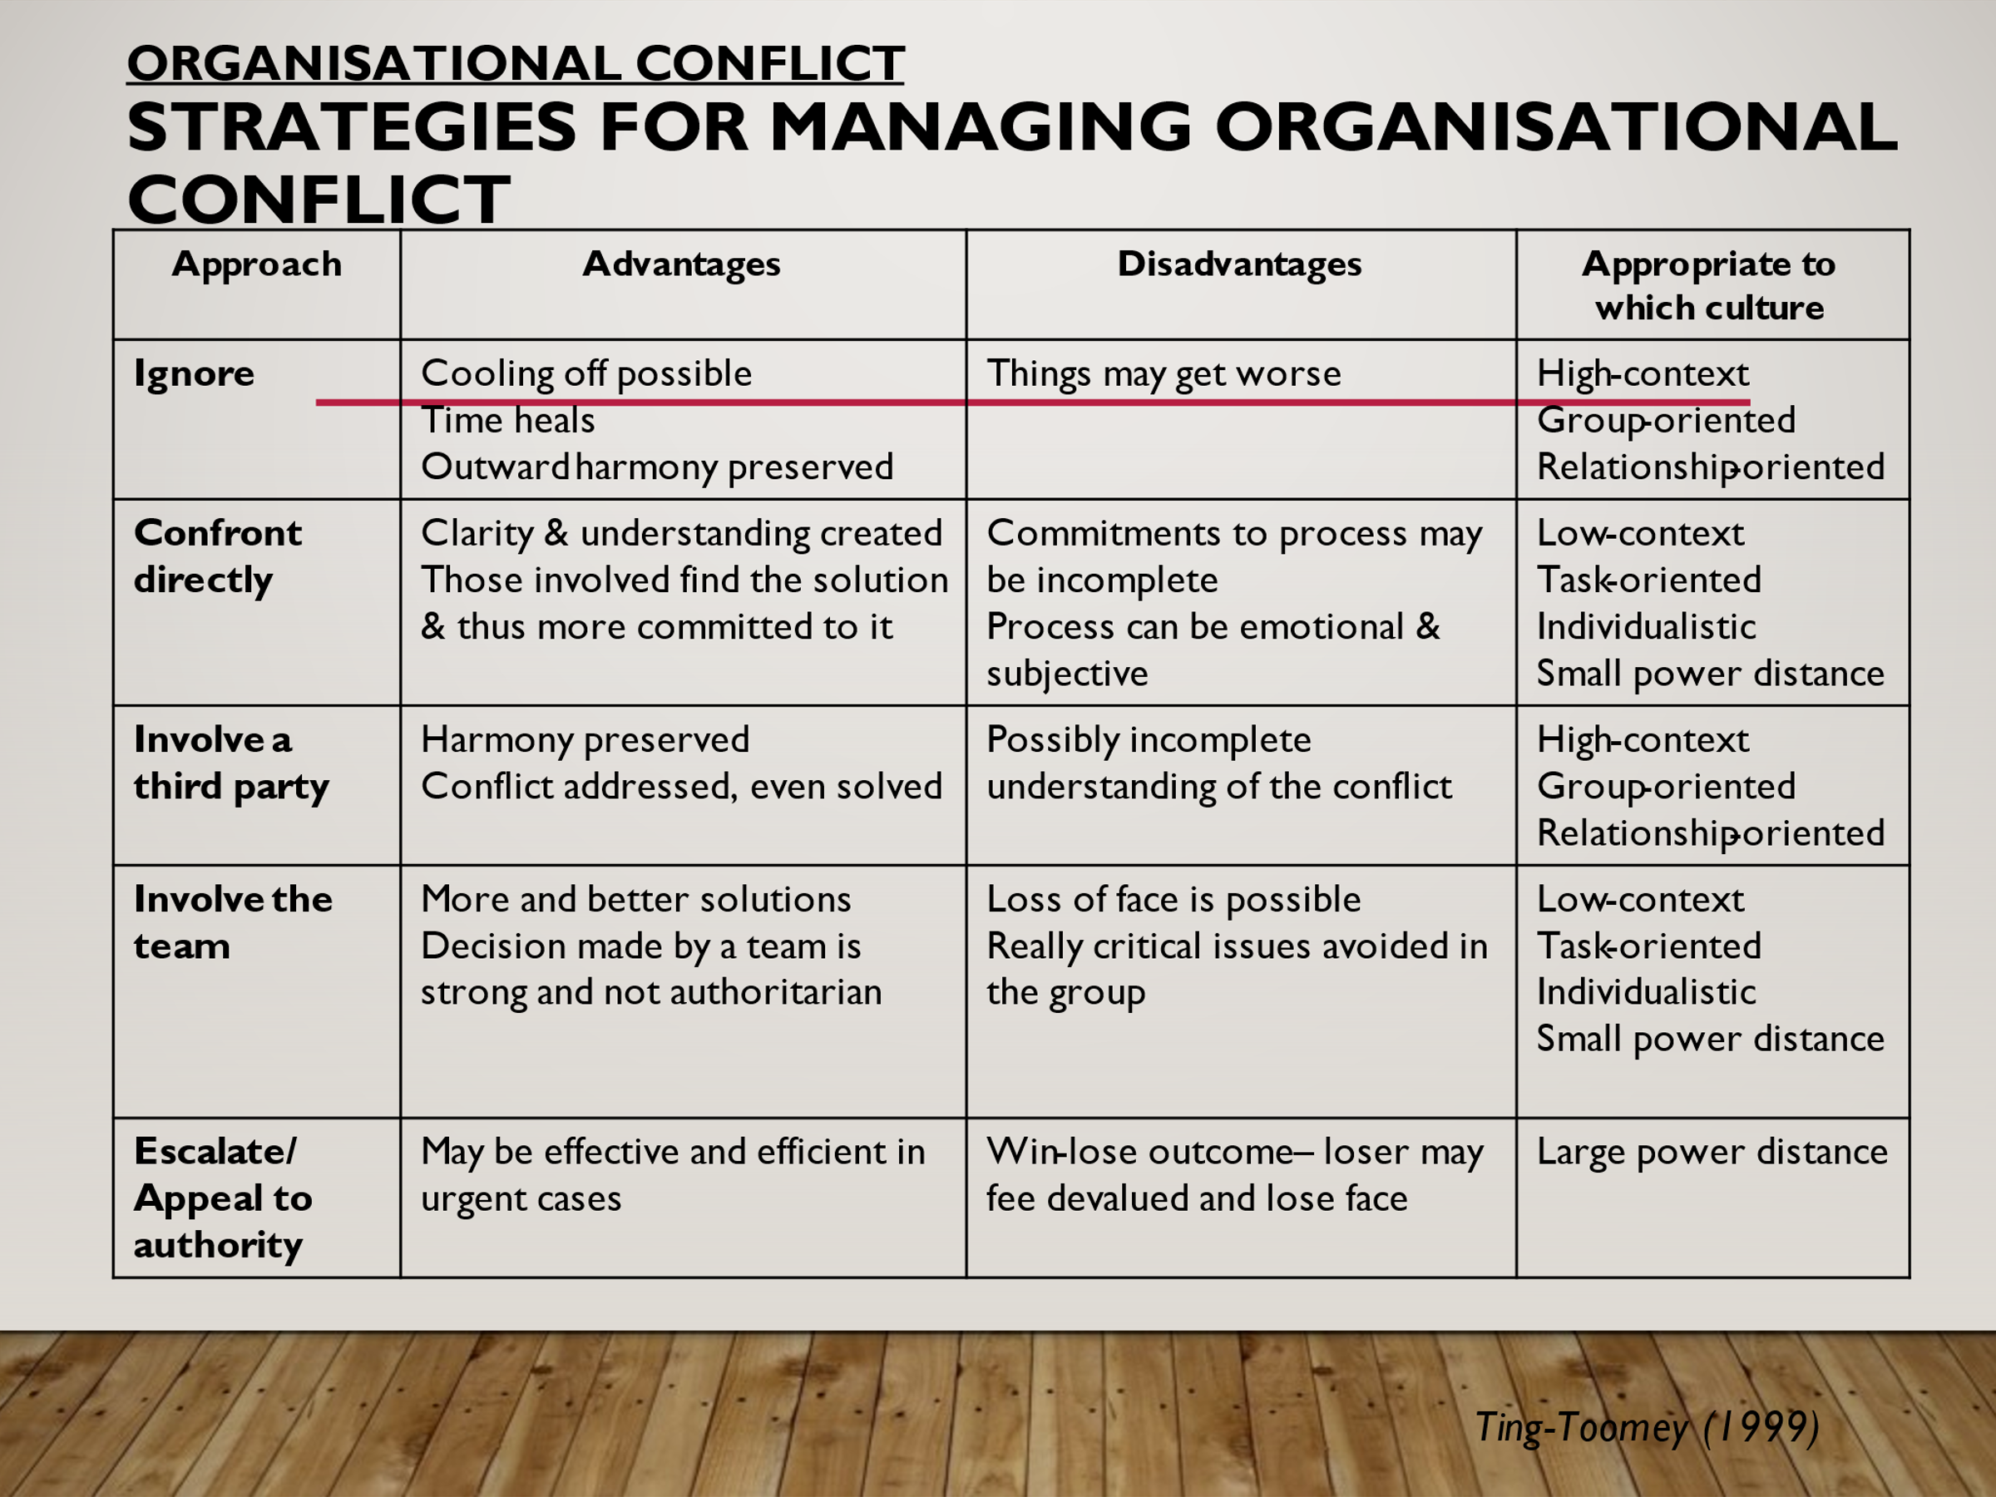
As Shown in Figure No 4 above: Toulmin Model identifies the three essential parts of an argument for organisational conflict.
7.5 ALTERNATIVE MODEL THAT CAN BE USED TO SOLVE CONFLICTS
Thomas-Kilmann Conflict Mode Instrument- This strategy is used by human resources around the world (HR); professionals, there are five major styles of conflict management used for varied situations once they arise within the workplace -collaborating, competing, avoiding, accommodating, and compromising (Dix, 2008). See Appendix 2A for the Thomas Kilmann Conflict Mode Instrument on page 27
Collaborating-Collaboration is not about one side being victorious over the other party. Knowing the different approaches and your managerial style will help guide you to better and improved outcomes. Competing: Competing for this strategy is purely the win-lose approach to conflict; in this situation, the manager acts assertively to achieve the organization’s goals. It is done without seeking advice or opinions from team members, which may be detrimental to the other party involved (Meyer, 2007).
Accommodating – This strategy is used when the stakes are very high and may require the manager to work against their own goals, objectives, and desired outcomes for the organization. This approach can be a deal breaker when the other party is the expert in their field and has a better solution which benefits both parties. Avoiding – Normally used when you want to avoid a crisis that is confronted. You’re not engaging with the other party to reach their objectives and are not assertively pursuing your own. Works when the issue you are facing is deemed trivial and when there is no chance of being successful. You must bear in mind that it can be effective when in a crisis and can also be costly (Edwards, 2003). See Appendix No 3 B: Different Levels of Organizational Conflict on page 27

8.0 CONCLUSION
In summary, Kaplan and Norton (2004) define Organizational culture as a company that incorporates trust, values, and mindset and how these influence the behaviour of its employees in the workplace. (Morgan,1986) states that power is having a reasonable disagreement of interest that ultimately come to a good end. Power is all about creating a system with the intention of a win-win situation. Cameron and Quinn (2011) suggest that power distance affects leadership and that, in turn, involves other aspects of culture in a particular organization. Rue (2000) defines National Culture as a large group of staff who buy into the organization’s mission and vision. Factors with a national culture tend to influence how employees’ values are developed concerning language, religion, education, legal system, and values such as working patterns. (Brooks 2003) Santoro (2018) defines conflict management as identifying and managing conflicts sensibly, fairly, and efficiently. The conflict management process deals with disagreements arising from example, diverging opinions, objectives, and needs. Santoro (2018) defines conflict management as identifying and managing conflicts sensibly, fairly, and efficiently. The conflict management process deals with disagreements arising from example, diverging opinions, objectives, and needs. The report pointed out that conflict is a basic fact of life in many ways. We will experience conflict in both our personal and professional lives. For the reason that conflicts are disagreements resulting from employees, people or teams having differences in attitudes, beliefs, values or needs. There will be a time when conflict cannot be avoided. The conflict is not a bad situation as long as the conflict is managed effectively. Resolving conflicts can be beneficial and lead to growth and maturity. Conflict management will increase confidence in several aspects of life management within the business world.
9.0 RECOMMENDATIONS
Recommendations are based on the updated evidence obtained by researching and reviewing the evidence gathered for this report.
- Clarify what is at the heart of the conflict: As a manager, it would help, if warranted to discuss the needs which are not being met on both sides of the issue. Obtain as much detail as possible on each side’s outlook, which helps move the conflict forward. Also, we need to warranty mutual understanding.
- To determine ways to meet the common goal of both parties, we need to sit down with both parties and have an open discussion to find ways to execute and meet common goals. Listen, communicate and brainstorm together until exhausting all options.

10.0 REFERENCE LIST

- Apple, M. W. (1995). Education and power (2nd ed.). New York: Routledge.
- Athota, V. S., Budhwar, P., & Malik, A. (2019). Influence of personality traits and moral values on employee well-being, resilience, and performance: A cross-national study. Applied Psychology, 1–33. https://doi.org/10.1111/apps.12198.
- Sourced from: https://www.google.com/search?q=cultural+web+model&sxsrf Accessed on: 28-01-2023
- Bain & Co (2007) Bain’s global 2007 management tools and trends survey, Strategy & Leadership, 35 (5), pp 9–16
- Ballou D. and Podgursky M. (1997) Teacher Pay and Teacher Quality, Kalamazoo, MI: W.E. Upjohn Institute for Employment Research.
- Bourne, H, and Jenkins, M (2013) Organizational values: a dynamic perspective, Organization Studies, 34 (4)
- Brazeal, D. V., Schenkel, M. T. & Kumar, S. (2014). Beyond the Organizational Bounds in CE Research: Exploring Personal and Relational Factors in a Flat Organizational Structure. The Journal of Applied Management and Entrepreneurship, Vol. 19 (2) pp. 78-106
- Burnes B (2007) Kurt Lewin and the Harwood Studies: The foundations of OD. The Journal of Applied Behavioral Science 43(2): 213–231.
- Cameron, E and Green, M (2008) Making Sense of Leadership, Kogan Page, London
- Cameron, K S, and Quinn, R E (2011) Diagnosing and Changing Organizational Culture: Based on the competing values framework, Jossey Bass Wiley, San Francisco, CA
- Carr,D. (2003). Making sense of education: An introduction to the philosophy and theory of education and teaching. London: Routledge Falmer.
- Child, J. (1988). Organization: A Guide to Problems and Practice (Second Edition). Boston Paul Chapman
- Child J (2005) Organization: Contemporary Principles and Practice. Oxford: Blackwell
- Clegg SR, Kornberger M and Pitsis T (2005) Managing & Organizations: An Introduction to Theory and Practice. London: SAGE.
- Cominetti, N., Costa, R., Eyles, A., Moev, T. and Ventura, G. (2022) Changing jobs? Change in the UK labor market and the role of labor mobility. London: Resolution Foundation
- Cooke B and Alcadipani R (2013) Towards a global history of management education: The case of the Ford Foundation and the Säo Paulo School of Business Administration, Brazil. Academy of Management Learning & Education. DOI: 10.5465/amle.2013.0147.
- Dilworth-Anderson, P., Williams, I. C., & Gibson, B. E. ( 2002 ). Issues of race, ethnicity, and culture in caregiving research: A 20-year review (1980-2000). The Gerontologist , 42 , 237 – 272 .
- Dix, G., Forth, J. and Sisson, K. (2008) ‘Conflict at Work: The pattern of disputes in Britain since 1980’. NIESR Discussion Paper. 316.
- D’Silva (2022, April 23rd). Increasing administrative work, and demanding parents are among the reasons teachers quitting early. New Straits Times Online. Retrieved May 11, 2022, from https://www.nst.com.my/news/nation/2022/04/791951/increasing- administrative-work-demanding-parents-among-reasons-teachers

- Dyke, E., & Muckian Bates, B. (2019). Educators striking for a better world: the significance of social movement and solidarity unionism. Berkeley Review of Education, 9(1).
- Edwards, P. (2003) Industrial Relations: Theory and Practice. Oxford: Blackwell
- Fairbrother, P. (2015). Rethinking trade unionism: Union renewal as a transition. The Economic and Labour Relations Review, 26(4), 561-576.
- Figlio D. (1997) ‘Teacher Salaries and Teacher Quality’, Economics Letters 55(2): 267–271.
- Gerhart, B. 2008. National culture, intracultural variability, and attraction-selection attrition. Working Paper, School of Business, University of Wisconsin-Madison.
- Greenberg, J. (2011). Behavior in organizations (10th ed.). Upper Saddle River, NJ: Prentice Hall.
- Hampden-Turner, C (1990) Creating Corporate Culture, Addison-Wesley, Reading, MA
- Hofstede, G. 2001. Culture's consequences: Comparing values, behaviours, institutions, and organizations across nations (2nd ed.). Thousand Oaks, CA: Sage Publications.
- Kelly, N., Sim, C., & Ireland, M. (2018). Slipping through the cracks: teachers who miss out on early career support. Asia-Pacific Journal of Teacher Education, (3), 292–316. https://doi.org/10.1080/1359866x.2018.1441366
- Kleiner M. and Petree D. (1988) ‘Unionism and Licensing of Public School Teachers, Impact on Wages and Educational Output’ in Freeman R. and Ichniowski C. (eds.) When Public Sector Workers Unionize, Chicago, IL: University of Chicago Press: 305–322
- Kotter, John (2011). Change management vs. Change leadership. What's the difference? Forbes (online version 12 July 2011), retrieved from www.forbes.com.
- Lee, Y., & Kramer, A. (2016). The role of purposeful diversity and inclusion strategy (PDIS) and cultural tightness/looseness in the relationship between national culture and organizational culture. Human Resource Management Review, 26, 198–208. doi:10.1016/j. hrm.2016.01.001
- Lewin K. (1949). Cassirer’s philosophy of science and the social sciences. In Schilpp P. A. (Ed.), The library of living philosophers. The Philosophy of Ernst Cassirer (pp. 269-288). George Banta Publishing Company.
- Lewin K (1951) Field Theory in Social Science: Selected Theoretical Papers (ed. Cartwright D). New York: Harper & Row.
- Lippitt G (1973) Visualizing Change: Model Building and the Change Process. La Jolla, CA: University Associates.
- Lunenburg, F. C., & Ornstein, A. O. (2012). Educational administration: Concepts and practices. Belmont, CA: Wadsworth Cengage Learning.
- Meyer, E., Ashleigh M., George J.M. and Jones G.R. (2007) Contemporary Management. Maidenhead: McGraw-Hill
- Mullins, L.J. (2006). Essentials of Organisational Behaviour. FT Prentice-Hall
- OECD (2020), TALIS 2018 Results (Volume II): Teachers and School Leaders as Valued Professionals, TALIS, OECD Publishing, Paris, https://doi.org/10.1787/19cf08df-en.
- Othman, Zahiruddin & Sivasubramaniam, Vevehkanandar. (2019). Depression, Anxiety, and Stress among Secondary School Informants in Klang, Malaysia. International Medical Journal (1994). 26. 71-74. 10.5281/zenodo.2586221
- Pau, K., Ahmad, A. B., Tang, H.-Y., Jusoh, A. J. B., Perveen, A., & Tat, K. K. (2022). Mental Health and Wellbeing of Secondary School Teachers in Malaysia. International Journal of Learning, Teaching and Educational Research, (6), 50–70. https://doi.org/10.26803/ijlter.21.6.4
- Kaplan, R S and Norton, D P (2004) The Strategy Map: A guide to aligning intangible assets, Strategy & Leadership, 32 (5), pp 10–17
- Mumford, M.D. (2000) ‘Managing creative people: strategies and tactics for innovation, Human Resource Management Review, Vol. 10, No. 3, pp.313–351
- Pagell, M. (2004). Understanding the factors that enable and inhibit the integration of operations, purchasing, and logistics. Journal of Operations Management, 22 (5), 459–487. doi:10.1016/j.jom.2004.05.008
- Palmer I, Dunford R and Akin G (2009) Managing Organizational Change: A Multiple Perspectives Approach. New York: McGraw-Hill Irwin.
- Rahim, M. A. (2001). Managing conflict in organizations (3rd Ed.). Westport, CT: Quorum Books.
- Reitzig, M. (2022). Get Better at Flatter—a Guide to Shaping and Leading Organizations with Less Hierarchy. Palgrave Macmillan, London
- Rue, L. W. and Byars, L. L. (2000). Management Skills and Application (9th edition). USA: McGraw- Hill Companies Inc
- Santoro, Doris A. (2018). Demoralized: Why Teachers Leave the Profession They Love and How They Can Stay. Harvard Education Press.
- Smith, P., Farmer, M. and Yellowley, W. (2012) Organizational Behaviour. Hodder Education
- Sorenson, O. (2022). Flat firms, complementary choices, employee effort, and the pyramid Principle. Journal of Organization Design, Vol. 11, pp. 11–14.
- Simmons, T. L., & Peterson, R. S. (2000). Task conflict and relationship conflict in top management teams: The pivotal role of intragroup trust. Journal of Applied Psychology, 85, 102–111.
- Steiner, E. D., & Woo, A. (2021, June 15). Job-Related Stress Threatens the Teacher Supply: Key Findings from the 2021 State of | the Teacher Retrieved from RAND. U.S. Survey 15, 2022, May https://www.rand.org/pubs/research_reports/RRA1108-1.html
- The Effect of Scientific Management Theory on the Work Design in the Contemporary Organizations. (2022, August 25). Edubirdie. Retrieved April 4, 2023, from https://edubirdie.com/examples/the-effect-of-scientific-management-theory-on-the-work-design-in-the-contemporary-organizations/
- Ting-Toomey, S. (1999) Communicating Across Cultures. The Guildford Press, NY.
- Thompson, A. and Strickland, T. (1987). Strategic Management. Homewood: Illinois.
- Trickey, D. & Ewington, N. (2003) A Wrold of Difference: Working Successfully Across Cultures. Capita Learning & Development, London.
- Trompenaars, F. & Hampden-Turner, C. (1997) Riding the Waves of Culture: Understanding Diversity in Global Business. McGraw-Hill.
- Zamri EN, Moy FM, Hoe VC. Association of psychological distress and work psychosocial actors with self-reported musculoskeletal pain among secondary school teachers in Malaysia. PLoS ONE. 2017; 12(2): e0172195. doi: 10.1371/journal.pone.0172195.

11.0 APPENDICE LIST
Appendix: 1. A: Taylor’s Scientific Management Model Theory, theories of motivation for the workplace.
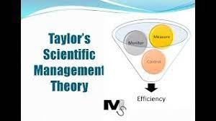

Appendix No 2B : Conflict Resolution Thomas Kilmann Model

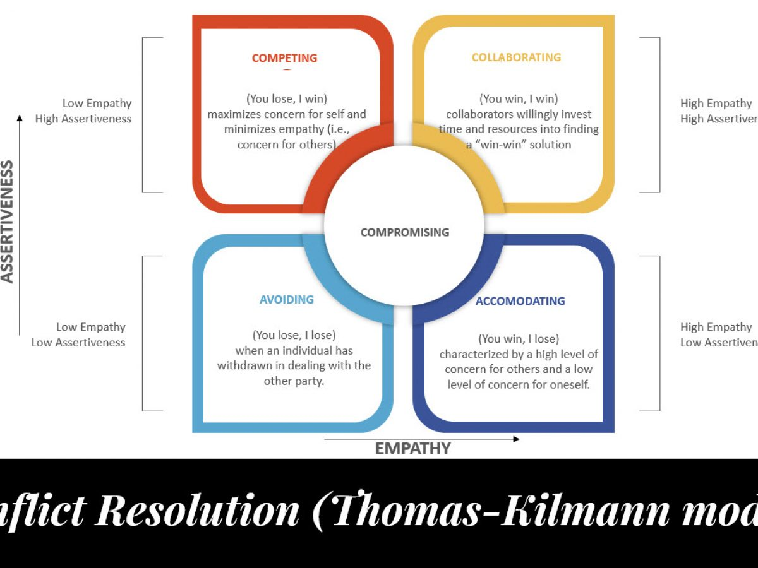

Appendix No 3 B: Different Levels of Organizational Conflict


