Awe and Wonder: Science, Mathematics and the Outdoors

Part 1 – Photograph

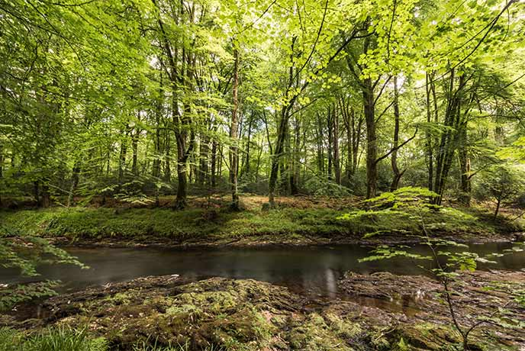
(Classic Cottages, 2025)

Part 2 – Learning Story
This image shows the area that the activities I will be discussing took place. It shows an area for physical activity and the development of gross motor skills as well as a river in front of the trees. These elements allow for children to discover nature, life cycles and many necessary life skills they will be able to utilise throughout their lives.
I and another member of staff took six children, aged 3, to the grassy, open area for a nature walk to learn about the natural elements first hand. The area shown is a short walk from the setting meaning we could add to the experience by walking rather than using a vehicle to get to our destination. The children got very excited during the walk to the woodland area, so we decided to play a game of ‘eye-spy’. During this game, my college and I guessed what the children were finding, encouraging the children to focus and observe their surroundings.
Once we had reached our destination, I asked the children to explore the environment and collect objects that they think are interesting after setting clear boundaries in order to maintain supervision of all children, whilst myself and my college stood near the water to ensure the children remained safe. Once the children had taken some time to investigate on their own, we sat on the grass, and I asked the children what they had seen, heard and felt so that the children would need to analyse what they had experienced.
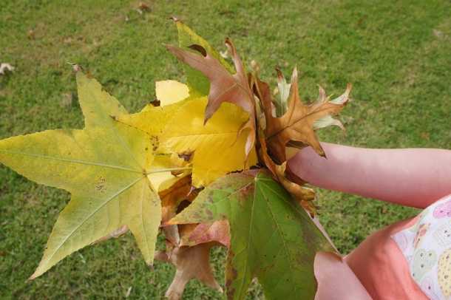
(Laughing Kids Learn, 2013)
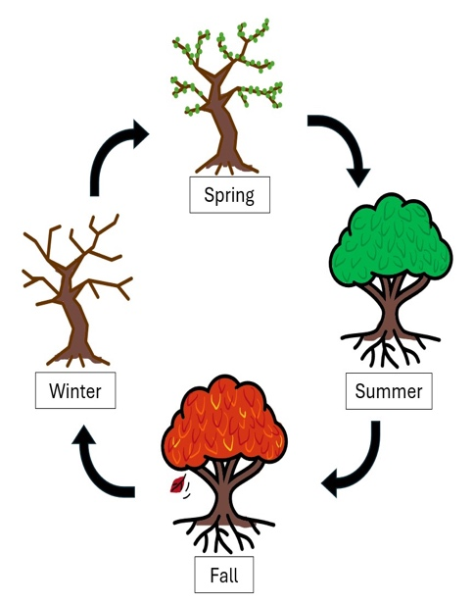
Child A brought a range of leaves, some crisp and dry, others green and soft saying “look at all the leaves I got Emily!”. I asked the child why they had decided to show the group the leaves. They explained that the leaves made a crunchy noise when they stood on them and they liked that there were so many colours. As a group, we discussed the different coloured leaves Child A had found and decided to separate the leaves by matching the colours. One child said, “my leaf has green and yellow on it” and another child was attempting to organise the piles shouting out “I need more brown leaves!”. The children were communicating with each other to try and create a vast collection of all the different coloured leaves which encouraged the development of their teamwork skills. The children were curious as to why the leaves were different colours and textures. I explained to them that the colour of the leaf’s changes because of time of year, when the weather gets colder, the days get shorter, the trees are getting ready to sleep until spring comes back and gives the tree more sunshine to feed the leaves which makes them happy and green again. Explaining the process in this manner helps the children to understand what is happening to the tree and what causes the leaves to change colour. This encouraged the group to ask questions, analyse the leaves and discuss what they had found.
(Chesapeake & Ohio canal National Historical Park, 2026)
During this experience the children were able to develop their understanding of colours and the different shades that can be found of the same colour as well as mathematical concepts such as counting, sorting, comparing and patterns. During these conversations regarding the finding of the leaves, the children were able to develop their language through the learning of new words, for example, texture, brittle, stem and crumple.
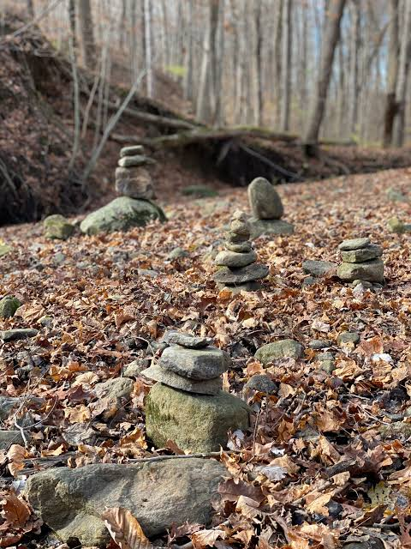
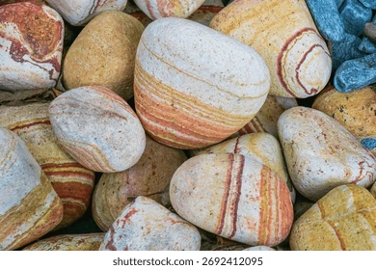
Then, Child B shared that they found a collection of rocks and presented the group with them and started describing the individual rocks regarding the size, shape, texture and colour. The child shared the rocks between their friends so that they could all analyse the rocks and pebbles. A child exclaimed “this rock is heavier than that one, look!”. The other children joined in with their peer and enjoyed comparing the rocks and began discussing between themselves about what rocks they had, which ones were bigger, smaller, heavier lighter, smooth and sharp. I showed the children how they could build towers with rocks, ensuring the tower stays balanced so that it doesn’t tip over. This made all the children shocked and immediately they started trying to build their own tower. Child B got slightly upset when their tower kept falling but with some guidance and words of encouragement, we built one together and they grew visibly confident and determined to build another. Once the children had finished building, they started to observe the rocks and pebbles more closely, noticing that some rocks have patterns and layers leading to some questions about what they mean. A child asked me what these lines were, so I explained in the best way I could by telling them that the layers in rocks are formed over many years, the rocks travel through rivers and streams where the small parts of sand and mud stick to the rocks and squash together over many many years, making the rocks we hold today. The lines and layers in the rocks are different materials that have stuck to and become a part of the rock over many years.
(Star Press, no date)
( Shutterstock, no date)
Throughout this activity the children expanded their knowledge revolving mathematical learning by counting, sorting and measuring as well as their scientific knowledge on how the layers they see on rocks are made. This encourages the children to think in a more critical way to involve scientific thinking as they analysed, questioned and compared. As the children’s curiosity grows, it encourages them to take a closer look at their surrounding environments and to share their discoveries with their peers.

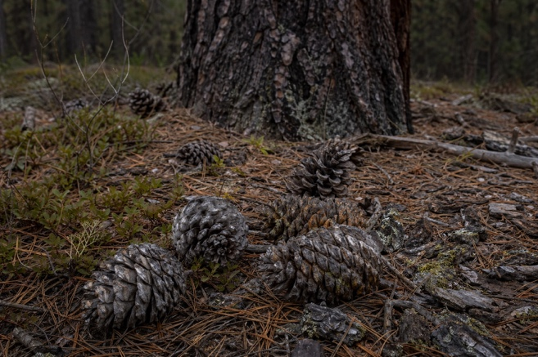
Child C then shared that they gathered a variety of pinecones they had found under the range of trees. They said, “these are really scratchy, what are they?’ They were very interested in the different sizes and the overall shape and pattern of the pinecones. I explained to the children that these are pinecones, and they serve a very important purpose they all got rather excited and curious. I proceed to tell the children that pinecones keep seeds safe from the weather and hungry bugs looking to steal food. Pinecones are very smart and know when the weather is rainy and cold, so they close really tightly to keep the seeds safe and dry. Once the weather is warm and dry again, the small wooden ‘petals’ open and the wind carries the seeds out of the pinecone helping them land on the floor ready to grow.
(Outforia, 2023)
(Pacific Science Centre, 2025)
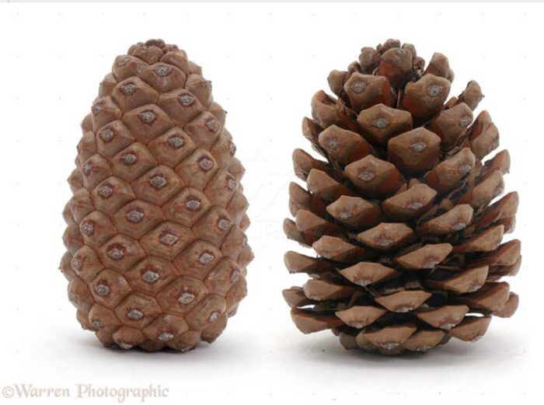
Once the pinecones were passed around to their peers, they noticed how rough and hard they were and once again started comparing the sizes. They noticed how some were bigger than others and some were wider than others and noted the texture of the pinecones were very unusual and unique. We decided to carry out an experiment involving the pinecones and the river. We collected all of the open pinecones that we could find and then filled up out buckets with water from the river that the children each gathered with the help from myself and my college. We submerged the pinecone s in the water while we sat and ate out pre-made sandwiches for dinner and we checked in the pinecones every fifteen minutes to see the progress. Within an hour of the experiment, the children were amazed to see the pinecones were closed. One child said, “no way” with his hands on his head in disbelief, while another said, “oh my goodness, its magic”.
Being able to physically show the children this experiment heightened their awareness of nature as they were able to fully understand the workings of pinecones instead of simply hearing me talk about it. This experiment enabled the children to develop their scientific knowledge as the demonstration of cause and effect allows the children to clearly see the link between the environmental change and the reaction.
After a very busy morning of exploring and learning, my college and I counted all the children to ensure we returned to the setting with all the children, and we then made our way back to the setting. On the way back, I heard some of the children talking about the different things that they had seen and learnt which was an amazing thing as it meant that the children had broadened their knowledge regarding the outdoor environment, mathematics and science.

Part 3 – Risk Benefit Assessment
Activity. | How will children benefit from this activity? | Hazard/ Risk. | Who is at risk? | Control measures. | Overall risk.
Exploring the river area. | Encourages curiosity and scientific investigations as the children watch the waters movements, currents and learning about objects that float and sink. | The children are at risk of falling in the wet environment causing injury or even falling into the river. | Children and practitioners. | A boundary will be established at a safe distance for the children to observe from a safe distance. Practitioner will always remain with children and carry out regular head counts to ensure all children are accounted for. | M
Nature walks within the woodland area. | Allows for the development of the children’s gross motor skills, spatial awareness, balance and coordination. | Falling over hidden tree roots and uneven ground can lead to children injuring themselves. | Children and practitioners. | Children will be made aware of the risk and spoken to about walking rather than running as well as practitioners will check area before the activity takes place. | L
Collecting and investigating leaves. | Developing sensory and scientific learning as the children can compare and analyse the leaves by their size, colour, shape and texture. | Leaves may be sharp, prickly or unsafe to touch and eat. | Children. | Children will be supervised and reminded to not put leaves in their mouths and practitioners will check objects before they are handled. | L
Looking for insects, animals and wildlife. | Allows for children to observe living things, extend understanding and encourages the children to respect and care for all living things. | Some minibeast creatures bite, or sting which could lead to an allergy reaction from the children. | Children and practitioners. | Children will watch and observe without touching or disturbing the wildlife. Practitioner will always carry a first aid kit and know about any existing allergies. | L
Investigating rocks and pebbles. | Encourages mathematic learning as the children are able count, sort, compare and weigh as well as encouraging scientific observations. | Rocks may have sharp edges that cause cuts, could cause injuries if objects are thrown or dropped. | Children. | Under supervision, children can carry out their investigations using appropriately sized rocks and be reminded that the objects used are not to be thrown. | L
Counting, Sorting and Comparing natural materials. | Develops mathematical skills early on and encourages analytical skills used in matching and comparing. | Small objects could pose a risk as they could be placed in mouths and may lead to choking, an allergic reaction or illness. | Children. | Close supervision during activity and only using age-appropriate materials. | L
Sharp objects and litter | Allows children to be made aware of the environmental hazards of littering and how to make safe choices. Also, it enables children to understand how to care and respect for the environment. | Objects found may cause cuts and injure the children and smaller items found may present as a choking hazard. | Children. | Practitioners will inspect the area beforehand and avoid areas where there are visible hazards. Children will be reminded not to pick up unknown objects and should tell an adult. Practitioners will supervise closely and remove hazardous items if it is safe to do so. | L
General public. | Provides an opportunity for children to develop their awareness of the community, practise appropriate social behaviours and understand personal boundaries. | There is a risk of children being around unfamiliar adults and being separated from the group, approaching or being approached by strangers. | Children. | Children will be reminded to stay within the boundaries set by practitioners. Regular head counts will be carried out by practitioners and high visibility vest will be worn by children and practitioners to that they are easily recognisable. | L
Exploring pinecones and sticks. | Allows for investigative skills and develops descriptive language as children can explore patterns, materials, shapes and sizes. | These materials could leave scratches or splinters due to the rough and sharp aspects of these objects. | Children. | Practitioners will check materials to show children the correct way to handle the objects safely. Children will be made aware of the risks of waving and throwing the sticks. | L
Dogs and other animals. | Opportunity to discuss animals, habitats and behaviours. Children can learn about respecting animals and understanding that animals have their own boundaries. | Dogs may act differently to what is expected. A child may become frightened, knocked down or hurt by an over-excited dog. And some children may have allergies to dogs or other animals. | Children and practitioners. | Children will be reminded not to touch or approach unfamiliar dogs and practitioners will keep the group a safe distance away from dogs that may approach. If necessary, the group can move to another area if the space is occupied by other animals. | L

Part 4 – The Important of Adults supporting Science and Mathematics in the Outdoors.

Outdoor environments allow children to develop their understanding of mathematics and science by providing rich and meaningful opportunities through exploration and first-hand experiences. Maynard, Waters and Clement (2011) express that the increased space offered by the outdoors enables children to construct on a bigger scale and move more freely. This suggests that the wider space granted by outdoor learning provides a more child-led approach, creating opportunities for learning that may be more difficult to obtain in a classroom. Having the freedom of a larger environment also supports a child’s physical development, which has a strong connection to brain development. Rise Early Learning (2025) highlights that when children engage in movement, they stimulate a part of their brain that is responsible for their memory, attention span, language development and emotional regulation. This statement reinforces the concept that physical development and a child’s learning go hand in hand, especially in an outdoor space where children are surrounded by learning opportunities that engage all their senses, challenge their knowledge and encourage children to test their boundaries with risky play activities. However, as much as children thrive in an outdoor environment, some studies suggest that humans are born with an innate sense of numbers, according to Thomson (2026). This implies that babies could have a concept of maths at such an early age as they have already been exposed to rhythms and heartbeats when in the womb which conveys that learning is not simply about sitting in a classroom learning but it can also be biological and learning through actively doing, even from before birth.

Access to the outdoor is not the only tool needed to provide a purposeful learning experience. The role of the adults within early years is important as these are the individuals that ensure that the learning provided is stimulating, meaningful and fun. Regarding the activities that are provided, if they are not inviting to young children, they will not participate meaning the learning opportunity will pass by. Hayes, et al. (2025) believes that practitioners forget that they lead and support the children in new discoveries and the next stage of their development, suggesting that the adults within childcare may not always realise the importance of their care and practice as well as how they conduct themselves. Daily routines, observations and pressures may distract practitioners and distract them from what is paramount. This does not necessarily mean that the adults within childcare do not value they role, rather that the demands of the setting can become overbearing at some moments. The role of the practitioner is extraordinarily important and one of the most important relationships a child can build, outside of family members. Within the setting, a practitioner’s key responsibility is to care for, enable and support the children who attend the setting. This involves providing activities that develop the children’s knowledge and understanding, in line with the government and curriculum’s requests. The curriculum for Wales consists of six areas of learning which are as follows: expressive arts, health and well-being, humanities, language, literacy and communication, mathematics and numeracy and finally science and technology. All settings in Wales should follow this, meaning the planning that the practitioners produce should mainly consist of learning opportunities that revolve around these areas. Tinney (2023) explains that the Curriculum for Wales main aim is to enable children of all ages to engage in meaningful learning experiences both inside and outside of the classroom. This highlights the value of providing children with opportunities to learn through real life experiences with their surrounding environment. Outdoor learning can offer particularly valuable opportunities as children are able to explore and investigate, using the knowledge that has been acquired in the classroom.

Vygotsky’s theory supports the importance of adult involvement in outdoor learning as practitioners can scaffold children’s problem solving, modelling what it can look like to explore the outdoor environment and introduce new vocabulary. Vygotsky’s concept of the zone of proximal development (ZPD) is based around acknowledging what a child can achieve individually and what a child is able to achieve with support from an adult or more knowledgeable child. Within an outdoor environment, practitioners can support children by using questions and providing appropriate challenges, which demonstrates how adults’ interaction can extend children’s existing knowledge of mathematics and science whilst allowing the children to remain active participants in their learning and development. Utami and Yus (2025) believe that teachers must understand Vygotsky’s concept of the zone of proximal development to be able to support children’s learning in order to scaffold the learning processes and help children to develop new cognitive skills. This reinforces the importance of Vygotsky’s theory surrounding the zone of proximal development and can also be extended to outdoor learning. For example, when exploring a woodland space, a child may independently collect and compare different rocks, noticing that some are smaller or larger than others. The practitioner can extend this learning opportunity by asking open-ended questions that appropriately support the child’s learning and encourages them to investigate and develop their knowledge and concepts relating to mathematics and science. Without the adult interaction, the learning opportunity may not have been fully realised, and the child would have missed out on said opportunity. Therefore, the zone of proximal development shows that outdoor learning does not have to be solely child-led, instead adults can recognise that appropriate support can extend a child’s existing knowledge and encourage more curious, meaningful thinking. As an extension of Vygotsky’s theory of the zone of proximal development, the term ‘scaffolding’ has become a well-known term which Forest School Secret (2020) describes as referring to the instructionally supportive moments and discussions child and adult as they guide effective learning and development in the zone of proximal development. This is an essential factor as it enables practitioners to respond to each child’s individual needs and adapt their manner to each child’s level of understanding so that all the children’s needs are met with appropriate support.

Froebel held strong beliefs that nature, play and direct experiences are all in the best interest of the child. McNair (2012) explains that the outdoor space can be a place where children turn to for solitude and answers to questions about life, as Froebel did at a young age. McNair (2012) conveys that an outdoor environment can be essential for a child’s wellbeing. This alone conveys that introducing nature to young children is a way in which they can self-regulate their emotions and learn in an environment which allows them to be free and curious whilst not being overstimulated, which may occur in a classroom. Adults working in early years should be aware of the influence they hold over the children in their care, meaning that learning through modelling, role play, and experiments can be just as important as learning how to read and write, with the correct support from practitioners. Bruce (2012) illustrates that Froebel believed that play is one of the most efficient ways of learning showing that play has been at the front of theorist’s minds since the early 1800’s. This demonstrates the importance of play regarding a child’s development. Allowing children to play openly and freely in an outdoor area enables them to discover natural materials and explore the world around them, which is why adults should be supporting children rather than controlling their play. Practitioners have a duty to observe, question and facilitate a child’s learning and not simply supervise as these are the key moments where the extension of a child’s thinking and learning happens. Froebel’s ideas of learning through play can be put into action in an outdoor environment just as easily as an indoor environment as in the outdoors children naturally wish to explore which leads to collecting, comparing, building and experimenting meaning the children’s mathematical and scientific knowledge is growing constantly. With the appropriate support from adults, children can develop new language, social skills and learn about the surrounding wildlife and environment. “To learn a thing in life and through doing is much more developing, cultivating and strengthening than to learn it merely through the verbal communication of ideas” (Froebel, 1885, cited in Tovey, 2020). This demonstrates that Froebel’s views that children develop their knowledge and understanding through active, hands-on participation instead of being told information by an adult. The concept remains in an outdoor environment as children can investigate materials, explore surroundings and develop mathematical and scientific understanding through active participation rather than being told.

To conclude, outdoor environments provide meaningful opportunities for children to develop their mathematical and scientific understanding through active, hands-on experiences. Mathematical concepts can be explored within an outdoor environment by counting, sorting, measuring, comparing as well as analysing an objects shape and size, while also understanding scientific concepts through the means of plants, wildlife, water, rocks, weather and the child’s surroundings. These first-hand experiences enable children to utilise their knowledge in real-life situations rather than learning through activities within the classroom. Although, the outdoor environment alone does not guarantee the development of a child’s mathematical and scientific understanding. The role of the practitioner is a vital aspect regarding the learning opportunities found through exploration and play as the true development occurs when adults extend a child’s thinking through meaningful questioning, modelling and scaffolding. As discussed, Vygotsky’s zone of proximal development conveys how effect appropriate adult support can develop the understanding above what a child may have accomplished independently, and Froebel’s beliefs reinforce the importance of children being active participants in their own education. Outdoor experiences provide the chance for first-hand learning for children and scaffolding by supporting adults to create an environment that allows young children to investigate real, nature objects through direct experience. Therefore, the outdoors should be considered one of the finest ‘classrooms’ for optimal learning and the development of mathematical and scientific understanding, not simply a space for free play and physical activity.

Reference List

Bruce, T. (2012). Early childhood practice: Froebel today. London: SAGE, pp 13.

Chesapeake & Ohio Canal National Park (2026), Trees, Trees, Trees. Available at: https://www.nps.gov/choh/learn/kidsyouth/meet-lock-key.htm (Accessed on; 13 September).

Classic Cottages (2025), Woodland walks in Devon. Available at: https://www.classic.co.uk/nas/places-to-go/woodland-walks-in-devon-2154.html (Accessed on: 7 September 2026).

Forest School Secrets (2020) “The Zone Of Proximal Development And Forest School”, Medium. Available at: https://compassforestschool.medium.com/the-zone-of-proximal-development-and-forest-school-1bbfac0153f3 (Accessed on: 19 Septemeber 2026).

Hayes, C. et al. (2025) Developing as a Reflective Early Years Professional: a thematic approach. Routledge. Available at: https://doi.org/10.4324/9781041054948. (Accessed on 16 September 2026).

Helen Thomson (2026) “Babies are born with the neural foundations for maths” New Scientist. Available at: https://www.newscientist.com/article/2532352-babies-are-born-with-the-neural-foundations-for-maths/ (Accessed on: 16 September 2026).

Laughing Kids Learn (2013), Learning with Leaves. Available at: https://laughingkidslearn.com/learning-with-leaves/ (Accessed on 13 September 2026).

Maynard, T., Waters, J., Clement, J. (2011) “Moving Outdoors: Further exploration of “child-initiated’ learning in the outdoor environment” Education 3-13, 41(3). Available at: https://doi.org/10.1080/03004279.2011.578750. (Accessed on 13 September 2026).
McNair, L. (2012) ‘Offering children first-hand experiences through forest school: relating to and learning about nature’, in Bruce, T.(ed.) Early childhood practice: Froebel today. London: SAGE, pp. 60.

Outforia (2023), Exploring the 20 weirdest and most amazing types of pinecones. Available at: https://outforia.com/types-of-pine-cones (Accessed on: 13 September 2026).

Pacific Science Centre (2025) Why do pinecones open and close and how does that affect seeds? Available at: https://pacificsciencecenter.org/blog/why-do-pinecones-open/ (Accessed on 13 September 2026).

Rise Early Learning (2025) “The Connection Between Movement and Learning: Why Active Kids Learn Better” Available at: https://riseearlylearning.edu.au/the-connection-between-movement-and-learning-why-active-kids-learn-better/ (Accessed on: 16 September 2026).

Shutterstock (no date) Available at: https://www.shutterstock.com/image-photo/close-striped-natural-stones-displaying-rich-2692412095?trackingId=35d5551f-e4bb-4b84-a441-ebeea414b002&listId=searchResults (Accessed on: 13 September 2026).

Star Press, no date, Stacking rocks leaves nature in the balance. Available at: https://eu.thestarpress.com/story/life/2021/01/19/nature-preserves-rocks-national-parks/4219317001/ (Accessed on 13 September 2026).

Tinney, G. (2023) “Big Changes! The Great Outdoors and the Curriculum for Wales”.

Tovey, H. (2020) Froebel’s Principles and Practice Today. London: Froebel Trust. Available at: https://files.froebel.org.uk/production/documents/FT-Froebels-principles-and-practice-today.pdf (Accessed on: 20 September 2026).

Utami, A.D. and Yus, A. (2025) “Interpreting Vygotsky’s zone of proximal development in the context of children’s learning through play”, Journal of early childhood teacher education, pp. 1-14. Available at: https://doi.org/10.1080/10901027.2025.2591098. (Accessed on 19 September 2026).

