

BMIH5004

Management & Organisational Behaviour

Hotel Organisational Audit, a case of Hilton Hotel group

Name: Vlad Alexandru Radu
ID:2111633
Table of Contents
1. Introduction 3
2. Organisational structure, culture and goals of the hotel 3
3. Change initiatives of Hilton and the way they influenced the organisational operations 5
4. Strategic direction and current business performance of Hilton 7
5. Conclusion 9
6. References 11

1. Introduction
The following audit report is focused on the Hilton Hotel group, which is one of the major hotel giants in the global market and based on this a critical analysis of each of the business elements practised by the Hilton Hotel group would be discussed at both corporate and individual unit levels. It has been stated that the organisational structure, culture and goals of the hotel would be explained properly. Furthermore, the change management initiatives taken by the hotel and its role in maintaining the organisational competitiveness in the global market would have been discussed for better understanding. Besides, a critical exploration of the strategic direction and current business performance of Hilton in the global market would be provided as well. As reported by Statista (2023), the revenue of the hotel group become enhanced by 8.77 billion US dollars in 2022, which was 5.79 billion US dollars in the previous year respectively.

Figure 1: Hilton Hotel group logo
(Source: Business Wire, 2023)

2. Organisational structure, culture and goals of the hotel
According to the opinion of Al‐Jinini, Dahiyat and Bontis (2019), the role of organisational structure and culture helps to maintain the consistency and direction of the business, which would help in decision-making by the management and ensures better productivity of the organisation in the global market. Additionally, it has been identified that organisational culture could play an integral role in the business and ensures long-term engagement of the employees with the organisation respectively (Andersson et al., 2019). In this way, the report from Organimi (2023) highlighted that the organisational structure of Hilton is divisional, which includes three main divisions such as ownership, management and franchise. All of these three main divisions have their departments, which fall under the leadership of the hotel group respectively.
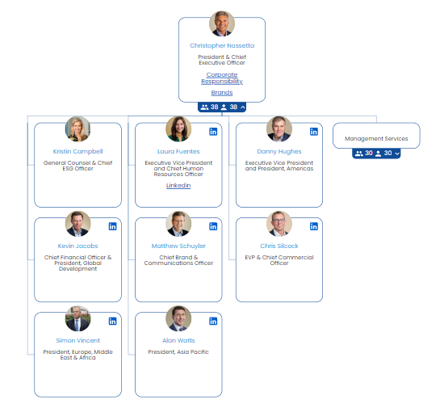
Figure 2: Organisational structure of Hilton Hotel group
(Source: Organimi, 2023)
As per the opinion of Vaidya (2023), divisional organisational structure helps in making effective decisions at the corporation and individual management for operational success, which helps to drive the company's success in the business market. Considering this, it has been identified that the managerial department of the Hilton hotel group considers an effective decision-making process regarding business strategy through its divisional structure based on which high-quality business outcomes become possible in the global market (Organimi, 2023).
Furthermore, Lambrano (2020) reported that the organisational culture of Hilton considers diversity and inclusion practices based on which a positive workplace culture could have been maintained. In this way, high employee engagement of the hotel on a long-term basis become possible. According to the report of Gay (2016), the award-winning culture of Hilton considers four key elements including hospitality to the guests, leadership, integrity and teamwork based on which the employee motivation could be maintained and thereby the overall high-quality hospitality service of the hotel could be possible. Additionally, it has been identified that the gender pay gap at Hilton is 7.8% and 46% of the employees at the management level are women while 50% of the women employees are working on the global corporate board of the hotel group (Jeffery, 2019).
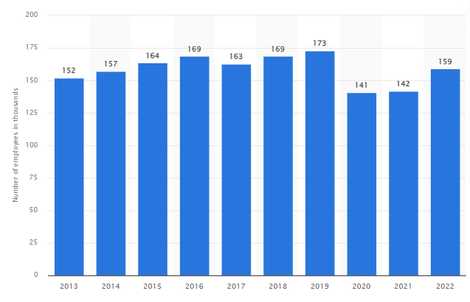
Figure 3: Employee number of Hilton Hotel group in the global market
(Source: Statista, 2023)
Considering this, the inclusive and equal organisational and overall corporate culture of Hilton could be ensured within the global business market. In this way, the employee engagement of the hotel in 2022 become 159 thousand in 2022 after a massive reduction in the previous years due to the impact of the pandemic (Statista, 2023). Contrarily, the employee number of Marriott International in 2022 is 140 thousand, which has been reduced from the previous years (Statista, 2023). In this way, a better organisational culture of the Hilton Hotel group in comparison to its competitor become recognised, which has enhanced employee engagement with the organisation respectively.
Furthermore, the key organisational goal of Hilton Hotels considers the delivery of light and warmth to the earth in terms of excellent hospitality service for every hotel and every guest at every time (Hilton, 2023). In this way, the hotel group provides effective value to its customers, owners and shareholders for enhancing their engagement and thereby ensuring better organisational competitiveness for the long-term future as well.

3. Change initiatives of Hilton and the way they influenced the organisational operations
As per the opinion of Khandate (2018), change management within the organisational culture could help to ensure modification of the existing business strategy for driving operational success and thereby ensuring better organisational competitiveness in the target market. It has been identified that companies often undergo change for fostering successful adaptation of the trendy factors in the global business market and increase their business efficacy in a better manner. Considering this, the Hilton Hotel group mainly implement change management through their digital transformation and sustainability practice in the corporate and individual hotels based on which the brand value of the company becomes enhanced, which is 12.04 billion US dollars respectively (Statista, 2023).
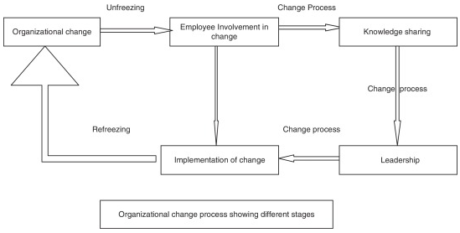
Figure 4: Change management model by Kurt Lewin
(Source: Hussain et al., 2018)
Considering this, the application of Lewin's change management aspect would be helpful for Hilton in understanding its change management aspects. Awati (2022) stated that Lewin’s change management considers three important elements such as unfreezing, changing and refreezing. The first step considers the importance of change within the organisational culture, which would motivate the employees for making a decision on the change implementation. Followed by this, actual change strategy in the business culture, organisational structure and practices become conducted (Hussain et al., 2018). In this aspect, careful monitoring of the change process needs to be done for ensuring a better outcome. Furthermore, the last stage of theory, refreezing comes, which ensures acceptance of the change for a long-term basis as the business strategy respectively (Awati, 2022).
In this aspect, due to the impact of the pandemic, the operational practices of the Hilton Hotel group become reduced, as a majority of the global guest were not willing to travel due to Covid-19 restrictions. Thus, the revenue of the hotel becomes significantly reduced in the pandemic scenario as well (Statista, 2023). Considering this, the corporate management body of the Hotel has implemented digital transformation and sustainability practices within its service management for better outcomes. According to the report of Mixson (2022), Hilton implemented personalised guest experiences through a personalised digital booking process. Additionally, it has been identified that the hotel has developed DEX (Digital Employee Experience) based on which digitally transformed workplace culture and people management within the hotel operation could be possible. In this way, the management body of the hotel has focused on digital practices and implements hybrid solutions by using high-speed bandwidth, cameras and other technological advancements.
Furthermore, Global Data (2022) reported that the hotel has implemented AI, Machine learning and advanced analytics for better employee and guest experiences within the individual hotels respectively. As opined by Denham (2019), a key competitor of Hilton, which is Marriott has faced a data breach for customer data hacking due to improper digital transformation practices. In this way, the brand value of the hotel group becomes reduced significantly in comparison to Hilton as well. Besides, concerning the sustainability practice, the hotel group has focused on reducing waste and driving their business towards the world of circular economy (Hilton ESG, 2023).
In this way, the service area of the hotel group considers waste prevention, recycling, food up cycling and donation practice based on which the above sustainability change becomes possible within the target market. Besides, Otley (2022) reported that the hotel group has established the Science Based Targets Initiative (SBTi) for reducing greenhouse gas emissions through their operational practices. In this way, the brand value and competitive advantage of the hotel in the target market have been enhanced compared to its competitors.

4. Strategic direction and current business performance of Hilton
According to the report of Bigelow and Pratt (2022), the strategic direction of a business could help to proceed with the ongoing strategy adopted by the organisation for a long-term basis. In this aspect, the competitive advantage of the company could be enhanced in the target market. As reported by Mixson (2022), the hotel group has adopted digital transformation and sustainability practices, as their corporate strategy, which has helped them to enhance their revenue and profit in the global market. Additionally, the hotel has adopted the ESG practice based on which the entire operational focus become kept on greenhouse gas emission and waste reduction.
Furthermore, the report from Hilton (2023) stated that the key strategic direction of the Hilton hotel group is to become the number one premium-price provider hotel in the global market and provide the best quality services to the guests for improving their experiences, which would help to improve their long-term commitment with the hotel. In this way, the digital transformation and sustainability practice by the hotel could help to ensure the success rate of the above strategic direction of the hotel by providing effective and ethical guest experiences through their services (Global Data, 2022). Besides, it has been reported that considering the above strategies, the hotel comes able to attract the majority of the global customers, which ensured their competitive advantage for the future (Hilton ESG, 2023).
It has been reported that the current business performance of Hilton is mainly focused on the integrated system of operation for providing innovative solutions to the guests with the help of technological advancement, which has helped them to ensure better business opportunities in the global market (Hilton, 2023). Additionally, the study by Business Wire (2023) pointed out that the hotel group has opened 108 new individual hotels, which contributes 17,000 rooms in the fourth quarter of 2022 and throughout the year, the group launched 355 new individual hotels across the global countries respectively.
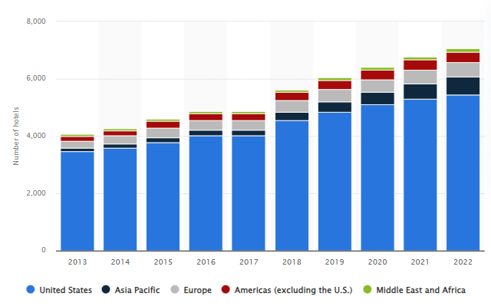
Figure 5: Current global presence of the hotel group
(Source: Statista, 2023)
In addition, Statista (2023) reported that the Hilton Hotel group is operating their business across the global regions including the United States. Asia Pacific, European region, American region excluding the US, Middle East and Africa. In this way, it can be stated that proper change adaptation through digital transformation and sustainability practice has helped the hotel for providing high-quality service to the guest based on which their brand awareness and value become enhanced in the international market and thus, the hotel group become able to practice their business effectively in those regions as well.
Additionally, it has been denoted that the key aim of the hotel becomes focused on their ESG and digital transformation practice based on which the long-term business sustainability of the Hilton Hotel group becomes ensured in the global market (Nassetta, 2023). The report has stated that the hotel has committed to their guest and society in the context of the chosen strategic direction and thereby implementing them in their current business operation based on which high brand value and organisational competitiveness of Hilton Hotel Group in the global market become possible.

5. Conclusion
At the end of the report, it can be concluded that organisational management and behaviour play a vital role in managing the overall operational efficiency of the company and thereby ensuring its competitive advantage in the global market. In this audit, the analysis of the organisational structure, culture, goal, change management, strategic direction and current business performance of the international hotel such as the Hilton Hotel group has been done. It has been observed that the hotel follows the divisional organisational structure and focuses on diversity as well as inclusion strategy, which helped to develop a positive and interactive workplace culture. In this way, employee engagement with the hotel become increased compared to its other competitors.
Furthermore, the hotel practices digital transformation and eco-sustainability for guest service, as their change management protocol based on which the strategic direction of the hotel comes focused on these two contexts. In this way, Hilton become able to provide technologically advanced solutions to the guests and ensures reduced carbon emission and waste management practice for a better outcome, which enhanced its brand value across the global market. Moreover, the overall strategic practices have effectively influenced the current operation of the hotel, which would ensure a long-term competitive advantage for the Hilton Hotel group in the global market.

6. References
Al‐Jinini, D.K., Dahiyat, S.E. and Bontis, N., (2019). Intellectual capital, entrepreneurial orientation, and technical innovation in small and medium‐sized enterprises. Knowledge and Process Management, 26(2), pp.69-85.
Andersson, T., Cäker, M., Tengblad, S. and Wickelgren, M., (2019). Building traits for organizational resilience through balancing organizational structures. Scandinavian Journal of Management, 35(1), pp.36-45.
Awati, R. (2022) What is unfreeze, change, refreeze (Kurt Lewin Change Management Model)?, TechTarget. Available at: https://www.techtarget.com/whatis/definition/Kurt-Lewins-Change-Management-Model-Unfreeze-Change-Refreeze (Accessed: 13 June 2023).
Bigelow, S. J. and Pratt, M. K. (2022) What is strategic planning? definition and steps - techtarget, TechTarget. Available at: https://www.techtarget.com/searchcio/definition/strategic-planning (Accessed: 14 June 2023).
Business Wire (2023) Hilton reports fourth quarter and full year results, Business Wire. Available at: https://www.businesswire.com/news/home/20230209005067/en/Hilton-Reports-Fourth-Quarter-and-Full-Year-Results (Accessed: 13 June 2023).
Denham, H. (2019) Marriott International Facing Legal Backlash for online reservations, The Washington Post. WP Company. Available at: https://www.washingtonpost.com/business/2019/07/10/marriott-international-facing-legal-backlash-online-reservations/ (Accessed: 13 June 2023).
Gay, W. (2016) 4 things companies can learn from Hilton’s award-winning culture, Forbes. Forbes Magazine. Available at: https://www.forbes.com/sites/wesgay/2016/12/31/4-things-companies-can-learn-from-hiltons-award-winning-culture/?sh=4f6c484e745c (Accessed: 13 June 2023).
Global Data (2022) Hilton Worldwide Holdings Inc (HWHI) - digital transformation strategies, Global Data. Available at: https://www.globaldata.com/store/report/hilton-worldwide-holdings-inc-enterprise-tech-analysis/ (Accessed: 13 June 2023).
Hilton (2023) Hilton Performance Advantage, Hilton . Available at: https://www.hilton.com/en/corporate/development/hilton-performance-advantage/ (Accessed: 13 June 2023).
Hilton (2023) Welcome to Hilton, Hilton Brands | Global Hospitality Company. Available at: https://www.hilton.com/en/corporate/#:~:text=To%20fill%20the%20earth%20with%20the%20light%20and%20warmth%20of,%2C%20every%20guest%2C%20every%20time. (Accessed: 13 June 2023).
Hilton ESG (2023) Environmental impact: Travel with purpose: Hilton ESG, Hilton ESG. Available at: https://esg.hilton.com/environment/ (Accessed: 13 June 2023).
Hussain, S. T. et al. (2018) ‘Kurt Lewin’s change model: A critical review of the role of leadership and employee involvement in organizational change’, Journal of Innovation &amp; Knowledge, 3(3), pp. 123–127. doi: 10.1016/j.jik.2016.07.002.
Jeffery, R. (2019) Hilton is improving female progression by encouraging its teams to think differently, People Management. Available at: https://www.peoplemanagement.co.uk/article/1744385/hilton-improving-female-progression-changing-way-teams-think#:~:text=Hilton’s%20latest%20median%20gender%20pay,now%2050%20per%20cent%20female. (Accessed: 13 June 2023).
Khandate, U. (2018) Why is change important in an organization?, LinkedIn. Available at: https://www.linkedin.com/pulse/why-change-important-organization-umesh-khandate/ (Accessed: 13 June 2023).
Lambrano, L. (2020) A brief history of the corporate culture transformation at Hilton, LinkedIn. Available at: https://www.linkedin.com/pulse/brief-history-corporate-culture-transformation-hilton-lambrano-ms-1e (Accessed: 13 June 2023).
Mixson, E. (2022) Inside Hilton Hotels Post-Pandemic Digital Reinvention, Intelligent Automation Network. Available at: https://www.intelligentautomation.network/transformation/articles/inside-hilton-hotels-post-pandemic-digital-reinvention (Accessed: 13 June 2023).
Nassetta, C. J. (2023) 2030 goals: Travel with purpose: Hilton ESG, Hilton ESG. Available at: https://esg.hilton.com/2030-goals/ (Accessed: 14 June 2023).
Organimi (2023) Hilton’s organizational structure [Interactive Chart], Organimi. Available at: https://www.organimi.com/organizational-structures/hilton/ (Accessed: 13 June 2023).
Otley, T. (2022) How sustainable is Hilton?, Business Traveller. Available at: https://www.businesstraveller.com/features/how-sustainable-is-hilton/ (Accessed: 13 June 2023).
Statista (2023) Hilton Worldwide Hotels by region 2022, Statista. Available at: https://www.statista.com/statistics/297754/number-of-hilton-worldwide-hotels-by-geographical-region/ (Accessed: 13 June 2023).
Statista (2023) Hilton Worldwide Revenue 2022, Statista. Available at: https://www.statista.com/statistics/297760/revenue-of-hilton-worldwide-holdings-inc/#:~:text=International%20hotel%20company%20Hilton%20Worldwide,year’s%20total%20of%205.79%20billion. (Accessed: 12 June 2023).
Statista (2023) Most Valuable Hotel Brands Worldwide 2022, Statista. Available at: https://www.statista.com/statistics/732907/most-valuable-hotel-brands-worldwide/#:~:text=Hilton%20was%20the%20most%20valuable,approximately%2012.04%20billion%20U.S.%20dollars. (Accessed: 13 June 2023).
Statista (2023a) Hilton Worldwide employee numbers 2022, Statista. Available at: https://www.statista.com/statistics/297758/number-of-hilton-worldwide-employees/#:~:text=Global%20hotel%20company%20Hilton%20Worldwide,thousand%20people%20globally%20in%202022. (Accessed: 13 June 2023).
Statista (2023b) Marriott Employees Worldwide 2022, Statista. Available at: https://www.statista.com/statistics/297269/number-of-marriott-international-employees-worldwide/#:~:text=Multinational%20hotel%20company%20Marriott%20International,thousand%20people%20worldwide%20in%202022. (Accessed: 13 June 2023).
Vaidya, D. (2023) Divisional structure - what is it, organization, Examples - Wallstreetmojo, Wall Street Mojo. Available at: https://www.wallstreetmojo.com/divisional-structure/ (Accessed: 12 June 2023).

