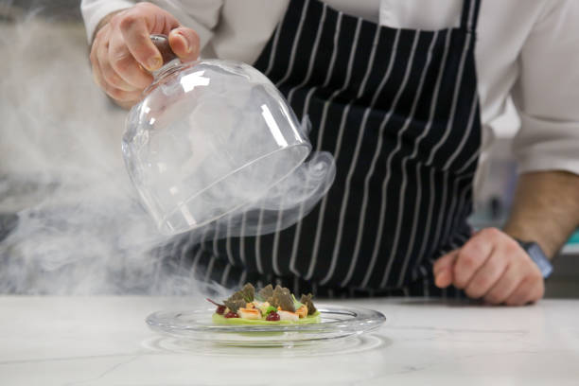
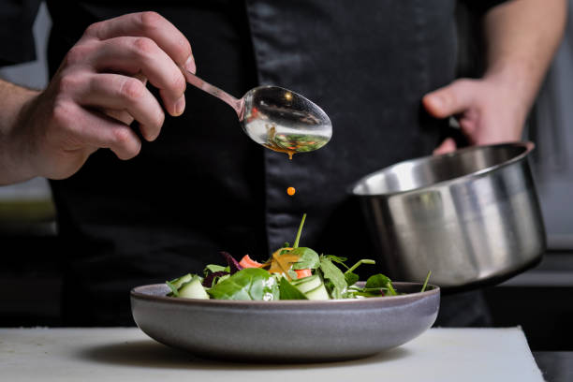


Beverages
Hot chocolate (with a milk of choice) £4
iced coffee £2
Latte £1.50
Espresso £2
Cosmopolitan £3
Long island iced tea £3
Vodka martini £3
Pina colada £3
Americano £3
Bloody Mary £3
Mojito £3
Manhattan £3

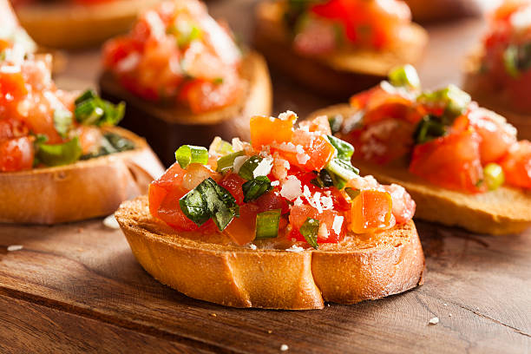
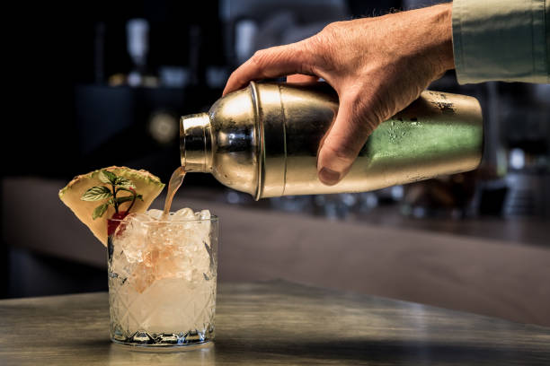


Valentine’s Day Dinner Menu
TRINITY HOTEL
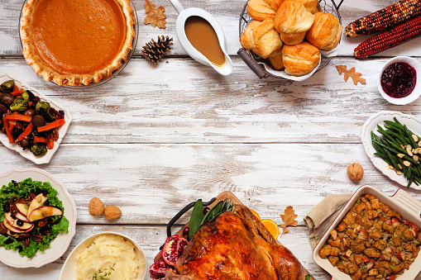
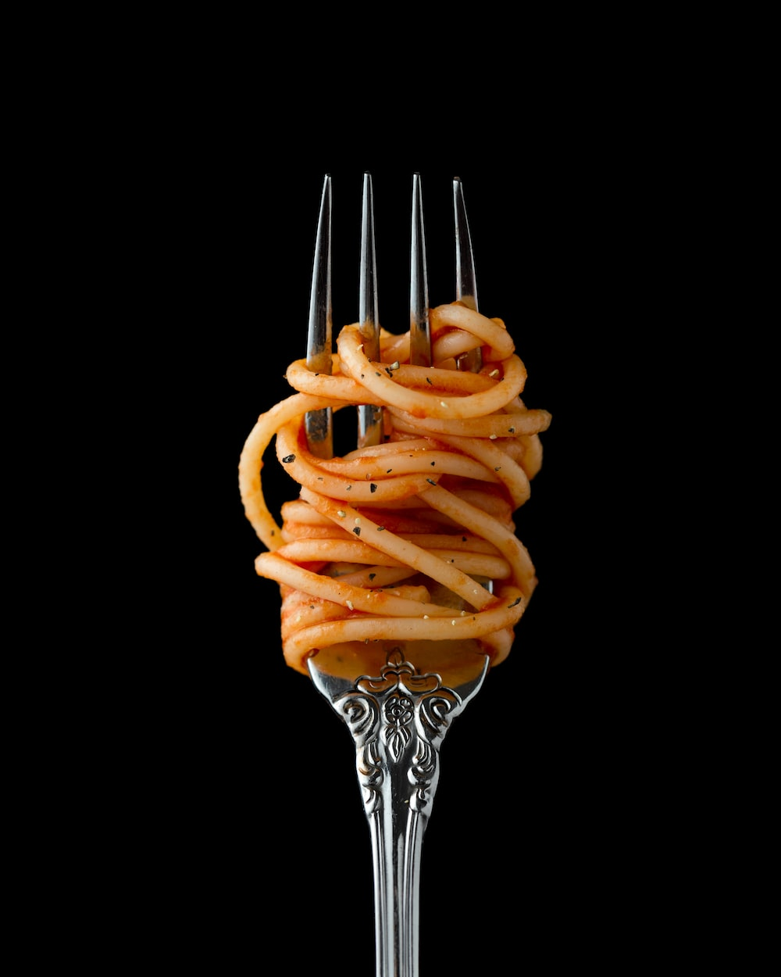
Starters
Salt and pepper squid £5
Grilled scallops with butter £6
Ceviche with charred sweetcorn £6
Leek cappuccino soup £5
Grilled broccoli with pistachio nuts and olive oil £7
Cheese samosas £5

Side dishes
Asian noodle cabbage £4
Mexican corn on the cob £3
Balsamic roasted potatoes £5
Broccoli with garlic and chilies £3
Peanut and cucumber salad £3
Cauliflower mash £5
Coleslaw £5
Chives mashed potatoes £7
Roasted asparagus £6

Dessert

Mixed berry mouse £4
Mango and coconut soufflé £3
Carrot cake £4
Vegan chocolate cake £3
Blondie vanilla ice cream £2.50
Chocolate mint bars £1.95
Vanilla cheesecake with cherry toppings £2
Salted caramel ice cream £2.50

All meals on the menu are available on order
Main courses
Braised chicken legs with grapes and fennel £11
Double stack mushroom and cheese cheeseburgers £12
Potato gnocchi £10
Lasagna with parmesan and green peas £15
Caesar salad with roast chicken £15
Mast biryani (vegetarian) £10



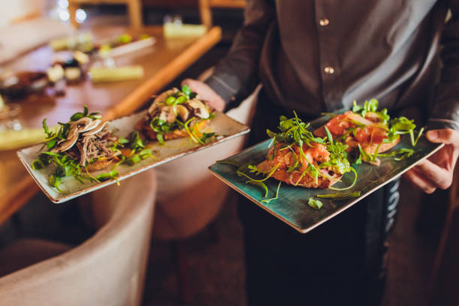





For bookings and reservations contact:
+44 345 345 567
Social media handles trini_ hotel
Instagram trini_ hotel
Facebook trini_ hotel
Tik tock @trini_ hotel

Allergen information
Gluten free
Desserts contain lactose
Some soups may contain nuts



Valentines specials
All meals are served with a glass of wine
Surprise performance by an artist

References
Allrecipies (2022) Main dishes, Allrecipes. Available at: https://www.allrecipes.com/recipes/80/main-dish/ (Accessed: February 17, 2023).
Creme De La Crumb (2023) Easy Main Dishes & Dinner recipes, Creme De La Crumb. Available at: https://www.lecremedelacrumb.com/category/main-dishes/ (Accessed: February 17, 2023).
Overhiser, A.S. et al. (2021) 30 great cocktail recipes you should know, A Couple Cooks. Available at: https://www.acouplecooks.com/best-cocktail-recipes-to-make-at-home/ (Accessed: February 17, 2023).
Prince of wales menu (2021) Menu, MENU | The Prince of Wales, Pub, Dining & Garden. Available at: https://www.princeofwaleskt8.co.uk/food-and-drink/menu (Accessed: February 16, 2023).
RecipeTin Eats (2020) Side dishes, RecipeTin Eats. Available at: https://www.recipetineats.com/category/side-dishes/ (Accessed: February 16, 2023).
Shutterstock (2010) 21,978 Trinity symbol images, stock photos & vectors, Shutterstock. Available at: https://www.shutterstock.com/search/trinity-symbol (Accessed: February 16, 2023).
Team, D. (2023) 77 easy desserts for effortless entertaining - delicious.com.au. Available at: https://www.delicious.com.au/recipes/collections/gallery/60-easy-desserts-for-effortless-entertaining/77cijfrr?page=25&nk=4bb80b87e2ec07b8ab2561b5fafff7b8-1674793020 (Accessed: February 17, 2023).
VinePair (2017) The 50 most popular cocktails in the World (updated 2022), VinePair. VinePair. Available at: https://vinepair.com/articles/50-most-popular-cocktails-world-2017/ (Accessed: February 17, 2023).

