Materials Buildings and Services

Assignment 2

Light and Sound

Elliot Brice

C O N T E N T S

1. Task A - Designing a lighting installation layout
(a) Room Index Page 3
(b) Utilisation Factor Page 3
(c) Number of lamps Page 4
(d) Suitable layout Page 4

Scale Drawing of best fit design for Page 5
the luminaire installation

2. Task B – Sound Reduction Index (SRI) for Page 6 – 7
Entire wall
Implications for factors of frequency and wavelength:
- Internal sound management Page 7 – 8
- Partition wall construction technique Page 8
- Insulation material choice Page 8 – 9

References Page 10

TASK A
- Designing a lighting installation layout

- Room Index (RI)
To work out the room index I multiplied the length and width of the production area in the factory and divided by the height of luminaire measured from the working plane (top of the factory’s work benches).

RI = (L x W) / Hm(L + W)) Hm = 8m – 1m
RI = (60m x 24m) / 7(60m + 24m)
1440 / 588
RI = 2.45

- Utilisation Factor
To find out the utilisation factor I used the architects’ specification for interior lighting which shows the values from CIBSE Code of Interior Lighting working plane. The utilisation factor gives the luminaire properties, down LOR, reflectance of room surfaces, the geometric proportion of the room (Room Index) and the direct ratio.
Using the Utilisation Factor sheet I looked at the first column which specified the florescent lamps in recessed louvre with DLOR of 50% (which is the downward light output ratio). I then used the Room Index of 2.45 (2.5) to move across to the columns marked area of reflectance for ceiling (0.3) and walls (0.5) and crosslinked to give the utilisation factor of 0.46 (as specified on the utilisation factor sheet below).
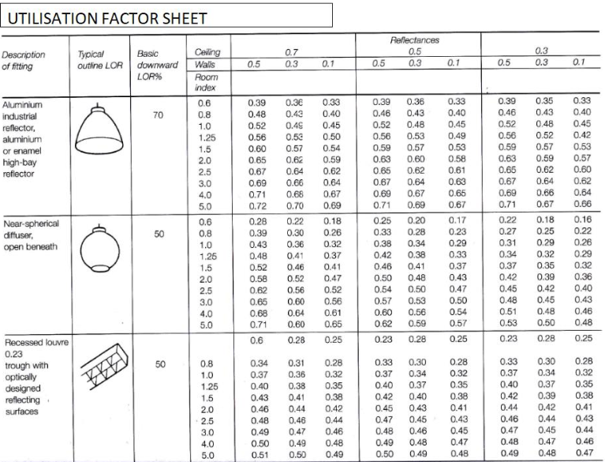

- Number of lamps required
To provide luminance across the working plane I needed to work out the number of lamps required. Therefore the following formula was applied:
N = E x A
F x UF x LLF
Number of lamps = Lux x Area at working plane height (m2)
Average luminous flux per light (lm) x utilisation factor x light loss factor (from
deterioration or dust)
Therefore in this case :
N = 200 lux x 1440 m2 = 288,000 = 46.376 rounded up to
18,000 x 0.46 x 0.75 6,210 48 lamps

- Suitable Layout

Florescent tubes in diffusing luminaires is S max = 1.5 x Hm (the mounting height – height of luminaire from the working plane e.g. surface of the benches). S max is the maximum spacing between fittings. In this case the mounting height is 8m – 1m = 7m

Therefore:

S max = 1.5m x 7 = 10.5m apart

If there are 48 lamps then the maximum distance between lamps is less than10.5m apart.

The best fit for the geometry of the production area of the factory :

Based on the 48 lamps (4 rows of 12) I multiplied by the length of the factory (60 – 2m = 58m) by 11 lamp gaps which worked out 5.27m apart. This gives an equal amount of lamps across the room so as not to exceed the lux).

- Draw the plan layout on a scale drawing of the factory floor indicating your ‘best fit’ design for the luminaire installation.
Points on the row layout should indicate the position of the lamp centres.

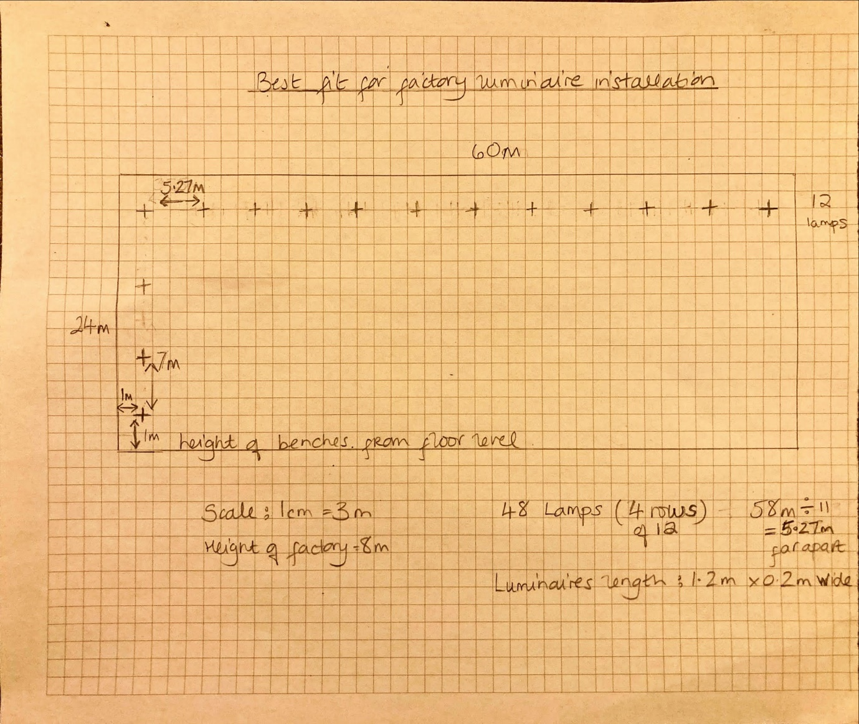

TASK B
A brick wall of area 20m2 contains a window of area 4m2. The values of sound reduction indexes are:
50dB for the brickwork and 10dB for the window.
Calculate the overall sound reduction index for the entire wall. Include the full arithmetic development of your answer.
Overall SRI for entire wall
SRI
For brick wall: T1 A1 = 20-4=16m2 50dB
Window: T2 A2= 4m2 10dB
Using SRI = 10(log10(1/T) )
- Brick wall
50 = 10 x (log10(1/T) )
5= log10 x (1/T1)
1/T1 = 105
T7 = 10 -5
= 0.000010
Transmission coefficient for brick
- Window
10 = 10 x (log10(1/T2)
1 = log10 x (1/T2)
1/T2 = 101
T2 = 10-1
= 0.10
Transmission coefficient for window

T0 = (T1 x A1) + (T2 x A2)
A1 + A2
= (10-5 x 16) + (10-1 x 4) = 1.6 + 0.4 = 0.020008
16 + 4 20
Average transmission coefficient = 0.032

Using SRI formula and substituting:
SRI = 10 x (log10 (1/T) )
= 10 x (log10 (1/0.020008)
= 10 x (log10 (16.98)
= 10 x 1.68 = 17dB
SRI for the entire wall is 17dB

Discuss the implications of the factors of frequency and wavelength in:
1). Internal sound management
Sound can be controlled depending on how it is emitted, travels through mediums and arrives at the receiver. One of the sources of sound that impact internally is airborne coming from traffic, wind, birds, aircraft, jackhammers which may have high level of decibels sending sound pressure, energy and vibration to the building. It depends on the fabric or external skin to counteract sound coming from the outside. Sound travels faster in solids and can be heard clearer in hot weather as opposed to snow or dense humidity. Any low pitched notes (bass) are caused by low frequency sound waves which has significant acoustic energy in frequency range (8-100 Hz) and are less well absorbed than high frequency e.g. lawnmower. If these are long distance and long length waves it is hard to muffle the sound as it is perceived as pressure e.g. Swansea to Cork ferry horns. The higher the frequency the higher pitched sound.
Structure borne sound travels through solid materials in direct mechanical contact with sound source or from impact on that material e.g. in multioccupancy flats footsteps, hard heavy objects falling on floors upstairs, loud speakers on the floor, mechanical ventilation units, washing machines etc. can be annoying sound to human health and wellbeing. Each surface of a room has its own absorption coefficient. The makeup of a room can affect the patterns of soundwaves e.g. cinemas and auditoriums measures are put in place to reflect and absorb sound e.g. plane which is hung above a stage and curved (concave to concentrate on sound and convex to diffuse or spread the sound). This is called building a reverberant field and is measured from the time it takes for sound to decay by 60dB after the original source has finished. Reverberation time controls the noise in cinemas, concert halls and lecture rooms. The shorter reverberation time the clearer the speech. Rooms without absorption have longer reverberation time and can be measured by the Sabine formula :
t = 0.16V
A
Total absorption of the room surface measured in sabins is divided by the volume of the room.
Rooms with high absorption such as recording studios would be measured by the Eyring formula.

2). Partition wall construction technique
To suppress noise for internal walls it is approximately 1dB per inch of insulation for low frequency sound and 4dB for high frequency. There are three basic principles for good sound proofing:
- Weight (MASS LAW)
According to MASS LAW “the sound insulation of a single leaf partition rises in proportion to its mass”. Therefore any solid object that is thick and heavy will block sound energy very well because high density supresses sound vibrations e.g. air sound reduction of a brick wall increases from 45dB to 50dB when thickness is increased.

- Completeness (airtight)
Sound travels through air so a building that is airtight provides good insulation should be no gaps or holes in walls, doors, floors. Some aerated blocks do not provide much insulation.

- Isolation
Sound transfers through any medium and converts to different wave motions at the junction of different materials, energy is lost and an increased amount of insulation is gained. This is the reason for air cavities in windows, floating floors, carpets and resilient mountings for vibrating machines. Cavity constructions must be also be wide enough the air to be flexible, otherwise resonance can cause the insulation to be reduced at certain frequencies. If vents and ducting are not fixed to the fabric or too close to it then this creates vibration and noise. To take away resonance or reduce noise/vibration hangers should be placed to keep them off the fabric. Air gaps or glass fibre gaps, and rigid stud links can be also be used.

3). The Insulation material choice
All materials attenuate sound energy from airborne or impact. A surface absorbs 40% of the incident sound energy. Before solving noise control acceptable background noise must be determined e.g. large auditorium 20-25 Db. Sound levels would have to be measured by using the Sound Reduction Index (SRI) both sides of the wall to determine the most effective insulation material.
Porous absorber materials are effective for frequencies above 1kHz. Panel Absorbers have air gap or porous absorbent in between for low frequencies range 4 - 400 Hz. Cavity absorbers e.g. perforated acoustic tile provides high absorption coefficient over narrow band of frequencies. Damping materials create mechanical resistance to structural borne sound by converting sound energy into heat through friction e.g. spray on coating compound. Concrete blocks, solid brick, plasterboard on timber stud walls are materials that reduce sound.
(778 words)

References
Javitz Production - Structure of Human Ear (2010) Available at: https://www.youtube.com/watch?v=0jyxhozq89g (Accessed on 23rd March2021)

SciencephotoLibrary - Animation Sound waves through different mediums Available from: http://www.sciencephoto.com/media/395559/view
(Accessed on 23rd March 2021)

Sound Bible – Traffic Sounds (2006-2021) Available from: https://soundbible.com/search.php?q=traffic+sounds (Accessed on 23rd March)

