
Skills for the Workplace
Module Assignment Submission
Student Name: | Jemma Rees
Student Number: | 2008032
Module No: | BMSK4004
Module Title: | Problem Solving and Decision Making

Statement of Confirmation of Authenticity
By the act of making this submission, the student declares that this is the work of the student named above. The work has not, in whole or in part, been knowingly presented elsewhere for assessment, or where assessment has been built on a previous assessment, this has been identified. Where materials have been used from other sources it has been properly acknowledged. If this statement is untrue, the student acknowledges that an assessment offence has been committed.
Attention is drawn to the plagiarism and unfair practice policies of UWTSD.

Table of Contents
Define a complex problem in the workplace, including its scope and impact 3
Analyse information on the identified problem, to help inform the decision making process 5
Propose a range of alternative solutions to the problem 6
Using a decision making technique, evaluate a range of solutions to identify the most appropriate option 7
Develop a detailed plan for implementing the solution 10
Assess appropriate monitoring and review techniques to ensure successful implementation of solution 12
References 14
Appendix 1 16
Appendix 2 17
Appendix 3 18
Appendix 4 19
Appendix 5 20
Appendix 6 21
Appendix 7 22
Appendix 8 23
Appendix 9 24
Appendix 10 25

Define a complex problem in the workplace, including its scope and impact

The capacity of the human mind for formulating and solving complex problems is very small compared with the size of the problem whose solution is required for objectively rational behavior [sic] in the real world or even for a reasonable approximation to such objective rationality (Simon, 2013)
Complex problems are often difficult to define; it can be challenging to identify components of problems; how they impact and interact with each other. It is essential to consider several different approaches to problem-solving; due to the complexity, a linear approach is unlikely to provide a suitable solution (Mainzer, 2009).
The following report will consider this whilst using a range of problem-solving tools and decision-making techniques to identify and solve a complex problem in the workplace and detail the successful implementation.
After securing significant funding to deliver a complex data project, the planning team created a high-level programme plan to ensure successful and timely delivery. The planning team initially met to discuss how best to begin the planning process. Due to the complexity of the project and its cross-functional capabilities, the amount of information required was extensive. Several meetings took place to discuss which workstreams would need to be involved in the initial plan creation and to identify key stakeholders.
All information was then gathered and collated, enabling the planning team to compile the information into a programme plan. The business case was consulted to ensure the correct terminology was applied to the milestones and tasks. During the plan creation, it became apparent that the programme plan was becoming very complex and increasingly challenging to differentiate between workstreams. In addition, they were unable to keep comprehensive a log of any additions or changes to the milestones and tasks.
Furthermore, the Programme Management Office (PMO) holds regular meetings to report weekly highlights, risks and issues. These contribute to the fortnightly checkpoint reports, and finally, these reports are collated and updated to present to the monthly programme board to indicate the project's overall status. The governance department compiles these reports using the information directly supplied from the workstreams and responsible owners of the corresponding tasks.
As the project progressed, it became clear that the programme plan lacked the clarity to define milestone ownership and subtask workstreams. Without this information, it became time-consuming and challenging to cross-reference across the reporting network. Subsequently, it caused additional costs to the business in wasted administrative hours and delays in reporting to the project and programme boards.
The planning team realised that a robust process would be required to accurately report key milestones at project and approval boards. In addition, this process would need to uniquely identify each task within the project, thus enabling a comprehensive changelog to be created, maintained and referenced as required.
Due to the complexity of the project and the volume of stakeholders and cross-functional workstreams involved, this problem would need rectification as soon as possible to allow implementation before the first programme review in one month. The planning team were assigned sole responsibility for solving this problem. However, with their limited resources and other daily commitments, this would be a challenge.

Analyse information on the identified problem, to help inform the decision making process

As a manager, decision-making skills are fundamental and highly sought after. There is an expectation for managers to make quick and sound decisions. By collecting information and using problem-solving methods, it is possible to avoid a biased view and understand the implications of the decision. (Chartered Management Institute, 2020)
Creating a mindmap (Appendix 1) establishes the scope, impact, and nature of the problem to provide clarity. Without analytical tools, it would become difficult to identify these areas correctly. Potentially leading to incorrect problem identification and, in turn, a poor resolution (Mindtools, 2017). Breaking the problem into these three sections makes it easier to understand who may be impacted by the problem and how far the problem could span across the company.
The use of a mind map helps to generate ideas. Capturing the team's thoughts in this way can lead others to think of alternatives that may not have initially been visible. Creativity is vital to draw out a wide variety of ideas. It does not matter if the ideas are not taken forward or considered tangential; quantity over quality aims to provide further discussion points.
In defining the nature of the problem as operational, the team can understand that this is a medium to a short-term problem, meaning that once they have identified a suitable resolution, implementation is relatively quick. In addition, it indicates that the buy-in of the entire department is required to ensure success. The process ensures that relevant parties sufficiently support the solution by involving stakeholders at the appropriate level, as identified in the stakeholder map (Appendix 2).
Further analyses were required to ensure that the identified problem was the root cause and to begin formulating ideas to progress with problem-solving.
With the use of a cause and effect technique (Appendix 3), also known as the Ishikawa Diagram (ASQ, 2021), the problem is broken down further and provides a more in-depth explanation as to how the problem is affecting not only the immediate planning team but the company as a whole. Using this bottom-up technique clarifies that the problem reaches beyond just operational but can potentially impact the company's reputation negatively.
Once the results from several tools are compared, the root cause becomes apparent, tasks and milestones require a unique identifier to enable ease of use, the unique identifier will also enable swift identification of associated workstreams. A system is required to identify each task uniquely whilst retaining the ability to differentiate between workstreams. The process is required to be understood by the company and not just the planning team.

Propose a range of alternative solutions to the problem

Once the root cause of the problem is established, a further brainstorming session is used to identify possible solutions (Appendix 4) and to answer the question; how do we create a unique referencing system that everyone can adopt and understand to provide congruency across the directorate?
The initial options available to rectify the situation are:
Option 1 Do something
Option 2 Do nothing
Option 3 Create a unique referencing system

In this situation, it is not practical to select option 2, as previously established; if nothing is done, the companies reputation could be at stake. The brainstorming session provides several further options to expand on option 3.

Option 3
Early into the session, it becomes apparent that a code of some nature is a popular suggestion; these include the use of numbers and or letters. Either it is created at source by the programme software used to produce the plan, a code produced by the individual workstreams or something entirely new.

To expand on this idea, further analysis is applied to identify solutions and draw out requirements. A brainstorming activity is undertaken to generate ideas; these ideas do not need to be overthought, all possibilities are captured, with the encouragement that no idea is a bad idea. By brainstorming in this way, the team can think creatively, and as one idea is presented, another follows. Once the team have exhausted this process, the ideas are discussed, and the most suitable are expanded upon.

Whilst exploring the suggested solutions, it is essential to remember the previously identified scope and impact. The solution will need to ensure that all stakeholders requirements are met. The solution will not be viable if one or more of the stakeholders are likely to oppose it. This will require further consideration when implementing the chosen option to generate interest and obtain the necessary buy-in.

The impact is equally essential; to successfully rectify the problem, the solution will need to consider what is not currently working and the implications of this. Additionally, the best possible action is to solve as many of these current issues without indirectly or directly causing more.

It is good practice to carry out an impact analysis. Assuming that each action will affect another, impact analysis can provide the best guess to a possible outcome (Weber, 2019). The results from an impact analysis and the decision-making tools and techniques covered in this report will aid in providing a fully informed decision.

Using a decision making technique, evaluate a range of solutions to identify the most appropriate option

The brainstorming session is further evaluated to determine popular and potentially viable components to identify a suitable solution better. This is achieved by marking each of the suggestions as either; Yes, No or Weird. (Appendix 5)
The idea labelled 'weird' is not rejected, but retained to perhaps be built upon or used in another capacity. A key factor identified is that the code needs to be succinct and clear. The 'No` ideas are identified as either too complicated to produce suitable buy-in across the directorate or not unique enough to quickly identify each milestone and subtask as the plan grows in size and complexity.
After this initial exercise, the remaining ideas labelled 'yes` are taken forward for further consideration.
These are the determining criteria:
The code must be, short, clear, time saving and unique
Possible options include numbers, letters or to build upon the level 0 milestone reference number, which is produced by the corporate team for their own monitoring purposes. These are added to a grid analysis (Appendix 6) and given a weighting to decide which criteria are most important.
Firstly each of the options is scored 1-3, 1 being a poor solution and 3 being the most suitable. These are considered in order against each factor and recorded in black on the grid. Once all boxes have been filled, these are added together to provide an overall score for that option. Initially, all of the possible solutions score highly and do not present a clear decision to the team.
To enable a stronger analysis, a weighting is attributed to each of the factors between 1 and 4. 1 – least important and 4 – most important. After considering each factor's suitable importance, the team has identified that the code has to be unique and time-saving. However, this still does not provide enough clarity to assist in the decision making process. A final score is added in red to the grid; this score is determined by multiplying, in turn, each of the options by the weighting.
For example:
Factor: Short (1)
Multiplied by the option: Numbers (3)
= 3
These scores are then added together and entered, in red, into the total column.
Once the entire process has been followed, it should become apparent as to the best option to proceed with. However, the scores are not significantly different; regardless, a decision can be reached.
By carrying out this exercise, the grid analysis confirms that each of the proposed options are a suitable solution to the problem. In light of this, the team decide to use all three options combined to create a unique identifier.
To further confirm that this decision is correct and beneficial to the company, a cost-benefit analysis is carried out to determine that suitable savings will be made once this is implemented. The ability to present a significant saving to the company is pertinent to the buy-in of senior stakeholders and departments.
The solution will require limited resources to implement and can be carried out alongside business as usual activities. The value of the solution will become apparent over the duration of the project, which is scheduled to operate for five years. The previous tools and techniques are consulted to ascertain where the lack of resolution has the most financial impact.
As demonstrated in the initial mind map (Appendix 1), the 'impact` strand indicates that time is wasted in reporting due to the lack of clarity, leading to mistakes and the need to spend additional time correcting these reports. In addition, time is wasted in identifying the correct workstreams, which lead to a delay in collecting information required for the reporting and updating processes.
Based on this, the following details are used to attribute a monetary value to time spent; the average cost per hour for administration is £14.46.
The average time spent in collating and producing information has been worked out:
 | Time per week | Cost per week
Administration time spent creating and correcting reports | 2 ½ hours | £36.15
Administration time spent in meetings to record and correct errors | 1 ½ hours | £21.69
Ad hoc amendment requests | 1 hour | £14.46
Totals | 5 hours per week | £72.30 per week
(Microsoft,2021)
These figures are then multiplied by the additional hours required per week and amount of weeks worked in the year, 46 weeks out of 52 weeks. The yearly costs take into consideration an increase of time required each year in line with the growth and complexity of the project across the 5 year period. It is assumed that ad hoc requests will remain and therefore have not been attributed with a cost-benefit.
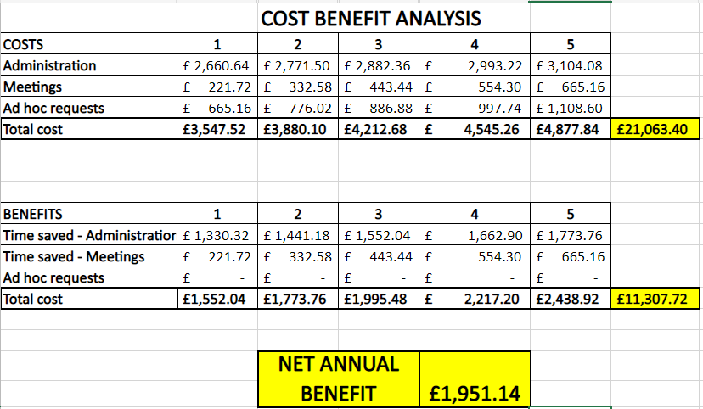
(Microsoft,2021)
It is evident from the cost-benefit analysis that the administration time saved is significant and will provide an estimated annual saving of £1,951.14 to the company. Additionally, administration time saved can be redirected to other areas within the business, providing currently unknown benefits. Furthermore, the qualitative impact is currently unknown and cannot be represented here as a figure, but the implication is clear. With a unique identification assigned to each milestone and task of the project plan, the team's reputation across the directorate will improve, in turn gaining confidence in the ability to correctly report at important board meetings.

Develop a detailed plan for implementing the solution

When implementing any change to a process considered `business as usual', there are several important factors to be aware of. As explained in Dr John Kotter's 8 step process for leading change (2021). Change can often be perceived as a negative and is primarily met with resistance. The goal is to generate excitement for change and create an inclusive, open space in which ideas are encouraged, leading to buy-in across an organisation.
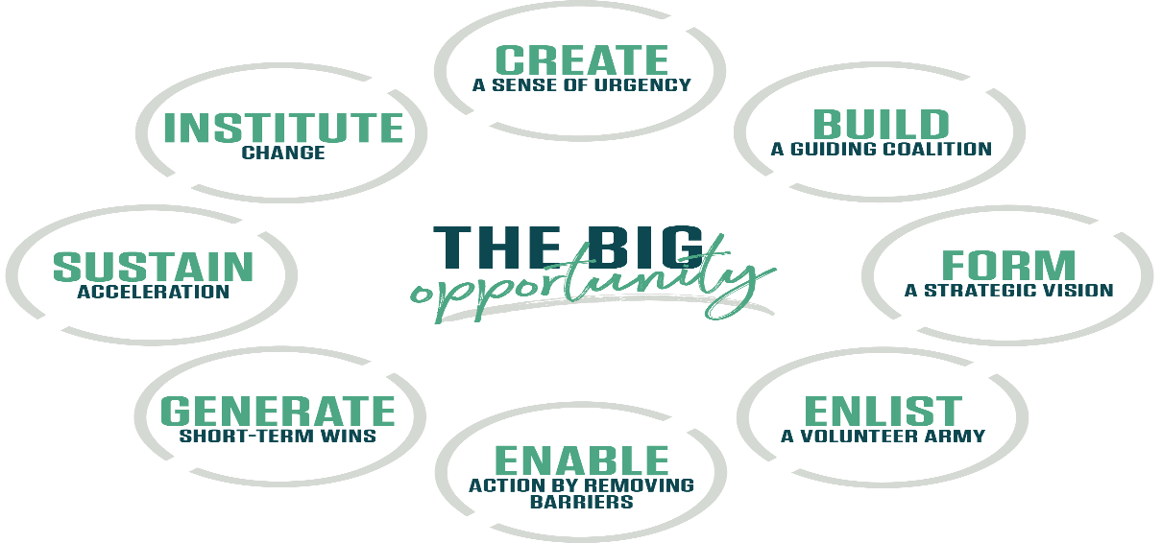
(Kotter, 2021)
Before the solution can be applied, a suitable tool is used to create a visual representation detailing the implementation process. In this instance, a Gantt chart is produced to present to stakeholders. (Appendix 7)
A Gantt chart is handy when conveying large amounts of complex information. The minutiae of information are not particularly interesting to the stakeholders if too much information is presented; they could lose interest or push back, assuming that the task is too complicated and likely to fail. By presenting the information in a Gantt chart, the stakeholders can see important high-level tasks along with their start and end dates.
The overall purpose of a Gantt chart is to enable planning and scheduling of required activities and to aid in the monitoring and progress of these activities; a tool largely utilised within project management. (Association for Project Management, 2021)
The view is customisable to show more or less information depending on the target audience. A Gantt chart can be used in communicating the plan to relevant stakeholders. When doing this, there are two key points to bear in mind. Firstly that the information is clearly defined so that a variety of audiences can understand it. Secondly, by identifying the audience to ensure that that information presented is relevant to this group. (Bob, 2012).
When identifying stakeholders, it is pertinent to include all people and organisations who have a vested interest in the project and who could positively or negatively impact the projects success or parts thereof. It is good practice to consider internal and external stakeholders, as neither one is more important than the other at this stage (Smith and PMI.org, 2020).
In identifying the problems scope, impact and nature, the key stakeholders were also identified, thus assisting in creating a stakeholder map (Appendix 2). This tool is used to ascertain the level of influence and impact each stakeholder could exhibit (Appendix 8).
Each stakeholder will have a different interest in the project and will need to be informed at different stages. It is unlikely that one stakeholder will want to know all of the information all of the time (Lopez, A. 2021). Once the stakeholders have been identified and their level of interest and influence mapped, a stakeholder communication plan is produced (Appendix 9). This enables a deeper clarity as to the frequency and method of communication required to ensure stakeholders are updated and informed throughout the process. A communication plan could be added to the Gantt chart if required to stipulate these dates and methods.
The stakeholder communication plan (Appendix 9) is populated with the information from the stakeholder map (Appendix 2). Once complete, it is necessary to consider several further points for each stakeholder or stakeholder group. The amount of engagement has already been established, based on their impact, but the method has not. This may be something that has already been discussed or detailed in the project initiation documents. An important factor here is the frequency of engagement and to recognise that this may change over the life of the project.
A stakeholder may want to be informed regularly at the beginning of the project to ensure that they are fully aware of any potential risks and issues, however as the project progresses, they may require less frequent updates if there has been little to report on, conversely if several issues and risks have been reported on in the early stages of the project they may require frequent updates for the life of the project.
In addition, the initial engagement method may require face to face meetings to provide updates or video calls with the key stakeholders. As they gain confidence in the project, they may wish to appoint a delegate to attend in their absence or request that an email is sent in place of a meeting. The communication plan can be expanded to show this. It may also be necessary to state that the frequency of engagement will change for the duration of the project. For instance, weekly updates may be required initially, changing to a monthly update mid-project and returning to weekly towards the project completion.
Again the engagement plan will be specific to the needs of the stakeholders and project complexity and duration.

Assess appropriate monitoring and review techniques to ensure successful implementation of solution

Implementing change can highlight incorrect decisions and provide an opportunity to learn from the diagnostic process, enabling insight into more suitable methods or solutions. From this, the process can begin again but with better-informed choices and decisions. (Hayes, 2018, p. 441)
There are many tools and techniques available to monitor and review the success of a project or change. Such as, S.M.A.R.T (Doran, 1981). This technique requires consideration of specific, measurable, achievable, relevant, and time-bound actions. By creating statements that adhere to these criteria, it becomes easier to measure success as the expected outcome has already been stated. As the problem referred to is project-based, the most suitable tools and techniques are a Gantt chart, success criteria and an action plan.
Gantt chart
Monitoring of the resolution can be achieved by utilising the earlier created Gantt chart; additional milestones and tasks can be added to schedule review and meeting points. The complexity of the Gantt chart can be dependent on the size and length of the project and the volume of workstreams feeding into it. There are many ways in which this type of plan can be utilised, depending on the desired outcome. In this instance, the time allowed for implementation is relatively short, and the actions required to achieve the goal can primarily be managed by one team. Therefore there is no need to create a large and complex Gantt chart. Conversely, if a project were to span several years and require the coordination of several workstreams, the Gantt chart would likely require several milestones and more regular checkpoints to ensure that the project is progressing to time, scope and quality.
Success criteria
Many projects will create acceptance or success criteria documents. These documents are usually created in the initial stages of a project with the stakeholders, end-users and/or the customer to ascertain what the acceptable outcomes are. The criteria will be exact to ensure there is no ambiguity (Copper, 2018).
For the purpose of this report, a success criteria document is created at the same time as the planning Gantt chart. When creating this document, the previously mentioned S.M.A.R.T technique can be applied to provide a list of requirements to be achieved. Once these have been met, the team will know that the implementation of the solution has been completed and the objectives have been achieved.
Action plan
Action plans recommend a sequence of events to achieve the desired objectives (Bridges, 2019). The information gathered in the Gantt chart and the success criteria document are collated and entered into an action plan, thus allowing the identification of 'what does success look like?'. By drawing this information out early into the planning, it becomes easier to recognise when a task is not achieving the desired outcome. Early identification allows early mitigation to ensure that the plan remains focused on the objective and will achieve the stipulated goal.
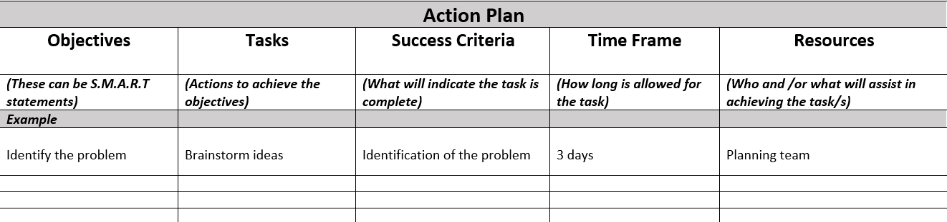
(Microsoft, 2021)
There are many available tools and techniques to monitor the implementation of change; in time, through practical experience and by learning from previous projects and colleagues, experience is gained in selecting the most appropriate tool or tools.
Once the solution has been implemented and achieved, it may be necessary to conduct a benefit analysis. It reiterates the findings from the cost-benefit analysis, ideally confirming that the project has achieved the projected cost-benefit and that the benefits outweigh any initial costs required to implement this change. It will aid in providing previously unknown qualitative information to demonstrate further how this change is beneficial to the company and employees.

References
ASQ (2021) ASQ: About: Kaoru Ishikawa | ASQ [Online]. Available at https://asq.org/about-asq/honorary-members/ishikawa (Accessed 19 August 2021).
Association for Project Management (2021) What Is A Gantt Chart? | Definition & Examples | APM [Online]. Available at https://www.apm.org.uk/resources/find-a-resource/gantt-chart/ (Accessed 26 August 2021).
Bob (2012) Presenting projects with your audience in mind (1/4) | OnePager Blog [Online]. Available at https://www.onepager.com/community/blog/presenting-projects-with-your-audience-in-mind-14/ (Accessed 30 August 2021).
Bridges, J. (2019) How to Make an Action Plan (Example Included) [Online]. Available at https://www.projectmanager.com/training/make-action-plan (Accessed 30 August 2021).
Chartered Management Institute (2020) Decision Making - CMI [Online]. Available at https://www.managers.org.uk/knowledge-and-insights/resource/decision-making/ (Accessed 31 August 2021).
Copper (2018) PM 101 — How to Define Project Success Criteria? - Copper Project Management Software [Online]. Available at https://www.copperproject.com/2018/03/pm-101-define-project-success-criteria/ (Accessed 30 August 2021).
Doran, G. T. (1981) "There’s a S.M.A.R.T. way to write management’s goals and objectives. Management Review, Volume 70,” There’s a S.M.A.R.T. way to write management’s goals and objectives, vol. 70, no. 11, pp. 35–36 [Online]. Available at https://community.mis.temple.edu/mis0855002fall2015/files/2015/10/S.M.A.R.T-Way-Management-Review.pdf (Accessed 30 August 2021).
Gilmore, N. (2016) The Purpose & Benefits of Gantt Charts | TeamGantt [Online]. Available at https://www.teamgantt.com/blog/10-benefits-of-using-a-gantt-chart-of-your-next-project (Accessed 28 August 2021).
Hayes, J. (2011) The Theory and Practice of Change Management, Google Books, Palgrave [Online]. Available at https://books.google.co.uk/books?id=sbZIDwAAQBAJ&pg=PA441&source=gbs_toc_r&cad=3#v=onepage&q&f=false (Accessed 31 August 2021).
Hayes, J. (2018) The theory and practice of change management, 5th edn, Basingstoke, Hampshire, Palgrave Macmillan [Online]. Available at https://books.google.co.uk/books?id=sbZIDwAAQBAJ&pg=PA441&source=gbs_toc_r&cad=3#v=onepage&q&f=false (Accessed 31 August 2021).
Kotter (2021) The 8-Step Process for Leading Change | Dr. John Kotter [Online]. Available at https://www.kotterinc.com/8-steps-process-for-leading-change/ (Accessed 26 August 2021).
Lopez, A. (2021) Stakeholder Mapping 101: A Quick Guide to Stakeholder Maps [Online]. Available at https://www.projectmanager.com/blog/stakeholder-mapping-guide (Accessed 17 August 2021).
Mainzer, K. (2009) “Challenges of Complexity in the 21st Century. An Interdisciplinary Introduction,” European Review, vol. 17, no. 2, pp. 219–236 [Online]. DOI: 10.1017/s1062798709000714 (Accessed 30 August 2021).
MatchWare (2021) Mind Mapping and Project Management Software | MindView [Online]. Available at https://www.matchware.com/ (Accessed 24 August 2021).
Microsoft (2021) Microsoft – Cloud, Computers, Apps & Gaming [Online]. Available at https://www.microsoft.com/en-gb (Accessed 19 August 2021).
Microsoft Project (2021) Microsoft Project | Manage Projects Easily in MS Project [Online]. Available at https://www.microsoft.com/en-gb/microsoft-365/project/project-management-software (Accessed 19 August 2021).
Mindtools (2017) What Is Problem Solving?: [Online]. Available at https://www.mindtools.com/pages/article/newTMC_00.htm (Accessed 24 August 2021).
Miro (2019) Fishbone Template [Online]. Available at https://miro.com/app/board/o9J_l17jy5M=/ (Accessed 19 August 2021).
Simon, H. A. (2013) Administrative Behavior, 4th edn, New York, Free Press [Online]. Available at https://books.google.co.uk/books?id=_obn42iD3mYC (Accessed 30 August 2021).
Smith, L. W. and PMI.org (2020) Stakeholder analysis: a Pivotal Practice of Successful Projects [Online]. Available at https://www.pmi.org/learning/library/stakeholder-analysis-pivotal-practice-projects-8905 (Accessed 24 August 2021).
Weber, J. L. (2019) What Is Business Impact Analysis & Why Is It Important? [Online]. Available at https://www.projectmanager.com/blog/business-impact-analysis (Accessed 31 August 2021).

Appendix 1
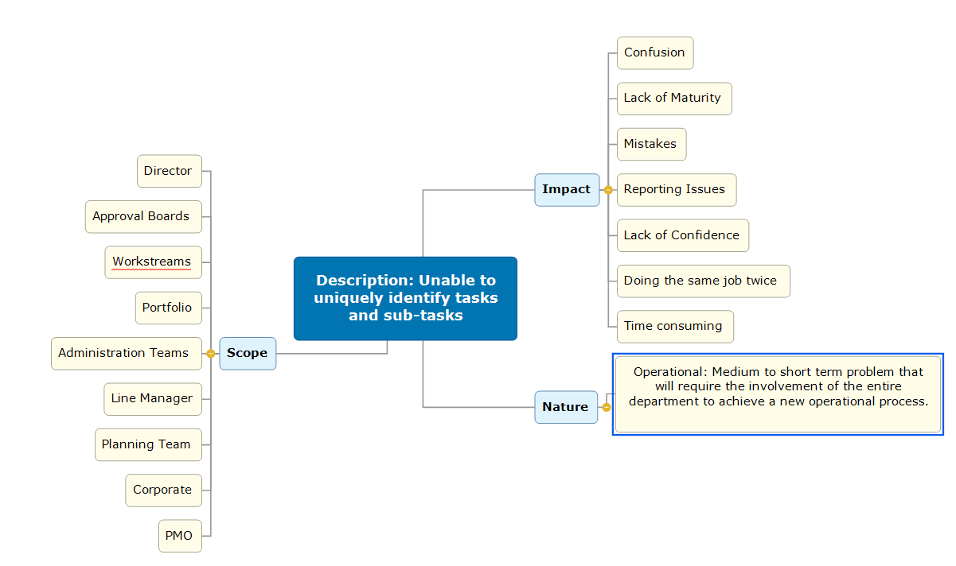
(MatchWare, 2021)

Appendix 2
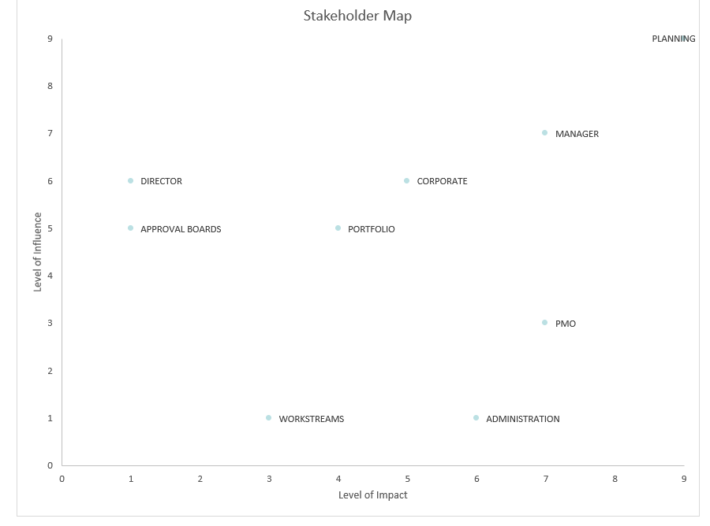
(Microsoft, 2021)

Appendix 3

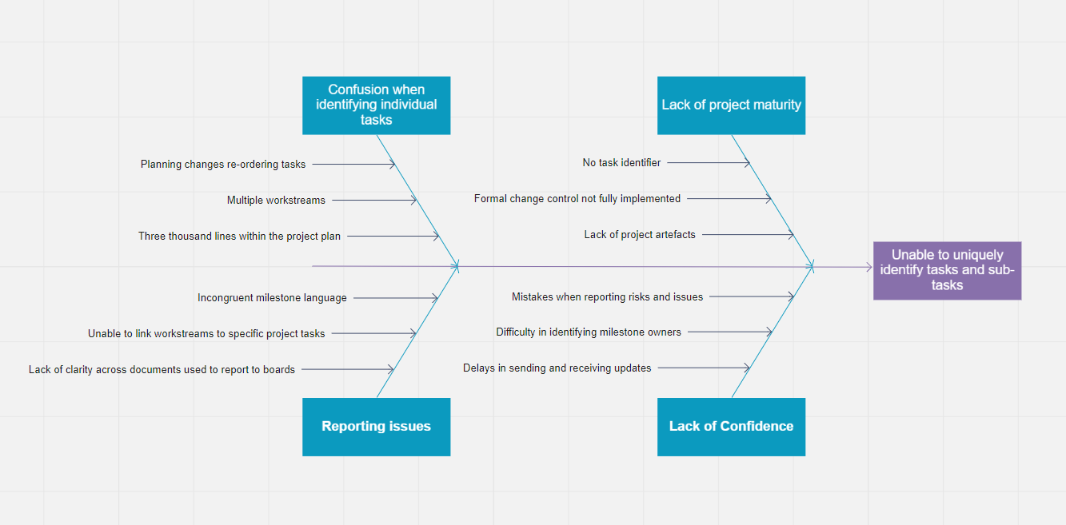
(Miro, 2019)

Appendix 4
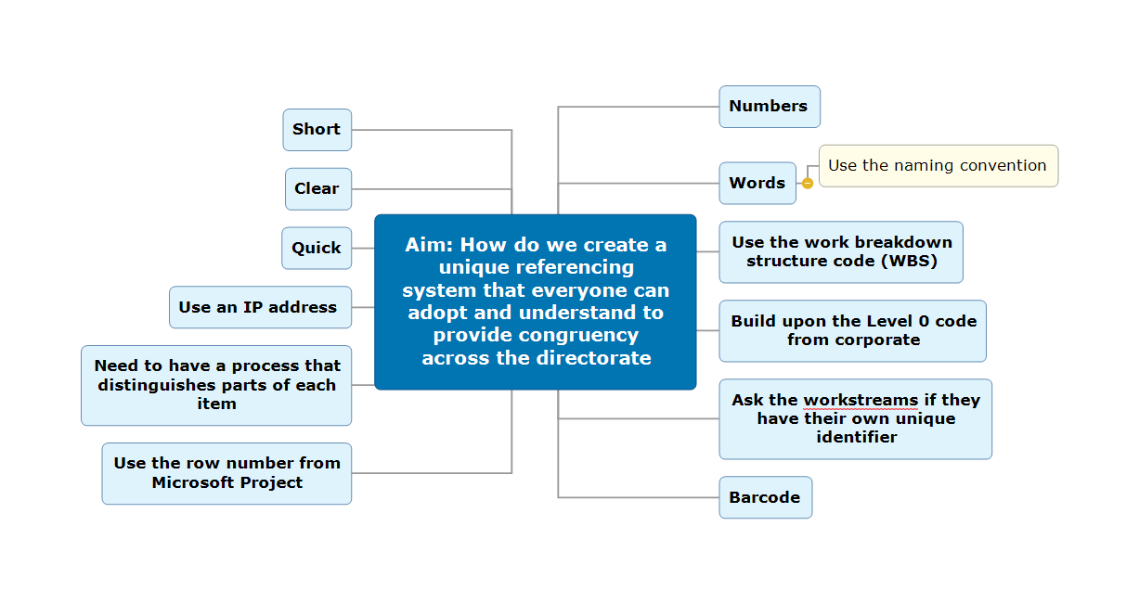
(MatchWare, 2021)

Appendix 5
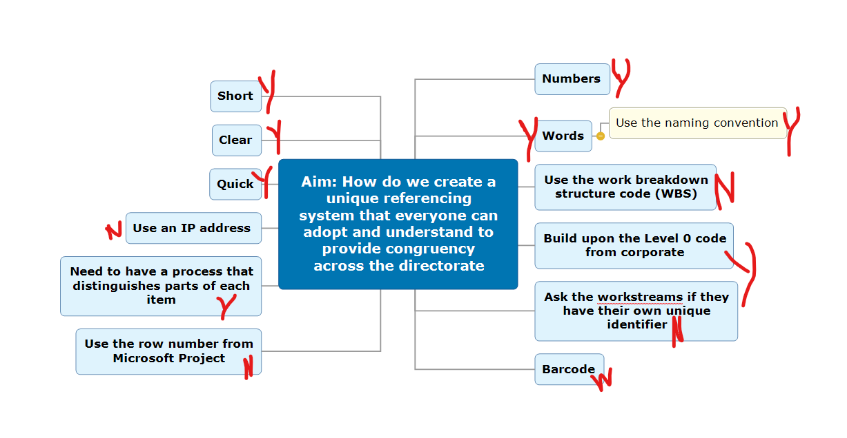
(MatchWare, 2021)

Appendix 6

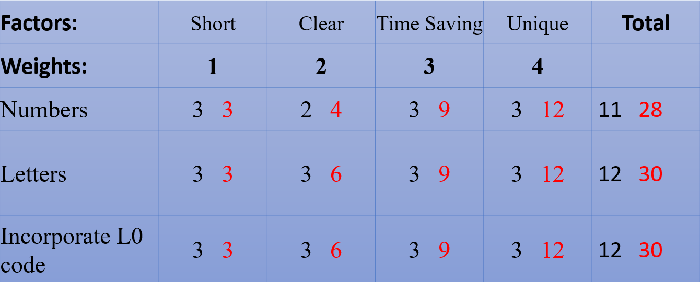
(Microsoft, 2021)

Appendix 7

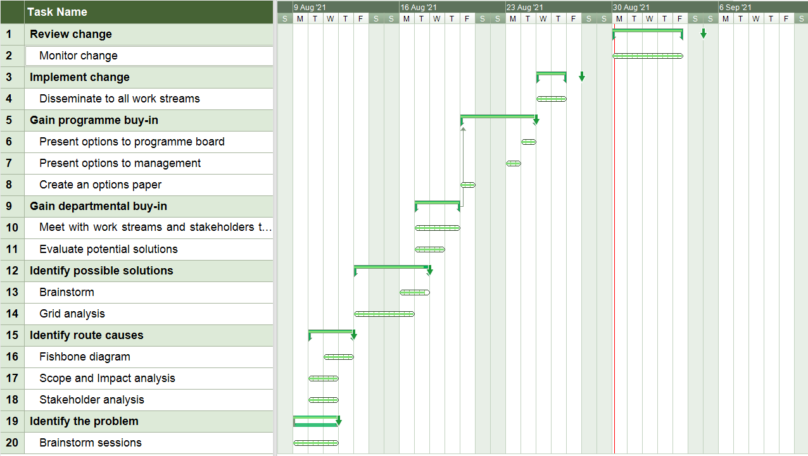
(MatchWare, 2021)

Appendix 8
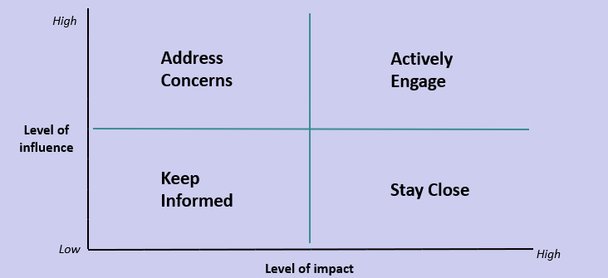
(Microsoft, 2021)

Appendix 9

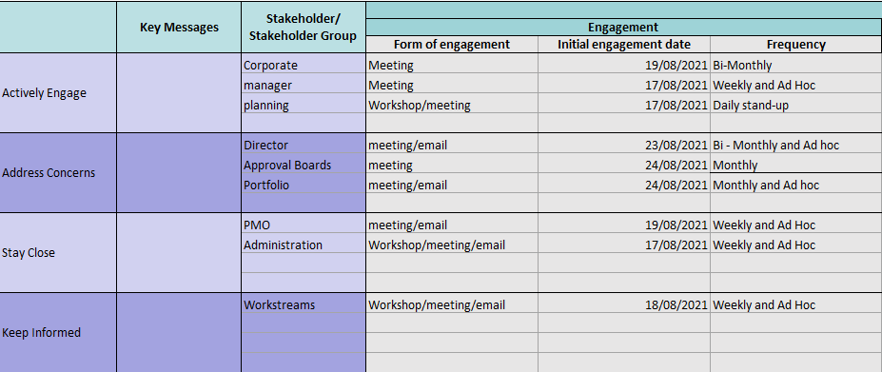
(Microsoft, 2021)

Appendix 10
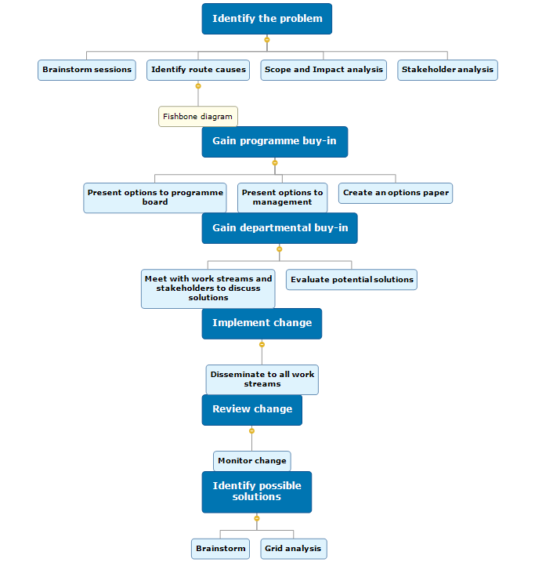
(MatchWare, 2021)

