Strategic Management for SMEs

Sustainable business strategy – GOODERY LTD

Kamil Kazimierz Lenczowski
Student ID: 2120445
Module: Strategic Management for SMEs
Programme: BA Leadership and Management Skills for the Workplace
BMSW6104
University of Wales Trinity Saint David

Contents
Introduction 4
The company strategic direction 5
Goodery’s vision 5
Goodery's mission 5
Critical analyses of external and internal environmental factors 6
PESTEL Analysis of Goodery, and E-commerce Business aspect 7
Political Factors 7
Economic Factors 7
Social Factors 7
Technological Factors 7
Environmental Factors 7
Legal Factors 8
SWOT Analysis of Goodery Ltd, Nottingham 9
Strengths 9
Weaknesses 9
Opportunities 9
Threats 10
Stakeholder mapping and analyses 11
Stakeholder theory (Ed Freeman) 11
Internal Stakeholders 11
External Stakeholder 11
Mendelow’s Matrix 12
Categories in Mendelow’s Matrix: 12
Goodery’s Market Analysis: 15
Internal Capabilities: 16
Comparison of Strategic Models 17
Ansoff Matrix 17
Porter’s Generic Strategic 19
Cost Leadership 19
Differentiation 20
Focus 20
Proposal for a New Strategy and Recommendations for Goodery Ltd 21
Proposal for a New Strategy (ANSOFF MATRIX) 21
Proposal for a New Strategy (Porter’s Generic Competitive Strategies) 21
Recommendations 23
Conclusion 25
Appendix 26
PORTER’S FIVE FORCES 26
References list 28

Introduction

This report explores the strategic management practices of Goodery, an SME based in Nottingham employing fewer than 20 people. Goodery operates in the organic food delivery sector, focusing on providing fresh, locally sourced organic produce. The company is dedicated to sustainability, evident through its use of eco-friendly packaging and electric vehicles for deliveries. Goodery's mission is to promote environmental stewardship while supporting local agriculture.
Goodery’s strategic direction emphasises sustainability and market differentiation by aligning with consumer preferences for environmentally responsible businesses. This analysis will evaluate Goodery's current strategies, its internal and external environments using PESTLE and SWOT tools, stakeholder expectations and potential growth strategies. By focusing on these areas, the report aims to demonstrate how Goodery can improve its competitive advantage and achieve sustainable growth.
To ensure sustainable growth and competitive advantage, strategic management is crucial for SMEs like Goodery Ltd.
This report will explore:
- Goodery Ltd's current strategies.
- The internal and external environments using PESTLE and SWOT tools.
- Stakeholder expectations and influences.
- Potential growth strategies to enhance competitive advantage.

The company strategic direction
Strategic management adopts planning for the long-term future of the business. Strategic management is the process of defining and executing major goals and plans by an organisation's top leaders. It involves analysing both the internal and external environments to create realistic strategies that improve performance and achieve long-term success. This approach balances theoretical concepts with practical actions, ensuring the organisation effectively address challenges and benefit from the opportunities within its broader economic context (White, C. 2004).
A clearly defined strategic management framework is crucial for a business's long-term success. It is essential to articulate core elements such as the mission and vision in clear statements. Understanding these components helps in grasping the company's objectives and direction. When the mission and vision are well-defined, they provide a clear roadmap for the organisation's goals and strategic initiatives, ensuring alignment and focus across all levels of the business.
Goodery’s vision, "Redesigning the local food chain by increasing organic growing and eating in East Anglia, one veg box at a time" outlines its long-term aspirational goal. This statement reflects the company's broader aim to transform the local food ecosystem and promote organic food consumption in East Anglia.
Goodery's mission, "Organic food and everyday essentials delivered fresh from local producers" describes its day-to-day operations and core purpose. It highlights the delivery of fresh organic food and essentials from local producers, emphasising the company's commitment to sustainability and local sourcing.
Goodery Ltd's current strategies align well with its mission and vision. For instance, the company has successfully implemented initiatives like partnering with local farmers and using electric vehicles for deliveries, which reinforce its commitment to sustainability and supporting local agriculture.

Critical analyses of external and internal environmental factors
Over the time, we can notice a high volume of e-commerce practices becoming more and more familiar. According to the article of the article 70+ eCommerce Statistics and Trends for 2024 written by Devis Sears and Tiffani Anderson, the changing market and trends are crucial for the development of e-commerce. Before the pandemic, consumers preferred physical stores for instant purchases. However, lockdowns triggered a surge in online shopping, changing consumer habits. Now, 90% of Americans primarily use e-commerce for shopping.
Understanding the current e-commerce trends for 2024 is essential for running an online business effectively. Analysing these trends, including product categories, demographics, regions, payment methods, and technologies, will help in adapting business strategies to a rapidly changing market (Sears, D. et al. 2024)
According to Goodery’s case study, they also perform on e-commerce platforms. To illustrate this, the chart above shows the significance of understanding the potential of e-commerce.

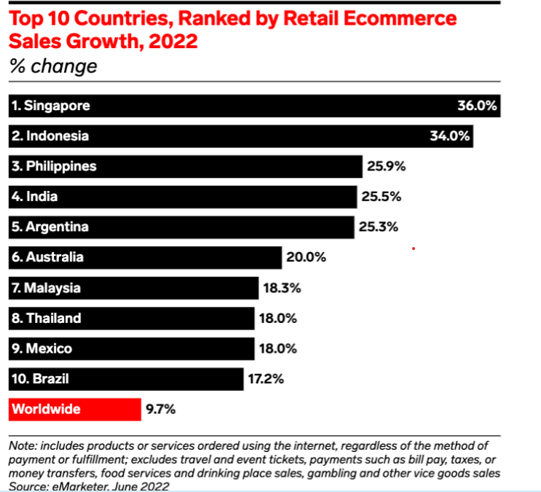
Figure 1: Countries ranking by the retail e-commerce
Goodery`s vision statement stands for "Redesigning the local food chain by increasing organic growing and eating in East Anglia, one veg box at a time," it align with the thoughts of Many businesses.
Sustainability and ethical consumerism are expected to gain further momentum. As consumers become more informed about sustainability practices and the environmental impact of consumerism, businesses will face increasing demands to contribute positively. This may lead to a rise in demand for refurbished or ecological products and influence shipping options, including considerations for carbon offsets, according to insights from Emerging Europe. (Sears, D. et al. 2024)

PESTEL Analysis of Goodery, and E-commerce Business aspect
A PESTLE analysis offers valuable insights into a company’s direction, brand positioning, growth goals, and potential productivity risks, such as a pandemic. It helps assess current products and services while guiding the development of new ones. (Parades, R., 2023).
This work aims to help understand the role of strategic planning. Focusing on PESTLE analysis will provide insight into how important these factors can be for the business.

Political Factors
Local government policies regarding e-commerce, business taxes, and consumer protection regulations impact their business. Additionally, any changes in local regulations related to digital business practices or internet sales can affect Goodery. Political stability and local government support for small businesses and digital transformation initiatives can further influence Goodery's business environment.
These political factors influence Goodery's ability to operate smoothly within Nottingham's local market.

Economic Factors
Economic conditions in the UK, particularly in Nottingham, significantly influence Goodery's performance. Local economic health, including employment rates and consumer spending power, directly impacts sales (Hayes, A. 2024). Inflation rates and changes in local economic policies also affect operating costs and pricing strategies. The overall economic growth and recovery post-COVID-19 have boosted local consumer confidence and spending, presenting opportunities for Goodery. (ELLISON, J. Goodery n.d.)
Goodery can take advantage of local government support for small businesses by participating in digital transformation initiatives.

Social Factors
Trends towards supporting local businesses and buying locally sourced products align with Goodery’s offerings. Consumer demand for convenience, health-conscious products, and ethical business practices are critical. (Sears, D. et al. 2024)

Technological Factors
Technological advancements are vital for Goodery's e-commerce success. Using modern e-commerce platforms, secure payment systems, and efficient logistics management tools improves customer experience and operational efficiency. Adopting technologies such as AI for personalised marketing and customer service can provide a competitive edge. Staying updated with technological trends and investing in the latest tools is essential for maintaining market relevance. (Yildirim, H 2023).
Goodery should invest in modern technologies to refine customer experience and operational efficiency.

Environmental Factors
Environmental factors are increasingly significant for Goodery. With a growing consumer focus on sustainability, Goodery's commitment to eco-friendly practices, such as using sustainable packaging and reducing waste, resonates well with customers. Compliance with local environmental regulations and active participation in green initiatives can build Goodery's brand image and attract environmentally conscious consumers. (Loredana, E. M. 2017)

Legal Factors
Legal factors affecting Goodery include compliance with local regulations on e-commerce, consumer protection, data privacy, and business operations. Adhering to laws such as the UK's Data Protection Act 2018 is crucial to avoid legal issues. (Data protection Act 2018) Additionally ensuring that all products meet local health and safety standards is necessary to maintain consumer trust and avoid regulatory penalties.
Conducting a PESTEL analysis provides Goodery with a comprehensive understanding of the external factors influencing their local business environment. By addressing political, economic, social, technological, environmental, and legal factors, Goodery can develop informed strategies to navigate challenges and capitalise on opportunities. This approach will support Goodery's sustainable growth and maintain their competitive position in the Nottingham market area.
A PESTLE analysis helps businesses understand their position, growth goals, and potential risks like a pandemic. It allows them to study the market and competition, evaluate current products, and plan for new ones.
By analysing external factors, PESTLE helps predict changes that can affect the business while being an extension of a SWOT analysis.
- Positive Changes (positive shocks) make the business’ products more attractive and increase sales.
- Negative Changes (negative shocks) make the business’ products less attractive and decrease sales. (Tarver, E. 2022)
Understanding these changes helps businesses protect themselves from risks and take advantage of opportunities. PESTLE analysis is essential for effective strategic planning and business resilience.
Understanding Shocks with PESTLE
Goodery can anticipate changes and prepare:
- Positive Shocks: Government support could increase sales.
- Negative Shocks: Economic downturns or new laws could reduce sales or increase costs.
Regular PESTLE analysis helps Goodery stay prepared for changes, ensuring growth and stability.

SWOT Analysis of Goodery Ltd, Nottingham

Strengths
Local Focus and Community Support: Goodery emphasises supporting local farmers and ethical businesses in Nottingham and the surrounding areas, creating a strong community connection and loyalty.​ (Goodery)​​
Sustainability Commitment: The company uses electric vehicles for deliveries and promotes low waste and zero carbon emissions, aligning with the increasing consumer demand for environmentally friendly practices.​ (Goodery)​​
Organic and Ethical Products: Goodery offers a wide range of organic and ethically sourced products, catering to the growing market for health-conscious and ethically minded consumers.​ (Goodery)​
Flexibility and Convenience: Customers can choose from seasonal boxes or build their own, with subscription options and flexible delivery schedules, enhancing customer convenience and satisfaction.​ (Goodery)​

Weaknesses
Limited Geographic Reach: Goodery currently serves primarily the local market in Nottingham and East England, which may limit its growth potential compared to competitors with a broader geographic reach.​ (Goodery)​
Dependence on Local Suppliers: The reliance on local producers can be a weakness if there are supply chain disruptions or if local production cannot meet increasing demand.​ (Goodery)​
Higher Costs: Organic and ethically sourced products typically have higher production costs, which can result in higher prices for consumers and potentially limit market segments. (Goodery)

Opportunities
Growing Demand for Organic Products: The increasing consumer awareness and demand for organic and sustainable products present significant growth opportunities for Goodery. (Goodery)
Expansion of Product Range: There is potential to expand the range of products offered, including more everyday essentials and specialty items, to attract a broader customer number. (Goodery)
Technological Advancements: Investing in advanced e-commerce technologies, personalised marketing, and customer relationship management systems (CRM) can improve customer experience and operational efficiency. (Goodery)
Community Engagement and Education: Engaging with the community through educational initiatives about the benefits of organic farming and sustainable living can further strengthen brand loyalty and customer base.​ (Goodery)

Threats
Market Competition: The e-commerce market is highly competitive, with larger companies having more resources to invest in technology, marketing, and logistics, posing a threat to Goodery’s market share. (Goodery)
Economic Downturns: Economic instability can impact consumer spending power, leading to reduced demand for premium-priced organic and ethical products (Goodery), however, the results for the consumption of fresh organic food shows that most consumers are prepared to pay a premium of between 5% and 10%. Income and the presence of organic labeling are significant predictors of willingness to pay, while environmental concerns and the place of purchase are not. (Watanabe, A. M. E., et al. 2023)
Regulatory Changes: Changes in local or national regulations related to organic certification, environmental standards or e-commerce operations could increase operational costs and complexity. (Goodery)
Supply Chain Disruptions: Dependence on local suppliers means that any disruption in local agriculture (due to weather, pests, or other factors) can directly impact Goodery's ability to meet customer demand. (Goodery)
By understanding these strengths, weaknesses, opportunities, and threats, Goodery Ltd can develop strategies to benefit from their advantages, mitigate their weaknesses, capitalise on opportunities, and prepare for potential threats in the dynamic e-commerce landscape.

Stakeholder mapping and analyses

Stakeholder theory (Ed Freeman)
Stakeholder analysis is a strategic process used to identify and evaluate the individuals or groups that can affect or are affected by the achievement of organisational objectives. This analysis helps to understand the interests and influences of various stakeholders and is crucial in making informed decisions that balance these interests. According to Ed Freeman’s stakeholder theory, a stakeholder is defined as “any group or individual who can affect or is affected by the achievement of organisational objectives.” (Alford, H. 2006)
It is pivotal for Goodery to allocate stakeholders in order to understand their power.
Stakeholders for Goodery Ltd, can be categorised into:

Internal Stakeholders
- Owners and shareholders: interested in profits and business growth.
- Employees: concerned with job security, working conditions and fair wages.

External Stakeholder
- Customers: people always interested in high quality products or services also customer service.
- Suppliers: supplier chain will be interested in stable business relationship and payments to be made on time.
- Local community: interested in all the business contribution to the local economy and environmental practices.
- Government and Regulators: concerned with compliance with laws and regulations, and tax payments.
- Investors and creditors: interested in financial stability and profitability of the business.
- Competitors: Affected by Goodery's actions and position in the market.

Mendelow’s Matrix
To understand how much influence stakeholders have on the business, use Mendelow’s Matrix which looks at two aspects:
Power: How much they can affect the project.
Interest: How much they want to help and improve the project.
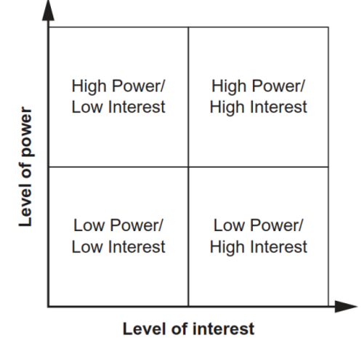
Figure 2: Mendelow's Matrix (Cadle, P. et al. 2014)

Categories in Mendelow’s Matrix:
Low Power, Low Interest: These stakeholders do not have much impact and are not very interested. Keep an eye on them in case their status changes.
Low Power, High Interest: They care a lot but cannot do much to affect the project. Keep them informed and watch their interest.
High Power, Low Interest: They can greatly affect the project but are not very interested. Give them attention to keep them engaged.
High Power, High Interest: They are very powerful and very interested. These are the most important stakeholders and need the most attention to make sure they stay supportive. (Yildirim, H. 2023)
Mendelow's Matrix can be adjusted to fit different needs, such as changing the position of stakeholders if necessary. This flexibility allows organisations to prioritise and manage their stakeholders more effectively by reassessing their level of power and interest over time.
Mendelow’s Stakeholder Matrix for Goodery Ltd
Low
Low
High
INTEREST
POWER
High

X Owners and Shareholders
X Employees
X Customers
X Suppliers
X Local Community
X Government and Regulators
X Investors and Creditors
X Competitors
Stakeholders
Figure 3: Mendelow’s Stakeholder Matrix for Goodery Ltd, prepared by the author

As mentioned, the grid can also show how to treat stakeholders:
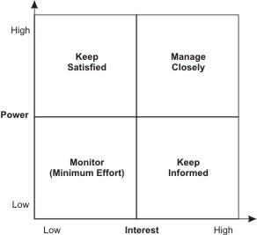
Figure 4: Source UWTSD power/Interest GRID.
Category | Stakeholder | Power | Interest | Strategy
Monitor (Minimal Effort) | Suppliers | Low | Low | Maintain stable relationships with minimal engagement.
 | Competitors | Low | Low | Monitor market behaviour.
Keep Informed | Employees | Low | High | Keep updated and involved.
 | Customers | Low | High | Regular updates and engagement.
 | Local Community | Low | High | Inform about company activities.
Keep Satisfied | Investors and Creditors | High | Low | Ensure regular financial and strategic updates.
Manage Closely | Owners and Shareholders | High | High | Prioritise their needs.
 | Government and Regulators | High | High | Maintain close relationships and legal compliance.

Table 1: Summarised table of stakeholders based on their power and interest, suggestion of appropriate strategy for managing each group.
This table effectively categorises stakeholders by their power and interest, and it provides a concise strategy for managing each group.

This work will also look at classical strategy, which is deeply analytical. The patron of this strategy is Michael Porter, who came up with the five forces approach to analyse the market. (Owen, J. 2021)
Different strategies such as Porter’s Five Forces and the Ansoff Matrix will be compared to develop a market-based strategy.

Goodery’s Market Analysis:
- Current Trends: There is a growing demand for local and organic products, which Goodery Ltd already offers.
- Competitor Analysis: Look at other companies selling similar products, both local businesses and larger national brands such as:

- Customer Insights: Nowadays it is important to listen what customers are saying about products and services to find ways to improve and create new products. (Barron S. B. 2021)

Internal Capabilities:
- Strengths: Goodery Ltd has strong ties to the community, a loyal customer base and a reputation for high-quality products.
- Weaknesses: The company faces challenges like limited production capacity and supply chain issues.
According to the owner of Goodery Ltd strategy, they emphasise the importance of maintaining high product quality and strong community relationships.
They believe when we buy produce from local organic suppliers, we make a huge difference to the impact our food habits have on the environment and economy of our region. (Goodery)

Comparison of Strategic Models
Ansoff Matrix
The Ansoff Matrix, created by the American planning expert Igor Ansoff, is a strategic planning tool that links an organisation's marketing strategy with its general strategic direction. It presents four alternative growth strategies in the form of a 2x2 table or matrix. One dimension of the matrix considers "product" (existing and new) and the other dimension considers "markets" (existing and new). (Loredana, E. M. 2017)
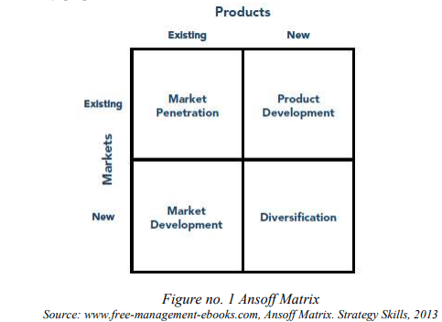
Table 3: Ansoff Matrix

According to an article of The Use of Ansoff Matrix in the Field of Business, the Ansoff Matrix is a strategic planning tool that helps organisations determine their product and market growth strategy. (Loredana, E. M. 2017). The matrix presents four growth strategies:
Market Penetration: Sell more existing products to the current market.
For instance, Goodery ltd would increase sales in Nottingham through improved marketing and customer engagement, such as loyalty programs and promotions.
Market Development: Sell existing products to new markets. GOODERY LTD would Expand to nearby regions by identifying new market segments and tailoring marketing strategies to attract new customers.
Product Development: Develop new products for the current market.
The way how GOODERY LTD would apply it is, they would create new products, like new flavours or packaging, to meet changing customer preferences and keep the product line fresh.
Diversification: Develop new products for new markets. GOODERY LTD would enter new markets, such as the wellness or health food market, by developing new products that align with these trends. This may involve research and development and forming strategic partnerships to facilitate market entry.

Porter’s Generic Strategic
According to the Harvard Business Review Manager`s handbook pp 261 (2017), once the business has a picture of how the changing external world effects them and what the company or their team looks like right now from the insight, it is time to think about direction for change. Christensen has advocated that strategy teams first prioritise the threats and opportunities they find (he calls them “driving forces” of competition) and then discuss each one in broad strokes. (Anonymous, 2017)
According to the Journal of Business and Management and the article Porter’s Generic Competitive Strategies by Ritika Tanwar, Porter's Generic Strategy is a framework that helps businesses gain a competitive edge. It includes three main strategies:
- Cost Leadership
- Differentiation
- Focus

This framework looks at the market size (strategic scope) and the company’s strengths (strategic strength). Porter says it is important for a company to choose one clear strategy to be successful. Companies that try to do everything for everyone often end up 'stuck in the middle' and do not achieve a strong competitive advantage. (Tanwar, R., 2013)
While Porter's Five Forces help companies understand what affects their competitiveness and profits, Michael Porter introduced Porter's Generic Strategies to show how a company can gain a competitive advantage. Those three key points indicate the areas where we should look at.
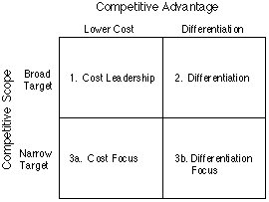
Figure 5: Porter's Generic Competitive Strategies (ways of competing) University of Cambridge

Michael Porter identified three main stages for the companies to be able and compete with others. According to University of Cambridge and their research Porter's Generic Competitive Strategies (ways of competing), the explanation of each component is as follows:

Cost Leadership
Cost Leadership is about trying to be the cheapest producer in the market. To achieve this, a company can produce large quantities, which will reduce costs. Another crucial aspect is to be efficient by streamlining operations to save money. Additionally, the company should focus on suppliers and buy cheaper raw materials to reduce costs. As a result of implementing these techniques, such as selling products at lower prices, the company will attract more customers.

Differentiation
Involves making products unique and better than competitors. This can be achieved by creating new, unique products, ensuring high quality, and building a strong, recognisable brand. By offering unique features and high quality, companies can charge higher prices.

Focus
It targets a specific group of customers. There are two types of focus strategies: cost focus and differentiation focus. Cost focus means being the cheapest in a small market segment. Differentiation focus means offering unique products for a small market segment, like Rolls Royce, which makes luxury cars for a wealthy clientele. By focusing on a specific market, companies can build strong loyalty among specific customers and face less competition. Rolls Royce offers high-end, customised luxury cars to attract a specific group of wealthy customers.

Proposal for a New Strategy and Recommendations for Goodery Ltd
To grow and overcome challenges, Goodery Ltd should adopt a multifaceted strategy that incorporates product diversification, market penetration, and regional expansion. According to Dennis Lock in his book of Handbook of Management (third edition, pp. 38-40, 1992), a comprehensive approach to organisational development is essential for sustainable growth. (Lock, D. 1992)
Currently, Goodery Ltd emphasises maintaining high product quality and strong community relationships. The company focuses on sustainability and local sourcing, using electric vehicles for deliveries and partnering with local farmers. To further improve its market position, Goodery should expand its strategies as follows:

Proposal for a New Strategy (ANSOFF MATRIX)
Market Penetration: Increase sales in Nottingham through improved marketing and customer engagement, such as loyalty programs and promotions.
Market Development: Expand to nearby regions by identifying new market segments and adapting marketing strategies to attract new customers.
Product Development: Create new products, like new flavours or packaging, to meet changing customer preferences and keep the product line fresh.
Diversification: Enter new markets, such as wellness or health food, by developing new products aligned with these trends. This may involve research and development and forming strategic partnerships.

Proposal for a New Strategy (Porter’s Generic Competitive Strategies)
Goodery Ltd should adopt a Differentiation strategy by focusing on their unique, high-quality organic products and sustainable practices. Collaborate with local organic farmers to ensure a consistent supply of fresh produce, which will build customer trust and allow for premium pricing. Use electric vehicles for deliveries and highlight this eco-friendly practice in marketing to attract environmentally conscious consumers. Develop innovative products, such as gourmet organic meal kits with locally sourced ingredients, to meet the needs of busy professionals who prioritise health and convenience. (It would be profit if they could apply HelloFresh similar products and services).
Additionally, target eco-conscious and health-conscious customers by tailoring marketing efforts to highlight the health benefits of organic products and the positive environmental impact of sustainable practices. Offer personalised subscription services, such as curated organic product boxes based on customer preferences, to enhance convenience and build long-term relationships. Engage with the local community by hosting organic gardening workshops and partnering with local health clubs for co-branded promotions. This approach will help maintain high standards, ensure customer loyalty, justify premium pricing, and uphold Goodery’s brand integrity.

Recommendations
Invest in Digital Transformation: Develop a competitive e-commerce platform to improve online customer experience and reach a broader audience.
Improve digital marketing using social media, SEO and email campaigns to attract and retain customers. (Steinbrink, K. 2024)
Carry out data analytics to understand customer preferences and personalise marketing strategies. (Mehta J, 2023)
Expand Geographical Reach: Implement a market development strategy by expanding into nearby regions.
Conduct market research to identify new target areas and tailor marketing strategies to local preferences.
Establish partnerships with local delivery services to ensure efficient distribution in new markets.
Diversify Product Offerings:
Focus on product development by introducing new, health-focused, and eco-friendly products.
Regularly survey customers to identify emerging trends and preferences and innovate accordingly.
Consider seasonal and limited-edition products to create excitement and attract repeat purchases.
Boost Customer Engagement:
Implement loyalty programs and offer incentives to increase customer retention.
Establish a feedback mechanism to gather customer insights and improve service quality.
Engage with the community through events and collaborations with local organisations to strengthen brand loyalty.
Optimise Supply Chain and Operations:
Improve supply chain efficiency by diversifying suppliers and negotiating long-term contracts.
Adopt sustainable practices such as using eco-friendly packaging and reducing waste.
Invest in technology to streamline operations and enhance productivity.
Focus on Sustainability Initiatives:
Maintain and promote eco-friendly practices to appeal to environmentally conscious consumers.
Participate in local and national sustainability programs to enhance brand reputation.
Educate customers about the environmental benefits of choosing Goodery’s products through marketing campaigns.
By implementing these recommendations, Goodery Ltd can strengthen their market position, achieve sustainable growth, and maintain their commitment to quality and community focus. These strategies will help Goodery navigate challenges and capitalise on opportunities in the dynamic e-commerce landscape. However, company should consider applying more than one strategy on board as combined strategy can be more effective.

Conclusion
Goodery Ltd, a small enterprise in Nottingham, operate in the organic food delivery sector with a strong emphasis on sustainability. The company's strategic alignment with eco-friendly practices and local agricultural support positions it favourably within the market. This report has analysed Goodery's strategic management practices through tools such as PESTLE and SWOT, revealing significant growth opportunities and potential challenges.
The increasing consumer demand for organic and sustainable products presents a substantial opportunity for Goodery. However, the company must navigate competitive pressures and economic fluctuations. To improve their competitive advantage and ensure sustainable growth, several strategic initiatives has been recommended.
First, Goodery should consider expanding their geographical reach to nearby regions, thereby increasing their customer base. This can be achieved through targeted marketing strategies and establishing partnerships with local delivery services.
Second, product diversification is crucial. By developing new, health-focused, and eco-friendly products, Goodery can cater to evolving consumer preferences and create excitement through seasonal or limited-edition offerings.
Third, investing in digital transformation is essential. Improving their e-commerce platform and using advanced technologies for personalised marketing and customer relationship management will improve operational efficiency and customer satisfaction.
Lastly, community engagement and sustainability initiatives should remain a priority. Implementing loyalty programs, gathering customer feedback, and participating in local sustainability programs will strengthen brand loyalty and community support.
By adopting these multifaceted strategies, Goodery can navigate the dynamic e-commerce landscape, improve their market position and achieve sustainable growth. These efforts will not only boost Goodery's competitive advantage but also reinforce their commitment to environmental stewardship and support for local agriculture.

Appendix

PORTER’S FIVE FORCES
According to the article "The Five Competitive Forces That Shape Strategy" (2008) by Michael E. Porter in the Harvard Business Review, Porter's Five Forces is a model that helps organisations analyse their competitive environment. The model examines five key forces:
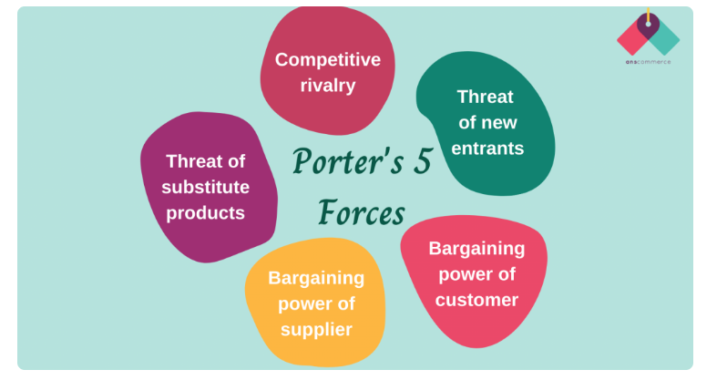
Table 2: Porter’s 5 forces source https://www.linkedin.com/pulse/why-porters-5-forces-important-driving-business-manish-prajapat
Threat of New Entrants: This force looks at how easy or difficult it is for competitors to join the market.
For instance, Goodery Ltd needs to look at barriers to entry, like how much money is needed to start and how loyal customers are to existing brands. By building strong relationships with customers and offering unique products, Goodery Ltd can make it harder for new competitors to enter the market.
Power of Suppliers: This looks at how much power suppliers have over prices.
Goodery Ltd can reduce supplier power by having multiple suppliers, negotiating long-term contracts, and building strong relationships with suppliers to avoid depending on just one source.
Power of Buyers: This looks at how much power customers have to influence prices.
At Goodery ltd they should continuously innovate to offer products that are better than alternatives. By keeping up with market trends and offering high-quality, unique products, Goodery Ltd can make substitutes less attractive.
Competitive Rivalry: This looks at how intense the competition is within the industry.
Goodery Ltd can stand out through unique branding, high product quality, and great customer service. Competitive pricing and strategic partnerships can also help Goodery Ltd stay ahead of rivals.

References list
Alford, H. (2006) Stakeholder theory. In Proceedings of the VI International Conference on Catholic Church Social Thinking and Manager Education, The Good Company. Catholic Social Thought and Corporate Social Responsibility in Dialogue, Rome (Vol. 57).available at: https://www.oikonomia.it/images/immagini_X_Articoli/2007/2007_giugno/pdf/05_studi_Helen%20alford.pdf
Anonymous (2017) Strategy: A Primer, Managing the Business, Harvard Business Review, Manager’s Handbook, The 17 Skills Leaders Need to Stand Out, Chapter 5, pp. 261-262.
Anonymous (2017) The Ansoff Matrix, Understanding the Risks of Different Options, Michigan Scouting, available at: https://michiganscouting.org/wp-content/uploads/2017/11/The-Ansoff-Matrix.pdf
Anonymous n.d. Connected, Creative, Competitive Nottingham, The Nottingham City Deal, Nottingham City Council, available at: https://assets.publishing.service.gov.uk/media/5a7f756aed915d74e622a94d/Nottingham-City-Deal-final.pdf
Anonymous n.d. PESTLE : How to do this analysis ?, E-commerce Nation, available at: https://www.ecommerce-nation.com/pestle-analysis-free-template/
Anonymous n.d. Redesigning the local food chain by increasing organic growing and eating in East Anglia, one veg box at a time..., Goodery, available at: https://goodery.co.uk/
Anonymous n.d. The Data Protection Act 2018, UK Government, available at: https://www.gov.uk/data-protection
Barron, S. B. (2021) Why (& How) You Should Actually Listen to Your Customers, HubSpot, available at: https://blog.hubspot.com/service/listening-to-customers
Beattie, A. (2022) The Pitfalls of Porter's Five Forces, Investopedia, available at: https://www.investopedia.com/articles/investing/103116/pitfalls-porters-5-forces.asp
Hayes, A. (2024) Understanding Purchasing Power and the Consumer Price Index, Investopedia, available at: https://www.investopedia.com/terms/p/purchasingpower.asp
Kutin, N. (2014) Presentation of the report on "Stakeholders's Analysis Within the Context of Maritime and Inland Waterways Observatory of Cambodia", available at: https://www.researchgate.net/profile/Nikola-Kutin-2/publication/282973869_Presentation_of_the_report_on_Stakeholders's_Analysis_Within_the_Context_of_Maritime_and_Inland_Waterways_Observatory_of_Cambodia/links/5624a47c08aed8dd1948cf69/Presentation-of-the-report-on-Stakeholderss-Analysis-Within-the-Context-of-Maritime-and-Inland-Waterways-Observatory-of-Cambodia.pdf
Lambert, D. M. (2009) Customer relationship management as a business process, Journal of Business and Industrial Marketing 25(1):4-17, available at: https://www.researchgate.net/publication/235271019_Customer_relationship_management_as_a_business_process
Lin, Y., Fan, D., Shi, X., Fu, M. (2021) The effects of supply chain diversification during the COVID-19 crisis: Evidence from Chinese manufacturers, Transportation Research Part E: Logistics and Transportation Review, Volume 155, available at: https://www.sciencedirect.com/science/article/pii/S1366554521002556
Lock, D., Boyle D. (1992) The strategic planning process, Handbook of Management, Third edition, Gower Publishing, Company, pp 24-33.
Loredana, E. M. (2017) The use of Ansoff Matrix in the field of business, University of TG-Jiu, available at: https://www.utgjiu.ro/revista/ec/pdf/2017-02.Volumul_2_Special/21_EcobiciL.pdf
Mehta, J. (2023) The benefits and challenges of implementing personalized marketing, ABMATIC AI, available at: https://abmatic.ai/blog/benefits-and-challenges-of-implementing-personalized-marketing
Mekić, E., and Mekić, E., 2013. Supports and Critiques on Porter's Competitive Strategy and Competitive Advantage. IOSR Journal of Business and Management (IOSR-JBM), 15(1), pp. 11-17. Available at: https://www.researchgate.net/publication/266967720_Supports_and_Critiques_on_Porter's_Competitive_Strategy_and_Competitive_Advantage
Ormanidhi, O., Stringa, O. Porter's Model of Generic Competitive Strategies. Bus Econ 43, 55–64 (2008). https://doi.org/10.2145/20080305
Owen, J. (2021) The leadership skills handbook, 100 essential skills you need to be a leader, Fifth edition, Kogan Page, pp 252-256.
Paredes, R. (2023) Using PESTLE Analysis in Strategic Business Planning, Safety Culture, available at: https://safetyculture.com/topics/pestle-analysis/
Peterdy, K. n.d. Ansoff Matrix, The Product/Market Expansion Grid, Corporate Finance Institute, available at: https://corporatefinanceinstitute.com/resources/management/ansoff-matrix/
Phan, S. T. (2021) The effect of PESTLE factors on development of e-commerce, International Journal of Data and Network Science, available at: https://www.researchgate.net/publication/348131882_The_effect_of_PESTLE_factors_on_development_of_e-commerce
Phillips, R. A. (2011) Stakeholder Theory, Impact and prospects, Edward Elgar Publishing, available at: https://books.google.co.uk/books?hl=en&lr=&id=6TjaV8vNZO4C&oi=fnd&pg=PR1&dq=Stakeholder+theory+(Ed+Freeman)&ots=lkohVvubps&sig=FVRNbEGrTn5Xzi-ZgrSloTdybLk#v=onepage&q=Stakeholder%20theory%20(Ed%20Freeman)&f=false
Porter, M. E. (2008) The Five Competitive Forces That Shape Strategy, Harvard Business School, available at: https://www.hbs.edu/faculty/Pages/item.aspx?num=34522
Prajapat, M. (2023) Why Porter's 5 forces are important for driving the business analysis?, E-commerce Made Easy in India, LinkedIn, available at: https://www.linkedin.com/pulse/why-porters-5-forces-important-driving-business-manish-prajapat
Sears, D., Anderson, T. (2024) 70+ eCommerce Statistics and Trends for 2024, Bluehost, available at: https://www.bluehost.com/blog/ecommerce-statistics/
Steinbrinck, K. (2024) Email Marketing and SEO Strategies: What are the Connections?, Email on Acid, available at: https://www.emailonacid.com/blog/article/email-marketing/seo-connections/
Tanwar, R., 2013. Porter’s Generic Competitive Strategies. IOSR Journal of Business and Management (IOSR-JBM), 15(1), pp. 11-17. Available at: https://www.researchgate.net/profile/John-Yanney/post/What-is-best-research-instrument-to-measure-porters-strategy-of-differentiation-cost/attachment/59d6438579197b807799ef67/AS%3A443993927491586%401482867809983/download/PGS+2.pdf
The Dorset Meat Company (2024) Gourmet Meals. Available at: https://www.thedorsetmeatcompany.co.uk/product-category/chef-prepared/gourmet-meals/ (Accessed: 7 July 2024).
Thompson, G. D. (1998) Consumer Demand for Organic Foods: What We Know and What We Need to Know, American Journal of Agricultural Economics, Vol. 80, No. 5, Proceedings Issue, pp. 1113-1118, available at: https://www.jstor.org/stable/1244214
Watanabe, E. A. M., Alfinito, S., Branco, T. V. C., Raposo, C. F., Barros, M. A. (2023) The Consumption of Fresh Organic Food: Premium Pricing and the Predictors of Willingness to Pay, Journal of Food Products Marketing, 29(2–3), 41–55., available at: https://www.tandfonline.com/doi/ref/10.1080/10454446.2023.2185118?scroll=top
White, C. (2017) Strategic Management, Bloomsbury Publishing, available at: https://books.google.co.uk/books?hl=en&lr=&id=V5lGEAAAQBAJ&oi=fnd&pg=PR1&dq=strategic+management+&ots=JpciKY2xVJ&sig=6h3M-ep12ii1yfym0nowGDDRdzs#v=onepage&q=strategic%20management&f=false
Wood, A. (2022) PESTLE Analysis Examples, On Strategy, available at: https://onstrategyhq.com/resources/pestle-analysis-examples/
Yildirim, H. (2023) Building a Stakeholders’ Map of R&I in Europe, Master Thesis, pp. 6-22, available at: https://upcommons.upc.edu/bitstream/handle/2117/388361/memoria.pdf?sequence=2&isAllowed=y

