COMPONENT 1- ESSAY
INNOVATIVE MOBILE COVERS WITH INBUILT POWER-BANK AND SOLAR PANELS

Ahammed Azharudeen Master house
2229990
Program of study: MBA
Module name and code: Entrepreneurship LCMB7004
Lecturer name: Jayalakshmi Gopalkrishnan
Contents
Introduction 2
Overview of proposed business idea 2
Identification of gap in the market 3
Analysing the ways this business idea aims to identify the gap 4
Proposed location of the business along with its legal entity 6
Describing the SWOT analysis of the proposed business 6
Explanation of the target market 7
Evaluating the strategies adopted by the business for capturing the target market 8
Financial planning with funding requirements 10
Potential external funding source with the justification of choices 11
Financial Plan for Investors 11
Conclusion 12
References 13
Appendices 15

Introduction
This essay is all about the discussion of new business ideas, innovative mobile covers with inbuilt power bank and solar panel additionally a slide cover for panel, for understanding the importance of renewable energy in the business process. Overviewing of the proposed idea along with identified gaps and locations will be described which allows for conducting the SWOT framework for evaluating the strengths, weaknesses, opportunities and threats. Moreover, business strategies will be discussed to capture the target markets and the financial requirements along with external funding sources which will help in supporting the business idea to achieve the long-term sustainable goal shortly.

Overview of proposed business idea
The proposed business idea is to manufacture innovative mobile covers with inbuilt power banks and solar power, which means mobile covers will seamlessly integrate a power bank with foldable solar panels. The modern technological world is continuing to upgrade day by day to seek a credible energy source for ensuring a promising ground, with this innovation, Photovoltaic energy may be produced with the help of solar energy (Soomar et al., 2022). The motive of maintaining this innovative business idea allows the mobile covers to harness renewable energy from the sun, eliminating reliance on fossil fuels and focusing on a more sustainable future. In the context of this business idea, conventional power banks are inconvenient and bulky while solar power provides a green alternative which supports the users to drive the need for portable power solutions. Justification for this business idea is that these mobile cover designs give the users a portable and convenient power source which reduces the requirements for constant charging, durable and stylish covers add a personal touch to mobile phones by giving a combination of aesthetic and functionality. One main target for supporting this solar energy application scheme in products is to reduce the costs of capital which lowers the risks for projects developed and may create sustainable results (Eicke, Eicke and Hafner, 2022, p.157-169).
This new business idea of manufacturing the mobile cover with solar panels and battery power system is connected with the United Nations Sustainable Development Goals (SDG 7 and 13) which are SDG 7 for affordable and clean energy and SDG 13 for climate action positively. Using this business idea enhances the battery life due to solar-powered phone cases, with the help of SDG 7, solar power banks convert sunlight into electric energy and stored energy may be utilised to change mobile devices through USB ports. This business idea has the aim of following SDG 13 in a way of reducing carbon emissions and identifying the environmental challenge, the environmental impact of using this mobile cover is positive by eliminating reliance on non-renewable energy sources. The energy sustainability framework insists the business follow the application of solar energy to achieve the goal in a way of creating a positive impact on the environment and economic development (Maka and Alabid, 2022).
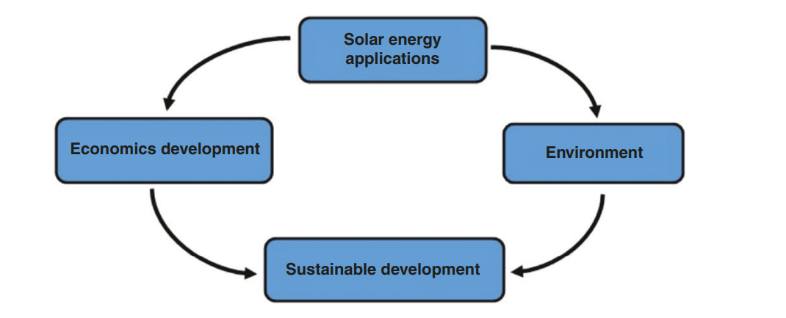
Figure 1: Energy sustainability framework
(Source: Maka and Alabid, 2022)

Identification of gap in the market
The market gaps are identified through Porter's five forces which summarise the high market competition, high bargaining power of customers, substitute and new entrants and high impact allowing the business to think about the application of solar panels for conversion of sun into electricity. The reason for high market competition is to use of renewable energy in the business process or product by the competitor company for meeting the sustainable business goals, which allows the new business to adopt these strategic moves. Through this gap, the importance of SDG 7 goals has been addressed in a way of getting access to reliable, affordable and modern energy services to reduce the global challenge, for example, 13% of the worldwide population lacks access to modern electricity, identified as a gap (He et al., 2022).
Growing customer satisfaction in using sustainable products or services by the company may create gaps for the existing companies which are not focusing on solar energy and minimise the profitable market by increasing the customer's bargaining power and substitutes. The companies are not using solar energy in the business process or product manufacturing, the gap is that those companies are faced with high competition, not maintaining sustainability and not achieving sustainable goals. According to this graph, the global solar energy market will reach 422 billion U.S. dollars in 2022 from 86 billion U.S. dollars in 2015 which identifies the importance of using solar energy in business that creates a gap for the companies which are not using it yet (Alves, 2023).
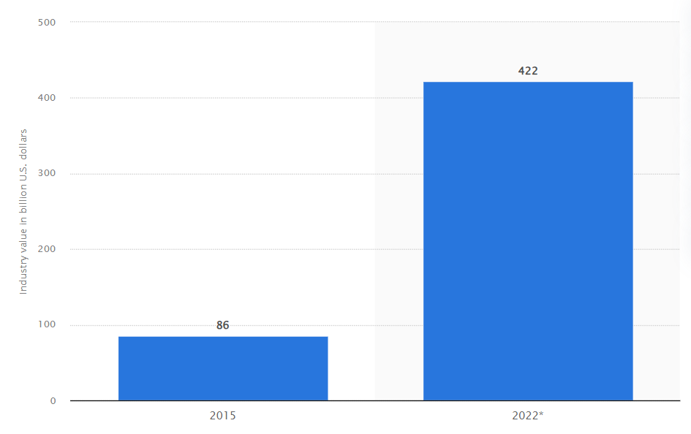
Figure 2: Global solar energy market
(Source: Alves, 2023)

Analysing the ways this business idea aims to identify the gap
This business idea may help in achieving the aim of increasing demands for sustainable mobile accessories by identifying the gap such as high competition, which means if the company has to remove the high competition then it may meet the business idea aim. For instance, the current market statistics of global mobile phone accessories are expected to reach $367.5 billion by 2027 with this business idea of building solar panels and power banks in mobile cover (Laricchia, 2023). This statistic identifies that the high substitute market for mobile cover production companies will be under control if the new business ideas are followed by all mobile cover companies. The requirements for eco-friendly mobile accessories as the business aim is steadily met by the companies by focusing on environmental concerns similar to electronic wastes in landfills and the use of fossil fuels in traditional power generation.
By removing the environmental impact by adopting solar energy in mobile cover, the companies reduce another gap of high level of new entrants in the industry, which has created a strong brand reputation for sustainability and innovation. This sustainability and innovation have dealt with technology-specific subsidies and regulations that have been identified to influence the adoption of the solar model in a region or country (Altunay, Bergek and Palm, 2021). The business aims to increase revenue after following the sustainable strategy of solar energy in a way of enhancing customer satisfaction which in turn develops the customers' loyalty towards the purchasing power of the company. Therefore, the market gaps such as customers' bargaining power, high impact of new entrants and competitive rivalry have been mitigated through this innovative business idea.
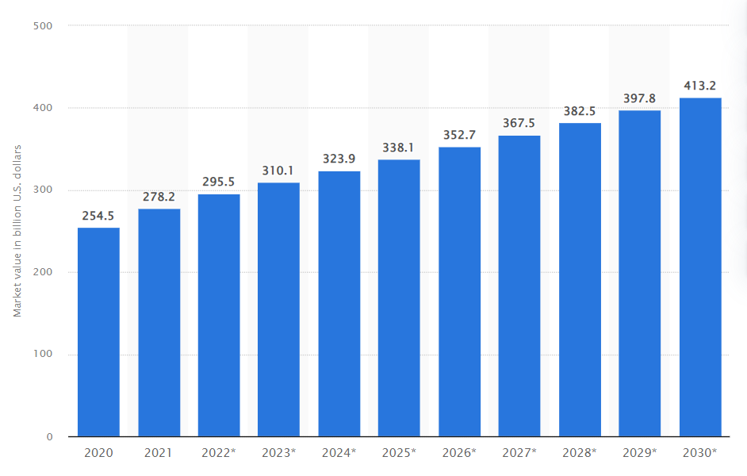
Figure 3: Global phone accessories market size
(Source: Laricchia, 2023)

Proposed location of the business along with its legal entity
The UK is the ideal country for the proposed location of this business as 87% of the adults in the UK use smartphones along with the second-highest smartphone penetration rate at 78.9% which influenced the new business idea to start this business in the UK for generating higher revenue (Refer to Appendix 1). The legal entity that has been followed by this business idea in the UK is Intellectual Property Rights (TRIPS), bilateral free trade agreements involving EU-UK Cooperation and Trade Agreements 2020 which allows the business to bring long-term success (Bently et al., 2022). Both are justified with the business idea properly, for instance, the UK location allows the business to get a huge range of customers and generate the highest sales, similarly, legal entities bring corporate success.

Describing the SWOT analysis of the proposed business
Strengths | 1. Innovative business ideas with unique product concepts of in-building power banks and solar panels are the greatest strength of fulfilling sustainability  2. Durable and stylish design of the products for increasing the diverse performances  3. Reducing the operational costs by using solar energy as this is cheaper rather than another energy source (Rabaia et al., 2021)  4. Focusing on the eco-friendly strategy which is aligned with growing sustainability trends
Weaknesses | 1. Being new business innovation planning, production capacity is initially limited, considered a weakness  2. Lack of knowledge or education of the employees regarding new sustainable ideas  3. Weakness is that the charging system depends on the weather conditions as solar power only transfers into electric power when the weather condition is favourable (Maradin, 2021)
Opportunities | 1. UK political stability and good political relationship with neighbouring countries support growing demands for sustainable mobile accessories  2. Collaboration or establishing partnerships with solar energy companies to manufacture mobile phone brands for product integration  3. Expansion opportunities of the business are enhanced by maintaining the SDG goals
Threats | 1. Rapid technological changes  2. High rivalry in the industry of the UK market is the reason for the threat of this business to achieve the ultimate goal of increasing the demand for mobile accessories  3. Brexit hurts the creation of economic and governance challenges and puts the business in a problematic situation (Billing et al., 2021)
Table 1: SWOT analysis
(Source: self-created)

Explanation of the target market
The country of the UK will be considered to be the target market where STP (Segmentation, targeting and positioning) will be used to provide essential power bank-enabled mobile covers for UK consumers.
Segmentation
The process by which potential customers have been easily identified based on psychographics, demographics and variables of behaviour is considered to be segmentation (Huang, 2021). The segmentation will done within the UK market through demographic segmentation where the young and middle-aged both male and female groups will be identified for this innovative product
Targeting
Targeting will be done among middle and young-aged consumers of different genders from 18 to 35, who effectively use smartphones and tablets for official and university purposes and needs of a unique power bank. The needs and wants of the specified customers are required to be identified by the companies for market targeting, which may be done through micro-targeting (Hollebeek et al., 2019)
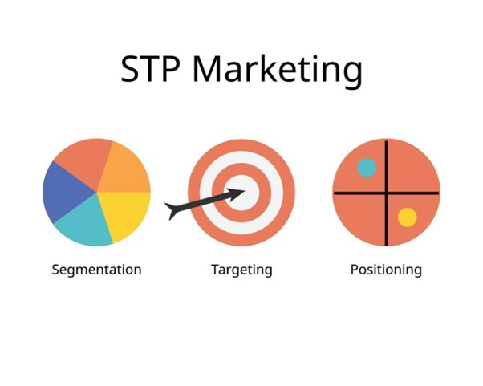
Figure 4: Attributes of STP
(Source: Hollebeek et al., 2019)
Positioning
Positioning of the sustainable business idea in the form of power bank-enabled innovative models covered with attached solar panels will be done through the designing of different promotional strategies in social media to generate a sense of attraction among middle and young-aged consumers.

Evaluating the strategies adopted by the business for capturing the target market
The aspects of the marketing funnel may be implemented to set up strategies for capturing the target market of the UK based on its solar power-enabled battery charging mobile covers.
Awareness
Based on brand awareness the company needs to attract consumers to make the product recognised by making it attractive and usable and to provide a brand message through that awareness specifically in terms of values, tone, culture, name and messaging (Amazon.com, 2023). The sustainable business idea of power bank-enabled mobile covers may be taken into consideration and awareness among the specified UK consumers will be done through different traditional media such as Billboards and Televisions as well as social media such as Facebook and YouTube. Similarly, the product appears to be a mobile cover with innovative mobile covers with solar panels and an inbuilt power bank, which will be sold in the UK market as of the 4p marketing mix.
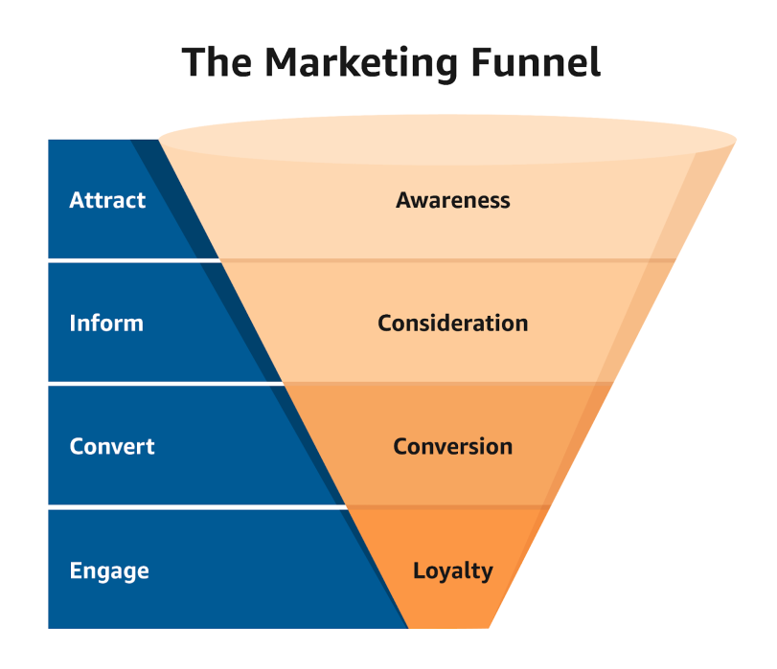
Figure 5: Attributes of Marketing Funnel
(Source: Amazon.com, 2023)

Consideration
Based on the consideration stage of the marketing funnel, the pain points of the consumers belonging to the targeted market of the UK will be identified to make consumers consider the innovative product of solar panels enabled power bank mobile covers. Different promotional campaigns such as webinars may be conducted and similarly, seminars may be conducted at the University level to make students consider this product. The product of innovative mobile products will be launched through adaptation of the pricing strategy of premium pricing.
Conversion
Based on the conversion stage of the marketing funnel, a sense of encouragement may be made among the targeted consumers that using innovative mobile covers with solar panels and inbuilt power banks may be the right product for the consumers. The benefits of this innovative product may be provided through specific advertisements where the benefits of this product may be provided, which may be more useful than a simple power bank or charger, which may further improve the conversion rate. Both the online and offline platforms will be used to sell this innovative product based on the place aspect of the 4p marketing mix.
Loyalty
A seamless experience may be provided to the specified consumers while buying and using the innovative product of mobile covers having an in-built charging facility, which may be done through providing discounts and offers on that product and different promotional campaigns may be further implemented to make this innovative product more affordable. Promotion of repeated purchasing and improvement in the customer's relationships towards the product may be done through different loyalty programs (Chen et al., 2021).

Financial planning with funding requirements
Resources | Expenses for adopting those resources
Research and Development | £2500
Costs for packaging and manufacturing | £3500
Strategies for promotion and marketing | £1500
Costs for distribution Channels | £2000
Technologies | £ 3500
Cost of Operations | £ 2000
Total | £ 15000
Table 2: Financial Planning of the required resources
(Source: Self-Created)
A financial plan has been created to specifically mention the resources which are required to be used for creating the readymade innovative product of mobile covers having an inbuilt power bank and solar panels, thus each of the resources has individual expenses. Thus expenses have been calculated for each of the adobe mentioned resources and others as per the above table which amounts to £5 Million.

Potential external funding source with the justification of choices
An investment strategy is required for getting funds to manage each of the individual expenses mentioned in the financial budget which may be done through getting a financial investor or group of financial investors, who will help to provide expenses in return for the financial goals. Taking help from angel investors may be done to get funding for the expenses required for adopting the resources to produce and launch the innovative product of mobile covers with solar panels enabled charging facility. Angel Investors may be wealthy person, who appears to be investing in this new business venture within the early stages to investments in the long term within the future (Bdc.ca, 2023). Angel Investors such as Bristol Equity Private Club, Angel Investment Group and 24 Haymarket may help to provide funds to make this new business idea successful.

Financial Plan for Investors
The above-mentioned Angel Investors should invest in this new business idea as the company may provide long-term returns to these inventors by earning a high amount of profits. The estimated profit of this new business idea of power banking facility-enabled mobile covers appears to be 2 Million GBP within the financial year 2024, which will further increase within the next few years.
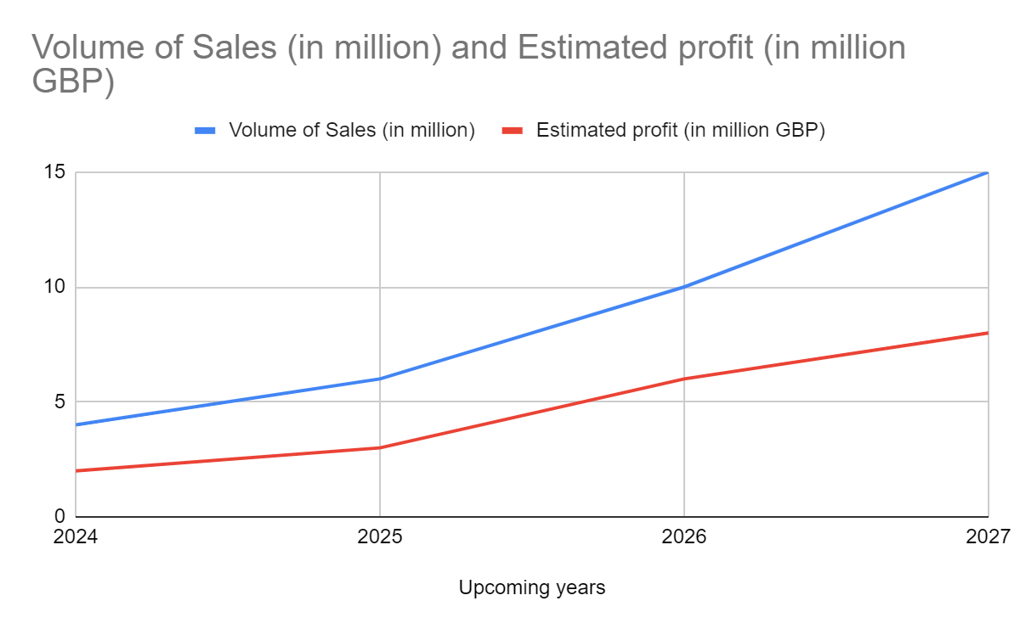
Figure 7: Estimated Volume of Sales and Profit
(Source: Self-Created)

Conclusion
It has been observed that the sustainable business idea of a power bank facility-enabled mobile cover with equipped solar panels may be successful within a developed market of the UK as the customers may be attracted through this newly launched innovative product. Implementation of STP and the aspects of the marketing funnel may contribute to successfully launching this marketing plan within the targeted market and similarly, Angel Investors may effectively contribute to providing funds for this business plan.

References
Altunay, M., Bergek, A. and Palm, A., 2021. Solar business model adoption by energy incumbents: the importance of strategic fit. Environmental Innovation and Societal Transitions, 40, pp.501-520.https://doi.org/10.1016/j.eist.2021.10.013
Alves, B. (2023) Solar Power Market Value globally 2022, Statista. Available at: https://www.statista.com/statistics/217177/global-projected-growth-of-solar-power-by-2020/ (Accessed: 18 December 2023).
Amazon.com, (2023). What is marketing funnel? Hoe they work, stages and examples-The library,. Available at: https://advertising.amazon.com/library/guides/marketing-funnel#:~:text=The%20marketing%20funnel%20is%20a,with%20customers%20along%20their%20journey. (Accessed: 18 December 2023).
Bdc.ca, 2023. What is an angel investor BDC.ca. Available at: https://www.bdc.ca/en/articles-tools/entrepreneur-toolkit/templates-business-guides/glossary/angel-investor#:~:text=An%20angel%20investor%20is%20a,claim%20on%20the%20company’s%20assets. (Accessed: 18 December 2023).
Bently, L., Sherman, B., Gangjee, D. and Johnson, P., 2022. Intellectual property law. Oxford University Press.
Billing, C., McCann, P., Ortega-Argilés, R. and Sevinc, D., 2021. UK analysts’ and policy-makers’ perspectives on Brexit: Challenges, priorities and opportunities for subnational areas. Regional Studies, 55(9), pp.1571-1582.https://doi.org/10.1080/00343404.2020.1826039
Chen, Y., Mandler, T. and Meyer-Waarden, L., 2021. Three decades of research on loyalty programs: A literature review and future research agenda. Journal of Business Research, 124, pp.179-197.
Eicke, L., Eicke, A. and Hafner, M., (2022). Solar Power Generation. In The Palgrave Handbook of International Energy Economics. Cham: Springer International Publishing.
He, J., Yang, Y., Liao, Z., Xu, A. and Fang, K., 2022. Linking SDG 7 to assess the renewable energy footprint of nations by 2030. Applied Energy, 317, p.119167.https://doi.org/10.1016/j.apenergy.2022.119167
Hollebeek, L.D., Sprott, D.E., Andreassen, T.W., Costley, C., Klaus, P., Kuppelwieser, V., Karahasanovic, A., Taguchi, T., Islam, J.U. and Rather, R.A., 2019. Customer engagement in evolving technological environments: synopsis and guiding propositions. European Journal of Marketing, 53(9), pp.2018-2023.
Huang, M.H. and Rust, R.T., 2021. A strategic framework for artificial intelligence in marketing. Journal of the Academy of Marketing Science, 49, pp.30-50.
Laricchia, F. (2023) Global mobile phone accessories market 2020-2030, Statista. Available at: https://www.statista.com/statistics/1256273/worldwide-mobile-phone-accessories-market-revenues/ (Accessed: 18 December 2023).
Maka, A.O. and Alabid, J.M., 2022. Solar energy technology and its roles in sustainable development. Clean Energy, 6(3), pp.476-483.https://doi.org/10.1093/ce/zkac023
Maradin, D., 2021. Advantages and disadvantages of renewable energy sources utilization. International Journal of Energy Economics and Policy.doi:10.32479/ijeep.11027
Rabaia, M.K.H., Abdelkareem, M.A., Sayed, E.T., Elsaid, K., Chae, K.J., Wilberforce, T. and Olabi, A.G., 2021. Environmental impacts of solar energy systems: A review. Science of The Total Environment, 754, p.141989.https://doi.org/10.1016/j.scitotenv.2020.141989
Soomar, A.M., Hakeem, A., Messaoudi, M., Musznicki, P., Iqbal, A. and Czapp, S., 2022. Solar photovoltaic energy optimization and challenges. Frontiers in Energy Research, 10, p.879985.https://doi.org/10.3389/fenrg.2022.879985

Appendices
Appendix 1
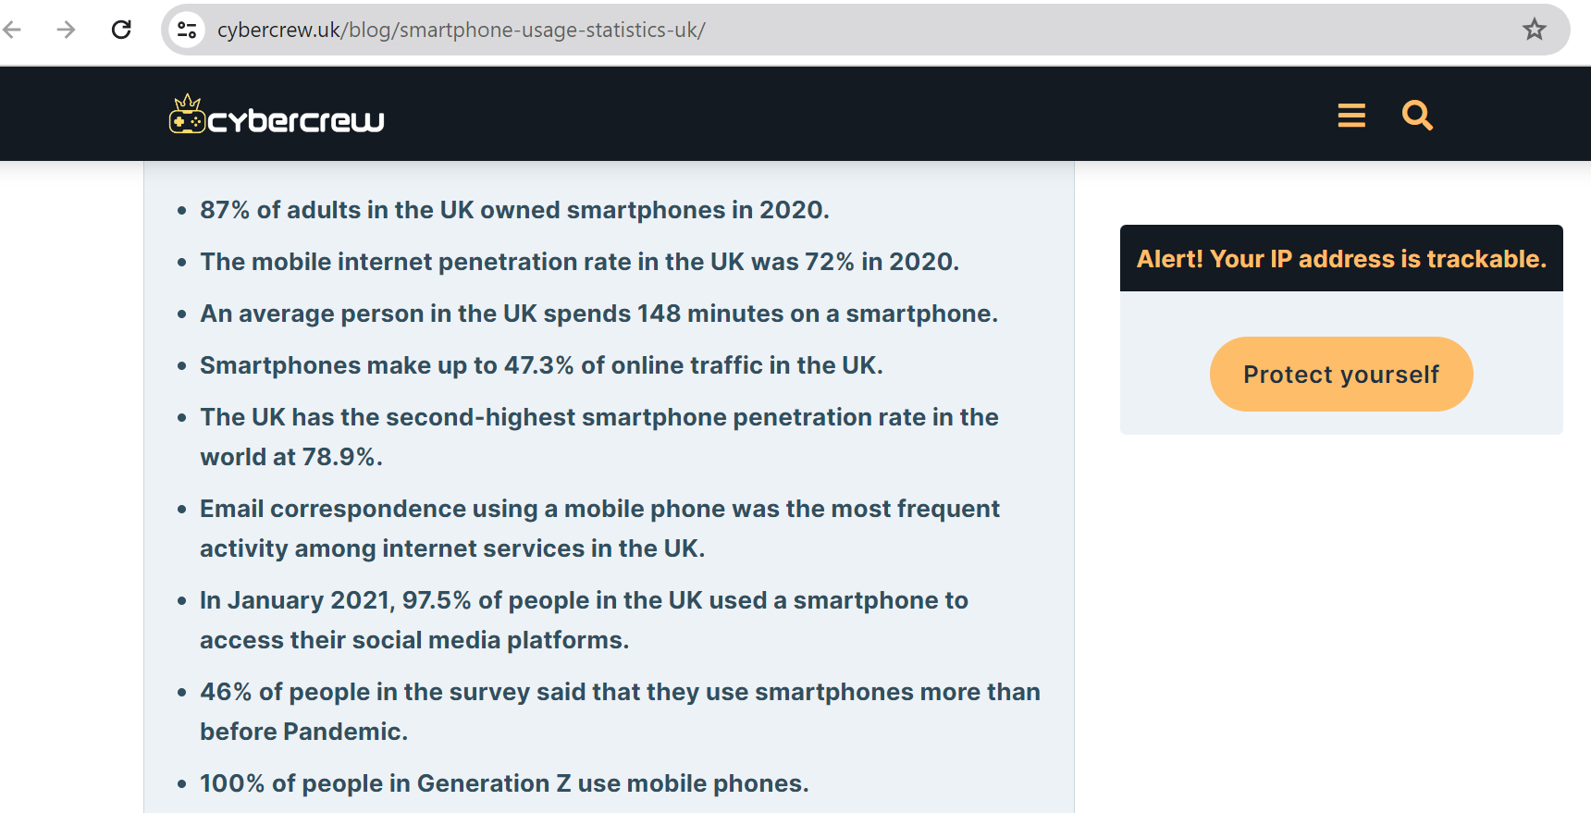
https://cybercrew.uk/blog/smartphone-usage-statistics-uk/

