NAME:
Rose-Ellen Kemp

STUDENT NUMBER:
2223712

TITLE:
What is the role of the singing teacher, if any, in the treatment of aging voice and presbyphonia?

WORD COUNT:
Part 1: 2,920
Part 2: 1,764
Table of contents:
Part 1 – Literature review…………………………………………………………………………….3
Table 1. Observable symptoms from the literature………………………………………………..6
Table 2. Aims of voice therapy for the aging voice from the literature………………….……..10
Strategy…………………………………………………………………………………..…………..11
Part 2 – reflective practice ………………………………………………………………..……….13
References…………………………………………………………………………………………..18
Appendix 1 – My client’s ages chart………………………………………………………………26
Appendix 2 – Prevalence of presbyphonia……………………………………………………....26
Appendix 3 – Atrophy illustration………………………………………………..........................27
Appendix 4 - links to youtube videos …………………………………………………………….27
Appendix 5 – Parkinson 2016 model………………………………………………………….….28
Appendix 6 – Search terms used for the project …………………………………………….…29
Appendix 7 - Personal Development Plan ………………………………………………………30

TITLE: What is the role of the singing teacher, if any, in the treatment of aging voice and presbyphonia?

PART 1: LITERATURE REVIEW AND STRATEGY

Defining ‘aging voice’ and presbyphonia

Populations in many countries are aging year on year (United Nations, 2024), and therefore, the issue of aging voice warrants attention, especially by singers and singing coaches (Mitton, 2022; Yuen & Ma, 2023).

Presbylarynx is a term which refers to anatomical and functional changes which are visible in the larynx resulting from aging and these changes can contribute to vocal aging, which is called presbyphonia (Mezzedimi et al., 2017).

The diagnosis of presbyphonia is typically one of exclusion made in the absence of other laryngeal diseases in older patients presenting a gradual weakening of voice and hoarseness (Galluzzi and Garavello, 2018). Therefore, presbylarynx can be considered an anatomical term and presbyphonia a voice term (Santos et al., 2022).

Many studies use age 65 as a cut off for consideration of ‘older adult’ or ‘elderly’ (Davids, 2012; Mautner 2015; Santos et al., 2022). This is the retirement age in many countries but there is no specific age that signs of presbylarynx become evident. Sataloff & Kost (2020) report that they sees aging-related challenges in singers starting around age 30. However, it is argued that physiological age may also be a helpful predictor of presbyphonia (Mitton, 2022). The aging process is determined by genetics, environment, and lifestyle choices, making for a highly individualized experience. Although I cannot predict my clients’ physiological ages, the 65+ bracket would pertain to around half of my client group.

My voice studio runs weekend events for which I am a singing technique teacher, working primarily with groups of around 15 adults over 4 intensive days. My students are largely avocational singers between 56-75 years (see appendix 1). Voice clients have approached me over the years with symptoms of presbyphonia. The aim of this paper is to ascertain the role of the singing teacher in cases where concerns around ‘aging voice’ are disclosed by the client or perhaps where a client discloses that they have received a medical diagnosis of presbyphonia. I will use the literature to develop a strategy to inform or assist in such cases.

Impact of presbyphonia
Presbyphonia is clinically common among the elderly population (Garabet et al., 2024)
and can cause significant impact on life satisfaction (Golub, Chen & Otto et al 2006; Roy, Stemple, Merrill et al., 2007; Zeigler et al., 2014). Potentially, somewhere around 1/3 of people aged 65+ presenting with voice complaints could have vocal fold (VF) atrophy but will not necessarily be seeking treatment (see appendix 2).

Garabet, Melley & Sataloff (2024) explain that a functioning voice is an important aspect of many parts of life including good communication, self-expression, emotion expression, wellbeing, work and other responsibilities. Individuals with aging voice are less able to communicate effectively due to issues such as vocal tiredness and trouble being heard over background noise which can lead to fewer social interactions and a lower quality of life (Etter et al., 2019, Porcaro et al. 2021). Older adults with more general communication difficulties have been found to suffer from higher levels of anxiety (Roy et al., 2007), loneliness (Palmer et al., 2016), stress and depression (Dietrich et al., 2008; Merrill et al., 2011). This could cause older adults within singing settings feeling they struggle to be heard, not feeling confident to speak, bowing out earlier or count themselves out of singing opportunities altogether.

Physiology of the aging voice – background

Aging can cause anatomical and physiological changes in both the larynx and the vocal tract which impact phonatory functions (Ramig et al., 2001). “Presbyphonia is the result of multi-system aging throughout the body, including changes to the respiratory, phonatory, resonatory, and articulatory subsystems of voice” (Sund et al., 2024, p. 1) leading to glottal incompetence (Linville & Rens, 2001) and a decline in pressure for inspiration and expiration (Miller, 2010). There is also evidence that cognitive decline can lead to less phonatory control due to a lack of coordination in muscle recruitment (Ballard et al., 2018).

The ‘hallmark’ physiological appearance of vocal fold atrophy includes glottic gap, vocal fold bowing and prominent vocal processes (Davids et al., 2012; Bradley et al., 2014). The most frequently observed presentation of glottal gap was spindle-shaped (see appendix 3) and the next most frequently seen was anterior glottal gap (Santos et al., 2022). This results in the vocal process protruding even more than before in relation to the edge of the folds and when the vocal folds move to adduct, they struggle to meet and phonate affectively (Pontes & Brosolotto., 2005). The underlying cause of this is atrophy of the thyroarytenoid muscle fibres, loss of collagen causing fibres in the epithelial and lamina propria covering of the vocal folds to lose their criss-cross organisation and, therefore, viscoelasticity (Pontes & Brasolloto 2005; Martins et al., 2015; Bradley et al, 2014). This would be incredibly concerning for a singer because the larynx is a tiny, intricate mechanism and any change in structure will vastly affect function.

Janssens et al. (1999) found reduced respiratory muscle strength and stiffening of the chest wall as well as muscle atrophy (known as sarcopenia) reducing respiratory muscle mass. Fillit et al (2010) state that the stiffening of the chest wall can reduce the coordination of these muscles including the diaphragm which can lead to reduced air flow to the glottis and cause a sensation of breathlessness. Other changes can include the ossification of cartilages in the larynx, the edge of the vocal fold becoming less smooth and changes in nerve chemical transmission (Mitton, 2022) all contributing to loss of vocal efficiency.

The postural decline which has been associated with aging (Gadelha et al., 2018) may also change the vocal tract resonance. One example of postural decline is a forward head posture or ‘kyphosis–lordosis posture’ (Wilson Arboleda et al., 2008) which has been found to narrow the pharynx and alter the resonance of the voice and although it often seen in the older adult population (Nemmers et al., 2009), I have observed it in all age groups of my clients without necessarily any audible damage being done to the voice.

Tarafder et al. (2012) found an association between aging and a lowering of the larynx and Linville & Rens (2001) showed that this lowering is reflected in the decrease in the spectral peaks on a spectrogram taken over a long-term average. The lowering of the whole laryngeal structure is space would affect pitch range. This is an issue for a singer as repertoire would have to shift keys or perhaps even change altogether.

These physiological symptoms and presentations can all affect singing as any mechanisms used for speech are employed for singing but often with greater demand being placed on the subsystem (respiratory, articulatory, phonatory). If a singer were to suffer with even a handful of these issues, it would be enough to cause major changes to their voice, their repertoire and perhaps even their identity.

Observable symptom (without laryngoscopy)

Table 1. Observable symptoms from the literature
General population:
Breathiness, roughness, reduced vocal loudness, and/or change in pitch, as well as increased vocal effort | Rapoport et al. (2018)  Etter et al. (2013)
Air escape and decreased vocal endurance.  Women’s voices will often become lower pitched initially and then gradually higher pitched and shrill, whereas older men’s voices will gradually become more high-pitched as the vocal folds lengthen to try and achieve approximation | Bradley et al. (2014)
Gradual “weakening” of voice and hoarseness | Galluzzi & Garavello (2018)
Breathiness, slightly decreased volume, “thinning” of the voice, and loss of vocal efficiency. | Mitton (2022)
Singers specifically:
Losses in accuracy, speed, endurance, stability, strength, coordination | Mitton (2022)
Loss of pitch range in up and down directions, noise in the sound; breaks in the voice; compensatory effort; intonation; need to take a few more breaths; slower vibrato; warming up taking longer; unclear open vowels; slower ornamentation; less ring and intensity in the sound; vocal fatigue; cramping in voice: ceiling; intrusive /h/ between notes; difficulty with softer singing; debilitating and compensatory efforts to make up for compromised function | Johnson & Brunssen (2008)

Many of the above symptoms are present in other voice pathologies and some terms such as ‘roughness’ would require explanation and training to detect correctly (which singing teachers do not usually have). Therefore, a singing teacher would not be able to use these symptoms to draw any conclusions.

Diagnosis - how phesbyphonia is currently diagnosed

In the U.K. a member of the ear, nose and throat (ENT) team would examine the vocal folds, usually by performing a laryngoscopy. This can be done indirectly with mirrors or directly with a laryngoscope (thin tube with a camera and a light on the end, inserted via the nasal cavity). This information would then be passed to an SLT to aid the rest of the auditory diagnostic process and any subsequent treatment.

It is possible to find elderly people with vocal complaints synonymous with presbyphonia but no endoscopic sign of presbylarynx. Additionally, it is possible to find endoscopic signs but no vocal complaints (Crawley et al 2018; Misono 2017; Mallick et al 2019; Santos et al 2022). This is not surprising given the similarities in the auditory detection of different voice pathologies and the difficulties we have in describing them in words and grading them without subjectivity. Moreover, Santos et al. (2022) raise issues with the subjective nature of laryngoscopic diagnosis (for example some ENTs would diagnose based on glottal gap and pronounced vocal processes, some just on pronounced vocal processes), however, they still state that laryngoscopy is the gold standard for diagnosis.

Best described as a diagnosis of exclusion (Martins et al., 2015; Rapoport et al., 2018) made in the absence of other laryngeal diseases in older patients presenting a gradual weakening of voice and hoarseness (Galluzzi & Garavello 2018). Sund et al. (2021) study excluded participants, diagnoses of certain systemic disorders such as neurologic disorders, auto-immune disease, history of thoracic or head and neck surgery, thyroid pathology, cancer, and history of radiation therapy.

Patients with suspected presbyphonia should be evaluated by a multidisciplinary team (MDT) (Santos et al. 2021). They require a comprehensive evaluation including complete medical history and a physical head and neck examination by the ENT. The medical history to check vital information such as any serious health condition affecting respiratory function, smoking status, comorbidities and general health (Desjardins et al. 2022; Mitton, 2022), the physical palpation for any unforeseen structural anomalies which may need to be investigated.

Lu et al., (2013) tested the efficacy of Lee Silverman Voice Therapy (LSVT) on two participants with presbyphonia. They undertook tests for their research which would not be used as standard in clinical settings such as acoustical analysis and examination with a strobolaryngoscope (viewing the vocal folds via the oral cavity and producing a much higher quality, more detailed image).

The VH-10 and GRBAS tools appear to be very helpful in indicating the seriousness of the condition as Santos et al. (2022) found that the more severe classification (type 2, see appendix 3) score significantly higher on these two measures that the less severe types. However, the issues of ethics and client engagement for this kind of diagnostic tool would need to be considered. Although the above study (ibid) points to the reliability of these measures, they state that the literature remains controversial due to concerns for the subjectivity of acoustic and audio-perceptual measures and the myriad factors that may influence the self-assessment questionnaires, such as vocal demands, health status, or social life.

Treatment overview
There are surgical and non-surgical approaches which are currently recommended and effective treatments for presbylarynx (Sund et al. 2024, Bhatt et al., 2023; Brown et al., 2020; Mallick et al., 2019, Bradley et al., 2014). There are two main types of surgery which have benefits; injection augmentation which are temporary fillers and the more permanent implantation thyroplasty (Salinas & Chhetri, 2014; Zhang et al., 2015). Bhatt et al (2023) found all modalities of treatment to be superior to controls for patients with age-related bilateral VF atrophy. As with any surgical option, they are invasive and there can be safety concerns for older patients (Sataloff & Kost, 2020; Stradtman & Etter, 2022).

Non-surgical voice therapy delivered by a speech and language therapist is generally thought to be the first response in treating presbyphonia (Johns et al 2011, Galluzzi & Garavello, 2018; Mallick et al., 2019, Bradley 2014). However, there is very little in the literature about how a singing teacher can be of help with presbyphonia, although there are YouTube videos by qualified voice clinicians which would suggest that some treatments for the aging voice can be carried out without expert on-line feedback (see appendix 4). This may mean that there are some voice treatments, or elements of them, which can be delivered by singing teachers and speech and language therapy assistants.

Voice therapy
There are two therapies which are currently used for aging voice: Voice Therapy for the Elderly (VFE) and Phonation Resistance Training Exercises (PhoRTE). Both were designed to be delivered by an SLT and the literature suggests that intensive voice therapy of this kind (as opposed to traditional voice therapy or no treatment) is just as effective as surgical options (Yuen & Ma 2024). Bhatt et al. (2023) could not determine the superior treatment type. Lee Silverman Voice Treatment, an established voice therapy for Parkinson’s disease was tested for effectiveness in presbyphonia by Lu et al. (2013). Both participants in this study had good outcomes which were visible by laryngoscope but this is a very small sample size to draw conclusions from. This evidence, along with the evidence for singing being effective for COPD and the similarity of most study therapy programmes to my work and that of many other voice practitioners, suggests that my earlier thought that any voice work is beneficial is likely true. Therefore, singing practitioners are helping vital function in their usual practice. However, to improve at the laryngeal level is more specialised. Moreover, SLTs require more research to be carried out to find the most effective treatments because their time with clients is limited.

Yuen & Ma’s (2024) exhaustive systematic review ‘Singing-Based Interventions to Improve Physical Functions Related to Aging Voice in Older Adults´ suggests there is limited evidence for singing-based interventions for aging voice although there is evidence of efficacy for Chronic Obstructive Pulmonary Disease (COPD) (Yuen & Ma, 2024). The outcome measures only suggested effect on respiration. There were no outcome measures reported for phonation or posture in any papers, although respiration was noted to have moderate outcomes in some papers (Bonilha et al., 2009; Miyazaki and Mori, 1999; Kaasgaard, 2022) These papers and a handful of others which were deemed strong enough to be included in the review (Goodridge et al., 2013; Farquharson, 2021; Cahalan et al., 2022) have treatment programs which contain many of the elements of my own work, albeit with a different dosage frequency . This suggests that singing work improves the vital respiratory function which is particularly important given the issues for the elderly singer.

Overall, behavioural voice therapy trains the patients to improve their voice quality with voicing techniques through modelling and feedback (Allen & Hine 2015). However, a study by Oates (2014) on voice therapy in the elderly showed a diversity between the interventions, as well as in the methodology of application and evaluation of the proposed therapeutic models. This is echoed in slightly varying aims in the table below (see table 2). Although, varying, these aims have some commonalities and all could bring great benefit to all singers and help prevent dysphonia in younger people because of the fundamental underlying muscle work involved.

Table 2. Aims of voice therapy for the aging voice from the literature
Based on a causal model targeting the biological basis of the condition, VT protocol should include high intensity phonation exercises overload the respiratory and laryngeal system and improve vocal loudness, reduce vocal effort, and increase VRQoL. | Bradley (2014)
Increasing vocal dose exercise training of the involved vocal muscles | Johnson (2018)
Voice therapy for the elderly focusing not just on loudness but also on mucosal vibration, resonance, pitch modulation and control, and phono-respiratory coordination | Godoy et al. (2018)
SLTs voice therapy work should include exercises designed to increase pulmonary support for voicing, lessening of laryngeal tension | Kaneko, Hirano, Tateya et al., (2015)
More effective glottic adduction, sustained phonation, vocal stability, vocal extension, and exercises to improve resonance and articulatory precision | Morrison and Rammage (1994)
Increased phonatory energy or vocal effort | (Gartner-Schmidt Rosen 2011).

Previous studies have suggested that a low dose of vocal activity may result in the deterioration of vocal musculature and function in older adults, causing presbyphonia and affecting daily communication (Sato et al., 2011; Titze, 2017; Ziegler & Hapner, 2020). Zeigler et al. (2014) state that their study shows additional support to a previous finding that individuals with presbyphonia regularly practice voice exercises and exhibit good adherence to treatment recommendations. This means that it is likely that if my clients perceive an issue with their voice and I can give them a set of exercises to do as ‘homework’, they are likely to carry out the work which will increase their vocal dose.

Santos et al. (2022) consider treatment which is tailored to the needs of the patient essential in improving the management of aging voice. They also think that treatment should be based on the findings of patient-reported Voice Related Quality of Life questionnaires (VRQoL) opining that this is more important than endoscopic findings. And although I am sure that singing in and of itself promotes an increase in quality of life, perhaps incorporation of aspects of these therapies could make a bigger difference to those who have symptoms of presbyphonia. A singing teacher could offer a VRQoL to a client. It has the possibility to make them feel heard and it may even help them to recognise the severity of the issue and seek help from an SLT. However, from an ethical standpoint, there is also the possibility that they may have a strong emotional reaction to the outcome of the questionnaire. Considerations of wellbeing and safeguarding would have to be managed carefully. Ethically, I would have to consider consent, confidentiality, anonymity and data protection (surveysparrow.com accessed: 5/2/25).

Although it is not clear which treatment option is the most effective (surgery or VT), and it is not clear which voice therapy is most effective because of a lack of high-quality randomized, controlled studies, it stands to reason that there are benefits for older people intrinsic to voice therapy which do not appear as part of surgical treatment (Garabett et al., 2024; Yuen & Ma, 2024). An overwhelming majority of patients with presbyphonia believe voice therapy is beneficial (Gartner-Schmidt et al 2011) and exhibit a significant improvement in voice-related quality of life, (Saunder et al., 2010; Berg et al., 2008) a finding not observed in patients who forego voice therapy (Berg et al 2008). Zeigler et al., (2014) suggest that PhoRTE and VFE as carried out by an SLT can improve a patient’s VRQoL. Furthermore, patients with presbyphonia report a significant decrease in phonatory effort after completing voice therapy (Saunder et al., 2010). Most importantly, patients with presbyphonia who receive voice therapy exhibit a significant improvement in their functional vocal status (Jacobson et al., 2010). Although all of these treatment modalities have demonstrated success in treatment of the aging voice, it is also important to remember that many older patients are simply looking for reassurance that their vocal changes do not point to more serious pathologies such as malignancy (Bradley 2014).

Strategy: best practice general guidance for singing teachers with no medical training

I will have the following bullet points ready to relay to those who have disclosed diagnosis initially and any choir leaders who approach me for advice:
- Ask which professionals have been involved with their diagnosis, what exactly was disclosed and what was recommended.
- Ask if their perceived or diagnosed voice changes have caused them to make any changes to their vocal or physical activity.
- Ask them if they feel any pain or discomfort in their throat area when they sing or speak.
- Voice related quality of life assessments standing by but not necessarily utilise every time.
- Be aware that in the group setting, if there are singers with symptoms that they may have lessened interactions due to feeling less confident in their voice when they go to speak or sing.
- They may be experiencing anxiety, loneliness, stress or depression (Roy et al., 2007; Dietrich et al., 2008; Merrill et al., 2011; Palmer et al., 2016)
- Use a GRBAS scale or note if they have any of the following: breathiness, roughness, reduced vocal loudness, and/or change in pitch, as well as increased vocal effort (Rapoport, Meiner, Grant 2018; Etter, Stemple, Howell 2009), air escape and decreased vocal endurance (Bradley et al., 2014) or has their voice recently become higher or lower (Bradley et al., 2014).
- Ask them if they are experiencing any of the symptoms raised by Johnson & Brunssen (2008).
- Ask an SLT who has delivered VFE and PHoRTE if I can deliver any useful part of it as a means of prevention or to aid cure and integrate the advice into my practice
- Bear in mind it is potentially only about 1/3 of older adults with voice complaints who are likely to have atrophy.
- Be reassured that singing work can help with vital function as seen in treatment for COPD.
- Consider giving homework (Zeigler et al., 2014) to keep up vocal dosage for all singers (Sato et al., 2011; Titze, 2017; Ziegler & Hapner, 2020).
- The majority of patients believe VT to be beneficial and that is my experience of singing work too.
- Remember that many patients just want reassurance that it isn’t anything serious and although I have correctly detected significant voice pathology in training as an SLT and in my singing clients a handful of times and feel confident to do so, only the MDT can provide diagnosis and reassurance with certainty.
- My role can be to detect with professional listening and signpost on to the medical MDT and reassurance that there are therapies with efficacy for aging voice.

Conclusion:
The evidence suggest that the type of singing exercises I carry out will assist anyone with strengthening their vital function and increase their vocal dose, both of which are helpful. However, there is no evidence to suggest a singing teacher can diagnose or treat presbyphonia directly but can have a professional listening ear to help with signposting.

PART 2: CRITICAL REFLECTION

Reflections on my practice

Perspectives on reflection:
There are many tools we can use as a guide for reflective practice. They are often in the form of a model, and all originate from John Dewey’s (1933) model. Dewey believed that reflection on an experience helped the learner to affect change and growth (Thompson 2022). Further to this, Loughran (2000) recommends placing emphasis on effective reflective practice which focusses the task on the resulting action. This means that reflection should aim to have real-life implications, such as those specified in our personal development plan (see appendix 7) and not merely become an exercise in naval gazing or self-flagellation.

Workplaces come with regular timetabled commitments, deadlines, procedures and systems which are an integral part of the work itself. They can also come with embedded attitudes, values and cultural norms which can cause you to work on autopilot and misremember the ‘why’ behind the ‘what’ (Thompson, 2022). Therefore, scheduling-in time to reevaluate your personal and professional values, reflecting on practice and reworking systems and procedures in line with changing times and perspectives would be a valuable use of time resource in any voice practice.

During a typical 4-day course at my voice studio, there is no spare time to work through a model. If there is any spare time, it is taken up with discussion about re-working the programme and timetable to suit the individual participants’ needs often due to differences in learning style, needing to meet their very specific interests or time taken with basic skill acquisition. Therefore, whilst I am continually learning ‘in-action’ and adjusting key documents and procedures accordingly, any substantial reflection (whether on an ‘activating event’ (Thompson, 2022, p. 61) or on my professional aims (Parkinson, 2016) or reflecting-on-action about my stance on societal issues (Schön, 1983) would always have to be after-the-fact. Therefore, making my reflections as contemporaneous as possible would be essential as the human memory changes events rapidly.

Questioning our own practice is often difficult because unless we use a probing tool and dig a bit deeper, we often just find what we expect to find (Thompson, 2022). However, there is no one-size-fits-all model and we need a breadth of skills to gain effectively from the process knowing that it will be affected by our personal interpretations, influences and the context (Thompson, 2022).

I have found the Gibbs Reflective Cycle (Gibbs, 1988) to be a very effective tool for my own reflective digging. The Gibbs model is widely used and well known (Thompson, 2022) and has helped me in the past when reflecting on collaborative working situations, academic learning experiences and business development practice. Gibbs’ cycle has been adopted into nurse training and many other types of professional education to facilitate reflection (Finlay, 2022) which gives it great credibility.

I have found that in these several different contexts, the Gibbs model has helped me to gain insight and perspective and the more I use it, the more efficient and intuitive it becomes.
However, Finlay (2008) argues that it offers only a basic set of questions to help elicit personal reflection on one’s practice and that to effect bigger change, a broader more reflexive examination is needed. There should be consideration of and commitment to personal values, quality of work and intersectional perspectives (Zeichner & Liston 1996). Therefore, adding prompts for other key elements into the Gibbs model could work well for my reflective practice.

Finlay (2008) also warns against using models in an unthinking and mechanical way which can lead to the opposite of Schön’s (1983) concept of ‘professional artistry’ (Finlay, 2008, p.3) (discussed below). Concluding that it is undesirable to settle on one model and that different models are needed for different endeavours and require judicious flexible and purposeful usage.

Another dimension could be added to Gibbs’ model with aspects from Schön, Brookfield and Handal & Lauvas. The other side of Schon’s reflection-in-action is reflection-on-action which concerns a teacher’s stance in relation to societal influences and issues. Brookfield (2012) talks about hunting for assumptions when reflecting on a specific event. Looking at the event from different angles and perspectives to challenge yours and others’ assumptions. And perhaps some perspective could be gained from Handal & Lauvas’ (1987) ‘Practice Triangle’ which encourages reflection on ethical and moral considerations.

Values as a basis for practice
“Through reflection we can consider professional values and develop different understandings and approaches” (Thompson, 2022). I have found Parkinson’s (2016) model for vocal and instrumental teachers helpful in taking an overview of my teaching culture and motivations and to identify my aims, values and purpose, consideration of which are often found lacking in teaching practice (Jamillo, 2008).

The model aims to elicit critical thought from the music teacher on the push and pull of two prominent paradigms in music education: mastery vs. enjoyment and tradition vs. innovation. In the appendix (see appendix 5) I have plotted the model from two perspectives; repertoire and pedagogy. I could also use this model to consider the aims of contrasting teaching events (as suggested by the author) as I teach at many different styles of event with different emphases.

Parkinson (2016) states that “a lack of opportunities for professional dialogue within instrumental teaching has also been identified” which I can relate to as I am often a lone practitioner myself. Robinson (2012) notes that experiences and knowledge are not often shared between teachers. I may have to also timetable in some opportunities to spend time at other singing leaders’ events, ask questions and meet up with them outside of work.

Conclusions:
Hobbs (2007) sees the process of self-development through reflection and necessary practice for anyone working with people, which is relevant to singing teachers, as soft skills are the basis of our every success.

Regarding my own learning of the soft skills and other essential teaching tools, I relate strongly to Schon’s theory of ‘professional artistry’ stating that as professionals become ever more expert at their practice, they developed the ability to monitor and change their practice concurrently on-line, in an intuitive way (Finlay, 2008). I have built my tacit knowledge and skills almost entirely through this ‘knowing-in-action’. I enjoy rules, procedures and systematising but have learned to create those from tacit knowledge and utilise them flexibly on-line. However, the background knowledge of anatomy, physiology and voice work theory were all book-learned and, therefore, my continued education is important as a grounding for my tacit knowledge.

The aims of my teaching, utilising the above skill set, have always centred around skilfully sharing relevant knowledge of voice science, practical singing work and making singing fun and as to promote wellbeing. This chimes with Hallam & Creech (2010) who say, “the aims of instrumental and vocal teaching should … be to make musical experiences enjoyable while continuing to provide challenge and intellectual stimulation” (Hallam & Creech, 2010, p. 101) to promote life-long learning and enjoyment of music. And with a life-long enjoyment comes a higher vocal dose and, therefore, less chance of presbylarynx. It follows, then, that my practice is on track to being efficacious.

Reflection on learning experience:
For this project, I studied ‘aging voice’, presbylarynx/presbyphonia and the possible role of the voice teacher. I have utilised the Voice Study Centre library of resources along with University of Wales Trinity St Davids own library (see appendix 6 for search terms). The sources were largely scientific papers from the last 5-10 years along with recent books.

The information gleaned from studying has been of little but not no value to me as a practitioner, but the studying itself has aided the building of my study skills back up after a long break. I did learn several scientific term and medical names I was unfamiliar with. It also provided me with the opportunity to ascertain more in-depth knowledge about what exactly constitutes the bowing of the vocal folds physiologically and the criteria by which criteria presbylarynx/presbyphonia is diagnosed. I had hoped to find many different specific, practical exercises I could carry out with my clients which were within my remit and had proven efficacy. Instead, the advice found in scientific papers is largely irrelevant to singing teachers or is concurrent with what I currently practicing and signposting seems to be all that is expected of my role. However, a rich background knowledge of the subject is always a helpful addition to practice. I now have information which I can pass along to other singing leaders and choir leaders locally when approached to provide advice.

I would like to discuss my findings with a voice-specialising speech and language therapist to enquire about implementation of known therapies for ‘aging voice’ and related disorders such as Parkinsons. I would like to know if they have themselves administered LSVT and PhoRTE with clients with presbyphonia and whether they are safe to implement via an SLT assistant or a voice teacher.

Using the Gibbs cycle to reflect on Module 1 study:
Description: What actually happened?
It was expected that my research skills would be rusty and perhaps outdated. This turned out to be worse that I had imagined. I struggled with even the basic research skills (searches, cutting down subheadings list to a reasonable amount, choosing appropriate subheadings to put paragraphs from papers under, navigating newer AI read-aloud software, keeping track of which paragraphs I has used from papers and which paragraphs belonged to which papers).

Feelings: What emotions came up?
Panic, inadequacy, frustration, unhappiness.

Evaluation: What went well? What did not go well?
- some enthusiasm for learning in this way returned, although it was in short bursts.
- Some self-confidence for essay writing returned although it is often short lived and presents as a quieter voice that the criticism and panic. This is due to a long educational history of not having enough time to finish any given task and watching people all around me succeeding.
- Much procrastination but I managed to breakthrough that sometimes with strategies.

Analysis: What factors contributed? Was it part of a pattern? What was the context?
My diagnosed learning difficulty and suspected neurodivergence are contributing factors in my struggles to focus, stay interested, collate information etc. My difficulties with all past formal education experiences contribute to the panic and inadequacy. These are all recurring patterns.

Conclusion: What could you change? What lessons have you learned?
I was never open about how much I struggled academically because any admission was always met with one of two unhelpful reactions; ‘But you seem so clever, why are you struggling when the rest of your cohort is not?’ or ‘I do not believe you are actually struggling, I think you are just not trying hard enough or dedicating enough time to this’. However, now I understand neurodivergence I can be kinder to myself. I can also develop strategies and crucially, ask for help when I am encountering novel pitfalls I cannot traverse.

Action plan: What steps will you take next? Do other factors have to change too?
- I will keep reflecting on my systems and strategies for studying and revise and rethink as and when a problem is encountered.
- Build up my study skills by utilising the resources the university offers.
- I will keep having regular meetings with my tutor for which I will be prepared with questions and drafts ahead of time where possible, remembering to be realistic and kind.
- Keep pushing for help from the university to keep the support as closely in line with what can realistically help me to reach my potential within the context of this course given my diagnosis of dyslexia and the other related issues (see appendix 7 for Personal Development Plan).

References:

Allen, K.D., & H.J.F. (2015) “ABA applications in the prevention and treatment of medical problems,” in H. S. Roane, J. L. Ringdahl, & T. S. Falcomata (Eds.), Clinical and organizational applications of applied behavior analysis. Academic Press, pp. 95–124.

Ballard, D.P. et al. (2018) “Systematic Review of Voice Outcomes for Injection Laryngoplasty Performed under Local vs General Anesthesia,” Otolaryngology - Head and Neck Surgery (United States). SAGE Publications Inc., pp. 608–614. Available at: https://doi.org/10.1177/0194599818780207.

Berg, E.E. et al. (2008) “Voice Therapy Improves Quality of Life in Age-Related Dysphonia: A Case-Control Study,” Journal of Voice, 22(1), pp. 70–74. Available at: https://doi.org/10.1016/j.jvoice.2006.09.002.

Bhatt, N.K. et al. (2023) “Treatments for Age-related Vocal Atrophy: A Systematic Review,” Laryngoscope. John Wiley and Sons Inc, pp. 2846–2855. Available at: https://doi.org/10.1002/lary.30653.

Brookfield, S.D. (2012) Teaching for Critical Thinking, Tools and Techniques to Help Students Question their Assumptions. San Francisco, CA: Jossey-Bass.

Brown, H.J., Zhou, D. and Husain, I.A. (2020) “Management of presbyphonia: A systematic review of the efficacy of surgical intervention,” American Journal of Otolaryngology - Head and Neck Medicine and Surgery. W.B. Saunders. Available at: https://doi.org/10.1016/j.amjoto.2020.102532.

Cahalan, R., G.J., M.C., & G.A. (2022) “ ‘Sing- Strong’: Singing for better lung health in COPD – A pilot study,” Physiotherapy Theory and Practice, 38(12), pp. 1978–1986.

Crawley BK, D.S.T.C. et al. (2018) “Assessment of clinical and social characteristics that distinguish presbylaryngis from pathologic presbyphonia in elderly individuals,” JAMA, 144, pp. 566–571.

Desjardins, M. et al. (2022) “Voice and Respiratory Characteristics of Men and Women Seeking Treatment for Presbyphonia,” Journal of Voice, 36(5), pp. 673–684. Available at: https://doi.org/10.1016/j.jvoice.2020.08.040.

Dewey, J. (1933) How We Think. Boston. Boston: DC Heath.

Dietrich, M. et al. (2008) “The Frequency of Perceived Stress, Anxiety, and Depression in Patients with Common Pathologies Affecting Voice,” Journal of Voice, 22(4), pp. 472–488. Available at: https://doi.org/10.1016/j.jvoice.2006.08.007.

Etter, N.M. et al. (2019) “Aging Voice Index (AVI): Reliability and Validity of a Voice Quality of Life Scale for Older Adults,” Journal of Voice, 33(5), p. 807.e7-807.e12. Available at: https://doi.org/10.1016/j.jvoice.2018.04.006.

Etter, N.M., Stemple, J.C. and Howell, D.M. (2013) “Defining the lived experience of older adults with voice disorders,” Journal of Voice, 27(1), pp. 61–67. Available at: https://doi.org/10.1016/j.jvoice.2012.07.002.

Farquharson, K. (2021) “Neurophysiological activity during music therapy with individuals with dementia [Mini Dissertation, University of Pretoria].”

Fillit, H.M., R.K., & W.K. (2010) Brocklehurst’s textbook of geriatric medicine and gerontology . 7th edn. Elsevier.

Finlay, L. (2008) Reflecting on “Reflective practice.” Available at: www.open.ac.uk/pbpl.

Gadelha, A.B. et al. (2018) “Severity of sarcopenia is associated with postural balance and risk of falls in community-dwelling older women,” Experimental Aging Research, 44(3), pp. 258–269. Available at: https://doi.org/10.1080/0361073X.2018.1449591.

Galluzzi, F. and Garavello, W. (2018) “The aging voice: a systematic review of presbyphonia,” European Geriatric Medicine. Springer International Publishing, pp. 559–570. Available at: https://doi.org/10.1007/s41999-018-0095-6.

Garabet, R., Melley, L.E. and Sataloff, R.T. (2024) “Noninvasive Management of Voice Disorders: An Umbrella Review,” Journal of Voice [Preprint]. Elsevier Inc. Available at: https://doi.org/10.1016/j.jvoice.2024.03.027.

Gartner-Schmidt J, R.C. (2011) “Treatment success for age-related vocal fold atrophy Treatment success for age-related vocal fold atrophy,” Laryngoscope, 121, pp. 585–589.

Gibbs, G. (1988) Learning by Doing: A guide to teaching and learning methods. Oxford: Further Education Unit, Oxford Polytechnic.

Gimenes Bonilha, A. et al. (2009) Effects of singing classes on pulmonary function and quality of life of COPD patients, International Journal of COPD. Available at: https://www.dovepress.com/.

Godoy J, S.K.B.A. (2018) “Effectiveness of vocal therapy for the elderly when applying conventional and intensive approaches: a randomized clinical trial,” Journal of Voice [Preprint].

Godoy, J.F. et al. (2020) “Método intensivo de terapia vocal para idosos,” Audiology - Communication Research, 25. Available at: https://doi.org/10.1590/2317-6431-2018-2098.

Golub, J.S. et al. (2006) “Prevalence of perceived dysphonia in a geriatric population,” Journal of the American Geriatrics Society, 54(11), pp. 1736–1739. Available at: https://doi.org/10.1111/j.1532-5415.2006.00915.x.

Goodridge, D., N.J.J., H.K.J., & B.S. (2013) “Therapeutic singing as an adjunct for pulmonary rehabilitation participants with COPD: Outcomes of a feasibility study,” Music and Medicine, 5(3), pp. 169–176.

Hallam, S., & C.A. (2010) “Learning to play an instrument,” in Music education in the 21st century in the United Kingdom: Achievements, analysis and aspirations . London: Institute of Education, pp. 85–104.

Handal, G.& L.P. (1987) Promoting Reflective Teaching. Milton Keynes: Open University Press.

Hobbs, V. (2007) “Faking it or hating it: can reflective practice be forced? ,” Reflective Practice, 8(3), pp. 405–417.

Howell, S. et al. (2009) “Delivering the Lee Silverman Voice Treatment (LSVT) by web camera: A feasibility study,” International Journal of Language & Communication Disorders, pp. 287–300. Available at: https://doi.org/doi:10.1080/13682820802033968.

Janssens JP, P.J.N.LP. (1999) “Physiological changes in respiratory function associated with ageing,” Eur Respir J, 13, pp. 197–205.

Jaramillo, J. (2008) “The music educator’s professional knowledge. Music Education Research,” 10(3), pp. 347–359.

Johns, M.M., Arviso, L.C. and Ramadan, F. (2011) “Challenges and opportunities in the management of the aging voice,” Otolaryngology - Head and Neck Surgery, pp. 1–6. Available at: https://doi.org/10.1177/0194599811404640.

Johnson, A.M. and B.K. (2018) “The Senescent Singer,” in The Evolving Singing Voice . San Diego, CA: Plural, pp. 228–229.

Kaasgaard, M. (2022) “Singing in pulmonary rehabilitation of patients with chronic obstructive pulmonary disease [Doctoral dissertation, Aarhus University].”

Kamrul Hassan Tarafder, P.G.D.A.T. (2012) “The Aging Voice,” BSMMU J, (5), pp. 83–86. Available at: http://www.entnet.org/AboutUs/.

Kaneko M, H.S.T.I.K.Y.H.N.F.-K.M. et al. (2015) “Multidimensional analysis on the effect of vocal function exercises on aged vocal fold atrophy,” Journal of Voice, 29(5), pp. 1–7.

Kate Williams (2024) Ethical Surveys: A Guide to Responsible Research, https://surveysparrow.com/blog/ethical-surveys/.

Linville, S.E. and R.J. (2001) “Vocal Tract Resonance Analysis of Aging Voice Using
Long-Term Average Spectra,” Journal of Voice, 15, pp. 323–330.

Loughran, J.J. (2000) Effective Reflective practice, A paper presented at Making a difference through.

Lu, F.L., Presley, S. and Lammers, B. (2013) “Efficacy of intensive phonatory-respiratory treatment (LSVT) for presbyphonia: Two case reports,” Journal of Voice, 27(6), p. 786.e11. Available at: https://doi.org/10.1016/j.jvoice.2013.06.006.

Mallick AS, G.G.M.J. (2019) “Presbylaryngis: a state-of-the-art review,” Curr Opin Otolaryngol Head Neck Surg, 27(3), pp. 168–177.

Martins, R.H.G. et al. (2015) “Aging voice and the laryngeal muscle atrophy,” Laryngoscope, 125(11), pp. 2518–2521. Available at: https://doi.org/10.1002/lary.25398.

Mau T, J.B.G.CG. (2010) “Factors associated with voice therapy outcomes in the treatment of presbyphonia,” Laryngoscope, pp. 1181–1187.

Mautner, H.D. (2015) “An acoustic and electroglottographic study of the aging voice with and without an open jaw posture,” Journal of Voice, 29(4).

Merrill, R.M., Anderson, A.E. and Sloan, A. (2011) “Quality of life indicators according to voice disorders and voice-related conditions,” Laryngoscope, 121(9), pp. 2004–2010. Available at: https://doi.org/10.1002/lary.21895.

Mezzedimi, C. et al. (2017) “Objective Evaluation of Presbyphonia: Spectroacoustic Study on 142 Patients with Praat,” Journal of Voice, 31(2), p. 257.e25-257.e32. Available at: https://doi.org/10.1016/j.jvoice.2016.05.022.

Miller, M.R. (2010) “Structural and physiological age-associated changes in aging lungs,” Seminars in Respiratory and Critical Care Medicine, 31(5), pp. 521–527.

Misono S, Y.B.S.A. et al. (2017) “Minimal important difference in voice handicap index,” JAMA Otolaryngol Head Neck Surg, 143, pp. 1098–1103.

Mitton, D. (2021) “Habilitation for the Aging Avocational Singer,” Journal of Singing, 78(3), pp. 347–354. Available at: https://doi.org/10.53830/sdkt8167.

Miyazaki H, Y.H.M.T. al. (1999) “Transcutaneous PCO2 monitoring in the evaluation of hyperventilation of patients with recurrent nerve paralysis,” Eur Arch Otorhinolaryngol , 256, pp. 47–50.

Morrison M, R.L. (1994) “Voice disorders in the elderly,” in The management of voice disorders. San Diego: Singular Publishing, pp. 141–149.

Nemmers, T.M., M.J.W., & H.M.D. (2009) “Variability of the forward head posture in healthy community dwelling older women,” Journal of Geriatric Physical Therapy, 32(1), pp. 10–14.

Oates JM (2014) “Treatment of dysphonia in older people: the role of the speech therapist,” Curr Opin Otolaryngol Head Neck Surg [Preprint].

Palmer, A.D., Newsom, J.T. and Rook, K.S. (2016) “How does difficulty communicating affect the social relationships of older adults? An exploration using data from a national survey,” Journal of Communication Disorders, 62, pp. 131–146. Available at: https://doi.org/10.1016/j.jcomdis.2016.06.002.

Parkinson, T. (2016) “Mastery, enjoyment, tradition and innovation: A reflective practice model for instrumental and vocal teachers,” International Journal of Music Education, 34(3), pp. 352–368. Available at: https://doi.org/10.1177/0255761414563196.

Pontes P, B.A.B.M. (2005) “Glottic characteristics and voice complaint in the elderly,” Journal of voice, 19, pp. 84–94.

Porcaro, C.K., S.C., D.B., D.A.A., T.R., & E.G. (2021) “Perceived voice disorders in older adults and impact on social interactions,” Perspectives of the ASHA Special Interest Groups, 6(1), pp. 143–150.

Ramig LO, G.S.B.K.C.-L.K.B.E.L.E. et al. (2001) “The aging voice: a review, treatment data and familial and genetic perspectives,” Folia Phoniatr Logop, 53, pp. 252–265.

Rapoport, S.K., Meiner, J. and Grant, N. (2018) “Voice Changes in the Elderly,” Otolaryngologic Clinics of North America. W.B. Saunders, pp. 759–768. Available at: https://doi.org/10.1016/j.otc.2018.03.012.

Robinson, T. (2012) “Popular musicians and instrumental teachers: the influence of informal learning on teaching strategies,” British Journal of Music Education, 29, pp. 359–370.

Roy, N. et al. (2007) “Epidemiology of voice disorders in the elderly: Preliminary findings,” Laryngoscope, 117(4), pp. 628–633. Available at: https://doi.org/10.1097/MLG.0b013e3180306da1.

Santos, M. et al. (2022) “Stratifying Presbylarynx: Characterization of its Three Types,” Journal of Voice [Preprint]. Available at: https://doi.org/10.1016/j.jvoice.2022.09.019.

Sataloff, R.T. and Kost, K.M. (2020) “Presbylarynx: Anatomy/physiology, nonsurgical treatment, and surgery,” Operative Techniques in Otolaryngology - Head and Neck Surgery, 31(3), pp. 211–222. Available at: https://doi.org/10.1016/j.otot.2020.07.006.

Sato, K., U.H., O.T., & N.T. (2011) “Histopathologic study of human vocal fold mucosa unphonated over a decade,” Acta Oto-Laryngologica, 131(12), pp. 1391–1325.

Schön, D.A. (1983) The reflective practitioner: how professionals think in action. New York: Basic Books.

Stradtman, M., & E.N.M. (2022) “Reframing aging voice and presbyphonia: What else can we do? ,” Perspectives of the ASHA Special Interest Groups, 7(5), pp. 1335–1346.

Sund, L.T. et al. (2024) “Laryngologists’ Reported Decision-Making in Presbyphonia Treatment,” Journal of Voice, 38(3), pp. 723–730. Available at: https://doi.org/10.1016/j.jvoice.2021.10.008.

Taryn Davids, M.F.A.M.K.M.F.M.M.J.I.M.F. (2011) “Current dysphonia trends in patients over the age of 65. Is vocal atrophy becoming more prevalent?,” The Laryngoscope, p. 1.

The United Nations (2024) Global issues: Ageing, https://www.un.org/en/global-issues/ageing.

Thompson, C. (2022) Reflective Practice for Professional Development; A Guide for Teachers. New York: Routledge. Available at: https://doi.org/DOI:10.4324/9781003056812.

Titze, I.R. (2017) “Human speech: A restricted use of the mammalian larynx,” Journal of Voice, 31(2), pp. 135–141.

Wilson Arboleda, B.M. and Frederick, A.L. (2008) “Considerations for Maintenance of Postural Alignment for Voice Production,” Journal of Voice, 22(1), pp. 90–99. Available at: https://doi.org/10.1016/j.jvoice.2006.08.001.

Yuen, C.W.N. and Ma, E.P.M. (2024) “Systematic Review: Singing-Based Interventions tImprove Physical Functions Related to Aging Voiin Older Adults,” Journal of Speech, Language, and Hearing Research. American Speech-Language-Hearing Association, pp. 2139–2158. Available at: https://doi.org/10.1044/2024_JSLHR-23-00641.

Zeichner, K.& L.D. (1996) Reflective Teaching: an introduction. Mahwah, New Jersey: Lawrence Erlbaum Associates .

Zhang, Z., C.D.K., & B.J.L. (2015) “Effects of implant stiffness, shape, and medialization depth on the acoustic outcomes of medialization laryngoplasty,” Journal of Voice, 29(2), pp. 230–235.

Ziegler, A. et al. (2014) “Preliminary data on two voice therapy interventions in the treatment of presbyphonia,” in Laryngoscope. John Wiley and Sons Inc., pp. 1869–1876. Available at: https://doi.org/10.1002/lary.24548.

Ziegler, A., & H.E.R. (2020) “Vocal dose in older adults with presbyphonia: An analytic, cross-sectional study,” 34(2), pp. 221–230.

Appendices:

Appendix 1 – My client’s ages chart

Appendix 2 – Prevalence of presbyphonia from the literature

In the United States, self-reported voice disorders among non–treatment-seeking older adults living independently to be 20% (Golub et al., 2006), 29.1% (Roy et al., 2007), and 32.5% (Porcaro et al., 2021) chronologically
A similar prevalence of voice problems among non–treatment-seeking older adults in Hong Kong (27.7%) was reported by Wong and Ma (2021)
In Portugal 12-72% reported by Santos, Freitas and sousa et al (2021).
In Brazil, the prevalence of self-reported voice disorders in older adults living in nursing homes was 39.3% (Pernambuco et al., 2017).
Davids et al (2012) reported that 25% of patients over 65 years of age who presented with a voice complaint were diagnosed with vocal fold atrophy.

These percentages are remarkably similar given that they span different cultures, researchers and methods. I interpret this to mean that potentially, somewhere around 1/3 of people aged 65+ presenting with voice complaints could have VF atrophy but will not necessarily be seeking treatment.

Appendix 3 – Atrophy illustration in comparison to no presbylarynx
Illustrative diagram of 3 types
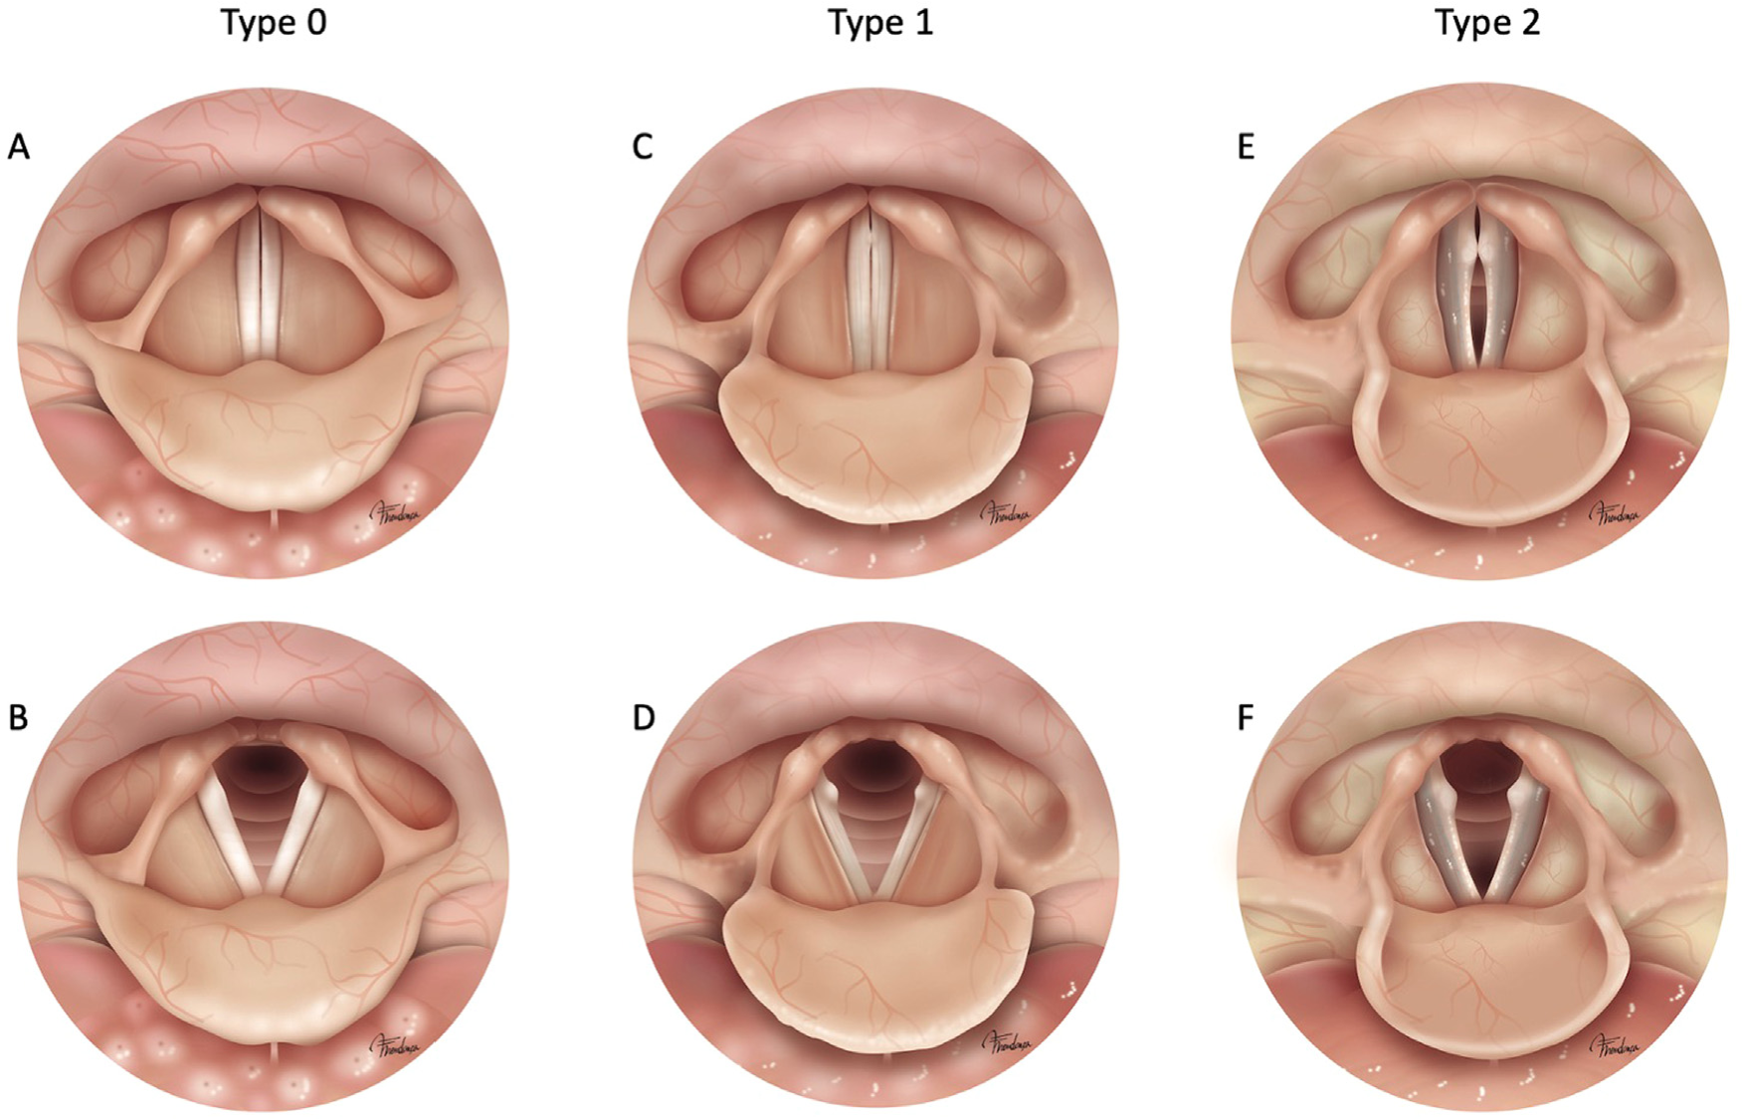

FIGURE 1.
Type 0 (A and B) - there is no significant morphological alteration in the glottal configuration. Some histological or neuromuscular alterations may exist caused by the aging process, but it is not noticeable by laryngostroboscopy.
Type 1 (C, D, and F) - two or more of the following endoscopic signs are present: atrophic vocal folds, vocal fold bowing, prominence of vocal processes, supraglottal hyperactivity (laryngeal vestibule constriction), decreased amplitude (vocal fold edge stiffness without evidence of vocal post-traumatic scar), and tremor of laryngeal structures.
Type 2 (E and F) - elderly patients with type 1 plus glottal insufficiency (anterior or spindle-shaped glottal gap).

Appendix 4 - links to youtube videos
YOUTUBE THERAPY/ PATIENT ADVICE SEARCH:
Melissa Grassia Chisholm – vocal specialist speech pathologist
PhoRTE
https://www.youtube.com/watch?v=RryuQG5336E
SOVT straw
https://www.youtube.com/watch?v=PsjUJjrSE7A
VFE
https://www.youtube.com/watch?v=X8-anR0e-qU
PhoRTE
https://www.youtube.com/watch?v=zNUGeFDSWlc
PhoRTE
https://www.youtube.com/watch?v=52_7Lkw5eI4
NHS lax vox SOVT straw
https://www.youtube.com/watch?v=JNPOAgGMK9o
ENT straw
https://www.youtube.com/watch?v=eC_BFfTzhYE
VFE
https://www.youtube.com/watch?v=g49L2zE8AkE
VFE strengthening
https://www.youtube.com/watch?v=t6pUB3Y07Vg

Appendix 5 – Parkinson 2016 model
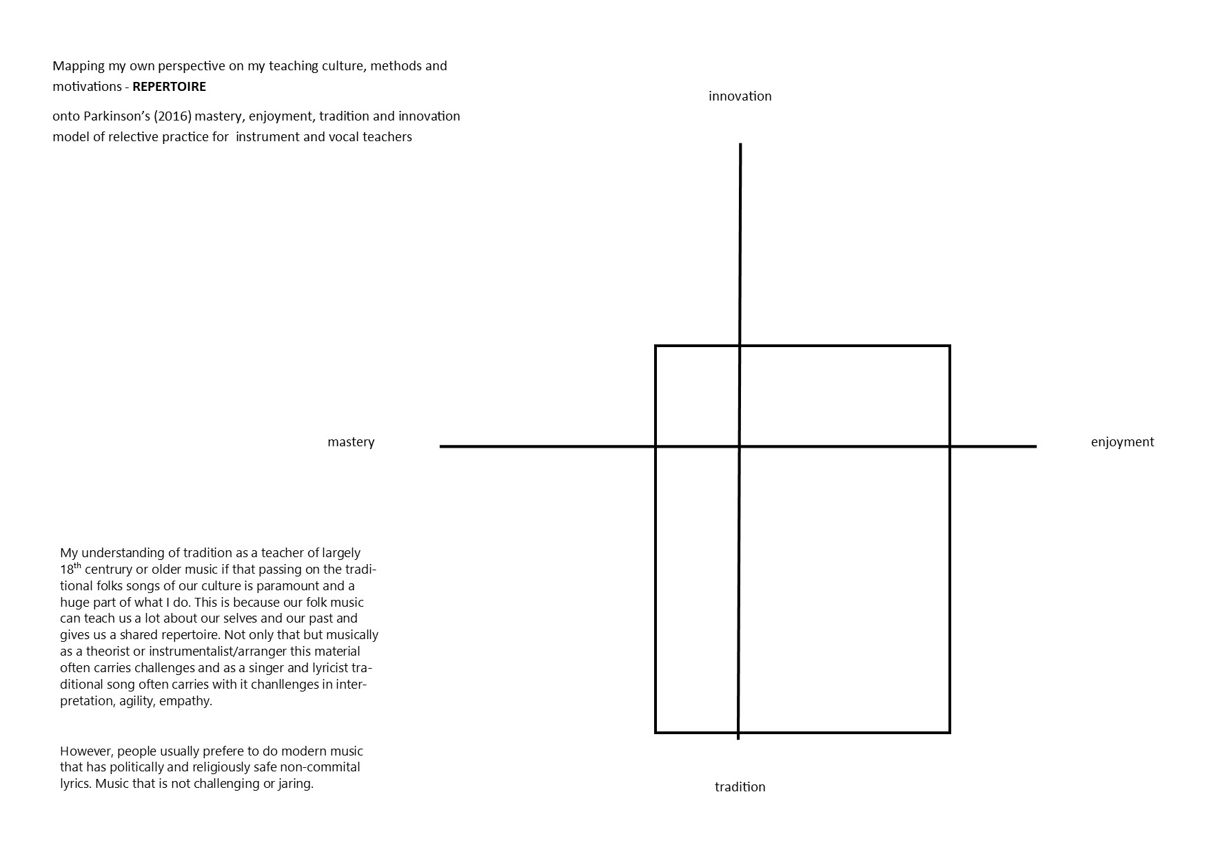
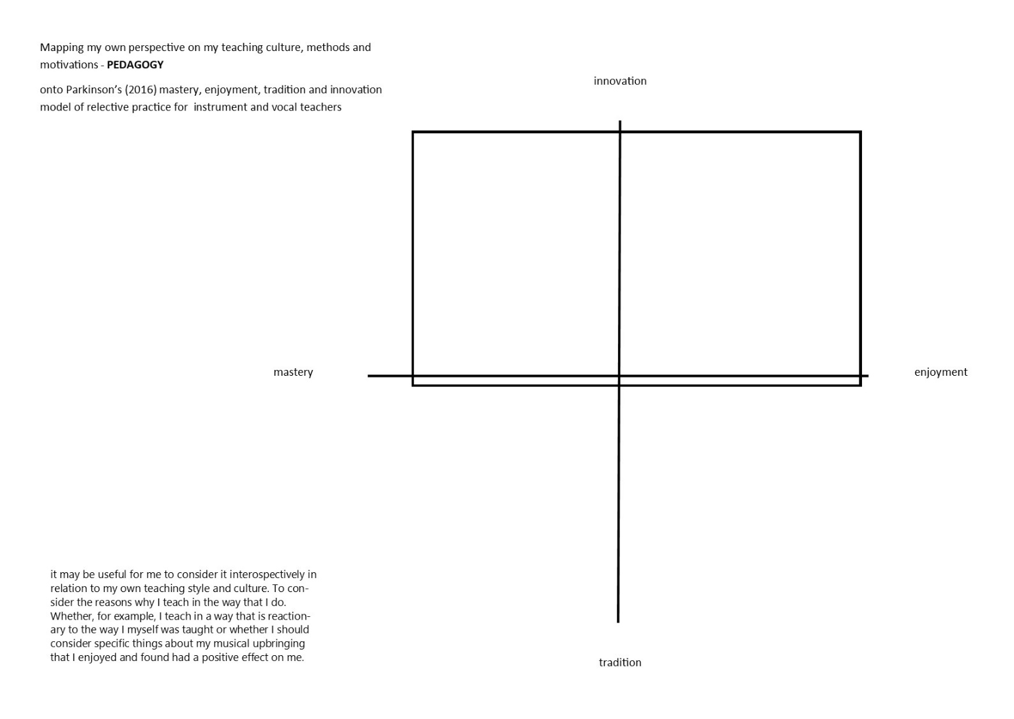

Appendix 6 – Search terms used for the project
Vocal fold aging
Voice aging
voice aging lung
voice lung health
singing lung health
singing for health
laryngeal atrophy
presbylarynx treatment
presbylarynx intervention
injection laryngoplasty, presbylarynx, presbyphonia, vocal atrophy, voice therapy.
Voice older adults
Singing older adults
Voice elder care
Singing elder care
Voice gerontology
Singing gerontology
Voice geriatrics
Singing geriatrics
Singing for the brain
Singing 4 health
Presbyphonia
Presbyphonia treatment
Presbyphonia intervention
Lsvt
FVE
Reflective practice teacher/ing
Reflective practice music teacher/vocal teacher

Appendix 7 - Personal Development Plan

NB: my version include an extra column for ‘Progress (make a note of any specific areas that worked and any for further development)’.

Areas for development | I will achieve this by the following methods: | What's happenning now? | How will I know I've been successful?
"will keep reflecting on my systems and strategies for studying and revise and rethink as and when a problem is encountered. " "Build up my study skills by utilising the resources the university offers." (Date will be achieved by: Before the start of module 2) | 1. I will reflect very specifically on my study methods and systems at the end of module 1 by completeing another Gibbs cycle analysis. | currently, just trying not to accidentally plagerise by losing track of what is paraphrased and what is not is very challenging and takes a huge amount of organisational energy and means I am not able to focus on the creative aspects of writing. This is one of a handful of issue which need to be addressed. The Gibbs cycle will help me to hone in on that list. | I will have completed a Gibbs cycle and feel certain I have a list of areas which I can get help for.
 | 2. take lessons learned from Gibbs analysis to the university's writing skills support team and ask advice on how to be more efficient with organising my writing. | This is a great resource and will help me to achieve the goal of more efficient study much faster that self-study. | I will have had a productive meeting with the team
 | 3. consider their advice and how to implement the changes. Perhaps draft some templates and write some study 'rules'. | This advice will have to be carefully considered if it is going to be integrated into my studying practices. | module 2 will be completed more efficiently, quickly and with less stress. In concrete terms, will pass the module.
"I will keep having regular meetings with my tutor for which I will be prepared with questions and drafts ahead of time where possible..." (Date will be achieved by: continuous throughout the course. Although I would hope to be more confident by the end of module 2) | 1. Remember to sketch out the overview of the module demands and support that might be needed at the beginning. Take into account the demands in that time period from other aspects of your life so there are no big surprises. | I tried this at the beginning of module 1 but without the knowledge of the demands of the course and the demands of studying whilst working and parenting this was unrealistic. | Have a document which specifies which stages have to be reached by what time.
 | 2. Keep a document for questions I need to ask my tutor and update it after each study session. | this routine was lacking during module 1 and would help to organise my thoughts. | Document will be created and utilised.
 | 3. Make a more specific plan for any week leading up to a tutorial to make sure the project has move on sufficiently to get the most out of the help on offer. | Durring module 1 this was something I did in my head but would benefit from being written down so aid accountability and structure. | document will be filled in in more detail for each corresponding tutorial week but will not be so detailed that it takes up study time.
"...remembering to be realistic and kind." (Date will be achieved by: by the end of module 2. I would hope that it was more automatic but continuing throughout the course as it gets progressively more challenging and demanding) | 1. In moments of struggle, anxiety and stress, repeat the mantra "you have done what you can today, and that is enough". | This is, of course, a complex and long standing psychological issue and cannot merely be erradicated by organisation alone but I am hopeful that habbits can help. It did help me durring module 1 many times. | This habbit will become automatic because I will be using it more.
 | 2. Look after my physical health and that will in turn look after my mental health which will allow me to study. | I need to keep a general eye on hydration, exercise, diet and sleep whilst I am engaged in study otherwise they have a habbit of becoming low on my priority list but this always ends up being counter productive. | I recognise something in myself that I term 'a crash'. This is usually the result of failing to look after hydration, exercise, diet and sleep. If I avoid crashes, I have done well.
"Keep pushing for help from the university to keep the support as closely in line with what can realistically help me to reach my potential within the context of this course given my diagnosis of dyslexia and the other related issues." (Date will be achieved by: the end of module 2) | 1. Keep tutor and admin staff up to date with what is being put in place by the university. | There seems to be a disconnect and the weak link in the communication chain is usually me because I am trying to focus on my work, my family and my studies and getting additional help seems like another job. | If I have set an alarm and checked in with admin each week and added it as a permanent item on my 'questions fro my tutor' document.
 | 2. Set reminders to check my university email daily | This is how the university support team will communicate with me. I tend not to check it regularly because it is full of items that are not relevant to me and it can be quite overwhelming. | If the alarm has been set up and the habit persists.
PDP for my practice:
Re-draw Gibbs' model with added prompts based on Schon, Brookfield and Handal and Lauva (Date will be achieved by: Before our season begins again in March) | Create a digital template of the model plus more in-depth prompts. This template can be used each time I need to reflect on my teaching or a specific event. | Brookfield (2012) talks about hunting for assumptions when reflecting on a specific event. Looking at the event from different angles and perspectives to challenge yours and others’ assumptions. And perhaps some perspective could be gained from Handal and Lauvas’ (1987) ‘Practice Triangle’ which encourages reflection on ethical and moral considerations. | When the model template has been created
Timetable in regular reflections on practice (Date will be achieved by: After every course I teach) | Complete a Gibbs cycle alone and relay bullet points for discussion with colleagues to gage their perspective. | There is currently no formal, written reflective practice. And my reflection tends to be meandering and repetitive with no clear actions except to update procedural documents | when the timetable has been populated with opportunities to reflect
Make time to rework systems and procedures (Date will be achieved by: Once per year after every season) | Timetable in a date to re-evaluate documents with the other two main teachers. | Workplaces come with regular timetabled commitments, deadlines, procedures and systems which are an integral part of the work itself. They can also come with embedded attitudes, values and cultural norms which can cause you to work on autopilot and misremember the ‘why’ behind the ‘what’ (Thompson 2022). | when each document has been considered and a new date stamped version created
Go to other singing teachers' events (Date will be achieved by: Before the end of 2025) | Initially searching for teachers who I may not have met yet, as well as teachers I know and seeing what I can financially afford to book on to. | Parkinson (2022) states that “a lack of opportunities for professional dialogue within instrumental teaching has also been identified” which I can relate to as I am often a lone practitioner myself. Robinson (2012) notes that experiences and knowledge are not often shared between teachers. | when I have booked and completed 3x workshops or meetings with other singing leaders

