
BMSW 4001 : ACADEMIC AND EMPLOYABILITY SKILLS
STUDENT NAME : PAUL IONUT VADAN
STUDENT ID : 2018571
ASSIGNMENT TITLE : INDIVIDUAL PRESENTATION ACE
LECTURER : MOLLY JACK

Presentation on Employability & Academic
skills
.
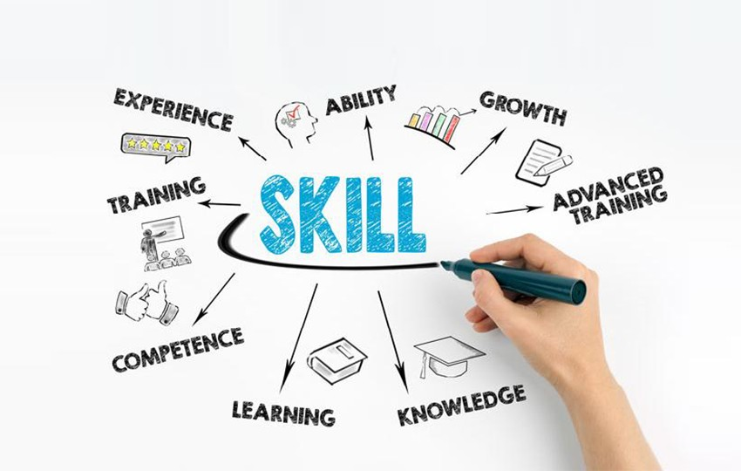
needs to demonstrate and provide parents
that will help to rectify in the future.
It will also demonstrate my weaknesses
•
business abilities and activities.
analyzing
by
entrepreneur
an
becoming
This presentation will also demonstrate for
•
a safe environment.
time for relaxing and children's have fun in
presentation
this
of
purpose
major
The
•
business activities in the hospitality field.
fundamental in this matter for developing
Employability alongside academic skills is
•
Introduction
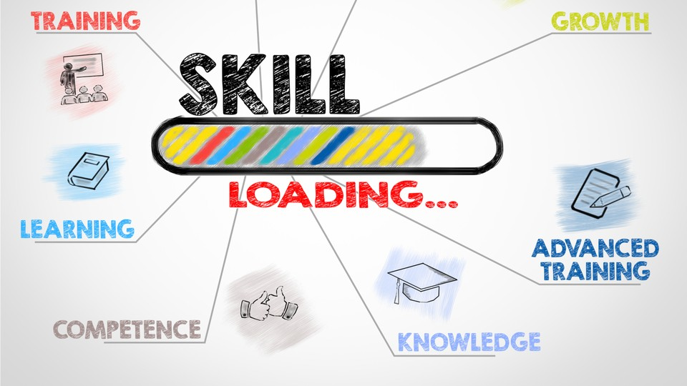
hospitality
requirements.
•
The next skill is followed by adaptability which is most needed in the hospitality section.
These are accurately dealing with predictability and regular transformation is much
needed which shows a positive attitude to customers (Peters, kallmuenzer, and
Buhalis, 2019).
•
Cultural awareness and compliance training are also necessary which are based on
the
Experience
At
should be the best method for fulfilling all abilities and also understand children's
section.
These
can
probably
help
to
being
an
entrepreneur and similarly developing a professional career.
balance communication which is significant to better consumer service (Teixeira et al.
Way to become a successful entrepreneur over my business
•
For transforming or improving family business, the chief must have some essential
skills that are helping to regulate hospitality in the United Kingdom over mountain area.
Skills are highlighted accordingly,
•
For regulating the hospitality industry, it is essential to develop communication with
colleagues and any kind of visitor. For making a positive atmosphere, it is needed to
2019).
•
Second profile things should be Resilient that is appropriately associated with enduring
stress levels. These are productive and optimistic for business activities to become
efficient entrepreneurs.
•
The next phenomenon step should be initiated in the hospitality industry. This is
fulfilling consumers' requirements alongside pulling their interest.
•
For becoming a productive entrepreneur, multitasking should be necessary and this

Weaknesses are mentioned below,
valuable
and
applicable for Hospitality Management.
•
A clear direction sense should be there in a productive
entrepreneur that could easily smoothly grow business.
•
Successful entrepreneurs should be goal-oriented and
decisive in daily operations that are so impactful.
•
are
•
Lack of proper communication might hurt consumers
•
Self-control alongside stress can easily be reflected over
daily work.
•
In certain situations, they are fear to grab chances for
development reasons (Devkota, Paudel, and Bhandari,
2021).
should
Demonstrates the capabilities to create good in business and also highlight the weaknesses
•
Multiple capabilities define to generate better business
according to proper hospitality.
•
A
successful
entrepreneur
be
self-discipline
towards daily tasks and make plans for innovation in a
perspective manner (Roundy and Fayard, 2019).
•
A productive entrepreneur should be dependent upon
persistence
and
integrative
that
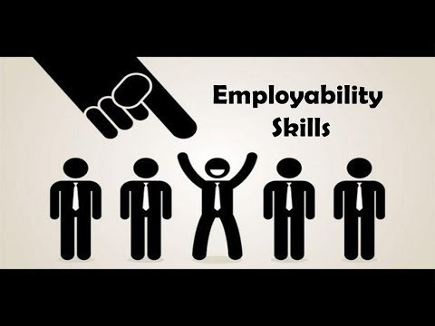
improve knowledge and insight regarding
Kingdom (Jackson and Wilton, 2017).
United
the
in
Management
Hospitality
regarding
perspective
consumer
from
It will also establish a better understanding
•
business activities.
easily
can
experience
work
Massive
•
will build positive character.
matter for successful entrepreneurs which
In the present scenario, work experiences
•
Deliver work experience will support me to grow business
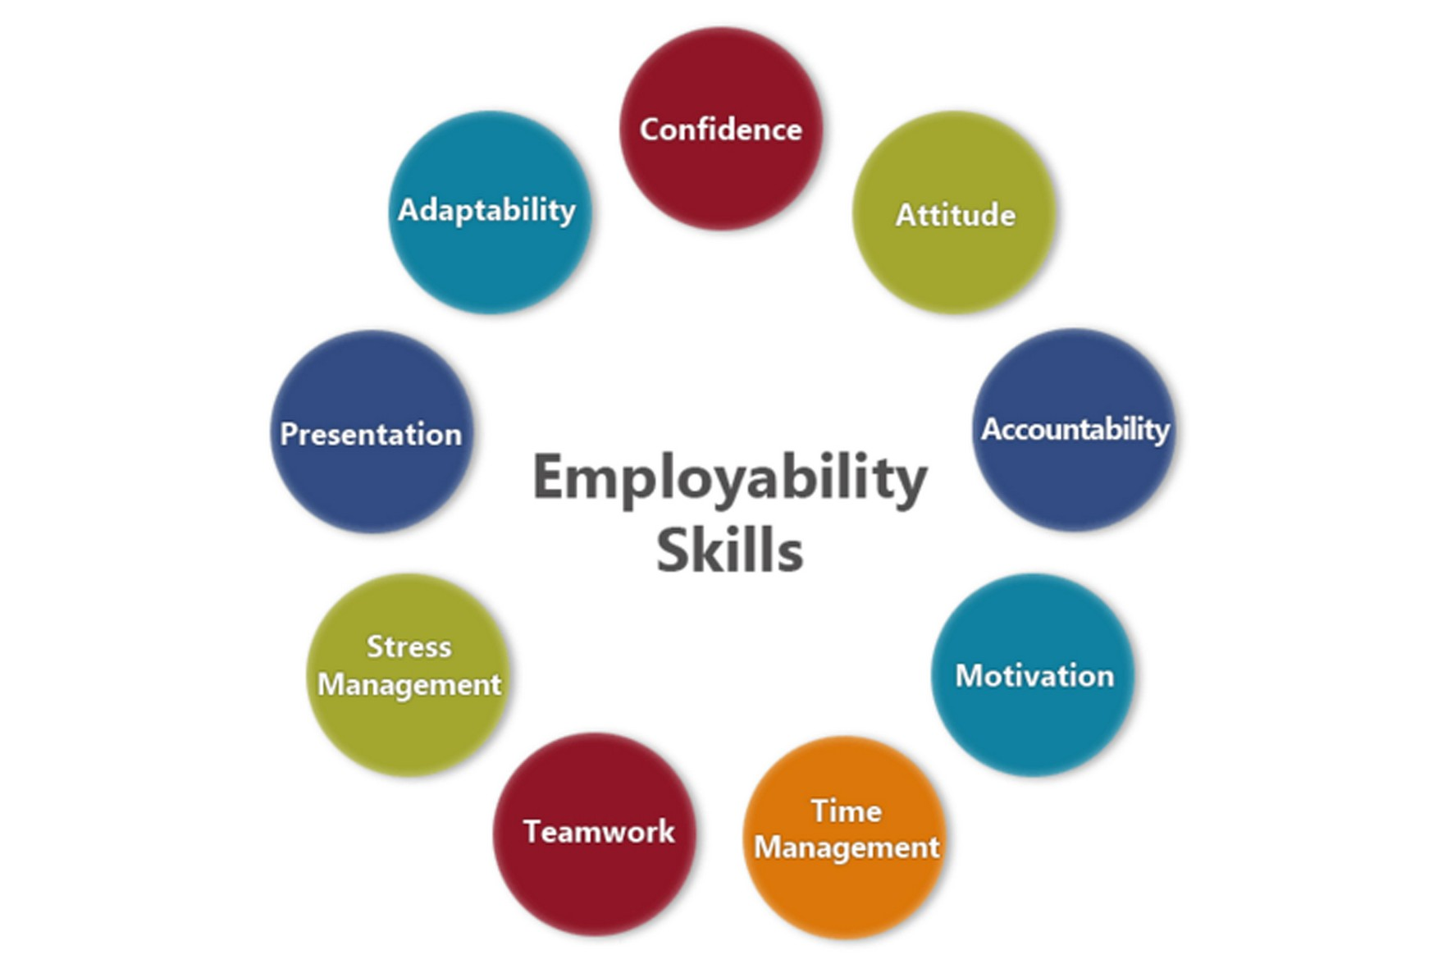
the
weaknesses are also mentioned critically.
effectual to Improve self-confidence and
Work experience has been beneficial or
•
division.
business establishment at the hospitality
capabilities that could easily turn around
importance of entrepreneurship skills and
demonstrated
has
presentation
This
•
Conclusion
•
167.
small hospitality enterprises. International Journal of Hospitality Management, 79, pp.158-
entrepreneurs use their social networks to access resources? Evidence from the lifecycle of
Teixeira, R.M., Andreassi, T., Köseoglu, M.A. and Okumus, F., 2019. How do hospitality
•
pp.94-120.
The micro-foundations of regional entrepreneurship. The Journal of Entrepreneurship, 28(1),
Roundy, P.T. and Fayard, D., 2019. Dynamic capabilities and entrepreneurial ecosystems:
•
quality of life and business growth. Current Issues in Tourism, 22(16), pp.2014-2033.
Peters, M., Kallmuenzer, A. and Buhalis, D., 2019. Hospitality entrepreneurs managing
Higher Education Research & Development, 36(4), pp.747-762.
importance of career self-management, work experience and individual characteristics.
Jackson, D. and Wilton, N., 2017. Perceived employability among undergraduates and the
•
Nepal. The Gaze: Journal of Tourism and Hospitality, 12(1), pp.88-111.
and Hospitality Entrepreneurship in Touristic Destination: Lessons Learnt from Pokhara,
Devkota, N., Paudel, U.R. and Bhandari, U., 2021. Conveying Impetus for Fostering Tourism
•
Reference

