

Marketing and Engagement within a Heritage Organisation
Practice Based Portfolio
Natalie Emma Male
BA Business and Management

B
BA Business and Management

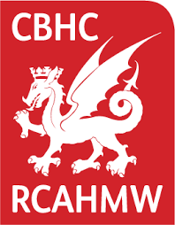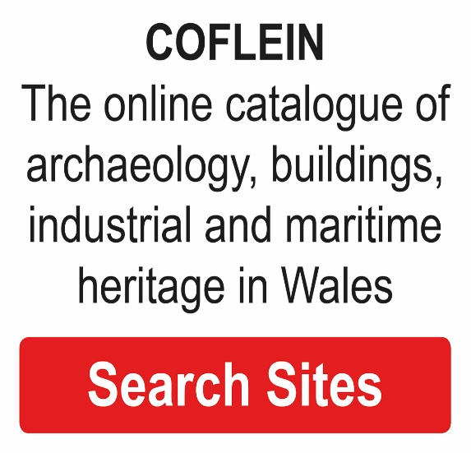
In collaboration with: The Royal Commission on The Ancient and Historic Monuments of Wales
Wordcount: 5494

SIGNED STATEMENT

In submitting this Dissertation, I confirm that:
- This work has not previously been accepted in substance for any degree and is not being concurrently submitted in candidature for any degree.

- This Dissertation is being submitted in partial fulfilment of the requirements for the degree of BA Business and Management.

- This Practice Based Portfolio is the result of my own independent research/investigation, except where otherwise stated. Other sources are acknowledged and appropriately referenced.

- I hereby give consent for my Dissertation, if accepted, to be deposited in the School Dissertation Library.

Name: Natalie Emma Male
Date of Submission:
Signature: N.E.Male

ACKNOWLEDGEMENTS

This Practise Based Portfolio has given me the valuable experience of a Marketing and Engagement role. A special thank you to The Royal Commission on The Ancient and Historical Monuments of Wales (RCAHMW) for enabling my Internship placement. This has further fuelled my passion for marketing. I have been fortunate to work alongside a group of passionate individuals. It has been a privilege to work with the organisation on this project.
I would like to give thanks to The Carmarthen Business School. Their continued support and encouragement helped me to exceed my expectations, shaping my learning journey and broadening my future opportunities. I would particularly like to thank Jessica Shore, for her help and support and her belief that I could manage this project, even when I doubted my capability. I sincerely credit each tutor for my progress and development, thank you all for your continued support.
Dr Alex Bell
Dr Louise Emmanuel
Dr Roisin Mullins
Glenn Behenna
Dr Anthony Burns
I would also like to thank my fellow students. They are truly a wonderful group of people and their input in my learning experience has been invaluable. Their continued support has kept me motivated, in a time where our lives changed overnight.
Lastly, I would like to give a special thanks to my husband and daughters. For their patience, with the many hours of research and late nights working on my studies, for the constant encouragement and endless cups of coffee. Not forgetting my mum and her continued offers to look after the children.
Thank you for keeping me motivated, I could not have completed this degree without the support of you all.

ABSTRACT

For the purpose of this dissertation the following abbreviations will be used
RCAHMW – The Royal Commission on the Ancient and Historical Monuments of Wales
Coflein - the name for the improved digital archive.
PCW - Peoples collection wales, a cultural organisation that the RCAHMW occasionally works in partnership.

The RCAHMW is a heritage organisation who faces many challenges with regard to marketing and engagement. The organisation is due to launch its new digital archive Coflein. Research conducted within the RCAHMW confirms that their patrons are predominantly retired males over the age of 50.This poses a potential sustainability crisis for the organisation; new users are infrequent and tend to only access resources for short periods of time. Furthermore, the organisation has little marketing budget, staff including those who update social media are already overstretched. There are approximately 30 staff at present. The organisation is guided by the Royal Warrant, giving the organisation a very formal image, which can discourage new users. Finally, as a government funded organisation all documentation published must be bilingual, this poses time issues as everything produced must be checked and translated into Welsh.
The objective of this study is to determine a strategic approach that will attract a larger demographic of customers. Information has been gathered during a 150-hour internship. The study seeks to utilise the literature available for comparison in this subject, developing an understanding of opportunities and barriers that exist within heritage organisations. Those who work for the RCAHMW are passionate in their given field and are keen to share their wealth of knowledge, through presentations and public engagement opportunities.
Recommendations have been presented to the RCAHMW in the process of the Internship. As the project has been time bound further recommendations are outlined for future implementation. A copy has been forwarded to the organisation for their consideration.

TABLE OF CONTENTS

SIGNED STATEMENT i
ABSTRACT iii
TABLE OF CONTENTS v
FIGURES AND TABLES 1
Chapter 1. INTRODUCTION 2
Chapter 2. LITERATURE REVIEW 4
2.1 The challenge of attracting a new audience. 4
2.2 Social media marketing’s value in historical institutions 6
Chapter 3. METHODOLOGY 10
3.1 Barriers within the project 10
3.2 The process 11
Chapter 4. FINDINGS 12
4.1 Qualitative Data 13
4.2 Quantitative Data 14
Chapter 6 Conclusion 20
Chapter 7 Recommendations 22
Chapter 8. REFERENCES 23
Chapter 9. APPENDICIES 26

FIGURES AND TABLES

Main Body
Figure 1. Value Proposition Canvas developed for Coflein digital archive.
Figure 2. Results of the Coflein survey, how did you hear about us ?
Figure 3. Results of the Coflein survey, which device did you use to access Coflein ?
Figure 4. Graph displaying Facebook analytics, from February 2020 to March 2021
Figure 5.Graph displaying Twitter analytics, from November 2020 to March 2021

Appendices
Figure 9.1 RCAHMW Segmentation, targeting and positioning 2020, prior research.
Figure 9.2 Simon Tanner's Balance Value Impact Model
Figure 9.3. Hootsuite Facebook analytics Nov 01 - Nov 30 and 2020 Feb - Mar 2021 Figure 9.4. Hootsuite Facebook analytics Feb 25 - Mar 22, 2021
Figure 9.5. Twitter Hootsuite analytics between Nov 01 - Nov 30, 2020 and Feb 01 - Mar 01, 2020
Figure 9.6. Twitter Hootsuite analytics Feb 25 - Mar 22, 2021
Figure 9.7. Coflein survey questions
Figure 9.8 . What makes it difficult for you to develop / deliver work with young people aged 11-25?
Figure 9.9. Social media poster example 1
Figure 10 Social media poster example 2 Figure
Figure 10.1 Peoples Collection Wales 18-month Race Framework.

Chapter 1. INTRODUCTION

The RCAMHW is an organisation that predominantly promotes tangible heritage, which is defined in three categories. Immovable cultural heritage, including monuments and archaeological sites. Moveable cultural heritage including maps and manuscripts and underwater cultural heritage such as shipwrecks or flooded villages (Unesco, 2017). The RCAHMW classifies itself as a heritage organisation, it does not own the monuments that it promotes, unlike organisations such as Cadw. Before the Covid -19 pandemic many staff had never worked remotely, adapting to the use of Microsoft Teams, and sharing information using this platform. This new way of working has proved beneficial and team members continued to work remotely for the last twelve months.
The organisation is government funded and unlike PCW has no digital marketing officer. They wish to expand their demographic of users. Preliminary research has showed that search engines are not guiding individuals to the organisation, as the largest online catalogue of historical information in Wales, this is a concern. The aim of the project is to promote the improved digital archive Coflein. This is an I base media platform, which will be easier to use than the previous website. Functioning as an e-commerce site, providing the opportunity to purchase images, in addition to free downloadable images. Through a two-week Induction and 150-hour Internship with the organisation, three key areas have been chosen by the commission to promote:
1. Coflein has over 180,000 free downloadable and purchasable images: The new I base system allows the purchase of high-resolution images.
2. Coflein in my pocket: The application will use digital mapping via GPS for mobile devices. Displaying sites of historical interest in the locality and throughout Wales. The aim is that it will be used by walking groups, families, and individuals. This is an area that has been considered due to the Covid-19 restrictions and daily exercise.
3. Attracting more members to the friends’ network : The friend’s network has approximately 1300 members and plays a large part in marketing the organisation. Friends share a lot of content through social media and word of mouth. The aim is to attract more friends to spread the message of the Commission. With developments in social media, evangelism is proving a powerful tool for organisations. Value co-creation is becoming increasingly important due to advancements in social media. Customers anticipate the opportunity to partake in the creation of products and services (Jung & Tom Dieck, 2017).
The promotion of Coflein is not exhaustive to these three areas. There are opportunities to market this resource in many ways, through numerous projects. For example, a member of staff wished to involve young farmers clubs in a project. This would help to document areas of land that were missing in the collection, whilst reaching a new demographic of people.

Chapter 2. LITERATURE REVIEW

The project aims to understand the complex nature of the RCAHMW and their current services. Information has been collated through primary sources during team meetings with staff, with supporting documentation provided by the organisation. The heritage sector is very diverse and there are many sources of reference available, however organisations promoting history have many different classifications, which are often interpretative. This becomes a barrier when applying for project funding as many organisations cannot determine which category projects fall under. Some members of staff recognise the commission as a cultural heritage organisation, others regard it as a heritage organisation. Although, research suggests that the commission has an element of both. Journal articles, reports and internet research of similar organisations will provide valuable insight for comparison. However, there appears to be a large area covered by the definition of culture and heritage. They include museums, libraries, monuments, memory institutions and intangible aspects such as culture and traditions. Heritage is defined as inherited resources, valued by individuals for reasoning surpassing mere utility. The concept of Heritage is broad and encompasses the cultural and natural environment (Historic England, 2021). The duty of Heritage organisations to document information is imperative, in order to sustain this valuable archive for future generations.

2.1 The challenge of attracting a new audience.

Heritage organisations face a number of challenges when trying to attract new audiences. Engaging new customers and holding their interest, accompanied with keeping loyal customers satisfied is a complex consideration. Historical information can often appear specialised and formal, making the appeal to a new target audience limited. Cultural organisations have been researched for many years, although little development has been made in creating a theoretical framework to understand visitor motivation (Dawson & Dawson, 2011). To be current and sustainable for future generations requires understanding and adaptation. Indeed, traditionally museums were predominantly concerned with the care of their collections. This gave little thought to serving the needs of the public or their customer base. However, over the last 20 years organisational marketing approaches have significantly developed, changing the perceived view of customers. Recognising the significance that they play in the success of their organisation (Harrison & Shaw, 2004).
There is frequently updated information on the subject of the demographics of heritage organisations in England. The department for Digital culture, media and sport conduct an annual audit report. The household survey ‘Taking Part’ measures engagement within the cultural sectors. Data is frequently used by academics, charities, and practitioners (Department for Digital Culture, 2019). However, it is difficult to find any information pertaining specifically to statistics in Wales. Furthermore, analysis of online statistics for heritage organisations during the pandemic could not be found. Organisations do have access to their own statistical data enabling the analysis of customer behaviours. The segmentation, targeting and positioning framework can be implemented to highlight and improve visitor demographics. Organisations depend upon segmentation to select specific customer groups to market relevant content to. Moreover, a deeper understanding of the needs and wants of customers will assist organisations to effectively engage with customers (An et al , 2018).

Educational establishments are a key target demographic for heritage organisations. Since 2015 UNESCO commenced the process of introducing culture as part of the sustainable development goals. Given the correct tools and technologies cultural heritage information can have a significant effect on creative industries, learning and education in many disciplines (Koya & Chowdhury, 2019). A large role in engaging and marketing to the younger generation is dependent on their view of heritage. The vast majority of young people are already engaged by technology and social media platforms. An important area of consideration for heritage organisations to increase their connectivity. Curating heritage needs to be in a format that is understood and creates interest for younger people. Barriers exist for organisations trying to engage children in heritage. There are safeguarding considerations and limited staff capacity. Often staff have not received appropriate training in order to work with a younger target group. Lack of funds is a major consideration as is staff having time to implement projects that are eligible for funding (Young people and the Heritage Sector, 2015).
Forging relationships with Universities can be a valuable experience for both parties, promoting materials for research purposes and inviting student internships. A collaboration with Sheffield University and Creswell Heritage trust had a profound effect for the organisation. Visitor numbers to the site increased which provided a greater understanding and public awareness of Ice Age Britain. With media, academics and the public becoming more aware, this led to an economic upturn for the organisation, including the ability to develop the site and build a new visitor centre (Markham et al, 2020).
There are many educational disciplines including art, history, business and management and geography. Heritage covers a wide range of skill sets that can be applied to almost any degree programme. Internships can offer the organisation assistance in areas that are usually underfunded, such as singular projects and media marketing. In turn the student gains a perspective of the working environment and experience in real life situations, outside of the university setting. Partaking in first-hand experiences and research provides an opportunity to develop a unique depth of understanding. Although, classroom-based learning is an important component of research, first- hand experiences offer an opportunity to explore and offer a new perspective to a topic or problem (Scott & Silby, 2000) . As organisations are highly specialised there can be a resistance to inviting internships. Perhaps lack of staff resources and previous experiences have discouraged collaborating with universities.

2.2 Social media marketing’s value in historical institutions

Advancements in technology have given heritage organisations the opportunity to have a far-reaching connectivity in everyday operations. At the start of the twentieth century studies have shown that museums have developed in their responsiveness to social media. Recognising the impact of new media and the shift in visitors’ digital skills, in how they learn and obtain information (Cerquetti & Ferrara , 2018). Heritage organisations are improving communication by utilising social media networks and tools, building on loyalty with existing customers, whilst attracting a new audience (Ayala et al, 2019). Social media connectivity has never been more important than in the last year. The impact of the Covid-19 pandemic changed how organisations communicated with their customers and staff. For heritage institutions, many were adapting to a new method of online working, whilst attempting to keep customers engaged via social media platforms. Equally, the lockdown has encouraged people to try to increase their connectivity, as they are not able to access resources traditionally. Marketing has rarely had the opportunity of such a captive audience, the consumption of digital media transformed immensely during the pandemic. Those who would not usually access social media were more inclined to participate, as a way of connecting and interacting with the outside world. This was an unprecedented event for businesses, never before had there been a global lockdown. The dramatic move to online operations became an urgent issue for memory institutions. Introducing new ways to connect and offer digital experiences (Samaroudi et al, 2020). Digital archives had the benefit that they were already established before the pandemic occurred. This led to the immediate closure of heritage organisations, with institutions striving to support and engage their communities. Digital resources are leading the way for institution’s virtual services (Kamposiori, 2020).

The utilisation of social media tools and social media engagement are referred to as one and the same, though the two areas are distinct in their identity. Social media refers to the various activities that are facilitated online. Social media engagement refers to the intellectual and impactful immersion of using such tools (Smith & Gallicano, 2014). Customer engagement in marketing can be described as an organisation’s aim to inspire, encourage, and quantify customer involvement to the marketing process (Harmeling et al, 2017).
Conservation and heritage sectors have become increasingly concerned with the issue of engagement. Although, the analysis of engagement goes further than likes and shares on social media. Liking a post could be considered a brief interaction, whereas the desire to share a post could be considered as evidence of increased engagement. It may be difficult to quantify if the individual will be engaged or indeed share future posts. Number of fans on an organisation’s webpage is not evidence of interaction. Followers are important though fundamentally the largest measure of success on social media platforms is not the size of the audience, but their level of engagement. Quality of information should be considered over quantity (McLachlan, 2020). Website analytics often display volume of visitors, many organisations use this data as evidence of engagement. It is interesting to note that this does not express a customer’s level of interest or how long they stayed on the website. Website hits are not evidence of prolonged engagement and may not determine if the customer moved onto different areas of the website.
Traditional measures of engagement for heritage organisations have been the volume of attendees at live or virtual conferences. With feedback forms to assess the level of enjoyment and interest. Engagement is a factor that needs to be achievable and measurable, this is vital in determining areas for improvement and development. With increased recognition for digital analytics as a marketing strategy. PCW’s digital audit outlines their objective clearly. (Roberts, 2020) states that “To analyse PCW’s current digital marketing activities to identify the current situation of PCW in terms of digital marketing successes and pitfalls over the last 18 months and identify future opportunities and threats for market development”.
As history is a topic that can be considered specialised there is a need to be relevant to a wider audience. Although heritage organisations can be funded by government and charity sectors, they are still a business, with the need to generate and expand on their customer base. Creating an income assists in sustainability . Social media can deliver a diverse platform for further engagement, conferences for example provide a low cost method of knowledge sharing and networking to a wider audience (UNESCO, 2019). The benefits of social networking are endless with a larger geographical reach for knowledge sharing institutions. Although social media networks vary in popularity, research shows that the average personal daily use is two hours and fifteen minutes, with 53.6% of the global population utilising social media (Chaffey, 2021).
Traditionally in a physical talk or conference attendance is limited to those who live within the locality, limiting the demographic of attendees and their participation. Furthermore, content can be recorded and shared again on YouTube, the resource has enabled heritage organisations to share content on a platform that reaches a vast demographic of users. Creating an interactive experience that can be accessed whenever the user chooses. Social media platforms such as Facebook, Twitter and YouTube encourage collaboration and creative expression. Enabling the ability of individuals or community groups to comment and share digital content created by heritage organisations. Sharing contents of collections via web 2.0 spaces can create an open environment for users to access previously guarded collections. (Liew, 2014)

Chapter 3. METHODOLOGY

The purpose of this research is to determine a project that will attract and engage a new demographic of customers, whilst recognising the barriers and opportunities that exist for the RCAHMW. Participant observation and interaction enabled the process of investigation. A micro ethnography provides the basis of this research project, meaning that information is documented in real time and not from memory. Ethical considerations were minimised due to the invitation to join the organisation. Reports and quotes provided by the RCAHMW have been permitted and referenced. It would have been impossible to have gained so much insight without the benefit of this Internship. Providing a first-hand knowledge and experience for valuable research, reflection, and analysis in this field.
The requirement of the RCAHMW was that I developed a project to increase engagement. The internship involved a 150-hour online placement, equal to six months of research and interaction within the organisation. The process began with a two-week induction learning the roles of staff members. Communication with the organisation was via email and Microsoft Teams. I attended all meetings that were requested, and this evolved into a specific group meeting called Coflein Marketing Group.

3.1 Barriers within the project

Although the aim of the project was to increase engagement, there were many barriers, especially in not wanting to tread on anyone’s toes. This referred to other organisations such as PCW who promote cultural history. This presents a complex problem in regard to engaging people in using Coflein, narrowing the demographic of interested parties. Recording cultural history forms a fundamental process of documenting social historical development. This reflects the diverse regional and local identities of communities, forming a positive reference point for growth and change. Local community’s heritage and combined memories are an irreplaceable and important foundation for development (Historic England, 2021).

3.2 The process

The organisation decided to market the key features of Coflein. The three areas identified were, engaging more friends’ members, Coflein in my pocket and the free images available to download. A social media campaign would be the method of engagement. The royal commission does not have an Instagram account I suggested this should become a priority. Analytics were requested for both Twitter and Facebook prior to the project, acting as a baseline.
The manager recommended that I consider Simon Tanners Balance Value Model. On further investigation it became apparent that this was a comprehensive tool for projects with a longer timeframe. (Kalpokas, 2021) suggests that “The BVI model is specifically aimed at measuring the impact of digital resources by demonstrating their quantifiable impact on the life and/or opportunities of communities”. A value proposition canvas appeared to be the most appropriate tool. The canvas maps out how products and services are arranged around customers’ expectations and desires. I developed the canvas in figure 1 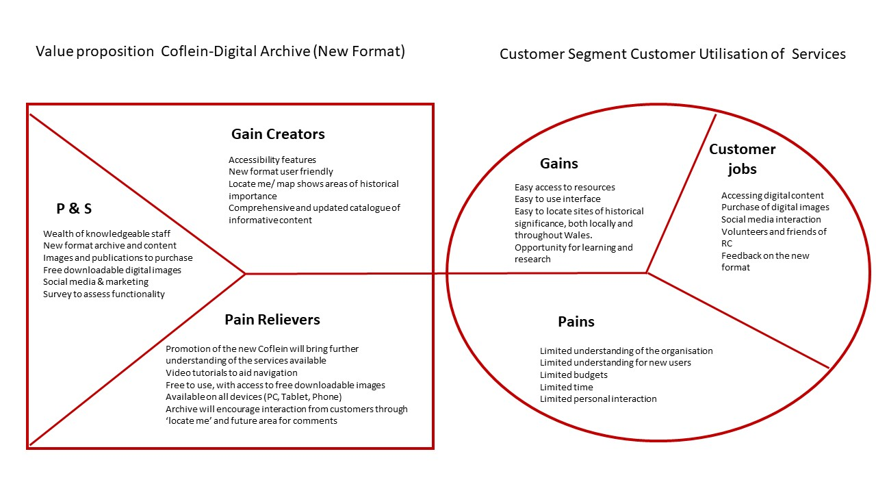
Figure 1
A week before launch the friends of the commission would be invited to use Coflein. Looking to increase involvement, I suggested that a survey be created to analyse personal experience and highlight issues. The survey was originally going to run for one week. I requested for the survey to be left ongoing for a period of two weeks. This would ensure an unbiased representative sample, gaining valid qualitative data. Coflein officially launched to the public on 24/02/2021. Despite the launch, the commission does not wish to promote Coflein until May 2021.
Posters are visually impacting, enabling the easy transfer of information. Evidence suggests that perception of humans is mainly visual, with 90% of information processed daily by our visual receptors. Visual content is most likely to be shared across platforms, as lives have become busier, so have attention spans. The majority of people will only remember 20% of what they read, opposed to 80% being able to recall what they have seen. Providing an effective and affordable method of marketing (Manic, 2015). I decided to develop two poster examples. The idea is to create a template that can be quickly changed to suit the needs of the commission. This can then be shared by members of the public and to interest groups. Both posters have been given as an example to the commission, this is being taken forward by a member of staff.

Chapter 4. FINDINGS

It is not possible to quantify the results of the main project as it is still ongoing. If marketing is a focus, then engagement should increase from the official launch in May. Marketing has not played a large part in the history of the organisation (Morgan, 2020) stated that "Marketing is so important, you have to be relevant nowadays or you get left behind. I remember it being said when I started that marketing 'cheapens the brand', maybe that stems from a fear of being exposed to the public and their scrutiny. Marketing does not have to be crass and pushy; it can be outreach, workshops, or blogs. Fundamentally, it is about sharing something you deem valuable with the world, effectively."

Analysis of the baseline data and survey data has been explored and evaluated. A mixed method approach of qualitative and quantitative research is appropriate for this study.

4.1 Qualitative Data

Survey results recognised two key areas, Fig 3 and 4. From a survey of 88 respondents only 22% heard of Coflein through Social Media, with the largest percentile finding Coflein through a search engine. This is likely to increase during the social media launch. Although, there are inconsistencies in the use of social media platforms, with some account content not being generated or shared. The commission has set out their key messages for the social media campaign :
- New, easy to use system that works across all devices.
- Amazing images available in high resolution – over 180,000 images, many available as free downloads, plus new ecommerce system for licensing.
- Carry Coflein in your pocket – locate me function in Map and detailed OS mapping mean you can learn about the archaeological sites and historic buildings all around you. (Pert, 2021)
To have any impact this will only be achievable if the social media presence of the organisation becomes of greater importance and focus. The survey showed that only 16% of visitors accessed Coflein using a mobile phone, another area that would need to increase to deem Coflein in my pocket, effective and successful. This number may also increase due to the official launch in May.

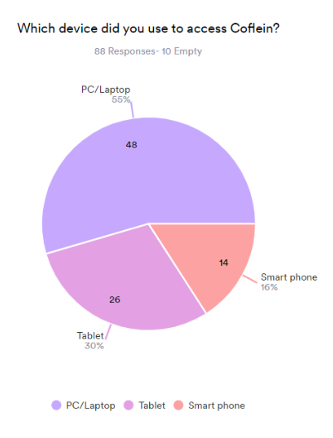
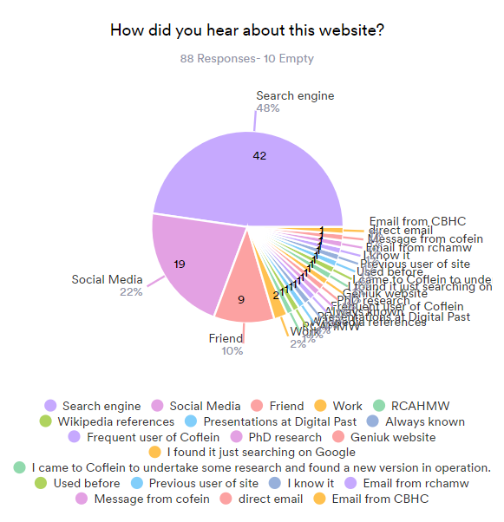
Fig 2. Fig 3.

Quantitative data is interpretive and open to bias, people are not always truthful when completing questionnaires. Despite this consideration the information offers a baseline for future comparison. The survey also gleaned information regarding usage issues.

4.2 Quantitative Data

Despite the lack of impact to measure, analysing the statistics will give a baseline before the promotion in May 2021. Figure 4.displays the Facebook analytics of the RCAHMW, for the period of February 2020 to March 2021. Evidence shows the number of posts created has declined since February 2020. Engagement from the public, sharing and reacting to posts has also dropped substantially since this time. However, it is interesting to note that the number of fans has increased steadily since February 2020. This could be attributed to people at home during the pandemic, having time to search for areas of interest. Followers increased, and this could have been an opportunity to engage the public further, in preparation for the launch. It is possible that due to the unprecedented effect on working through the pandemic, the organisation’s attention was focused on the logistics of establishing a remote working environment. Analysis of the data brings the conclusion that attention has been focused on developing Coflein and establishing a remote working network.

 | February - March  2020 | November  2020 | February -March  2021
Posts | 122 | 76 | 33
Number of Fans | 8517 | 9400 | 9500
Number of Reactions | 2637 | 2700 | 1200
Number of Comments | 163 | 408 | 159
Number of Shares | 351 | 364 | 133

Figure 4

Twitter statistics are made up of three accounts, it is interesting to note that the RCAHMWales account has 6400 followers with RC Survey and RC Archive having 1700, respectively. However, throughout November 2020, RC Survey were responsible for 3900 interactions, the highest amount on twitter opposed to 471 interactions from the RCAHMWales account. Statistics show similar results for February to March 2021. During the internship I discovered that the survey team have control of their own twitter account, with which they share daily content. I asked Dr Driver if there were any specific projects that have contributed to these statistics, he stated that “The RC Survey twitter account is managed by four of us, me, Louise, Sue Fielding and Meilyr Powell. We don't have a particular project around it but map out likely tweet themes for each month in advance and parcel up each day, so we all know who has to do a tweet” (Driver, 2021). This shows that teams having access to their own accounts may promote engagement, if managed effectively. Again, it is important to highlight that the RCAHMWales account has the largest number of followers yet the lowest amount of engagement, an area for further investigation.

November 2020 | Followers | Engagement
RCAHMWales | 6400 | 471
RC Archive | 1700 | 2600
RC Survey | 1700 | 3900

Feb - March 2021 | Followers | Engagement
RCAHMWales | 6600 | 396
RC Archive | 2000 | 1400
RC Survey | 2200 | 3200

Figure 5

Chapter 5. DISCUSSION AND ANALYSIS

This chapter will analyse and discuss the two themes of engagement identified for the RCAHMW, with supporting evidence provided in the literature review.
The Challenge of attracting a new audience.
Literature referring to history is wide and does not target specific areas, making it difficult to find information regarding heritage that does not include the word ‘cultural.’ As the organisation does not consider itself to be cultural, it is difficult to find specific literature that compares to the RCAHMW. Moreover, in the ‘Taking Part’ survey England is surveyed as a whole and information does not point to Wales specifically, nor does it include information regarding digital collections. However, the organisation has access to their own data for analysis. Nevertheless, as there is no marketing officer, targeted content is not created or analysed.
The RCAHMW has identified that there is a defined demographic of customers. The friends of the commission are highly regarded, with evident concern for keeping this customer base happy. Reliance on this group inhibits the desire to generate and engage new customers. There is a comfort that the ‘friends will provide positive critique and are familiar. Whereas there appears to be a concern for new customers’ expectations. The consequence of narrowing the demographic, results in loss of potential income and exposure of the organisation.
The commission does not look to develop projects to target specific demographics. Motivation is a difficult factor to determine, as theoretical frameworks are not in place to determine visitor motivations, perhaps if this were the case the Commission could confidently apply this information effectively to future projects. Further continued use of the segmentation, targeting and positioning framework can ensure customer segments are highlighted. Enabling the commission to identify and market to specific groups. Understanding customers wants and needs is vital for the commission to increase engagement.

The educational sector is a key demographic for heritage organisations. However, in the case of RCAHMW there are no links with primary or secondary education providers, with limited relationships with Universities. As a government organisation, a project could receive funding to support the SDG’s. Engaging a younger demographic is also dependant on how they view heritage, and what technologies are used to create and sustain interest. Nevertheless, barriers to providing heritage projects for children exist such as legislation, underfunding and lack of staff experience. The younger demographic has limited interaction with the commission. Consideration should be given to creating information that can be used by schools, perhaps an area in Coflein that is age appropriate. An opportunity exists to change the view of heritage that young people have. From a sustainable perspective this younger demographic is the Commission’s future market.
The commission does not market Coflein to schools or universities as a comprehensive tool for research. This is a lost opportunity to widen the demographic and increase engagement. University libraries would be an opportunity to inform students of this resource. This will engage an audience of frequent users.
Internships are an untapped and invaluable resource for the heritage sector. There is a vast number of subjects that can interact and assist the commission. Collaboration brings a fresh outlook and new ideas, with the benefit of offering voluntary work experience. Evidence suggests that collaboration with universities can be beneficial for the commission, leading to increased awareness and economic upturn. Though, further evidence may point to negative experiences and lack of staff resources to support such internships. The organisation had commented that previous internships had involved increased workload and did not benefit the organisation. Although this area may be improved by furnishing the student with a clear directive from the outset. The commission should consider carefully before overlooking this resource.

Social media marketing value in historical institutions.

Similar organisations have capitalised on using social media marketing, whilst engaging new audiences. Unlike other archival organisations such as PCW, the commission does not have a digital audit or marketing officer. Although there are several accounts of which content is shared, specific marketing is limited, displaying that social media marketing has been somewhat overlooked by the organisation. Although staff time is limited, tools such as poster utilisation, enable rapid transfer of information on social media. Underdevelopment of social media marketing will likely lose the commission valuable revenue. Though, implementation is a funding issue, the lack of a digital marketing officer could be detrimental to the organisation. This should be a future consideration for the commission if engagement is to be achievable and measurable. PCW’s report displays that a clear analysis and objective can increase engagement.
Social media platforms address the issue of cost for the commission, who have little marketing budget. This method of marketing is the most cost-effective way of advertising products and services. Customers now expect more interaction with organisations. However, the commission does not encourage co creation, for example blogs by members of the public on Coflein. An area may be created to allow people to share knowledge in future. Nevertheless, concern was highlighted that content should be edited to meet the commissions requirements. This does not allow for the free expression of experiences. Knowledge sharing should be an area for further consideration and an opportunity to create an interactive experience.
The RCAHMW measures engagement via google analytics, headcounts at events and evaluation forms that provide feedback. However, analytical data is not always evidence of prolonged engagement. Web analytics often do not determine the length of time that individuals are engaged, or if they move to other areas of the site. This is an area that should be further analysed to give an in-depth picture of visitor interest. The commissions main Facebook and Twitter pages have a large number of fans, though little implementation of engagement. The RC Twitter account shows the largest number of public engagements. Perhaps the commission should allow more co creation from staff and allow them to develop their own posts.

The Commission do not currently target specific groups on social media. There are numerous walking and community groups locally, of whom Coflein in my pocket could be marketed to. Additionally, there is a vast demographic of history groups to which the archive could be promoted. The commission’s premises are currently closed due to Covid-19. It is imperative to create content and engage audiences. There is no directive at present to indicate when heritage organisations will open.

Chapter 6. Conclusion

Heritage can be considered an inheritance of our past history, culture, and traditions. However, there must be acceptance that it is not possible to appeal to everyone. The commission should not be offended, this is not a reflection of the quality of their work, it is a personal preference. Nevertheless, there are future opportunities that can create more interest and exposure for the organisation. The RCAHMW have worked through an unprecedented time, whilst inviting an intern as an increased consideration. This has been a positive experience, although there is a defined organisational culture. This presents a barrier for engaging future marketing interns. In a project that the main focus was engagement it is an interesting paradox that I had to develop my own engagement within the project. Engaging more universities, and offering further internships, is an area the organisation should consider, addressing areas with little funding.
Although the friends of the commission are a valuable resource, reliance on this group will not provide prolonged sustainability. Attention should be focused on generating more users. There is a protectiveness to remain traditional and formal, though this will likely discourage people in the long term. Social media marketing has the potential to be a highly beneficial tool for the commission, as a cost effective and wide-reaching platform. If the commission can utilise this technology, whilst adapting to new developing platforms, they stand in good stead to engage a larger demographic. As the impact of Covid-19 will be a consideration for some time, social media engagement is both relevant and important. The commission should be proud in their achievements, with the confidence to invite co creation. There is a danger that if heritage organisations do not evolve, they will be left behind. Tradition and longevity are not always evidence of future sustainability and progression. Importance should be focused on utilising all available tools, to promote this valuable resource for the world to enjoy.

Chapter 7. Recommendations

Here are the key marketing areas, they are mainly directed at social media this is because of the restrictions due to Covid-19.The following recommendations have been identified with the collaboration of staff:
1.Development of a post for a qualified Digital Marketing Officer, ensuring engagement opportunities are created.
2. Establish an Instagram and LinkedIn account to widen public engagement.
3. Utilise a poster template as a swift way to update and share through social media platforms. This can be instantly shared from the RCAHMW page by members of the public.
4. Promote Coflein in my pocket, particularly during the pandemic and daily exercise. Promote to social media walking groups and community pages.
5. Attract more friends of the commission. Members are already effective at sharing and engaging others.
6. Promote a paid social media presentation, evidence suggests that it brings increased traffic.
7. Promote Coflein to local history groups on social media platforms.
8. Staff mentioned that they have ideas for small projects. Utilise the Universities and offer Internship placements to assist with projects. This is an excellent way of developing close relationships with the Universities. There is a pool of talented undergraduates who can assist in promoting a small new project twice a year, this will keep the public engaged.
9. Engage Universities outlining Coflein as a comprehensive research tool.
10. Coflein should appear first and foremost on the RCAMHW website as it is now an E-Commerce platform.
11. Promote Coflein as a tool to assist with boundary disputes, companies already use this resource and charge clients, losing the Commission revenue.

Chapter 8. REFERENCES

An, J. K. (2018). Customer segmentation using online platforms: isolating behavioral and demographic segments for persona creation via aggregated user data. Social Network Analysis and Mining , 8-54. doi:https://doi.org/10.1007/s13278-018-0531-0
Cerquetti , M., & Ferrara , C. (2018). Marketing Research for Cultural Heritage Conservation and Sustainability: Lessons from the field. Department of Education, Cultural Heritage and Tourism, 1-16.
Chaffey, D. (2021, March 11th). Global social media research summary 2021. Retrieved from Smart Insights.com: https://www.smartinsights.com/social-media-marketing/social-media-strategy/new-global-social-media-research/
Dawson, E., & Dawson, E. (2011). ) Towards A Contextual Turn in Visitor Studies: Evaluating Visitor Segmentation and Identity-Related Motivations. Visitor Studies, 127-140. Retrieved from http://discovery.ucl.ac.uk/1469309/
Department for Digital Culture, M. a. (2019). Taking part Survey England Audit Report. Department for Digital Culture, Media and Sport, London. Retrieved from https://assets.publishing.service.gov.uk/government/uploads/system/uploads/attachment_data/file/955293/Taking_Part_Survey_Adult_Report_2018_19_V2.pdf
Driver, D. T. (2021, April 7th). Microsoft Teams Chat.
England, H. (2021, March 31st). Heritage Definitions. Retrieved from Historic England: https://historicengland.org.uk/advice/hpg/hpr-definitions/#cat_H
Harmeling, C. M. (2017). Toward a theory of customer engagement marketing. Journal of the Academy of marketing science, 312-335. Retrieved from https://link.springer.com/article/10.1007%2Fs11747-016-0509-2
Harrison , P., & Shaw, R. (2004). Consumer Satisfaction and Post-purchase Intentions: An Exploratory Study of Museum Visitors. International Journal of Arts Management, 6(2). Retrieved from https://www-jstor-org.ezproxy.uwtsd.ac.uk/stable/41064817?seq=1#metadata_info_tab_contents
Jung, T., & Tom Dieck, M. C. (2017). Augmented Reality, Virtual Reality and 3D Printing for the Co-Creation of Value. Journal of Place Management and Development. doi:DOI: 10.1108/JPMD-07-2016-0045
Kalpokas, I. (2021, April 5th). Book Review: Delivering Impact with Digital Resources: Planning Strategy in the Attention Economy by Simon Tanner. Retrieved from Blogs.Ise.ac.uk: https://blogs.lse.ac.uk/impactofsocialsciences/2021/04/05/book-review-delivering-impact-with-digital-resources-planning-strategy-in-the-attention-economy-by-simon-tanner/
Kamposiori, C. (2020). The value of digital collections and resources in the era of Covid-19. Retrieved from RLUK: https://www.rluk.ac.uk/the-value-of-digital-collections-and-resources-in-the-era-of-covid-19/
Koya, K., & Chowdhury, G. (2019, July 29th). Cultural Heritage Information Practices and iSchools Education for Achieving Sustainable Development. OURNAL OF THE ASSOCIATION FOR INFORMATION SCIENCE AND TECHNOLOGY, 696-710. doi:https://doi.org/10.1002/asi.24283
Liew, C. L. (2014). Participatory Cultural Heritage: A Tale of Two Institutions' Use of Social Media. D-Lib Magazine. doi:doi:10.1045/march2014-liew
Male , N. E. (2020, January). Social and Ethical Marketing.
Manic, M. (2015). Marketing engagement through visual content. Bulletin of the Transilvania University of Brasov. Economic Sciences, 82-89. Retrieved from http://webbut.unitbv.ro/bu2015/series%20v/BILETIN%20I/12_Manic.pdf
Markham et al, K. (2020). Mapping collaborative interactions between Higher Education Institutions in the UK and the Heritage Sector. Newcastle University.
McLachlan, S. (2020, August 13th). How to Increase Social Media Engagement: A Guide for Marketers. Retrieved from Hootsuite : https://blog.hootsuite.com/social-media-engagement/
Morgan, M. (2020, December 10th). Microsoft Teams Chat.
Pert, T. (2021, February 5th). RCAHMW. Microsoft Teams Chat.
Roberts, J. (2020). Digital Marketing Audit. Peoples Collection Wales.
Samaroudi et al,, M., Echavarria , K., & Perry, L. (2020). Heritage in lockdown: digital provision of memory institutions in the UK and US of America during the COVID-19 pandemic. Museum Management and Curatorship, 35(4), 337-361. doi:https://doi.org/10.1080/09647775.2020.1810483
Scott, J. E., & Silby, S. S. (2000). Turning an Internship into a Research Opportunity. Center for Work and Service, 1-26. Retrieved from http://web.mit.edu/ssilbey/www/pdf/intern_to_research.pdf
Smith, B. G., & Gallicano, T. D. (2014). Terms of engagement: Analyzing public engagement with organizations. (Elseivier, Ed.) Computers in Human Behavior, 82-90. doi:https://doi.org/10.1016/j.chb.2015.05.060
Unesco. (2017). What is meant by "cultural heritage"? Retrieved March 24th, 2021, from http://www.unesco.org/new/en/culture/themes/illicit-trafficking-of-cultural-property/unesco-database-of-national-cultural-heritage-laws/frequently-asked-questions/definition-of-the-cultural-heritage/
UNESCO, U. N. (2019). Cultural Heritage Innovation. London: UK National Commission for UNESCO. Retrieved from https://www.unesco.org.uk/wp-content/uploads/2019/07/Cultural-Heritage-Innovation-2.pdf
(2015). Young people and the Heritage Sector. London: Icarus. Retrieved from https://www.heritagefund.org.uk/sites/default/files/media/research/young_people_and_heritage_sector_icarus-report-accessible-2.pdf

Chapter 9. APPENDICIES

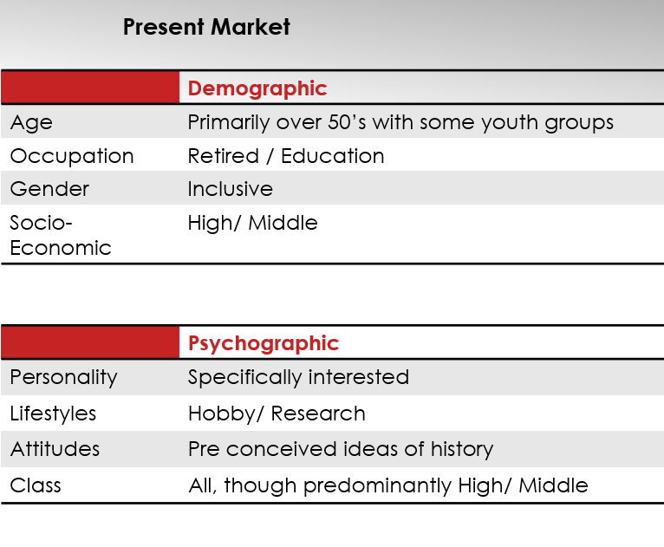
Fig 9.1 RCAHMW Segmentation, targeting and positioning 2020 (Male , 2020)

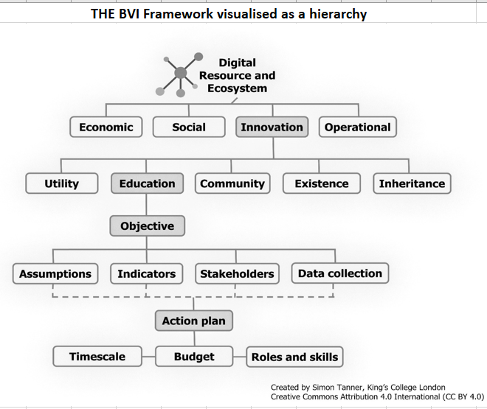

Fig 9.2 Balance Value Impact model (reference)

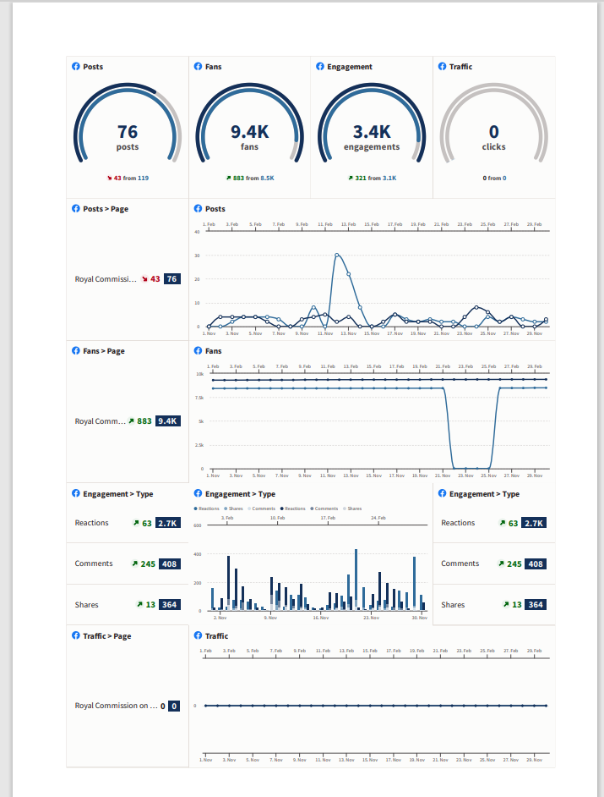

Fig 9.3 Hootsuite Facebook analytics Nov 01 - Nov 30 and 2020 Feb 01- Mar 01, 2021
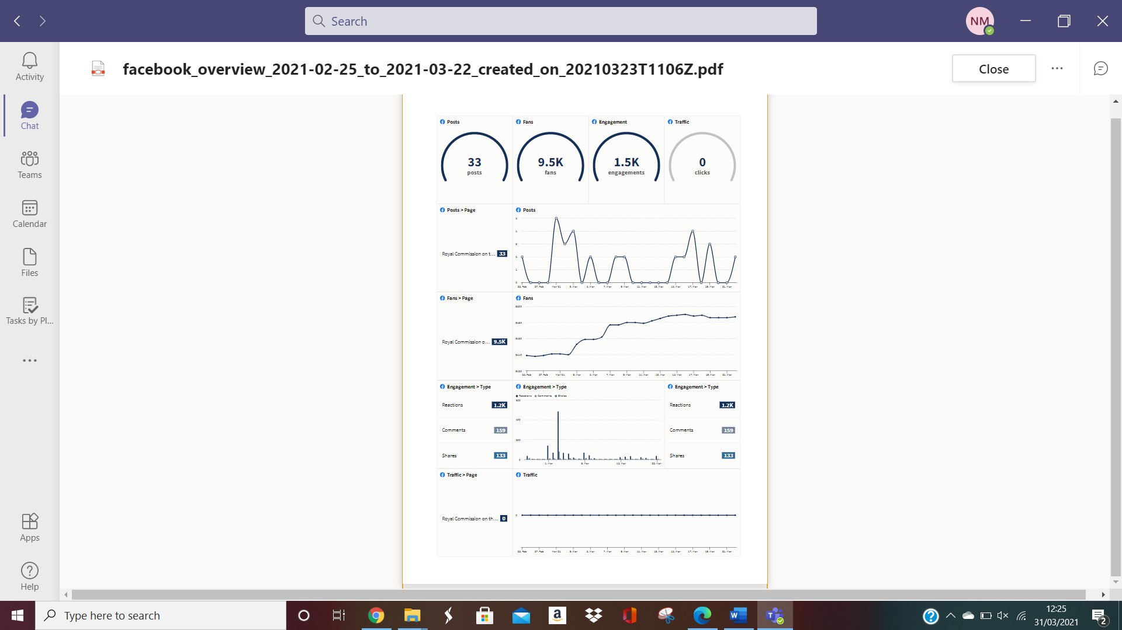

Figure 9.4 Hootsuite Facebook analytics Feb 25 - Mar 22, 2021

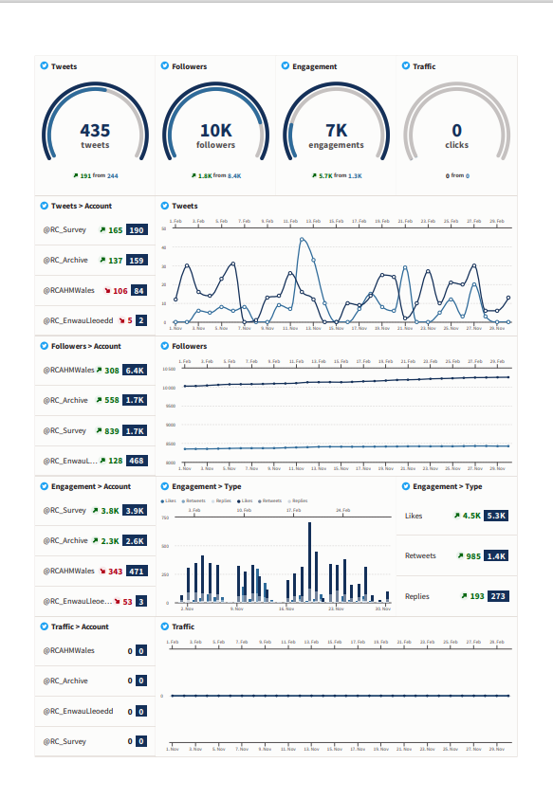
Figure 9.5 Hootsuite Twitter analytics between Nov 01 - Nov 30, 2020 and Feb 01 - Mar 01, 2020

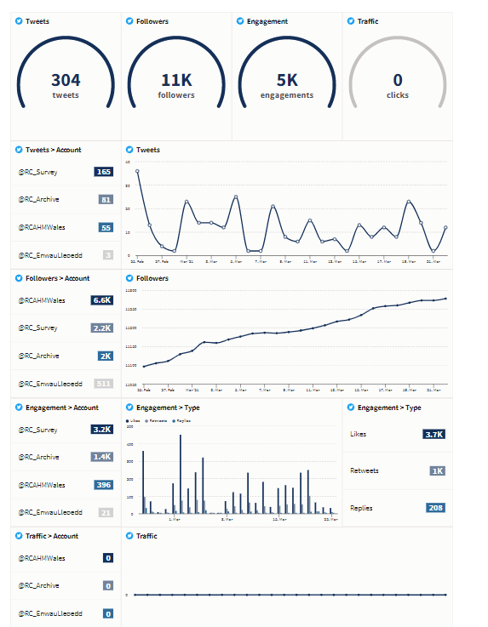

Figure 9.6 Hootsuite Twitter analytics Feb 25 - Mar 22, 2021

Survey Questions

• Thanks for using Coflein. On a scale of 1-5, how would you rate your overall experience?
• Which device did you use to access Coflein? (PC/Smartphone/Tablet)
• How did you hear about Coflein? (social media/search engine/friend/other)
• Did you find the information you were looking for?
• What features of the website do you like most? (Basic search/Advanced search/Map/Images/Other + free text option)
• Can you tell us how we could improve Coflein?
• Any further comments?

Figure 9.7 Coflein survey questions

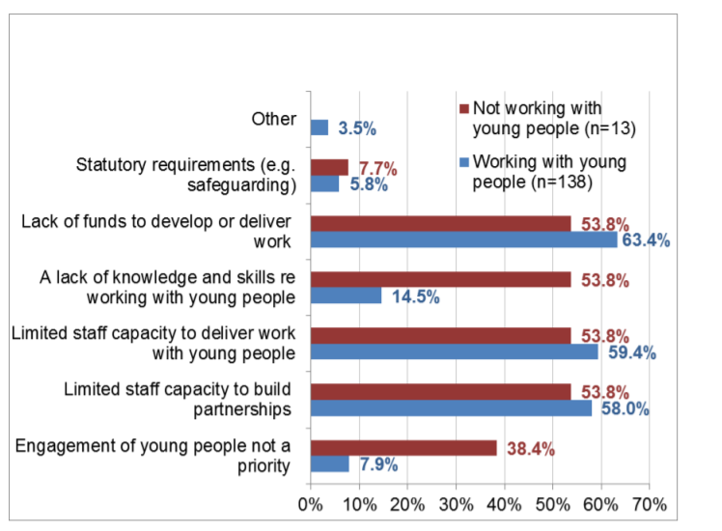
Figure 9.8 . What makes it difficult for you to develop / deliver work with young people aged 11-25

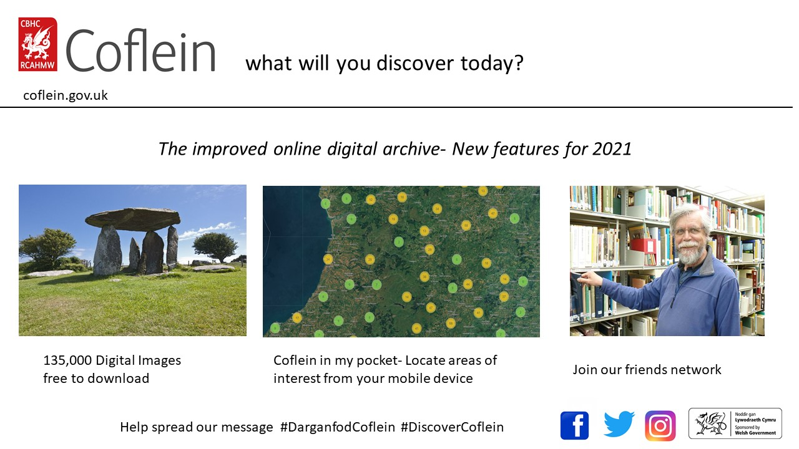

Figure 9.9 Social media poster example 1
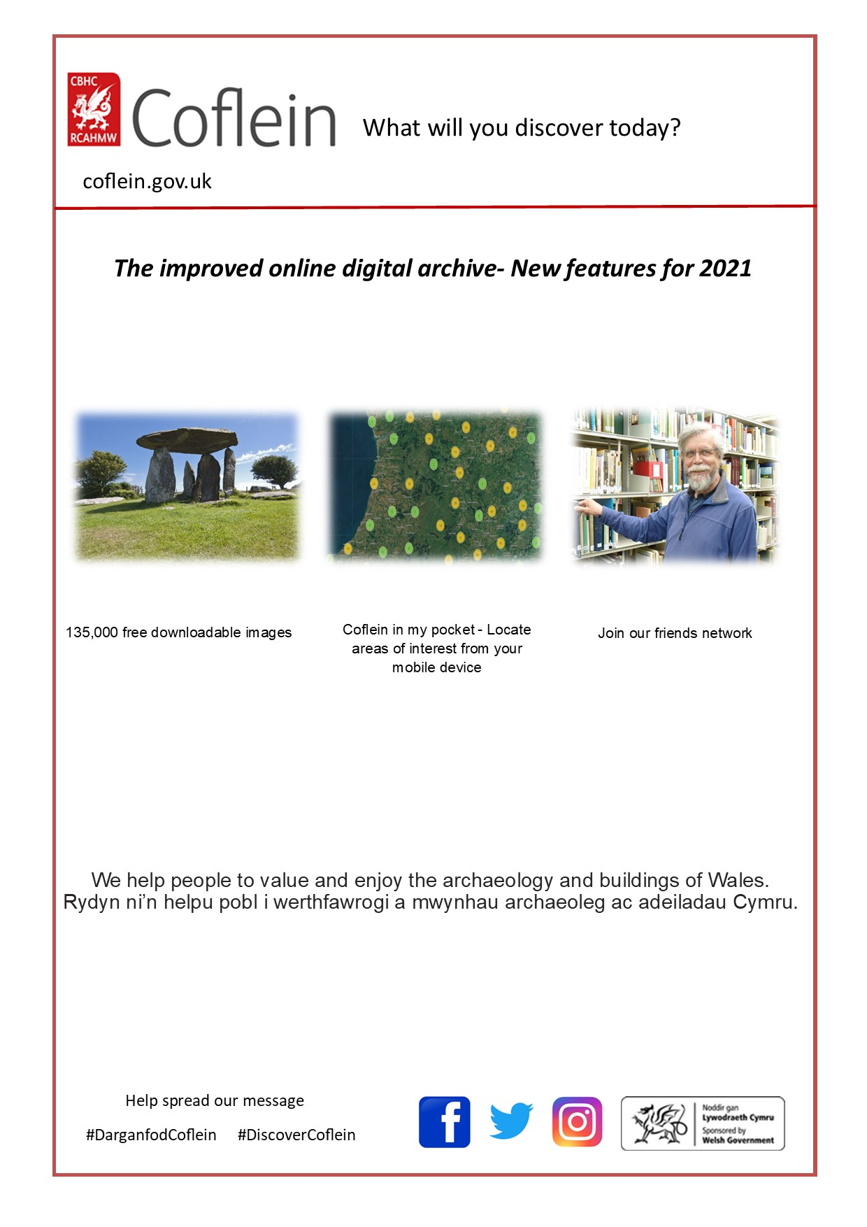
Figure 10 Social media poster example 2

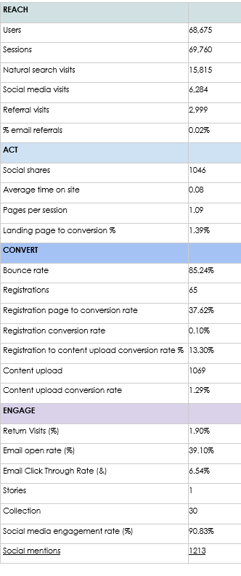
Figure 10.1 Peoples Collection Wales 18 month Race Framework.

