Giulia Chifari
Eugen Gherasim
2242387
Portfolio 4 components
Foreign Languages & Cultural Awareness
BMIH5003
Contents
Component 1 - Professional Reflection 2
Scenario 2
Cultural Misunderstandings 2
Reflection 3
Preventing Cultural Misunderstanding 3
Component 2 - Training Plan 4
Objective 5
Target Audience 5
Duration of training 5
Training Elements 5
Evaluation 6
Conclusion 6
Component 3 - Student Self-Reflection 6
Description 6
Feelings 6
Evaluation 7
Analysis 7
Conclusion 7
Action Plan 7
Component 4- Training Presentation 8
Introduction 9
Benefits of Multilingualism 9
The Importance of Language Awareness Skills 10
Examples from the Hotel Industry 10
Examples from Mercure Newport Hotel 11
Conclusion 11
References 12
References 12

Component 1 - Professional Reflection

Scenario
During my placement at Mercure Hotel Newport, a significant incident underscored the importance of language abilities and cultural knowledge in the hospitality industry. While conversing with a non-English-speaking foreign guest during lunch in the hotel restaurant, a language barrier became apparent. The guest's attempts to express their dietary requirements were met with misunderstandings and tension, creating a stressful atmosphere. This incident was a stark reminder of the need for enhanced language skills and cultural understanding in such situations.

Cultural Misunderstandings
Unfortunately, this scenario is too common in multicultural settings where subtle cultural differences and language barriers can cause significant friction. These cultural differences can manifest mainly in dietary preferences, as different cultures may have distinct expectations regarding taste and satisfaction. This experience has highlighted and underscored the crucial need for individuals in service roles to be attuned to these nuances, ensuring the best possible experience for all guests. It serves as a potent reminder that cultural sensitivity and effective communication are not just essential but vital in preventing such situations (Dimbleby & Burton, 2020).

Reflection
Upon reflection, this experience has ignited a strong desire to enhance my language abilities and broaden my cultural knowledge. This journey of self-improvement and cultural understanding is a professional necessity and a personal aspiration. I am eager to hone my linguistic skills, with a particular focus on the languages most commonly used in hospitality settings. This will undoubtedly enhance my ability to understand and address the client's needs, expressed in the language they are most comfortable with (Bonvillain, 2019). Furthermore, learning about culture-specific customs can expose me to different perspectives, equipping me to handle sensitive matters empathetically. As I continue interacting with a diverse range of people, I am confident I will gain a deeper understanding of navigating such interactions. Developing my listening skills is crucial in bridging communication gaps and ensuring accurate understanding.

Preventing Cultural Misunderstanding
As Allen and Lockwood (2016) assert, effective communication is not just a tool but a necessity in the hospitality industry. It plays a pivotal role in identifying guests' concerns and preferences. I believe that by paying close attention to guests and asking questions when necessary, I can gain valuable insights into their needs and expectations. This personalised approach can help develop a welcoming and open hotel environment, which is desirable and crucial in the hospitality industry. In my opinion, integrating cultural sensitivity training into employee development programs is not just a suggestion but a necessity to deliver exceptional customer service. This training equips staff to handle cultural differences respectfully, thereby preventing misunderstandings and enhancing the quality of services provided to guests. By incorporating cultural sensitivity training into employee development programs, hotels can ensure that staff members are well-prepared to handle cultural differences and create a welcoming and inclusive environment for all guests.
I believe hotels should prioritise adopting cultural sensitivity training programs for their staff. I often witnessed miscommunication during my placement, leading to negative guest experiences. Dealing with communication barriers can frustrate guests already in an unfamiliar environment. However, such instances can be avoided by providing staff with the appropriate training to handle guests from different backgrounds.
I believe that every guest deserves to feel valued and respected, regardless of their nationality or cultural background. Implementing a cultural sensitivity training program can foster a more inclusive and welcoming environment for all guests. Additionally, this training can promote a culture of empathy and understanding within the staff team, resulting in a more positive workplace culture.
Cultural sessions that would include language proficiency and Inter/cross-cultural communication are vital to creating an atmosphere where employees can navigate diverse interactions confidently (Chung, 2019).

Component 2 - Training Plan

Dimbleby and Burton (2020) highlight the potential for misunderstandings and tension in multicultural settings due to communication gaps. Allen and Lockwood (2016) emphasise the necessity of effective communication in the hospitality industry to identify guests' concerns and preferences. Additionally, Chung (2019) stresses the importance of cross-cultural training in the hospitality industry to boost employees' confidence in handling diverse interactions.
Formulating a detailed training program for Level 4 Placement Hotel staff, primarily concentrating on dealing with cultural misunderstandings in F&B services, requires a strategic and suitable approach. Staff will be equipped with the right skill sets and knowledge to be more confident in conducting challenging tasks regarding guest relationships. This approach encourages staff to consider their own cultural biases and perspectives and also to understand and respect the cultural perspectives of others. Language skills must be improved in the first place by implementing language proficiency programs, which contribute to better communication between personnel (Sato et al., 2019).

Training Plan
Objective
To promote cultural sensitivity and enhance communication skills, thereby preventing cultural misunderstandings and ensuring exceptional customer service.
Target Audience
All staff members (front-line and back-of-house employees)
Duration of training
1-2 days

Training Elements
1. Introduction to cultural awareness and sensitivity in the hospitality industry
- Understanding cultural differences and their impact on guests
- Developing cross-cultural communication skills
- Learning to recognise and value diversity in the workplace
2. Language proficiency training
- Basic language training for commonly used languages in hospitality settings
- Role-playing exercises for language use in typical guest interactions
3. Front Office and Guest Service Training
- Comprehensive training on how to handle guest inquiries and requests
- How to address and resolve cultural and language barriers
- Best practices for building cross-cultural relationships
4. Food and Beverage Training
- Understanding different cultural preferences in culinary practices
- Menu customisation tips and techniques for dietary requirements
- Proper handling of cultural and religious dietary restrictions
5. Organisational Cultural Sensitivity Training
- Understanding how to work efficiently with colleagues from diverse backgrounds
- Establishing a culture of inclusivity and mutual respect in the workplace

Evaluation
Feedback from staff members can be collected using anonymous questionnaires to evaluate the training's effectiveness. A follow-up session can be conducted to discuss what worked, what did not, and possible variations that can be incorporated to enhance the training's overall effectiveness.

Conclusion
A comprehensive training program focused on cultural sensitivity can significantly benefit hospitality establishments by improving their employees' communication and cross-cultural skills. Such programs can create an inclusive work environment, enhance guest experiences, and promote a culture of mutual respect and understanding.

Component 3 - Student Self-Reflection

Description
In my three months in the hospitality industry, I have encountered instances where cultural sensitivity is essential in guest interactions. One specific example is when a guest from a different culture expressed dissatisfaction with a dish due to religious dietary restrictions (Chang, 2019). Initially, I was unsure how to address the issue because I lacked a thorough understanding of their cultural background and beliefs.
Feelings
Confronted with this complex situation, I felt both perplexed and compassionate and determined to handle it with the utmost care. I empathised with the guests' concerns and extended my good wishes that their beliefs would be honoured and that they would also enjoy the cuisine provided. At the same time, I could not shake the uneasy feeling that someone from a different culture might struggle to navigate this level of cultural sensitivity.
Evaluation
I have tried to consider carefully and, at times, clarify various aspects of hospitality and culture. Cultural competence is directly linked to guest satisfaction, aids staff in understanding different cultures, and fosters a sense of inclusion. By taking the time to understand better and embrace cultural diversity, hospitality professionals can form solid and satisfying connections with their guests and surpass their expectations with personalised experiences (Rolfe & Freshwater, 2020).

Analysis

This experience taught me that continually learning new cultural advancements is essential, but the ongoing development of cultural skills through reflection is equally important. I understand that artistic awareness is not simply about memorising facts or making generalisations but rather about cultivating the ability to understand cultural values, norms, and lifestyles. This involves inclusivity, active listening to guests, empathising with their perspectives, and adapting communication styles to suit the audience (Gonulal, 2020).

Conclusion

In the beginning, my understanding of cultural awareness was limited and basic. However, as I continued to grow and learn, I came to appreciate the richness of multiculturalism. I now see it as more than just a valuable asset; it is essential to the success of hospitality services in my hotel. By fostering a culturally empathetic and inclusive environment, hotels can provide their guests with unforgettable experiences that transcend barriers (Williams et al., 2022).

Action Plan
I am committed to furthering my education and participating in training programs to expand my cultural knowledge. This may involve attending workshops or seminars that focus on different cultures. As the saying goes, "I will immerse myself and learn to appreciate cultures as they are" (Latham et al., 2020). Additionally, I will actively engage with partners and guests to learn about their cultural differences and seek ways to improve cross-cultural communication. A desire for continuous growth drives me, and I aim to become a skilled hospitality professional dedicated to providing guests with enriching experiences.

Component 4- Training Presentation



Introduction


Benefits of Multilingualism


The Importance of Language Awareness Skills
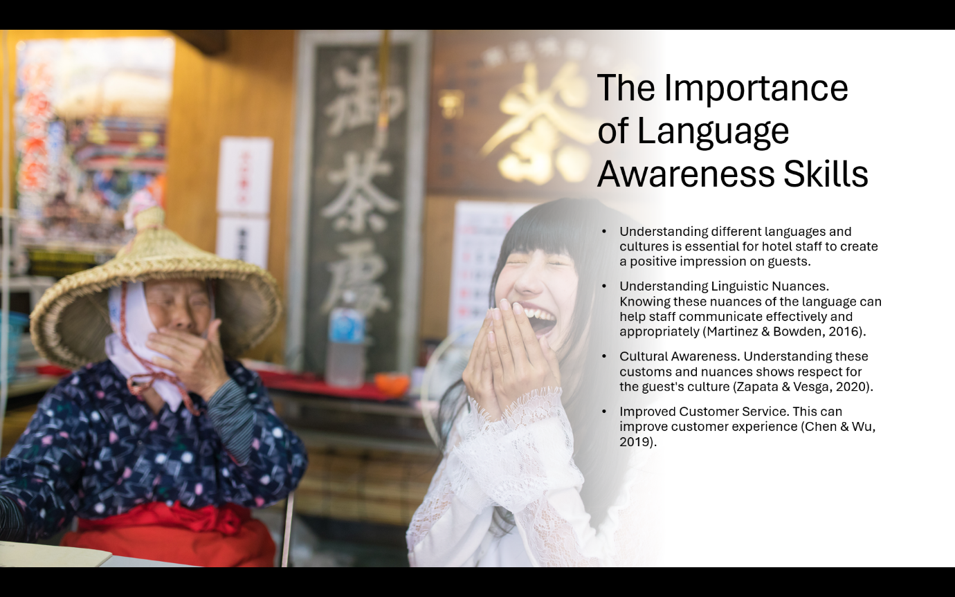

Examples from the Hotel Industry


Examples from Mercure Newport Hotel
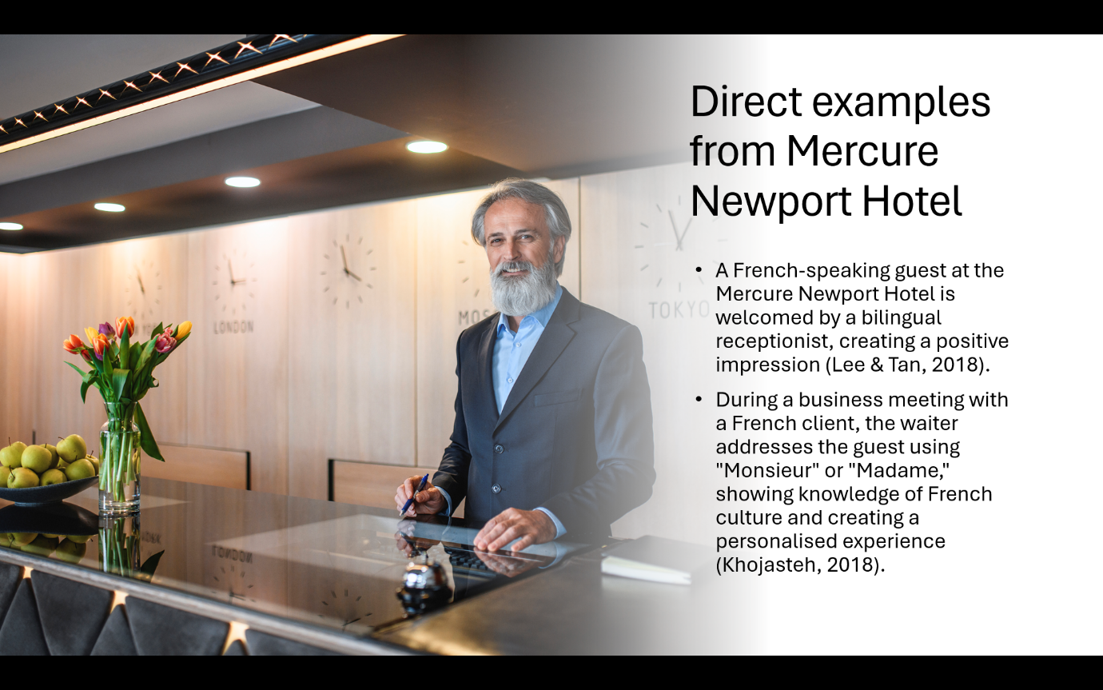

Conclusion


References
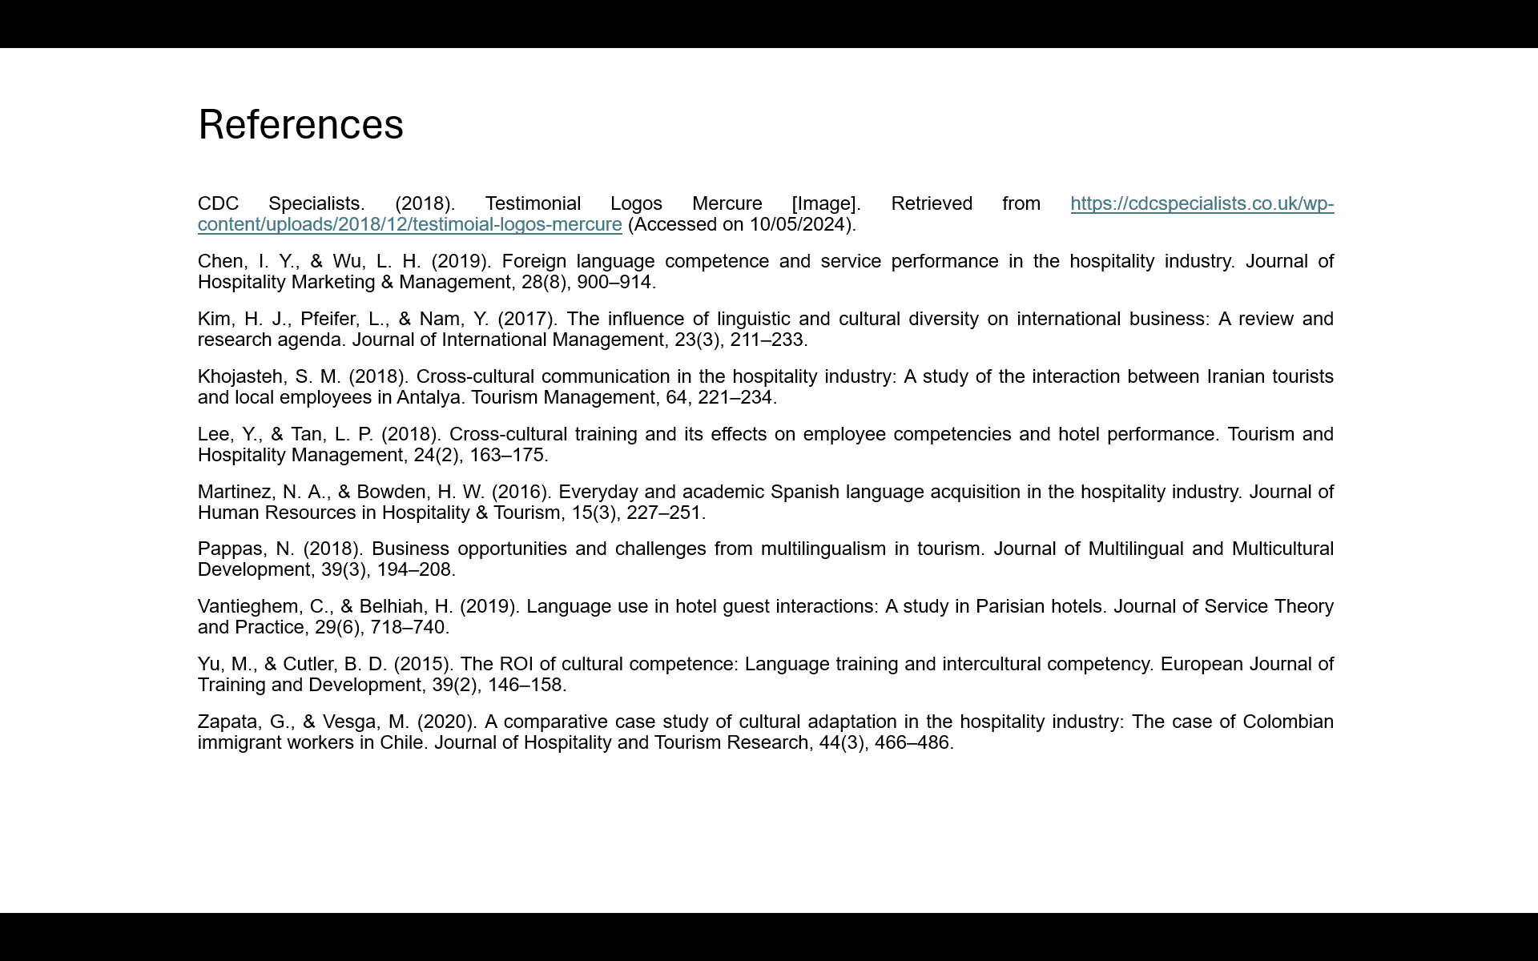

References

Allen, J., & Lockwood, A. (2016). The hotel business (7th ed.). John Wiley & Sons.
Allen, J., & Lockwood, A. (2016). Tourism and Hospitality Marketing: A Global Perspective. Sage Publications.
Bonvillain, N., (2019). Language, culture, and communication: The meaning of messages. Rowman & Littlefield.
CDC Specialists. (2018). Testimonial Logos Mercure [Image]. Retrieved from https://cdcspecialists.co.uk/wp-content/uploads/2018/12/testimoial-logos-mercure (Accessed on 10/05/2024).
Chang, B., (2019). Reflection in learning. Online learning, 23(1), pp.95–110.
Chen, I. Y., & Wu, L. H. (2019). Foreign language competence and service performance in the hospitality industry. Journal of Hospitality Marketing & Management, 28(8), pp.900–914.
Chung, L.C., (2019). Crossing boundaries: Cross‐cultural communication. Cross‐cultural psychology: Contemporary themes and perspectives, pp.375–397.
Chung, L. K. (2019). The Importance of Cross-Cultural Training in the Hospitality Industry. Jindal Journal of Hospitality and Tourism, 1(1), pp 9–21.
Dimbleby, R., & Burton, G. (2020). Cultural Awareness for Hospitality and Tourism. Bloomsbury Publishing.
Dimbleby, R. & Burton, G. (2020). More than words: An introduction to communication. Routledge.
Gonulal, T. (2020). Improving listening skills with extensive listening using podcasts and vodcasts. International Journal of Contemporary Educational Research, 7(1), pp.311–320.
Kim, H. J., Pfeifer, L., & Nam, Y. (2017). The influence of linguistic and cultural diversity on international business: A review and research agenda. Journal of International Management, 23(3), pp.211–233.
Khojasteh, S. M. (2018). Cross-cultural communication in the hospitality industry: A study of the interaction between Iranian tourists and local employees in Antalya. Tourism Management, 64, pp. 221–234.
Latham, K.F., Hartel, J. & Gorichanaz, T. (2020). Information and contemplation: a call for reflection and action. Journal of Documentation, 76(5), pp.999–1017.
Lee, Y., & Tan, L. P. (2018). Cross-cultural training and its effects on employee competencies and hotel performance. Tourism and Hospitality Management, 24(2), pp.163–175.
Martinez, N. A., & Bowden, H. W. (2016). Everyday and academic Spanish language acquisition in the hospitality industry. Journal of Human Resources in Hospitality & Tourism, 15(3), pp.227–251.
Pappas, N. (2018). Business opportunities and challenges from multilingualism in tourism. Journal of Multilingual and Multicultural Development, 39(3), pp.194–208.
Rolfe, G. & Freshwater, D. (2020). Critical reflection in practice: generating knowledge for care. Bloomsbury Publishing.
Sato, T., Yujobo, Y.J., Okada, T. and Ogane, E. (2019). Communication strategies employed by low-proficiency users: Possibilities for ELF-informed pedagogy. Journal of English as a Lingua Franca, 8(1), pp.9-35.
Vantieghem, C., & Belhiah, H. (2019). Language use in hotel guest interactions: A study in Parisian hotels. Journal of Service Theory and Practice, 29(6), pp.718–740.
Williams, S.E., Ford, J.H. and Kensinger, E.A., (2022). The power of negative and positive episodic memories. Cognitive, Affective, & Behavioral Neuroscience, 22(5), pp.869–903.
Yu, M., & Cutler, B. D. (2015). The ROI of cultural competence: Language training and intercultural competency. European Journal of Training and Development, 39(2), pp.146–158.
Zapata, G., & Vesga, M. (2020). A comparative case study of cultural adaptation in the hospitality industry: The case of Colombian immigrant workers in Chile. Journal of Hospitality and Tourism Research, 44(3), pp.466–486.

