

Programs in C and Documentation – Parts A and B
Module Code: ACCA4017
Course Title: Bachelor of Science (Part-time): Computing (Computer Networks and Cybersecurity)
Student Name: Michelle Chalmers
Student Number: 1809316
Contents
PART A – UNDERSTANDING 1
A1. Variables 1
A2. The for-loop 3
A3. The array 4
PART B – IMPLEMENTATION 5
Exercise 1 5
Steps 5
Assumptions 5
The code 5
Testing 6
Exercise 2 8
Steps 8
Assumptions 8
The Code 8
Testing 9
Exercise 3 11
Steps 11
Assumptions 11
The code 11
Testing 12
Exercise 4 13
Steps 13
Problems encountered 13
The Code 13
Testing 15

PART A – UNDERSTANDING

A1. Variables
A variable is a container in which data can be stored.
Variable types:
int integer a whole number i.e. 100
float floating-point number decimal number to 6 places i.e. 8.141592
double floating-point number decimal number to 10 places i.e. 8.1415926535
char character single letter i.e. m
strings a string of characters multiple letters i.e. rose
Examples:
x=100 an integer – int int x=100
initial=m a character – char char initial=’m’ (note single quotes).
average=8.141592 a decimal – float float average=8.141592
flower=rose a string – char[5] char flower[5]={‘r’, ‘o’, ‘s’, ‘e’}
note format of each character in single quotes, comma separated, within curly brackets. Number in square brackets defines the number of characters to expect (4), plus 1 (the escape).
Variable names typically start with a lower-case letter, but this is not a rule.
The following cannot be included in a variable name:
Spaces.
Special characters such as ()”@*, etc.
Math, for instance a+b*c.
C keywords, such as printf, volatile, null etc.
A number at the beginning, for instance 2much.
These can be included in a variable name:
A number that is not at the beginning, i.e. much2 or open4all.
Mixed case.
Underscores.
Variables are data containers that are designed to change. For instance, you might initially declare a variable as 10, but add 1 to it in the program, making it 11.

They are important in programming as they give flexibility, and the ability to manipulate data and the program. For instance, in a game you may give a player 3 lives:
int lives=3.
Their character dies, the program deducts 1 from the number of lives left. Now:
int lives=2.
Play on…
Their character dies, the program deducts 1 from the number of lives left. Now:
int lives=1.
Play on…
Their character dies, the program deducts 1 from the number of lives left. Now:
int lives=0.
The program moves to a stop point.
Game over.
If the player restarts the game the number of lives returns to the initial value of 3 as that is what is declared at the program start.

A2. The for-loop
A loop is a section of program that is repeated. The number of repetitions depends on the condition that is in place – they can be for, while or do while.
The for-loop defines conditions that must exist for the loop to keep repeating. For example :
for (i = 1; i < 21; i++)
i = 1 integer i is declared as 1
i < 21 the condition for the loop to run, i must be less than 21
i++ whilst the condition is met, add 1 to i (i++ is the same as i+1)
The integer (i) starts as 1
Whilst i is less than 21, add 1 to i
When i reaches 20 (less than 21), nothing is added to i, the looping ends, the program moves to the next action.
It is known as the counting loop because it is controlled by an integer that counts up to the defined maximum.
For example, you would use it when you know the number of repetitions you need, such as a times table where you define the number as 8, and the number of multiplications to be from 1*8 to 12*8. Rather than write a line for each multiplication you use the counting loop to do the same math 12 times.

A3. The array
An array can hold several items of associated data. For instance, you may wish to create a calendar and associate with each month the number of days in that month:
The code:
#include <stdio.h>

void main()
{
char month[12][12] = { "Jan", "Feb", "Mar", "Apr","May", "Jun", "Jul","Aug","Sep","Oct","Nov","Dec" };

int days[12] = { 30,28,31,30,31,30,31,31,30,31,30,31 };
int i;

for (i = 0; i < 12; i++)
{
printf("%s ", month[i]);
printf("%d\n", days[i]);
}
}
You would use arrays where you need to associate data – a telephone directory where a name is associated to a number, a customer list where a customer ID is associated to a name.

PART B – IMPLEMENTATION

Exercise 1

Steps
Set up containers to store the data:
A name is a string of characters.
Height is a float.
Age is an integer.
Ask the user to enter data.
Display the data.

Assumptions
Each name has a maximum of 10 characters.
Floats are limited to 2 points.

The code
#include <stdio.h>

void main()
{
int num;/*sets up the expectation of an integer*/
float height;/*sets up the expectation of an float/decimal*/
char name1[10], name2[10];/*sets up two expectations for character strings*/

{
printf("Enter your first name please\n");
scanf(" %s", name1);/*stores the input in string set name1*/
}
{
printf("And your family name is?\n");
scanf(" %s", name2);/*stores the input in string set name2*/
}
{
printf("What is your height in metres?\n");
scanf("%f", &height);/*stores the input in height*/
}
{
printf("How old are you?\n");
scanf("%d", &num);/*stores the input in num*/
}
{
printf("\nYour name is %s %s, you are %.2fcm tall, and you are %d years old\n\nThank you for the information, I shall use it to create my new identity\n\n", name1, name2, height, num);/*displays the collected data, adding lines to look tidy */
}
}

Testing
Without being able to restrict user input, the code broke quickly. Only the realistic values tested well.
Normal values:
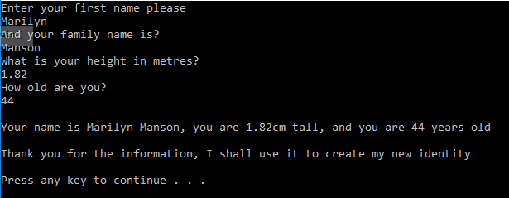
Boundary values:
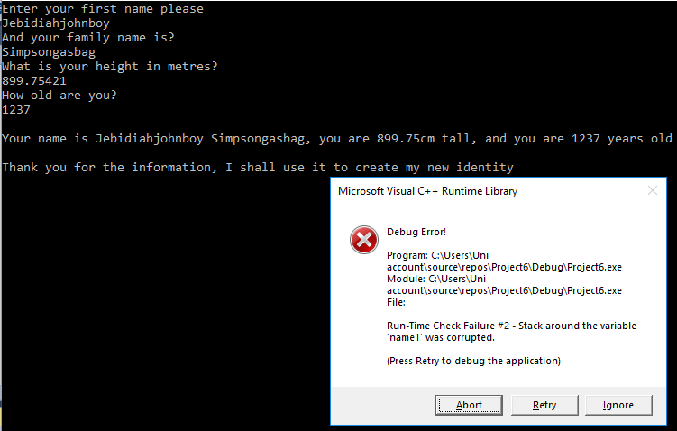
Presumably the error is because the entered name was more than the assigned 10 letters.
Impossible values:
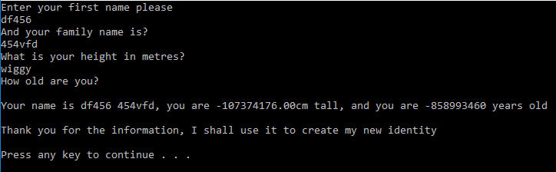
No age was entered, the program created it.

Exercise 2

Steps
Set up storage for:
radius, base, height, area of circle, area of triangle, shaded area.
Declare initial figures for base and height.
User to enter the radius, base and height.
Restrict the bae and height – see assumptions
Calculate the area of the circle.
Calculate the area of the triangle.
Subtract the area of the triangle from the area of the circle to get the area shaded blue.

Assumptions
The user might input decimals.
If the triangle is larger than the circle, the math won’t be correct. Restricting the height and base to a maximum of half the radius should keep the math correct.

The Code
#include <stdio.h>

#define PI 3.142/*constant*/

/*area = PI * rsquared*/

void main()
{

float rad, circlearea, triarea, shadearea;
float height = 12000;/*an initial number must be declared*/
float base = 12000;/*an initial number must be declared*/

{
printf("What is the circle radius?\n");
scanf("%f", &rad);
}
while (base > rad/2)/*condition - if the input is more than half the rad, keep prompting*/
{
printf("What is the triangle base? This cannot be more than half the radius\n");
scanf("%f", &base);
}
while (height > rad / 2)/*condition*/
{
printf("And the triangle height? This cannot be more than half the radius\n");
scanf("%f", &height);
}

circlearea = (rad*rad)*PI;/*the math*/
triarea = (base * height) / 2;
shadearea = circlearea - triarea;
{
printf("The area shaded blue is %.2f\n\n", shadearea);
}
}

Testing
Normal values:
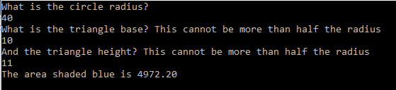
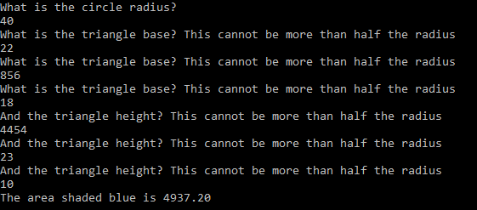
The program will not accept values for the triangle or radius that are outside the limit set.
The math has been checked several times and is confirmed accurate.
Boundary values:
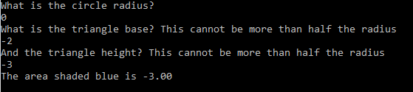
The program runs, but the values input are impossible.
Impossible values:
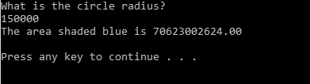
The initial base and height was declared as 12000, so the program did not prompt for the base/height. The math is correct though.
Entering text created a loop that had to be terminated.

Exercise 3

Steps
Declare a float array for 5 items.
Prompt user to enter each item.
Calculate the total price and display.
Calculate the price + 20% VAT and display.

Assumptions
The user may input decimals.
The items do not need to be named.

The code
#include <stdio.h>

void main()
{
float item[5];/*sets up an array of 5*/
float total, totalvat;
int i;/*defines the iterations of the for-loop*/
{
printf("You are required to enter the price for 5 items please\n\n");/*this text displays just once/*/
}
for (i = 0; i <= 4; i++)/*the for-loop*/

{
printf("Enter item price ");/*this loop runs as many times as the for-loop has defined*/
scanf("%f", &item[i]);/*store the input in the next array slot*/
}
total = (item[0] + item[1] + item[2] + item[3] + item[4]);/*the math*/
{
printf("\nThe total is %.2f", total);
}
totalvat = (total * 1.2);/*adding the VAT*/
{
printf("\nThe total including 20%% VAT is %.2f\n\n", totalvat);
}

}

Testing
Normal values:
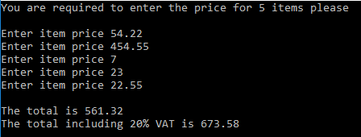
The math has been checked several times and is accurate.
Boundary values:
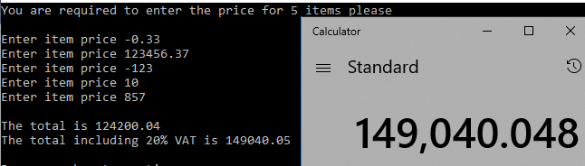
Despite the unrealistic figures entered, the end figures are correct. This was tested several times and was correct each time.
Impossible values:
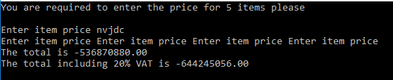
Meltdown!

Exercise 4

Steps
Set up the 3 ‘reels’.
Get user to ‘spin’.
Randomly select a number from each reel.
Calculate the score (there are 3 score scenarios).
Display score.
Prompt player to play again or exit.

Problems encountered
An attempt was made to display a cumulative score as well as per spin, but it was unsuccessful. The code is included below, commented out.

The Code
#include <stdio.h>
#include <stdlib.h>
#include <time.h>

void main()
{
int random1, random2, random3;
/*int score = 0, cumulative = 0;/*FAILED setting the ints for cumulative scoring*/
int low = 1;//set lowest of range
int high = 5;//set highest of range
int i = 1;/*defines the iterations of the for-loop*/
char spin;

/*cumulative = score + cumulative;/*FAILED add the new score to the cumulative to create new cumulative*/

srand(time(NULL));//srand from stdlib.h

printf("Do you want to play a game? (y/n)\n");
scanf(" %c", &spin);

while (spin != 'n') /*while the choice to spin is not no, run this loop */
{

random1 = rand() % (high - low + 1) + low;//from stdlib
printf("%d ", random1);

random2 = rand() % (high - low + 1) + low;
printf("%d ", random2);

random3 = rand() % (high - low + 1) + low;
printf("%d ", random3);

//points
if (random1 == random2 && random2 == random3 && random1 < 5 && random2 < 5 && random3 < 5)/*3 x matching numbers that aren't number 5*/
{
printf("Winning score - 20 points!");
/*scanf("20", &score);/*FAILED store this score for adding to cumulative*/
}

else if (random1 == 5 && random2 == 5 && random3 == 5)/*3 x number 5*/
{
printf("!!!YOU ARE A WINNER - 2000 POINTS!!!");
/*scanf("2000", &score);/*FAILED store this score for adding to cumulative*/
}

else if (random1 == 5 && random2 == 5)/* 2 x number 5 */
{
printf("Winning score - 100 points, well done!");
/*scanf("100", &score);/*FAILED store this score for adding to cumulative*/
}

else if (random1 == 5 && random3 == 5)
{
printf("Winning score - 100 points, well done!");
/*scanf("100", &score);/*FAILED store this score for adding to cumulative*/
}

else if (random2 == 5 && random3 == 5)
{
printf("Winning score - 100 points, well done!");
/*scanf("100", &score);/*FAILED store this score for adding to cumulative*/
}

else
{
printf("No points this time");
}

/*printf("\tYour cumulative points this game are %d\n",cumulative);/*FAILED display cumulative score*/

printf("\n\nDo you want to spin again? (y/n)\n");
scanf(" %c", &spin);
}
printf("\nThank you for playing today\n\n");
}

Testing
Normal values:
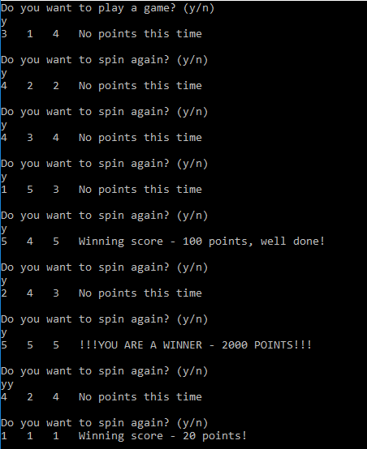
The game plays and scores as it should.

Boundary and Impossible Values:
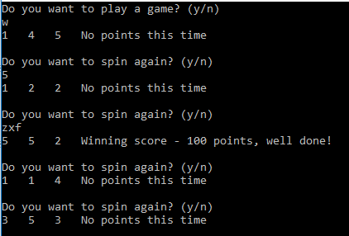
Entering unexpected letters and numbers kept the game running, scoring correctly. Where several letters were typed they were treated as separate inputs, i.e. ‘zxf’ caused 3 spins.

