Thomas Sellwood (2215661)

NOSS: Multi server and client setup

- In Swansea Network,
  - Install Routing and Remote access Service and modify firewall rules to allow ICMP Traffic.
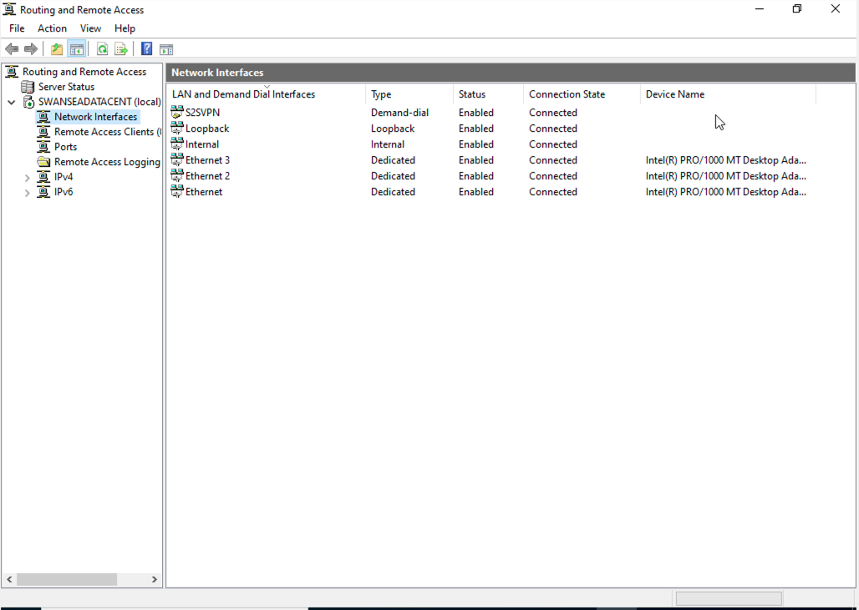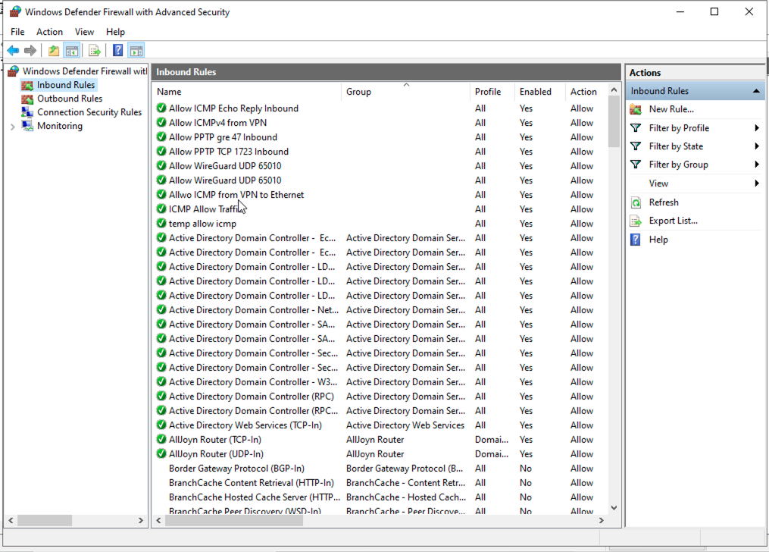
  - Configure Site-to-Site VPN to London Network. Set the connection type to “persistent connection”.
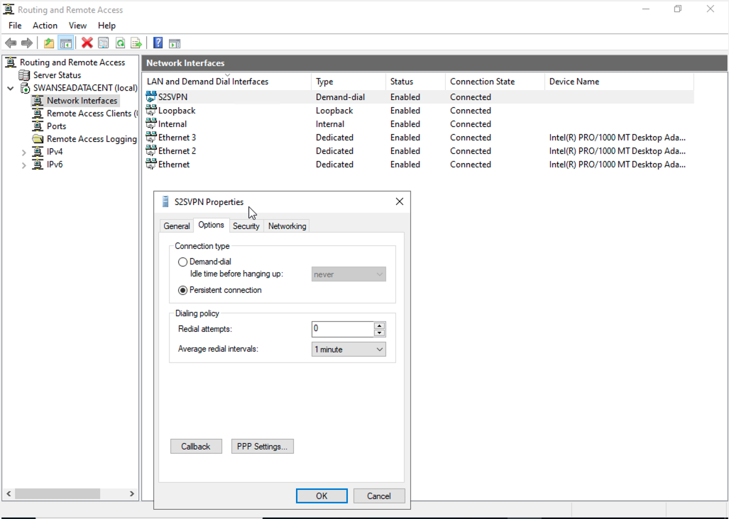
  - Create a forest named yourname.acca (For example: nitheesh.acca)
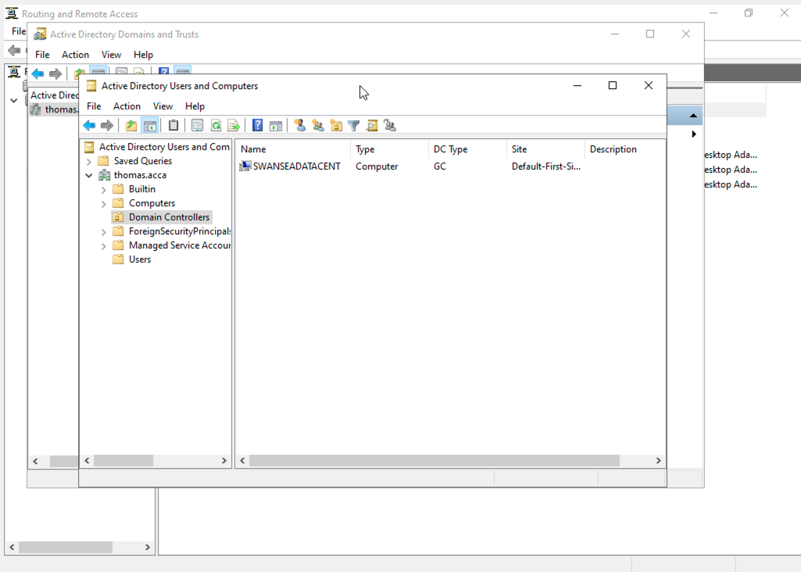
  - Create all appropriate A records for all servers on 10.1.1.0/24 and 172.16.1.0/24.
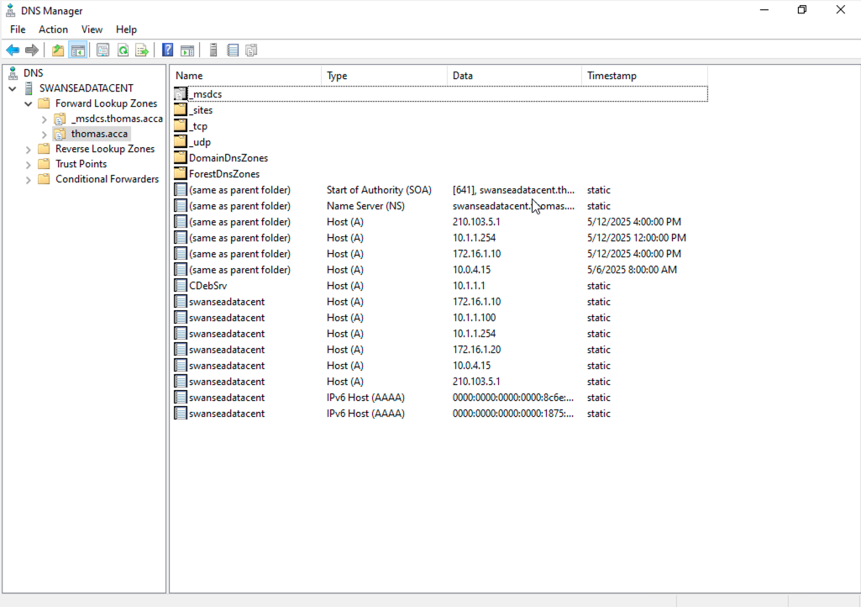
  - Create a reverse lookup zone creating PTR records for all servers.
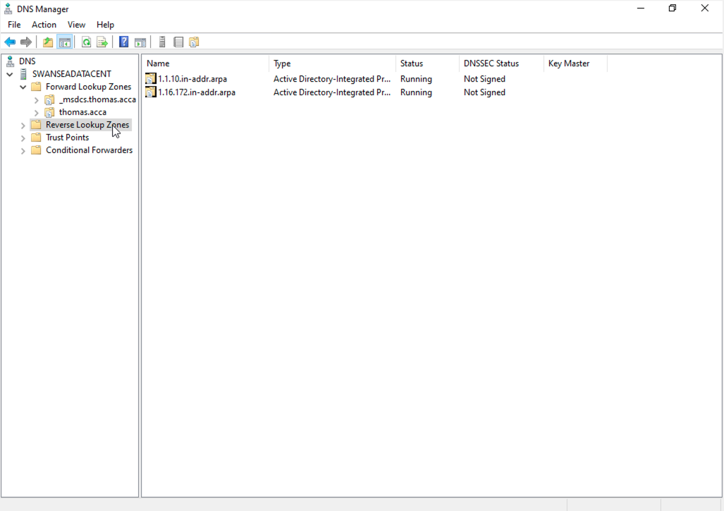
  - Create user accounts for yourname.acca domain with all the parameters defined in the users_list_updated.xlsx document. This document will be shared by your lecturer. You must use first letter from first name with a dot and last name as SAM Account Name. Eg: First Name: Nitheesh Last Name: Kaliyamurthy. → n.kaliyamurthy.
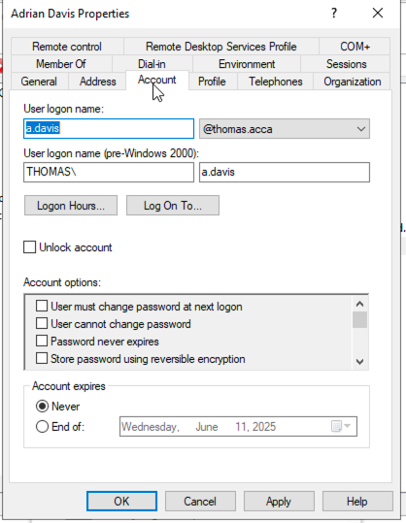
  - Mount second disk drive to D:\SwanseaFiles.
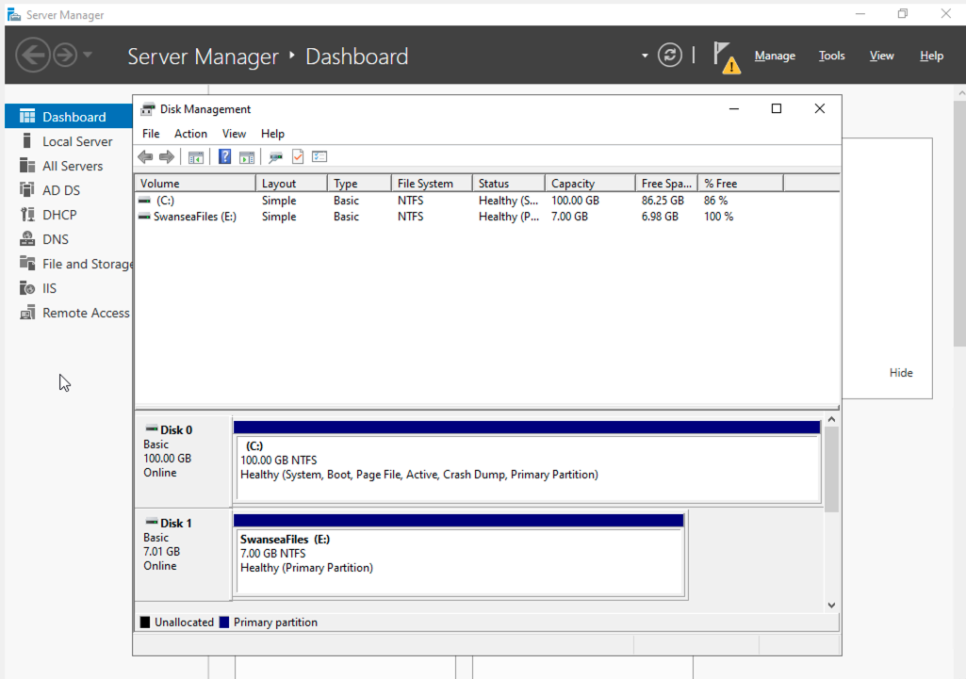
  - Configure DHCP Services. The range is 172.16.1.10 – 172.16.1.20. Determine other DHCP options as per the infrastructure.
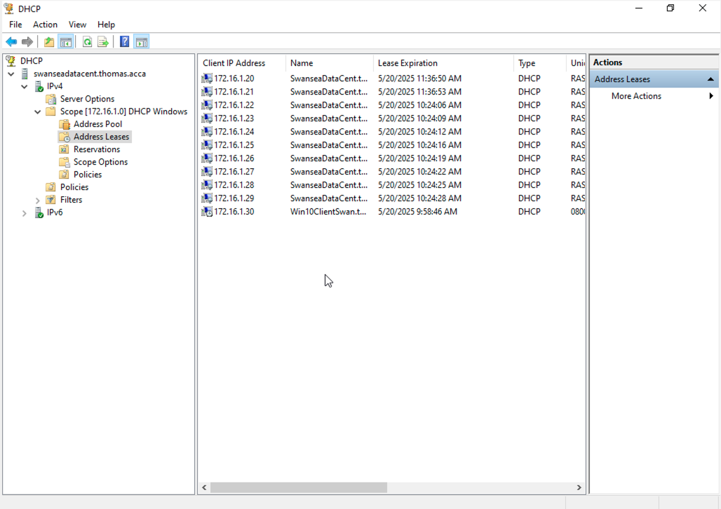
  - Join the ClientS1 to yourname.acca domain.
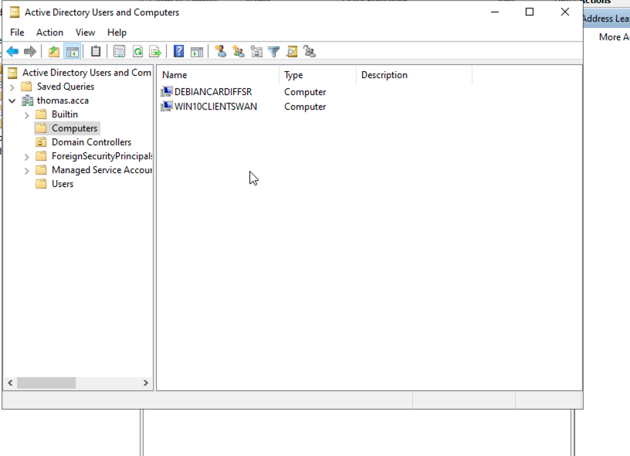
  - Assign ClientS1 with DHCP IP Address.
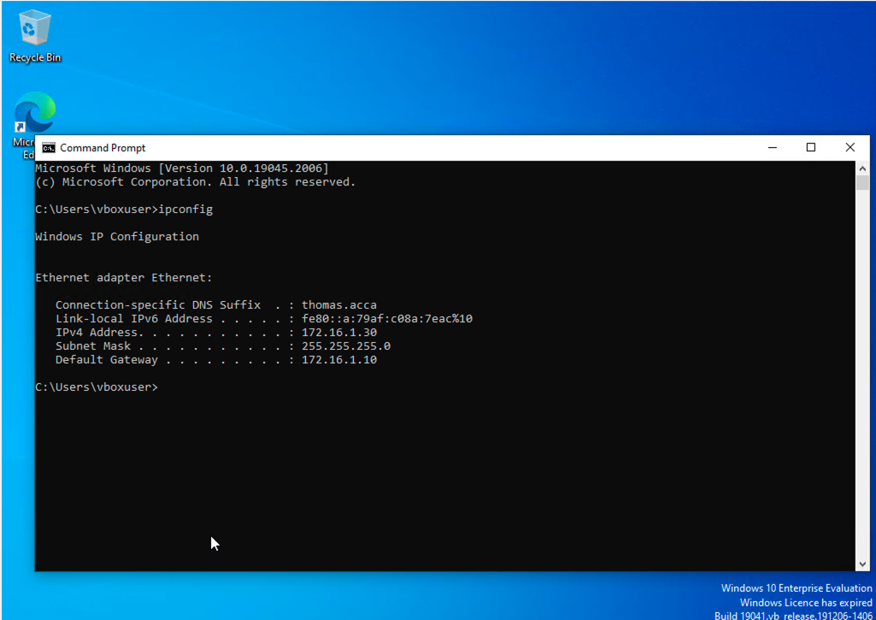
- In Cardiff Network,
  - Install Routing and Remote access Service (equivalent) and modify firewall rules to allow ICMP Traffic.
  - Configure Site-to-Site VPN to Swansea Network. Set the connection type to “persistent connection”.
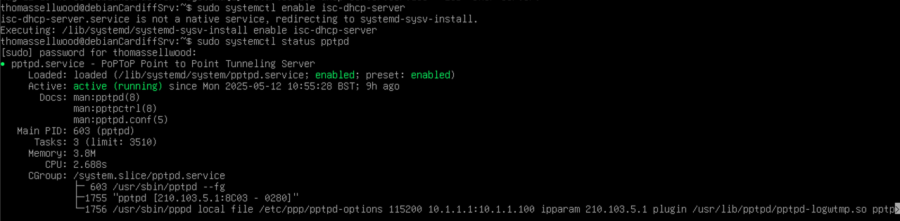
  - Create a child domain named car.yourname.acca in yourname.acca tree (Eg: car.nitheesh.acca) or Join devices in this network to the yourname.acca domain. Justify your action.
  - Configure DHCP Services. The range is 10.1.1.10 – 10.1.1.20. Determine other DHCP options as per the infrastructure.
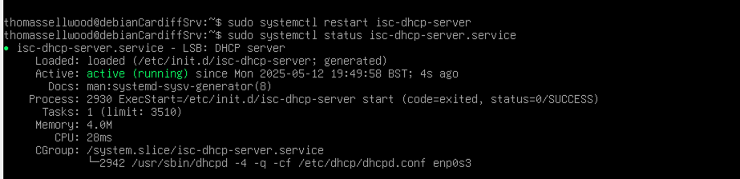
  - Depending on step no. 2.3, join the ClientC1 to appropriate domain and assign DHCP IP address.
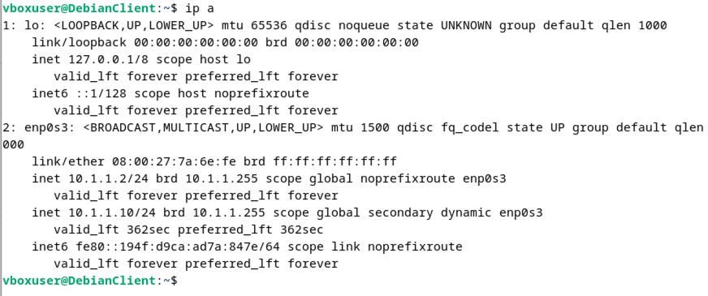
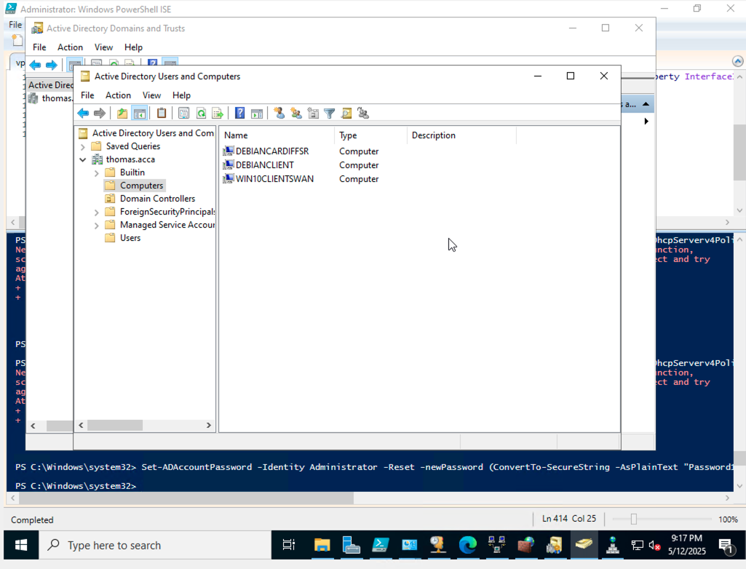
- Test the network for Connectivity. Note that at this stage, the Swansea and Cardiff networks are connected and fully operational. If not, Troubleshoot.
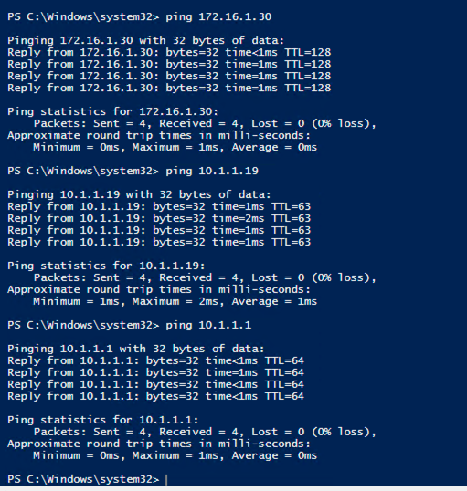
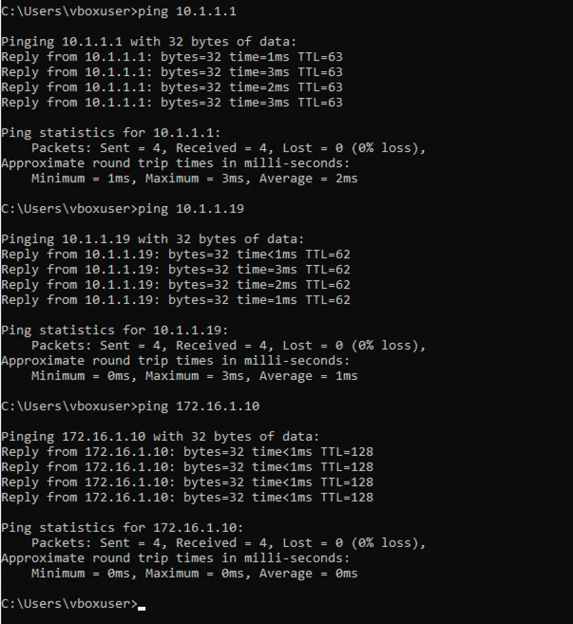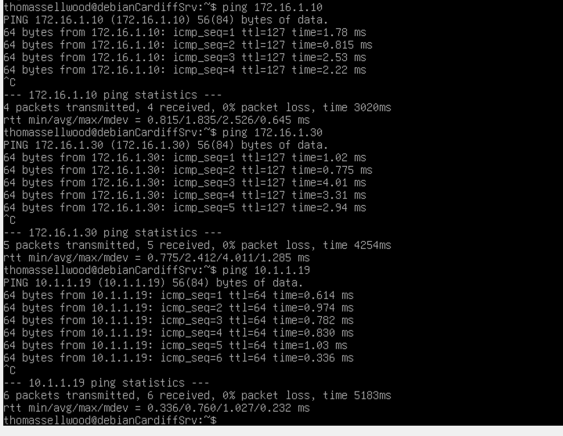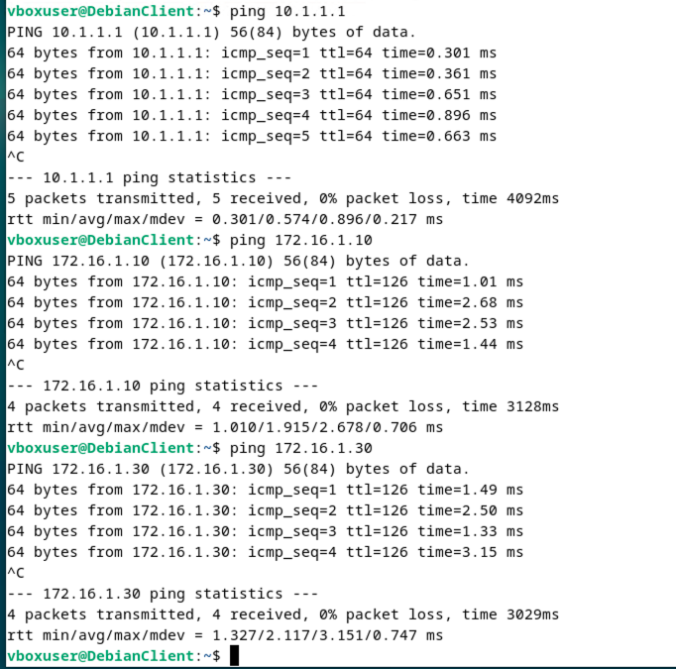
- Sharing Disk Drive: To the earlier created D:\SwanseaFiles, set access permissions to allow users in the users_list_updated.xlsx has full control permissions and other network users have only read access. Share the drive to both Cardiff and Swansea network.

