Summary
This journal presents reflective fieldwork (Gibson, 1998) and hypothetical management plan (Appendix A), for Cronfa Ddŵr Llys-y-Frân Country Park and Reservoir (2023); Sets guiding principles, vision, objectives and actions for managing The Site. Critical evaluation, uses theories and fieldwork journals which impact outdoor recreation resources, visitor experience, and Site facilities/services. Applied strategies suggest better approaches to social, economic and environmental provision, delivering high standard visitor experience to all. Carrying capacities, recognise as physical, ecological, economic and social (Brotherton, 1973). Management plan reflects on-site resources, safety quality standards in watersports, angling, mountain biking, education and facility zones.
Introduction
The reflective journal firstly critically evaluates the resources, visitor experience, facilities and services of Cronfa Ddŵr Llys-y-Frân Country Park and Reservoir (2023), and presents a hypothetical management plan and is referred to throughout as “The Site”. Established in 1972 and located NE of Haverford West, Pembrokeshire, SA63 4RR (Figure1).
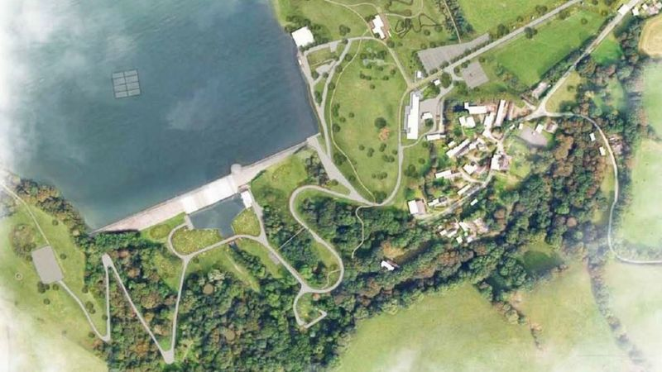
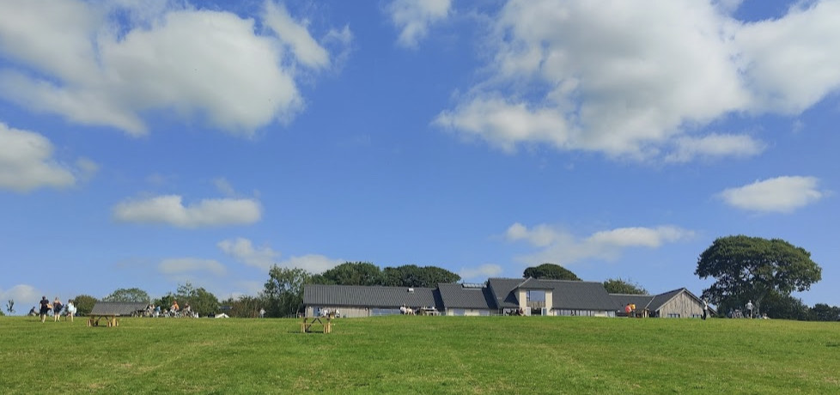
Figure 1. Llys-y-Frân Country Park Facilities & Reservoir. Source: https://llys-y-fran.co.uk/
The Site has Special Scientific Interest (SSSI) status and Special Area of Conservation (SAC), meaning it manages fragile habitats. Llys-y-Frân is owned and managed by Dŵr Cymru / Welsh Water (2023), only not-for-profit Water Company who return monies made for use in their water environment. In 2019, £1.7 million project, funded by European Union Regional Development, Welsh Government, Tourism Attractor Destination programme and Visit Wales. A ‘must see’ social destination was developed for tourists, outdoor enthusiasts and local residents (Pembrokeshire Herald, 2019). However, does The Site practically live-up to this ‘must-see’ description?
Llys-y-Frân site has been culturally settled since Neolithic times and has pre-historic burial chambers providing history and cultural landscape (Figure 2).
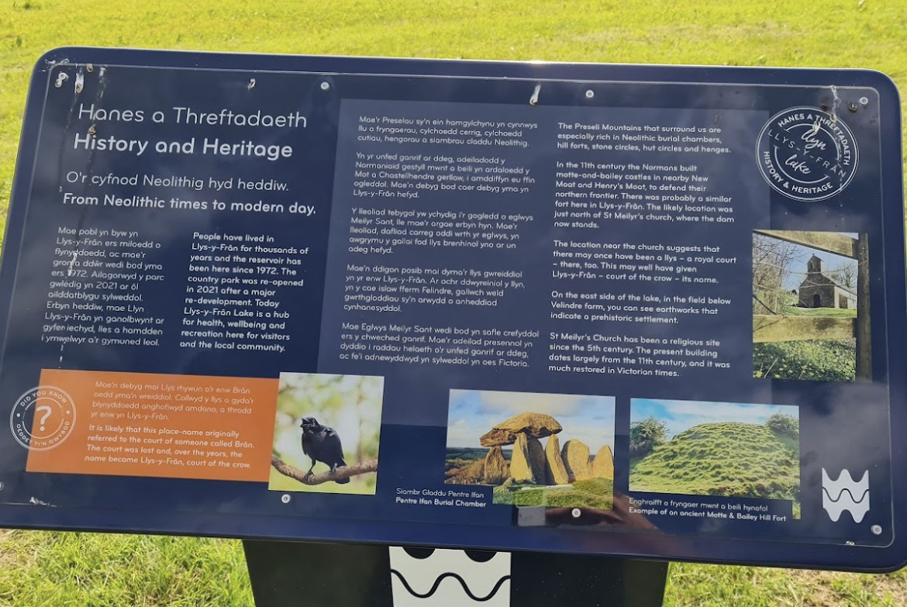
Figure 2. History & Heritage sign. Llys-y-Frân Country Park. Source: Llys-y-Frân, (2023).
In 2021, The Site re-opened to offer outdoor recreation, different activity hubs including practical changing rooms, a welcoming visitor centre/café with outstanding views and woof /people friendly ice-creams. Local communities benefit from services such as sports club meets, meeting rooms, creative outdoor adventure birthday parties and free dog agility. Although the car park charges, monies are re-invested back into site facilities.
Physical natural landscape, forms outdoor recreation hubs. Resources and environment carrying capacity are key to achieve Sustainable Development Goals (SDGs), created from 4 factors of physical, ecological, economic and social (Fan et al., 2015). Education also contributes to positive, social-cultural, economic and environmental impact to improve health well-being to visitors and local communities (Wellbeing of Future Generations (Wales) Act, 2015). However, Welsh climate, seasons, trail geology, fish ecology and weather conditions impact outdoor recreation, effecting visitor numbers. Although outdoor activity centre and waterside cabin provides useful lockers, changing/hot shower facilities to support wet activity users for watersports, walking, mountain biking (MTB) and affordable cycle hire (10 km) reservoir trails challenges all abilities. The Site applies appropriate strategy for different activities, aiming to provide high quality visitor experience.
Reflective practice evaluation
The chosen reflective practice model framework (Figure 3) has 6 stages: Description, Feelings, Evaluation, and Analysis, Conclusions and Actions (Gibbs, 1998). This classic model is used to critically evaluate, how and why I think, feel, and behave about impact of outdoor recreation at Llys-y-Frân, being mindful of my actions. Reflective practice, guides me to question what I already know about outdoor recreation, how I have come to know it and how I can use it in my work.
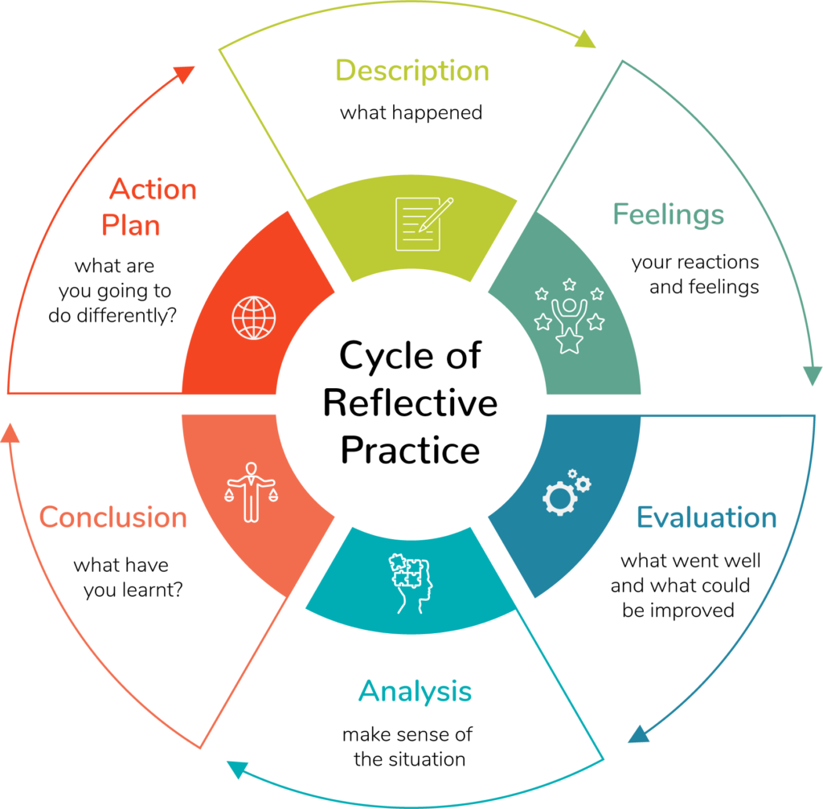
Figure 3. Reflective Practice Model. Source: Graham Gibbs (1998).
This reflective journal includes lessons learnt and conclusions which form management plan. (APPENDIX A). Reflective practice was chosen, because nobody really functions healthy, by not considering their feelings and values. Judgements and actions form from my reflections on issues which impact area resources, visitor experience, facilities/services guide me to suggestions for better approaches.
Health and Safety Standards
Safety is paramount for visitor experience. The Site reassuringly operates under Adventure Activities Licensing Regulations (2004) Licence number L76616 for Watersports, (AALA, 2023) and in accordance with HSE legal requirements.
Hazard warning signs seen around The Site (Figure 4.) clearly show safety information, although not all in Welsh language. These signs to be fully bi-lingual for local inclusiveness.
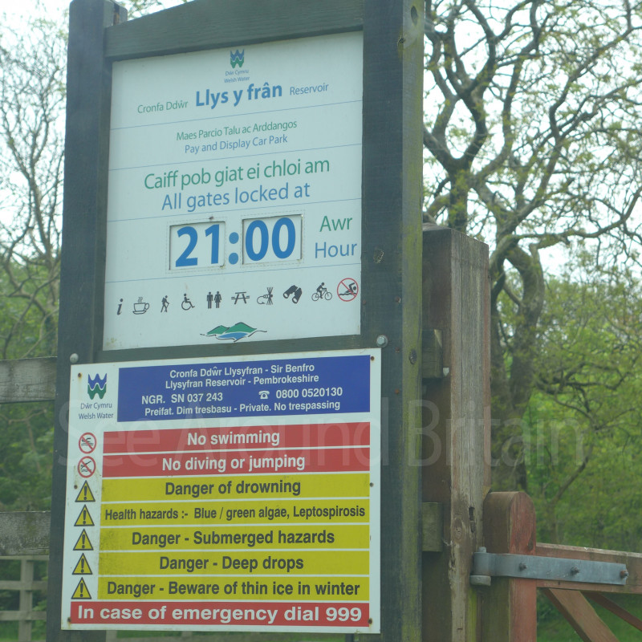
Figure 4. Health & Safety Sign. Source: Llys-y-Frân Welsh Water, 2023.
Zoning
Zoning, is a common method used effectively on-Site management and monitoring. Figure 5 shows 5 parts/zones for watersports, fishing, MTB, other land activities and support facilities, alongside reservoir walking paths/cycle trails (Llys-y-Frân, 2023) Zones are good ways to separately manage activities, rather than single whole 350 acre large area.
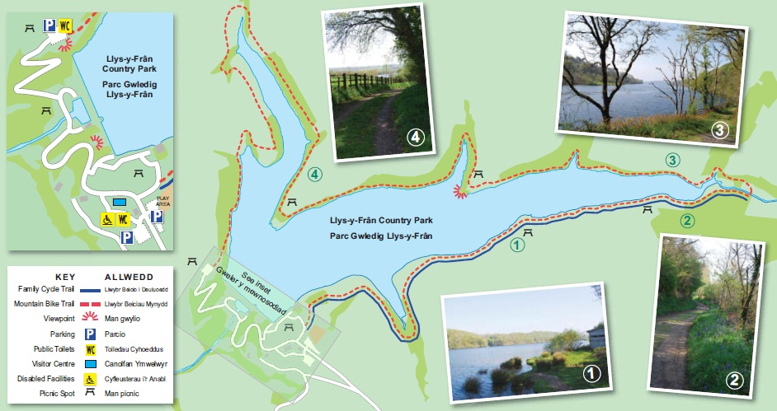
Figure 5. Zoning areas. Llys-y-Frân Country Park. Reference Source: Llys-y-Frân 2023.
Zoning studies (Fu M, et al, 2019) work best with full team of specialists, bringing key skills to manage each zone. For example, watersports specialists effectively lead lakes team, trail specialists lead MTB team, an ichthyologist heads-up fishing team. However, during UWTSD field work observations Spring term 2023, The Site was seen operating with specialist staff only on some activity zones.
A major critique of how Llys-y-Frân uses zoning is why limit specialists to watersports and land activities? As this means site managers rely on staff general experience with less levels of skill knowledge. However, fully specialist approach is costly if in place all-year round, due to greater professionalism, seasonal variation in visitor numbers and meeting higher standards. It is therefore, un-economic to operate specialists across every zone all-year round. Although by, engaging extended seasonal workers during more of year or recruiting local volunteers with appropriate training, knowledge and personal values, good industry standards (Figure 6).
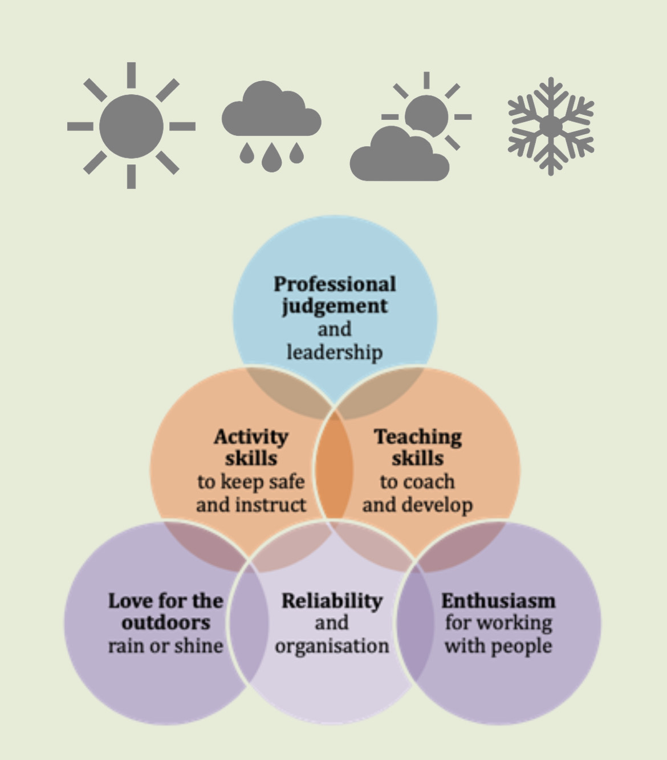
Figure 6. Outdoor Staff Qualities positively shape visitor experience. Source: Institute of Outdoor Learning (IOL) 2023.
Visitor experience does improve thorough in-house training and The Site gets trained teams across all zones, to better meet service delivery aims. Staff become more effective, having better skillset to positively shape each hub, without costly specialists (McEwen and Tocher, 1976).
Water Activities
On-site lake watersports zone is marked by buoys, for fleet of power boats, paddle boards, kayaks, rafting, SUP, dragon boats and canoes, available for group sessions or hire. Specific management plans are needed for different water activities. For example, weekly lake water testing samples monitor impact of powerboat use, because kayaking/SUP watercraft disturb fish breeding and below-water conditions (Hunt et al, 2019). Task results are therefore vital for monitoring ecology standards.
The Site beneficially stops off-season watersports and follows most UK watersports industry calendars - no water activities between November-March/April. A practical plan for nature restoration is useful suggestion, to rest lake water and wildlife regenerate peacefully. Most lakes offer watersports and fishing and conflict often occurs between anglers and watersports users. The Watersports Chief Instructor-in-charge has therefore strategically separated buoyed off zones for watersports to avoid conflict. Solar lighted buoys could extend provision of both these lake activities into evening sessions.
Educational Centre
Llys-y-Frân aims to be a sustainable educational centre, offering demonstrations of water treatment, trail maintenance and wildlife counts. While MTB trails, fishing and walking routes seem naturally connected, McCullough et al (2020) show watersports are also a ‘good-fit’ for acceptable change within education. However, at the moment watersports feels ‘bolted-on’. McCullough et al (2020), support how with care and belief, this should not be the case, because watersports, can be part of ecology; using experienced and qualified RYA, BCU instructors, operating high industry standards.
From my point of view, as a Site visitor with RYA and BCU qualifications and OA experience, from seasonal employment at PGL on Isle of Wight, Absolute Adventures on Jersey, Fore Adventure in Purbeck coast, Dorset, and soon to be fully employed at Calvert Trust on Exmoor providing Accessible activities; then watersports provision at Llys-y-Fran, definitely feels under-utilised and like a forgotten afterthought.
My feeling are based on seeing dirty un-maintained, moss-covered boat shed, rarely opened according to site management and experiencing staff with limited watersports knowledge. Therefore, to improve current situation and water landscape, a suggestion is to recruit specialist manager and qualified staff who openly show real passion and care for watersport environment (Figure 5) and start on-going ‘fix-up’ programmes. While existing activities have excellent potential, neglected sheds and being left out of educational provision sadly does not work so well.
Low Reservoir water levels (Figure 7) impact high-summer watersports, as it lowers carrying capacity of lake users (Wei et al., 2014). Suggestion for suitable lake access points during drought levels to improve existing facilities, user numbers and achieve full Accessibility requirements.
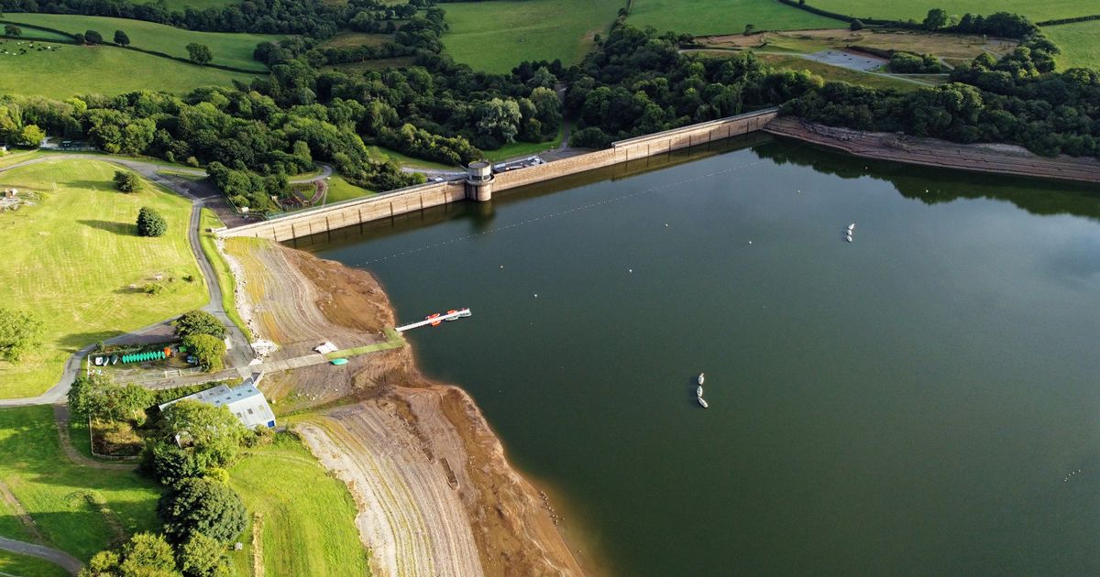
Figure 7. Reservoir water levels impact recreation. Source: Wales-On-Line, 2022.

As alongside outdoor recreation, lies practical infrastructure functions, (Dale B. et al, 2022). A dam and freshwater reservoir draw-off water during drought, such as UK 2022 heat wave.
Fishing Management

Angling and Watersports have dedicated zones to better manage fishing activities. Similarly to managing a deer park, Llys-y-Frân lake fishing needs strategic planning. Especially being upriver to a carp farm, which relies on reservoir water supplies, so its own fishery resources survive during farm’s natural low water levels, which influences fishing strategies.
Anyone wish to fish a “rod license” has to be bought. UK Government, (2015) states “You must have a rod fishing licence for England and Wales, if you fish for salmon, trout, freshwater fish, smelt or eel with rod and line.” In 2015, UK revised fishing licences, after government research on old licences. Appleby et al (2018). Three-year study findings UK fish population improved where more regulated and less impacted fishing environments than old licences. On-site fishing licences are good in supporting these findings, to improve fish resources and carrying capacity numbers by providing good angler visitor experience- justification why anglers buy rod licences.
To fulfil fishing experience, The Site strategically introduced rainbow trout, because it is a firm favourite to catch. Rainbow trout is however, an invasive species in UK waters. Graham et al (2003), domestic studies on rainbow trout had surprising findings, including presence of many invasive fish in UK freshwaters. Rainbow trout was recorded to eat eggs and carry sleeping disease called Oncorhynchus mykiss that kills UK carp; it is therefore essential these fish species do not mix.
However, in 2020, rainbow trout escaped from Llys-y-Frân Lake, causing damage to local carp farm downstream. Lesson learnt, a lower lake system was introduced on-site, to catch escaped fish. However this choice prioritised acceptable change to making angler guests happier, by stocking invasive rainbow trout and carrying environmental risk; because trout identify as a hazard, and greater access into UK’s waterways causes havoc to domestic fish stock (Fausch, 2007).

Mountain Biking Management
Mountain trail biking (MTB) UK’s fastest-growing action sports (Morley, 2021) and South Wales is UK’s MTB capital (MTB Beds, 2022). It is therefore important The Site sets high quality UK’s industry standards and effectively manages MTB, which is a great example and demonstrates high quality standards.
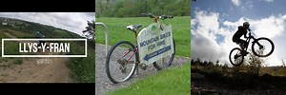
Figure 8. MTB sets high industry standards. Source: Llys-y-Frân 2023.
Llys-y-Frân Lakes has 6.5-miles cycle lakeside trails, previously managed in many different ways. The Site positively encourages new and low income entrants through reasonable charged hire-a-bike. Anti-clockwise MTB trails are safer multi-use for walkers. Current effective management plan for acceptable change, involves transported Welsh granite rocks to protect soil erosion under MTB trails, being long-lasting and resilient to constant abrasion. Good MBT trail preparation, mixed with trusty bi-daily monitoring practice, creates strong, safe-to-ride trails, with less permanent ground damage. Rather than converting trails, setting more top-dirt over existing damaged trails, The Site operates programmes to seasonally close MTB trails, planned re-opening for main season heavy use (Llys-y-Frân, 2023).
MTB presents challenges to mitigate environmental damage due to its tough nature. However, The Site’s existing MTB trails show best practice with high standards, matching European MTB trails and most of England (Burgin and Hardiman, 2012). Suggested economic opportunities to grow MTB on-site include wider visitor experiences offering instruction sessions, bike maintenance or guided family tours. As sustainable MTB trail building has global demand, skills could be taught on-site, creating local jobs.
MTB trail maintenance barriers identify as high costs and huge effort of transporting hard rocks into new environment. Economic and logistical barriers, mean many centres cannot afford this, so adequate funding resources are vital for sustainability. A reflected ecological issue is depositing rocks under MTB trails introduces alien rocks into local soils. Limited short-term impact but longer-term defects to be monitored because rocks introduced do not always naturally balance to soils.
Social Draw
The Site recreation includes; Axe throwing, climbing, mini-tank driving, birthday parties, play and dog agility areas, as essential visitor ‘draw’ visitors and much needed for country park settings to boost out-of-season carrying capacity numbers for all-year round attractions. Such activities carry ‘green’ appeal, and considered as ‘real-people bringers’. Fyall et al, (2022), ‘Managing Visitor Attractions’ identifies recreation opportunities that ‘draws’ visitors from outside of local area’.
From my visitor viewpoint, some activities are better maintained than others. Seeing mini-tank driving and climbing walls sadly both out of action (for over a year), due to poor location drainage, bad ideas for resolving drainage, using 1990’s on-site tyres as solution. This is not delivering good visitor experience. Mini-tanks are popular on The Site, with lost opportunity of unique selling point. Axe throwing, contrasts being newest activity, located away from potential drainage hazards and amazing 30-meter dam views.
Lesson Learnt
Locating axe throwing near hilltop, having reflected on poor downhill mini-tanks drainage conditions. Acceptable changes in niche activities bring unique flare to The Site, providing economic potential for drawing carrying capacity visitors, looking for different/quirky recreation. However, reflection to current asset maintenance, up-keep is alarming, seeing majority land hubs in poor condition just two years since re-opening. Assets should be maintained at higher standards. Mini-tank driving drainage/dirty boat shed examples, bring down whole-site, identifying as mis-managed items, requiring urgent attention.
Conclusions
In conclusion, Llys-y-Frân Country Park and lake are great natural combination of zoned water and land outdoor recreation areas. Site provision is generally beneficial towards visitor experience and provides local employment opportunities created from developing The Site.
Natural features and human activities combine many resources including, fish diversity, distinctive outdoor activities and welcoming local facilities/services bringing unique sense of place (REF REQ). Past and present users continually shape The Site’s identity. While SSSI and SAC status recognises and protects to benefit users now and in future. Resources and environment carrying capacity is the key to achieving Sustainable Development Goals (SDGs) with positive on-going climate actions of eco-tourism, towards sustainable net zero carbon sink site by 2030 and beyond.
In reflection, monitoring and reporting are carried out on-site, apart from mini-tanks poor drainage and boatshed maintenance. Site staff are aware of attempts to fix drainage or move location, but management choose to ignore problems, due to lack of funds.
Five zone areas seem manageable, but delivery could improve employing specialised/trained staff in all zones with higher quality skillset, knowledge and visitor experience. Lake fish choice is interesting, prioritising better angler visitor experience by introducing invasive rainbow trout, upstream of a carp farm. However, this actually benefits The Site’s reputation because Llys-y-Frân is known locally as a great spot to fish. Future green activities include bird hides, Sculpture Park and outdoor gym trail. However activity service is mediocre at best, needing improvement. The Site is good at promoting itself, but disappoints with low-maintenance levels in direct contrast to publically identify as a visitor ‘must-see’ attraction.
However, Llys-y-Fran’s sustainable Vision (Appendix 1) is gradually becoming a reality; using forward-thinking management plans. Funding restraints and staffing levels impact Vision. Time is also needed to fulfil objectives to bring The Site back to life, where visitors thrive, social economy develops, resources and environment are protected in a balanced carrying capacity relationship.
Finally, in reflection of my own reflections, reflective practice helps increase my awareness, of how I can approach situations and develop my CPD. The Site has great space to relax, connect to nature: far-reaching-views, enjoyable bike trails, tranquil fishing.
As a UWTSD Final year student and experienced seasonal Instructor, I fully support OA Activity. I fell positive about Management plans including future sustainable roll-out improvements and variety of safe, affordable outdoor recreation and great visitor experience. Welsh health and wellbeing levels need to improve, achieved by reconnecting visitors with natural resources that are unique to The Site - Llys-y-Frân Country Park and Lake.

References
Advanced Outdoor First Aid Incident Management (ITC, 2023)
Adventure Activities Licensing Regulations. (AALA, 2004). Dwr Cymru-Llys-y-Frân Activity Centre. Licence number L76616. Available at: AALS - Dwr Cymru - Llys y Fran Activity Centre (hse.gov.uk) (Accessed 07 May 2013).
Appleby, T., Cardwell, E. and Pettipher, J., (2018). Fishing rights, property rights, human rights: The problem of legal lock-in in UK fisheries. Elementa: Science of the Anthropocene, 6.
Brotherton. (1973). A management planning framework based on ecological, perceptual and economic carrying capacity: The case study of Vikos-Aoos National Park, Greece Journal of Environmental Management (1999) 56, 271–284 Article No. jema.1999.0285.
Burgin, S. and Hardiman, N. (2012). Is the evolving sport of mountain biking compatible with Fauna Conservation in National Parks? Coventry University. Available at: https://pureportal.coventry.ac.uk/en/publications/is-the-evolving-sport-of-mountain-biking-compatible-with-fauna-co (Accessed: 10 May 2023).
Burgin, S. and Hardiman, N. (2012) Extreme sports in natural areas: looming disaster or a catalyst for a paradigm shift in land use planning? Journal of Environmental Planning and Management, 55:7, 921-940, DOI: 10.1080/09640568.2011.634228
Dale, B. et al. (2022) Climate change: Summer 2022 smashed dozens of UK records, BBC News. Available at: https://www.bbc.com/news/science-environment-63244353 (Accessed: 10 May 2023).
Dŵr Cymru Welsh Water (2023) Your not-for-profit water company, Dŵr Cymru Welsh Water. Available at: https://www.dwrcymru.com/en (Accessed: 07 May 2023).
Fan, J., Wang Y.F., Tang Q., Zhou K., (2015). Academic thought and technical progress of monitoring and early-warning of the national resources and environment carrying capacity (V2014). Science. Geography. Sin. 35 (1), 1-10.1. Available at: https://www.sciencedirect.com/science/article/pii/S1470160X2200259X#bb0025 (Accessed: 07 May 2023).
Fausch, K.D., (2007). Introduction, establishment and effects of non‐native salmonids: Considering the risk of rainbow trout invasion in the United Kingdom. Journal of Fish Biology, 71, pp.1-32.
Fyall, A., Garrod, B., Leask, A. and Wanhill, S. eds., (2022). Managing visitor attractions. Routledge.
Fu, M., Tian, J., Ren, Y., Li, J., Liu, W. and Zhu, Y., (2019). Functional zoning and space management of three-river-source national park. Journal of Geographical Sciences, 29, pp.2069-2084.
Gibbs. G., (1998). Reflective Practice Cycle. Learning by Doing. A Guide to Teaching and Learning Methods. Further Education Unit at Oxford Polytechnic, UK.
Graham, D.A., Rowley, H.M., Walker, I.W., Weston, J.H., Branson, E.J. and Todd, D., (2003). First isolation of sleeping disease virus from rainbow trout, Oncorhynchus mykiss (Walbaum), in the United Kingdom. Journal of fish diseases, 26(11/12), pp.691-694.
Gov.UK. (2015). Buy a rod fishing licence, GOV.UK. Available at: https://www.gov.uk/fishing-licences (Accessed: 06 May 2023).
Health and Safety at Work Act (1974), Available at: About HSE (Accessed: 06 May 2023).
Hunt, L.M., Morris, D.M., Drake, D.A.R., Buckley, J.D. and Johnson, T.B., 2019. Predicting spatial patterns of recreational boating to understand potential impacts to fisheries and aquatic ecosystems. Fisheries research, 211, pp.111-120.
Llys-y-Fran., (2023) Welcome to Llys-y-Frân Lake: Discover your Welsh water adventure, Llys. Available at: https://llys-y-fran.co.uk (Accessed: 06 May 2023).
McCullough, B.P., Orr, M. and Kellison, T., (2020). Sport ecology: Conceptualizing an emerging sub discipline within sport management. Journal of Sport Management, 34(6), pp.509-520.
McEwen, D. and Tocher, S.R., (1976). Zone management: key to controlling recreational impact in developed campsites. Journal of Forestry, 74(2), pp.90-93.
Morley, R., (2021). The rise of MTB, BikeBiz. Available at: https://bikebiz.com/the-rise-of-mtb/amp/ (Accessed: 10 May 2023).
MTB Beds. (2022) Wales Mountain Bike Holiday, MTBBEDS. Available at: https://www.mtbbeds.com/destinations/Wales-Mountain-Bike-Holiday#:~:text=Wales%20is%20considered%20to%20be,be%20created%20in%20the%20UK (Accessed: 10 May 2023).
Pembrokeshire Herald, (2019). ‘Work begins on the multi million pound redevelopment at Llys-y-Frân Reservoir.’ Available at: Work begins on the multi million pound redevelopment at Llys-y-Frân Reservoir – The Pembrokeshire Herald (pembrokeshire-herald.com) (Accessed 12 May 2023).
Reporting of Injuries, Diseases and Dangerous Occurrences Regulations. (RIDDOR, 2013). Available at: RIDDOR - Reporting of Injuries, Diseases and Dangerous Occurrences Regulations 2013 - HSE (Accessed: 10 May 2023).
Risk Assessments. (HSE, 2023). Managing risks and risk assessment at work. Available at: Managing risks and risk assessment at work – Overview -HSE (Accessed: 10 May 2023).
Risk Education. (HSE, 2023). School trips and Outdoor Learning Activities. Available at: School trips and outdoor learning activities: Tackling the health and safety myths: (hse.gov.uk) (Accessed: 10 May 2023).
Wales-on-line., (2022). Available at: llys-y-fran - Bing images (Accessed: 07 May 2023).
Wei et al., (2014). Constructing an assessment indices system to analyse integrated regional carrying capacity in the coastal zones- A case study in Nantong. Available at: https://doi.org/10.1016/j.ocecoaman.2014.02.009 (Accessed: 10 May 2023).
Well-being of future generations (Wales) Act. (2015). Available at: Well-being of Future Generations (Wales) Act 2015: the essentials [HTML] | GOV.WALES

APPENDIX ONE MANAGEMENT PLAN SUMMARY TEMPLATE
Hypothetical Management Plan for The Site at Llys-y-Fran in 4 sections:
Section one: Vision | Presents Vision for Dwr Cymru-Llys-y-Frân Activity Centre; Sets the scene. Introduces philosophical ideas and Essential practical issues to underpin Management Plan
- Recognise The Site for its natural, cultural, social-economic and practical recreation use.
- Develop and protect natural landscape & cultural heritage over whole-site resources.
- Cultivate a safe haven for wildlife and nature to thrive and survive.
- Continue to improve site provision of diverse and inclusive outdoor recreation.
- Engage Professional Staff and Specialist knowledge in all zoned areas of the site.
- Provide safe environment, well-maintained Activity Hubs/Trails for all to explore & enjoy.
- Influence positive health & wellbeing for all users.
- Zero carbon sink aims for site including lakes, to achieve sustainable legislation by 2030.
- Develop trending opportunities for visitors to actively connect with natural environment.
- Add value and create opportunities for local communities.
- Allow free site access with affordable outdoor activities, support active lifestyles.
- Protect natural and cultural heritage for now and in future use.
Section 2: Delivery of Vision | Sets out what to do, how to do it and why? Describes The Site’s aims & objectives & expected outcomes.
Adequate Funding to Protect and maintain Site Resources. WHY? To protect and develop whole-site natural landscape environment:
Actions: Use and maintain The Site assets respectfully, with due care, safety & diligence. Stakeholders how regard for looking after nature.
By chasing adequate funding resources such as community grants and external funding opportunities to safeguard economic levels of spending. Welsh Water are a not-for-profit organisation, ploughing monies made back into their water assets, to help protect water environment and natural assets. Action examples- Woodland Investment grant run by National Lottery Heritage Fund.
Sustaining natural environment by allowing nature to recover off-season. WHY? To preserve nature and allow ecological environment to thrive and survive.
Actions: No Watersports in lakes out of-season. Closed season for MTB trails.
Ensure adequate and appropriate staff recruitment levels: WHY? To raise professionalism levels and to improve recreational offer. Actions: Recruit additional Staff members such as Professional Zone Specialists and Senior Instructors. Train /up-skilling seasonal staff. Use extended season contracts.
Actions: BTB trail construction develops new local skills and potential jobs in conservation. Education-centre aims to introduce practical demonstrations such as; Animal counts and water testing. Guided bike nature trails. Extended family bike hire facilities.
By recruiting professional qualified staff with RYA, BCU, and IOL Quality Standards & Personal Values. Create and Promote interesting Volunteering opportunities.
Maintain safety awareness on-site: WHY? To ensure safe site activities and operations and to prevent accidents. To maintain general public good reputation for the centre and customer engagement.
Actions: Use buoyed zoned areas for watersports and angling to avoid conflict. Use signs to raise awareness to potential hazards. Qualified Activity Instructors and Outdoor First Aiders.
By maintaining sufficient Welsh bi-lingual relevant hazard warning signs throughout the site. Regular maintenance tasks with a fix-up programme for Activity Hubs and buildings.
Section Three: List of legal requirements, environmental and social, economic factors which shape or impact site aims and objectives:
Welsh Government Legislation; Welsh Water Board Regulations; HSE legislation; IOL; RYA Regulations; BCU Regulations; Advanced Outdoor First Aid Incident Management (ITC, 2023)
Adventure Activities Licensing Regulations. (AALA, 2004). Dwr Cymru-Llys-y-Frân Activity Centre. Licence number L76616; Country Park Carrying Capacities; Ecological Legislation; Gov.UK. (2015). Buy a rod fishing licence; Well-being of future generations (Wales) Act. (2015).
Section Four: List essential organisations to bring management plan together:
By engaging positively and collaboratively with all stakeholders.
Dwr Cymru Welsh Water; CADW; Local Councillors; MPs; MTB Association; National Forest of Wales; National Lottery Heritage Fund in Wales; Pembrokeshire County Council; Pembrokeshire Herald; Swim Wales; Local schools- Ysgol Gymunedol Maenclochog; Ysgol Y Preseli; Visit Wales; Welsh Government. Network with stakeholders as interested parties to support, protect and develop the economic, social cultural and environmental growth of Dwr Cymru-Llys-y-Frân Country Park and Lake.

2500 Words +10%.

2686 total assignment words includes section titles, figures, body references, and models. Excludes Appendix 1 Management Plan.

Diolch.

