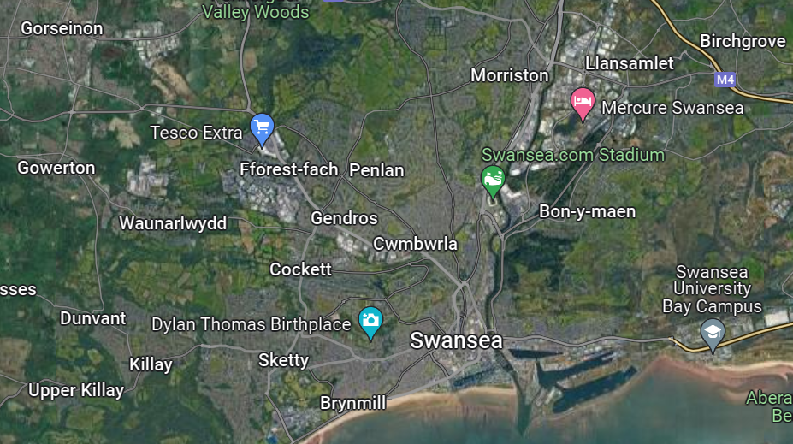
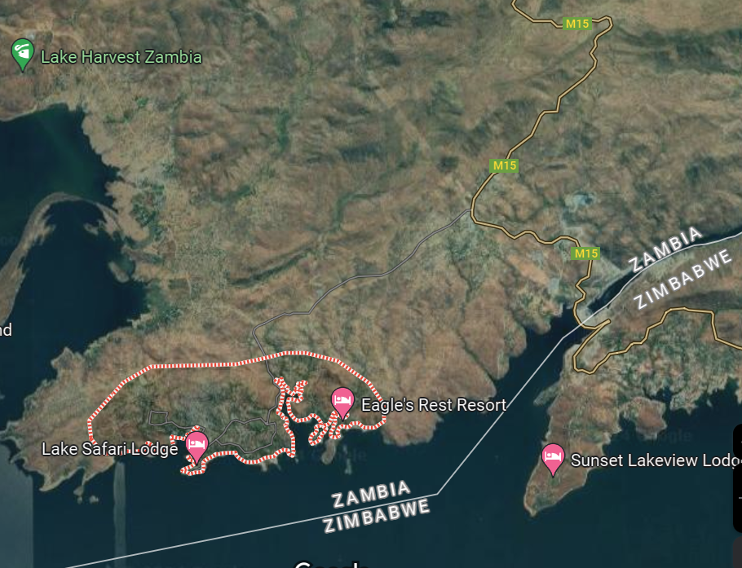
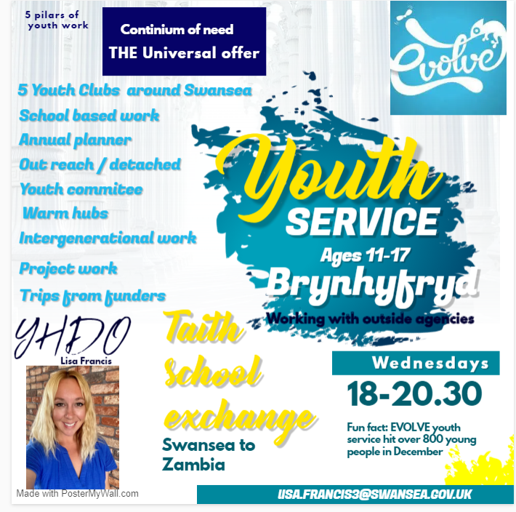

EVOLVE Mission Statement- Swansea Council Youth Workers working with young people in communities across Swansea to support , engage and educate!

My role- Youth Hub Development officer for East Early Help Hub. Brynfyfryd Youth Club.

Youth clubs-
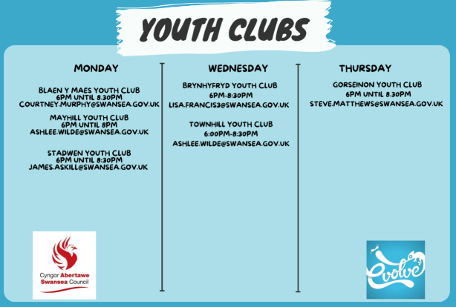

Meaningful measures – we invite young people month to take part in a questionnaire about how they feel about club. Some of the comments resulting from them are-
“To see our friends. Is a good place to be. It’s a safe space. It’s a great environment. It is free to come. There is always hot food here. The trips on offer are amazing. Youth workers are like family. The youth workers are and helpful and you can talk to them. I just love youth.”- Emmleigh Woods – attends club.

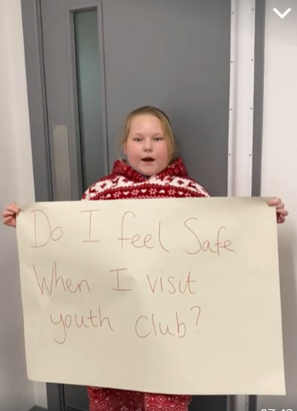

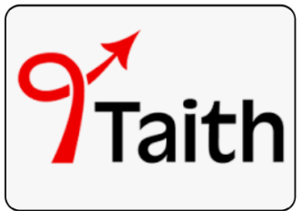

- Taith- Taith is a new programme enabling people in Wales to study, train, volunteer and work all over the world, while allowing organisations in Wales to invite international partners and learners to do the same here in Wales, supported by a £65m investment from the Welsh Government.
- Taith will run from 2022-2026.
- It will create opportunities to broaden horizons, experience new ways of life, and bring back lessons to share with people at home.
- Taith aims to fund 15,000 people from Wales to go on exchanges over the first four years, with 10,000 people from all over the world coming to study, train, volunteer or work in Wales.
- It means that Wales and its international partners can continue to benefit from exchanges in a similar way to the opportunities that flowed from Erasmus+, both in Europe and further afield.
- Hosting people in Wales will be a fundamental principle of the programme, with funding available to welcome learners, volunteers and staff from partner organisations around the world.
In October 2023 I hosted 10 Zambian teachers and introduced them to youth work. I took them to a place outside the classroom and showed them how informal and non-formal teaching takes place with young people. We gave them an opportunity to have a Q&A session with young people, invaluable teaching happened during club that evening for both the Zambian teachers and young people.
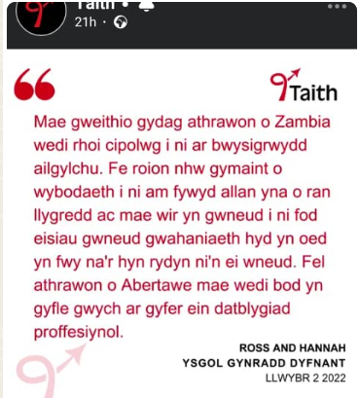
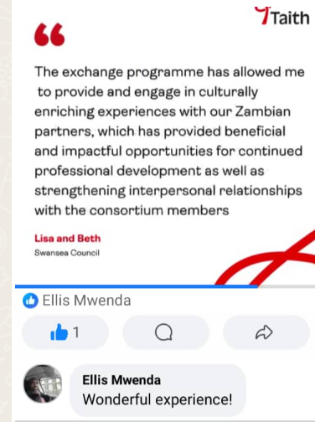

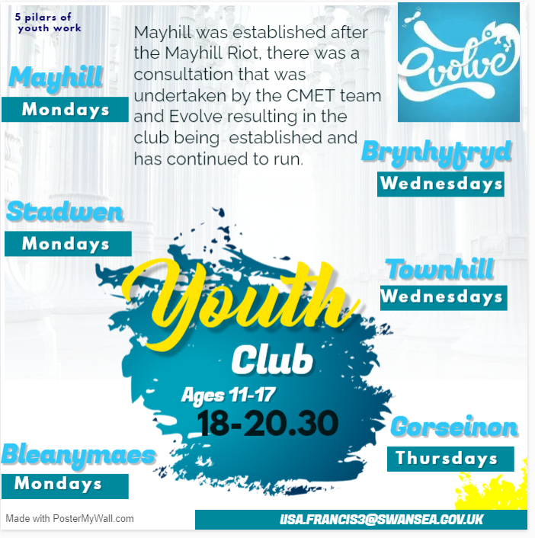

Our service currently offers 6 Youth Clubs throughout the week across our service areas – on Monday we have Blaenymaes, Mayhill and Stadwen, Wednesday has Brynhyfryd and Townhill and finally, on Thursday we have a club at Gorseinon.

- The Youth clubs are a big part of our universal service, offering all Young People a safe space to meet with their friends, have fun and build positive relationships with our Youth Hub Workers while understanding their place as part of the wider community on a voluntary basis.
- The staff can help young people find their voices and discover their talents, providing support to Young People through the various challenges they may face through adolescence. Each hub has a team of dedicated workers, led by our YHDOs, who provide consistency and guidance at this key time in a Young Person’s development.
- In line with the Youth Work Curriculum, all work undertaken that is planned, resourced and delivered in club is informed by the Principles, Purposes and Values of Youth Work, – our clubs offer Young People the chance to learn key life skills through informal education opportunities.
- The clubs offer a huge variety of different activities and events, all designed with Young People at the forefront – we undertake regular consultations with Young People so that we understand their needs, and what they want from the service - we have recently established Youth Committees in each of the clubs, ensuring we are delivering the right activities and opportunities.
- To assist in delivering an equal service across Swansea we have developed an annual planner that highlights important dates, weekly celebrations and monthly themes – from local to international observances, covering everything from the Swansea Christmas Parade to International Woman’s Day. The planner ensures the relevance of our sessions within club and gives us a framework from which to plan and deliver our sessions.
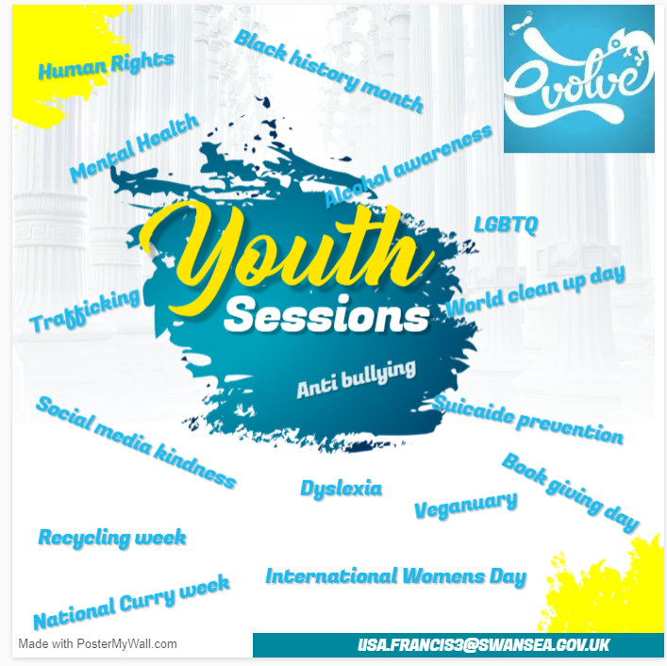

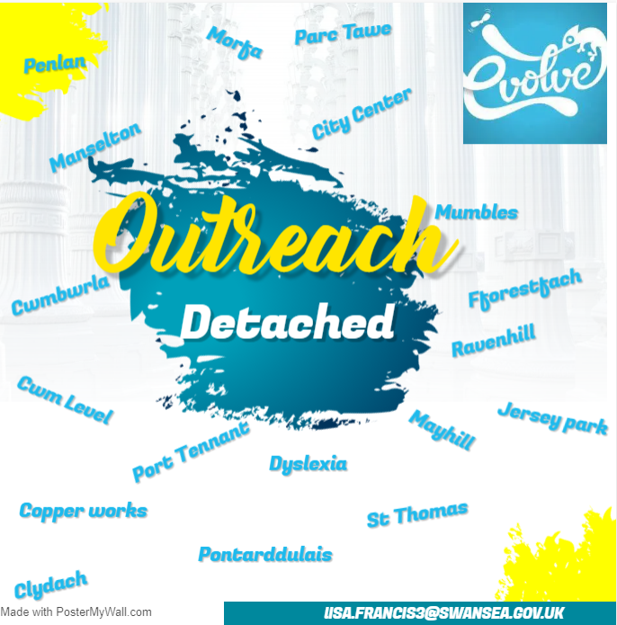

- Outreach is an extension of our Youth Club, and involves visiting the places that Young People hang out, engaging with them with the purpose of checking in, finding out what going on for them, informing, promoting and signposting to existing or proposed services in the local area. This often takes place in bus shelters, parks, local shops and shopping centres, residential estates and fast-food outlets.
- Detached work, on the other hand, is an extension of our work in Youth Clubs, taking our sessions to the places where Young People are in their communities. Examples include; pop-up Youth Clubs, the Christmas Hut in the city centre, pavilions in local parks etc.
- Through meetings and discussions with multiple agencies, other professionals and services, we identify the need in specific areas and respond appropriately. Additionally, through consultations and general discussions with Young People we can also identify other areas of need, which allows us to establish a positive presence in the community, minimising the risk of problems escalating.
- Very often this work is undertaken in communities where there is little or no Young Person specific offer, sessions can be a one off visit, or could be longer 8 – 10 weeks it really depends on the needs presented by the young people, professional partners and the wider community.
- Offers Young People, who may not access any other form of provision, the opportunity to establish and build strong relationships with professionals – in some cases moving these YP from ‘unknowns’ to regular attendees of a support service.
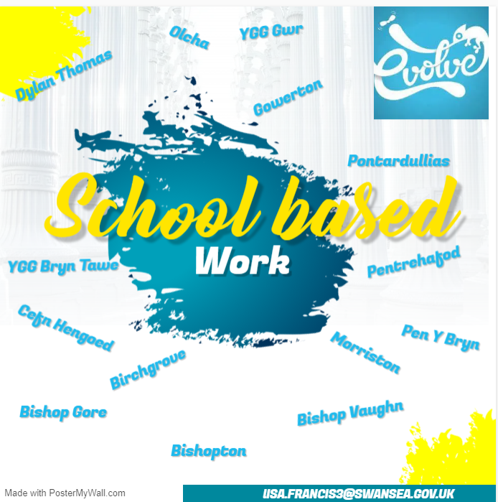

In the school we work closely with the pastoral teams, safeguarding leads, Early Help Hub lead workers, Emotional Health and Wellbeing Workers and any other relevant professional agency to inform our sessions.
PSHE/Group work sessions – A few examples of the sessions we’ve delivered or are scheduled to deliver include: Thinkb4youtype (Anti Bullying), Managing Conflict, Looking after yourself and self-care, Recognising your feelings- mindfulness, Body Confidence, Healthy Friendships, Drugs Awareness, Misogyny, Dealing with Stress
Quarterly review meetings – we meet with the pastoral teams, safeguarding Officers, Head Teachers/Deputy Head Teachers so we are able to evaluate the sessions, programmes delivered, responding to any needs identified by any of the parties involved in the work. Multi agency meeting are a monthly in some of the schools.
The VAP Data is currently used for tracking YP who are at risk of becoming NEET (Not in Education, Employment or Training) through Years 10&11, we are currently looking at how we could be utilising the data, at Year 7, 8 & 9 - allowing us to identify Young People with potential vulnerabilities at an earlier stage.
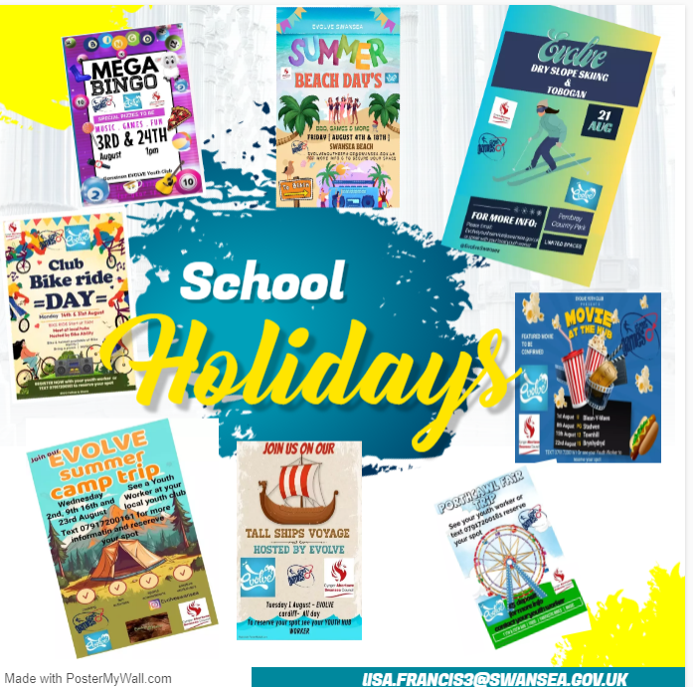

Every year we plan, prepare and deliver a summer offer of activities, we continually ask young people what they want, they never surprise us with their responses, on the agenda this year were, 4 back to nature wild camping trips, two voyages on the Tallships challenge, 1 skiing and tobogganing session, 2 bike ride days, 5 do it yourself movie days, 2 mega bingo sessions, 2 Porthcawl Fair and beach day trips, 2 summer beach days, families in the afternoon and young people in the evening, we also delivered warm hubs throughout the summer.
Over 635 young people accessed the activities over the summer holiday period.

References-
Early Help Hubs - Swansea
Introduction to Pathway 2 - Taith
Taith-Pathway-2-English.pdf
Taith Instagram
Facebook
Instagram
EVOLVE Swansea Instagram

