A Systems-Based Analysis of Leadership, Governance and Medication Safety Failure: A Case Study of Unintentional
Morphine Overdose in UK Healthcare.

Student Name: Charlotte Esi Jackson

Student ID: 2223874

Model code: LCHS7002

Assignment Title: Case Study Analysis Report

Programme: MSc Public Health and Social Care in Practice

Model: Health Care Systems Organisation and Leadership

Lecturer: Dr Fahad Khan

Table of Contents

1. Introduction 3
2a. Identifying the Problem and Setting the System Context: A Systems Thinking Perspective. 4
2b. Centralisation and Decentralisation within the Case Study 7
2c. Leadership Theories and Their Application to the Case Study 10
2d. Improvement and Lessons Learned 13
3. Recommendations 16
4 Conclusion 18

5 Reference List 19

Keywords:

Patient safety; Medication errors; Systems thinking; Healthcare leadership; Clinical governance; Communication failure; Integrated Care Systems; Quality improvement.

List of Figures:

Figure 1: The majority of medication errors occur during the administration stage (54%), highlighting a critical point of vulnerability in the system (Elliott et al., 2021).

Figure 2: Getting Started | A Practical Guide to Delivering Results. (Leeds.ac.uk., 2018).

Figure 2: Unified Communication System in Healthcare (adapted from Avery et al., 2021; Baxter et al., 2018).

1. Introduction
Patient safety is a paramount concern in modern health and social care systems, with medication-related damage being a major and preventable source of ill outcomes. Recent evidence suggests that pharmaceutical errors persist on a significant scale, especially within complex healthcare systems characterised by multiple transitions in care. In England, it is predicted that around 237 million drug errors occur each year, with a significant percentage leading to over 1700 deaths and costing £98 million for moderate to severe injury (Elliott et al., 2021; BMJ, 2020). These findings underscore that pharmaceutical safety is not solely a clinical concern but a systemic challenge influenced by organisational frameworks, communication protocols, and leadership methodologies.
This report examines an unintentional morphine overdose case involving an elderly patient, as investigated by the Healthcare Safety Investigation Branch (HSSIB, 2022). The incident occurred following the prescription and dispensation of morphine oral solution, during which a misinterpretation of dosage instructions led to excessive administration and a subsequent deterioration in condition. Current patient safety research underscores that such accidents rarely stem solely from human error, despite the apparent cause being patient misunderstanding. Rather, they emerge from complex relationships that involve system design, communication breakdowns, and organisational deficiencies (Camacho et al., 2024). This viewpoint corresponds with systems thinking methodologies, which aim to comprehend the interactions among many components within healthcare systems that affect outcomes.
Leadership is pivotal in shaping these systems and affecting patient safety results. In healthcare, leadership is defined as the capacity to influence individuals, teams, and organisational processes to achieve collective objectives related to quality and safety. Diverse leadership styles, including transformational, transactional, and situational, provide distinct frameworks for shaping behaviour and decision-making in healthcare settings. Transformational leadership is associated with enhanced safety cultures and increased staff involvement, whereas transactional leadership emphasises adherence to established protocols (West et al., 2015; Dirik et al., 2026). The efficacy of these methods is especially critical in high-risk scenarios, where prompt decision-making, unambiguous communication, and accountability are vital.
In addition to leadership, the delivery and administration of treatment are significantly influenced by the configuration of healthcare systems, particularly the equilibrium between centralisation and decentralisation. Centralised systems prioritise uniformity and control, whereas decentralised systems facilitate local autonomy and adaptability. The National Health Service (NHS) functions as a hybrid system, integrating national policy guidance with local implementation, which can present both opportunities and challenges for maintaining uniform patient safety protocols (Fulop et al., 2012).
This report will rigorously evaluate the chosen case study using systems thinking, leadership theory, and governance frameworks. The analysis will investigate the influence of structural, organisational, and leadership factors on the incident and identify essential lessons and evidence-based measures to enhance patient safety and system effectiveness.

2a. Identifying the Problem and Setting the System Context: A Systems Thinking Perspective.

The unintentional morphine overdose concerning Len signifies a significant failure in patient safety that transcends personal misinterpretation and highlights profound systemic deficiencies within healthcare provision. The immediate cause of the incident was the misinterpretation of dosage instructions; however, this rationale may oversimplify a complex, multifaceted systems failure. Current literature on patient safety consistently suggests that adverse events do not arise from a single human error; rather, they stem from the interplay among suppressed system factors, organisational structures, and communication systems (Camacho et al., 2024).

Globally, medication-related damage is a major factor in preventable morbidity and mortality.

The World Health Organisation has recognised unsafe drug practices as a primary contributor to injury and preventable harm in global healthcare systems, with an estimated economic impact of billions per year (WHO, 2017; Panagioti et al., 2023). Recent empirical evidence substantiates this worry, emphasising the enduring and systematic prevalence of pharmaceutical errors in both high- and low-income healthcare systems. Significantly, these errors often arise not at a singular point of care, but during transitions between services, where communication and responsibility are frequently disjointed (Assiri et al., 2018; Camacho et al., 2024).

In the UK, the magnitude of the issue is significant. Elliott et al. (2021) estimate that over 237 million pharmaceutical errors transpire annually in England, with approximately 66 million being potentially clinically serious.

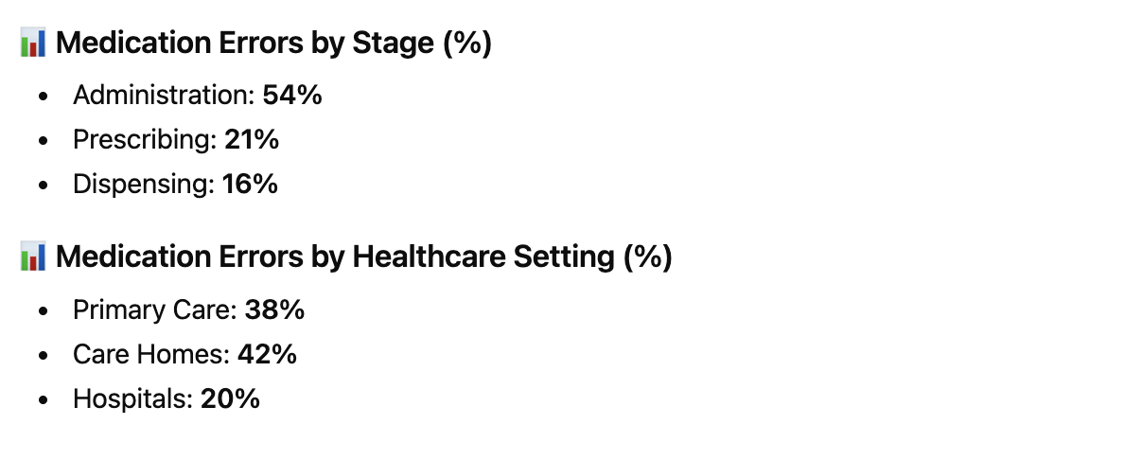

As illustrated in Figure 1, most medication errors occur during the administration stage (54%), highlighting a critical point of vulnerability in the system (Elliott et al., 2021).

A significant percentage of these errors occur in primary care and during transitions between community and hospital environments, reflecting the conditions noted in Len's case. The study reveals that drug errors are not only common but also embedded in standard healthcare procedures, suggesting that systemic weaknesses are treated as normal rather than extraordinary.

Len's story exemplifies the dysfunction of various interrelated elements within the healthcare system from a systems-thinking perspective. The prescribing phase, conducted in primary care, did not adequately account for the patient's ability to comprehend dosing instructions. The distribution process had unclear labelling and did not enhance patient education, and the monitoring and follow-up mechanisms were either non-existent or inefficient. Instead of operating as an integrated system, these components functioned in isolation, resulting in a failure of what ought to have been a coordinated, safety-focused process.

The implementation of systems thinking, especially as articulated in soft systems methodology, facilitates a deeper understanding of the origins of these errors. Systems thinking prioritises the analysis of relationships, feedback loops, and interactions among the components of a system rather than concentrating on individual activities (Checkland, 1982).

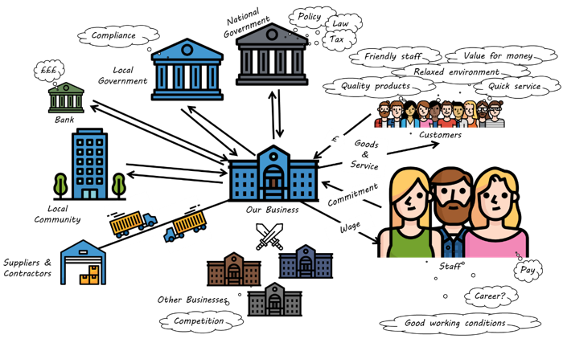

Figure 2: Getting Started | A Practical Guide to Delivering Results. (Leeds.ac.uk., 2018).

Figure 2 shows the complexity of the medication management system, which includes healthcare personnel, patients, and organisational structures. The diagram shows fragmented communication lines, the absence of feedback loops, and unclear accountability across care facilities, which led to Len's negative outcome.

The absence of a "closed-loop" communication system may reveal a significant failure. The patient received information about the medication dosage; however, there was no system in place to confirm comprehension or ensure proper administration. The lack of feedback signifies a critical design issue in the system, as efficient healthcare systems depend on ongoing information sharing and validation to ensure safety.

Moreover, the case underscores substantial communication failures, which are well known as a primary contributor to prescription errors. Studies demonstrate that inadequate communication significantly contributes to a considerable number of adverse medication events, especially in older individuals with intricate health requirements and diminished health literacy (Alqenae et al., 2020). Len's situation illustrates a reliance on textual instructions without sufficient verbal reinforcement or patient involvement, indicating a failure to tailor communication tactics to the patient's individual needs. This highlights procedural deficiencies and a lack of patient-centred care, which modern healthcare policies and practices increasingly prioritise.

Governance institutions significantly influenced the circumstances surrounding the tragedy. Healthcare delivery in the UK operates across various tiers, including local (general practice and pharmacy), regional, and national (NHS policy and regulation) levels. This multi-level governance structure facilitates flexibility and local adaptation, although it may lead to fragmentation and ambiguous accountability. In Len's situation, accountability for pharmaceutical safety was inadequately allocated among several stakeholders and lacked a definitive system for coordination or supervision. The diffusion of responsibility is an acknowledged risk in complex systems, where a lack of explicit accountability may lead to deficiencies in safety protocols (Braithwaite et al., 2017), ultimately resulting in increased risks to patient safety and potential harm to individuals relying on these pharmaceuticals.

Additionally, worker pressures and resource limitations may have intensified these systemic vulnerabilities. Evidence indicates that staffing shortages and increased workload pressures in primary care and pharmacy services can adversely affect the quality of communication, patient education, and error detection (NHS England, 2023). In such circumstances, safety-critical actions may lose priority or execute with diminished efficacy, thereby increasing the likelihood of adverse consequences.
Collectively, these indicators indicate that Len's overdose should not be perceived as an isolated event but rather because of systemic failure across various domains. The interplay of fragmented governance, weak communication, suboptimal system design, and contextual constraints fostered an atmosphere conducive to preventable harm, which ultimately contributed to Len's overdose and highlights the need for comprehensive reforms in healthcare practices. This underscores the necessity of implementing a systems-based approach to patient safety, which acknowledges that improving outcomes requires addressing fundamental organisational and structural challenges rather than focusing solely on individual performance.

2b. Centralisation and Decentralisation within the Case Study
The structure of healthcare systems, whether centralised or decentralised, significantly influences decision-making, accountability, and patient safety results. In Len's morphine overdose case, the UK healthcare system, particularly the National Health Service (NHS), demonstrates a hybrid model characterised by centralised strategic oversight and primarily decentralised operational execution. This setup aims to reconcile standardisation with local flexibility; yet this case illustrates how misalignment between these dimensions can create systemic weaknesses, such as inconsistent responses to overdose cases and varying levels of care across different regions.
Centralisation in healthcare often denotes the consolidation of authority, policy formulation, and standards setting at a higher organisational or national level. Centralised components within the NHS encompass national prescribing guidelines, patient safety protocols, and regulatory monitoring mechanisms designed to maintain uniformity and quality throughout the system (Fulop et al., 2012; Baxter et al., 2018). In principle, this centralised system should improve patient safety by minimising practice variability and ensuring compliance with evidence-based standards. National guidelines for high-risk drugs, such as opioids, aim to reduce the probability of prescribing and administration errors.
Nonetheless, the situation under examination demonstrates that the presence of centralised policies does not guarantee their effective execution. Notwithstanding the existence of national pharmaceutical safety procedures, Len was prescribed and administered morphine in a manner that ultimately resulted in injury. This indicates a disparity between policy and implementation, in which centralised standards were inadequately translated into secure operational procedures. Recent studies agree with this observation, suggesting that, although centralisation can enhance standardisation, it may also establish inflexible systems that cannot accommodate local patient requirements or contextual variables (Kislov et al., 2019). The prescribing process inadequately considered the patient's ability to comprehend dose instructions, indicating a deficiency in personalising care within a centrally regulated framework.
Conversely, decentralisation entails allocating decision-making power to local tiers, granting healthcare practitioners greater autonomy in providing care. Decentralisation within the NHS is evident in the roles of general practitioners, community pharmacists, and local care teams, who are responsible for making treatment decisions and engaging directly with patients. This framework aims to improve responsiveness, facilitate professional judgement, and promote patient-centred care (Exworthy and Frosini, 2008). Nonetheless, decentralisation increases implementation diversity and may undermine accountability in the absence of strong governance systems. In Len's morphine overdose case, the UK healthcare system, particularly the National Health Service (NHS), demonstrates a hybrid model marked by centralised strategic oversight and primarily decentralised operational execution. The division of duties is a proven challenge in decentralised systems, as coordination among many providers is frequently restricted, increasing the likelihood of communication gaps (Braithwaite et al., 2020). Consequently, essential safety assessments may be neglected, especially during transitions between care environments.
This scenario reveals a significant weakness: a lack of effective integration between centralised policy and distributed practice. Although national guidelines may have delineated suitable prescribing and dispensing criteria, their implementation depended on local agents operating in resource-limited, high-stress contexts. Evidence indicates that workforce shortages and rising demand for primary care and pharmacy services may jeopardise the quality of patient communication and adherence to safety protocols (NHS England, 2023). In these circumstances, decentralised decision-making may favour efficiency at the expense of thoroughness, hence heightening the likelihood of errors.
Moreover, the dispersed structure may have led to inadequate communication and a deficiency in continuity of care. Studies demonstrate that pharmaceutical errors are more common during transitions between healthcare settings, where responsibility shifts, and information exchange is often inadequate (Camacho et al., 2024). In Len's situation, the shift from prescribing to dispensing and subsequent administration lacked a unified communication structure, resulting in a failure to ensure that the patient and his carer fully understood the pharmaceutical regimen.
Figure 2 shows how electronic health records and e-prescribing systems allow healthcare professionals to share information continuously, minimising fragmentation and boosting patient safety.

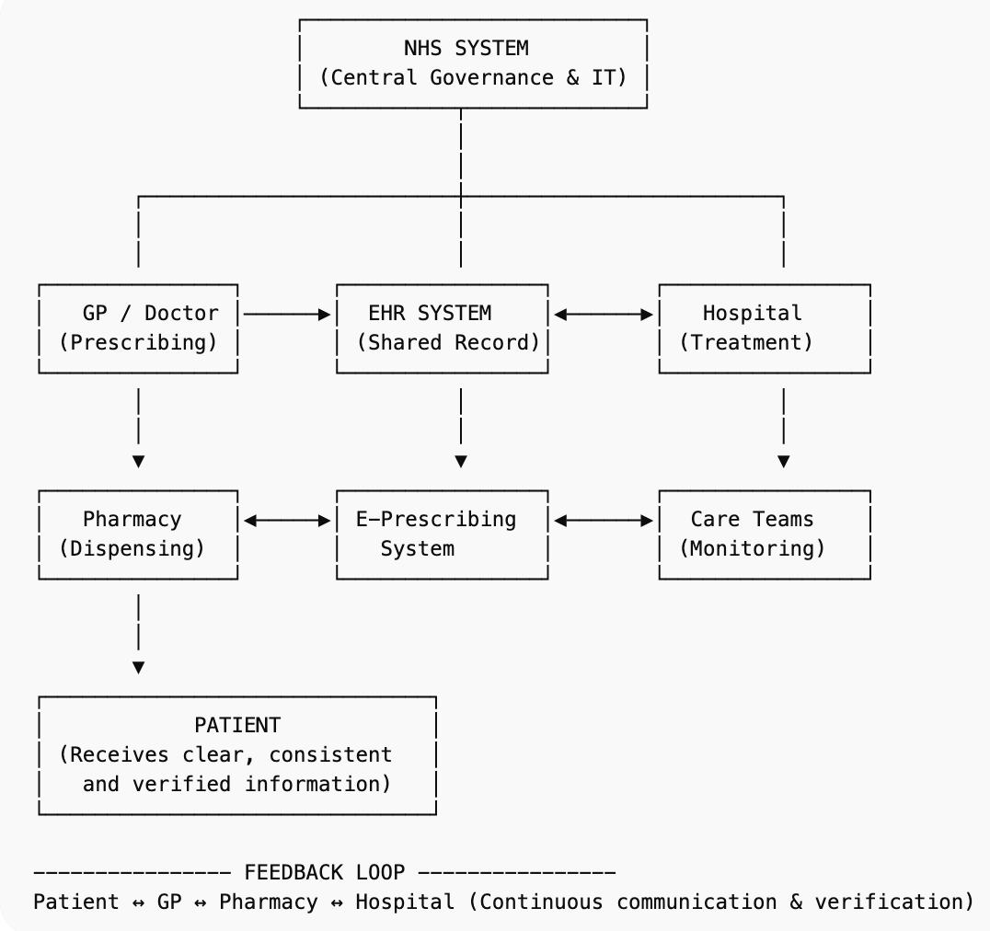
Figure 3: Unified Communication System in Healthcare (adapted from Avery et al., 2021; Baxter et al., 2018).
From a critical standpoint, the concern transcends the mere classification of the system as centralised or decentralised; it pertains to the efficacy of the alignment of various components. The hybrid structure of the NHS necessitates robust coordination systems to guarantee that central policies are effectively implemented at the local level. This case illustrates that the coordination was inadequate, resulting in a disparity between the stated safety requirements and actual implementation. This misalignment represents a systemic deficiency, in which neither central authority nor local autonomy is adequately utilised to ensure patient safety.
The situation notably prompts enquiries regarding accountability in hybrid systems. Centralised systems can dilute responsibility by establishing safety as a collective priority, whereas decentralised structures may obscure accountability by dispersing it among various stakeholders. In Len's situation, the locus of ultimate responsibility for ensuring the safe use of medication remains ambiguous, highlighting a significant governance deficiency. This is consistent with extensive evidence indicating that ambiguous accountability significantly contributes to patient safety failures in complex healthcare systems (Braithwaite et al., 2020).
In conclusion, the examination of centralisation versus decentralisation in this situation demonstrates that neither strategy is intrinsically adequate for guaranteeing patient safety. Although centralisation offers uniformity and direction, while decentralisation facilitates flexibility and responsiveness, the system's efficacy depends on integrating and coordinating these components. In Len's case, the inability to attain this equilibrium resulted in disjointed treatment, communication failures, and eventually avoidable injury. Resolving these difficulties necessitates structural modifications, enhanced governance, defined accountability, and leadership adept at reconciling policy with practice.

2c. Leadership Theories and Their Application to the Case Study
Leadership in healthcare systems is essential for defining organisational culture, influencing staff behaviour, and ultimately determining patient safety results. In high-risk settings like medication management, leadership transcends formal power, encompassing the coordination of care, facilitation of effective communication, and promotion of a safety-orientated culture. Len's inadvertent morphine overdose underscores significant deficiencies in leadership throughout several tiers of the healthcare system, illustrating how ineffective leadership can lead to avoidable harm.
This section rigorously applies transformational, transactional, and situational leadership theories to assess leadership effectiveness in the case.
Transformational leadership is widely recognised in the healthcare literature as a crucial factor in enhancing patient safety and organisational effectiveness. It emphasises the inspiration and motivation of personnel, the promotion of a collective vision, and the cultivation of a culture of perpetual enhancement. Research indicates that transformative leadership correlates favourably with enhanced safety outcomes, increased staff engagement, and a reduced incidence of adverse events (Boamah et al., 2018; West et al., 2015). In Len's situation, the lack of transformative leadership is apparent in the neglect of patient-centred communication and safety awareness. The prescribing and dispensing systems seemed to prioritise tasks over patient care, with insufficient emphasis on ensuring that the patient and carer fully understood the medication instructions.
Transformational leadership requires healthcare personnel to surpass mere procedural compliance and actively engage with the patient to ensure understanding, especially given the patient's age and frailty. Studies demonstrate that patient involvement and effective communication are critical elements of safe medication practices, particularly in older persons (Alqenae et al., 2020). The absence of such engagement in this instance indicates a deficiency in leadership practices that foster a safety culture and collective accountability. The system operated under the assumption of compliance without verification, rather than empowering the patient as an active partner in their care, thereby heightening the risk of error.
Conversely, transactional leadership prioritises structure, regulations, and performance oversight, depending on explicit expectations and corrective measures to sustain organisational efficacy. This strategy may effectively ensure conformity to established norms, but it can also lead to an overemphasis on compliance, thereby undermining critical thinking and adaptability. Len's situation illustrates aspects of transactional leadership through the dependence on established prescribing and dispensing protocols. Nonetheless, these methods proved inadequate in preventing injury, suggesting that mere adherence to procedures does not ensure patient safety.
From a critical standpoint, the shortcomings of transactional leadership are evident in its failure to address intricate, context-specific challenges. The healthcare providers involved may have adhered to conventional protocols but neglected to implement supplementary protections, such as verifying patient comprehension or modifying communication tactics. This aligns with the literature indicating that excessive reliance on rule-based methodologies can foster a misleading sense of security, in which compliance with procedures is mistaken for safe practice, despite unresolved underlying hazards (Kislov et al., 2021). The emphasis on task completion over outcome verification led to a deterioration in safety.
Situational leadership provides a flexible methodology, highlighting the need for leaders to adapt their style to the circumstances and individuals' requirements. In healthcare settings, this entails identifying disparities in patients’ capabilities, treatment complexities, and external influences. Len's case exemplifies the neglect of situational leadership, as the patient's advanced age and potential fragility necessitated customised communication and supplementary assistance. A uniform method was implemented without enough consideration of individual requirements.
Situational leadership necessitated that healthcare professionals modify their communication tactics to ensure information was presented in an accessible and comprehensible manner. This may have involved the utilisation of simplified language, verbal reinforcement, or further assessments to verify understanding. The lack of such adaptive behaviour signifies insufficient leadership responsiveness, a critical element in patient safety. Research indicates that inadequately customising care to meet individual patient needs frequently contributes to adverse events, especially within complex healthcare systems (Braithwaite et al., 2020).
In addition to implementing certain leadership theories, it is crucial to evaluate whether the leadership within the system was proactive or reactive. In this instance, leadership seems to have been primarily reactive, addressing the unfavourable event rather than anticipating and averting it. Proactive leadership, characterised by risk identification, implementation of preventive measures, and the cultivation of a vigilant culture, is crucial in high-risk settings such as medication administration. The lack of proactive leadership behaviours indicates a fundamental deficiency in risk management and safety governance.
Data from healthcare systems further substantiate the significance of leadership in influencing safety outcomes. Research indicates that businesses exhibiting robust leadership and favourable safety cultures experience reduced incidence of adverse events and enhanced staff engagement (West et al., 2015). In contrast, ineffective leadership correlates with inadequate communication, diminished accountability, and heightened risk of detriment. In Len's situation, the absence of effective leadership along the care pathway led to disjointed communication, ambiguous responsibilities, and inadequate patient support.
Significantly, alternative leadership strategies could have alleviated the hazards identified in this instance. Distributed leadership, characterised by the delegation of responsibilities among teams and the promotion of collaboration, may have enhanced coordination among primary care, pharmacy, and hospital services. Likewise, emotionally intelligent leadership, which prioritises empathy, communication, and comprehension of patient needs, could have improved patient participation and diminished the potential for misunderstanding. These methodologies correspond with modern healthcare leadership frameworks that emphasise teamwork, adaptability, and patient-centred care.
In conclusion, the application of leadership theories to Len's example illustrates that leadership shortcomings were a substantial contributing element to the negative outcome. The lack of transformational leadership hindered the establishment of a safety-focused culture, whereas reliance on transactional methods failed to adequately mitigate contextual risks. The absence of situational adaptation hindered effective communication and patient engagement. These findings underscore the necessity for a more cohesive and proactive leadership strategy, adept at navigating the intricacies of contemporary healthcare systems and guaranteeing safe, patient-centred treatment.

2d. Improvement and Lessons Learned
Len's inadvertent morphine overdose presents a significant opportunity to assess the interplay of deficiencies in leadership, governance, and system design that culminated in avoidable harm. This part transcends mere diagnosis by critically analysing the interplay among recognised weaknesses in communication, fragmented care delivery, and poor leadership, while also outlining necessary evidence-based enhancements. The analysis indicates that lasting progress requires coordinated adjustments across all elements of the healthcare system rather than isolated interventions.
A primary issue highlighted in this situation is the breakdown of communication within the drug pathway. The patient and carer misinterpreted medication directions, indicating a failure in information dissemination and verification protocols. Empirical research demonstrates that communication failures rank among the primary causes of medication errors, constituting a substantial percentage of adverse drug events (Alqenae et al., 2020). In the UK, medication-related damage significantly burdens healthcare systems, with millions of errors attributed to insufficient communication and inadequate information transfer (Elliott et al., 2021). Len's situation illustrates a deficiency in clear, patient-centred communication, indicating both a procedural shortcoming and a leadership failure to prioritise safety and comprehension.
A crucial lesson suggested by this failure is the necessity of establishing structured, reliable communication protocols. An evidence-based enhancement is the implementation of "teach-back" approaches, in which patients are asked to repeat instructions to verify comprehension. Studies indicate that these methods markedly reduce medication errors and improve adherence, especially among older adults and individuals with limited health literacy (Tamura-Lis, 2013). The lack of verification measures in this instance underscores a significant flaw in the system design, in which communication was treated as a unilateral process rather than a reciprocal exchange.
Conversely, a secondary critical issue is the disjointed governance and ambiguous accountability along the care continuum. Accountability for medication safety was allocated among general practice, pharmacy services, and hospital care; nevertheless, no singular organisation exercised comprehensive oversight of the entire procedure. This fragmentation is an acknowledged issue in intricate healthcare systems, as several stakeholders function within loosely integrated frameworks (Braithwaite et al., 2020). However, the lack of cooperation in Len's case led to deficiencies in safety inspections, particularly during transitions between care settings.
Enhanced integration of governance processes is necessary to resolve this issue. Integrated care models, which facilitate coordination among various healthcare providers, have demonstrated improvements in patient outcomes and reductions in errors through enhanced information sharing and accountability (Fulop et al., 2019). This may entail establishing shared digital health records, thereby facilitating real-time access to patient information across various treatment settings. Research indicates that computerised prescribing and integrated information systems may markedly reduce medication errors by enhancing accuracy and communication (Avery et al., 2021). The lack of such procedures in this instance signifies a lost opportunity to avert harm.
Leadership significantly influenced the result of this case. The absence of transformational and situational leadership led to insufficient patient engagement and an inability to adapt communication techniques. A crucial lesson is that leadership must transcend mere procedural adherence and actively foster a culture of safety and responsibility. Studies demonstrate that businesses exhibiting robust leadership and favourable safety cultures are more likely to recognise issues, encourage reporting, and implement effective improvements (West et al., 2014). Conversely, ineffective leadership may lead to a reactive safety strategy, in which measures are implemented only after an incident.
An evidence-based enhancement in this domain is the adoption of distributed leadership models, which promote collective accountability for safety across teams. These methods have demonstrated the ability to augment collaboration, boost communication, and reinforce accountability within healthcare systems (Kislov et al., 2019). In Len's situation, a more collaborative leadership style may have enhanced coordination among healthcare providers and prioritised patient comprehension throughout the care continuum.
A significant concern identified is the absence of effective feedback mechanisms inside the system. Efficient healthcare systems depend on ongoing surveillance and feedback to recognise and mitigate hazards. In this instance, there was no system in place to identify or rectify the problem before it caused harm. This indicates a widespread deficiency across numerous healthcare systems, in which event reporting and learning mechanisms are either underutilised or inadequately incorporated into practice (Braithwaite et al., 2020).
Healthcare organisations must enhance their learning systems by fostering a culture of transparency and ongoing development. This encompasses promoting the reporting of near-misses, investigating occurrences to ascertain root causes, and executing system-wide modifications based on the results. The Healthcare Safety Investigation Branch underscores the significance of deriving lessons from occurrences via a systems-based methodology, rather than assigning culpability to individuals (HSSIB, 2022). Integrating these methodologies into organisational practices is crucial for minimising recurrence and enhancing patient safety.
The interplay of system structure, leadership, and feedback mechanisms must be recognised as dynamic and interrelated. The dispersed structure of care delivery in this instance led to fragmentation, while insufficient leadership hindered coordination and oversight. Simultaneously, inadequate feedback mechanisms hindered the early detection of risk. These elements did not function independently; instead, they mutually reinforced one another, creating conditions that increased the likelihood of injury.
This story underscores the necessity of transitioning from reactive to proactive strategies in healthcare systems. Organisations must anticipate risks and develop preventive measures rather than respond to incidents after the fact. This necessitates the incorporation of data-driven decision-making, in which information on errors and near-misses is systematically evaluated and utilised to guide enhancement initiatives. Research indicates that businesses that adeptly utilise data to inform decision-making attain superior safety results and optimise resource allocation (Avery et al., 2021).
In conclusion, the insights from Len's case emphasise the necessity of implementing a comprehensive, systems-orientated strategy for improvement. Mitigating communication failures, strengthening governance, enhancing leadership, and refining feedback mechanisms are critical elements of a holistic plan to avert medication-related harm. It is essential that these parts are integrated and linked to guarantee lasting and effective changes. The story illustrates that patient safety is influenced not solely by human actions but by the intricate interplay among systemic structures, leadership methodologies, and organisational processes. Consequently, significant enhancement necessitates synchronised initiatives throughout all tiers of the healthcare system.

3. Recommendations

The examination of Len's case reveals that an avoidable injury resulted from the interplay of disjointed governance, inadequate communication, and poorly adapted leadership within a hybrid healthcare system. Resolving these difficulties requires a series of coordinated, evidence-based recommendations that address the structural, organisational, and behavioural aspects of healthcare delivery. These ideas must transcend discrete efforts and instead advocate for systemic integration and sustainability.
A key recommendation is the implementation of transformative and distributed leadership paradigms throughout healthcare environments. Transformational leadership is crucial for cultivating a safety-oriented culture in which personnel are motivated to prioritise patient understanding, question harmful procedures, and participate in continuous improvement. Research suggests that businesses with robust, supportive leadership exhibit improved patient outcomes and reduced rates of adverse events (West et al., 2014). Leadership should not be restricted to top positions; dispersed leadership models, which promote shared accountability among interdisciplinary teams, are especially crucial in complex systems where care is delivered beyond organisational boundaries (Kislov et al., 2019). This would entail enabling chemists, nurses, and primary care providers to actively participate in ensuring pharmaceutical safety and patient understanding.

A second crucial proposal is to enhance governance and system integration, especially during care transitions. The example underscored considerable fragmentation across general practice, pharmacy services, and hospital care, resulting in unclear accountability and communication deficiencies. Healthcare institutions should adopt integrated digital health systems that encompass shared electronic prescribing and patient data. Evidence indicates that these systems can markedly decrease medication errors by enhancing information accuracy, continuity of care, and communication among physicians (Avery et al., 2021). Moreover, governance systems must be restructured to establish unequivocal accountability for patient safety throughout the full care continuum, rather than inside discrete organisational units.
Enhancing communication processes and patient involvement is essential. The results indicate that the pharmaceutical instructions were not properly understood, signifying a failure to tailor communication to patients' requirements. Healthcare companies ought to adopt organised communication tactics, such as the teach-back method, which has demonstrated efficacy in enhancing patient comprehension and minimising medication errors (Tamura-Lis, 2013). Furthermore, written instructions must be standardised, streamlined, and complemented by vocal explanations customised to the specific features of individual patients, especially for at-risk groups such as the elderly.
A further significant proposal is to improve technical and allocative efficiency through data-driven decision-making. Healthcare systems must transition to proactively identifying hazards by systematically analysing data on medication errors, near-misses, and patient outcomes. Research indicates that firms that proficiently leverage data for decision-making achieve superior safety results and more efficient resource allocation (Elliott et al., 2021). This necessitates investment in data infrastructure and training for personnel to analyse and implement data in clinical practice.
Healthcare organisations should enhance their learning systems and feedback processes to facilitate ongoing development. This requires fostering a culture of transparency, in which employees are motivated to disclose occurrences and near-misses without fear of retribution. Insights gained from such events should be integrated into organisational processes, accompanied by explicit methods for implementing findings into practice. The systems-based approach promoted by the HSSIB Healthcare Safety Investigation Branch underscores the necessity of understanding root causes rather than assigning blame, and this principle ought to be incorporated into standard practice (HSSIB, 2022).

Ultimately, prioritising stakeholder participation and co-production is essential to guarantee that enhancements are centred on patients and contextually suitable. Patients and carers ought to be actively engaged in the formulation of communication strategies, safety interventions, and service delivery models. Research indicates that co-production improves the relevance and efficacy of healthcare interventions, especially in enhancing adherence and minimising errors (Braithwaite et al., 2020).
In conclusion, these guidelines underscore the necessity of a coordinated and comprehensive approach to enhancement that incorporates leadership, governance, communication, and data-driven methods. By addressing the root causes revealed by the investigation, healthcare institutions can improve technological efficiency and patient safety, thereby preventing similar events in the future.

4 Conclusion

This report has rigorously analysed the case of an inadvertent morphine overdose from the perspectives of leadership, governance, and systems thinking. The research revealed that the incident was not solely due to individual human error but rather the consequence of intricate and interrelated system failures. These encompassed disjointed governance across care environments, inadequate communication processes, poorly adaptive leadership, and a lack of effective feedback mechanisms. These findings align with current patient safety research, which underscores that adverse events generally stem from systemic deficiencies rather than individual misconduct (Braithwaite et al., 2020).

The implementation of systems thinking has been crucial in elucidating the interactions among many components of the healthcare system that resulted in harm. The prescribing, dispensing, and administration processes operated independently rather than as an integrated system, resulting in communication failures and accountability gaps. This underscores the necessity of perceiving patient safety as a systemic concern, necessitating coordinated interventions across many tiers of the healthcare system (Checkland, 1982; Camacho et al., 2024).

Leadership has been recognised as a crucial factor influencing safety outcomes. The lack of transformational and situational leadership constrained healthcare personnel's capacity to respond to patient demands, foster effective communication, and foresee dangers. Conversely, evidence indicates that robust, proactive leadership is crucial for cultivating a safety culture, enhancing worker involvement, and minimising adverse incidents (West et al., 2015; Boamah et al., 2018). This case exemplifies how leadership deficiencies can directly lead to unsafe care provision.

The examination of centralisation and decentralisation indicated that the healthcare system's hybrid structure led to a misalignment between policy and practice. Centralised frameworks provided direction, whereas decentralised delivery led to unpredictability and fragmentation, underscoring the need for enhanced integration and coordination mechanisms (Fulop et al., 2019).

This report illustrates that enhancing patient safety requires a comprehensive, evidence-based strategy that addresses the fundamental structural, organisational, and behavioural issues that lead to injury. Healthcare organisations can mitigate the risk of pharmaceutical errors and provide safer, more effective care by fortifying leadership, refining governance, enhancing communication, and implementing systems-based methodologies for learning and improvement (Elliott et al., 2021; HSSIB, 2022).

5 Reference List

Alqenae, F.A., Steinke, D. and Keers, R.N., 2020. Prevalence and nature of medication errors and medication-related harm following discharge from hospital to community settings: a systematic review. Drug safety, 43(6), pp.517-537.

Alqenae, F.A., Steinke, D. and Keers, R.N., 2020. Prevalence and nature of medication errors and medication-related harm following discharge from hospital to community settings: a systematic review. Drug safety, 43(6), pp.517-537.

Alqenae, F.A., Steinke, D. and Keers, R.N., 2020. Prevalence and nature of medication errors and medication-related harm following discharge from hospital to community settings: a systematic review. Drug safety, 43(6), pp.517-537.

Assiri, G.A., Shebl, N.A., Mahmoud, M.A., Aloudah, N., Grant, E., Aljadhey, H. and Sheikh, A., 2018. What is the epidemiology of medication errors, error-related adverse events and risk factors for errors in adults managed in community care contexts? A systematic review of the international literature. BMJ open, 8(5), p.e019101.

Avery, A.J., Sheehan, C., Bell, B., Armstrong, S., Ashcroft, D.M., Boyd, M.J., Chuter, A., Cooper, A., Donnelly, A., Edwards, A. and Evans, H.P., 2021. Incidence, nature and causes of avoidable significant harm in primary care in England: retrospective case note review. BMJ Quality & Safety, 30(12), pp.961-976.

Avery, A.J., Sheehan, C., Bell, B., Armstrong, S., Ashcroft, D.M., Boyd, M.J., Chuter, A., Cooper, A., Donnelly, A., Edwards, A. and Evans, H.P., 2021. Incidence, nature and causes of avoidable significant harm in primary care in England: retrospective case note review. BMJ Quality & Safety, 30(12), pp.961-976.

Baxter, S., Johnson, M., Chambers, D., Sutton, A., Goyder, E. and Booth, A. (2018) Understanding new models of integrated care in developed countries: a systematic review. Southampton: NIHR Journals Library (Health Services and Delivery Research, 6(29)). Available at: https://www.journalslibrary.nihr.ac.uk/hsdr/HSDR06290 (Accessed: 23 March 2026).

BMJ (2020). 237+ million medication errors made every year in England - BMJ Group. [online] BMJ. Available at: https://www.bmj.com/company/%20newsroom/237-million-medication-errors-made-every-year-in-england/ [Accessed 24 Mar. 2026].

Boamah, S.A., Laschinger, H.K.S., Wong, C. and Clarke, S., 2018. Effect of transformational leadership on job satisfaction and patient safety outcomes. Nursing outlook, 66(2), pp.180-189.
Braithwaite, J., Glasziou, P. and Westbrook, J., 2020. The three numbers you need to know about healthcare: the 60-30-10 challenge. BMC medicine, 18(1), p.102.
Braithwaite, J., Glasziou, P. and Westbrook, J., 2020. The three numbers you need to know about healthcare: the 60-30-10 challenge. BMC medicine, 18(1), p.102.

Braithwaite, J., Hibbert, P., Blakely, B., Plumb, J., Hannaford, N., Long, J.C. and Marks, D., 2017. Health system frameworks and performance indicators in eight countries: a comparative international analysis. SAGE open medicine, 5, p.2050312116686516.

Braithwaite, J., Hibbert, P., Blakely, B., Plumb, J., Hannaford, N., Long, J.C. and Marks, D., 2017. Health system frameworks and performance indicators in eight countries: a comparative international analysis. SAGE open medicine, 5, p.2050312116686516.

Braithwaite, J., Hibbert, P., Blakely, B., Plumb, J., Hannaford, N., Long, J.C. and Marks, D., 2017. Health system frameworks and performance indicators in eight countries: a comparative international analysis. SAGE open medicine, 5, p.2050312116686516.

Camacho, E.M., Gavan, S., Keers, R.N., Chuter, A. and Elliott, R.A., 2024. Estimating the impact on patient safety of enabling the digital transfer of patients’ prescription information in the English NHS. BMJ quality & safety, 33(11), pp.726-737.

Camacho, E.M., Penner, L.S., Taylor, A., Guthrie, B., Avery, A.J., Ashcroft, D.M., Morales, D.R., Rogers, G., Chuter, A. and Elliott, R.A., 2024. Estimating the economic effect of harm associated with high risk prescribing of oral non-steroidal anti-inflammatory drugs in England: population-based cohort and economic modelling study. bmj, 386.

Camacho, E.M., Penner, L.S., Taylor, A., Guthrie, B., Avery, A.J., Ashcroft, D.M., Morales, D.R., Rogers, G., Chuter, A. and Elliott, R.A., 2024. Estimating the economic effect of harm associated with high risk prescribing of oral non-steroidal anti-inflammatory drugs in England: population based cohort and economic modelling study. bmj, 386.

Checkland, P., 1982. Systems thinking, systems practice. European Journal of Operational Research, 11(4), pp.405-407.

Dirik, H.F., Theiakouli, C. and Efstathiou, N., 2026. The Influence of Nursing Leadership Styles on Medication Safety: A Mixed‐Methods Systematic Review. International Nursing Review, 73(1), p.e70166.

Economic analysis of the prevalence and clinical and economic burden of medication error in England. BMJ Quality & Safety, 30(2), pp.96-105.

Elliott, R.A., Camacho, E., Jankovic, D., Sculpher, M.J. and Faria, R., 2021. Economic analysis of the prevalence and clinical and economic burden of medication error in England. BMJ Quality & Safety, 30(2), pp.96-105.

Elliott, R.A., Camacho, E., Jankovic, D., Sculpher, M.J. and Faria, R., 2021.
Elliott, R.A., Camacho, E., Jankovic, D., Sculpher, M.J. and Faria, R., 2021. Economic analysis of the prevalence and clinical and economic burden of medication error in England. BMJ Quality & Safety, 30(2), pp.96-105.

Elliott, R.A., Camacho, E., Jankovic, D., Sculpher, M.J. and Faria, R., 2021. Economic analysis of the prevalence and clinical and economic burden of medication error in England. BMJ Quality & Safety, 30(2), pp.96-105.

Exworthy, M. and Frosini, F., 2008. Room for manoeuvre?: Explaining local autonomy in the English National Health Service. Health policy, 86(2-3), pp.204-212.

Fulop, N., Walters, R. and Spurgeon, P., 2012. Implementing changes to hospital services: factors influencing the process and ‘results’ of reconfiguration. Health policy, 104(2), pp.128-135.

Fulop, N., Walters, R. and Spurgeon, P., 2012. Implementing changes to hospital services: factors influencing the process and ‘results’ of reconfiguration. Health policy, 104(2), pp.128-135.

Healthcare Safety Investigation Branch (HSSIB) (2022) Unintentional overdose of morphine sulfate oral solution. Available at: https://www.hssib.org.uk/patient-safety-investigations/unintentional-overdose-of-morphine-sulfate-oral-solution/investigation-report/ (Accessed: 23 March 2026).
Healthcare Safety Investigation Branch (HSSIB) (2022) Unintentional overdose of morphine sulfate oral solution. Available at: https://www.hssib.org.uk/patient-safety-investigations/unintentional-overdose-of-morphine-sulfate-oral-solution/investigation-report/ (Accessed: 23 March 2026).

Healthcare Safety Investigation Branch (HSSIB) (2022) Unintentional overdose of morphine sulfate oral solution. Available at: https://www.hssib.org.uk/patient-safety-investigations/unintentional-overdose-of-morphine-sulfate-oral-solution/investigation-report/ (Accessed: 23 March 2026).

Kislov, R., Pope, C., Martin, G.P. and Wilson, P.M., 2019. Harnessing the power of theorising in implementation science. Implementation Science, 14(1), p.103.

Kislov, R., Pope, C., Martin, G.P. and Wilson, P.M., 2019. Harnessing the power of theorising in implementation science. Implementation Science, 14(1), p.103.

Kislov, R., Pope, C., Martin, G.P. and Wilson, P.M., 2019. Harnessing the power of theorising in implementation science. Implementation Science, 14(1), p.103.

Kislov, R., Pope, C., Martin, G.P. and Wilson, P.M., 2019. Harnessing the power of theorising in implementation science. Implementation Science, 14(1), p.103.

Leeds.ac.uk. (2018). Getting Started | A Practical Guide To Delivering Results. [online] Available at: https://deliveringresults.leeds.ac.uk/a-practical-guide-to-documenting-and-designing-processes/process-documentation/getting-started/ [Accessed 25 Mar. 2026].

NHS England (2023) NHS Long Term Workforce Plan. Available at: https://www.england.nhs.uk/long-read/nhs-long-term-workforce-plan-2/ (Accessed: 23 March 2026).

NHS England (2023) NHS Long Term Workforce Plan. Available at: https://www.england.nhs.uk/long-read/nhs-long-term-workforce-plan-2/ (Accessed: 23 March 2026).

Panagioti, M., Hodkinson, A., Planner, C., Dhingra, N. and Gupta, N., 2023. Global burden of preventable medication-related harm in health care: a systematic review.

Tamura-Lis, W., 2013. Teach-Back for quality education and patient safety. Urologic nursing, 33(6).
Tamura-Lis, W., 2013. Teach-Back for quality education and patient safety. Urologic nursing, 33(6).

West, M., Armit, K., Loewenthal, L., Eckert, R., West, T. and Lee, A., 2015. Leadership and leadership development in health care: the evidence base.
West, M., Armit, K., Loewenthal, L., Eckert, R., West, T. and Lee, A., 2015. Leadership and leadership development in health care: the evidence base.

West, M.A., Eckert, R., Steward, K. and Pasmore, W.A., 2014. Developing collective leadership for health care (Vol. 36). London: King's Fund.
West, M.A., Eckert, R., Steward, K. and Pasmore, W.A., 2014. Developing collective leadership for health care (Vol. 36). London: King's Fund.

World Health Organization (2017) Medication without harm: Global patient safety challenge on medication safety. Geneva: World Health Organization. Available at: https://www.who.int/publications/i/item/WHO-HIS-SDS-2017.6 (Accessed: 23 March 2026).

