CULTURAL AWARENESS BETWEEN DIFFERENT COUNTRIES

STUDENT NAME: MIHAELA ADRIANA CRISTIAN
STUDENT NUMBER: 2017346
MODULE NAME: FOREIGN LANGUAGES & CULTURAL AWARENESS (BMIH5003)
LECTURER: MIKE DAVIES

Executive Summary

This report will cover all these points stated above and apply these dimensions to both the countries that we will take and then further analyze by comparing the results of both the countries to create a do`s and don`ts list as a handbook for the first country`s hotel to use when a guest from the second country visits them so that these cultural differences doesn`t create a problem when they host them. It is really important for a hotel to understand different cultures as every culture have different beliefs and traditions so it is important for hotels to try to follow the culture of the guest but at the same time make the guest aware of their own culture. India is one of the most diverse countries in the world where people from many different religions live and this creates a fusion in the culture among the people from different religions and backgrounds. It is very important for us to understand the cultural backgrounds of both countries individually and then comprehensively compare them to see how can these cultural differences could be bridged by hotels in India.
In the report below, we briefly discussed the cultures of two different countries which were India and the United Kingdom using Hofstede`s cultural dimensions and came to know what cultural differences there are between these two countries. Then we discussed the scenario that if a person from United Kingdom visits a hotel in India what challenges will the Indian hotels face due to their cultural differences. We found out that there we major cultural differences among the two countries, especially in the PDI and IVR dimensions. Based on these cultural differences, we created a do`s and don`t list for the hotel staff to keep in mind while attending a guest from England.

TABLE OF CONTENTS

CULTURAL AWARENESS BETWEEN DIFFERENT COUNTRIES 4
Introduction 4
Country A: India 5
Country B: England 6
Country Analysis 7
HOTEL HANDBOOK 8
WowStops-Hotel Clink 9
Conclusion 10
References 10

Introduction

Cultural awareness is the term used for understanding how people acquire their own culture and knowing about other cultures and learning about them at the same time. The differences among various cultures could come from various factors or dimensions which are precisely mentioned in Geert Hofstede’s study. These dimensions can be identified as follows:
- Power Distance Index.
- Individualism Versus Collectivism.
- Masculinity Versus Femininity.
- Uncertainty Avoidance Index.
- Long- Versus Short-Term Orientation.
- Indulgence Versus Restraint.
This report will cover all these points don’t above and apply these dimensions on both the countries that we will take and then further analyze by comparing the results of both the countries to create a dos and don’ts list as a handbook for the first country’s hotel to use when a guest from the second country visits them so that these cultural differences doesn't create a problem when they host them.

Country A: India

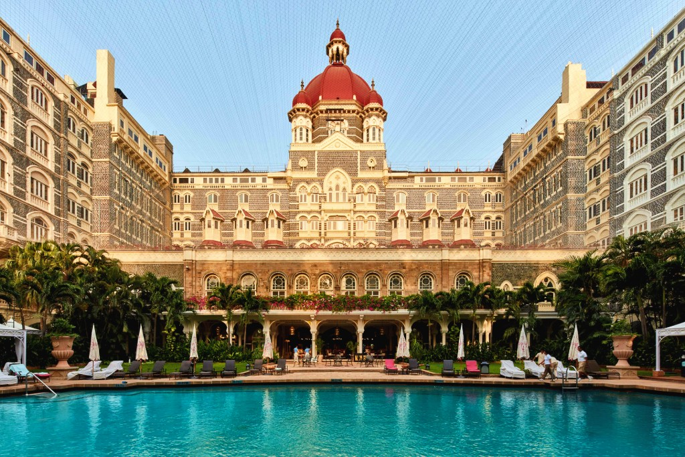
India is one of the most diverse countries in the world where people from many different religions live and this creates a fusion in the culture among the people from different religions and backgrounds. Through the years, a synthesis of many civilizations came to be, giving expression to what is now known as Indian culture.
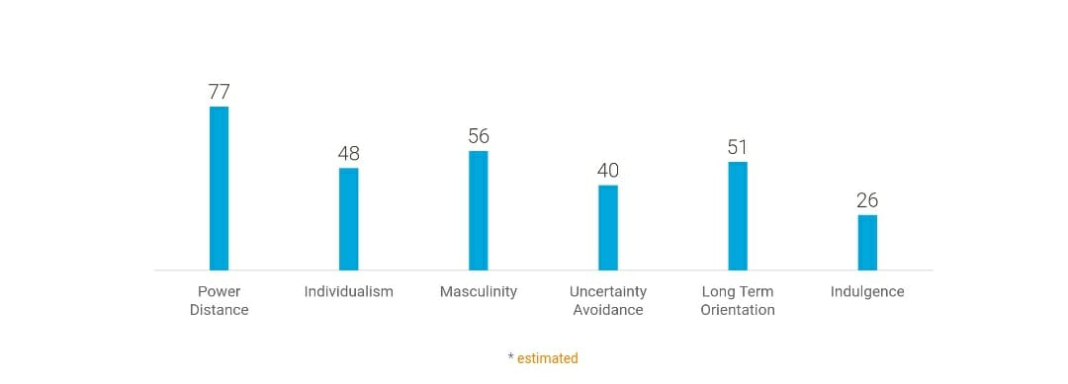
The above graph shows India’s values of all the 6 Hofstede dimensions. Since we see a high PDI (Power Distance Index) this means the hotels in India are more centralized and have complex hierarchies. The IDV (Individualism Versus Collectivism) is moderately low which means the hotel puts emphasis on the skills of their employees and people working for intrinsic rewards. Also, the MAS (Masculinity versus Feminine) is quite stable but more on the masculine side. The UAI (Uncertainty Avoidance Index) is on the lower side as people are more open to change and are generally inclusive. Now, the Long- Versus Short-Term Orientation is high since people often wonder how to know what is true. Lastly, the IVR (Indulgence Versus Restraint) is very low since people in India are more pessimistic and have rigid behaviors at work.

Country B: United Kingdom

The British culture is affected by the united nations' history, including its traditionally Christian religious life, engagement with European cultures, English, Welsh, Scottish, and Irish customs, and the British Empire's effect. So, we can say a lot of countries combined create the British culture and that’s what makes it diverse.

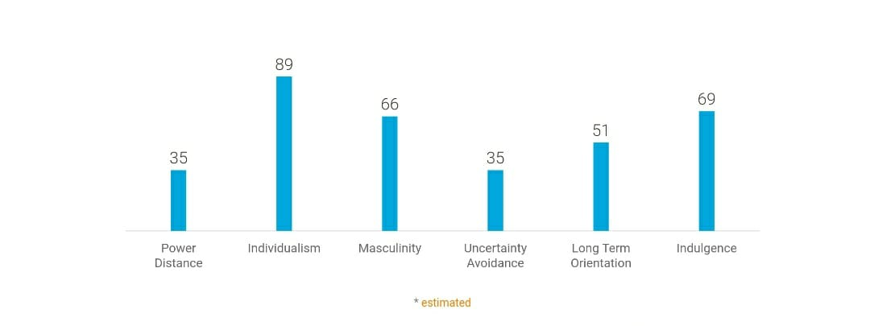
The graph above depicts the United Kingdom's values for each of Hofstede's six dimensions. Because the PDI (Power Distance Index) is low, this indicates that the hotels in the UK have flatter organizations, with managers and staff treated equally. The IDV (Individualism Versus Collectivism) is extremely high, indicating that individuals place a great value on their time as well as their need for privacy and independence. Also, because the MAS (Masculinity vs Femininity) is high, people might have big egos and pride. People are more receptive to change and are typically inclusive, hence the UAI (Uncertainty Avoidance Index) is on the lower side. People often ask how to know what is true, therefore the Long-Vs. Short-Term Orientation is now relatively high. Finally, because individuals in England are more hopeful and focused, the IVR (Indulgence Versus Restraint) is high.

Country Analysis

Both India and the United Kingdom have very different cultures so it is obvious when someone from UK visits an Indian hotel there will be a lot of cultural barriers and differences. Let us study these differences and try to find solutions to bridge these barriers using Hofstede’s cultural dimensions.
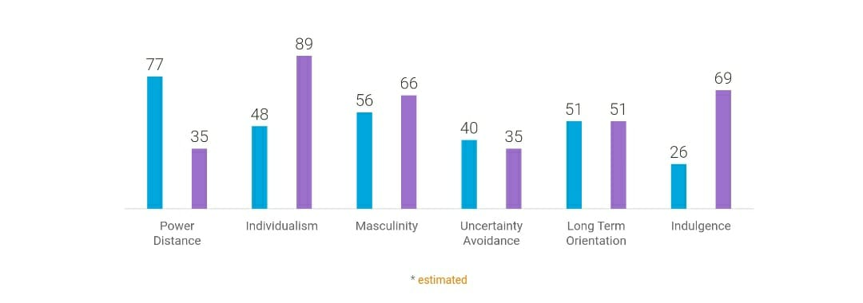
The above graph shows the values of cultural dimensions of India (blue) and UK (violet). We can clearly see that there’s a huge gap in PDI where India has almost double PDI than UK. This is because of the difference in the hierarchy system in the countries. England has a flatter organizational system whereas India has a complex and centralized hierarchy system. Moving on to the IDV, there is a huge gap between the countries as United Kingdom has approximately forty per cent IDV than India. This means people have a lot more privacy and freedom in the UK than in India, it also means people’s time is highly valued in the UK. The MAS in India is slightly less than that of the UK which means English people will have a strong ego and feeling of pride. Now the UAI level of India is more than in the UK which indicates that people in UK are more open to changes and are open-minded in nature. Then the Long-Vs. Short-Term Orientation is equal in both countries so there is no cultural difference in that dimension. Finally, the IVR in India is very low than UK’s IVR which is more than double the value which means English people are very optimistic and lay great importance on freedom of speech.

HOTEL HANDBOOK

DO’S | DON’T
- Treating subordinates equally. | - Discrimination of any kind.
- Respecting the privacy of guests and giving them a full sense of freedom. | - Disturbing the guests for small and silly reasons.
- Openness to change or innovation and generally being intrusive. | - Show off your knowledge or experience.
- Staying optimistic and addressing the guests with a smile. | - Attend guests with a dull face and a gloomy outlook.

WowStops-Hotel Clink
- WowStops-Hotel Clink Near Delhi Airport is located five minutes away from New Delhi International Airport. Therefore, the hotel offers transport service to and back from the airport for additional charges. The hotel offers facilities such as 24 hours from desk, room service and non-smoking rooms. Hotel objective is to deliver the high-quality services; however staff gets full training to shows knowledge and welcome staff with friendly smiley face as essential in the “Do’s & Don’s” list.
- European customers tend to travel with own pet. It orders to fulfil with cultural responsiveness the WowStops-Hotel Clink hotel is a pet friendly however it welcomes customers with pest, for extra charge.
- WowStops-Hotel Clink Near Delhi Airport is a family friendly hotel that provides family room with 3 beds inside and baby cots. Their customers are families with children across the world therefore the hotel offer a religious chapel. The chapel is available 24 hours for all customers that need to pray on different times of the day (A-hotel, no date). The religious chapel cultural responsiveness facility accomplishes with “Do’s” list that states to respect the privacy of guests and ensure them a sense a freedom within the hotel.

Conclusion
In the above report we briefly discussed the cultures of two different countries which were India and the United Kingdom using Hofstede’s cultural dimensions and came to know what cultural differences there are between the two countries. Then we discussed the scenario that if a person from the UK visits a hotel in India what challenges will the Indian hotels face due to their cultural differences. First, we identified each dimension of the country individually and then we analyzed the different cultural dimensions using statistical data and then compared each dimension to see where the differences lie. We found out that there we major cultural differences among the two countries, especially in the PDI and IVR dimensions. Based on these cultural differences, we created a do’s and don’t list for the hotel staff to keep in mind while attending a guest from the United Kingdom.
To compile with cultural awareness, WowStops-Hotel Clink Near Delhi Airport provides a range of “halal food” available on the a la’ carte menu. As customers of all cultures are welcome hotel provides 24 hours restaurant to satisfy all customers as they may have night flights and need to have dinner later in the night (Booking, 2021).

REFERENCES
Booking.com. (2021). WowStops-Hotel Clink near Delhi Airport, New Delhi, India. [online] Available at: https://www.booking.com/hotel/in/wowstops-clink-near-delhi-airport.en-gb.html#hp_facilities_box [Accessed 17 March 2022].
Complete Hospitality Training. (2021). Understanding Cultural Awareness in Hospitality. [online] Available at: https://cht.edu.au/news/understanding-cultural-awareness-in-hospitality [Accessed 15 March 2022].
Hofstede, G. J. (2019). Compare countries - Hofstede Insights. [online] Hofstede Insights. Available at: https://www.hofstede-insights.com/product/compare-countries/ [Accessed 15 March 2022].
Site Minder. (2017). Cultural Sensitivity: Does your hotel cater for all? [online] Available at: https://www.siteminder.com/r/trends-advice/hotel-guest-experience/cultural-sensitivity-hotel-cater-guests/ [Accessed 16 March 2022].
Timm, A. (2011). Intercultural problems in the tourism industry. Munich: Grin Verlang.
Wikipedia Contributors (2019). Hofstede’s cultural dimensions theory. [online] Wikipedia. Available at: https://en.wikipedia.org/wiki/Hofstede%27s_cultural_dimensions_theory [Accessed 15 March 2022].
Worthy, L.D., Lavigne, T. and Romero, F. (2020). Hofstede’s Cultural Dimensions. [online] open.maricopa.edu. Available at: https://open.maricopa.edu/culturepsychology/chapter/hofstedes-cultural-dimensions/ [Accessed 16 March 2022].
www.a-hotel.com. (n.d.). A-HOTEL.com - WowStops-Hotel Clink Near Delhi Airport, Hotel, New Delhi, India - price, reviews, booking, contact. [online] Available at: https://www.a-hotel.com/india/42856-new-delhi/7645311-1-wowstops-hotel-clink-near-delhi-airoport [Accessed 17 March 2022].
www.mindtools.com. (2010). Leading Equals: Motivating People Effectively, Without Authority. [online] Available at: https://www.mindtools.com/pages/article/newLDR_64.htm [Accessed 16 March 2022]

