Kayleigh Thieme

Regenerating Llanelli

In this report I will be looking at including its history and what caused its down the history of Llanelli and how it has become the town it is today. fall. The purpose of the report is to find out what the town is like and what is missing in order to find benefiting ideas in order to regenerate the town and bring it back to life. Firstly, I will look at what ‘regeneration’ means in order to know what exactly needs to be done and what the end goal is. Secondly, I will look into to the history of Llanelli in order to have a background and discover what the first intentions were for the town whilst it was being created. I will also be looking into its economy and comparing to other decades in order to see the true and devastating effect that the downfall of the town has had on it. Past regeneration projects will also be discussed in order to see what was created and Its effects on the town in order to compare any ideas before acting upon them and building something identical which had no effect. The importance of stakeholders will also be discussed as they need to be considered when discussing every idea idea as they will determine the outlook of each project. Finally, I will discuss two potential ideas that would regenerate the town and bring life back to it, whilst considering all of the above.

Contents Page
Executive Summary………………………………………………………………………………………………………………1
Contents Page…………………………………………………………....………………………………………………………..1
Introduction…………………………………………….……………………………………………………………………………2
History of Llanelli……………………..………………………………….…………………………………………….…………2
Llanelli’s Economy…………………………………………………………………………………………………………………2
Stakeholders………………………………………..……………………………………………………………………………….3
Youth Centre/Safe Space……..……………………………………………………………………………………………….3
Stalls in Sunken Gardens………………………..……………………………………………………………………………..5
Conclusion………………………..……………………………………………..……………………………………………………8
References……………………………………………………………………………………………………………….……………9
According to the Collins dictionary, “to regenerate something means to develop and improve it to make it more active, successful or important, especially after a period when it has been getting worse” (Collins, 2011). This is the case for regenerating Llanelli because during the past twenty years fewer and fewer people have been visiting town, which is why new and exciting businesses and ideas need to be brought to Llanelli. Firstly, I will be approaching this assignment by discussing the history of Llanelli and how it has shaped the town today, the economy today, And how any impact on stakeholders would need to be considered in order to create any developments in the town. Secondly, I will discuss my ideas that would benefit everyone in Llanelli and surrounding areas.

History has had a massive affect on Llanelli and has shaped it to what it is today. The Industrial Revolution altered the landscape of not only Llanelli, but also the whole of Wales. “In the 19th century Llanelli became known as ‘Tinopolis’ because it was the town that created the most amount on tinplates (Davies, 2022). The first works established in Kidwelly in 1737 and Dafen in 1846 (Davies, 2022), along side 12 other establishments that produced Tinplate (Hassan, 2019). Llanelli was perfect for tinplate works as it had “flat areas of land, low rental prices, good water supply and access to raw materials” (Davies, 2022). Due to this, tin from Llanelli was exported all over the world, most went to the USA (Davies, 2022). Working in Tinplate and Steel works would be extremely dangerous and hard labour, as shown in the photo on the left, which was taken in Tata Steel during the Industrial Revolution.

(Davies, 2022)
In the past 10 years Llanelli’s economy has only grown by 3% (Perkins, 2021), the lowest figure in Wales. The opening of Trostre Retail Park and Park Pemberton in the late 1980s (Perkins, 2021) enticed customers away from Llanelli Town Centre as it was brand new and had more shops and restaurants. Over time fewer people would visit the town, meaning that stores were forced to close due to lack of money, “the ‘to rent’ signs hang as evidence” (Perkins, 2021) of this. COVID-19 has increased the pressure on towns all across Wales. And has been a wake-up call for many, including Llanelli; Emlyn Dole, leader of Carmarthenshire Council, said “going forward we want to create more opportunities for small businesses” and they already “have several exciting projects underway and in the planning” (Perkins, 2021). By the council focusing on Llanelli hopefully town will be full again and businesses will be booming, just like back in the day. A project that has already began to achieve this is the construction of the Furnace Theatre, Odeon, Nandos and many rental buildings. The project began on the 29th of November 2010,completed on the 8th of January 2013, and cost just over £10 million (Claw, 2014). The project wan “Town Centre Regeneration joint Commendation Award”, this shows the success by not only regenerating the town, but it also creating hundreds of jobs during the build and after completion (Claws, 2014).
Whilst creating new plans in order to regenerate Llanelli, there are many people that would need to be considered, these are called Stakeholders. The press would need to be involved, including local newspapers and TV such as the BBC and S4C. Neighbours would need to be kept informed as they would be affected the most. Unions and lobbies would also need to be kept informed of the developments as it would be best that all information would come directly from the development rather than word of mouth where information could be false . CEO’s, Board members and investors would need to be Kept closely informed as they would play a big part in any type of regeneration because they would be investing into the idea and helping it come to life.

Youth Centre/ Safe Space
My first idea to regenerate Llanelli socially is to open a Youth Centre/Safe Space where people of all ages will be able to visit; whether it be to socialise and/or to receive advice or support. There are many empty buildings all around Llanelli that could be used and in communicating with reputable property developers, a plan of renovation could be put in place.
In 1841 Siloah Chapel in Seaside was established and closed in 2005, windows have been boarded up and no one has been there for 18 years (Bannon, 2020). This location would be ideal as it is a five minute walk from town centre and further away from Station Road, which is where most anti-social behaviour happens and begins (StreetCheck, 2021)
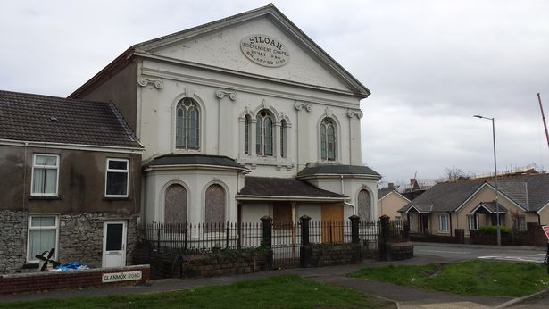
(Bannon, 2020)
The derelict building in Crown Precinct is another example of where the youth centre could open. The buildings were meant to be demolished in 2018 but are still standing today, as shown in the photo on the right. Back in the 1980s and 1990s there was a wine bar called Brannigans (Roderick, 2018), which is shown in the photo on the left. These buildings would be perfect as a youth club and support centre as they are in the town centre and have any modes of transport to access it, namely by bus or train, or by cycling and walking. As the building has many separate apartments within it, these could be used for a variety of purposes, such as, such as socialising or money advice. Young people would be able to go to the same area and feel comfortable by seeing the same people, like a second home.
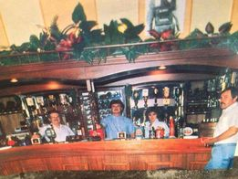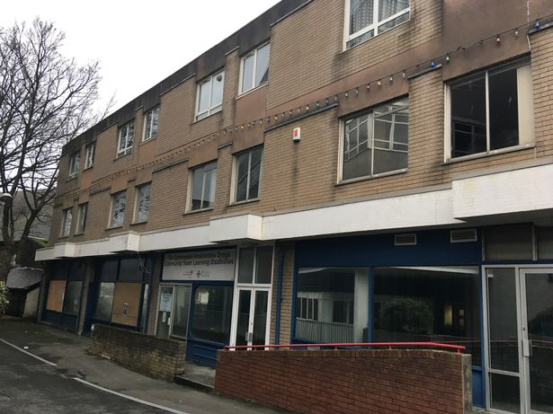
(Heidinger, 2019) (Bannon, 2020)
There are also many empty shops within the town centre, shown in the photos below; many have closed since COVID and due to a lack of support for additional funding to reopen, they have remained closed. They have remained closed as not many businesses would want to open a store in Llanelli due to the anti-social behaviour in the area. This was evident pre-covid but has become a feature of many towns across the UK, not just Llanelli.
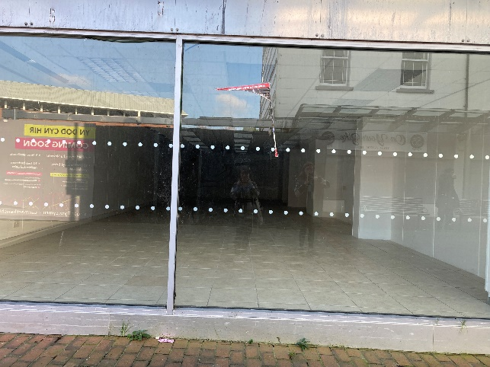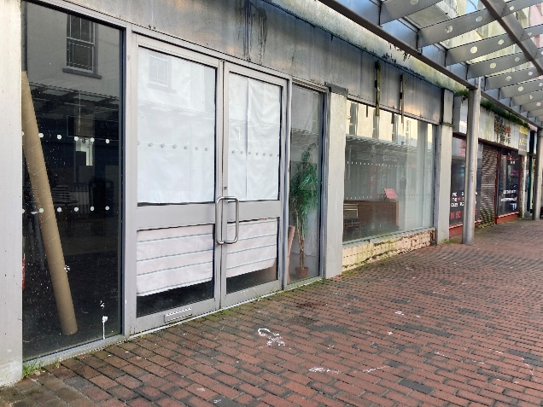
(Thieme,2023) (Thieme,2023)
By having a Support Centre in Llanelli this would allow people to access support in all areas; an example of this is help with homework/school work. Not everyone is able to receive help at home for simple tasks such as homework, but by having somewhere to go and be able to rely on an adults for help gives young people an advantage in school which will also benefit them for their career and future. According to SatsWales, there are 74,6601 pupils in Wales that have additional learning or additional needs in 2021/22, such as Autism, ADHD, Dyslexia: 98 in Nursery, 37,127 in Primary, 2,598 in Middle, 29,372 in Secondary and 5,466 in Special Schools (StatsWales, 2022). In the past 5 years more one-on-one teachers and teaching assistants have been hired by schools in order to help everyone with additional learning needs. This has been extremely beneficial for schools and children, but when homework is given to children, not everyone has the support at home; Youth Centres and Safe Spaces could do this. Since Covid a lot of children have fallen behind with their education. One of the reasons was their lack of access to digital devices - the youth centre could be equipped and resourced in order for young people to improve their digital skills
The Youth Centre would also be somewhere where young people could go to socialise, relax and feel safe rather than walking the streets and get drawn into anti-social behaviour, such as drug taking, which has been a big problem in Llanelli for decades. The centre would give them a chance to succeed in life and have hope. In 2020 there were 16 drug related deaths in Carmarthenshire, but in 2021 it went up to 21 deaths. In 2021 there were “4,859 drug poisoning deaths registered across England and Wales” (Williams, 2022).
If the centre were to open, there would be many stakeholders that would need to be considered. At the appropriate time, it would be good to introduce the media, for example, Carmarthen Journal, BBC or ITV Wales to help promote the youth centre as a drive to regenerate Llanelli. Locals, residents and youth/future generations would need to be kept informed as they would be the ones to use the centre and would have the biggest effect on. The local Government, such as local MPs, would need to be kept informed. The local council and investors would need to be managed closely as they would be able to contribute financially, which would determine the future of the centre. I may need to contact the council and hold a public meeting informing local people of the project. This will help them feel invested in the project and will get public opinion on board to support it.

Stalls in Sunken Gardens
My second idea to regenerate Llanelli is to open stalls in Sunken Gardens every Thursday and Friday, alongside the market that is already open Monday through Saturday, and the outside markets that appear every Thursday and Saturday. These stalls will allow small and local businesses to bring their products to town and enable people to purchase them in person, rather than online only. It will be more accessible and financially viable for small companies as they would need to pay on a daily basis rather than annually, this allows them to monitor their business and proffits closely and determine how long and often they decide to use the stalls. This idea will regenerate in an Urban way by opening new and unique businesses, but in the long run will also regenerate Llanelli in an economic way by bringing more money to the town.
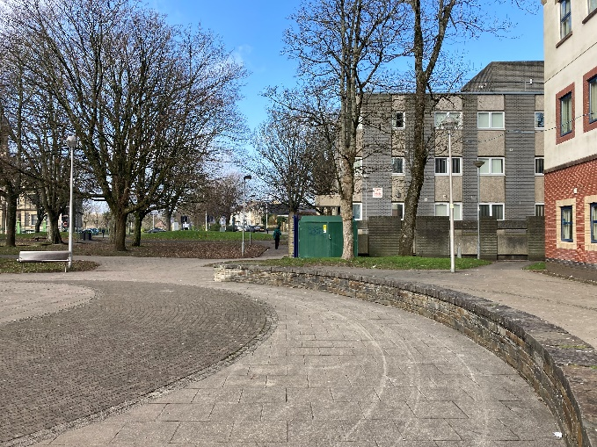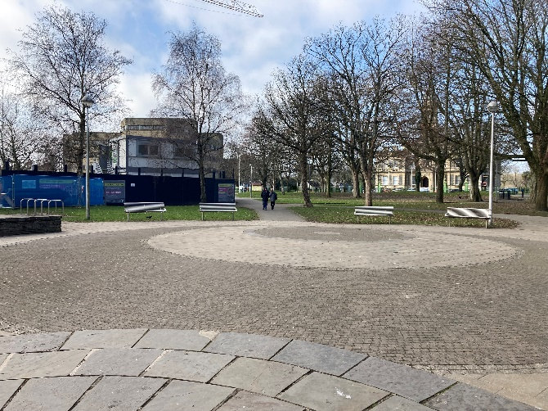
(Thieme,2023) (Thieme, 2023)
The stalls will be beneficial for may people, not only the small businesses they will be rented out to, but also to Llanelli Town itself by attracting more people and hopefully building a stronger sense of community and an improved reputation; this will then attract more companies and retailers. If some businesses using the stalls realise that their business is successful they could rent their stall for a year in advance or end up renting a building in town istelf, there are many just a few feet away from the gardens. An example of a building to rent in Llanelli is 9 Stepney Street, SA15 3YB; it would cost £47,500 a year for 4,014 square feet (Completely Retail, 2020). By renting a building it would allow businesses to store and sell more products, but not many businesses would want to risk this, making the stalls a perfect ‘trial run’.
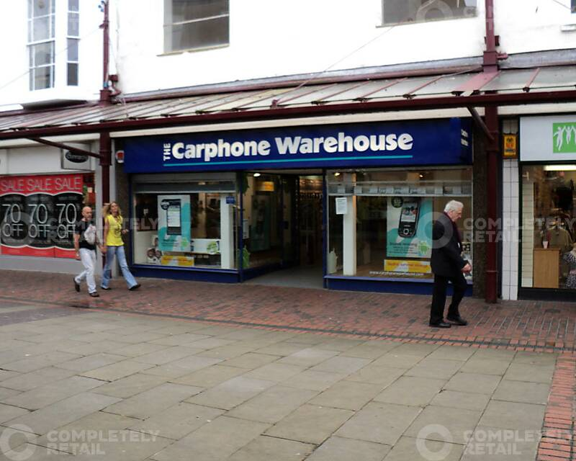
(Completely Retail,2020)
According to StatsWales, in 2022 30.2% of people in Wales were unemployed for over 12 months, and 69.8% were unemployed for less than 12 months ( StatsWales,2023). By opening more shops in Llanelli, not only will it attract more customers but also employers will need to employ staff. This regenerating idea provides an opportunity for people that have been out of work or for young people that need to gain experience in order for other companies to hire them in the future. It is often frustrating for young people when employers ask for past experience, yet the young person has not had an opportunity to gain any work experience. It will also give people a second chance in being independent by earning their own but alongside support from the Job Centre which right beside the gardens, as shown in the photo below.
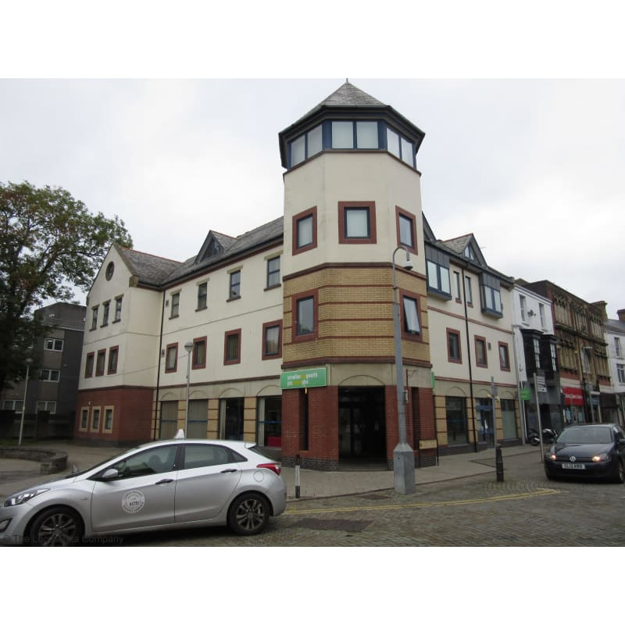
(Yellow Pages, 2013)
If these ideas were to be adopted in Llanelli, here to begin in Llanelli, there would be many Stakeholders that would need to be considered. Most importantly, young people who have interesting business ideas or those who are looking to gain work experience as well as the media, namely local newspapers, BBC and other TV channels could be brought in to promote the regeneration by reporting on its benefits to Llanelli… The public would also need to be kept informed as they would spread the word of the stalls and make or break it. There would be many people that would need to be kept informed, such as local residents and people from towns near by such as Swansea and Carmarthen would need to be persuaded of the benefits of this project. By doing this, we would be able to attract more people, meaning a higher chance of success. Local MPs would need to be encouraged to support the projects; it would be much easier to bring the idea to life with their support. The local council would need to be managed closely as they would be the point of contact in order to begin the process as it would be on public property. Investors and CEOs would also need to be Invited to participate in the project either in an advisory capacity or become directly involved as they would be able to help build the stalls themselves and be a major part of the project. In order to work closely with the Job Centre, unions would need to be on board and supportive of the scheme, particularly in relation to job creation and security

After looking at the history that shaped Llanelli to become what it is, and what Led to its downfall, it makes it clearer what needs to be done in order to bring life back to the town. By focusing on all stakeholders that would need to be considered to bring the ideas to life, it brings us one step closer to giving Llanelli the regeneration it needs and deserves. The first part of the regenerating project began in 2010 when the Furnace Theatre opened, alongside Odeon, Travelodge, Nandos, Jenkins, Costa and many more buildings available to rent (Claws, 2014). Since COVID-19, the council has focused more on the project as many businesses were forced to close due to not enough financial support. This has been a wake-up call to everyone; the council, business owners and residents of Llanelli, and has forced them to act swiftly. After listing some simple yet effective ideas that would benefit everyone involved, it just shows how easy how easy it can be to bring new ideas to the town to the town is, but acting upon them might be harder, especially without the support of the council and surrounding businesses.

Reference list
Bannon, C. (2020a). The derelict building in Crown Precinct, Llanelli. Wales Online. Available at: https://www.walesonline.co.uk/news/wales-news/empty-abandoned-buildings-llanelli-18060853. [Accessed 7 Mar. 2023].
Bannon, C. (2020b). The empty and abandoned buildings of Llanelli. [online] WalesOnline. Available at: https://www.walesonline.co.uk/news/wales-news/empty-abandoned-buildings-llanelli-18060853 [Accessed 3 Mar. 2023].
Claw (2014). CLAW | Project Database. [online] www.claw.wales. Available at: https://www.claw.wales/eng/project-database/7-ffwrnes-theatre-llanelli [Accessed 10 Mar. 2023].
Collins (2011). Regenerate. In: Collins dictionary. [online] Available at: https://www.collinsdictionary.com/dictionary/english/regenerate.
Completely Retail (2020a). Photo of Building to Rent in Llanelli Town Centre. Completely Retail. Available at: https://completelyretail.co.uk/property/41042.
Completely Retail (2020b). Shop for rent | 9 Stepney Street, 9 Stepney Street, Llanelli, SA15 3YB. [online] Completely Retail. Available at: https://completelyretail.co.uk/property/41042 [Accessed 5 Mar. 2023].
Davies, G. (2022a). Man working in Tata Steel during Industrial Revolution. Llanelli Standard. Available at: https://llanellistandard.com/the-tinplate-industry/.
Davies, G. (2022b). The Tinplate Industry | Llanelli Standard. [online] Llanelli Standard. Available at: https://llanellistandard.com/the-tinplate-industry/# [Accessed 7 Mar. 2023].
Hassan, D. (2019). The Rise Of Llanelli Through The Industrial Period | West Wales Chronicle : News for Llanelli, Carmarthenshire, Pembrokeshire, Ceredigion, Swansea and Beyond. [online] West Wales Chronicle. Available at: https://www.westwaleschronicle.co.uk/blog/2019/11/01/the-rise-of-llanelli-through-the-industrial-period/#:~:text=As%20a%20result%20of%20the [Accessed 7 Mar. 2023].
Heidinger, I. (2019). Photo of the inside of Brannigans 1985. Facebook, Memories of Llanelli group. Available at: https://www.facebook.com/memoriesofllanelli/posts/does-anyone-remember-or-have-any-photos-of-brannigans-wine-bar-behind-the-arcade/171764676267371/.
Perkins, L. (2021). The Welsh town that’s stagnated for a decade. [online] WalesOnline. Available at: https://www.walesonline.co.uk/news/wales-news/welsh-town-thats-stagnated-decade-22462745 [Accessed 8 Mar. 2023].
Roderick, O. (2018). Tales from the pubs that don’t exist anymore in Llanelli. [online] WalesOnline. Available at: https://www.walesonline.co.uk/news/wales-news/tales-pubs-dont-exist-anymore-15064968 [Accessed 3 Mar. 2023].
StatsWales (2022). Pupils with special educational needs by sector and year. [online] statswales.gov.wales. Available at: https://statswales.gov.wales/Catalogue/Education-and-Skills/Schools-and-Teachers/Schools-Census/Pupil-Level-Annual-School-Census/Special-Educational-Needs/pupilssen-by-sector-year.
StatsWales (2023). Unemployment in Wales and the UK by duration and year. [online] statswales.gov.wales. Available at: https://statswales.gov.wales/Catalogue/Business-Economy-and-Labour-Market/People-and-Work/Unemployment/ILO-Unemployment/unemploymentwalesuk-duration-year.
StreetCheck (2021). Local Crime Information for Station Road, Llanelli, Wales, SA15 1AN - November 2021. [online] StreetCheck. Available at: https://www.streetcheck.co.uk/crime/sa151an/2021/11.
Thieme, K. (2023a). Closed shops in Llanelli. Photo taken in Llanelli.
Thieme, K. (2023b). Photo of Sunken Gardens, Llanelli. Photo taken in Llanelli.
Williams, K. (2022). More drug deaths recorded in Carmarthenshire last year. [online] Tenby Observer. Available at: https://www.tenby-today.co.uk/news/more-drug-deaths-recorded-in-carmarthenshire-last-year-558323 [Accessed 3 Mar. 2023].
Yellow Pages (2013). Job Centre in Llanelli. Yellow Pages.

