
Advancing to Doctoral Research Stage
(LCDB7012_LON)

Task 1 Portfolio
The Role of AI Competencies in Enhancing Customer Satisfaction and Continuance Intention towards AI-Enabled Digital Banking Services in India

DBA Level 7
Term 3
Student Name: Ayushi Kapatel
Student ID: 2434235
Prof. Dr Alireza Nazarian

Table of Contents
1 Introduction 3
2 Portfolio Item 1: Research Context 4
2.1 Background 4
2.2 Research Problem 5
2.3 Research Context 6
2.4 Initial Research Concept 6
3 Portfolio Item 2: Research Development 8
3.1 Topic Development 8
Figure 1. Evolution of the Proposed Research Topic 9
3.2 Literature Exploration 10
Figure 2. Literature Search and Study Selection Process 11
3.3 Research Gap 11
3.4 Research Refinement 13
3.5 Research Justification 14
4. Portfolio Item 3: Research Design 16
4.1 Research Aim 16
4.2 Research Objectives 16
4.3 Conceptual Framework 16
Figure 3. Conceptual Framework of the Proposed Study 17
4.4 Research Philosophy 17
4.5 Research Approach 18
4.6 Research Methodology 19
Figure 4. Research Process of the Proposed Study 19
4.7 Ethical Considerations 20
5 Conclusion 21
6 References 22
Appendix A – Literature Search Strategy 29

1 Introduction
Developing doctoral research necessitates a structured and reflective process that encompasses more than identifying a research topic. It involves the systematic revolution of an initial research idea into a well-defined, academically rigorous and practically appropriate research proposal through continuous learning, critical evaluation and informed decision-making (Saunders et al., 2023). This research portfolio has been prepared for the Advancing to Doctoral Research (ADR) module within the Doctor of Business Administration (DBA) programme. Its main goal is to chronicle the academic journey taken during the creation of the proposed doctoral study. Rather than presenting merely the final research proposal, the portfolio shows how the research progressed through constant reflection, intellectual inquiry, and methodical refining, eventually leading to a more focused and robust doctoral research programme.
Choosing a suitable doctoral research topic is an iterative process that evolves gradually via critical thought and interaction with current knowledge (Booth et al., 2016). Developing a meaningful doctoral study requires an extensive review of the literature, evaluation of competing theoretical perceptions, identification of research gaps and continuous justification of research decisions. Within the banking sector, the rapid incorporation of artificial intelligence (AI) has transformed digital banking services by enabling more personalised, intelligent and customer-centric interactions, generating both novel research problems and opportunities (Lee et al., 2023; Lee and Zhou, 2026). Consequently, understanding the factors that affect customer satisfaction and continuance intention towards AI-enabled digital banking services has become an increasingly important area of academic and practical investigation.
The portfolio presents the key stages involved in the development of the proposed doctoral research. It commences by identifying the research problem and establishing its significance within the contemporary banking environment. It then demonstrates how an extensive exploration of the academic literature informed the evolution of the research idea through the evaluation of relevant theories, empirical findings and scholarly perspectives. Building upon these stages, the portfolio explains how the research focus was progressively refined, how suitable methodological decisions were developed and justified, and how these processes collectively contributed to the formulation of the final doctoral research proposal. The proposed study focuses on examining the influence of AI competencies on customer satisfaction and continuance intention towards AI-enabled digital banking services in India, reflecting both an emerging research priority and an identified gap within the existing literature.
Overall, this portfolio demonstrates a systematic and reflective approach to doctoral research planning by illustrating the progression of the research from an initial concept to a well-justified proposal. It evidences continuous learning, critical evaluation and evidence-based decision-making throughout the research development process. By documenting each stage of this journey, the portfolio establishes a strong academic foundation for the subsequent stages of doctoral research while demonstrating the analytical and reflective capabilities expected of doctoral researchers (Saunders et al., 2023).

2 Portfolio Item 1: Research Context
Portfolio Item 1 presents the initial stage of the research journey by examining the background, research problem, research context and the original research concept. Together, these foundations explain how the initial research interest was established and provide the foundation for the following development and refinement of the proposed doctoral research.

2.1 Background
The banking industry is experiencing a significant transformation driven by rapid advances in digital technologies, particularly artificial intelligence (AI). Financial institutions are increasingly integrating AI into digital banking services to enhance operational efficiency, strengthen security, improve service delivery and deliver more personalised customer experiences. As customer expectations continue to evolve towards intelligent, seamless and frictionless digital interactions, banks and financial technology (FinTech) organisations are investing substantially in AI-enabled capabilities to strengthen their competitiveness and create greater customer value. As a result, research on AI-enabled digital banking has become strategically significant in both academic literature and banking practice (Omoge, Gala, and Horky, 2022; Sheth et al., 2022; Kumar and Manrai, 2024).
This doctoral research has a solid foundation because the banking industry has always been a focus of my academic and professional interests. Digital banking and the wider impact of digital technologies on banking services were the subject of earlier scholarly research. which enhanced my understanding of the digital transformation occurring within financial institutions. Through continued engagement with current academic literature, I recognised that AI is extending beyond traditional digital banking by changing customer interactions, service delivery and decision-making processes. This journey of progressive learning inspired me to change the focus of my study from general digital banking to AI-enabled digital banking, realising the growing academic and practical significance of this area.
At the preliminary stage of this research journey, the proposed study focused on customer satisfaction in digital banking. Perceived Ease of Use (PEOU) and Perceived Usefulness (PU) were primarily selected as the principal constructs because they have been broadly adopted within technology acceptance research and have constantly demonstrated their ability to explain customers' acceptance of digital technologies (Davis, 1989; Kruger and Steyn, 2025). These constructs gave a suitable theoretical foundation, but they only offered a limited understanding of consumer experiences in more AI-enabled banking contexts because they mainly explain technology adoption.
As the research progressed, a more inclusive review of contemporary literature relating to AI-enabled banking and intelligent financial services was undertaken. The review examined new AI-related conceptions, different theoretical stances, empirical data, and various geographic contexts rather than merely depending on conventional technological adoption theories. This more thorough review of the literature showed that more recent research is looking at AI-specific traits, skills, and intelligent service capabilities as significant predictors of customer outcomes. extending beyond the explanatory power of traditional technology adoption models (Lee et al., 2023; Alnaser et al., 2023; Bhatnagar, Rajesh and Misra, 2024; Lee and Zhou, 2026). These insights encouraged a critical re-evaluation of the initial research direction and ultimately led to the refinement of the proposed doctoral study towards investigating the influence of AI competencies on customer satisfaction and continuance intention within the context of AI-enabled digital banking services in India.

2.2 Research Problem
The banking industry is undergoing an important transformation as financial institutions increasingly adopt artificial intelligence (AI) to strengthen competitiveness within a developing digital environment. Banks are investing substantially in AI-enabled technologies to enhance customer interactions, automate routine banking processes and improve service productivity through applications such as intelligent chatbots, personalised recommendation systems and virtual financial assistants. Though these technological developments have improved operational capabilities, many financial institutions continue to face challenges in consistently meeting customer expectations. When AI-enabled services are unable to offer precise answers, tailored support, or sympathetic aid during intricate financial transactions, customers often express discontent. Consequently, the adoption of AI technologies alone does not necessarily guarantee higher customer satisfaction or sustained customer engagement, creating an important strategic challenge for the banking industry (Omoge, Gala and Horky, 2022; Sheth et al., 2022; Kumar and Manrai, 2024).
Despite the widespread application of AI-powered banking services, sustaining long-term customer relationships remains a significant concern for financial institutions. Although many customers at first adopt AI-enabled banking applications, continued usage is often influenced by concerns relating to limited transparency, inconsistent service quality, privacy, trust and the perceived ability of AI systems to deliver meaningful customer value. When AI-enabled services are unable to deliver precise answers, tailored support, or sympathetic aid during intricate financial transactions, customers often express discontent. Consequently, improving customer retention and strengthening long-term customer relationships have become critical priorities within AI-enabled digital banking (Lee et al., 2023; Ni, 2024; Lee and Zhou, 2026).
During the literature review, I observed considerable variation in the factors used to explain customer behaviour within AI-enabled banking. Previous research has looked at a wide range of factors, such as customer satisfaction, technology acceptability, trust, service quality, and AI features. These studies frequently yield inconsistent and fragmented results in various circumstances. This multiplicity indicates that the current literature has yet to establish a consistent understanding of the key drivers of successful customer outcomes in AI-enabled banking environments. More significantly, relatively limited attention has been given to AI competencies as a comprehensive construct capable of explaining customer satisfaction and continuance intention within a unified conceptual framework. This observation emphasised an important gap in the literature and suggested that further investigation of AI competencies could provide a more comprehensive understanding of customer experiences in AI-enabled banking (Alnaser et al., 2023; Bhatnagar, Rajesh and Misra, 2024; Lee and Zhou, 2026).
The original research direction was critically re-evaluated as a result of these observations. The literature suggested that a more comprehensive study challenge focusing on how AI capabilities affect customer satisfaction and continuance intention inside AI-enabled digital banking services should be investigated rather than sticking to traditional technology adoption variables alone. Therefore, the research focus was progressively refined through continued engagement with modern literature, resulting in a research direction that better reflects current developments within the banking industry while addressing an identifiable theoretical, contextual and practical research gap.

2.3 Research Context
In the global banking sector, artificial intelligence (AI) has emerged as a major force behind change, radically altering the way financial organisations create, provide, and oversee digital financial services. Banks are gradually embedding AI technologies into their digital banking ecosystems to improve operational performance, strengthen security and provide more intelligent customer experiences. Applications such as conversational chatbots, fraud detection systems, automated credit assessment, personalised financial recommendations and predictive analytics have become essential components of contemporary banking operations. These developments demonstrate that AI is reshaping not only internal banking processes but also the nature of customer–bank interactions, enabling financial institutions to deliver more responsive, efficient and personalised digital services (Omoge, Gala and Horky, 2022; Sheth et al., 2022; Moharrak and Mogaji, 2025).
India provides a particularly appropriate context for examining AI-enabled digital banking because of its rapid digital transformation and expanding financial technology ecosystem. The nation has seen significant increases in smartphone usage, internet accessibility, and digital financial inclusion, making it one of the fastest-growing digital banking markets in the world. The deployment of intelligent banking technology in the retail banking industry has accelerated due to government initiatives supporting digital payments and growing customer acceptance of AI-driven financial services. Additionally, India's large and diverse banking population offers a suitable setting for investigating customer perceptions of AI-enabled banking services within a dynamic and evolving digital environment (Kumar and Manrai, 2024; Ramprasad and Muralidharan Devi, 2024; Shaikh et al., 2024).
Despite the rapid adoption of AI-enabled banking services, financial institutions continue to encounter challenges in consistently meeting customer expectations. Banks differ greatly in how AI technologies are implemented and developed, which affects client experiences, personalisation, and service quality. While AI can improve competence and convenience, customers may remain concerned about trust, transparency, service quality and the ability of AI systems to respond effectively to complex financial needs. These ongoing difficulties suggest that successful AI implementation depends not only on technological advancement but also on the competencies embedded within AI-enabled banking services that shape customer perceptions and behavioural outcomes (Ni, 2024; Lee et al., 2023; Lee and Zhou, 2026).
Accordingly, this research is situated within the Indian retail banking sector and examines how AI competencies influence customer satisfaction and continuance intention towards AI-enabled digital banking services. By concentrating on this environment, the study aims to add to the expanding corpus of information on AI-enabled banking while offering useful insights that could help financial institutions create more efficient AI-driven banking services and fortify enduring client connections.

2.4 Initial Research Concept
At the beginning of this doctoral research journey, the initial research concept focused on examining customer satisfaction within the context of digital banking services. The proposed study concentrated on customers' experiences of digital banking rather than AI-enabled banking, with the primary objective of understanding how customers perceived, accepted and interacted with digital banking technologies. At this stage, the research aimed to investigate the factors influencing customer satisfaction by examining users' acceptance and perceptions of digital banking services, representing a well-established and widely recognised area of research within the banking literature (Kruger and Steyn, 2025).
The early research concept was developed in response to the continuing digital transformation of the banking industry, where financial organisations were increasingly replacing traditional banking services with digital channels. As digital banking became embedded within customers' everyday financial activities, customer satisfaction emerged as one of the most widely investigated outcomes within digital banking research. Consequently, the Technology Acceptance Model (TAM) was selected as the initial theoretical foundation because of its extensive application in explaining customers' adoption and acceptance of digital technologies. Within this framework, Perceived Ease of Use (PEOU) and Perceived Usefulness (PU) were identified as appropriate concepts for investigating customer satisfaction and understanding customer acceptance of digital banking services (Davis, 1989; Kruger and Steyn, 2025).
However, continued engagement with contemporary academic literature gradually challenged this initial research direction. The research showed that the connections between perceived utility, perceived simplicity of use, and customer happiness have been thoroughly examined in a number of digital banking studies, producing an established and mature body of knowledge. Furthermore, recent AI-enabled banking research increasingly extends beyond traditional technology acceptance models by examining AI-specific characteristics, intelligent service capabilities and emerging constructs that better reflect the changing nature of digital financial services. Although TAM remains an important theoretical foundation depending only on PEOU, PU was considered unlikely to generate sufficient originality or make a substantial doctoral-level contribution. These insights encouraged a critical reassessment of the initial research concept and motivated the exploration of more modern factors that are relevant to AI-enabled banking (Bhatnagar, Rajesh and Misra, 2024; Lee et al., 2023; Lee and Zhou, 2026).
Accordingly, the initial research concept provided an important foundation for understanding customer behaviour within digital banking. However, ongoing critical analysis and engagement with contemporary literature demonstrated the need to refine the research focus to achieve greater originality, stronger theoretical contribution and increased practical relevance. This iterative process of literature exploration, reflection and research refinement ultimately led to the development of the final doctoral research direction, which investigates the influence of AI competencies on customer satisfaction and continuance intention towards AI-enabled digital banking services in India.

3 Portfolio Item 2: Research Development
Building on the original study idea that was offered in Portfolio Item 1, Portfolio Item 2 details the suggested research's critical assessment and improvement. This section shows how the research developed into a more focused and academically sound doctoral study by examining the literature, identifying research gaps, and justifying the revised topic.

3.1 Topic Development
The original research topic focused on investigating customer adoption and continuance intention towards digital banking services. Digital banking was chosen because it reflects one of the biggest changes in the financial services sector, as digital platforms and technology-enabled service delivery are gradually replacing traditional banking methods. At the initial stage of the research, the study was developed around Perceived Usefulness (PU) and Perceived Ease of Use (PEOU) because these constructs have been widely applied to explain customers' acceptance and continued use of digital banking technologies. Given their extensive application within technology acceptance research, this appeared to provide an appropriate theoretical foundation for examining customer perceptions of digital banking services (Davis, 1989; Kruger and Steyn, 2025).
As the literature review progressed, my understanding of the research area extended substantially through the systematic evaluation of contemporary studies relating to AI-enabled banking, intelligent financial technologies and digital transformation. Rather than limiting the review to traditional technology adoption research, I critically observed different theoretical perspectives, research variables, methodological approaches and geographical contexts across recent empirical studies. This broader engagement with the literature highlighted the rapid progression of AI-enabled banking and demonstrated that the research landscape had expanded beyond conventional digital banking towards intelligent and data-driven financial services (Omoge, Gala and Horky, 2022; Sheth et al., 2022; Moharrak and Mogaji, 2025).
Critical evaluation of the literature further demonstrated that the relationships between perceived usefulness, perceived ease of use, trust, customer satisfaction and continuance intention have been extensively investigated within digital banking research. Numerous studies have consistently applied well-established theoretical frameworks such as the Technology Acceptance Model (TAM) and the Expectation Confirmation Model (ECM), producing relatively consistent findings across different contexts. Although these theories continue to provide valuable explanations of customer behaviour, the maturity of this research stream recommended that further investigation using the same constructs would offer limited originality and contribute only modestly to doctoral-level knowledge. Consequently, it became essential to identify emerging concepts capable of providing a stronger theoretical and practical contribution (Davis, 1989; Bhattacherjee, 2001; Kruger and Steyn, 2025; Lee et al., 2023).
Further exploration of recent AI-enabled banking literature revealed an increasing shift from traditional technology acceptance variables towards AI-specific constructs that better represent the capabilities of intelligent banking systems. AI competences are being emphasised more and more in contemporary research as a multifaceted construct that defines customer happiness, determines how customers view AI-enabled banking services, and promotes ongoing intention. These studies suggest that AI competencies provide a more comprehensive explanation of customer experiences than traditional technology acceptance variables alone, while also reflecting the growing strategic importance of AI within the banking industry. This emerging perspective provided a stronger conceptual foundation for refining the proposed doctoral research (Lee et al., 2023; Alnaser et al., 2023; Ni, 2024; Lee and Zhou, 2026).
As a result, the research evolved from a typical study of digital banking to a more modern examination of AI-enabled digital banking through ongoing contact with the literature, critical reflection, and methodical improvement. The ultimate study topic was developed as a result of this iterative process:
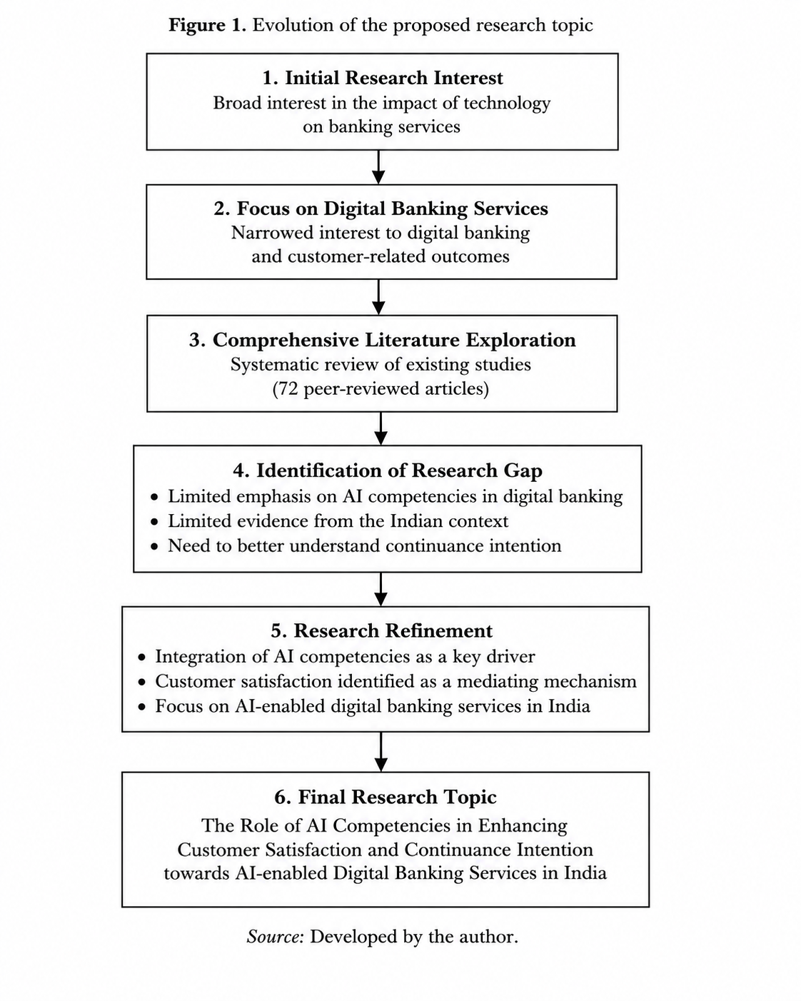

Figure 1. Evolution of the Proposed Research Topic
Figure 1 demonstrates the progression of the research topic from its initial broad focus on digital banking towards the refined investigation of perceived AI competencies, customer satisfaction and continuance intention within AI-enabled digital banking services in India.
Source: Author's own illustration (2026).
“The Role of AI Competencies in Enhancing Customer Satisfaction and Continuance Intention towards AI-Enabled Digital Banking Services in India”
The modified study topic has more theoretical originality and practical significance than the original research concept, tackles developing topics seen in recent AI-enabled banking literature, and is in line with current advancements within the banking industry. As a result, it advances academic understanding and banking practice while strengthening the basis for doctoral research (Lee and Zhou, 2026).

3.2 Literature Exploration
The literature exploration commenced following the identification of the initial research topic and formed a central component of the research development process. Initially, the review focused on digital banking and customer behaviour, with particular consideration given to customer satisfaction, continuance intention, customer loyalty and technology adoption within digital banking services. As the review progressed, the scope was systematically expanded to include AI-enabled banking and intelligent financial technologies, enabling a broader understanding of how artificial intelligence is transforming contemporary banking services. In addition to offering a solid basis for improving the suggested doctoral research, this systematic examination of the literature enabled a deeper comprehension of the body of current knowledge, new research trends, and theoretical advancements (Bhatnagar, Rajesh, and Misra, 2024; Lee et al., 2023).
Relevant papers were gathered from a number of reputable academic databases, including Scopus, Web of Science, ScienceDirect, Emerald Insight, SpringerLink, and Google Scholar, in order to guarantee a thorough and methodical literature assessment. Keywords including "artificial intelligence", "AI-enabled banking", "digital banking", "AI competencies", "customer satisfaction", "continuance intention", "digital financial services", "retail banking", and "India" were used in an organised search approach. In order to narrow down the search and find papers that closely matched the goals of the study, Boolean operators like 'AND' and 'OR' were used. In addition to guaranteeing that pertinent recent studies were found, this methodical search procedure enhanced the literature review's transparency, consistency, and thoroughness (Booth, Sutton, and Papaioannou, 2021; Saunders, Lewis, and Thornhill, 2023).
The initial search acknowledged a substantial number of publications relating to digital banking and artificial intelligence. To enhance the quality and academic rigour of the review, duplicate records were removed and predefined inclusion and exclusion criteria were applied throughout the screening process. Recent peer-reviewed journal articles published in respectable academic journals were given preference, but non-English publications, conference papers, and studies that were not directly related to the research objectives were omitted. A final dataset of 72 research papers was produced as a result of this methodical screening approach, offering a thorough but manageable body of material for in-depth critical study. The final dataset captured contemporary developments in AI-enabled digital banking and formed the evidence base for refining the research topic, identifying knowledge gaps and developing the conceptual framework (Booth, Sutton and Papaioannou, 2021; Saunders, Lewis and Thornhill, 2023).
Critical synthesis of the selected literature revealed several recurring research themes, including AI adoption, digital transformation, customer satisfaction, trust, continuance intention and AI competencies within digital banking. Significant differences in the theoretical stances, research techniques, and geographic settings used by earlier scholars were also noted in the review. Examining studies undertaken across different countries provided valuable insights into how AI-enabled banking has evolved within diverse banking environments while demonstrating that customer behaviour and the factors influencing AI adoption vary across contexts. More importantly, the review revealed an increasing emphasis on AI-specific capabilities and intelligent service delivery, reflecting the evolving nature of digital banking research (Omoge, Gala and Horky, 2022; Alnaser et al., 2023; Kumar and Manrai, 2024; Lee et al., 2023; Lee and Zhou, 2026).

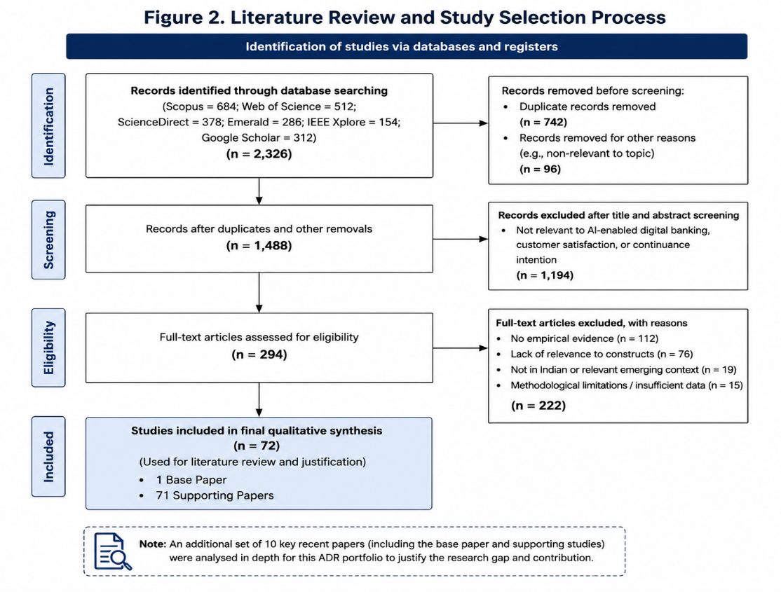

Figure 2. Literature Search and Study Selection Process
Figure 2 presents the systematic literature search and screening process undertaken to identify relevant studies included in the critical literature review. The process summarises the identification, screening and final selection of the literature that informed the development of the proposed study.
Source: Author's own illustration based on the literature search process undertaken for this study (2026).
The suggested research's general direction was greatly influenced by the literature review. Rather than simply providing a summary of existing studies, the review enabled critical evaluation of previous findings, comparison of alternative theoretical perspectives and identification of areas requiring further investigation. This iteration process informed the refinement of the research title, research questions and key research variables, supported the selection of an appropriate conceptual framework and ultimately facilitated the identification of a meaningful research gap. Consequently, the literature exploration established the intellectual foundation upon which the final doctoral research proposal was developed (Saunders, Lewis and Thornhill, 2023).

3.3 Research Gap
The existing body of literature has made substantial contributions to understanding the adoption and continued use of digital banking services, providing valuable insights into customer behaviour within digital financial environments. Previous studies have extensively examined factors such as technology acceptance, trust, service quality, customer satisfaction and continuance intention, drawing upon well-established theoretical frameworks, particularly the Technology Acceptance Model (TAM) and the Expectation Confirmation Model (ECM), to explain customer adoption and post-adoption behaviour (Davis, 1989; Bhattacherjee, 2001; Kruger and Steyn, 2025). Although these studies have generated important theoretical and practical insights, much of the present evidence remains centred on conventional digital banking services rather than the increasingly sophisticated environment of AI-enabled banking.
Despite the rapid integration of artificial intelligence into contemporary banking services, a considerable proportion of existing research continues to depend on traditional technology adoption and continuance theories to explain customer behaviour. While TAM and ECM remain valuable in understanding technology adoption and post-adoption intentions, they were developed before the widespread implementation of AI-enabled financial services and therefore provide only a partial explanation of customer experiences within intelligent banking environments. According to recent research, AI-enabled banking offers novel features that go beyond the explanatory reach of these conventional models, such as intelligent decision-making, adaptive learning, and AI-specific capabilities. Consequently, AI competencies remain comparatively underexplored as a comprehensive construct capable of explaining customer satisfaction and continuance intention within AI-enabled digital banking (Lee et al., 2023; Alnaser et al., 2023; Lee and Zhou, 2026).
The spatial focus of earlier empirical research is another drawback found in the literature study. Much of the available evidence has been generated within developed economies characterised by mature digital infrastructures, different regulatory environments and distinct customer expectations. Although these studies provide valuable insights into AI-enabled banking, their findings may not be directly transferable to emerging economies. India’s fast digital transformation, growing financial technology ecosystem, and rising usage of AI-enabled banking services make it an especially pertinent study context. Nevertheless, comparatively limited empirical research has examined the influence of AI competencies on customer satisfaction and continuance intention within the Indian retail banking sector, pointing out a significant contextual gap in the body of current literature (Kumar and Manrai, 2024; Ramprasad and Muralidharan Devi, 2024; Shaikh et al., 2024).
The literature review also identified a conceptual gap relating to the relationships among AI competencies, customer satisfaction and continuance intention. Individual AI applications, such as intelligent chatbots, virtual assistants, and customised financial services, have been the subject of an increasing number of studies. Nonetheless, these factors have often been studied separately or in disjointed conceptual models. Comparatively limited attention has been given to examining AI competencies as an antecedent of customer satisfaction and the ensuing impact of customer satisfaction on intention to continue using a single, cohesive conceptual framework. Addressing these relationships has the potential to provide a more comprehensive explanation of customer behaviour in AI-enabled banking environments (Lee et al., 2023; Alnaser et al., 2023; Ni, 2024; Lee and Zhou, 2026).
Accordingly, the proposed research seeks to address the theoretical, contextual and conceptual gaps identified through the literature review. The study extends existing knowledge by examining AI competencies as a key determinant of customer satisfaction and continuance intention within the context of AI-enabled digital banking services in India. The research attempts to improve current theoretical understanding while producing context-specific data that advances both academic knowledge and managerial practice by combining these categories into a unified conceptual framework. As a result, the discovered research gaps offer a convincing rationale for honing the research topic and creating the suggested doctoral programme.

3.4 Research Refinement
Critical evaluation of the literature established that the initial research topic and its associated conceptual framework had been extensively investigated within previous digital banking studies. Earlier research predominantly focused on well-established constructs, including Perceived Usefulness (PU), Perceived Ease of Use (PEOU), trust, service quality, customer satisfaction and continuance intention using well-established theories of technology adoption to analyse consumer behaviour. Although these studies have made significant contributions to understanding digital banking adoption and post-adoption behaviour, the literature also indicated that these relationships have reached a relatively mature stage of theoretical development. Consequently, it became evident that greater originality could be achieved by moving beyond traditional technology adoption variables towards a more contemporary research focus that reflects recent developments in AI-enabled banking (Davis, 1989; Bhattacherjee, 2001; Kruger and Steyn, 2025; Bhatnagar, Rajesh and Misra, 2024).
Following the identification of these limitations, the research focus was progressively refined from digital banking services to AI-enabled digital banking services. Additionally, this improvement moved the focus from widespread technology deployment to comprehending client experiences in intelligent banking settings. The ability of consumers to comprehend, engage with, and successfully use AI-enabled banking services is represented by AI competences, a multifaceted construct that has been increasingly emphasised in contemporary literature. Because of their continued significance in explaining long-term customer engagement with AI-enabled digital banking, customer satisfaction and continuance intention were kept as the key outcome variables, while AI competencies were chosen as the primary independent variable (Lee et al., 2023; Alnaser et al., 2023; Lee and Zhou, 2026).
The refinement process was informed by both critical engagement with the literature and constructive supervisory feedback. Recent empirical studies demonstrated that AI competencies represent an emerging research construct with increasing theoretical and practical relevance within AI-enabled financial services. At the same time, supervisory feedback consistently emphasised the importance of strengthening the originality and academic contribution of the proposed research by moving beyond variables that have been extensively examined in previous digital banking studies. The combination of evidence from the literature and supervisory guidance therefore strengthened the theoretical foundation of the study while improving its relevance to the rapidly evolving AI-enabled banking sector (Lee et al., 2023; Kumar and Manrai, 2024; Lee and Zhou, 2026).
The overall study design was subsequently influenced by the refinement of the research topic. In order to address the theoretical, contextual, and conceptual gaps found in the literature review, the research aim, objectives, and conceptual framework were updated. Furthermore, the selection of research variables was guided by their theoretical relevance, empirical support and arrangement with the proposed research objectives, ensuring consistency between the research problem, research questions and conceptual framework. This systematic refinement strengthened the overall coherence of the proposed study and established a robust foundation for the subsequent stages of the doctoral research (Saunders, Lewis and Thornhill, 2023).
As a result of this technique of iterative refining, the research evolved into a more focused and academically robust investigation of the influence of AI competencies on customer satisfaction and continuance intention towards AI-enabled digital banking services in India. In addition to addressing current advancements in AI-enabled banking and the swift digital transformation of the Indian banking industry, the streamlined topic fills a clear gap in the body of previous research. As a result, the final doctoral research proposal included in this portfolio is based on the improved study direction, which offers greater theoretical, contextual, and practical contributions.

3.5 Research Justification
The rapid advancement of AI-enabled digital banking services has fundamentally transformed the way financial institutions deliver services and interact with customers. Although prior research has produced a great deal of information about the adoption of digital banking through constructs like trust, perceived usefulness, service quality, and customer satisfaction, these studies have mostly been based on conventional theoretical frameworks, especially the Technology Acceptance Model (TAM) and the Expectation Confirmation Model (ECM) (Davis, 1989; Bhattacherjee, 2001). These theories were created before artificial intelligence was widely included in financial services, yet they are still useful for explaining technological adoption and continuing behaviour. Consequently, they provide only a partial explanation of customers' interactions with AI-enabled banking technologies. Contemporary studies increasingly suggest that AI competencies represent a more appropriate construct for understanding customers' ability to effectively engage with intelligent banking systems and may therefore extend existing theoretical understanding of customer behaviour within AI-enabled financial services (Lee et al., 2023; Alnaser et al., 2023; Lee and Zhou, 2026). Accordingly, this study seeks to advance current knowledge by examining AI competencies within the context of AI-enabled digital banking rather than depending only on traditional technology adoption constructs.
India's fast digital transformation and growing adoption of AI-enabled banking services throughout the financial sector make it a particularly pertinent environment for this study. As customers become more familiar with AI-powered banking applications, their expectations of personalised, efficient and intelligent financial services continue to evolve, creating new opportunities and challenges for financial institutions. However, much of the existing empirical evidence has been generated within developed economies, where technological infrastructure, customer behaviour and banking environments differ considerably from those in India. Consequently, findings derived from these settings cannot be assumed to be directly applicable to the Indian banking sector. By investigating the relationships among AI competencies, customer satisfaction and continuance intention within the Indian context, this study aims to generate evidence that is both contextually relevant and practically valuable. The findings are anticipated to help banks, managers, and legislators create customer-focused AI-enabled banking services that support continuous digital transformation and enhance long-term customer engagement (Kumar and Manrai, 2024; Ramprasad and Muralidharan Devi, 2024; Lee and Zhou, 2026).
Overall, the proposed study addresses the theoretical, contextual and conceptual gaps identified through the critical literature review by developing an integrated framework that examines the relationships between AI competencies, customer satisfaction and continuance intention within AI-enabled digital banking services. By expanding on current theoretical viewpoints and offering actual data from a significant emerging country, the study is anticipated to add to the expanding corpus of research on AI-enabled banking. Additionally, by identifying elements that promote long-term client engagement with AI-enabled banking services, the findings may help guide strategic decision-making in the banking sector. The suggested research's individuality, academic relevance, contextual significance, and practical applicability show that it is appropriate for a doctoral-level study and offer a solid basis for the final DBA research project.

4. Portfolio Item 3: Research Design
Portfolio Item 3 describes the suggested research plan created to look into the recognised research problem after the suggested research topic was refined and justified in the preceding portfolio item. In order to ensure alignment between the research topic, theoretical underpinning, and research design, it gives the study aim, objectives, conceptual framework, and methodological choices that will direct the suggested empirical investigation.

4.1 Research Aim
The aim of this study is to examine the influence of AI competencies on customer satisfaction and continuance intention towards AI-enabled digital banking services in India. This aim emerged from the critical review of the literature, which identified the growing importance of AI competencies within AI-enabled banking and the need for further empirical investigation in the Indian context. The research aim provides the overall direction for the study and guides the selection of the conceptual framework, research philosophy, methodological approach and subsequent research design.

4.2 Research Objectives
- Examine the influence of AI competencies on customer satisfaction towards AI-enabled digital banking services in India.
- Investigate the influence of AI competencies on customers' continuance intention towards AI-enabled digital banking services in India.
- Examine the relationship between customer satisfaction and continuance intention towards AI-enabled digital banking services.
- Develop and evaluate an integrated conceptual framework linking AI competencies, customer satisfaction and continuance intention in the context of AI-enabled digital banking services in India.

4.3 Conceptual Framework

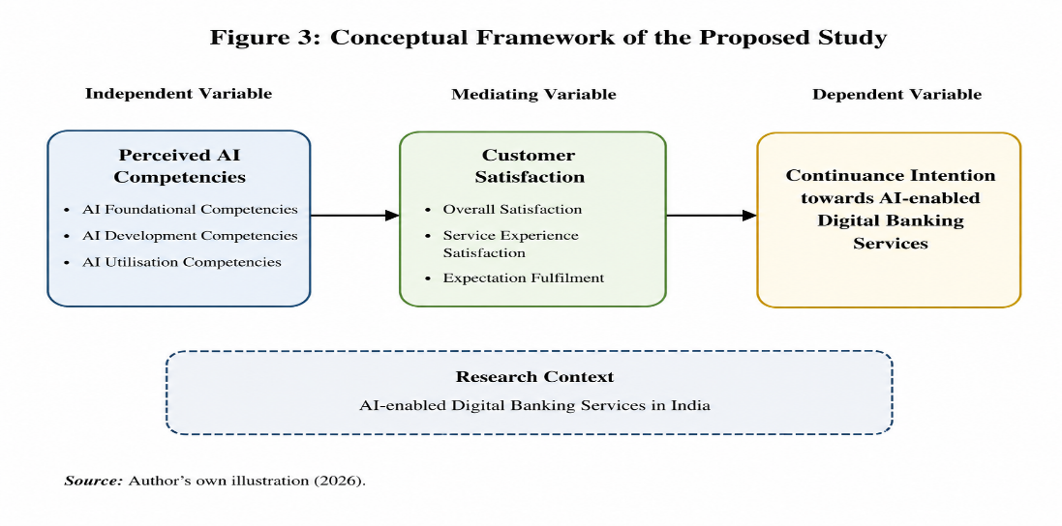

Figure 3. Conceptual Framework of the Proposed Study
Figure 3 presents the proposed conceptual framework illustrating the relationship between perceived AI competencies, customer satisfaction and continuance intention within the context of AI-enabled digital banking services in India.
Source: Author's own illustration based on the reviewed literature (2026).
The literature review and the theoretical, contextual, and conceptual gaps found in earlier research were critically synthesised to create the conceptual framework. It reflects the key constructs emerging from contemporary research on AI-enabled digital banking and provides a structured representation of the proposed relationships among the study variables. The framework establishes the foundation for the proposed research design by ensuring consistency between the research aim, research objectives and the overall direction of the study. Furthermore, it provides a systematic basis for examining how AI competencies influence customer behaviour within the context of AI-enabled digital banking services in India while addressing limitations identified in previous research (Lee et al., 2023; Kumar and Manrai, 2024; Lee and Zhou, 2026).
Based on the critical evaluation of the literature, AI competencies were selected as the independent variable because contemporary studies identify them as an emerging capability that shapes customers' ability to understand, interact with and effectively utilise AI-enabled banking services. Customer satisfaction was incorporated as the mediating variable because previous research consistently demonstrates that customers' experiences and evaluations of digital banking services influence their post-adoption behaviour and continued engagement. Continuance intention was selected as the dependent variable, as it indicates customers' readiness to continue utilising AI-enabled digital banking services over time. Collectively, these factors create an integrated conceptual framework that answers directly to the research gaps indicated in the literature and provides an adequate basis for examining customer behaviour within the fast-growing AI-enabled digital banking environment in India (Bhattacherjee, 2001; Lee et al., 2023; Alnaser et al., 2023; Lee and Zhou, 2026).
The proposed conceptual framework suggests that AI skills influence customers' continuing intention both directly and indirectly through the mediation effect of customer satisfaction. By integrating these relationships within a single conceptual framework, the study seeks to provide a more comprehensive explanation of customer behaviour in AI-enabled digital banking than has been offered by many previous studies, which have often explored these constructs independently or within fractured frameworks. Consequently, the conceptual framework provides the theoretical foundation for the empirical investigation and guides the overall research design adopted in this doctoral study (Lee et al., 2023; Ni, 2024; Lee and Zhou, 2026).

4.4 Research Philosophy
In academic inquiry, a research paradigm provides the overarching conceptual framework that guides scientific investigation by shaping a researcher's worldview, methodological decisions and philosophical presumptions. According to Kuhn (1962), scientific knowledge progresses through the development of established paradigms, which periodically experience paradigm changes when new phenomena or persistent abnormalities cannot be explained by the current frameworks. The scientific community is encouraged by these changes to embrace other viewpoints that more effectively explain emerging realities. However, rather than proposing an entirely new paradigm, the present study deliberately builds upon an established research paradigm to extend existing academic knowledge. Specifically, the research operates within the recognised boundaries of digital banking research while advancing understanding of AI-enabled digital banking by examining the influence of AI competencies on customer satisfaction and continuance intention. In doing so, the study applies established scientific principles to investigate how emerging AI technologies shape customer behaviour within contemporary financial services.
The present study adopts the positivist research paradigm, which is founded on an objectivist ontological assumption that reality is objective, singular and exists independently of human consciousness. From an epistemological perspective, positivism assumes that knowledge can be generated through systematic observation, objective measurement and empirical investigation, enabling researchers to examine causal relationships through empirical evidence rather than subjective interpretation (Crotty, 1998; Saunders, Lewis and Thornhill, 2023). From an axiological perspective The study takes a value-neutral stance, and the researcher uses objective statistical analysis, standardised research instruments, and consistent data collection methods to reduce personal bias. Consistent with these philosophical assumptions, the present study investigates measurable relationships between clearly defined variables within the proposed conceptual framework, examining the influence of AI competencies on customer satisfaction and continuance intention in the context of AI-enabled digital banking services in India. Structured quantitative data will be gathered using a standardised questionnaire in order to guarantee methodological rigour. This will enable objective analysis and improve the validity and reliability of the research findings.
Positivism provides an appropriate philosophical foundation for quantitative research because to investigate relationships between variables, it places a strong focus on objective data collecting, empirical observation, and statistical analysis. This philosophical stance enables the researcher to test theoretically informed relationships in a systematic and unbiased manner while enhancing the reliability and validity of the research findings (Saunders, Lewis and Thornhill, 2023). The positivist paradigm provides the best philosophical approach for accomplishing the research goal and guaranteeing methodological consistency throughout the study, since the current study aims to investigate the impact of AI competencies on customer satisfaction and continuance intention through measurable constructs.

4.5 Research Approach
The present study adopts a deductive research approach, which begins with existing theoretical knowledge before examining proposed relationships through empirical investigation. The critical literature review identified recurring relationships among AI competencies, customer satisfaction and continuance intention within the context of AI-enabled digital banking. The proposed study aims to expand current knowledge by experimentally examining these correlations within the Indian banking sector, building on previously established findings. Consequently, the deductive approach is considered appropriate because it enables the research to progress from established theoretical understanding towards empirical evidence, thereby providing a logical foundation for the proposed investigation (Saunders, Lewis and Thornhill, 2023; Bhattacherjee, 2001).
The deductive approach is closely aligned with the positivist research philosophy adopted in this study, since both place a strong focus on objective research using methodical empirical inquiry. It makes it easier to use quantitative data gathered using standardised survey instruments to examine predetermined correlations among precisely defined variables. This approach enables the proposed conceptual framework to be examined objectively while ensuring consistency between the research philosophy, research objectives, conceptual framework and research methodology. Furthermore, it encourages the creation of empirical data that advances our knowledge of consumer behaviour in AI-enabled digital banking services. Therefore, the deductive approach provides the most appropriate methodological foundation for achieving the research aim and objectives of the present study (Saunders, Lewis and Thornhill, 2023).

4.6 Research Methodology
The present study adopts a quantitative research methodology to investigate the relationships between AI competencies, customer satisfaction and continuance intention within the context of AI-enabled digital banking services in India. Consistent with the positivist philosophy and deductive research approach discussed in the preceding sections, quantitative methodology provides a systematic means of collecting numerical data to examine the proposed conceptual framework. It is well adapted to accomplishing the research purpose and meeting the research objectives because of its emphasis on quantifiable constructs and empirical investigation (Saunders, Lewis, and Thornhill, 2023).
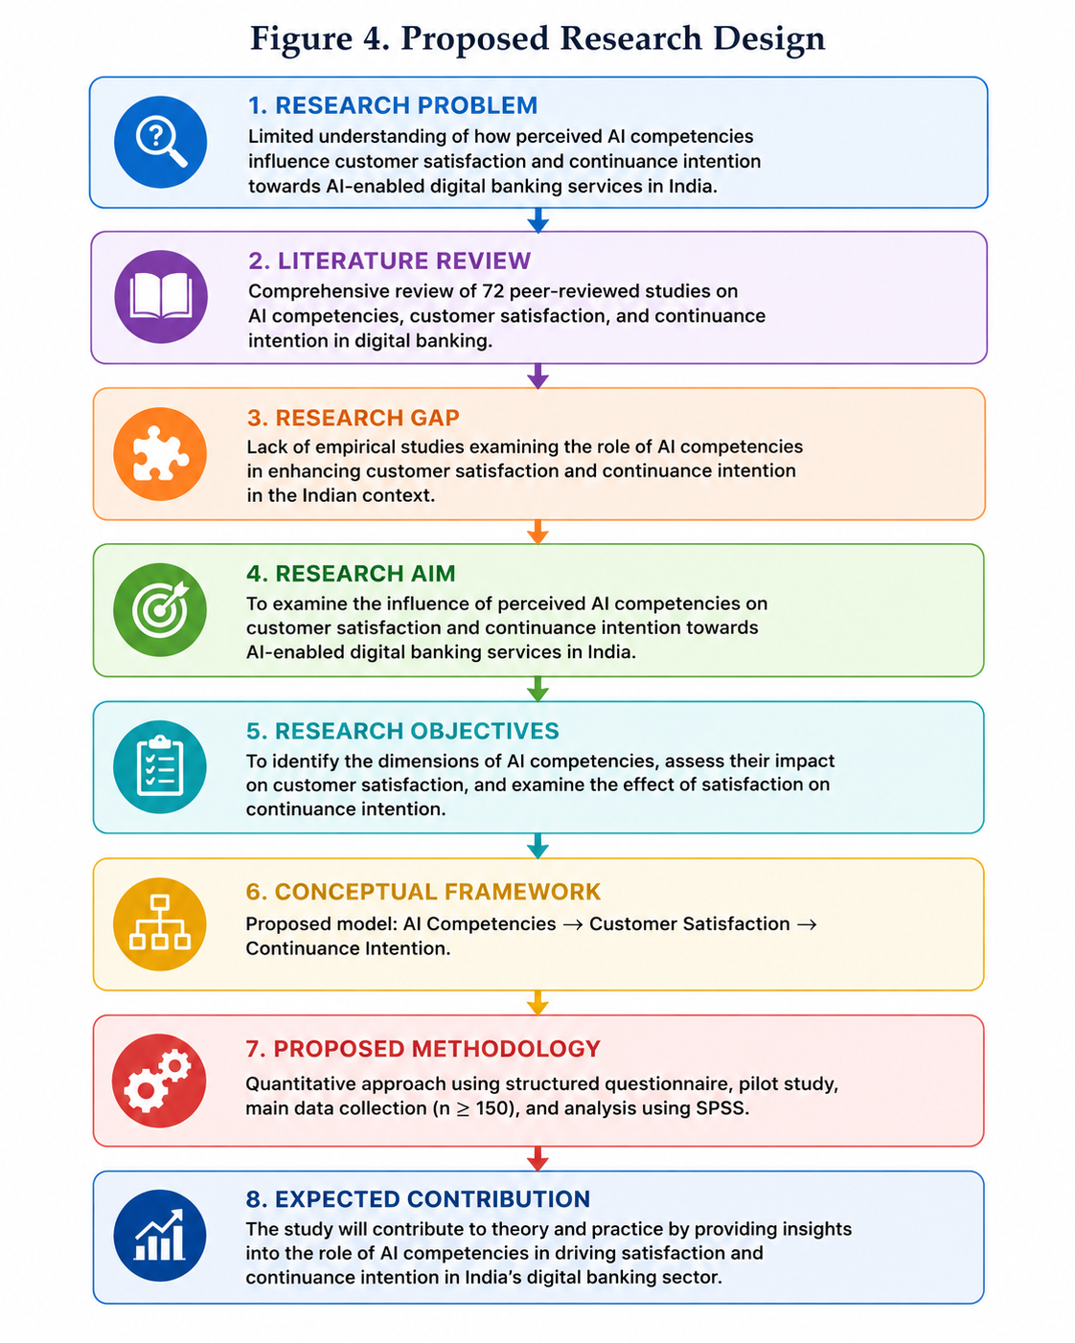

Figure 4. Research Process of the Proposed Study
Figure 4 illustrates the overall research process adopted for the proposed study, demonstrating the sequential stages from identifying the research problem through literature review, research gap identification, conceptual framework development and methodological design to the anticipated research contribution.
Source: Author's own illustration (2026).
Primary data will be collected through a structured questionnaire administered to customers who actively use AI-enabled digital banking services in India. To find respondents with pertinent experience with AI-enabled banking technology within the allotted research timeframe, a convenience sample technique will be used. Furthermore, the use of a standardised questionnaire will promote consistency in data collection and improve the comparability of responses across participants, thereby supporting the quality of the empirical evidence (Saunders, Lewis and Thornhill, 2023).
The selected quantitative methodology provides an appropriate framework for generating empirical evidence to examine the proposed conceptual relationships. By enabling the systematic collection and analysis of numerical data, this methodological approach supports the production of reliable and valid findings that address the research objectives. Consequently, quantitative methodology is considered the most suitable approach for achieving the purpose of the proposed doctoral study and establishing a robust foundation for the subsequent empirical investigation (Saunders, Lewis and Thornhill, 2023).

4.7 Ethical Considerations
Ethical considerations will form an integral part of the proposed doctoral research. As the study intends to involve human participants, appropriate ethical principles relating to informed consent, confidentiality, voluntary participation and research integrity will be incorporated into the research design. To make sure the planned research satisfies the necessary ethical standards, the study will be examined in compliance with the university's ethical approval processes prior to starting any empirical investigation.
Should the proposed research proceed to the data collection stage, participants will be provided with clear information regarding the purpose of the study before deciding whether to participate. Participation is intended to be voluntary, and respondents will be free to withdraw prior to submitting their responses. Additionally, by processing responses with confidentiality and limiting the collecting of needless personally identifying information, the proposed study will aim to protect participant privacy.
If ethical approval is granted and primary data are collected, the information will be stored securely and used exclusively for academic purposes. The research findings will be presented honestly and transparently, without fabrication, falsification or misrepresentation. These ethical principles are intended to support the credibility and integrity of the proposed doctoral research.

5 Conclusion
This Advancing to Doctoral Research (ADR) portfolio's main goal has been to methodically gather and provide thorough documentation of the research planning activities carried out to facilitate the shift to doctoral-level research. From the original conceptualisation of the study hypothesis to the creation of a cohesive and academically rigorous doctoral research proposal, the research development process has been recorded throughout the portfolio. This process incorporated extensive literature exploration, critical evaluation of existing theoretical perspectives and continuous refinement of the research focus, ensuring that each stage of development was supported by scholarly evidence and critical reflection. Consequently, the portfolio provides tangible evidence of a structured and methodical approach to long-term doctoral research planning.
The research journey began with a broad investigation of digital banking services, initially underpinned by the Technology Acceptance Model (TAM) through the constructs of Perceived Usefulness and Perceived Ease of Use (Davis, 1989). However, systematic engagement with contemporary literature broadened the understanding of the rapidly evolving AI-enabled banking landscape and highlighted limitations associated with relying solely on traditional technology adoption variables. The identification of important research gaps was made easier by the critical review of prior empirical studies, which also provided guidance for the proposed study's gradual improvement. Consequently, the study developed into the final doctoral proposal titled "The Role of AI Competencies in Enhancing Customer Satisfaction and Continuance Intention towards AI-enabled Digital Banking Services in India".
The refined research proposal seeks to examine the influence of AI competencies on customer satisfaction and continuance intention within the context of AI-enabled digital banking services in India. By integrating an emerging AI-focused construct into an established research domain, the study is expected to contribute both theoretically and practically. From an academic standpoint, it adds to the body of knowledge by offering up-to-date data on the adoption of AI-enabled banking and post-adoption behaviour. From a practical perspective, the findings are expected to support banking organisations in developing more customer-centred AI strategies that enhance customer experience and long-term engagement. Consistent with Kuhn's (1962) perspective on scientific progress, the proposed research does not seek to replace an established paradigm but rather contributes to its ongoing development by extending existing theoretical understanding within an emerging technological context.
The next stage of the doctoral journey will involve translating the proposed research design into an empirical investigation through questionnaire development, ethical approval, data collection and statistical analysis. Through these exercises, the conceptual framework presented in this portfolio will be able to be experimentally investigated while upholding ethical integrity and methodological rigour. Overall, this portfolio has established a coherent, feasible and academically robust foundation for the successful progression of the doctoral research and provides a clear direction for the subsequent empirical phase of the study.

6 References
- Adamyk, B., Benson, V., Adamyk, O., Fraczek, B., and Chinnaswamy, A. (2024) ‘Barriers to Trust in AI: A Study of the Explainability Technologies Adoption in Banks’, 2024 14th International Conference on Advanced Computer Information Technologies (ACIT), pp. 230–234. Available at: https://doi.org/10.1109/ACIT62333.2024.10712606.
- Al Sharif, B. M. M. (2026) ‘Artificial intelligence as a key strategic catalyst for enhancing banking service quality: 'Investigating the mediating role of digital innovation’, Corporate and Business Strategy Review, 7(1), pp. 144–144. Available at: https://doi.org/10.22495/cbsrv7i1art13.
- Aliyu Dantsoho, M., Jinjiri Ringim, K., and Maitama Kura, K. (2021) ‘The Relationship between Artificial Intelligence (AI) Quality, Customer Preference, Satisfaction and Continuous Usage Intention of e-Banking Services’, Indonesian Business Review, 4(1), pp. 24–43. Available at https://doi.org/10.21632/ibr.4.1.24-43

- Alkadi, R. S. and Abed, S. S. (2025) ‘Examining consumer intention to adopt AI-powered chatbots in the Saudi banking sector: the moderating role of knowledge in technology’, International Journal of Bank Marketing, 43(10), pp. 2229–2255. Available at: https://doi.org/10.1108/IJBM-10-2024-0635.
- Alshurideh, M. T., Ahmed, G., Shrouf, H., Shwedeh, F., and Alzoubi, H. M. (2026) ‘Leveraging Artificial Intelligence and Data Analytics for Digital Innovation: Insights from the Banking Sector’, Integrating 4IR and 5IR Technologies for Digital Business Innovation, pp. 81–93. Available at: https://doi.org/10.1108/978-1-83608-578-220251007.
- Apeksha Champaneri, C. S. (2024) 'Revolutionising Indian Banking: A Deep Dive into Consumer Perspectives and AI Integration: Systematic Literature Review (SLR)’, European Economic Letters (EEL), 14(4), pp. 1969–1982. Available at: https://doi.org/10.52783/eel.v14i4.2336.
- Arul, O. K. and Megargel, A. (2023) ‘Understanding human-centred artificial intelligence in the banking sector’, Journal of AI, Robotics & Workplace Automation, 2(4), pp. 332–332. Available at: https://doi.org/10.69554/EZLD4952.
- Ashrafuzzaman, M., Parveen, R., Sumiya, M. A., and Rahman, A. (2025) 'AI-powered personalisation in digital banking: a review of customer behavior analytics and engagement’, American Journal of Interdisciplinary Studies, 6(1), pp. 40–71. Available at: https://doi.org/10.63125/z9s39s47.
- Baffour Gyau, E., Appiah, M., Gyamfi, B. A., Achie, T., and Naeem, M. A. (2024) ‘Transforming banking: Examining the role of AI technology innovation in boosting banks' financial performance’, International Review of Financial Analysis, 96, pp. 103700–103700. Available at: https://doi.org/10.1016/j.irfa.2024.103700.
- BAUMGARTNER, M., HORVAT, D., KINKEL, S., and KICK, E. (2024) ‘KEY COMPETENCES FOR THE ADOPTION OF AI-BASED INNOVATIONS IN ORGANISATIONS’, International Journal of Innovation Management, 28(09n10). Available at: https://doi.org/10.1142/S1363919624400024.
- Bhatnagr, P., Rajesh, A., and Misra, R. (2024) ‘Continuous intention usage of artificial intelligence enabled digital banks: a review of expectation confirmation model’, Journal of Enterprise Information Management, 37(6), pp. 1763–1787. Available at: https://doi.org/10.1108/JEIM-11-2023-0617.
- Bhatnagr, P. and Rajesh, A. (2025) ‘Artificial intelligence features and expectation confirmation theory in digital banking apps: Gen Y and Z perspective’, Management Decision, 63(10), pp. 3642–3675. Available at: https://doi.org/10.1108/MD-07-2023-1145.
- Booth, W.C., Colomb, G.G., Williams, J.M., Bizup, J. and FitzGerald, W.T. (2016) The Craft of Research. 4th edn. Chicago: University of Chicago Press.
- Bhattacherjee, A. (2001) ‘Understanding Information Systems Continuance: An Expectation-Confirmation Model’, MIS Quarterly, 25(3), pp. 351–370. Available at: https://doi.org/10.2307/3250921
- Crotty, M. (1998) The Foundations of Social Research: Meaning and Perspective in the Research Process. London: Sage.
- Chandni Bansal, Krishan Kumar, Rajni Goel, and Anuj Sharma (2025). ‘A PLS-SEM mediation analysis of factors influencing the adoption intention of banking chatbots’, Issues in Information Systems. Available at: https://doi.org/10.48009/3_iis_2025_2025_116.
- Chaouali, W. (2026) ‘Understanding elderly customers' resistance to AI-powered chatbots in banking’, International Journal of Bank Marketing, 44(4), pp. 654–679. Available at: https://doi.org/10.1108/IJBM-06-2025-0424.
- Davis, F.D. (1989) ‘Perceived usefulness, perceived ease of use, and user acceptance of information technology’, MIS Quarterly, 13(3), pp. 319–340.
- de Matos, C. A., Rohden, S. F., and Lourenço Azevedo, A. B. (2026) ‘AI-induced privacy concerns: examining the moderating effect of AI fear on customer data sharing’, International Journal of Bank Marketing, 44(6), pp. 1271–1294. Available at: https://doi.org/10.1108/IJBM-05-2025-0403.
- Dharmadhikari, S. P. (2024) ‘Assessing the customer adoption and perceptions for AI-driven sustainable initiatives in the Indian banking sector’, Environment and Social Psychology, 9(5). Available at: https://doi.org/10.54517/esp.v9i5.1934.
- Dr Muhammad Hasan, Zaheer Abbas, Syed Itrat Hussain Zaidi, Muhammad Shayan Ali, and Dr Atif Aziz (2026) ‘AI-Enabled Digital Banking Service Quality and Customer Satisfaction: A SmartPLS-Based Analysis of Value Creation and Continuance Intention in Pakistan’, The Critical Review of Social Sciences Studies, 4(1), pp. 442–464. Available at: https://doi.org/10.59075/sahwjf12.
- Dr R. Prasanth (2025) ‘A Study on Artificial Intelligence–Enabled Digital Banking and its Influence on Customer Usage, Experience, and Technology Transformation in Coimbatore District’, International Journal of Advanced Research in Science Communication and Technology, pp. 615–615. Available at: https://doi.org/10.48175/IJARSCT-30470.
- Ernest Mfumbilwa, E., Mnong’one, C., Chao, E., and Amani, D. (2024) ‘Invigorating continuance intention among users of AI chatbots in the banking industry: an empirical study from Tanzania’, Cogent Business & Management, 11(1). Available at: https://doi.org/10.1080/23311975.2024.2419482.
- Fundira, M., Edoun, E. I., and Pradhan, A. (2024) ‘Evaluating end‐users' digital competencies and ethical perceptions of <scp>AI</scp> systems in the context of sustainable digital banking’, Sustainable Development, 32(5), pp. 4866–4878. Available at: https://doi.org/10.1002/sd.2945.
- Fundira, M., Edoun, E. I., Pradhan, A., and Mbohwa, C. (2024) ‘Assessing digital competencies and AI ethics awareness among customers in the banking sector’, African Journal of Science, Technology, Innovation and Development, 16(6), pp. 792–807. Available at: https://doi.org/10.1080/20421338.2024.2388619.
- Gallego-Gomez, C. and De-Pablos-Heredero, C. (2020) ‘Artificial Intelligence as an Enabling Tool for the Development of Dynamic Capabilities in the Banking Industry’, International Journal of Enterprise Information Systems, 16(3), pp. 20–33. Available at: https://doi.org/10.4018/IJEIS.2020070102.
- Gao, J., Opute, A. P., Jawad, C., and Zhan, M. (2025) ‘The influence of artificial intelligence chatbot problem-solving on customers’ continued usage intention in e-commerce platforms: an expectation-confirmation model approach’, Journal of Business Research, 200, pp. 115661–115661. Available at: https://doi.org/10.1016/j.jbusres.2025.115661.
- Garekwe, L., Ferreira-Schenk, S. J., and Dickason-Koekemoer, Z. (2024) ‘Modelling Factors Influencing Bank Customers’ Readiness for Artificial Intelligent Banking Products’, International Journal of Economics and Financial Issues, 14(1), pp. 73–84. Available at: https://doi.org/10.32479/ijefi.15238.
- Graham, G., Nisar, T. M., Prabhakar, G., Meriton, R., and Malik, S. (2025) ‘Chatbots in customer service within banking and finance: Do chatbots herald the start of an AI revolution in the corporate world?’, Computers in Human Behaviour, 165, pp. 108570–108570. Available at: https://doi.org/10.1016/j.chb.2025.108570.
- Helen, H. (2025) ‘Drivers of AI-Powered Digital Banking Adoption: Corporate Reputation, Customer Trust, and Anthropomorphic Interface Design’, Journal of Cultural Analysis and Social Change, pp. 3966–3986. Available at: https://doi.org/10.64753/jcasc.v10i4.3714.
- Hussain, M. A., Vemaraju, S., and Garg, A. (2025) ‘Customer loyalty in the age of AI: A comprehensive study on the mediating effect of satisfaction in digital banking’, International Journal of Innovative Research and Scientific Studies, 8(4), pp. 1957–1971. Available at: https://doi.org/10.53894/ijirss.v8i4.8279.
- Hussain, M. A., Rahman, M. A. U., Hussain, M. A., Vanitha, K. B., Kumar, P., and Kuril, A. (2026) ‘An Analytical Study on the Role of Satisfaction in Mediating Customer Loyalty and AI-Powered Digital Banking’, International Review of Management and Marketing, 16(2), pp. 406–417. Available at: https://doi.org/10.32479/irmm.22326.
- Ikhsan, R. B., Fernando, Y., Prabowo, H., Yuniarty, Gui, A., and Kuncoro, E. A. (2025) ‘An empirical study on the use of artificial intelligence in the banking sector of Indonesia by extending the TAM model and the moderating effect of perceived trust’, Digital Business, 5(1), pp. 100103–10010 3. Available at: https://doi.org/10.1016/j.digbus.2024.100103.
- Irawan, B. A., Tjakraatmadja, J. H., Ghazali, A., and Mulyono, N. B. (2022) ‘Corporate Digital Competencies for Digital Banking Innovation: Case Studies in Indonesian Banking Sector’, Journal of Educational, Health and Community Psychology, 11(4).
- Junior Ladeira, W., de Oliveira Santini, F., and Hasan Jafar, S. (2026) ‘Mapping meta-analytic insights in banking research: thematic clusters, heterogeneity and research agendas’, International Journal of Bank Marketing, 44(7), pp. 1447–1487. Available at: https://doi.org/10.1108/IJBM-04-2025-0336.
- Kuhn, T.S. (1962) The Structure of Scientific Revolutions. Chicago: University of Chicago Press.
- Kasinathan, A., Sampath, S., and Sampath, H. (2024) ‘Evaluating Customer Satisfaction and Trust in Autonomous AI Banking Systems’, pp. 87–103. Available at: https://doi.org/10.4018/979-8-3693-5767-5.ch006.
- Kruger, S. and Steyn, A. A. (2025) ‘Navigating the fourth industrial revolution: a systematic review of technology adoption model trends’, Journal of Science and Technology Policy Management, 16(10), pp. 24–56. Available at: https://doi.org/10.1108/JSTPM-11-2022-0188

- Kumar, J., Rani, V., Rani, G., and Sandhu, K. (2025) ‘What attracts me or prevents me from using AI-enabled neo-banking services? Unveiling the nexus between service quality and customer loyalty’, International Journal of Quality & Reliability Management, 42(10), pp. 2793–2814. Available at: https://doi.org/10.1108/IJQRM-11-2024-0421.
- Kumar, P. and Manrai, R. (2024) ‘A study on accelerating digital financial inclusion for positioning India through AI-enabled banking services’, International Journal for Multidisciplinary Research, 6(4). Available at: https://doi.org/10.36948/ijfmr.2024.v06i04.25511
- L. Vousinas, G. and Saluja, S. (2025) ‘The Impact of AI on Banking Services: Trends, Challenges, and Future Aspects’. Available at: https://doi.org/10.5772/intechopen.1011534.
- Lee, J., Tang, Y., and Jiang, S. (2023) ‘Understanding continuance intention of artificial intelligence (AI)-enabled mobile banking applications: an extension of AI characteristics to an expectation confirmation model’, Humanities and Social Sciences Communications, 10(1), pp. 333–333. Available at: https://doi.org/10.1057/s41599-023-01845-1.
- Lee, J. and Zhou, X. (2026) ‘The impact of artificial intelligence (AI) competencies on subjective financial well-being in AI-enabled mobile banking: A construal level theory perspective’, Journal of Business Research, 206, pp. 115922–115922. Available at: https://doi.org/10.1016/j.jbusres.2025.115922.
- Lee, J. and Chen, X. (2022) ‘Exploring users' adoption intentions in the evolution of artificial intelligence mobile banking applications: the intelligent and anthropomorphic perspectives’, International Journal of Bank Marketing, 40(4), pp. 631–658. Available at: https://doi.org/10.1108/IJBM-08-2021-0394.
- Lian, J. and Li, C. (2025) ‘Using a two-stage method to understand the critical factors influencing customers’ intention to switch from traditional to artificial intelligence-based banking services: A perspective based on the push–pull–mooring model’, Computers in Human Behavior, 168, pp. 108645–108645. Available at: https://doi.org/10.1016/j.chb.2025.108645.
- Lin, R. and Lee, J. (2024) ‘The supports provided by artificial intelligence to continuous usage intention of mobile banking: evidence from China’, Aslib Journal of Information Management, 76(2), pp. 293–310. Available at: https://doi.org/10.1108/AJIM-07-2022-0337.
- Manser Payne, E., Peltier, J. W., and Barger, V. A. (2018) ‘Mobile banking and AI-enabled mobile banking’, Journal of Research in Interactive Marketing, 12(3), pp. 328–346. Available at: https://doi.org/10.1108/JRIM-07-2018-0087.
- Mi Alnaser, F., Rahi, S., Alghizzawi, M., and Ngah, A. H. (2023) ‘Does artificial intelligence (AI) boost digital banking user satisfaction? 'Integration of the expectation confirmation model and antecedents of artificial intelligence-enabled digital banking', Heliyon, 9(8), pp. e18930–e18930. Available at: https://doi.org/10.1016/j.heliyon.2023.e18930.
- Moharrak, M. and Mogaji, E. (2025) ‘Generative AI in banking: empirical insights on integration, challenges and opportunities in a regulated industry’, International Journal of Bank Marketing, 43(4), pp. 871–896. Available at: https://doi.org/10.1108/IJBM-08-2024-0490.
- Ms Prachi Pandey and Mrs Manshi Dangi (2024) ‘TRANSFORMING BANKING THROUGH AI: ANALYSING THE IMPACT OF CUSTOMER PERCEPTION FACTORS’, EPRA International Journal of Economics, Business and Management Studies, pp. 43–52. Available at: https://doi.org/10.36713/epra18879.
- Naeem, M., Jawaid, S. T., and Mustafa, S. (2026) ‘Intention-retention phenomenon for online banking services in Pakistan: an application of technology acceptance model and expectation continuance theory’, Journal of Modelling in Management, 21(2), pp. 826–875. Available at: https://doi.org/10.1108/JM2-03-2025-0101.
- Ni, Y. (n.d.) ‘The Impact of Explainable AI on Customer Trust and Satisfaction in Banking’. Available at: https://doi.org/10.62836/jitp.v1i1.165.
- Omoge, A. P., Gala, P., and Horky, A. (2022) ‘Disruptive technology and AI in the banking industry of an emerging market’, International Journal of Bank Marketing, 40(6), pp. 1217–1247. Available at: https://doi.org/10.1108/IJBM-09-2021-0403.
- Othayoth, P. K. and Khanna, S. (2024) ‘Chatbot Service Quality in Banking: Analyzing Indian Banking Customer Perceptions and Influence on Customer Satisfaction and Value’, Indian Journal of Marketing, 54(2), pp. 44–44. Available at https://doi.org/10.17010/ijom/2024/v54/i2/173474.

- Othayoth, P. K. and Khanna, S. (2024) ‘Exploring the future of customer-centric banking: A comprehensive examination of chatbot service quality and development of an advanced chatbot interfaces framework for Indian banking’, JIMS 8M The Journal of Indian Management and Strategy, 29(3), pp. 4–13. Available at: https://doi.org/10.5958/0973-9343.2024.00015.9.
- Park, K. and Yoon, H. Y. (2024) ‘Beyond the code: The impact of AI algorithm transparency signaling on user trust and relational satisfaction’, Public Relations Review, 50(5), pp. 102507–102507. Available at: https://doi.org/10.1016/j.pubrev.2024.102507.
- Pfoertsch, W. and Sulaj, K. (2023) ‘Integrating Artificial Intelligence with Customer Experience in Banking: An Empirical Study on how Chatbots and Virtual Assistants Enhance Empathy’, 2023 International Conference on Computing, Networking, Telecommunications & Engineering Sciences Applications (CoNTESA), pp. 69–74. Available at: https://doi.org/10.1109/CoNTESA61248.2023.10384979.
- R, D. and S, S. (2025) ‘Assessing the Impact of Artificial Intelligence Adoption on Customer Satisfaction in the Indian Banking Sector’, International Journal for Multidisciplinary Research, 7(6). Available at: https://doi.org/10.36948/ijfmr.2025.v07i06.64409.
- R., N. K., M., J., and R., P. (2026) ‘Assessing the influence of AI adoption and trust on customer satisfaction in digital banking services’, SAM Advanced Management Journal, 91(2), pp. 165–183. Available at: https://doi.org/10.1108/SAMAMJ-12-2024-0100.
- Rokhimah and Suhermin (n.d.) ‘factors influencing continuation intention of mobile banking usage: extending expectancy confirmation model (ECM) and artificial intelligence (AI) with security as moderation’.
- Salman, S. and R, D. C. (2026) ‘Customer satisfaction in AI-enabled banking: the roles of preferred banking mode and digital literacy’, Journal of Corporate Finance Management and Banking System, pp. 23–23. Available at: https://doi.org/10.55529/jcfmbs.61.23.34.
- Santana, M. and Díaz-Fernández, M. (2023) ‘Competencies for the artificial intelligence age: visualisation of the state of the art and future perspectives’, Review of Managerial Science, 17(6), pp. 1971–2004. Available at: https://doi.org/10.1007/s11846-022-00613-w.
- Saunders, M., Lewis, P. and Thornhill, A. (2023) Research Methods for Business Students. 9th edn. Harlow: Pearson.
- Satyanarayana, P. and Rajiv, C. (2026) ‘Exploring the Impact of Artificial Intelligence on Service Quality and Financial Outcomes in Indian Banks’, Advanced International Journal for Research, 7(1). Available at: https://doi.org/10.63363/aijfr.2026.v07i01.2853.
- Shaikh, A. A., Kumar, A., Mishra, A., and Elahi, Y. A. (2024) ‘A study of customer satisfaction in using banking services through Artificial Intelligence (AI) in India’, Public Administration and Policy, 27(2), pp. 167–181. Available at: https://doi.org/10.1108/PAP-05-2023-0060.
- Sharma, V. a. S. S. (2024) ‘Determinants of AI Adoption in Banking Services in India: An Empirical Investigation'. Journal of Informatics Education and Research. Available at: https://doi.org/10.52783/jier.v4i2.1153.
- Sharma, B. (2026) ‘&lt;b&gt;From Awareness to Adoption: Understanding Customer Acceptance of AI Banking Services in India&lt;/b&gt;’, Interdisciplinary Journal of AI, Machine Learning & Data Science, 1(1), pp. e006–e006. Available at: https://doi.org/10.66261/0qkfrs72.
- Sheth, J. N., Jain, V., Roy, G., and Chakraborty, A. (2022) ‘AI-driven banking services: the next frontier for a personalised experience in the emerging market’, International Journal of Bank Marketing, 40(6), pp. 1248–1271. Available at: https://doi.org/10.1108/IJBM-09-2021-0449.
- Shin, N. and Son, J. (2026) ‘Impacts of AI-integrated services and corporate reputation on digitalised banking recommendations: a view of goal-framing theory’, International Journal of Bank Marketing, 44(2), pp. 173–194. Available at: https://doi.org/10.1108/IJBM-09-2024-0560.
- Singh, G., Sao, A., Singh, S., and Hinchey, M. (2023) ‘AI-Enhanced SEM Analysis: Evaluating E-CRM's Effect on Customer Experience in NCR's Private Banking Sector’, 2023 3rd International Conference on Technological Advancements in Computational Sciences (ICTACS), pp. 957–962. Available at: https://doi.org/10.1109/ICTACS59847.2023.10390044.
- Srivastava, S. and Sharma, S. (2024) ‘CUSTOMER TRUST AND DATA PRIVACY IN DIGITAL BANKING SERVICES – A STUDY IN CONTEXT OF ARTIFICAL INTELLIGENCE’, ShodhKosh: Journal of Visual and Performing Arts, 5(1). Available at: https://doi.org/10.29121/shodhkosh.v5.i1.2024.3505.
- Suhartanto, D., Syarief, M. E., Chandra Nugraha, A., Suhaeni, T., Masthura, A., and Amin, H. (2022) ‘Millennial loyalty towards artificial intelligence-enabled mobile banking: evidence from Indonesian Islamic banks’, Journal of Islamic Marketing, 13(9), pp. 1958–1972. Available at: https://doi.org/10.1108/JIMA-12-2020-0380.
- T.P. Ramprasad, D. (2024) ‘The Role of Artificial Intelligence for Enhancing Customer Experience – An Empirical Study in Indian Banking Sector’, Educational Administration: Theory and Practice, pp. 3713–3719. Available at: https://doi.org/10.53555/kuey.v30i1.7472.
- Vikram Kumar Sharma and Saumya Singh (2024) ‘Determinants of AI Adoption in Banking Services in India: An Empirical Investigation', Journal of Informatics Education and Research. Available at: https://doi.org/10.52783/jier.v4i2.1153.
- Wirapraditya Ramdhani, A., Fangdinata, F., and Mandoyo, J. (2025) ‘Understanding the Determinants of Continuance Intention for Banking Chatbots: A TCT Study’, Jurnal Algoritme, 5(2), pp. 243–253. Available at: https://doi.org/10.35957/algoritme.v5i2.11383.
- Wu, G. and Sun, X. (2026) ‘Unlocking Satisfaction Dynamics in the AI-Driven Banking Era: Insights from a Hybrid SEM-fsQCA Analysis’, Sage Open, 16(1). Available at: https://doi.org/10.1177/21582440261421318.
- Xu, Y., Shieh, C., van Esch, P., and Ling, I. (2020) ‘AI Customer Service: Task Complexity, Problem-Solving Ability, and Usage Intention’, Australasian Marketing Journal, 28(4), pp. 189–199. Available at: https://doi.org/10.1016/j.ausmj.2020.03.005.
- Zulaikha, S. and Faricha, A. (2026) ‘The continuance intention to use Islamic digital banks: the extended theory of expectation confirmation model’, Journal of Islamic Marketing, 17(6), pp. 2021–2046. Available at: https://doi.org/10.1108/JIMA-02-2025-0123.

Appendix A – Literature Search Strategy
Search Element | Description
Databases | Scopus, ScienceDirect, Emerald Insight, SpringerLink, Google Scholar
Publication Period | 2018–2026
Language | English
Document Type | Peer-reviewed journal articles
Inclusion | Empirical and review studies relevant to AI-enabled banking
Exclusion | Duplicates, unrelated studies, non-English
Final Studies | 72 papers
Keywords Used:
Artificial Intelligence
AI-enabled Digital Banking
AI Competencies
Customer Satisfaction
Continuance Intention
Trust
India

