BA Leadership and Management Skills for the Workplace
Assignment Title: Emergent Leadership Skills for the Workplace

Firon miah
1605305
Yajesh Kumar

Table of Contents
Introduction 4
Task-1 5
Understanding of the Concept and Importance of Leadership and Management 5
Different models, theories, and styles of leadership 5
Roles and Responsibilities of Leadership 6
Evaluating different leadership styles 7
The repertoire of leadership styles with different people in different situations 8
Emotional intelligence in leadership roles and responsibilities 9
Importance of Understanding Own Strengths and Limitations 10
Techniques to Identify Personal Characteristics, Strengths, and Weaknesses 11
A Critical Evaluation of My Leadership Strengths and Weaknesses 12
Importance of continual self-development and identifying opportunities to develop the leadership roles 13
Confidence and self-assurance in taking calculated risks of leadership 14
Social awareness for empathy, political awareness, and service to others 15
Relationship management to inspire others 15
Task 2 17
Critical analysis of Whitbread annual report-2018 17
A brief evaluation of business strategy of Whitbread plc 17
Evaluation of business strategy 21
The business model of Whitbread Plc 21
Leadership styles and approaches of the CEO of Whitbread plc 25
The Transformational Leadership Model at Whitbread plc 26
Comparing and Contrasting Leadership Approaches and Styles of the CEO of Whitbread plc with Me 27
Conclusion 29
References 30

Introduction
The business world is witnessing more and more competition over the years. Organizations are struggling to hold their position in the industry. Some organizations are winning the game but some large organizations are even losing in this business game. We know some big names like Nokia, Kodak, Xerox, Enron, Lehman Brothers, MCI Inc., DeLorean Motor Company, etc. Once in their lifecycle, they were dominant companies. But they failed to sustain in the business game. There are numerous arguments regarding their failure but all are agreed on the point that lack of dynamic leadership is the hidden secret of their failure. Schein, (2017) defined leadership as a dynamic field of business management to pursue both the organizational and individual vision by inspiring, motivating, encouraging, and leading the employees. Effective Leadership is the best solution for sustainable business success. Considering the immense significance of leadership this report is going to explore the roles and responsibilities of leadership in the workplace and the critical importance of the objective analysis of personal strengths and weaknesses. For this, I have selected Tesco PLC one of the leading retailer chains in the UK. This work will also apply different models and theories of leadership to get practical knowledge in real-world leadership and management. Later part of the report will evaluate and analyze the annual report of Whitbread in the area of leadership to compare and contrast the leadership styles and approaches of the CEO of Whitbread with me.

Task-1

Understanding of the Concept and Importance of Leadership and Management
Leadership and Management
Leadership is setting a new direction or vision for a group that they follow, a leader is a spearhead for that new direction. Management controls or directs people/resources in a group according to principles or values that have been established (Sinek, 2019).

Different models, theories, and styles of leadership
Leadership models refer to the specific guidance and manner that specify specific leadership behaviors in a specific environment or situation. There are numerous leadership models and theories including traits and behavioral models of leadership, contingency theories of leadership, situational theory, path-goal theory, charismatic leadership theory, transactional leadership theory, transformational leadership theory of leadership, etc.
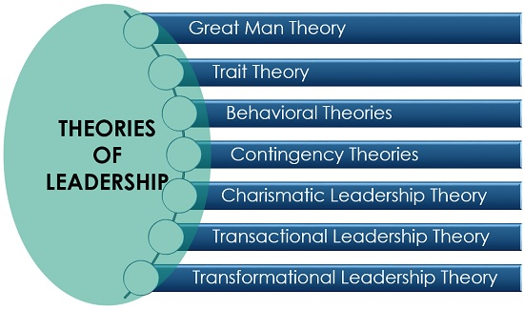
Figure: Theories of leadership
Source: (Kelly, 2012)
These theories and models of leadership have specified some styles of leadership. Different leadership styles are autocratic leadership style, democratic leadership, Team leadership, cross-cultural leadership, transformational leadership, strategic leadership style, transactional leadership style, visionary leadership, laissez-faire leadership style, etc. (Sinek, 2019).

Roles and Responsibilities of Leadership
I'm in the position of a store manager at Tesco in Old Street, London. As a manager and a leader, I have to play different roles and perform different responsibilities within my position. My key roles and responsibilities are as follows:
- I need to develop organizational goals considering the perceptions and goals of my subordinates.
- Define the roles and responsibilities of the subordinates
- Provide clear and constructive immunization
- Provide required training and instructions
- Listen and evaluate the feedback
- Monitor the participation and motivation
- Manage and control day to day operation
- Render support for further development
As a leader I have also needed to rectify bad habits, empower the subordinates, eliminate ineffective practices, maintain timelines, make the environment enjoyable, design rewards systems considering the contribution, establish a shared culture to celebrate the success, set examples, and adapt policies in response to changes and uncertainties.

Evaluating different leadership styles
Different leadership styles have some specific features. One approach can be better than another but every approach has its implementation area. Considering my responsibilities at Tesco a brief evaluation of different leadership styles are as follows:
- Autocratic leadership style
This style refers to the authority of taking decisions without consulting with the subordinates (Sinek, 2019). This style is effective when I need to take a very quick decision and the opinions of my subordinate managers are not required. But considering my whole basket of responsibilities this style has little application except for some special cases.
- Democratic leadership style
This leadership style considers the opinion of subordinate managers and encourages innovation and creativity (Steward, 2013). I have used to apply this style while I develop organizational objectives, goals, and strategies. The participation of the subordinates encourages their internal motivation that results in their credibility and involvement toward achieving the objectives.
- Transformational leadership style
It is a very effective leadership style while a task is innovative and requires high involvement. According to this style, leaders inspire their subordinates to explore the best outcomes (Eacott, 2011). I have found it very effective when the sales target becomes challenging to pursue. It incorporates emotional intelligence and increases the intrinsic motivation of the employees. I have found that conflict resolution skills are crucial in pursuing the best outcomes.
- Coaching style
It is the process of improving and developing employees to achieve a shared goal. Tesco applies this leadership style for newly employed managers. Tesco wants to pursue its goal along with the individual objectives.
- Affiliate style
Tesco is the market leader in the retail industry in the U.K. Team working is very crucial for attaining long-run goals. This leadership style focuses on the harmony among the team members to pursue organizational objectives. Good relationship among the working teams in Tesco is very crucial for improving morale, building trust, and effective communication.
Different leadership styles focus on different aspects and objectives. But the usefulness of using different leadership styles depends on certain situations with aspects, perceptions, and behavior of the subordinates.

The repertoire of leadership styles with different people in different situations
Leadership styles should incorporate the demand of the organization and perception of the people with different situations. Leadership is something more than individual needs. We have already seen different leadership styles like visionary, coaching, affiliative, pacesetting, commanding, democratic, etc. The effectiveness of leadership depends on quick movements among these styles to be adapted to the demands of the situation with the requirements of the subordinates (Kelly, 2012). A visionary leadership style can be very effective in a situation when Tesco requires a new direction for competitive goals. Employees prefer freedom, independence, and taking calculated risks in this regard. Again democratic leadership style can be very effective in a situation where shared knowledge, skills, collectivism with Group communication is very crucial for setting direction. All other leadership styles also have effectiveness in different situations with the demand of the subordinates. All the leadership styles can become a part of the leaders' repertoire. The success of leadership comes from leadership traits, emotional intelligence, understanding the situations, demands of the employee, and the execution abilities (Sinek, 2019).

Emotional intelligence in leadership roles and responsibilities
Emotional intelligence refers to the intrinsic ability to recognize, control, and express own emotions and those of others to discern between different feelings and emotions to handle interpersonal relationships judiciously and empathetically. Emotional intelligence incorporates self-awareness, empathy, social skills, self-regulation, and motivation (Steward, 2013). A Successful leader has forcible control over his emotions and feelings that ensures sustainable success. Application of emotional intelligence and leadership is as follows:
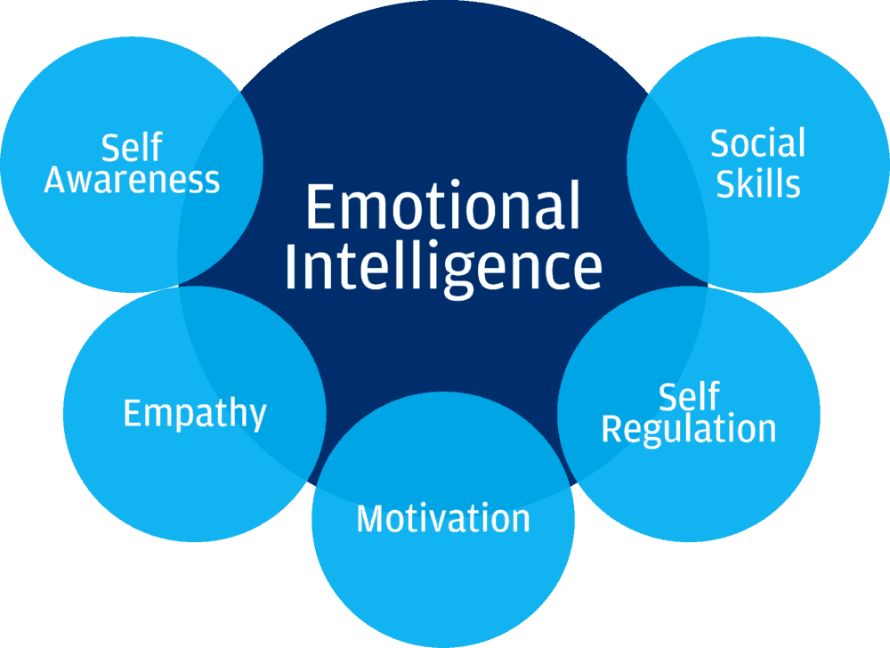
Figure: Emotional intelligence in leadership
Source: (Kelly, 2012)
- Self-awareness
Self-awareness refers to a clear understanding of own strengths and weaknesses. The higher level of self-awareness encourages effective leadership, and a lower level of self-awareness eliminates fruitless behavior (Eacott, 2011). To increase self-awareness as a leader we need to think about weaknesses and spend a few minutes on it. We should try to slow down our anger and should try to find a positive way to react to it.
- Self-regulation
Like self-awareness, a higher level of self-regulation is also positively correlated with effective outcomes of leadership. To increase our self-regulation as a leader we need to know our values, hold ourselves accountable, and practice being calm in challenging situations. It increases leadership flexibility and commitment to achieving organizational goals.
- Social skills
A higher level of social skills enables a leader to manage the changes and resolve workplace conflicts diplomatically. To improve social skills as a leader will need to learn from conflicts and improve our communication skills. Learning to praise others also increases social skills and inspires loyalty in the workplace.
- Motivation
Self-motivation of the leaders makes them consistent towards attaining the business objectives ensuring the required quality of works. Higher self-motivation ensures higher job satisfaction, involvement, and accountability of the leaders (Eacott, 2011). Leaders of Tesco should try to find something positive even in a failure situation.
- Empathy
To manage and control a business organization successfully empathy plays a very crucial role. It enables the leaders to draw constructive feedback by putting themselves in the position of the subordinates. Understanding the emotions, feelings, and perceptions of the employee are very crucial for effective leadership. Paying attention to the body language and responding to the feelings of the employees help to pursue the respect and loyalty of the employees (Steward, 2013). The empathy of the leaders makes leadership easier and enjoyable.

Importance of Understanding Own Strengths and Limitations
A clear understanding of the strengths and weaknesses enables us to reduce gaps. When we can identify our Weaknesses we can corrective actions. We have explained five factors of emotional intelligence that make success leadership. Focusing on improving our weaknesses helps to increase self-confidence, empathy, and self-regulation. On the other hand, Our strengths encourage us to go for opportunities instead of problems. Our strengths keep us ahead of a lot of things. It helps leaders to explore challenging goals and helps to develop the best strategy to explore the aims. A clear understanding of strengths and weaknesses ensures continual personal development by reducing weaknesses and strengthening the existing strengths (Kelly, 2012).

Techniques to Identify Personal Characteristics, Strengths, and Weaknesses
It is a very difficult and subjective matter to identify personal characteristics, strengths, and weaknesses accurately. We can simply apply some scientific and widely accepted principles in this regard.
To identify the strengths and weaknesses of a leader, first, we need to identify personality traits. There are five major types of personality traits. We can apply the below-described figure to explore different types of personality:
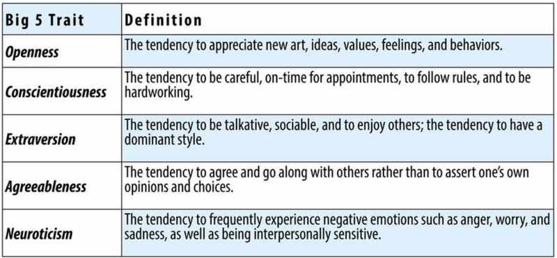
After identifying personal characteristics we can use the questionnaire method or qualitative analysis technique along with the personality traits to identify our strengths and weaknesses.
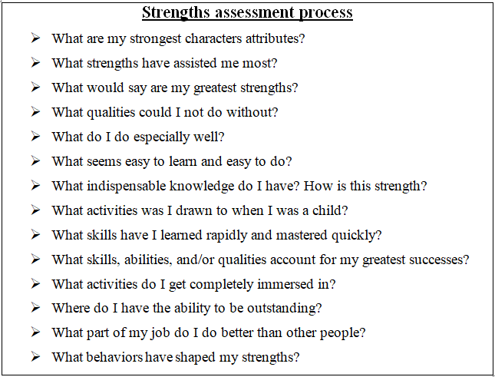
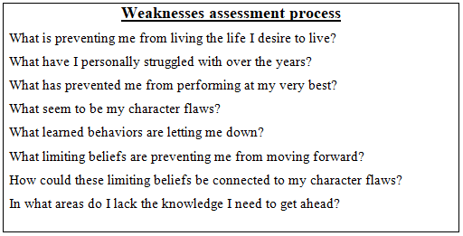

A Critical Evaluation of My Leadership Strengths and Weaknesses
Strengths | Limitations
I have a good commitment and passion for my works.  I have good communication skills with my subordinates.  I can work under tremendous pressure and tight schedule  I also have good conflict management skills with effective decision making.  I believe in delegation, empowerment, and accountability  Honesty, integrity, trust, and inspirational skills are dominant in my character.  Besides, I believe in creativity and continual support. | I think I have a point of improvement in the area of interpersonal skills.  I need to work on my time management skills.  I also need to work on an effective team management approach.  I need to raise my self-awareness to build self-confidence  I also need to improve empathy for a better understanding of the employees.  Improvement of my self-regulation can bring more effective leadership and management.  I also need to work on my execution strategy for effective leadership and management.

Importance of continual self-development and identifying opportunities to develop the leadership roles
The development of skills and competences is a continuous process. Leadership requires some crucial skills knowledge and experience. Some leaders have some unique by born leadership skills. There is also a common myth that the leaders are born not made. But things are changing very rapidly. It is very much possible to make a leader through the continuous development process. Besides, leadership strategies and styles are also changed over the years. Earlier great man leadership theory (the 1840s) was replaced by trait leadership theory (1930s to 1940s). Then came the behavioral leadership theory in the 1940s to 1950s and contingency leadership theory came in the 1960s. Finally, the transformational and transactional theory of leadership was developed in the 1970s. All of these leadership approaches require different leadership skills and knowledge. Besides, there is also a change in human perception, beliefs, and values. Workplace diversity is also increasing with cultural changes (Kelly, 2012). The internal and external business environment has also changed 360 degrees. Continual learning and personal development are very crucial for adapting to these changes to becoming a success in the competitive business arena.
Continuous self-development increases the passion to improve skills, self-awareness, self-regulation, social skills, and boost the confidence level of a leader. It improves the leadership quality and contributes to the realization of leadership goals and aspirations. It enables leaders to keep pace with the current leadership standards. As a result, continuous self-development reduces the weaknesses and skill gaps of a leader (Steward, 2013). Thus it develops a sense of direction, greater resilience, fulfilling relationships, and improves efficiency and effectiveness of leadership.
Continual self-development of leaders enables them to identify opportunities to ensure long-run sustainable performance.
Currently, Tesco is losing market share to Sainsbury's, Asda, Lidl, and Aldi including some local competitors. Continuous self-development is the best weapon that can enable Tesco to be in the market-leading positions for a very long time.

Confidence and self-assurance in taking calculated risks of leadership
Self-confidence and self-assurance are the two major factors of emotional intelligence. It increases personal judgment abilities. As a result, these factors are crucial for taking calculated risks and accomplishing goals. Confidence and self-awareness of the leaders encourage them to direct the problems and conflicts immediately instead of ignoring or passing problems to others. Confident leaders also increase the confidence of the subordinates. Self-confidence and awareness work as a positive image that gives reward power to the leaders. Reward power increases the intrinsic motivation of the employees and makes them cool, confident, and articulate. It can also assure positive thinking. Thus leaders become positive in exploring the vision and willing to take risks. It is such a strength of a leader that always keeps him ready to take calculated risks and explore every single opportunity. It is also very effective for leaders of Tesco for taking immediate decisions in consideration of all the risk factors to pursue opportunities.

Social awareness for empathy, political awareness, and service to others
Social awareness refers to the consciousness shared by a group of individuals within a society. Social awareness with an organization also plays a very big role as a part of central emotional intelligence. It enables leaders to respond to the needs of others. It is directly related to national politics and political awareness (Steward, 2013). But having a hierarchical organizational structure organizational politics has very little scope to influence others within the hierarchy. But political awareness is crucial for understanding the power webs at Tesco. But in consideration of empathy, political awareness, and service to other leaders of Tesco should carefully consider the demands of employees, plan to communicate with them, and develop ways to meet their demands on a persistent basis.

Relationship management to inspire others
Building and managing intrinsic motivation is the secret of the success of a leader. Effective relationship management plays a very big role in building and management an effective team. It refers to the ability to be aware of the emotions of the subordinates and managing own emotions simultaneously. It is also described as a systematic discipline of identifying, analyzing and managing relationships with the people inside and outside of the organization (Eacott, 2011). Below chart shows the intrinsic relationship between relationship organization and required skills to inspire the subordinates:
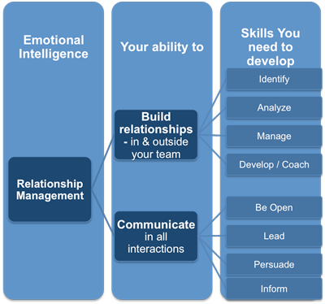
Figure: relationship management
Source:
Effective relationship management at Tesco can inspire subordinates by helping them to reach their full potential. For this, leaders need to ensure successful negotiation, conflict resolution and working with subordinates with a shared goal. Thus the required competencies of relationship management to inspire others are:

- Influence
- Leadership
- Conflict management
- Collaboration
- Communication
- Team working and
- Coordination

Proper management of these factors by a leader in Tesco can inspire the subordinates to explore shared objectives.

Task 2

Critical analysis of Whitbread annual report-2018
This section of the study is going to evaluate the annual report of Whitbread plc in the area of leadership & management and performance. Whitbread plc is the UK’s largest hotel and restaurant company. It owns Premier Inn and Costa as well as Brewers Fayre, Beefeater, Table Table, and Bar+ Block.

A brief evaluation of business strategy of Whitbread plc
- Aims and financial performance review
Whitbread plc aims at growing their brands by building a strong customer heartbeat and innovating to stay ahead. It has a total revenue of £ 3,295m with a growth rate of 6.1%, underlying profit before tax £591m with a growth rate of 4.5%, statutory profit before tax £548m with a growth rate of 6.4%, and underlying operating profit £622m with a growth rate of 5% in 2018. A brief overview of financial performance over the last four years is as follows:
- Revenue growth of Whitbread (2014/15 to 2017/18)

Revenue of Whitbread
2014/15 | £2608
2015/16 | £2922
2016/17 | £3106
2017/18 | £3295
Source: (Whitbread, 2018)
Whitbread has ensured very consistent revenue growth. In the last four years, its revenue has raised from £2608 to £3295. But the interesting thing is that growth is consistently positive over the last four years.
- Underlying profit before tax growth of Whitbread (2014/15 to 2017/18)

Underlying profit before tax
2014/15 | £488
2015/16 | £546
2016/17 | £565
2017/18 | £591
Source: (Whitbread, 2018)
Whitbread has also ensured a very consistent underlying profit before tax growth. In the last four years, its underlying profit before tax has raised from £488 to £546. The growth is also consistently positive over the last four years.
- Statutory profit before tax growth of Whitbread (2014/15 to 2017/18)

Statutory profit before tax
2014/15 | £464
2015/16 | £488
2016/17 | £515
2017/18 | £548
Source: (Whitbread, 2018)
Whitbread has very good statutory profit before tax growth. In the last four years, its statutory profit before tax growth has raised from £464 to £548. The growth is very fast and consistently positive over the last four years.

- Underlying operating profit growth of Whitbread (2014/15 to 2017/18)

Underlying operating profit
2014/15 | £504
2015/16 | £569
2016/17 | £592
2017/18 | £622
Source: (Whitbread, 2018)
The underlying operating profit growth rate of Whitbread is also consistently positive. But it is not as fast as statutory profit before tax grows. But it is still raised by £118 over the last four years.
It has also a 15.4% return on capital and 240p basic EPS with a growth rate of 3.6%. Considering the above Financial performance indicators, we can say that over the years financial performance of Whitbread is improving. Besides, it is very consistent in the last four years. It is outperforming the industry, market, and country where the UK has an average growth rate of 2.1%.

Evaluation of business strategy
We know that superior financial performance is an outcome of superior leadership and management, functional coordination, and overall business strategy. For this, Whitbread focuses on three strategic priorities including:
- Grow and innovate in their core the UK business
- Focus on their strengths to grow internationally
- Build the capability and platform to support long term growth
To explore these business strategies, Whitbread focuses on delivering high standards to the customers through strong employee involvement. For this, their leadership approaches focus on developing the potential employees' training, coaching, organizational support, and inclusive environment. They aim at improving three distinctive areas including opportunities, communities, and responsibilities and they consider these areas as their pillar of success.

The business model of Whitbread Plc
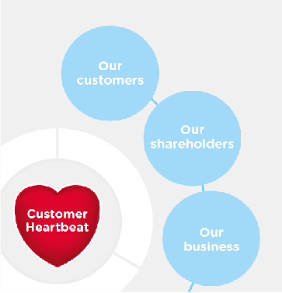
Source: (Whitbread, 2018)

The business model of Whitbread has put the customer at the top of their strategic area. It refers that Whitbread is a customer service oriented business organization. A brief evaluation of their business model is as follows:
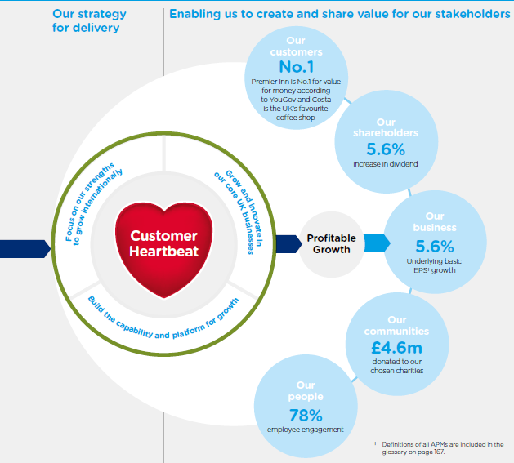
Source: (Whitbread, 2018)
Both the financial and non-financial performance of Whitbread plc shows that their business model is competent enough to explore their business objective, mission, and vision. They have ranked 1 in the customer service areas in the UK. Shareholders are also getting their perceived value from Whitbread at a 5.6% growth rate of their dividend. Very crucial thing is that their communities had donated 4.6 million pounds to their chosen charities in 2017/18. They should also be happy with the YourSay survey outcomes that disclosed a 78% employee engagement in 2017/18 (Whitbread, 2018).
- Brief evaluation of financial and non-financial indictors
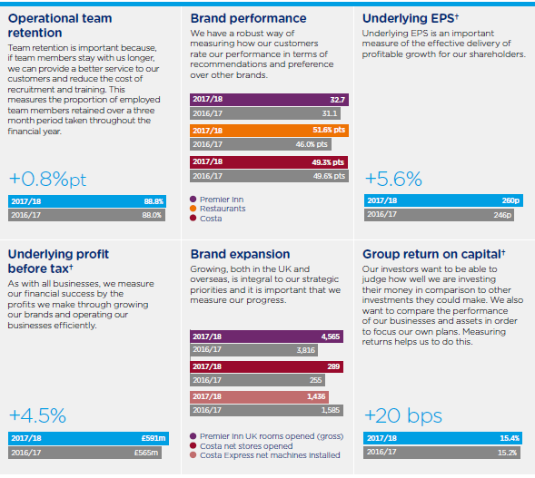
Source: (Whitbread, 2018)

- Evaluation of broad structure
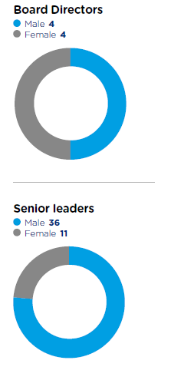
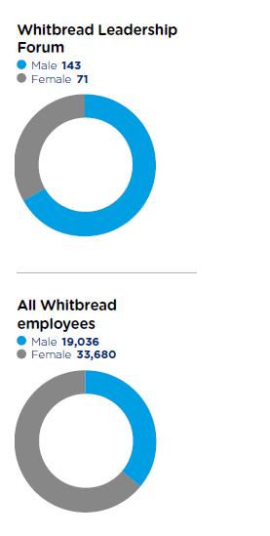

Source: (Whitbread, 2018)
There are four major classifications of the organizational structure of Whitbread is shown in the annual report. The classifications are made based on the board directors, senior leaders, leadership forum, and overall employees. In the overall structure of Whitbread female employees dominate Whitbread. But they have more males in senior leaders and leadership forum section. Governing board is constructed with an equal number of male and female (Whitbread, 2018).

Leadership styles and approaches of the CEO of Whitbread plc
Whitbread plc aims at delivering exceptional service every day. Their 50000+ employees are the most significant source of their value creation process. Whitbread plc treats its employees as a team member. They have scored 78% in team engagement in the YourSay survey in 2018. They always try to make Whitbread as the best place to work. For this, their leadership styles focus on the improvement of their core people strategies including the following:
- They have ensured Fair and transparent rewards system considering the contributions of the team members to ensure the motivation of all the team members
- They have focuses on creating no limit ambition environment to create an innovative and diverse team
- They continually introduce innovative technologies to make a great workplace to work
- They value the opinions of the tailenders to collect customer feedback to develop a customer-driven business strategy
- Whitbread plc believes in empowering the employees for sustainability
The above activities of Whitbread refer to that they are encouraging, inspiring, and motivating the employees to innovate and create a change in leadership that will help them to grow and shape future success. Besides, the core features of their leadership are:
- A strong sense of positive corporate culture
- The higher level of job environment and engagement
- Independency in the workplace
- Bigger room for innovation and creativity
- Creating a sense of trust and confidence among the employees
- Focusing on the intrinsic motivation being loyal, ethical, and supportive in the workplace
- Application of leadership model in Whitbread plc
We have already found some crucial features of leadership in Whitbread plc to explore the shared goals. We can explain their relationship approach and style through the Transformational leadership model. Because the leaders of Whitbread plc are visionary, thoughtful thinkers, inspiring, risk-taker, and they have charismatic appeal as well.

The Transformational Leadership Model at Whitbread plc
The transformational leadership model is the contribution of James V. Downton, James Burns, and Bernard M. Bass. Though this leads model was developed in the 1970s still it very effectively practiced by modern business organizations. Application of the model is as follows:
- Inspirational motivation
The leader of Whitbread plc focuses on consistent vision and a set of values to the members. They are a growing brand that customers love. They are consistently focusing on their winning teams and are passionate about the communists that force for good. The leaders of Whitbread know well what they want from every interaction. Whitbread is the market leader and consistently beating the market with a higher growth rate. The leaders foster a sense of challenges and meaning to glide the employees. Their ‘no limit to ambition' strategy increases intrinsic motivation to work enthusiastically and optimistically to foster the team spirit within the organization (Whitbread, 2018).
- Individualized consideration
YourSay survey results in Whitbread plc disclosed some very interesting aspects of the leadership at Whitbread. 84% of their employees said that they feel like a valued team member, 88% said that they work together to deliver for the customers, 89% said that they are treated fairly, and 87% said that they have received correct training from Whitbread. This section of the transformational leadership focuses on the empowerment of the employees with a proper rewards system for creativity and innovation. A YourSay survey result is very much relevant that Whitbread has been able to ensure fair rewards and value system to encourage the intrinsic motivation of the employees (Whitbread, 2018).
- Intellectual stimulation
Since Whitbread is an innovation seeker organization it needs to encourage followers. We have seen that Whitbread has a very sophisticated rewards system to encourage the winning teams. Whitbread has launched ‘Whitbread Investing in Skills and Employment (WISE)’ to provide opportunities and support to the team members. The leaders of Whitbread don't even criticize their employees publicly. They believe that every recognition of success and appreciation of the winning team taught them different skills and leaders' abilities. Even in the challenging situations leaders of Whitbread want to know what the problems are by not blaming the employees. These works of the leaders of Whitbread are the signals of intellectual stimulation (Whitbread, 2018).
- Idealized influence
The leadership styles and approaches at Whitbread believe in the philosophy that they can influence the behavior of the employees by creating trust, confidence, and respect. The leaders of Whitbread always try to maintain high ethical conduct in pursuing the goals. They have ensured integrity, loyalty, competence, openness, and consistency to create trust. The ultimate results of these variables are higher job engagement, involvement, and superior consistent performance (Whitbread, 2018).
It is very difficult to explain the whole leadership system of an organization by a single leadership model. There different situational factors that change over time (Eacott, 2011). Besides, the objectives of the employees and objectives of the firm are quite different. There are also differences in culture, perception, behavior, and values of the employees. So, leadership is a dynamic discipline and the success of leadership depends on numerous situational factors with leaders' emotional intelligence and execution intelligence. Leaders of Whitbread plc are quite successful in these areas. Their emotional intelligence, execution excellence, experience, adequate resources, and leadership skills are the major factors of the success of Whitbread.

Comparing and Contrasting Leadership Approaches and Styles of the CEO of Whitbread plc with Me
Being a leader in different industries but in the same centuries, we have some similarities and some differences in leadership styles and approaches.
- Similarities with Allison Brittain
- Being a leader of the 21st century I also encourage innovation and creativity like Allison Brittain, the Chief Executive of Whitbread.
- We both focus on the internal motivation of the employees to ensure the optimum productivity of the employees.
- We both like to create trust through integrity, fairness, loyalty, competence, openness, and consistency.
- We believe in empowering the employees and clear leadership to increase efficiency as much as possible.
- We both consider customers and employees equally important for organizational success and try to maintain the best quality of our services.
- We celebrate the success and achievements of our employees and try our best to ensure a fair reward system considering the contributions and efforts of the employees.
- We both believe in developing internal talent as well as hiring the best competent employees from diversified sources. We provide personal development opportunities and career prospects within our servicing area.
In summary, as a leader, both of us prefer the best consistent performance by ensuring job satisfaction and engagement of employees with a higher loyal customer base.
- Differences between our leadership approaches and styles
We have differences in leadership traits with the differences in our playing areas. I operate as a store manager in Tesco plc where Allison Brittain is the CEO of a hotel and restaurant chain. Being a manager in a retailer I have little ground for innovation in comparison to Allison Brittain. Some of the leading areas where we have some systematic differences in leadership approaches and styles are as follows:
- I was a leader react to problems when they arise but Allison Brittain address issues before they are problematic
- I often need to comply and exercise the existing organizational culture of Tesco to maintain certain cultural standards where Allison Brittain always focuses on new ideas and has developed a strategy to make a big room for innovation
- I often need to comply with the common notion of leadership like planning, controlling, organizing, and monitoring while managing my workplace at Tesco but Allison Brittain adheres more closely to what is colloquially referred to as leadership.
- I often set sales target as goals and provide explicit guidance where Allson Brittain makes more room for individual judgment of his team members
- I often need to respond to deviations from the benchmarks but Allison Brittain treats deviations as a way of innovation
Overall, these differences in leadership approaches have come from the differences in our playing field and behavioral attributes. But I believe leadership nowadays is concentrating more on behavioral aspects.

Conclusion
With the passing of times different leadership approaches, theories, models, and styles have come up with different features, nature, and characteristics in response to situational demands and perceptions of the people. Autocratic leadership was dominant for a very long time. But things have changed. Business organizations in the 21st century require more dynamic leadership approaches (Kelly, 2012). Leadership in consideration of emotional intelligence becomes the more dominant factor for sustainable success in the workplace. Thus the report has explored the application of different leadership models and theories in Tesco and Whitbread. The leaders are more dynamic in these organizations. They believe in employee engagement and intrinsic motivation. Leaders nowadays believe in empowering the employees, build confidence, ensure a fair reward system, and raise employee engagement in the workplace. Thus the sustainable success of business organizations in the 21st century will still come from execution intelligence, emotional intelligence of the leaders, demands of situations, and perceptions of the people.

References
Bridges, J. (2019). Leadership vs Management, What's the Difference? - Project Management Training. [online] YouTube. Available at: https://www.youtube.com/watch?v=to6dPqKQan0 [Accessed 18 Jul. 2019].
Eacott, S. (2011). Leadership strategies: re-conceptualizing strategy for educational leadership. School Leadership & Management, 31(1), pp.35-46.
Kelly, P. (2012). Nursing leadership & management. Clifton Park, NY: Cengage Learning.
LEADERSHIP MANAGEMENT. (2017). [Place of publication not identified]: CLANRYE INTL.
Schein, E. (2017). Organizational culture and leadership.
Sinek, S. (2019). The Infinite Game: How to Lead in the 21st Century. [online] YouTube. Available at: https://www.youtube.com/watch?v=3vX2iVIJMFQ [Accessed 18 Jul. 2019].
Steward, J. (2013). Sustaining emotional resilience for school leadership. School Leadership & Management, 34(1), pp.52-68.
Stumpf, M. (2019). 21st Century Leadership: Redefining Management Education: Educating Managers in the Modern Era. [online] strategy+business. Available at: https://www.strategy-business.com/article/19405?gko=d24c2 [Accessed 18 Jul. 2019].
Tesco Plc (2019). TescoPlc. [online] Tescoplc.co.uk. Available at: https://www.tesco.co.uk/ [Accessed 29 Jul. 2019].
Whitbread plc. (2019). Whitbreadplc. [online] whitbread.co.uk. Available at: https://www. whitbread.co.uk/ [Accessed 29 Jul. 2019].
UKEssays. November 2018. Management And Leadership Styles In Tesco. [online]. Available from: https://www.ukessays.com/essays/business/management-and-leadership-styles-in-tesco-business-essay.php?vref=1 [Accessed 18 July 2019].

