Student name: Bianca Negreanu
Student number: 2244613
Module title: Sustainable Hospitality & Tourism
Management
Module code: BMIH5006
Lecturer’s name:Lisa Knight

I confirm that I have not used any AI tools in the research and creation of this
assignment. I confirm that I have not presented any AI generated materials as my own
work. I confirm I have copies of my drafts, notes, and other resources I used, which I may be asked to provide in evidence.

Acknowledgment
I would like to showcase my sincere thankfulness and acknowledge the credit of the authors who have played a major role in accomplishing this report. All of these sources have been cited properly and No contents have been generated from AI.
Executive Summary
The report intends to understand the concept of hospitality transportation and its development in managing tourist attractions. According to the few types of hospitality transportation the report has chosen evaluation of tourist buses as transport mode. Different ways and implementations have been identified which worked for the development of bus transportation along with impacting positive efforts on the environment. However, there are some gaps in the market that caused the damage of this mode of transportation. The solutions have been recommended to justify the way these damages can be resolved.

Table of Contents
1.0 Introduction 5
2.0 Main Findings 5
2.1 The key concept of the mode of transport in the hospitality industry 5
2.2 Discussion about the damages caused by this mode of transport 6
2.3 Impact of this mode of transport initiative on the environment/landscape/community 8
2.4 The effective ways for the betterment of this mode of transport to benefit the environment 9
2.5 Solutions to Eliminate These Damages 12
3.0 Conclusion 13
References 14

1.0 Introduction
The term hospitality transport includes the system and service that enables the inclusion of hotels, rooms, and restaurants for tourist attractions. This is about providing service to people around the globe with transportation through various routes. It plays a crucial role in enhancing the overall guest experience to ensure positive convenience for the destination. This term does not include physical movement however, it is the provision of services that cater to comfort during the transit of people. Hospitality transportation involves various services that can be operated through public or even private companies (Cooper, 2021). A few examples of hospitality transportation include airlines, trains, cruise ships, and tourist buses. In this report, Tourist Buses will be discussed as the mode of transportation. This service is commonly used by hotels to provide transportation service for guests from airports or between other attractions. Tourists bus is designed with spacious seating with panoramic windows which enhance customer experiences (Haski-Leventhal, 2018). There are other amenities such as audio audio-visual system, air conditioning along another refreshment for passengers. The report aims to evaluate different aspects of tourist buses through their development in community engagement. The role of it is associated with the environmental landscape by understanding the improvement of this transport over a few years.

2.0 Discussion

2.1 The key concept of the mode of transport in the hospitality industry
The hospitality industry relies strongly on tourist buses to deliver an efficient organized and convenient transportation service for visitors. Tourists benefit from these buses since they provide planned transportation to major sites thus creating an enhanced visitor experience. General comfort features are incorporated into many tourist buses through air conditioning systems alongside comfortable seating and potentially guided narration systems to make trips pleasant for passengers (Sloan et al., 2017). In terms of the hospitality industry, this mode of transport offers several advantages. Tourist buses deliver improved transportation management systems to visitors and service hosts which relieves strain from finding their way through new locations and eliminates parking hassles (Ngeoywijitet al., 2022). Tourist buses serve local economies through their ability to maintain extended guest stays that subsequently lead to visits to various local attractions. Hotels and tour operators can leverage their access to tourist buses as a marketing tool because the buses enable package deals between transportation and accommodation or guided tours. Mass tourism becomes more sustainable by reducing its carbon emissions through these forms of transport. The hospitality sector alongside tourists benefits through the implementation of comfortable tourist bus transportation which enhances their complete travel enjoyment.
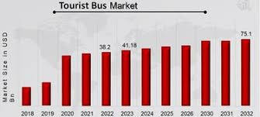
Figure 1: Market size of tourist Bus
(Source: SejalAkre, 2025)

2.2 Discussion about the damages caused by this mode of transport
The sustainable aspects of the hospitality industry suffer because of tourist buses which create environmental effects together with resource usage problems and social tolls. Sustainable tourism faces these issues at great significance while gaining global recognition. Tourist buses produce substantial carbon pollution because most of them operate with diesel fuel as their primary source of energy. More tourist buses operating in popular destinations create pollution that damages both environmental quality and creates greenhouse gas emissions. Continuous emissions from transportation lead to climate change that damages both tourist attractions alongside the businesses maintained by tourism-dependent communities (Ruiz-Meza and Montoya-Torres, 2021). The disruptive effects of noise pollution occur especially in densely populated regions as well as sensitive environments where it troubles the wildlife and indigenous residents.
Bus transportation convenience leads to excessive tourism because it enables numerous visitors to frequently see popular attractions. The impact of excessive tourist volume leads to destructive effects on natural environments that involve destructive interactions with vegetation and harmful effects on natural geography as well as historical cultural sites. When popularity drops for tourist hotspots in the hospitality sector the sustainable nature of these destinations deteriorates by harming their main attractions which originally brought visitors (Ghanem and Shaaban, 2022). High numbers of tourists arriving in limited-resource settings face increased depleting effects on natural resources such as water and energy because of large bus transportation.
Higher tourist traffic generates more waste which is worsened by large groups of passengers who use buses because this increase causes substantial garbage accumulation including excessive plastic waste along with environmental polluting materials. Tourist areas face more serious problems in waste management since these regions often lack appropriate waste disposal systems. The hospitality industry ends up managing extensive waste accumulation from tourist activities at additional operational costs while facing more environmental problems.
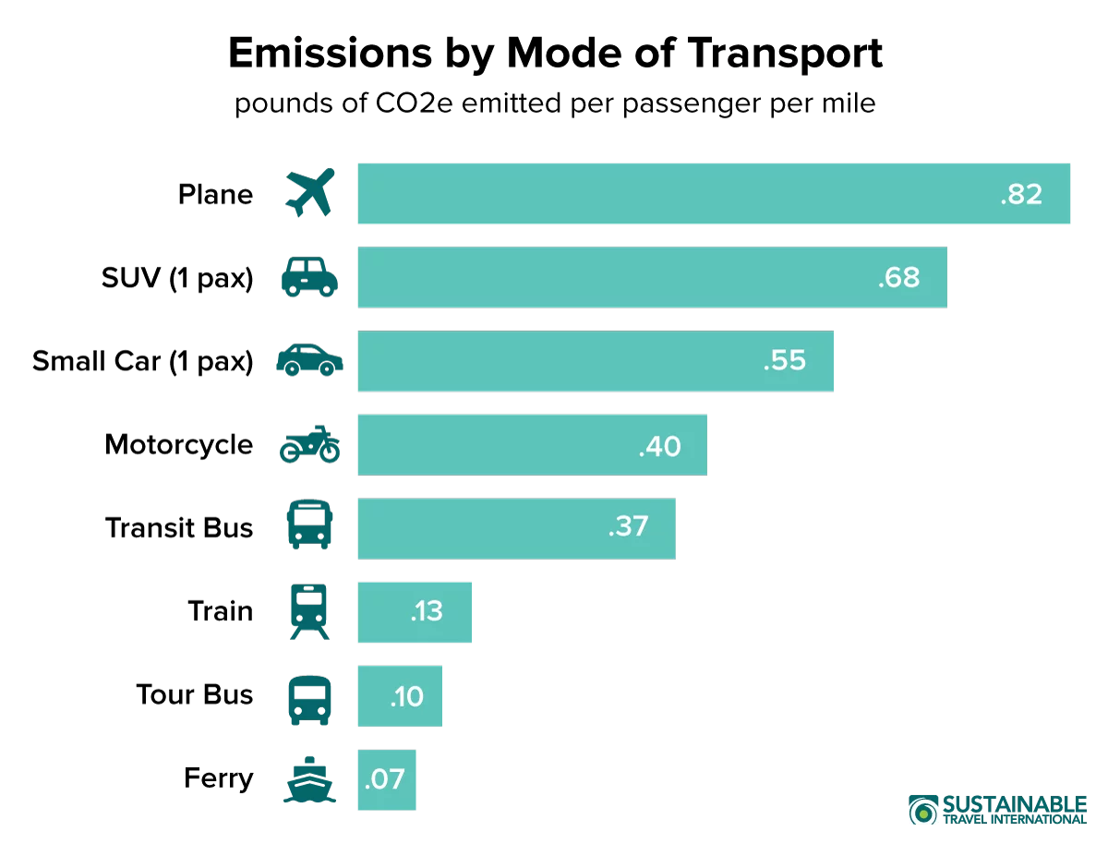

Figure 2: Carbon emission caused by Mode of transport
(Source: Sustainable Travel, 2024)

2.3 Impact of this mode of transport initiative on the environment/landscape/community
Tourist buses produce dual effects on the environment and community sustainability which present both advantages and disadvantages.
Environmental Impact
In the hospitality industry, Visitors using buses for transportation create less environmental harm than personal vehicles. Tourist buses merge multiple passengers into one vehicle which decreases road traffic as well as minimizes emissions and creates smoother traffic while lowering road deterioration. Attaining environmental sustainability requires more focus on buses like all other transportation systems. Old or poorly maintained buses tend to leak out considerably high CO2 alongside multiple pollutants. The large size of buses becomes a problem for natural reserves and narrow streets as they produce pollution and noise and disrupt habitats (Rifaiet al., 2022).
Impact on the Community
Tourist buses generate positive economic effects by creating business support for hotels and restaurants as well as attractions. The transportation business generates employment opportunities as well as cultural encounters between different groups of people. Excessive greetings of visitors create serious stress for the towns' available services and facilities. The number of visitors in busy tourist areas creates strain that impacts the basic facilities of residents and degrades their overall living standards (Kartsan, 2022). Tourist buses that visit small towns often cause traffic congestion which transforms quiet residential areas so the residents develop tensions with tourists visiting their neighborhoods.
Balancing Sustainability
Tourist buses need to implement eco-friendly operations including using emission-friendly vehicles to prevent adverse consequences and should promote travelling outside peak hours for population density control. Sustainable tourism remains protected together with environmental health through local government rules that govern tourist transportation systems.

2.4 The effective ways for the betterment of this mode of transport to benefit the environment
Tourist buses as a mode of transport are developed in effective ways which benefit the environment. The main element for this development includes the adoption of electric and hybrid buses which have less impact on the environment. According to the report of 2023, the adoption of electric buses has reached 1.206 units which has increased sales up to 320% (Zemo, 2024).
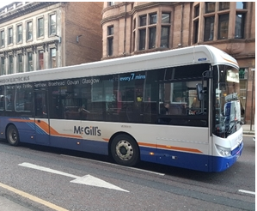
Figure 1: Electric bus
(Source: Zemo, 2024)
This has focused on developing zero-emission activities with the operations of its specific vehicle. According to the adoption of these hybrid buses, the industry has been able to operate quietly and emit different pollutant elements from the air. As a result, the process has prevented the use of 1,255,000 liters of fuel which has saved more than 3,175 tonnes of carbon emission in 2024 (Oxfordbus, 2025). Thus, the system has served the environment with a positive impact by reducing the rate of pollutants. This has eventually led to better air quality which is involved with eliminating tailpipe pollutants in different tourist destinations. According to the transition of electric buses from the traditional ones, the lower operational emission has been noticed which enhances the overall travel experience for all the customers worldwide. Another effective way has been initiated to develop the mode of transportation which is Optimised route and scheduling to minimize fuel consumption. According to efficient route planning, the industry has been able to reduce its carbon emissions. The new fleet of 104 electric buses introduced the reduction of carbon emissions by 75% in 2025 (Oxfordbus, 2025). According to a recent report, the UK has optimized electric bus routes by 63 which set the revolution of transportation (sustanabilitymag, 2024). As a result, UK transport buses have been electrified with the capital bus system which is part of the green transportation revolution. Efficiently the bud route has been optimised which minimised fuel consumption has optimised bus schedules to avoid unnecessary detours. This operating management has decreased the carbon footprint. This specific approach helped alleviate traffic congestion which made the travel smoother for all the passengers. Another effective way of developing tourist buses includes Demand Responsive transportation service which has set another solution for impacting the environment positively (Gov, 2022). This way has been implemented with a transportation draft which allows flexible systems that are scheduled based on the passenger needs. This has developed through shared transport which helped to reach the desired location along with maintaining times for pick-up and drop-off. This also has reduced CO2 emissions emitted per passenger per kilometer through the DRT services. This policy has been documented through the development of applicable policies in the UK which eventually increased passenger occupancy levels. This development has been linked with all the users with the fixed route of bus services into the local transport network to be effective.

2.5 Solutions to Eliminate These Damages
In the mode of tourist bus transportation, there is the damage of depleting effects on natural resources. However, the solution to eliminate this damage includes the implementation of a smart transit system that helps with GPS tracking. This solution can help with the automated scheduling tools which help with the enhancement of better bus operations. This system helps with tracking so the operator can see the rate of affected natural resources (Ngeoywijit et al., 2022). This tool is useful for understanding the bus operation efficiently by reducing energy usage along with carbon emission. This has also minimized unnecessary trips with waiting times which are maintained through optimised scheduling. In order to decrease substantial garbage accumulation the industry should integrate its waste collection with public transport. It is recommended to manage different equipment for waste collection management and its capabilities (Łapkoet al., 2021). Since this approach helps all the tourist buses to serve their amenities, the transportation system has been managed positively. Thus, buses have served dual functions which helped with the collection of wastage while transporting passengers. According to the scheduled waste collection process, the bus transportation system can collect all the waste by scheduling it on time. This also minimizes the number of employees and vehicles required for this specific process. In order to manage excessive plastic waste, the industry should optimize transportation networks through the positive recession-making process. According to the use of geographic information systems, the transportation network can manage heavy wastage of plastics (Wei et al., 2022). Through the application of this strategy, the industry can involve a data-driven decision-making process which is capitalized through the implementation of a data analytics tool. This helps with the monitoring process by generating less waste from plastic while decreasing plastic pollutants. Based on the peak waste generation times the industry involves its better alignment with the development of transportation resources.

3.0 Conclusion
Based on the above discussion it is concluded that the adoption of electric and hybrid buses which engage less impact on the environment. The tourist bus has incorporated this system which reduced the rate of carbon emissions in the last few years. This has eventually led towards the better air quality which is involved with eliminating tailpipe pollutants in different tourist destinations. According to better route and scheduling the transportation system has been developed with responsive demand methods. However, there are few gaps in the environment and on other landscapes which should be prioritised by this specific industry. Thus, few recommendations have been developed to mitigate few issues in the industry.
The study also noted that public transportation and waste collection should be integrated by the industry to reduce significant garbage accumulation. It was advised to oversee several pieces of equipment for the management of garbage collection and its functions. This strategy has improved the management of the transportation system since it enables all tourist buses to provide their services. Buses have therefore performed two tasks that have aided in the collecting of waste while carrying people.

References
Cooper, C. (2021) Essentials of tourism.Third edition. London: SAGE.
Ghanem, M. and Shaaban, K., (2022). Determinants of memorable sightseeing bus-tour experiences: Identifying and evaluating destination related attributes. Tourism and Hospitality Research, 22(2), pp.209-225.
Gov.UK, (2022). Demand responsive transport: local authority toolkit. Available at: https://www.gov.uk/government/publications/demand-responsive-transport-local-authority-toolkit/demand-responsive-transport-local-authority-toolkit#:~:text=Demand%20responsive%20transport%20(%20DRT%20)%20is,low%2Ddemand%20times%20of%20day. [Accessed on 30 January, 2025]
Haski-Leventhal, D. (2018) Strategic corporate social responsibility : tools & theories for responsible management. London: SAGE.
Kartsan, P., (2022). Transport communication and organization of transport services in the tourism sector. Transportation Research Procedia, 61, pp.180-184.
Łapko, A., Hącia, E. and Wieczorek, R., (2021). Collection of waste from passenger ships and its impact on the functioning of tourist port city Świnoujście. Sustainability, 13(4), p.2133.
Ngeoywijit, S., Kruasom, T., Ugsornwongand, K., Pitakaso, R., Sirirak, W., Nanthasamroeng, N., Kotmongkol, T., Srichok, T., Khonjun, S. and Kaewta, C., (2022). Open innovations for tourism logistics design: a case study of a smart bus route design for the medical tourist in the City of Greater Mekong Subregion. Journal of Open Innovation: Technology, Market, and Complexity, 8(4), p.173.
Ngeoywijit, S., Kruasom, T., Ugsornwongand, K., Pitakaso, R., Sirirak, W., Nanthasamroeng, N., Kotmongkol, T., Srichok, T., Khonjun, S. and Kaewta, C., 2022. Open innovations for tourism logistics design: a case study of a smart bus route design for the medical tourist in the City of Greater Mekong Subregion. Journal of Open Innovation: Technology, Market, and Complexity, 8(4), p.173.
Oxfordbus.UK, (2025). Oxford Bus Company electric transition improves air quality. Available at: https://www.oxfordbus.co.uk/oxford-bus-company-electric-transition-improves-air-quality [Accessed on 30 January, 2025]
Rifai, A.I., Putra, M.G.D., Isradi, M., Mufhidin, A. and Prasetijo, J., (2022).Evaluation of Selection of Public Transport Mode Corridor Blok M–Bundaran Hotel Indonesian in the New Normal Era with Stated Preference.IJEBD International Journal Of Entrepreneurship And Business Development eISSN 2597-4785 pISSN 2597-4750, 5(4), pp.792-805.
Ruiz-Meza, J. and Montoya-Torres, J.R., (2021).Tourist trip design with heterogeneous preferences, transport mode selection and environmental considerations.Annals of Operations Research, 305(1), pp.227-249.
SejalAkre, (2025). Global Tourist Bus Market Overview Source:Available at: https://www.marketresearchfuture.com/reports/tourist-bus-market-16138. [Accessed on 30/1/2025]
Sloan, P., Legrand, W. and Chen, J.S. (2017) Sustainability in the hospitality industry : principles of sustainable operations. 3rd edn. London: Butterworth-Heinemann.
Sustainable Travel, (2024).Carbon footprint of Tourism.https://sustainabletravel.org/issues/carbon-footprint-tourism/
sustanabilitymag.com, (2024). London's Electric Bus Route 63 is Revolutionising Transport. Available at: https://sustainabilitymag.com/net-zero/end-to-end-solution-behind-first-fully-electric-bus-route [Accessed on 30 January, 2025]
Wei, Y., Jiang, N., Li, Z., Zheng, D., Chen, M. and Zhang, M., (2022). An improved ant colony algorithm for urban bus network optimization based on existing bus routes. ISPRS International Journal of Geo-Information, 11(5), p.317.
Zemo.UK, (2024). UK leads the way in zero emission bus market. Available at: https://www.zemo.org.uk/news-events/news,uk-leads-the-way-in-zero-emission-bus-market_4617.htm#:~:text=The%20UK%20led%20adoption%20of,sales%20up%20320%25%20on%202022. [Accessed on 30 January, 2025]

