Marketing Fundamental
IULIA-ANDREEA FLITA
Student ID no.2027759

Executive Summary
The main objective of the report is to explain the marketing strategy and impact of Covid-19 is being felt by all businesses across the world. The report has discussed the different kinds of issues such as keeping the employee and customer safety, shoring up, and liquidity as well as taking support from government support programs to deal with uncertain conditions. The Marketing Manager of Argos mainly focuses on internal and external analysis for future growth. For successful entrance into the market, the Company mainly focuses on marketing strategy and approach to attain a competitive edge. The report has illustrated the stages of marketing, STP, and marketing mix strategies of Argos.

Table of Contents
Introduction 4
Company Background (Argos) 4
Process and Stages of Marketing 5
Internal and External Analysis of Argos 7
Segmentation, Targeting and Positioning 10
Marketing Mix of Argos 11
Conclusion 13
Reference List 14

Introduction
Marketing management is the best way to identify the opportunities that help to satisfy customer demand (Bergkvist and Eisend, 2021). Moreover, the Marketing Manager of Argos mainly focuses on high-quality products or services to fulfill the demand of customers for future growth. Argos focuses on identifying the internal and external policies to analyze the factor that impacts business activities. The main goal of this report is to provide concise information about Argos is a retail online store that provides variety of products to meet customer preference. The report has discussed the SWOT, STP, and marketing mix at Argos. With efficient marketing process, Argos executes best strategy to create value for the customer for future growth.

Company Background (Argos)
Argos is an online retail store and offers household products to accomplish the customer demand of the UK. The Company emphasize upon technology to improve the customer experience. Argos focuses on retail stores and online shops to improve the value of the customer for future growth (Argos, 2021). In 1972, Argos is established as an online retail store. With the development of technology, Argos mainly focuses on fundamental and permanent shifts in the way of customer shift. The Company has more than 130 million customers across the world to fulfill their demand. Argos has employed over 15,381 people to enhance shopper experience for future success.
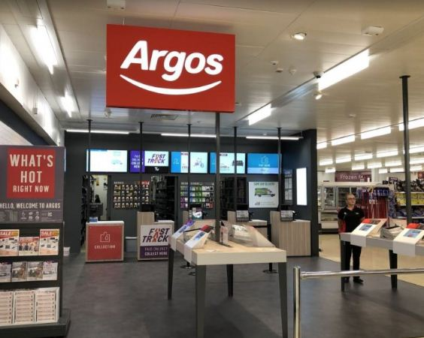
Source: (Argos, 2021)

Process and Stages of Marketing
The marketing procedure mainly focuses on understanding the market opportunities that are available in the market to earn huge profits (Bergkvist and Eisend, 2021). Through marketing, Argos concentrates the creation of value and optimize operational processes to satisfy customer needs. Marketing is the best way to focus on fundamental concepts like production, managing quality standards, and tracking the marketing program to satisfy customer needs. In a pandemic, Digital marketing is developed by Argo's focus on the convenient shopping experience of local people. In a pandemic, Argos focuses on the effective implementation of all safety measures to safeguard the health and mitigate the risk of employees. Argos focuses on extraordinary health and safety Committee form a new set of rules and regulations to protect the customer (Mintz et al., 2021). The Company mainly focuses on Google Meet, Zoom, and another online sessions to grab the attention of large customers. In an epidemic, Argos collaborated with Sainsbury and other departmental stores to fulfill the increased demand of the customer. Argos mainly focuses on social media promotion daily posts and schemes to attract customers for future growth. Strategic marketing planning mainly focuses on setting goals, objectives, internal, and external analysis, product planning, and implementation for future growth in the competitive market (GURL, 2017).

Source: (Bergkvist and Eisend, 2021)
Mission: It mainly includes a relevant objective and goals to retain an existing customer in the competitive market (Palmatier, and Steinhoff, 2019). Argo's main mission is to deliver the product or service at the doorstep of the customer. The Company mainly focuses on maintaining strong relationships with stores, online and over the phone to satisfy customer needs.
Situational Analysis: In this stage, Argos mainly focuses on finding the best way to fulfill customer demands. With the help of SWOT analysis, Argos can identify the strength and weaknesses of the firm (Argos, 2021). PESTLE analysis also helps Argos to understand the best marketing option to survive in the competitive market. Argo's focus on competitive advantage is driven through its commitment to understand the customer's need, focus on products or services, and build a collaborative culture to grab the attention of the customer.
Marketing Strategy: After analyzing the situation, Argos mainly focuses on a strategic plan to reach the desired goals. With the help of marketing strategy, Argos may develop a new technology on brand loyalty from an existing customer to gain a competitive edge (Palmatier, and Steinhoff, 2019). Through marketing tactics, Argos used an online platform to showcase best quality products or service among customers.
Marketing Mix: In this stage, Argos mainly focus on marketing mix to control the parameter regarding marketing that include decision like product development, pricing, and promotional strategy for future growth (Bergkvist and Eisend, 2021). Argos focuses on differentiation pricing strategy and focuses on distribution channels to fulfill the customer demand.
Implementation and Control: At last, Argos implemented the marketing plan and monitor to make a change in the marketing mix as per the changing demand of the market (Mintz et al., 2021). The Company mainly focuses on the planned strategy to transform into action for future success in the global market.

Internal and External Analysis of Argos
SWOT Analysis of Argos
It refers to a marketing model that is used to analyze the merits and limitations of the firm (Awais and Samin., 2012). It mainly includes opportunities that help Argos to retain and maintain good position in the global marketplace. Argos mainly focus on a strategic approach to improve their business performance as compared to its competitor.
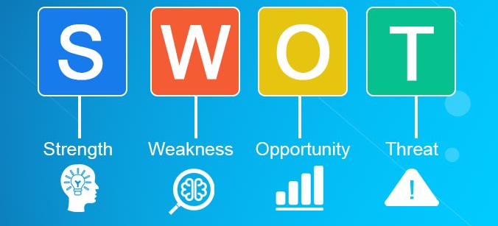
Source: (Palmatier, and Steinhoff, 2019)

Strengths: Argos is perceived as largest online retailer in the UK and has more than 800 stores across the world to fulfill customer needs. The online retailer utilizes latest technology to offer online services to create best world-class shopping experience for customers. Argos has recruited 51,000 people to enhance the shopping experience of customers for future growth (Mintz et al., 2021). The Company has reached out to 130 million customers and more than 18 million Household of UK to become successful. The Company has offered a wide range of products or services named toys, home furnishing, and technology products to gain customer attention. With the help of social media platforms, Argos focuses on an IT system to enhance brand loyalty.

Weaknesses: The Company has few controversies about their poor working hours (including working on Sunday) and heavy prices which has slightly affected the brand image (Awais and Samin., 2012). Argos has faced tough competition in the retailer market and limited market share. In the global market, Argos has a limited presence as compared to other retail chain in the UK. Due to a lack of financial planning, the Company does not effectively manage the cash flow, and difficult to deal with uncertain conditions (GURL, 2017). The company often experience higher staff turnover that has negative consequences upon business performance.
Opportunities: Argos is highly driven by latest technological capabilities to improve their future performance. Through digital technology, The e-commerce retailer focuses on online shopping as convenient for the customer (Palmatier, and Steinhoff, 2019). The Company focuses on changing the attitude and behavior of customers to gain a competitive edge. In the pandemic, Argos collaborated with Sainsbury to increase more than 25% of sales coming from the online platform. Moreover, the Company mainly focuses on other social media platforms to increase the sales and profit margin.
Threats: International expansion of another brand will increase competition in the global market. The Company suffers from a price war with other retailer chain brands in the competitive environment (Argos, 2021). During the global outbreak, UK Government has changed policies and regulations that directly impact business activities. Argos has the threat of data insecurity, negative attitude of the customer and other issues decline the profit margin of a physical store. Argos emphasize upon latest fashion & apparel trends to fulfill customer expectations (GURL, 2017).
PESTLE Analysis of Argos
This is a strategic model used to understand the macro-environmental factor that could enhance the strategic management of the firm. With the help of this tool, Argos mainly focus on evaluating the environmental factor that helps to shape the organization (Perera, 2017). This model helps Argos to develop new marketing strategies to deal with the economic recession and mitigate the market risk. Different environmental factors of PESTLE analysis are discussed as under:
Political Factor: In the epidemic, Changes in political factors negatively impact the operation of the Argos. The Current Covid-19 has taken an advantage of the favorable condition to expand the market for future growth. With the help of policies, the Company has an active price comparison with the network to fulfill the increased demand of the customer. In a pandemic, Argos partnership with Sainsbury to deliver the product or service with all safety measures to protect the customer from infection (Vassileva, 2017). The government has made changes in taxation strategies, norms of leadership, and employment regulations to improve the performance of the firm. Moreover, UK Government is committed to offering support of technology and a good strategy for future success in the global market.
Economical Factor: The current Covid-19 direct impact on changes in price fluctuation in the local and international market. In the pandemic, Argos was acquired by Sainsbury because of purchasing power of many customers is high especially in the food sector (Perera, 2017). A high inflation rate may require Argos to continue increasing prices in the line of inflation to maintain their brand loyalty. The government of the UK also motivates their online outlets to maintain balance between customer needs and future requirements. The Company mainly focuses on the latest technology to improve its presence in the global marketplace.
Social Factor: In the pandemic, Customer has increased their demand for healthy and nutritious products to satisfy the demand. Argos has the opportunity to develop a platform with easy access to fulfill the demand for future success in the competitive market (Bergkvist and Eisend, 2021). During the global outbreak, the cost of living of the customer has decreased while customer spends their money on basic requirements to survive in the market. In this condition, Argos mainly focuses on online platforms to facilitate service or products to a potential customer. Argo's main focus on corporate social responsibilities is to fulfill the demand of the target market customer for future growth.
Technological Factor: Argos wishes to improve its digital platform with the latest software and technique to improve the customer experience. With the help of the internet, Argos maintained strong relationships with others to expand their customer base (Palmatier, and Steinhoff, 2019). The online shop or platform of Argos offered customers convenience, variety, and value of a product to fulfill the demand of the customer. In a pandemic, the Company needs to focus on data security and safety to protect the customer information from a third party (Frue, 2020). Through research and development, Argos mainly focuses on developing a chance of self-sustaining ecosystem to gain a competitive edge.
Legal Factor: With the help of laws and regulation, Argos mainly focuses on stable, and functions of interest of everybody equally in the global market (Perera, 2017). The Company focuses on health and safety regulations to protect the employee as well as the customer in the competitive edge. Due to the impact of a pandemic, Customer spending on luxurious products has reduced while customers spend funds on the necessary need to gain customer attention.
Environmental Factor: In the pandemic, Argos mainly focuses on the environmental approach and local communities to reduce the impact on business (Phan, 2021). With the help of this policy, Argos recycled the business waste up to 94%. The Company mainly focuses on 100% recyclable catalogs to gain the attention of the customer. Argos also takes support from Government and collaborative organizations to reduce the impact on the environment positively. The Company mainly focuses on the environmental standard to reach desired goals for future success (Frue, 2020). Argos focuses on the disposal and recycling of old electronic waste products to accomplish a set objective.

Segmentation, Targeting, and Positioning
Market Segmentation: It refers to dividing the market segment into diverse sub-segments of the customer with the different needs to gain customer attention (Lim, 2021). In this competitive market, variable plays an essential role intake the right decision for the customer. Argos focuses on the demographic segment understand based on income, age, gender, and religion. The Company mainly targets local and high-income group people to attain a market demand. Moreover, Argos focuses on men and women in a different segment of the market for future growth. The Company mainly focuses on different segmentation to fulfill the need of each customer (Weinstein, 2013). Argos has maintained a strong balance between market segments to target customers and fulfill the demand to a potential customer.
Target Audience: During the global outbreak, Argos saw huge changes in buying behavior of the customer. Through latest technology, the e-commerce retailer focuses on understanding the changing habits and perception of customer toward products or service (Kotler and Keller, 2016). At present, Argos used an online platform to improve the shopping experience of the customer. The Company mainly focuses on a different channel to communicate with customers and offers different facilities to increase purchases for future development. Argos develops a site through which the customer easily asks a question regarding products or services before making a purchase (Perera, 2017). In the UK, households prefer to use the Argos network to identify the need and demands of a potential customer differently. Moreover, Argos mainly focuses on advanced technology to enhance shopper experience to foster future development.

Positioning: In this factor, product positioning is designed with product features to gain customer attention. Argos has maintained positioning with differentiated marketing tactics to grab a new customer base. The Company mainly focuses on a lower pricing strategy that creates value for the customer, and branded products line help to meet the demand of customers (Argos, 2021). The Company focuses on Royal mail and another delivery service to improve the customer experience. Argos has spent capital on the store to create a product position in the competitive market. Through market positioning, Argos mainly focuses on maintaining and improving its operational standard to gain a competitive edge for future growth (Kotler and Keller, 2016). Argos need for changes in the behavior, attitude, habit, and increased demand of customers in a pandemic.

Marketing Mix of Argos
This is a strategic tool that helps businesses to choose the best promotional tactics and strategies to improve their products or service to fulfill customer demand (Lim, 2021). With the help of marketing tactics, Argos focuses on brand value to maintain a strong position in the competitive market and attain its business goals. Argos has discussed the different elements of the marketing mix as under:
Products: Argos mainly focuses on leading retail chain brands across the UK. The Company has developed a website with more than 1600 pages to grab the attention of the customer. Argos focuses on uploading attractive images of items, small descriptions, prices, and numbers to attract customers for future development (Vassileva, 2017). The online retailer focuses on variety of products such as furniture, personalized care, and other products to fulfill the increased demand of the customer. Argos mainly focuses on the attractive logo to attract new customers and explore their market presence across the world. It mainly includes different brands such as Challenges, Cookworks, Visit, and Pro fitness to attract large customers.
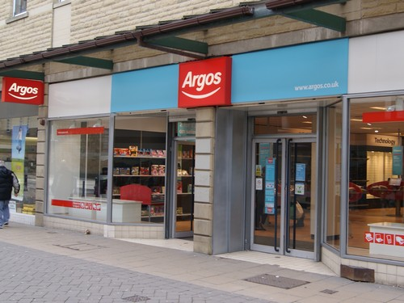
Source: (Argos, 2021)
Price: Argos has executed competitive pricing strategy as well as an economical pricing strategy to gain customer attention (Phan, 2021). The management team of Argos focuses on maintaining a strong relationship with a supplier to reduce the cost of products and improve the customer experience. Product differently prices in Ireland as compared to the UK to enhance the shopping experience of the online customer.
Place: The Company has mainly targeted more than 75% of the UK household to fulfill the customer demand. Argos has managed both online and physical stores to reach the desired goals (Weinstein, 2013). The Company has operated more than 850 stores across the world to target customers and maintain brand loyalty. Argos has decided to open new stores in different nations to expand its global presence.
Promotion: With the help of promotional strategies, Argos ensures the customer is aware of its offering. The Company mainly focuses on direct promotional strategies like Facebook, Instagram, and Twitter to improve the satisfaction level of the customer for future growth (Thabit and Raewf, 2018). Argos also focuses on print media, online banners, and social media engagement to become successful in the global marketplace.
People: Argos has employed more than 15,000 people across its entire internet channel to fulfill the increased demand of customers (Vassileva, 2017). In an epidemic, the Company mainly focuses on changing attitudes and coming with a new variety of products to gain a competitive edge. Argos also decides to conduct an online meeting with the employee to increase their morale for future growth.
Process: Argos has adopted efficient electronic database to provide detailed information to customers regarding delivery slots, pricing and product features (Kotler and Keller, 2016). With the help of the delivery channel, Argos focuses on shipment and procurement for faster and safer delivery of products at the doorstep of the customer.
Physical Evidence: Argos focuses on households, and another strategy to gain a competitive edge. The Company has developed catalog and window shopping at the store to improve the experience of the customer (Thabit and Raewf, 2018). Argos has built a good pass time and culture to become successful in the global market.

Conclusion
Overall, the report has critically analyzed marketing strategy with a stage at Argos to fulfill customer demands. The report has discussed the impact of covid-19 on a broad range of interrelated issues that span for keeping their employees safe at the workplace. Moreover, the ultimate goals of this report are to examine the segment, target audience, and position of Argos in extreme competitive space. Argos mainly focuses on marketing mix tactics to improve the shopping experience of the customer. The Company has conducted a training and development program for an existing employee to maintain its long-term presence in marketplace.

Reference List
2021. [online] Available at: <https://www.argos.co.uk/webapp/wcs/stores/servlet/ArgosStaticPageSecondLevel?includeName=AboutArgos.htm&langId=110&storeId=10151&catalogId=1001> [Accessed 20 December 2021].
Awais, M. and Samin, T., 2012. Advanced SWOT Analysis of E-commerce. International Journal of Computer Science Issues (IJCSI), 9(2), p.569.
Bergkvist, L. and Eisend, M., 2021. The dynamic nature of marketing constructs. Journal of the Academy of Marketing Science, 49(3), pp.521-541.
Frue, K., 2020. PEST analysis ultimate guide: Definition, template, examples. PESTLE Analysis.
GURL, E., 2017. SWOT analysis: A theoretical review.
Kotler, P. and Keller, K.L., 2016. A framework for marketing management (p. 352). Boston, MA: Pearson.
Lim, W.M., 2021. A marketing mix typology for integrated care: the 10 Ps. Journal of Strategic Marketing, 29(5), pp.453-469.
Mintz, O., Gilbride, T.J., Lenk, P. and Currim, I.S., 2021. The right metrics for marketing-mix decisions. International Journal of Research in Marketing, 38(1), pp.32-49.
Palmatier, R.W. and Steinhoff, L., 2019. Relationship marketing in the digital age. Routledge.
Perera, R., 2017. The PESTLE analysis. Nerdynaut.
Phan, S., 2021. The effect of PESTLE factors on development of e-commerce. International Journal of Data and Network Science, 5(1), pp.37-42.
Thabit, T. and Raewf, M., 2018. The evaluation of marketing mix elements: A case study. International Journal of Social Sciences & Educational Studies, 4(4).
Vassileva, B., 2017. Marketing 4.0: How technologies transform marketing organization. Óbuda university e-Bulletin, 7(1), p.47.
Weinstein, A., 2013. Handbook of market segmentation: Strategic targeting for business and technology firms. Routledge.

